**Configuration Management with Chef, Puppet, and Ansible**

Lab Migration Document



**Lab Migration Document**

**Objective:**

We are migrating our **Configuration Management with Chef, Puppet, and Ansible** lab setup from Azure cloud to AWS cloud. This document will help you to recover the resources, services, and demos you have created on the old lab.

**Following steps should be performed:**

Step 1: Log in to your **Configuration Management with Chef, Puppet, and Ansible** course

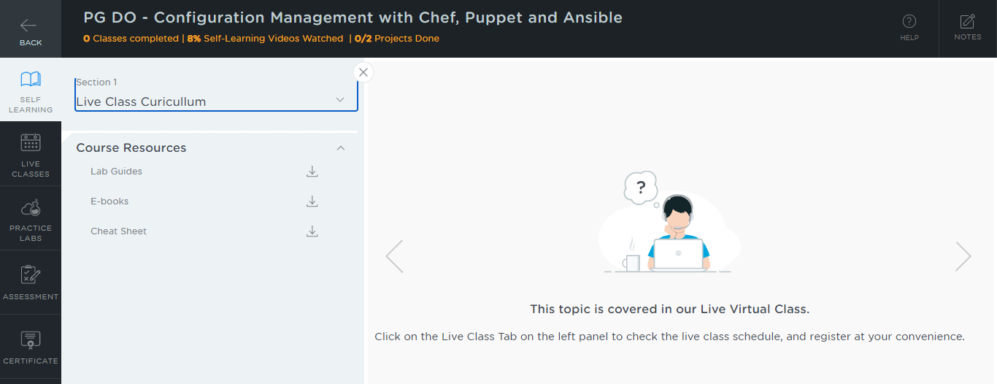

Step 2: Go to the **PRACTICE LABS** tab

Step 3: Select the old lab setup and click on **LAUNCH LAB** button

Step 4: Open your Chrome browser

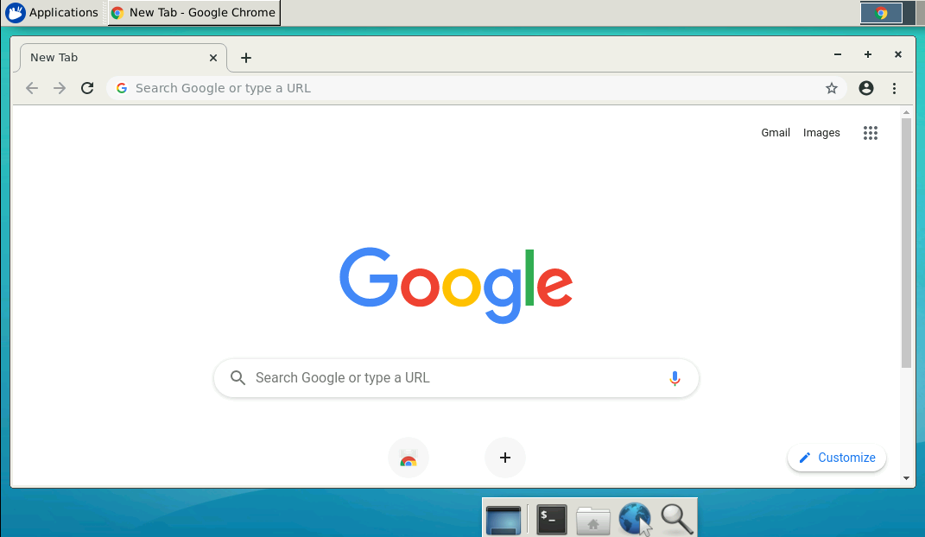

Step 5: Go to <https://github.com/>

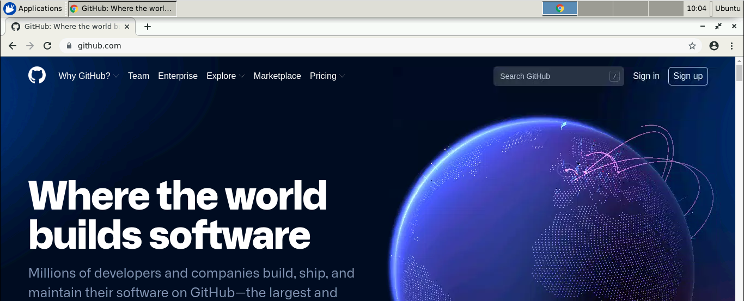

Step 6: Click on **Sign in** and enter the credentials of your GitHub account to log in

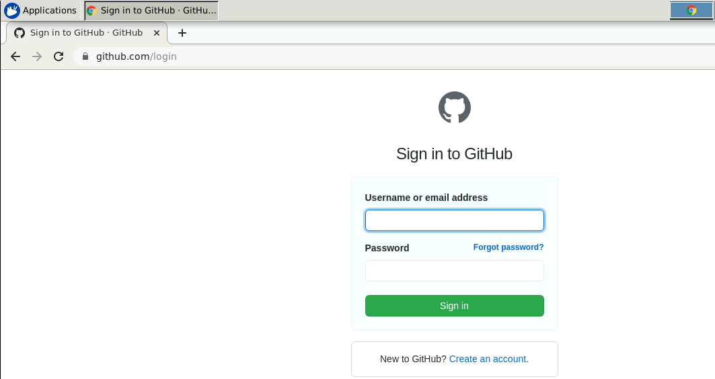

Step 7: Create a repository for migrating resources from the old lab to the new

* Click on **+** symbol and select **New repository**

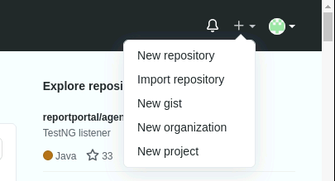

* Provide the repository name

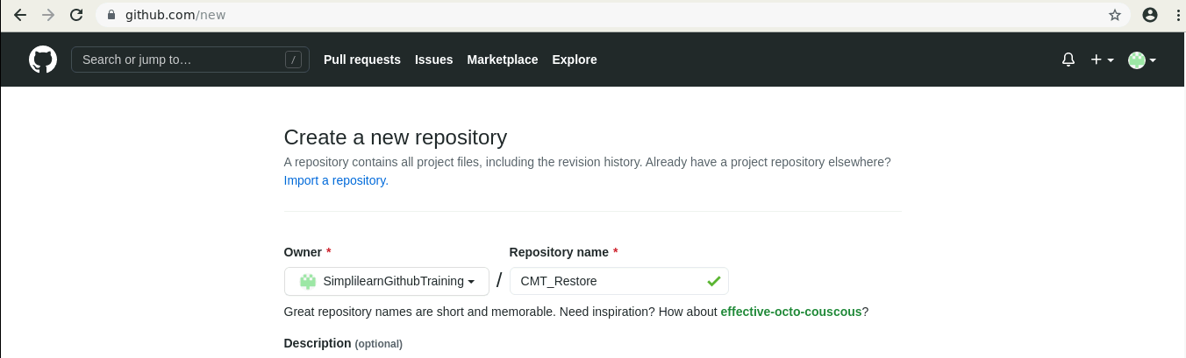

* Select the checkbox of **ADD a README file** and click on **Create repository**

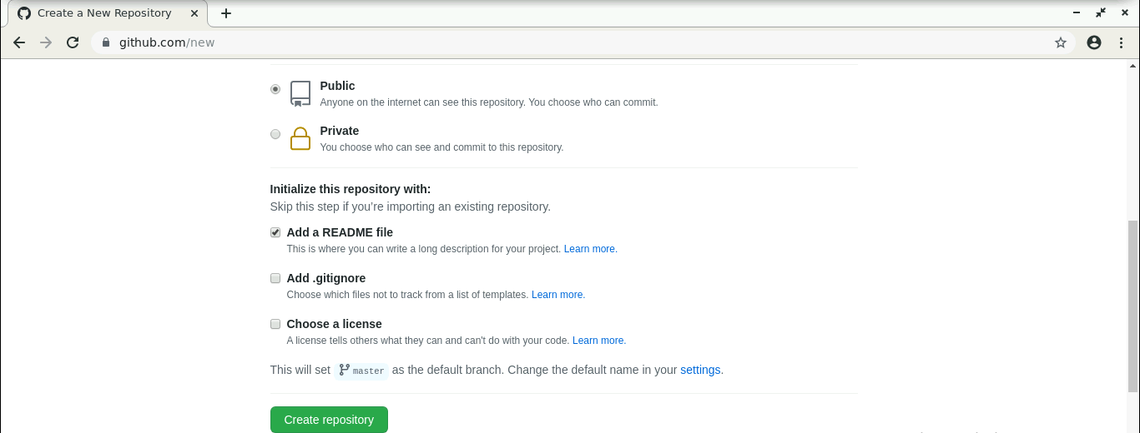

Step 8: Upload all the files, resources, services, and demos you have created

* Click on **Add file** and select **Upload files**

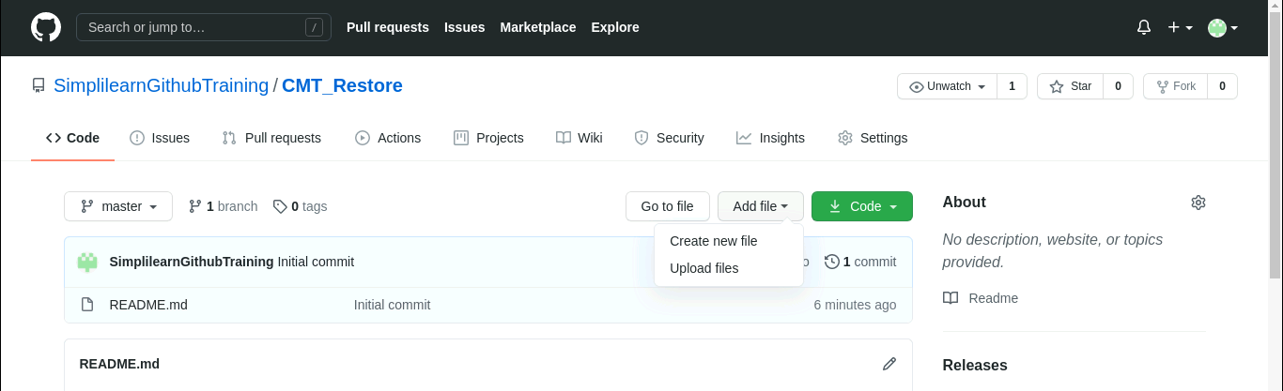

* Drag drop the files or click on **choose your files** option

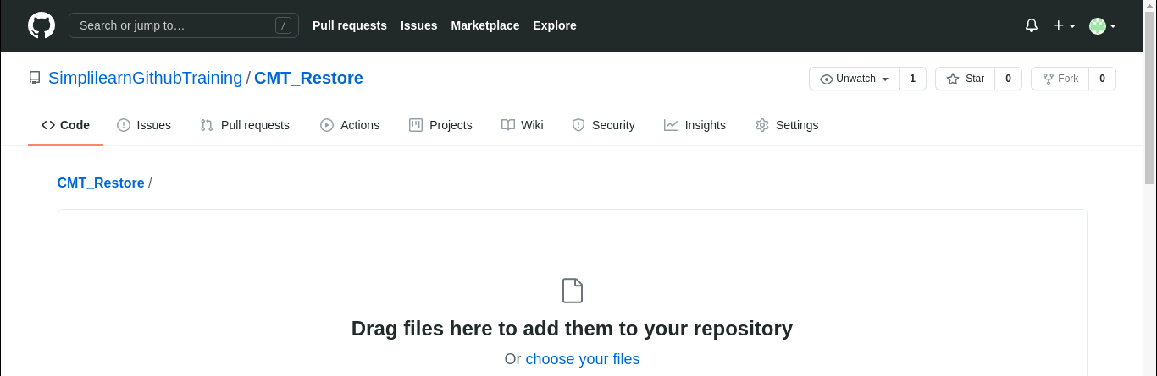

* After selecting all the files, click on **Commit changes**

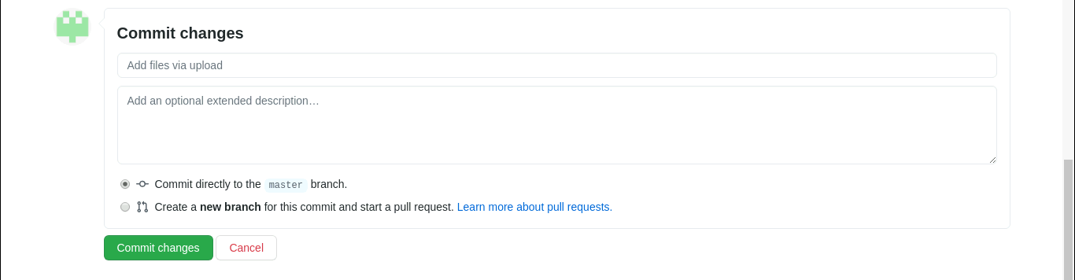

* All the selected files will get uploaded to your GitHub repository

Step 9: Now, start the New lab setup by clicking on the **LAUNCH LAB** button

Note: Select the **RDP Access**

Step 10: Open the internet browser

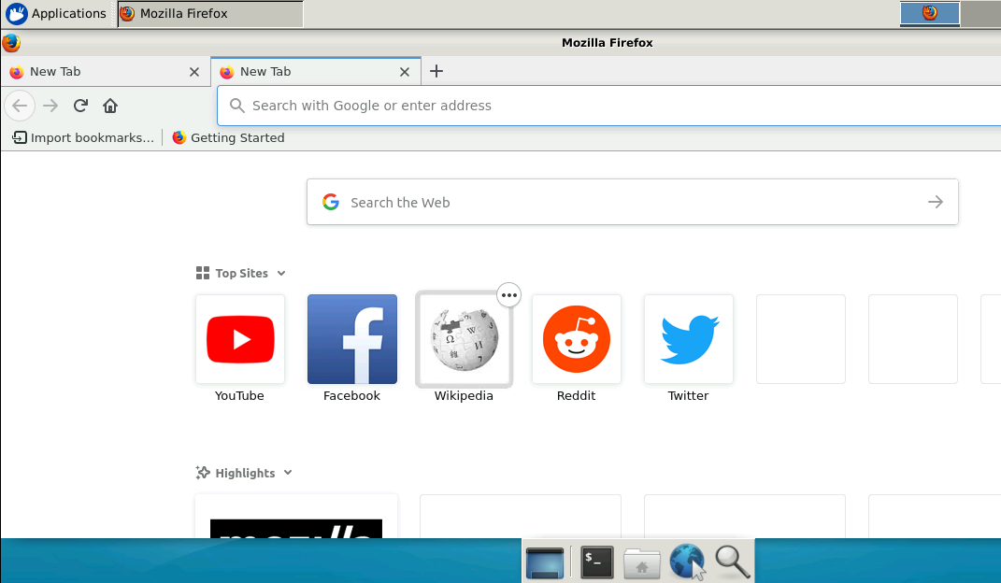

Step11: Go to <https://github.com/>

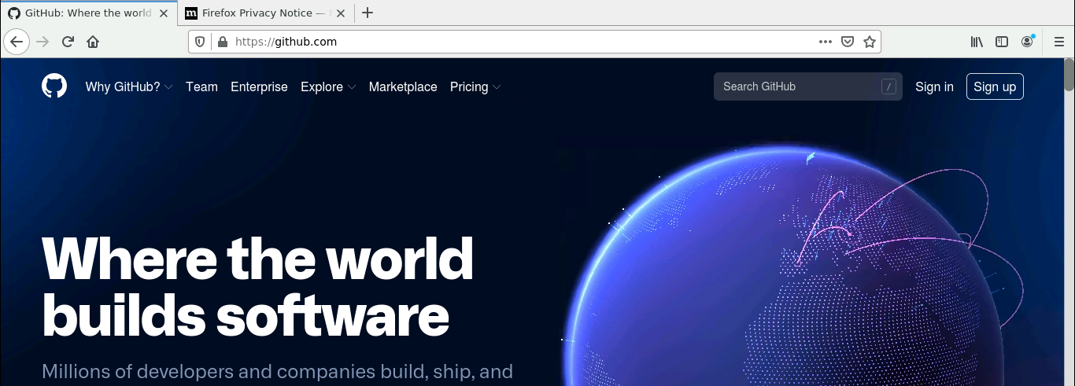

Step 12: Log in to your GitHub account

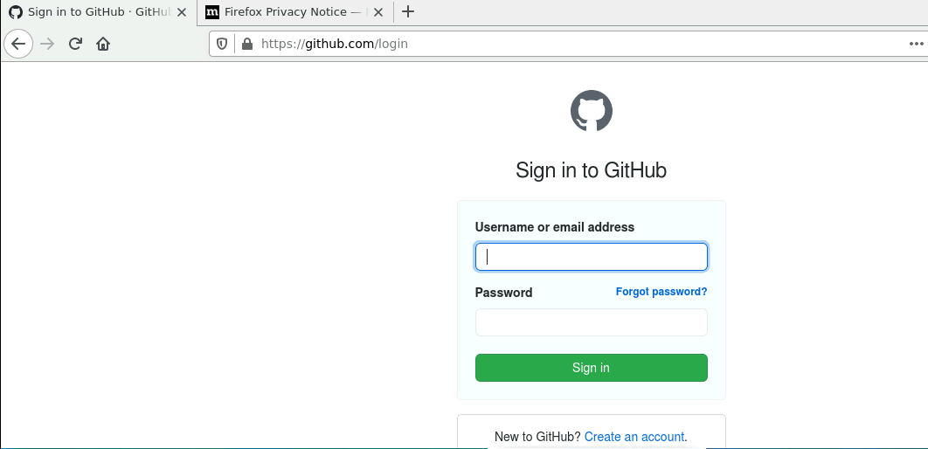

Step 13: Go to the created repository

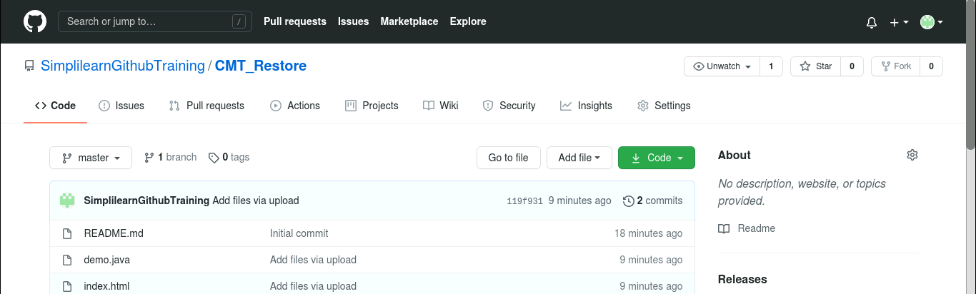

Step 14: Click on **Code**

Step 15: Copy the **HTTPS** link

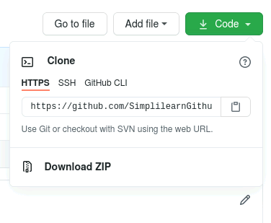

Step 16: Open the terminal in your new lab setup

Step 17: Type the following command to restore the data in new lab

*git clone copied_github_link*

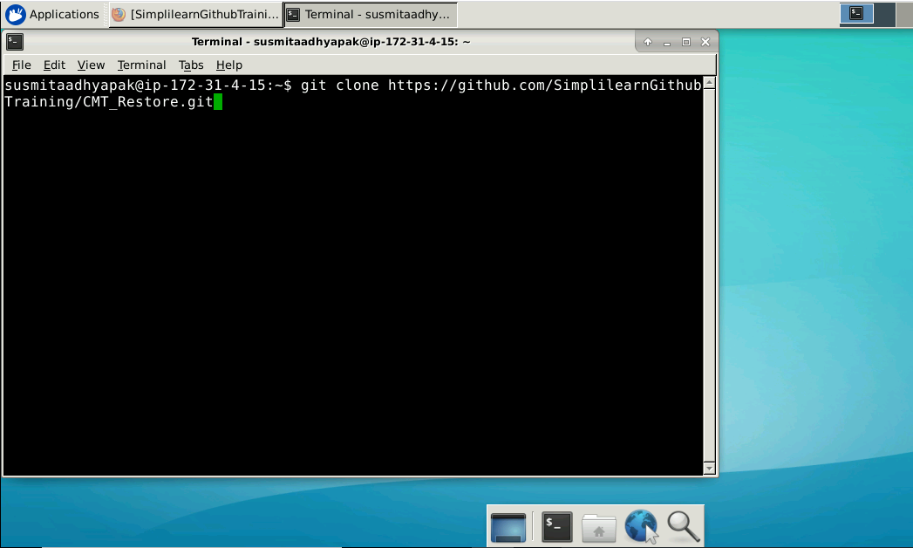

* All the files uploaded on your GitHub account will get cloned in your new lab setup
* You can now start working on the files