**DevOps Certification Training**

Lab Migration Document

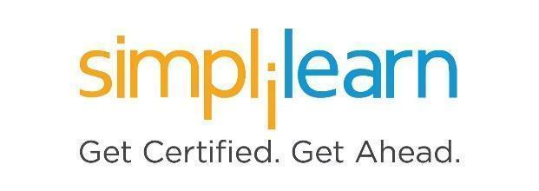

**Lab Migration Document**

**Objective:**

We are migrating our DevOps lab setup from Azure cloud to AWS cloud. This document will help you to recover the resources, services, and demos you have created on the old lab.

**Following steps should be performed:**

Step 1: Log in to your **DevOps Certification Training** course

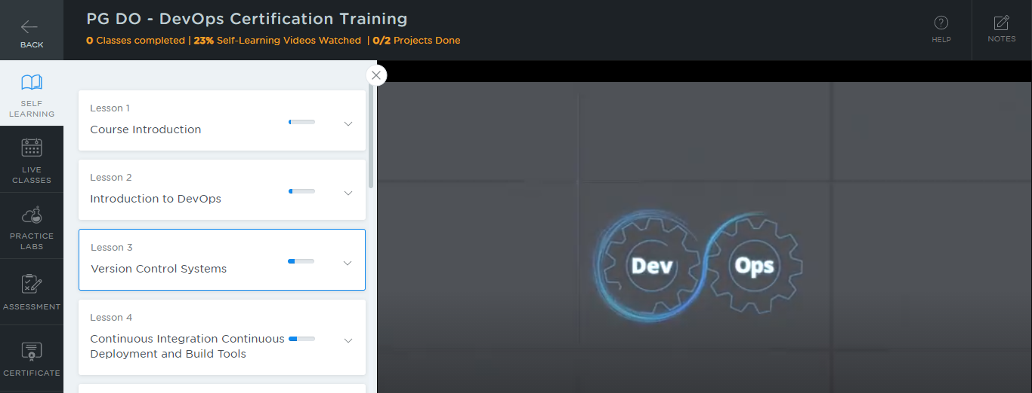

Step 2: Go to the **PRACTICE LABS** tab

Step 3: Select the old lab setup and click on **LAUNCH LAB** button

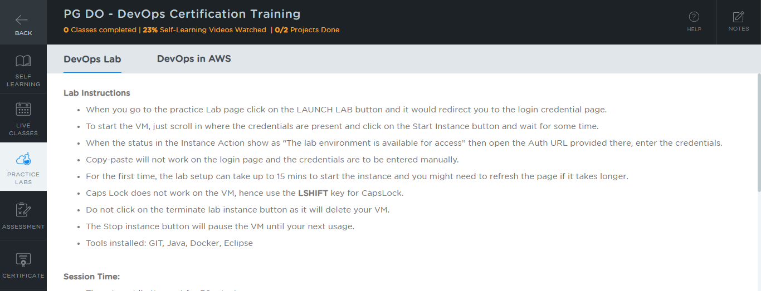

Step 4: Open your Chrome browser

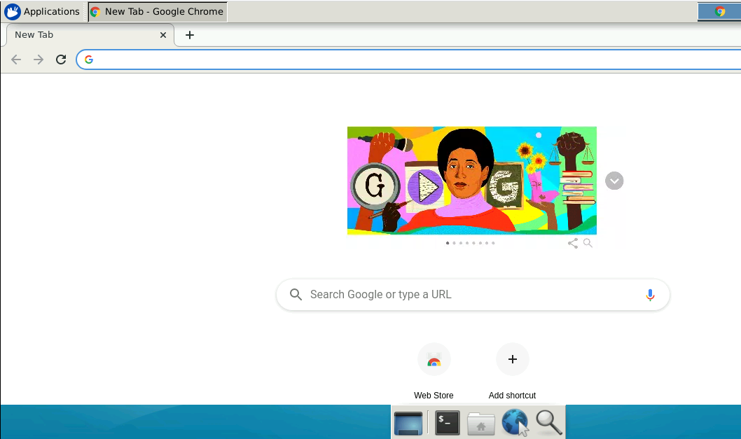

Step 5: Go to <https://github.com/>

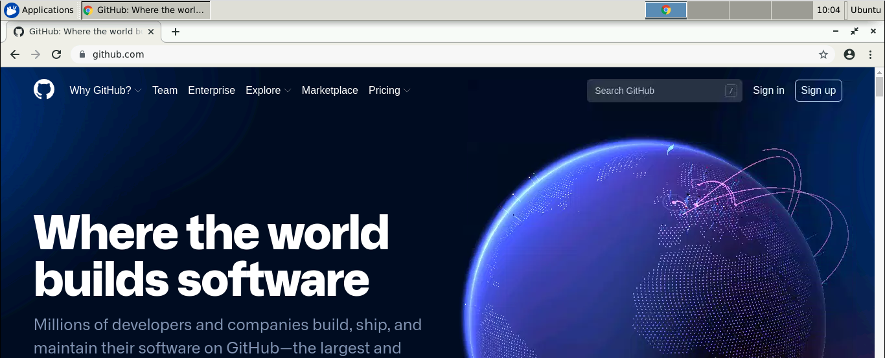

Step 6: Click on **Sign in** and enter the credentials of your GitHub account to log in

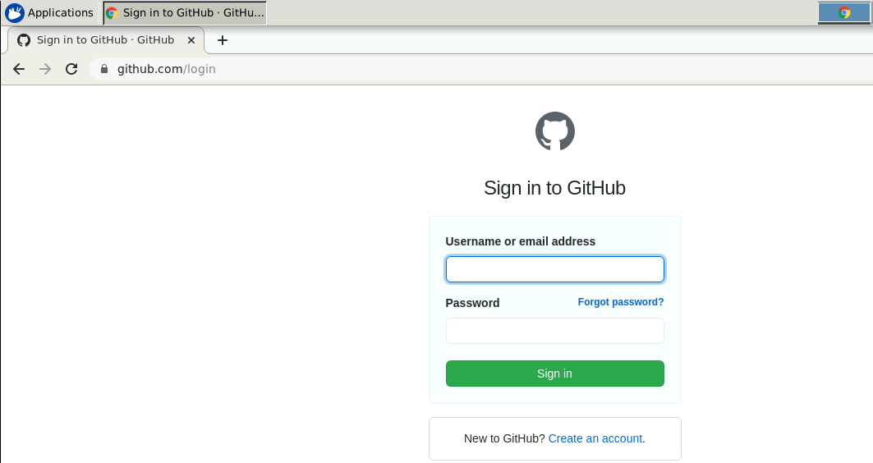

Step 7: Create a repository for migrating resources from the old lab to the new

* Click on **+** symbol and select **New repository**

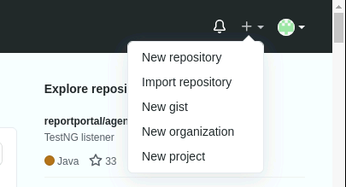

* Provide the repository name

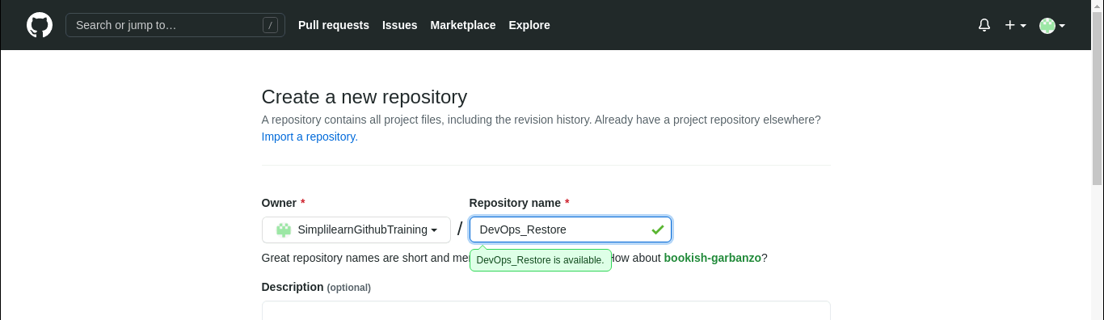

* Select the checkbox of **ADD a README file** and click on **Create repository**

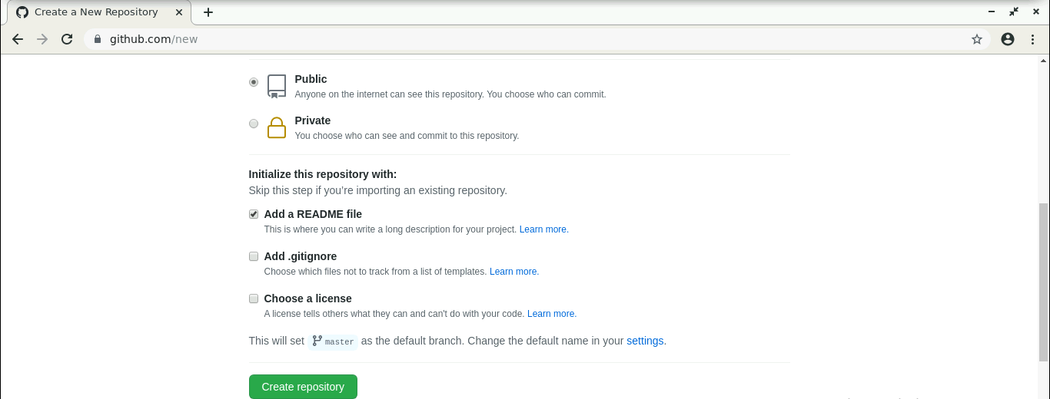

Step 8: Upload all the files, resources, services, and demos you have created

* Click on **Add file** and select **Upload files**

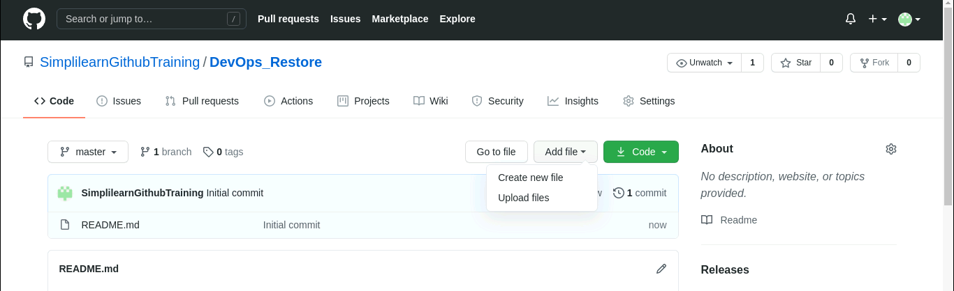

* Drag drop the files or click on **choose your files** option

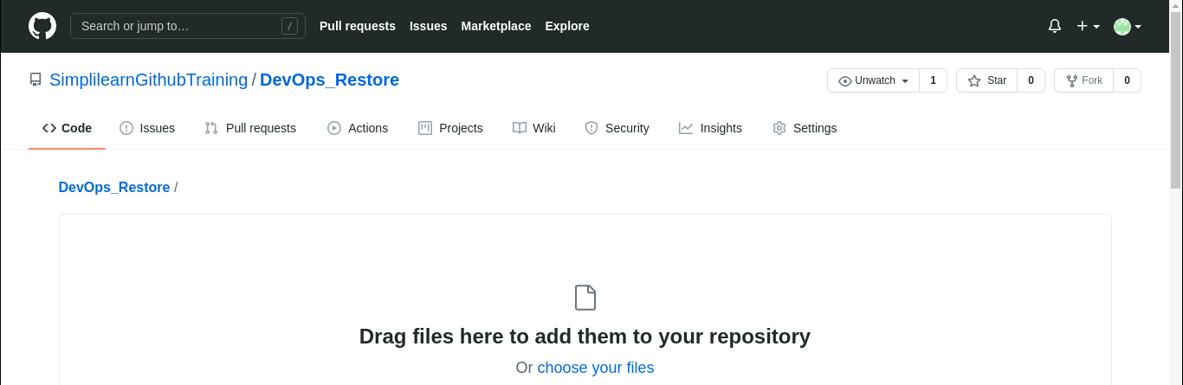

* After selecting all the files, click on **Commit changes**

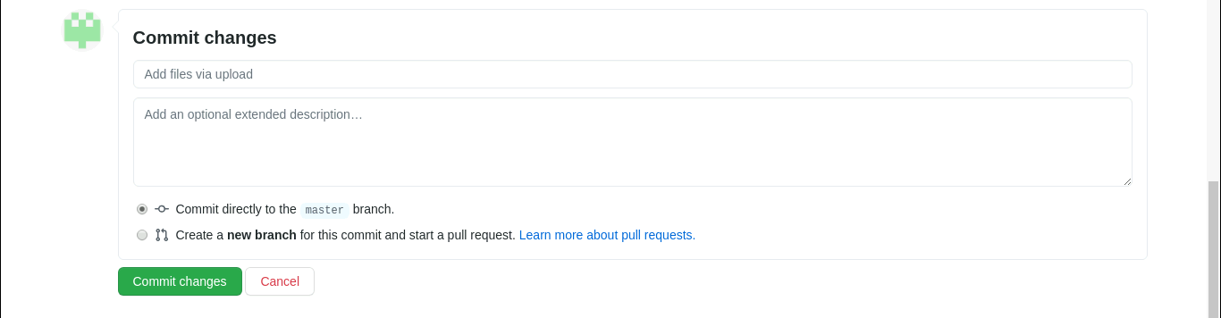

* All the selected files will get uploaded in your GitHub repository

Step 9: Now, start the New lab setup by clicking on the **LAUNCH LAB** button

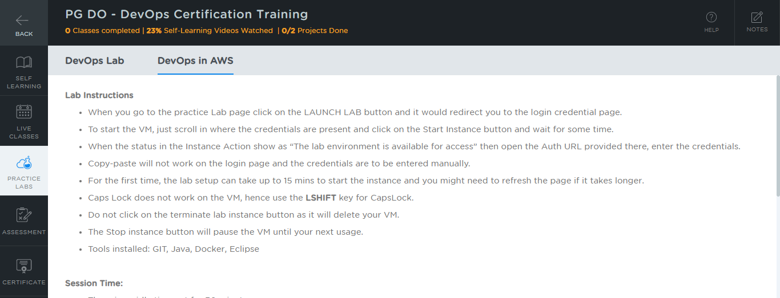

Step 10: Open the internet browser

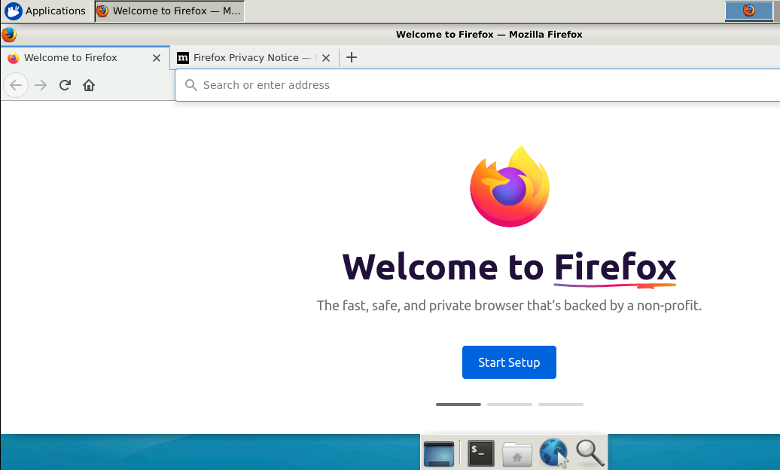

Step11: Go to <https://github.com/>

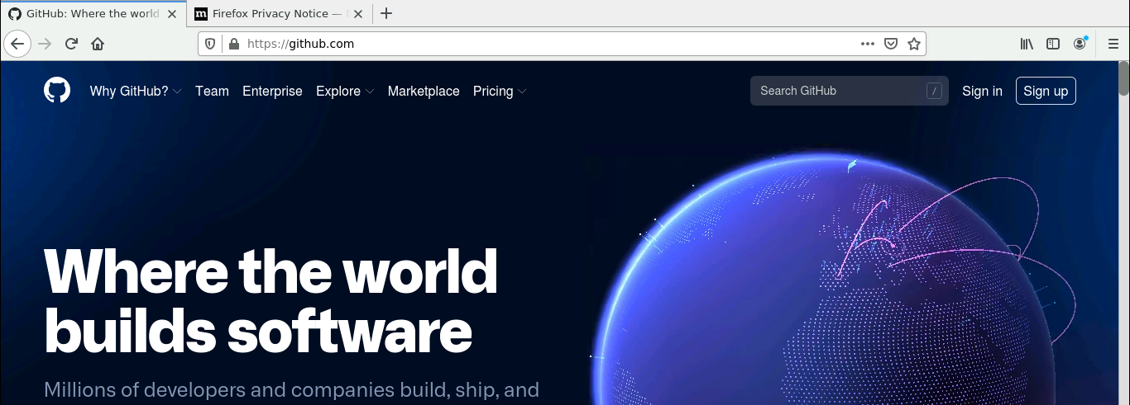

Step 12: Log in to your GitHub account

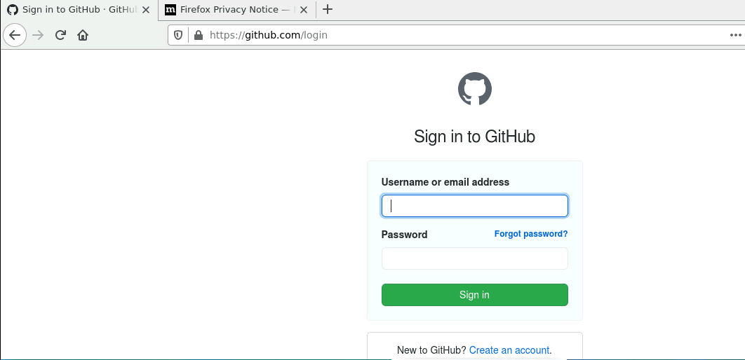

Step 13: Go to the created repository

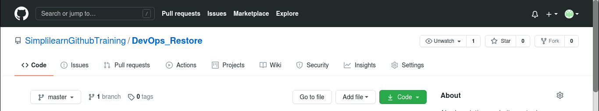

Step 14: Click on **Code**

Step 15: Copy the **HTTPS** link

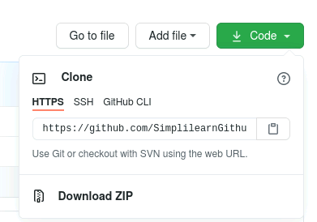

Step 16: Open the terminal in your new lab setup

Step 17: Type the following command to restore the data in new lab

*git clone copied_github_link*

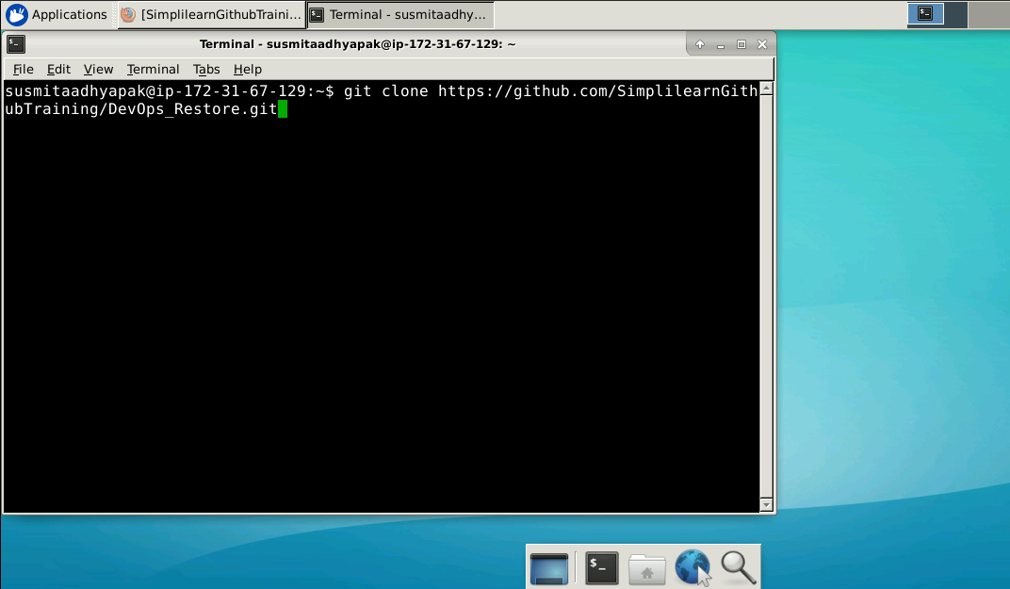

* All the files uploaded on your GitHub account will get cloned in your new lab setup
* You can now start working on the files