**A COURSE WORK REPORT**

**ON**

**SWD327 (MANDATORY SKILL ACQUISITION)**

**WRITTEN BY:**

**CHUKWU KOSOLU ANASTASIA**

**2023/HND/37287/CS**

**COMPUTER SCIENCE**

**SUBMITTED TO:**

**DR. A. C. ONUORA (COURSE LECTURER)**

**COMPUTER SCIENCE DEPARTMENT**

**SCHOOL OF SCIENCE**

**AKANU IBIAM FEDERAL POLYTECHNIC UNWANA, AFIKPO, EBONYI STATE.**

**AUGUST 16, 2024**

**IMAGE EDITING PROJECT**

**Before Image Description:**

**Subject:** Person facing away from the camera.

**Visible Features:** Back of the head and upper shoulders.

**Hair:** Dark, possibly braided or twisted into locks.

**Privacy Edit:** Face obscured by a blurred rectangular area.

**After Image Description:**

**Subject:** Person from the shoulders up.

**Visible Features:** Face and hair blurred out, making it impossible to identify any facial features or expressions.

**Background:** Neutral color.

**Editing Steps in Lightroom:**

**1. Import Image:** Imported the original image into Lightroom.

**2. Crop and Straighten:** Adjusted the crop to focus on the upper body and face.

**3. Exposure Adjustments:**

- Increased exposure to brighten the image.

- Adjusted contrast to enhance details.

**4. Color Corrections:**

- Tweaked white balance for a more neutral tone.

- Enhanced vibrance and saturation slightly to make colors pop.

**5. Detail Enhancements:**

- Applied sharpening to enhance details in the hair and clothing.

- Used noise reduction to smooth out any graininess.

**6. Blur Effect:**

- Applied a blur effect to the face and hair to maintain anonymity.

- Ensured the blur was smooth and consistent to avoid any harsh edges.

**7. Final Adjustments:**

- Made minor tweaks to shadows and highlights for better balance.

- Applied a vignette to subtly draw attention to the subject.

**Export Settings:**

- *Format*: JPEG

- *Quality*: High (80-100%)

- *Resolution*: 300 dpi for print quality

**SOCIAL ACCOUNT:**

**LINKEDIN: https://www.linkedin.com/in/james-sandra-670905323**

**GITHUB: SANDRA-SWD327**

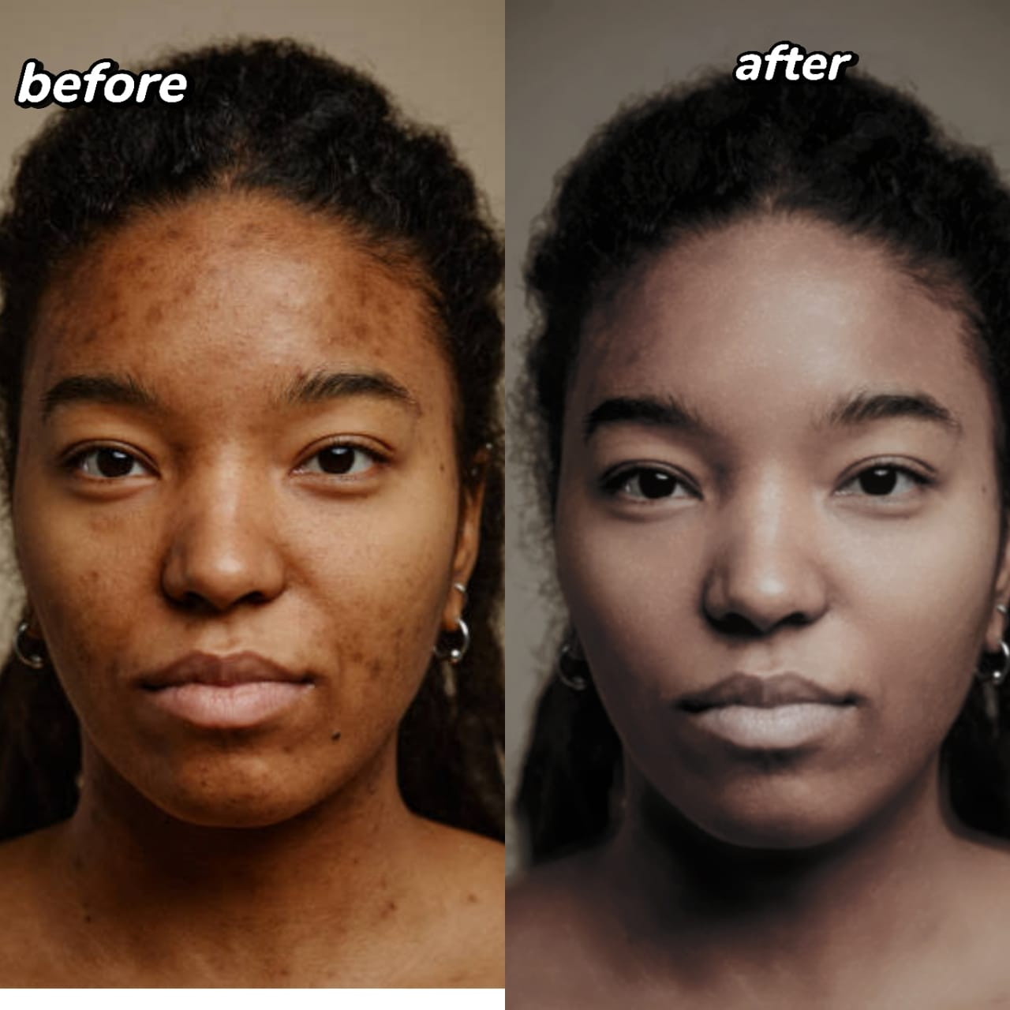**OUTPUT:**