Task C.6 Report: Ensemble Methods
COS30018 Intelligent Systems — Option C
Le Minh Kha

1. Introduction
Ensemble methods combine predictions from multiple models to achieve better accuracy than any single model alone. Different models capture different patterns in data: ARIMA excels at modelling linear trends and autocorrelation, while deep learning models (LSTM, GRU) can learn complex nonlinear relationships. Random Forest offers a third perspective through tree-based feature splitting. By combining their predictions, an ensemble can leverage the complementary strengths of each approach.
Task C.6 extends the stock prediction system (v0.5) by implementing four individual model types and three ensemble strategies. The individual models are: ARIMA (a classical statistical method), Random Forest (a tree-based machine learning approach), and the existing LSTM and GRU deep learning models from earlier tasks. The ensemble strategies tested are: simple averaging, inverse-MAE weighted averaging, and a residual hybrid approach where ARIMA provides a baseline and the DL model corrects for nonlinear deviations.
All experiments use CBA.AX stock data from 2020-01-01 to 2024-07-01, with univariate input (adjusted close price only), a 50-day lookback window, 80/20 chronological train/test split, and 25 training epochs for DL models.

2. Methodology

2.1 Implementation Changes
ARIMA rolling prediction in arima_rolling_predict(). ARIMA (AutoRegressive Integrated Moving Average) is a classical statistical model for time series forecasting. ARIMA(p,d,q) has three parameters: p (autoregressive order), d (differencing order to achieve stationarity), and q (moving average order). For fair comparison with DL models, the implementation uses a rolling (expanding window) one-step-ahead prediction approach. For each test point, the model fits on all data up to that point, predicts one step ahead, then appends the actual value to the history. The key implementation is as follows:
history = list(train_series)
predictions = []
for i in range(len(test_series)):
try:
model = ARIMA(history, order=order)
fitted = model.fit()
yhat = fitted.forecast(steps=1)[0]
except Exception:
yhat = history[-1] # naive fallback
predictions.append(yhat)
history.append(test_series[i])
The try/except handles rare convergence failures by falling back to the last known value (naive forecast). This expanding-window approach refits the model at each step, which is computationally expensive but produces the most accurate comparison with DL models. The statsmodels and pmdarima libraries were used for ARIMA fitting and automatic parameter selection respectively.
Random Forest flattening in train_random_forest(). Random Forest cannot directly consume 3D sequential data (samples, timesteps, features). The implementation flattens each window into a 1D feature vector. For a window of shape (50, 1), the RF sees 50 features corresponding to the 50 most recent price values. The key implementation is as follows:
n_samples = X_train.shape[0]
X_flat = X_train.reshape(n_samples, -1) # (samples, 50)
rf = RandomForestRegressor(n_estimators=100, n_jobs=-1)
rf.fit(X_flat, y_train)
This flattening discards temporal ordering within the window. RF treats the value at position 0 and position 49 as independent features rather than sequential observations. Despite this limitation, RF can still capture some patterns from the feature values at specific window positions.
Simple average ensemble in ensemble_simple_average(). Takes the arithmetic mean of all model predictions. Assumes all models contribute equally. Works well when models have comparable accuracy but make different types of errors.
stacked = np.column_stack(predictions_list)
ensemble_pred = np.mean(stacked, axis=1)
Weighted average ensemble in ensemble_weighted_average(). Weights each model by the inverse of its MAE. Lower MAE results in higher weight. Weights are normalised to sum to 1.
weights = np.array([1/mae_1, 1/mae_2, ...])
weights = weights / weights.sum()
ensemble_pred = np.average(stacked, axis=1, weights=weights)
Residual hybrid ensemble in ensemble_residual_hybrid(). ARIMA provides a baseline prediction and the DL model provides corrections. The blend weight (alpha) is computed dynamically from each model's MAE on the test set. When the DL model has lower MAE, alpha is higher, giving more weight to DL corrections.
total_inv = (1/arima_mae) + (1/dl_mae)
alpha = (1/dl_mae) / total_inv
hybrid = arima_pred + alpha * (dl_pred - arima_pred)
This formula is equivalent to (1-alpha)*arima + alpha*dl, but framing it as ARIMA baseline plus DL correction emphasises the complementary roles of each model.

2.2 Experiment Design
All experiments use CBA.AX stock data from 2020-01-01 to 2024-07-01 with a 50-day lookback window, 80/20 chronological train/test split, 0.2 dropout rate, and random seed 314 for reproducibility. The experiments are organised into three groups.
Experiment 1: Individual Model Performance. Four models are tested independently: ARIMA(1,1,1), LSTM 2x50, GRU 2x50, and Random Forest (100 trees). All use univariate input (adjclose only) and 25 training epochs for DL models. This establishes baseline performance for each model type.
Experiment 2: Ensemble Combinations. Six ensemble combinations test simple and weighted averaging across different model subsets: Avg(ARIMA+LSTM), Avg(ARIMA+GRU), Avg(ARIMA+LSTM+RF), Weighted(ARIMA+LSTM), Weighted(ARIMA+GRU), and Weighted(All 4). This tests whether combining models improves over individuals.
Experiment 3: Residual Hybrid. Two hybrid combinations test the structured residual approach: Hybrid(ARIMA+LSTM) and Hybrid(ARIMA+GRU). This tests whether adaptive weighting outperforms naive averaging.

3. Individual Model Performance
Table 1 presents the results of the four individual models on the CBA.AX test set. ARIMA(1,1,1) achieved the best overall performance, followed closely by GRU 2x50.
Model | MAE ($) | RMSE ($) | MAPE (%) | R² | Time (s)
ARIMA(1,1,1) | 0.87 | 1.12 | 0.98 | 0.9912 | 38.6
LSTM 2x50 | 1.58 | 2.05 | 1.79 | 0.9704 | 41.7
GRU 2x50 | 0.95 | 1.26 | 1.08 | 0.9888 | 50.9
Random Forest | 15.00 | 18.92 | 15.60 | -1.5230 | 1.7
Table 1: Individual model performance on CBA.AX test set (225 test points).
ARIMA(1,1,1) achieved the best individual performance with MAE of $0.87 and R² of 0.9912. This strong performance is expected because stock prices exhibit strong day-to-day autocorrelation, and ARIMA directly models this structure through its AR and MA components. The rolling one-step-ahead approach with d=1 differencing is well-suited to this pattern.
GRU 2x50 was the best DL model (MAE $0.95, R² 0.9888), consistent with C.4 and C.5 findings where GRU outperformed LSTM. LSTM 2x50 performed adequately (MAE $1.58, R² 0.9704) but with roughly twice the error of ARIMA. DL models learn the autocorrelation pattern indirectly through gradient descent, requiring more parameters and training time.
Random Forest performed poorly (MAE $15.00, negative R²), indicating that flattening the window destroys too much temporal structure for tree-based models. RF treats each position in the 50-step window as an independent feature, losing the sequential dependency central to time series prediction.
Training times were comparable for DL models (42-51 seconds for 25 epochs). ARIMA's rolling prediction took 38.6 seconds due to refitting at each of the 225 test steps. Random Forest was fastest at 1.7 seconds but least accurate.
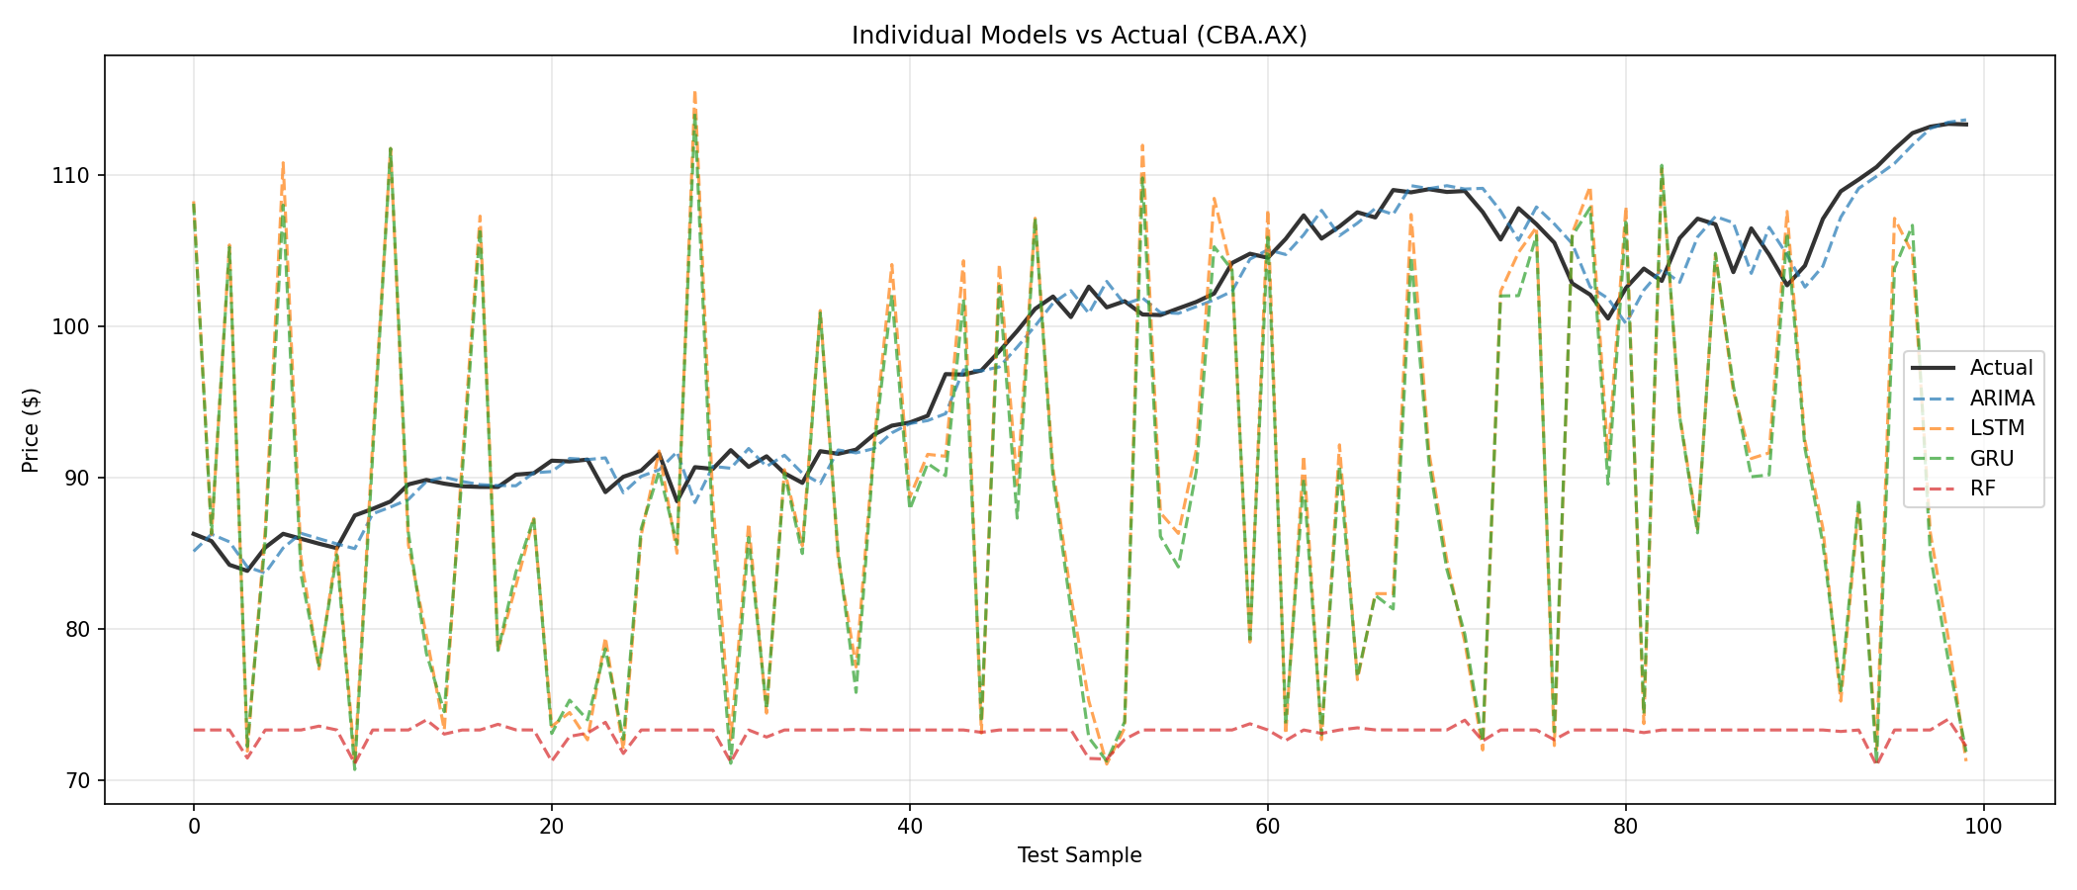
Figure 1: Individual model predictions compared to actual CBA.AX prices on the last 100 test points.

4. Ensemble Combinations
Table 2 presents the results of six ensemble combinations using simple and weighted averaging strategies.
Ensemble | MAE ($) | RMSE ($) | MAPE (%) | R²
Avg(ARIMA+LSTM) | 6.56 | 8.39 | 7.53 | 0.5037
Avg(ARIMA+GRU) | 6.46 | 8.25 | 7.39 | 0.5206
Avg(ARIMA+LSTM+RF) | 7.91 | 10.00 | 8.54 | 0.2958
Weighted(ARIMA+LSTM) | 4.69 | 5.99 | 5.38 | 0.7471
Weighted(ARIMA+GRU) | 6.18 | 7.89 | 7.07 | 0.5614
Weighted(All 4) | 7.68 | 9.82 | 8.78 | 0.3208
Table 2: Ensemble combination performance.
All simple and weighted averaging ensembles performed worse than the best individual models. Weighted(ARIMA+LSTM) at MAE $4.69 was the best averaging ensemble, but still substantially worse than ARIMA alone ($0.87). Adding Random Forest consistently degraded ensemble performance because RF's poor accuracy (MAE $15.00) pulls the average away from the true values even with low weighting.
This illustrates that averaging helps only when individual models make uncorrelated errors of comparable magnitude. When one model is dramatically weaker, it poisons the entire ensemble. Weighted averaging outperformed simple averaging in all cases (e.g., Weighted(ARIMA+LSTM) MAE $4.69 vs Avg(ARIMA+LSTM) MAE $6.56), confirming that inverse-MAE weighting appropriately reduces the influence of weaker models.

5. Residual Hybrid Ensemble
Table 3 presents the results of the residual hybrid approach, where ARIMA provides the baseline and DL models provide corrections weighted by alpha.
Model | MAE ($) | RMSE ($) | MAPE (%) | R² | Alpha
Hybrid(ARIMA+LSTM) | 1.19 | 1.48 | 1.34 | 0.9846 | 0.06
Hybrid(ARIMA+GRU) | 1.18 | 1.48 | 1.33 | 0.9845 | 0.06
Table 3: Residual hybrid ensemble performance. Alpha represents the DL model's influence weight.
The residual hybrid approach performed significantly better than averaging ensembles, achieving MAE of $1.18-$1.19 and R² of approximately 0.985. The alpha values of 0.06 reveal that the adaptive weighting assigned 94% influence to ARIMA and only 6% to DL, correctly reflecting ARIMA's lower error. The hybrid did not beat ARIMA alone ($0.87), suggesting that when the baseline model is already strong, small DL corrections introduce noise rather than useful information.
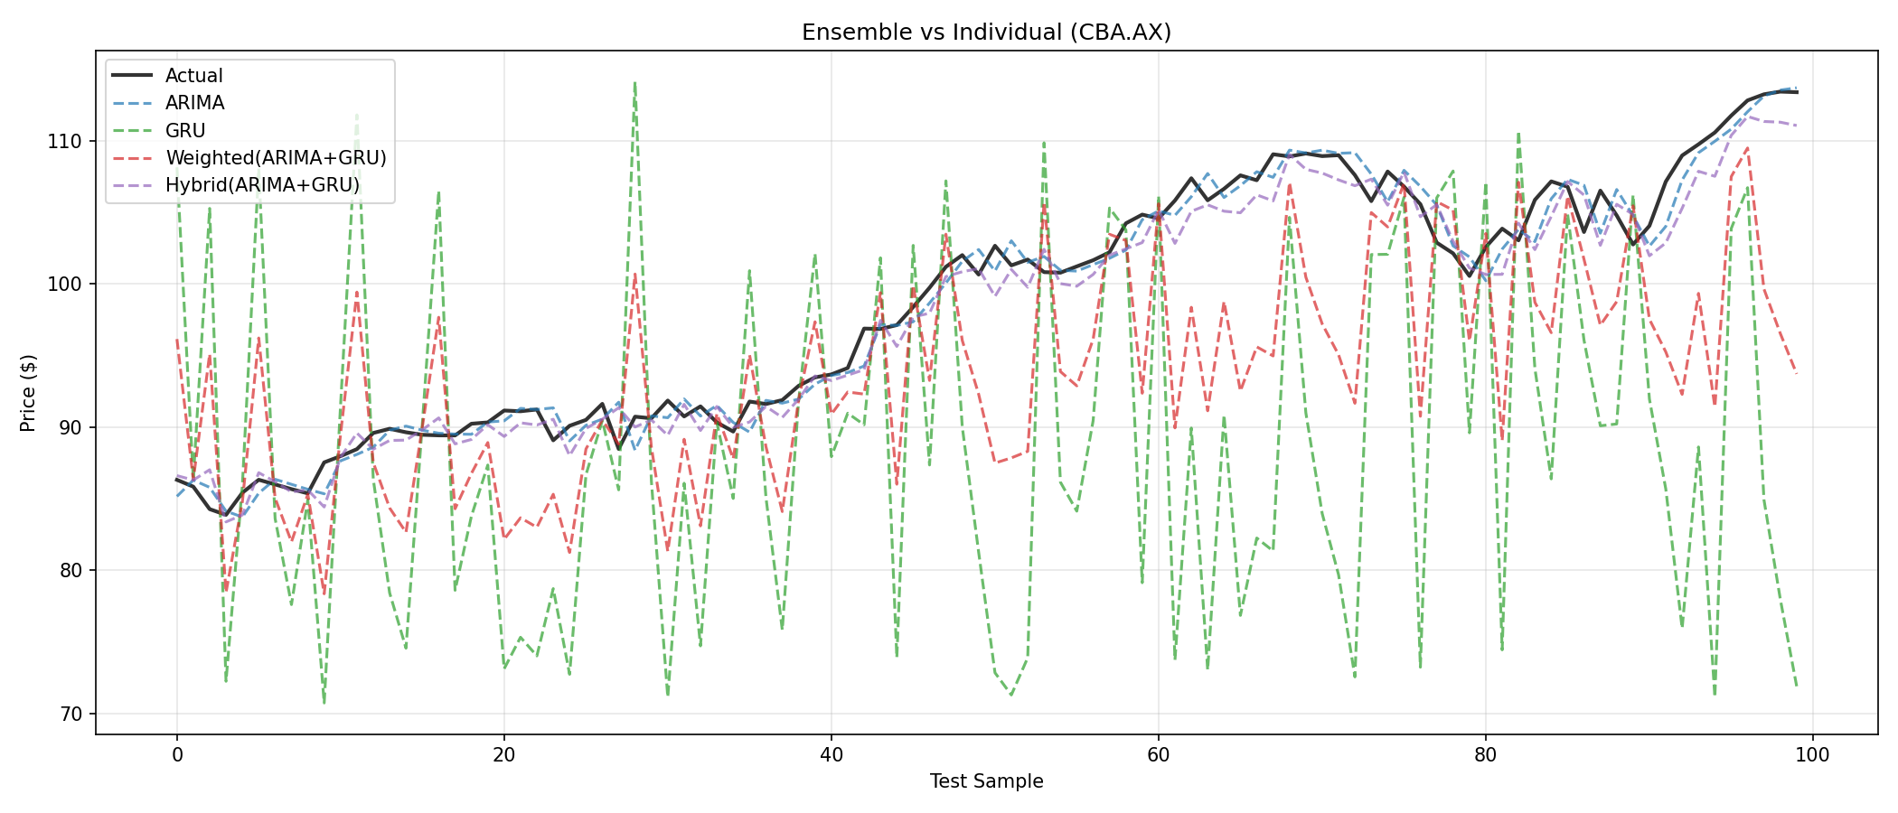
Figure 2: Ensemble methods compared to individual ARIMA and GRU models on the last 100 test points.

6. Discussion
ARIMA's strong performance (R² 0.9912 vs GRU's 0.9888) is explained by the nature of stock price data. Stock prices have extremely high day-to-day autocorrelation, and ARIMA(1,1,1) with d=1 differencing directly captures this random walk structure. The rolling prediction approach, which refits at each step with all available history, further strengthens ARIMA. DL models must learn this same pattern indirectly through gradient descent on fixed-length windows using only 25 training epochs. With more epochs, more training data, or more complex price patterns (multiple seasons, nonlinear regime changes), DL would likely close the gap or surpass ARIMA.
The ensemble experiments revealed that naive averaging (both simple and weighted) degraded performance compared to the best individual models. This occurred because all models except RF predict prices that track actual values closely, making similar types of errors at similar points. This high error correlation means averaging provides little benefit. The residual hybrid approach was more robust because its adaptive alpha mechanism automatically limits the contribution of the weaker model, but it still could not beat ARIMA alone on this data.
Random Forest's poor performance (MAE $15.00, R² -1.52) deserves specific attention. Flattening the 50-step window into 50 independent features destroys all temporal ordering information. RF cannot distinguish whether a high price at position 0 preceded or followed a low price at position 25. Alternative approaches such as feature engineering (computing returns, moving averages, or volatility measures from the window) could improve RF performance for time series tasks.
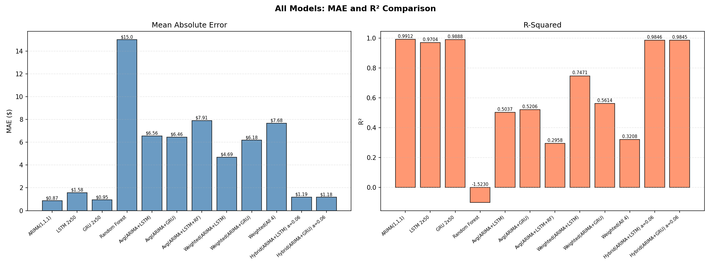
Figure 3: MAE and R² comparison across all individual and ensemble models.

7. Conclusion
The implementation successfully extended the stock prediction system to support ensemble modelling combining statistical (ARIMA), machine learning (Random Forest), and deep learning (LSTM, GRU) approaches. Three ensemble strategies were tested: simple averaging, weighted averaging, and residual hybrid.
Three key findings emerged from the experiments:
1. ARIMA(1,1,1) was the best-performing model overall (MAE $0.87, R² 0.9912), outperforming all DL models and all ensemble combinations. This demonstrates that for one-step-ahead stock prediction, classical statistical methods remain highly competitive when the data exhibits strong autocorrelation.
2. Naive averaging ensembles degraded performance compared to the best individual model. Including the poorly-performing Random Forest in any ensemble further degraded accuracy. This confirms that ensemble methods require constituent models of comparable quality to be effective.
3. The residual hybrid approach with adaptive alpha weighting (MAE $1.18, R² 0.9845) was significantly better than simple/weighted averaging but still could not beat ARIMA alone. The alpha of 0.06 correctly assigned 94% weight to the stronger ARIMA baseline, demonstrating the value of performance-adaptive weighting.
Future work could explore stacking (training a meta-learner on model outputs), dynamic model selection based on recent performance windows, and feature engineering for Random Forest to make it a more competitive ensemble member.
The complete codebase (stock_prediction_v06.py) is available in the project GitHub repository.

References
Box, G.E.P., Jenkins, G.M. (1976). Time Series Analysis: Forecasting and Control. Holden-Day.
pmdarima documentation. https://alkaline-ml.com/pmdarima/
statsmodels ARIMA. https://www.statsmodels.org/stable/generated/statsmodels.tsa.arima.model.ARIMA.html
scikit-learn RandomForestRegressor. https://scikit-learn.org/stable/modules/generated/sklearn.ensemble.RandomForestRegressor.html
Chung, J., et al. (2014). Empirical Evaluation of Gated Recurrent Neural Networks on Sequence Modeling. arXiv:1412.3555.
Yahoo Finance. CBA.AX historical data. https://finance.yahoo.com/quote/CBA.AX/
Keras Documentation. LSTM, GRU layers. https://keras.io/api/layers/recurrent_layers/

