1. Introduction
This report documents Task C.7 of the COS30018 Intelligent Systems project. Tasks C.1 through C.6 focused on regression: predicting the next day's stock price as a continuous value. Task C.7 represents a fundamental shift to binary classification: predicting whether the stock price will rise or fall on the next trading day. This formulation is more practically relevant because directional prediction directly informs trading decisions (buy vs. sell), whereas a precise price prediction is less actionable if the model cannot reliably distinguish upward from downward movements.
The task also introduces external data: news sentiment. The core research question is whether incorporating sentiment from financial news headlines improves next-day stock movement prediction compared to using technical indicators alone. Two sentiment analysis tools are compared: VADER (a generic, rule-based model) and FinBERT (a transformer model fine-tuned on financial text). This comparison forms the independent research component of the task.
All experiments target CBA.AX (Commonwealth Bank of Australia) stock data from January 2020 to July 2024, consistent with previous tasks.

2. Methodology

2.1 Data Sources
Stock data: CBA.AX daily OHLCV data from Yahoo Finance via yfinance, covering 2020-01-01 to 2024-07-01. This provides 1,174 trading days with open, high, low, close, adjusted close, and volume. The price ranged from $48.59 to $119.26 over this period, reflecting the COVID crash and subsequent recovery.
News data: Financial news headlines collected via pygooglenews, which wraps the Google News RSS feed. Three search queries were used: 'Commonwealth Bank Australia', 'CBA ASX stock', and 'CommBank financial'. Headlines were collected by querying month by month across the full date range and cached locally to avoid repeated API calls. After deduplication, 611 headlines were collected across 444 trading days, providing 37.8% coverage of the total 1,174 trading days. Days without news (the remaining 62.2%) received forward-filled sentiment scores, carrying the last known sentiment forward.

2.2 Sentiment Analysis
VADER (Valence Aware Dictionary and sEntiment Reasoner) is a rule-based sentiment model included in the NLTK library. It uses a lexicon of approximately 7,500 words with pre-assigned valence scores, combined with rules for handling negation, punctuation emphasis, and capitalization. VADER returns four scores: positive, negative, neutral, and a compound score in the range [-1, +1]. The compound score is the primary feature used. VADER was originally designed for social media text, not financial text, which is a known limitation.
The VADER scoring call:
vader = SentimentIntensityAnalyzer()
for headline in headlines:
score = vader.polarity_scores(headline)
compound = score['compound'] # range: [-1, +1]
FinBERT is a BERT-based transformer model fine-tuned on 10,000+ financial texts including analyst reports, earnings calls, and financial news (Araci, 2019). It classifies text into three categories: positive, negative, or neutral, returning a confidence score. This confidence is converted to a numeric score: positive maps to +confidence, negative to -confidence, neutral to 0.0. The key advantage over VADER is that FinBERT understands financial language. For example, 'the bank downgrades its outlook' is clearly negative in financial context, but VADER's general-purpose lexicon may not weight 'downgrades' strongly enough.
The FinBERT scoring call:
finbert = pipeline('sentiment-analysis',
model='ProsusAI/finbert')
results = finbert(headlines, truncation=True)
# Each result: {'label': 'positive', 'score': 0.87}

2.3 Technical Indicators
Fifteen technical features were computed from the OHLCV data. These capture different aspects of price behavior: momentum, trend, volatility, and volume.
Momentum features: Daily return (1-day percentage change) and five lagged returns (1-5 day lookback). These capture recent price direction and auto-correlation patterns.
RSI (14-day): The Relative Strength Index compares the magnitude of recent gains to recent losses over a 14-day window. Values above 70 suggest overbought conditions (potential reversal down); values below 30 suggest oversold conditions (potential reversal up).
RSI implementation:
delta = prices.diff()
gain = delta.where(delta > 0, 0.0)
loss = -delta.where(delta < 0, 0.0)
avg_gain = gain.rolling(14).mean()
avg_loss = loss.rolling(14).mean()
rs = avg_gain / avg_loss
rsi = 100 - (100 / (1 + rs))
MACD: Moving Average Convergence Divergence uses the difference between 12-day and 26-day exponential moving averages. Three features are derived: the MACD line, the signal line (9-day EMA of MACD), and the histogram (MACD minus signal). A positive histogram indicates upward momentum.
Bollinger %B: Measures where the current price sits relative to 20-day Bollinger Bands. Values above 1.0 indicate the price is above the upper band (overbought); values below 0.0 indicate it is below the lower band (oversold).
Additional features: Volume change (1-day percentage change in trading volume), price-to-SMA ratios (5-day and 20-day), and 5-day rolling volatility (standard deviation of daily returns).

2.4 Classification Target
The binary target is defined as: 1 if the next trading day's adjusted close is higher than today's adjusted close, 0 otherwise. This is implemented as:
next_close = df['adjclose'].shift(-1)
target = (next_close > df['adjclose']).astype(int)

2.5 Experiment Design
Six experiments were conducted, comparing two classifiers (Random Forest and Gradient Boosting) across different feature sets:
Experiment | Classifier | VADER | FinBERT | N Features
Baseline (Tech Only, RF) | Random Forest | No | No | 15
Tech + VADER (RF) | Random Forest | Yes | No | 21
Tech + FinBERT (RF) | Random Forest | No | Yes | 18
Tech + VADER + FinBERT (RF) | Random Forest | Yes | Yes | 24
Baseline (Tech Only, GB) | Grad. Boosting | No | No | 15
Tech + VADER + FinBERT (GB) | Grad. Boosting | Yes | Yes | 24
All experiments use a chronological 80/20 split (923 training samples, 231 test samples). No shuffling is applied to prevent lookahead bias. Features are standardized using StandardScaler fitted on the training set only. Random Forest uses 200 trees with max_depth=10 and balanced class weights. Gradient Boosting uses 200 trees with max_depth=5, learning_rate=0.05, and 80% subsampling.

3. Data Collection Results

3.1 News Coverage
A total of 611 headlines were collected via Google News, covering 444 out of 1,174 trading days (37.8% coverage). Monthly headline counts ranged from 2 to 21, with coverage being relatively uniform across the period. The sparse coverage is a known limitation of Google News RSS for specific Australian stocks. Professional financial data providers (Bloomberg Terminal, Refinitiv) would offer substantially better coverage, but these require paid subscriptions.
For the 62.2% of trading days without news, sentiment scores were forward-filled (carrying the most recent sentiment forward). This approach assumes that market sentiment persists in the absence of new information, which is a standard technique in sentiment-based financial prediction.

3.2 Sentiment Score Distributions
The mean VADER compound score across all headlines was 0.0034, very close to neutral. The mean FinBERT score was -0.0136, also near neutral but with a slight negative bias. This near-neutral average is expected: financial news coverage of a single stock includes a mix of positive earnings reports, negative regulatory actions, and neutral operational updates.
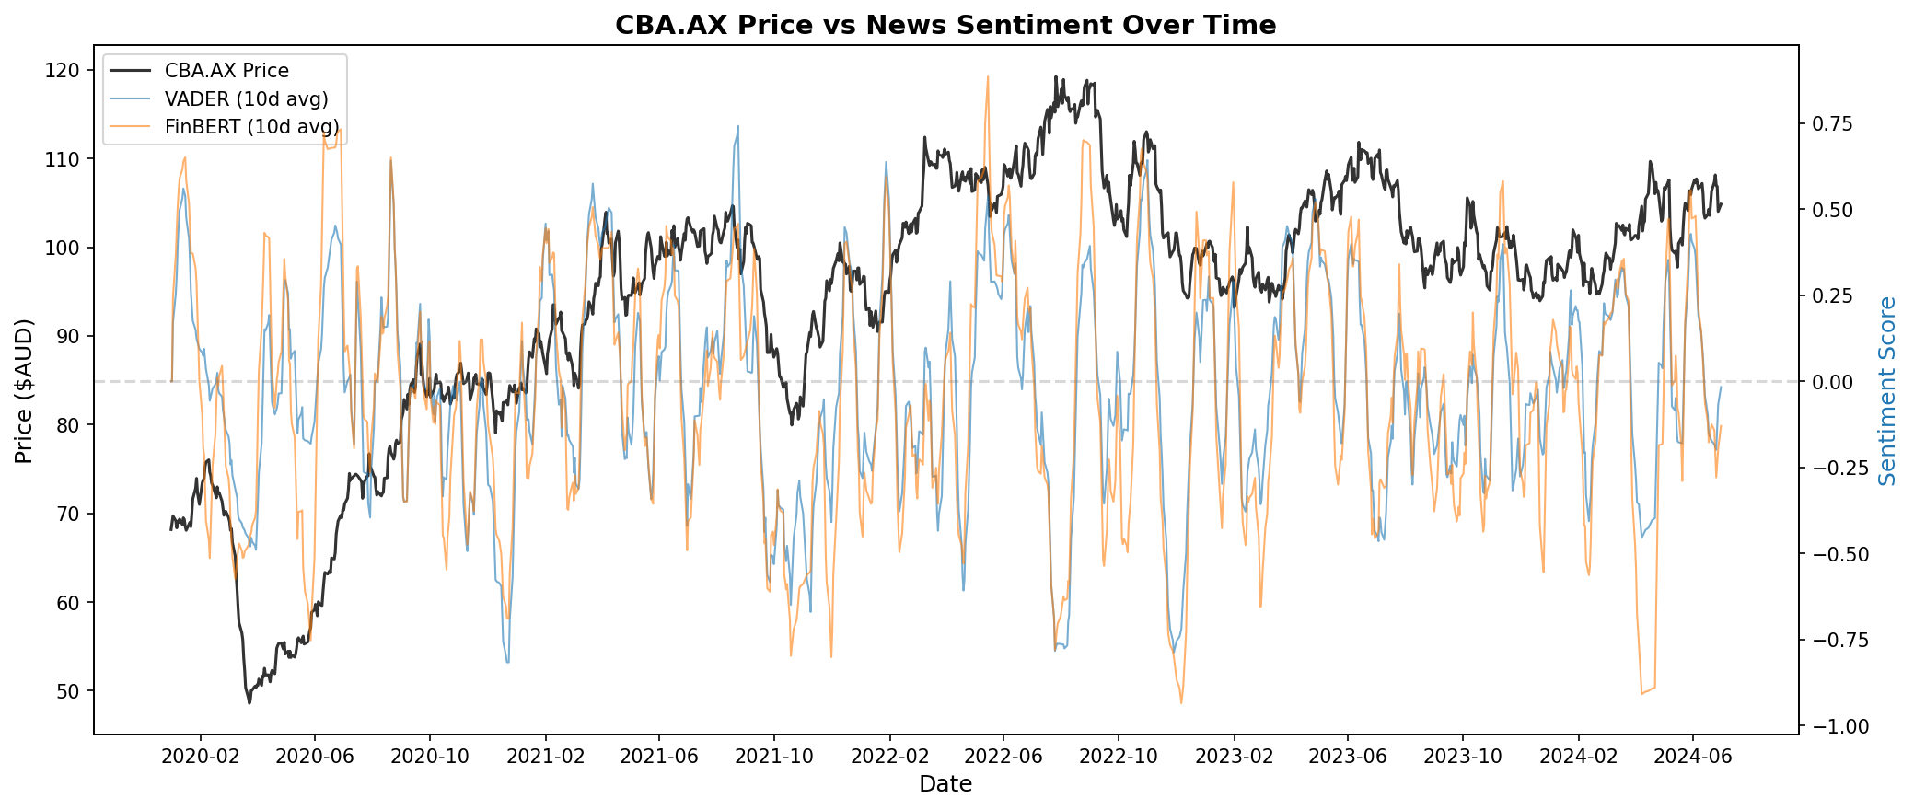
Figure 1: CBA.AX price and 10-day rolling average sentiment scores (VADER and FinBERT) over the study period.
Figure 1 shows the relationship between stock price and sentiment over time. Sentiment scores fluctuate around zero with occasional spikes corresponding to major events. VADER and FinBERT scores generally track each other but diverge at times, reflecting differences in how each tool interprets financial language.

4. Classification Results
Model | Accuracy | Precision | Recall | F1-Score | ROC-AUC | Features
Baseline (Tech Only, RF) | 0.4935 | 0.4865 | 0.6372 | 0.5517 | 0.5037 | 15
Tech + VADER (RF) | 0.5238 | 0.5113 | 0.6018 | 0.5528 | 0.4958 | 21
Tech + FinBERT (RF) | 0.4762 | 0.4683 | 0.5221 | 0.4937 | 0.4705 | 18
Tech + VADER + FinBERT (RF) | 0.4805 | 0.4729 | 0.5398 | 0.5041 | 0.4880 | 24
Baseline (Tech Only, GB) | 0.5065 | 0.4966 | 0.6372 | 0.5581 | 0.5253 | 15
Tech + VADER + FinBERT (GB) | 0.5065 | 0.4962 | 0.5841 | 0.5366 | 0.5013 | 24
Table 1: Classification performance across all six experiments. Best accuracy highlighted.

4.1 Baseline Performance
The technical-only baseline achieved 49.35% accuracy with Random Forest and 50.65% with Gradient Boosting. Both are close to the 50% random baseline, which is consistent with academic literature on short-term stock direction prediction. The confusion matrix (Figure 2) reveals that the baseline model has a bias toward predicting UP: recall for UP class is 63.72%, meaning the model catches most upward movements but at the cost of many false positives (predicting UP when the price actually went down).
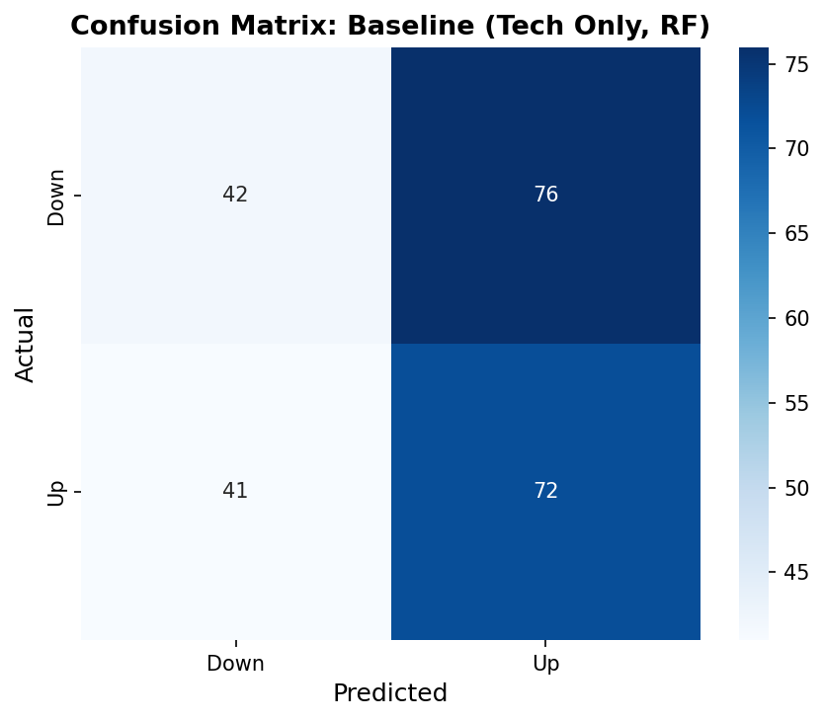
Figure 2: Confusion matrix for the baseline Random Forest model (technical indicators only).

4.2 Effect of Sentiment Features
Adding VADER sentiment features to Random Forest improved accuracy from 49.35% to 52.38% (+3.03 percentage points). This was the best-performing configuration across all experiments. The improvement came primarily from better specificity (fewer false positives): the model became more conservative in predicting UP, reducing false alarms from 76 to 65.
However, adding FinBERT features alone actually decreased accuracy to 47.62% (-1.73pp vs baseline). Combining both VADER and FinBERT produced 48.05% accuracy, worse than VADER alone. This suggests that FinBERT features introduced noise that diluted the signal from technical indicators.
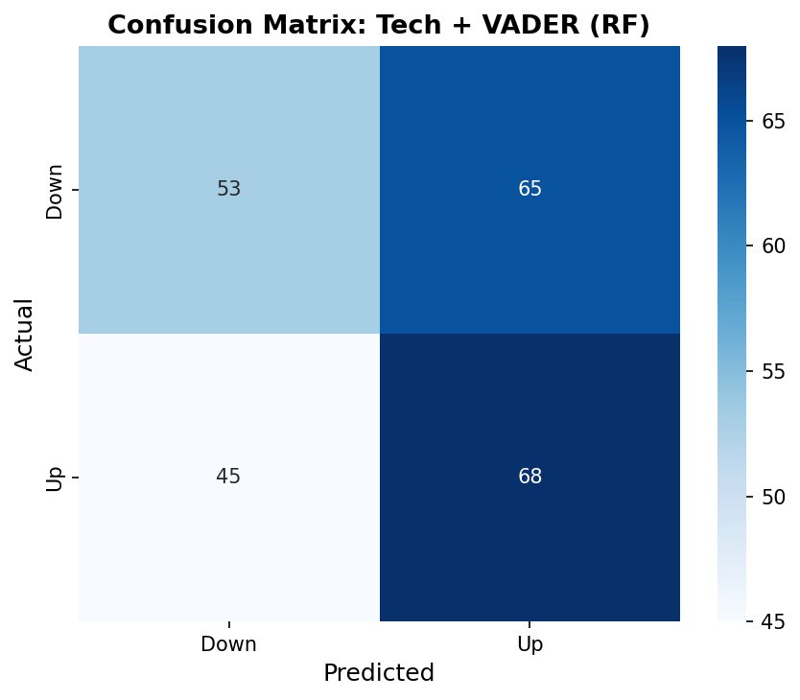
Figure 3: Confusion matrix for the best sentiment model (Tech + VADER, Random Forest).

4.3 VADER vs FinBERT (Independent Research)
The comparison between VADER and FinBERT is the independent research component of this task. The results show that VADER outperformed FinBERT in this context:
VADER-enhanced RF: 52.38% accuracy, 0.5528 F1-score. FinBERT-enhanced RF: 47.62% accuracy, 0.4937 F1-score. The 4.76 percentage point gap is substantial given the difficulty of the task.
Several factors explain this result. First, VADER's compound score is a single continuous value that directly captures sentiment intensity, making it an efficient feature for tree-based classifiers. FinBERT's three-class output (positive/negative/neutral) is converted to a numeric score, but this conversion may lose information about classification confidence. Second, the headlines in this dataset are short (typically 8-15 words), and VADER is specifically designed for short text. FinBERT's transformer architecture is better suited for longer financial documents where contextual understanding matters more. Third, with sparse news coverage (37.8% of days), both tools often receive the same forward-filled score, reducing FinBERT's opportunity to demonstrate its contextual advantage.
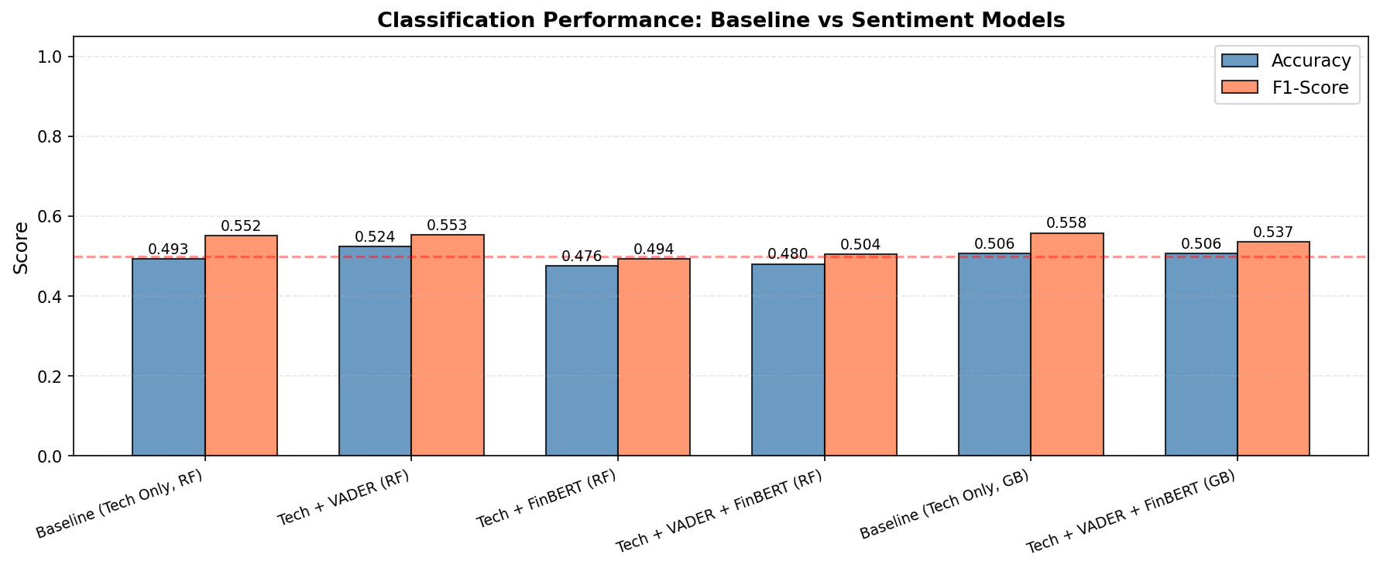
Figure 4: Accuracy and F1-Score comparison across all six experiments.

4.4 Feature Importance
Figure 5 shows the feature importance ranking for the best-performing model (Tech + VADER, RF). Technical indicators dominate the top positions: return_1d (daily return), RSI, MACD histogram, and lagged returns are the most important features. Among sentiment features, vader_compound and vader_ma5 (5-day rolling average) appear in the middle ranks, contributing meaningfully but not dominating. This suggests sentiment provides supplementary signal that refines predictions made primarily from price patterns.
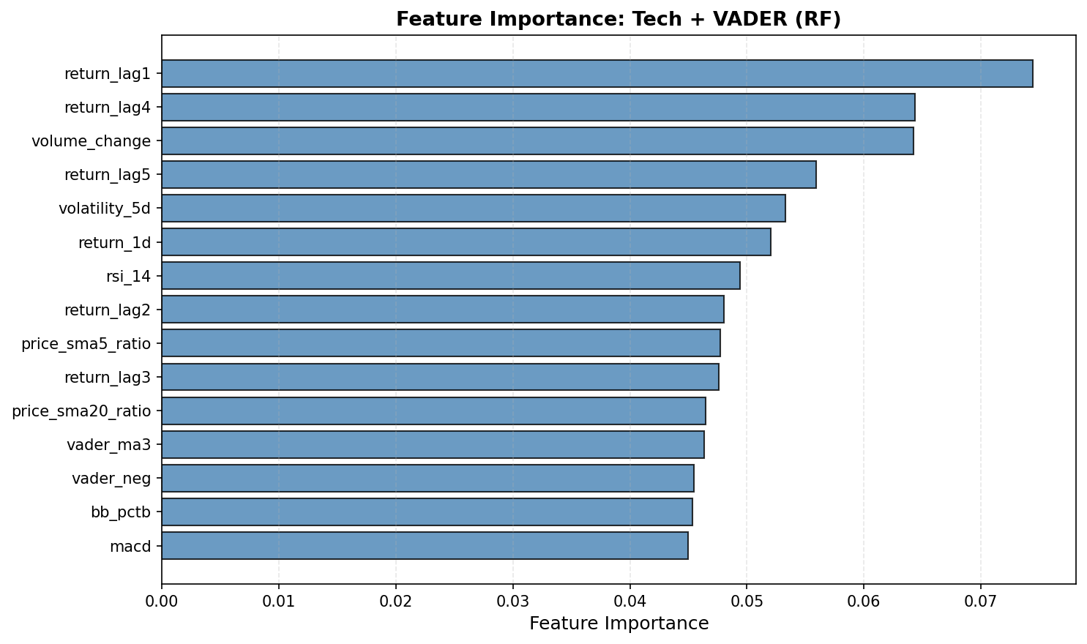
Figure 5: Feature importance ranking for the best-performing model (Tech + VADER, Random Forest).

4.5 ROC Curve Analysis
Figure 6 shows ROC curves for all models. Most curves cluster near the diagonal, confirming that all models are operating close to random in terms of discriminative ability. The Gradient Boosting baseline achieved the highest AUC at 0.5253, slightly above the Tech + VADER RF model at 0.4958. AUC values below 0.5 (such as FinBERT RF at 0.4705) indicate the model is performing worse than random on the probability ranking task, even if its binary accuracy is near 50%.
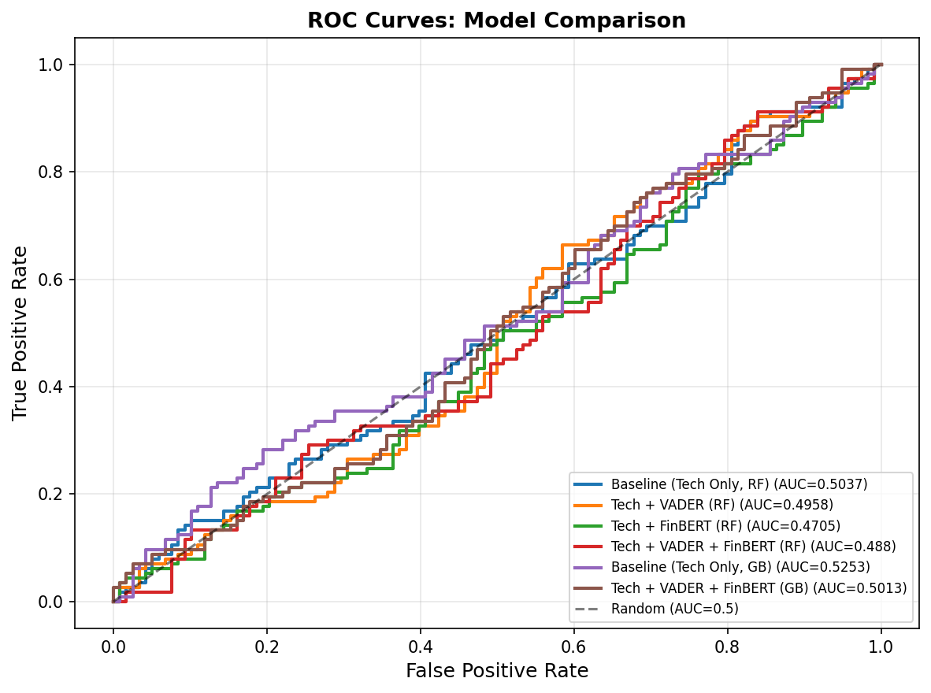
Figure 6: ROC curves for all six experiments. The diagonal represents random performance (AUC = 0.5).

5. Discussion

5.1 Why Stock Direction Prediction is Difficult
Accuracy around 50% is not a failure. Stock prices are influenced by countless factors beyond what any model can capture from historical prices and news headlines: macroeconomic conditions, interest rate decisions, institutional order flow, global events, and market microstructure. The Efficient Market Hypothesis (Fama, 1970) argues that prices already reflect all publicly available information, making consistent short-term prediction fundamentally difficult. Our technical indicators capture price patterns, and sentiment captures market mood, but neither captures the full information set that moves markets.
Academic studies on sentiment-based stock prediction typically report accuracy in the 50-55% range for daily prediction horizons. The 52.38% achieved by VADER-enhanced RF falls within this expected range and is consistent with findings by Bollen et al. (2011), who demonstrated that Twitter mood could predict short-term market direction with similar modest improvements over baseline.

5.2 Data Quality and Coverage Limitations
Google News RSS provided only 37.8% coverage of trading days. This means that for nearly two-thirds of the test period, sentiment features were carrying stale (forward-filled) values. Stale sentiment reduces predictive power because the model is using yesterday's (or last week's) mood to predict tomorrow's movement. Professional data sources like Bloomberg Terminal, Refinitiv, or Twitter/X firehose would provide substantially higher coverage. The sparse coverage is arguably the biggest bottleneck in this pipeline, more so than the choice of sentiment model.

5.3 VADER vs FinBERT: When Domain Specificity Helps
The finding that VADER outperformed FinBERT contradicts the intuition that a domain-specific model should always be better. Three factors explain this:
First, FinBERT is designed for longer financial text (analyst reports, earnings transcripts) where understanding context across sentences matters. Short headlines (8-15 words) may not provide enough context for FinBERT's transformer architecture to add value over a simple lexicon lookup. Second, VADER's compound score is a single, well-calibrated continuous value, while FinBERT's output requires conversion from categorical labels to numeric scores, potentially losing granularity. Third, with limited training data (923 samples), adding more features (FinBERT adds 3 features) risks overfitting in tree-based models without proportionally more signal.

5.4 Regression vs Classification: Honest Assessment
The regression models in C.1 through C.6 achieved R-squared values above 0.9, which appears excellent. However, much of that performance comes from price autocorrelation: today's price is very similar to yesterday's. The model learns to 'predict' tomorrow's price by essentially outputting today's price with minor adjustments. Classification strips away this illusion by asking the harder question: will the price go up or down? The ~50% accuracy here is a more honest measure of how difficult stock prediction actually is. A model that achieves R-squared=0.95 in regression but only 50% in classification has learned the trend, not the direction.

5.5 Future Work
Several directions could improve these results. Higher-quality news data from Bloomberg or social media APIs would increase coverage from 37.8% to potentially 90%+. Intraday sentiment (hourly or minute-level) could capture faster-moving market reactions. Alternative classification targets, such as predicting whether the price moves more than 1% (filtering out noise), may be more tractable than predicting any directional change. An LSTM-based classifier could leverage the sequential nature of both price and sentiment data. Finally, alternative data sources like earnings call transcripts, insider trading filings, or options market sentiment could provide additional predictive signal.

6. Conclusion
This task implemented a complete classification pipeline for next-day stock price movement prediction, combining technical indicators with news sentiment analysis. Six experiments compared Random Forest and Gradient Boosting classifiers across four feature configurations: technical-only baseline, technical + VADER, technical + FinBERT, and technical + both.
The key findings are:
1. VADER-enhanced Random Forest achieved the best accuracy at 52.38%, a 3.03 percentage point improvement over the technical-only baseline (49.35%). This modest improvement is consistent with academic literature on sentiment-based stock prediction.
2. FinBERT did not improve prediction in this context, likely due to the short headline format, sparse news coverage, and the overhead of additional features without proportional signal. Domain-specific models are not universally superior; their advantage depends on the text length and available data volume.
3. All models operate near the random baseline of 50% accuracy, reflecting the inherent difficulty of short-term stock direction prediction. The classification framing provides a more honest assessment of predictive ability than the high R-squared values observed in regression tasks C.1 through C.6.
The methodology demonstrates a complete pipeline from data collection through sentiment scoring to model evaluation, and the VADER vs FinBERT comparison provides insight into when domain-specific NLP tools add value versus when simpler approaches suffice.

References
Araci, D. (2019). FinBERT: Financial Sentiment Analysis with Pre-Trained Language Models. arXiv:1908.10063.
Bollen, J., Mao, H., & Zeng, X. (2011). Twitter mood predicts the stock market. Journal of Computational Science, 2(1), 1-8.
Fama, E.F. (1970). Efficient Capital Markets: A Review of Theory and Empirical Work. Journal of Finance, 25(2), 383-417.
Hutto, C.J. & Gilbert, E.E. (2014). VADER: A Parsimonious Rule-based Model for Sentiment Analysis of Social Media Text. Proceedings of ICWSM.
scikit-learn documentation. RandomForestClassifier, GradientBoostingClassifier. https://scikit-learn.org/stable/
pygooglenews. https://pypi.org/project/pygooglenews/
Yahoo Finance. CBA.AX historical data. https://finance.yahoo.com/quote/CBA.AX/

