Q1. What type of TV screen technologies are currently available in Australia and which are the most frequent?

Column Name | Data type (Nominal/Numeric) | Description
Screen_Tech | String, Nominal/Categorical | Type of screen technology (e.g., LCD, Plasma, OLED, QLED)
Count | Integer (derived) | Number of models per screen technology

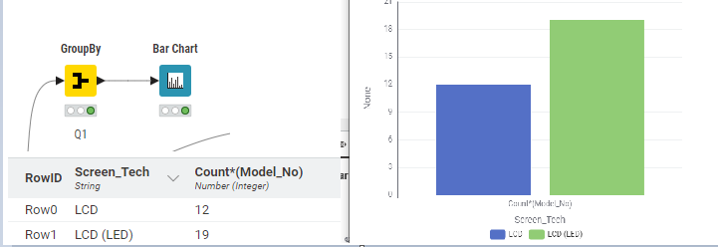

Chart Type: BAR
Reason: A bar chart makes it easy to compare categories (screen technologies) and quickly identify the most common type in the dataset.

Q2. What screen sizes are available and which are most frequent?
Data Needed
- Screen_Size_Category (Nominal, derived from Rule Engine bucket)
- Count (Integer, frequency of models in each size group)
Chart Type
- Bar Chart.
Reason: Easy to compare frequency of models in each size group and see the most common advertised sizes.
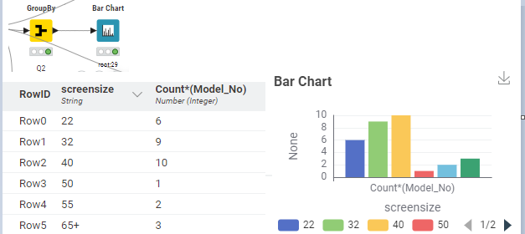
Q3. Which brands have the largest number of models?
Data Needed
- Brand (Nominal/Categorical)
- Count (Integer, number of models per brand)
Chart Type
- Bar Chart (sorted descending).
Reason: Highlights market leaders by showing which brands dominate in terms of number of models.
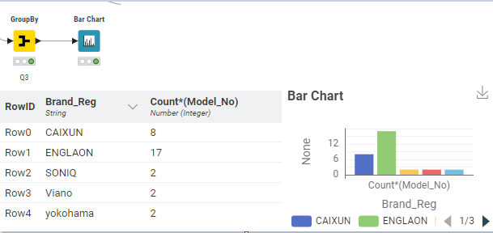
Q4. Which type of screen technology consumes the least amount of power?
Data Needed
- Screen_Tech (Nominal)
- Annual_Energy_Use (kWh) (Numeric, continuous)
- Aggregation: Mean (average consumption per technology)
Chart Type
- Bar Chart (sorted ascending).
Reason: Easy to identify lowest consuming technology since bar length directly shows average power.
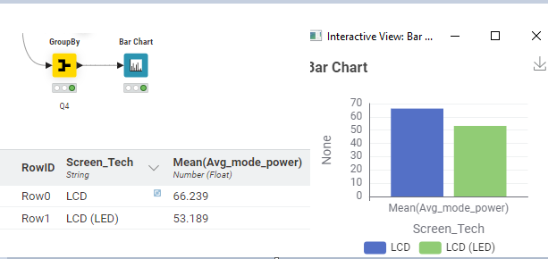
Q5. What is the relationship between screen size and power use?
Data Needed
- Screen_Size (inches) (Numeric, continuous, converted in Math Formula)
- Avg_mode_power (kWh) (Numeric, continuous)
Chart Type
- Scatter Plot.
Reason: Scatter plot is the most effective for showing correlation or trends (larger screens typically consume more power).
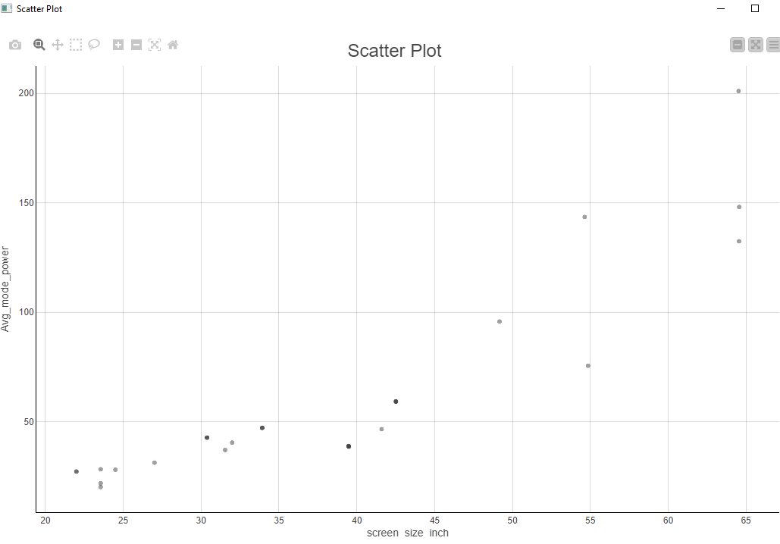

Q6. What is the relationship between star rating and screen size?
Data Needed
- Star_Rating (Nominal/Ordinal)
- Screen_Size (inches) (Numeric, continuous)
Chart Type
- Violin Plot (Plotly).
Reason: Violin plot shows distribution (median, spread, density) of screen sizes across different star ratings, not just averages.

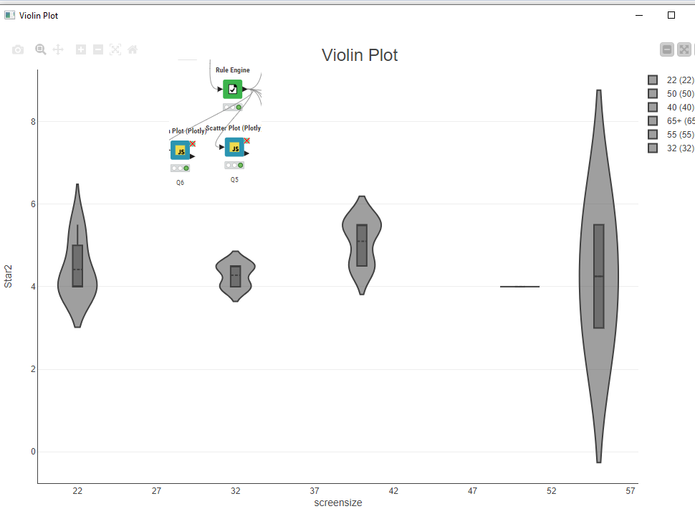

Q7. Are there differences in power consumption between brands?
Data Needed
- Brand (Nominal)
- Annual_Energy_Use (kWh) (Numeric, continuous)
- Aggregation: Mean
Chart Type
- Bar Chart.
Reason: Bar chart makes it easy to compare average power consumption across brands
