SimplyWerx Portfolio
A selection of interactive exhibits and products developed by SimplyWerx Pte Ltd.

Move The Balls
Visitors guide balls through a dynamic course using electromechanical controls.
Client: Science Centre Singapore | Category: Electrical & Mechanical Engineering

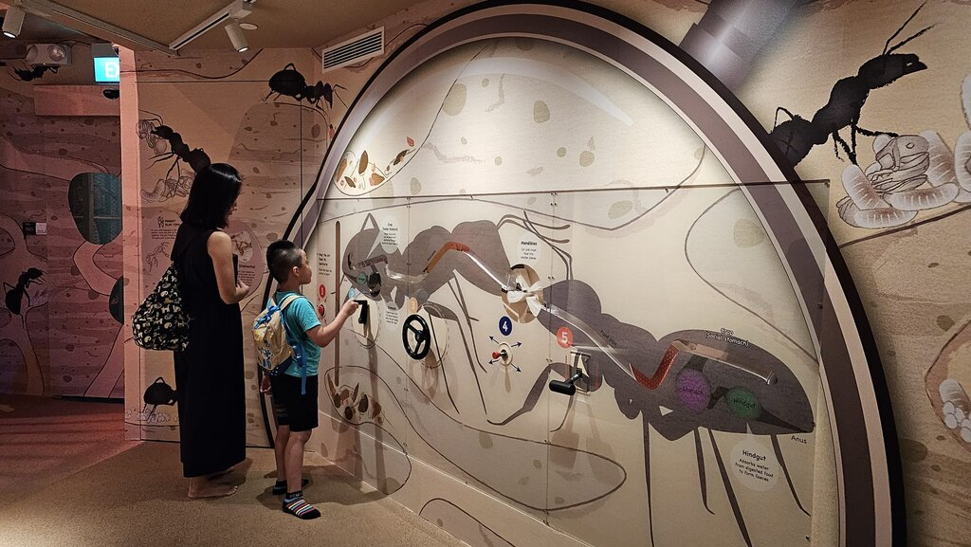
Move The Balls interactive
This interactive exhibit combines playful design with engineering precision, inviting participants to guide balls along a track using levers, switches, and motorized mechanisms. The experience demonstrates principles of motion, control systems, and mechanical feedback in a way that is intuitive and engaging.
[Video: https://www.youtube.com/embed/cN51SotAc3M]
Built with robust electromechanical components and tested for durability, Move The Balls is made to withstand repeated use in public spaces while remaining accessible to visitors of all ages. By blending fun with STEM learning, it turns a simple challenge into a hands-on exploration of engineering concepts.

3, 2, 1... Blast Off
An interactive exhibit on hydrolysis and combustion
Client: Science Centre Singapore | Category: Electrical & Mechanical Engineering

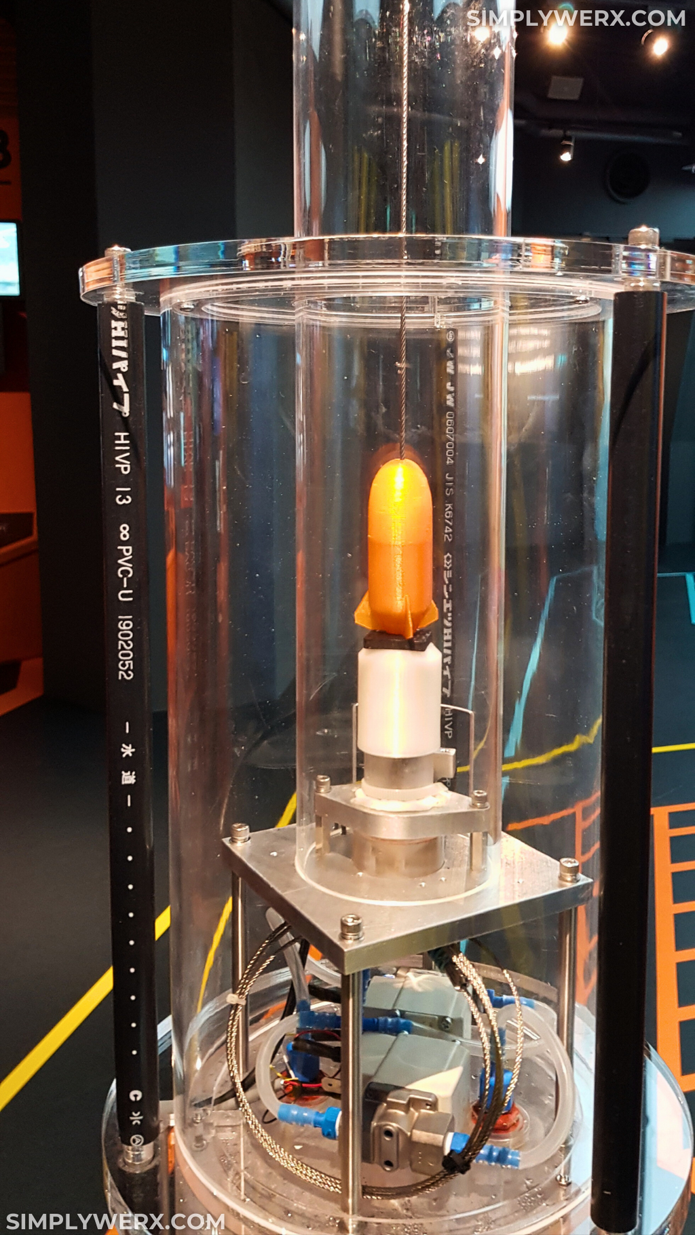
Blast Off
Visitors spin a handwheel to supply the electrical energy for hydrolysis, producing hydrogen and oxygen at the precise 2:1 ratio by volume. They watch the gases being collected, then witness the dramatic moment when a tiny spark ignites the mixture. The reaction releases energy rapidly, launching a miniature rocket upward along its guide line.
Designed to be both educational and exciting, Blast Off turns abstract chemistry and physics into a hands-on experience. By combining safe experimentation with interactive play, it helps learners understand how energy conversion and chemical reactions power modern rocketry.
[Video: https://www.youtube.com/embed/YwnQw59oi0Y]

Compass Steel App
A precision mobile compass app on Google Play
Client: Team SimplyWerx | Category: Mobile App Development


Compass Steel app icon
We designed and developed a sleek mobile compass application that combines precision engineering with intuitive design. Built for accurate directional readings, the app integrates smartphone sensor data and presents it through a clean, minimal interface.
With elegant visuals and responsive performance, Compass Steel quickly became a popular tool for everyday navigation, offering users both reliability and style. By blending technical accuracy with thoughtful UX, it demonstrates our ability to build mobile products that are both functional and engaging.
We released two versions of Compass Steel, each powered by a different graphics engine:
* A 2D version leveraging the efficiency of Android’s Canvas system.
* A 3D version built on optimized OpenGL for immersive, dynamic rendering.
## User Feedback
> "Perfect, simple app. Large, clear display. Multiple display skins – the colorful 'luminous black' option is gorgeous. Calibrate by waving in the air a few times, explanatory animated graphic shows how. Calibrated quickly, responds very promptly when I move my phone, good accuracy. Doesn't take up much space on the phone, and only asks for minimal permissions…"
>
> — A Google user, October 9, 2021

Cycling with Skeleton
A synchronized cycling exhibit that brings anatomy to life
Client: KidsStop, Science Centre Singapore | Category: Electrical & Mechanical Engineering

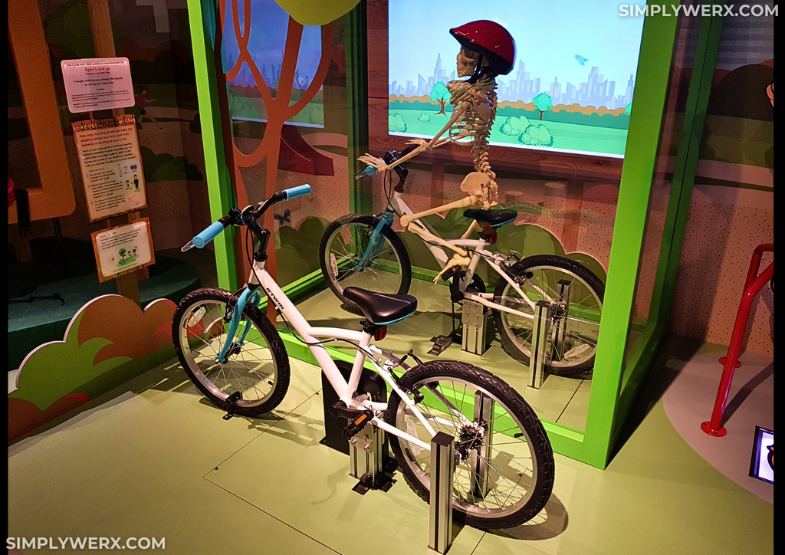
Cycling with Skeleton
Children pedal on a stationary bike positioned beside a second bike fitted with a life-sized skeleton model. Through a linked electro-mechanical system, every rotation is mirrored in real time, allowing the skeleton to match the rider's pedaling motion and posture.
A scrolling animated background on a large display creates the feeling of movement and turns the setup into a highly engaging, camera-friendly experience. The exhibit combines play with science communication, helping young visitors connect body mechanics, motion, and coordination through direct interaction.
[Video: assets/video/Cycling with Skeleton_low_res.mp4]

Autonomous Drone Flight Controller
An all-in-one controller for autonomous indoor performance drones
Client: Science Centre Singapore | Category: Electrical Engineering

[Image: Custom designed All-In-One drone flight controller]
We designed and built an all-in-one flight controller tailored for autonomous and scripted miniature performance drones. The system integrates IMU sensors, an ARM-based microprocessor, an NRF 2.4 GHz radio link, and BLHeli-based ESCs with MOSFET drivers for brushless motors.
To enable precise indoor navigation, the controller incorporates Decawave (Qorvo) UWB chipsets supporting Time Difference of Arrival (TDOA) positioning. It is engineered to work seamlessly with miniature off-the-shelf brushless motors, making it versatile and cost-efficient for performance applications.
A variation of this controller was deployed in the Robot Theatre at Science Centre Singapore, where it powered a tethered autonomous drone. Its choreography was synchronized with the show, demonstrating how the system combines engineering precision with creative performance in a live interactive environment.
[Video: assets/video/Robot Theatre Drone_low_res.mp4]

Generating Electrical Energy
Visitors generate electrical energy by spinning a barrel linked to a dynamo.
Client: Science Centre Singapore | Category: Electrical & Mechanical Engineering

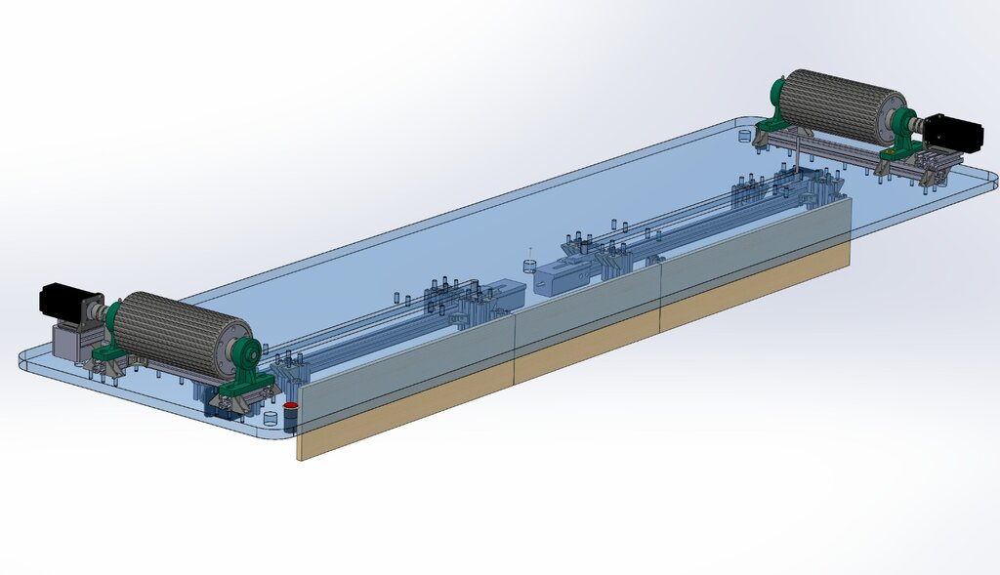
Generator interactive
This interactive exhibit demonstrates energy conversion through fun, hands-on play. Visitors spin barrels linked to dynamos, generating electrical energy that powers their totems along a race track. The faster they spin, the more energy they produce, turning science into an exciting competition.
We solved the engineering challenge of making the exhibit robust enough for unattended play and intuitive enough for visitors to use without instructions. The result is an experience that remains accessible, reliable, and durable in high-traffic environments.
[Video: https://www.youtube.com/embed/8Yw0uq_FTfw]

Tap, Learn, and Play with Food
Kids use specialized spoons to tap on the correct food items. The digital interactive game guides them to select the right food groups, teaching balanced nutrition through fun, hands‑on play.
Client: Science Centre Singapore | Category: Electrical & Mechanical Engineering

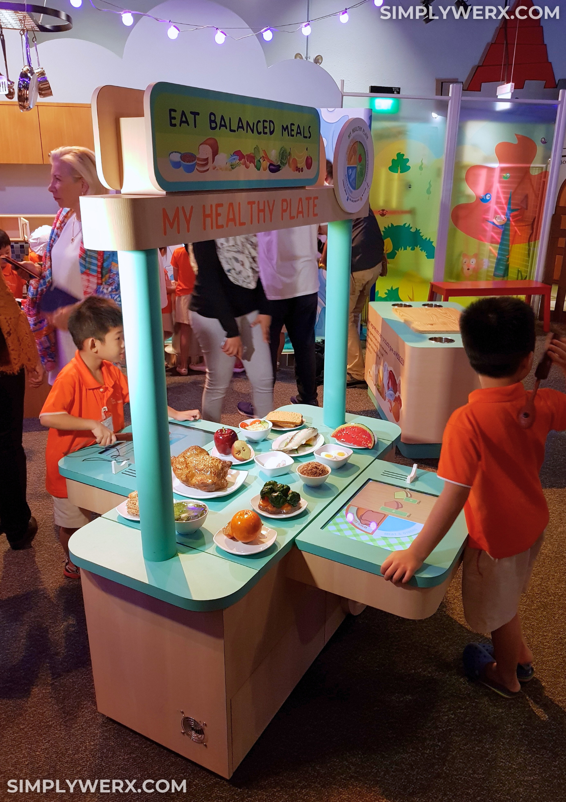
Healthy Plate interactive
An interactive, tactile experience that helps children discover the basics of balanced nutrition. Through play and exploration, kids learn how to build a healthy plate, understand food groups, and make smarter eating choices in a fun, memorable way.
[Video: https://www.youtube.com/embed/mUi0ZnHfQtk]
Custom‑fabricated touch sensors are synchronized with the spoons, ensuring they respond exclusively to spoon contact. Leveraging advanced electric‑field sensing techniques, the system achieves robust performance with consistently low error rates.
These custom sensors can be adapted to turn virtually any object into a touch target, programmed to recognize only specific actuators — in this case, the spoons — for precise and reliable interaction.

Hydraulic Arm Challenge
A hands-on exhibit that introduces hydraulics through robotic control
Client: Science Centre Singapore | Category: Mechanical Engineering

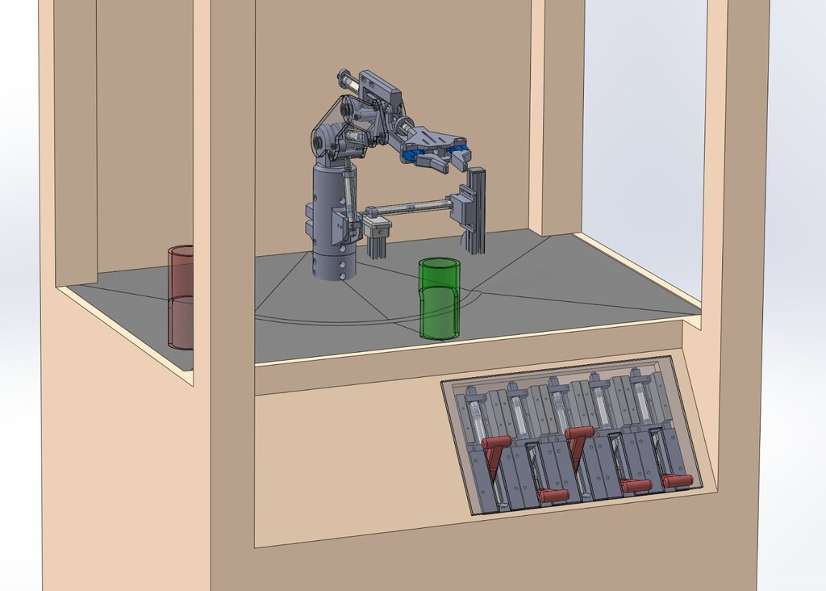
Hydraulic robotic arm and grip
We created a hands-on STEM exhibit that introduces children to hydraulics and their role in modern machinery and robotics. Using simple levers, participants control a five-degree-of-freedom robotic arm and gripper, learning how hydraulic systems translate force into motion as they pick up and move a ball.
The project covered concept design, CAD modeling, simulation, prototyping, 3D printing, CNC machining, and extensive user testing to ensure both durability and intuitive operation in a public setting.
[Video: https://www.youtube.com/embed/uw1bcroC_Tw]
The interactive has been deployed at Science Centre Singapore and as part of a travelling exhibit that brings STEM learning directly to schools, inspiring young learners to explore engineering through play and discovery.

Lion Fence
An interactive circuit challenge with electromagnets, RFID, and flashing lights
Client: Science Centre Singapore | Category: Electrical & Mechanical Engineering

[Image: An interactive circuit challenge with electromagnets, RFID, and flashing lights]
Kids learn how to “complete the circuit” by inserting the correct cable into the matching socket. When the circuit is completed, flashing lights activate to “keep away the lions,” making the challenge both fun and educational
The system combines electromagnets, customized RFID antennas, and embedded RFID tags. Inserting the correct cable energizes an electromagnet at the socket. After a timed interval, the electromagnets automatically switch off, causing the cables to retract back into their holders — resetting the puzzle for the next participant.
[Video: assets/video/Lion Fence Full_low_res.mp4]

Standing Wave Explorer
An interactive exhibit on standing waves, frequency, and perception
Client: Science Centre Singapore | Category: Electrical & Mechanical Engineering

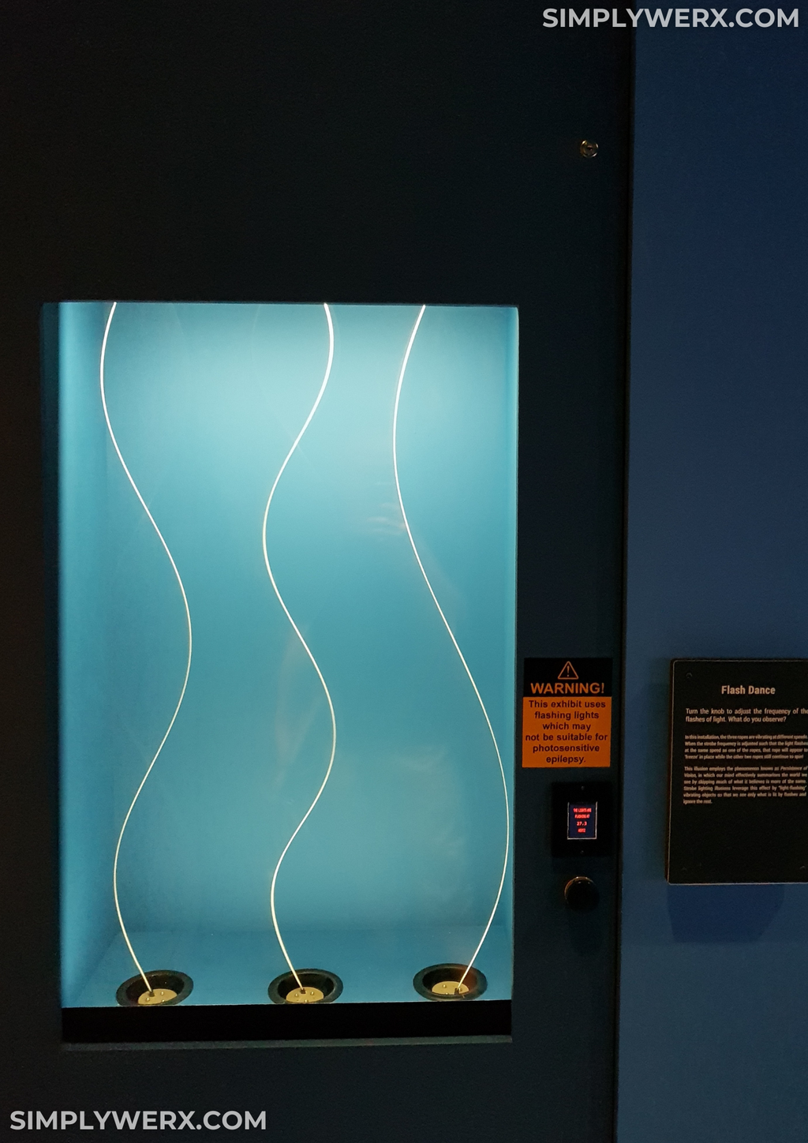
Standing Waves
The exhibit uses three vertically mounted ropes, each with a different length and amount of slack. As the ropes rotate at different speeds (RPM), they produce distinct wave patterns. Visitors then adjust the strobe light frequency (flashes per minute) to match the rope motion and reveal standing waves.
By combining motion and controlled lighting, the interactive makes abstract wave behavior visible and intuitive. It helps visitors explore standing waves, frequency matching, and visual perception through direct, hands-on experimentation.
[Video: https://www.youtube.com/embed/eLeNiWSV9VE]

Taipei 101 Damper Challenge
An interactive exhibit on how tuned mass dampers reduce building sway
Client: Science Centre Singapore | Category: Electrical & Mechanical Engineering

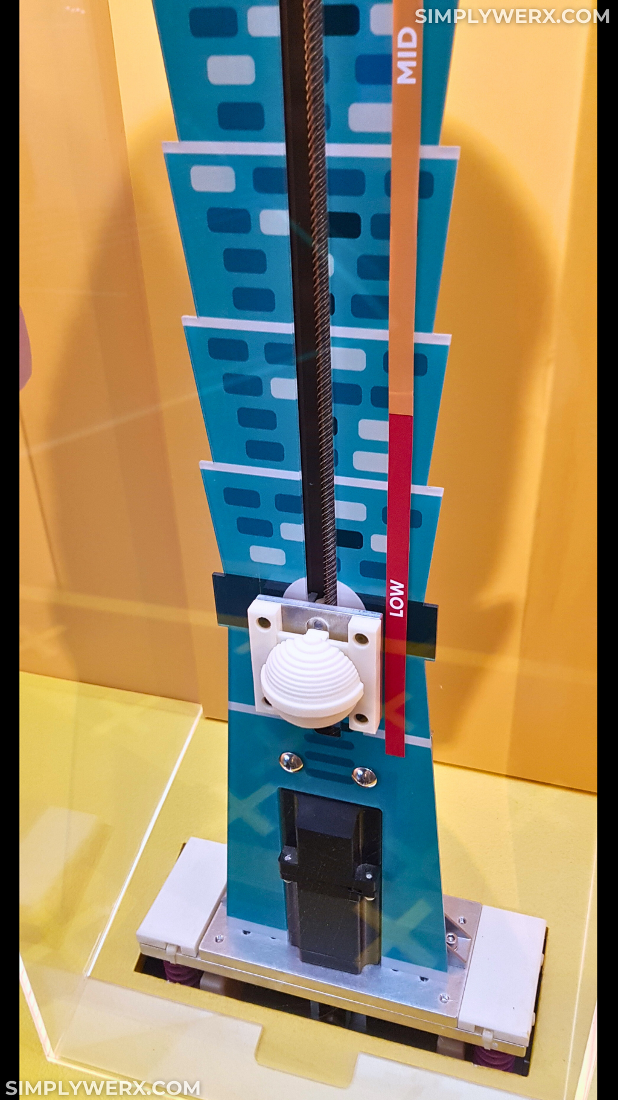
Taipei 101
Visitors turn a knob to adjust the position of a spherical mass damper inside a Taipei 101 building model. A simulated earthquake then shakes the structure, allowing visitors to observe how different damper settings affect building motion. An accompanying screen provides guided instructions and clear scientific explanations throughout the experience.
This interactive combines industrial-grade motion actuators with precise motion-control programming to deliver reliable, repeatable demonstrations in a public setting. It simplifies a complex structural engineering concept into an intuitive, hands-on activity that helps visitors understand how smart design improves earthquake resilience.
[Video: https://www.youtube.com/embed/GLAzxbo0Ino]

