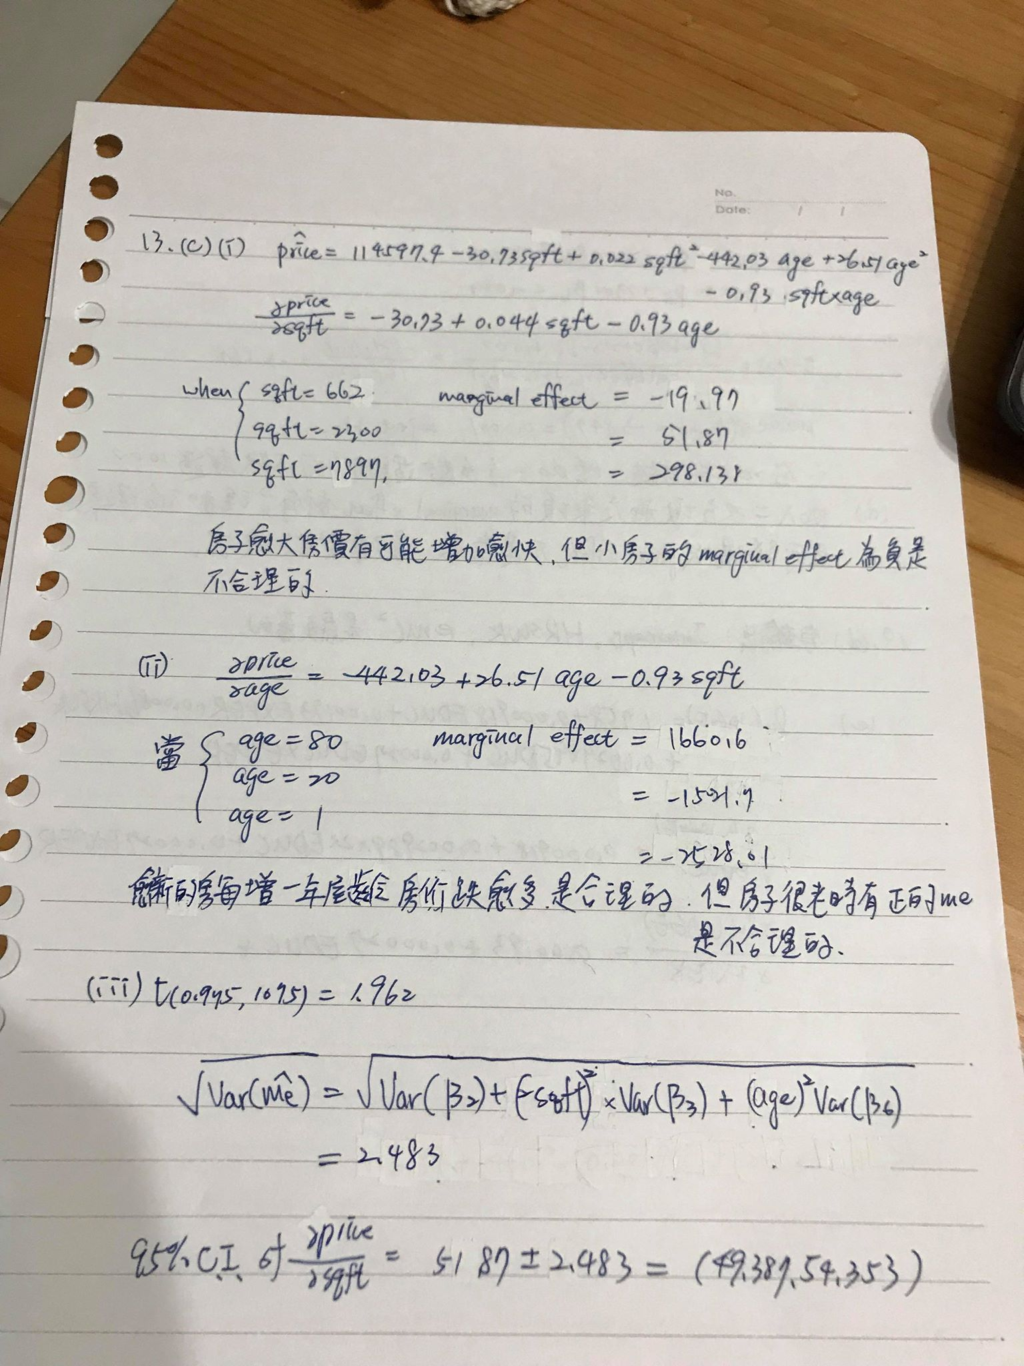



library(devtools)

library(PoEdata)

library(bookdown)

library(Knitr)

library(xtable)

library(printr)

library(stargazer)

library(rmarkdown)

setwd("C:\Users\User\Desktop\economtericsHw")

##13

sqft2=br2$sqft^2

age2=br2$age^2

m2=lm(price ~ sqft + sqft2 + age + age2+ sqft*age,data = br2)

summary(m2)

min(br2$age)

##19d

educxexper = cps4_small$educ*cps4_small$exper

educ2=cps4_small$educ^2

exper2=cps4_small$exper^2

lnwage=log(cps4_small$wage)

model2=lm(lnwage ~ educ + exper + hrswk + educxexper + educ2 + exper2, data = cps4_small)

summary(model2)

Coefficients:

Estimate Std. Error t value Pr(>|t|)

(Intercept) 0.92660810 0.34040722 2.722 0.0066 **

educ 0.04902807 0.03662576 1.339 0.1810

exper 0.05274463 0.00974926 5.410 7.89e-08 ***

hrswk 0.00669297 0.00156812 4.268 2.16e-05 ***

educxexper -0.00092378 0.00050537 -1.828 0.0679 .

educ2 0.00236488 0.00110476 2.141 0.0325 *

exper2 -0.00062873 0.00008881 -7.080 2.73e-12 ***

#10-4a

data("ivreg1")

x=ivreg1$x

e=ivreg1$e

y=1+1*x+e

summary(x)

summary(y)

summary(e)

> summary(x)

Min. 1st Qu. Median Mean 3rd Qu. Max.

-2.4265 -0.6975 -0.1009 -0.1771 0.3650 2.4822

> summary(y)

Min. 1st Qu. Median Mean 3rd Qu. Max.

-3.6513 -0.8019 0.9507 0.6557 1.5397 5.9829

> summary(e)

Min. 1st Qu. Median Mean 3rd Qu. Max.

-2.5763 -1.0529 -0.0834 -0.1672 0.3943 2.5007

#10-4b

plot(x,y)

abline(a=1,b=1)

#沒有隨機分布在回歸線周圍 x<0時資料分布在回歸線下，x>0在線之上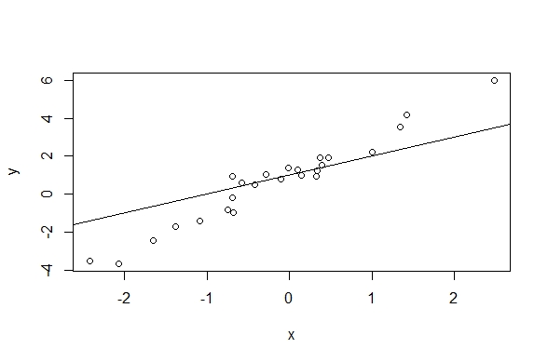

#10-4C

model3=lm(y~x)

model3

Coefficients:

(Intercept) x

1.001 1.949

#y=1.001+1.989x

#10-4d

abline(reg=model3,col="red")

真實的回歸線(紅)較靠近資料的中心，是較好的。顯示資料中的e可能和x不獨立

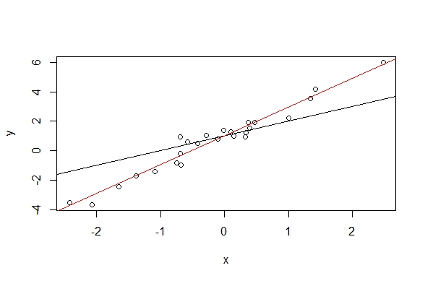

#10-4e

e2=y-1.001-1.989*x

mat=cbind(x,e,e2)

cor(mat)

x e e2

x 1.00000000 0.9096781 -0.09188479

e 0.90967807 1.0000000 0.32997159

e2 -0.09188479 0.3299716 1.00000000

x和e高度相關，x和e hat接近獨立

#10-6a

**corr=cov(x,e)/sqrt(x)*sqrt(e)=0.6364**

#10-6b

data("ivreg2")

y=ivreg2$y

x=ivreg2$x

e2=y-3-x

cor(x,e2)

0.65136 比(a)的correlation稍微高一些

#10-6c

plot(x,y)

abline(3,1)

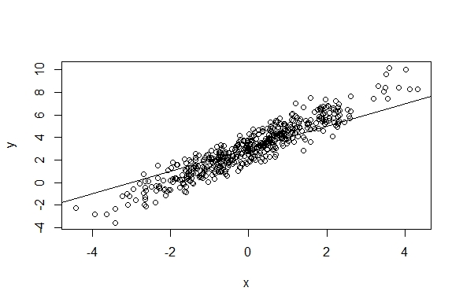

#10-6d

model7=lm(y~x)

y10=ivreg2$y[1:10]

x10=ivreg2$x[1:10]

y100=ivreg2$y[1:100]

x100=ivreg2$x[1:100]

y500=ivreg2$y[1:500]

x500=ivreg2$x[1:500]

model4=lm(y10~x10)

model5=lm(y100~x100)

model6=lm(y500~x500)

model4

model5

model6

model7

(Intercept) x10 (N=10)

2.778 1.372

(Intercept) x100 (N=100)

3.008 1.402

(Intercept) x500 (N=500)

3.018 1.454

(Intercept) x (True value)

3.018 1.454

愈來愈接近以真實值得出的回歸