Animal list script

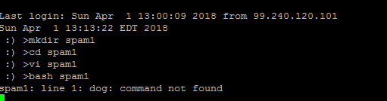

S1:

In this shell script , user was asked to enter five numbers and then sum of those five numbers were displayed .

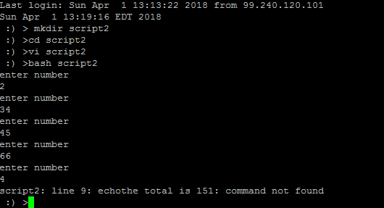

S10:

In this shell script, user was asked to enter argument , a file name

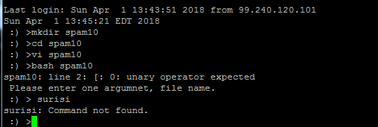

S11: In this script , after editing file spam 11, the result was displayed as given below:

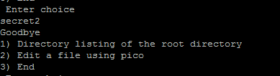

S12: Program asks user to select different options such as d, l, w or q and display the following result

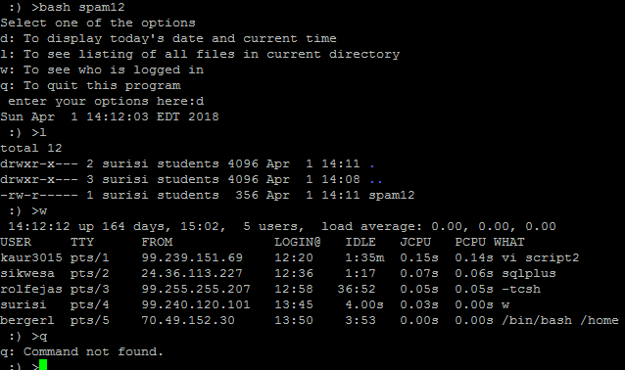

S13: Program asks user to enter two numbers and display which number is greater

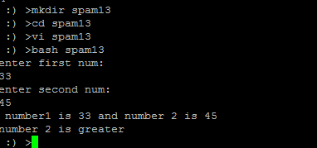

S14: Program display date

