**SECTION –A**

1. 4
2. 1,3,4,5
3. 2
4. 1
5. 1
6. 2
7. 3,4,5
8. 4
9. 3
10. 4
11. 4
12. 1,2,4
13. 2
14. 1
15. 1
16. 4
17. 1
18. 2
19. 4
20. 3

**SECTION-B**

1. **Validation Rules**
2. Only Admins should be allowed to change the account owner.

Error Message : "You are not authorised to transfer the account.

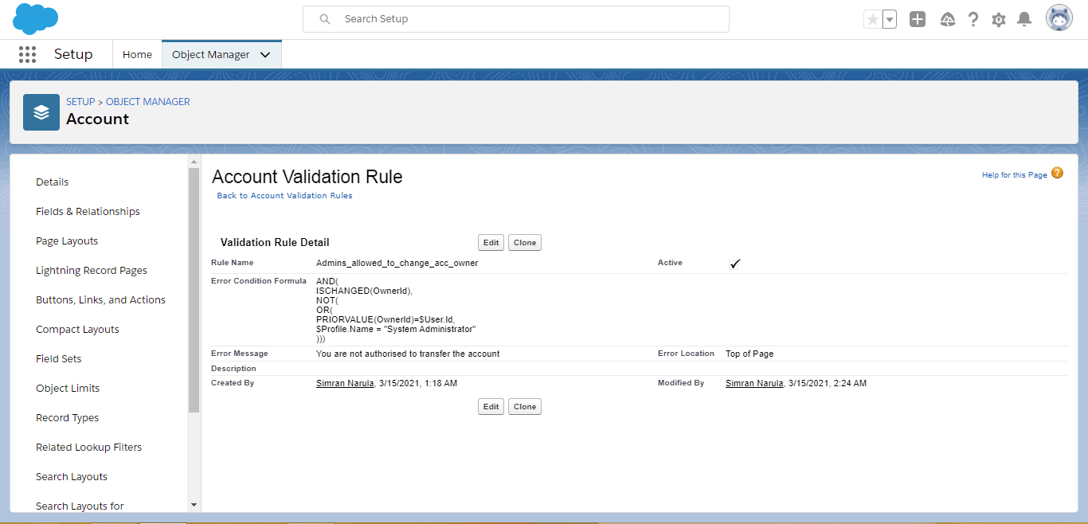

1. While closing the opportunity ( 'Closed Won') , an Opportunity Line Item should be present. If  opportunity line item is not present under a opportunity ,

it should give the error message "Opportunity Line Item should be present while closing the opportunity."

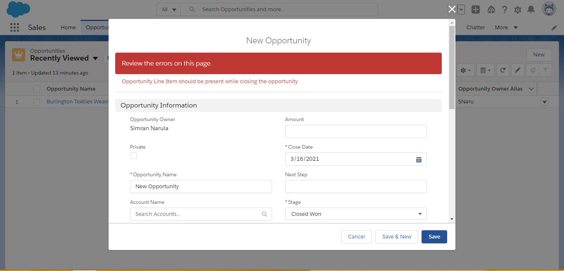

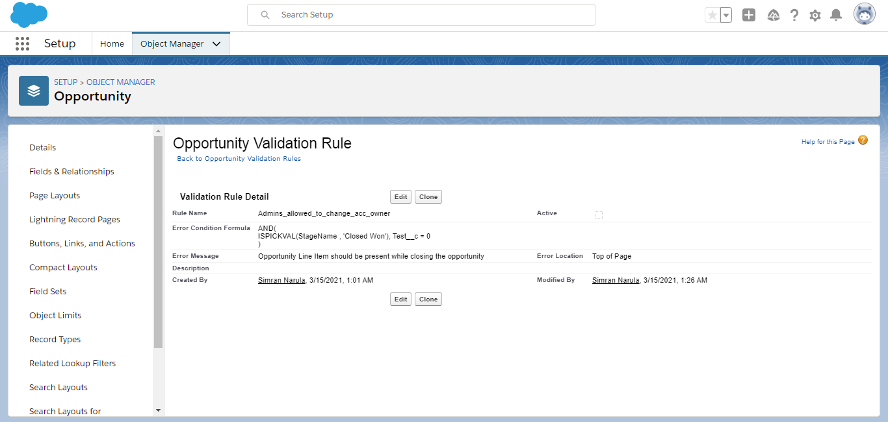

1. **Workflow Rule**

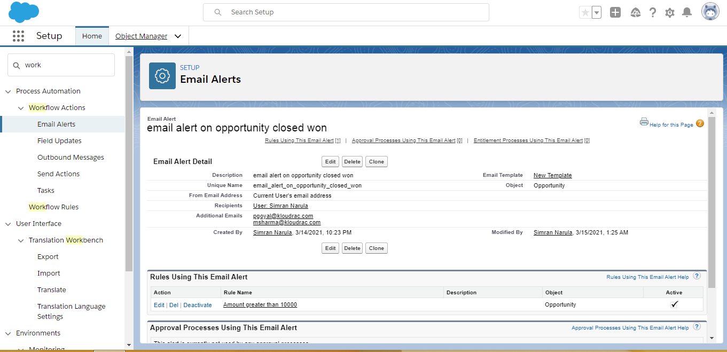

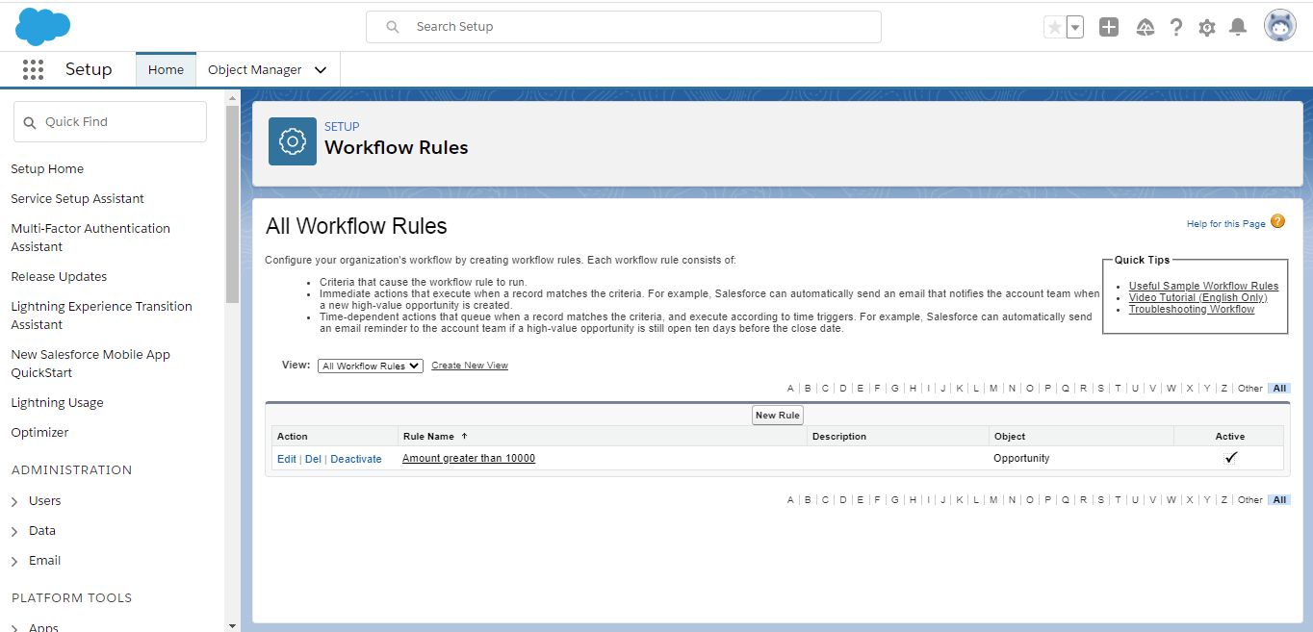

1. **Process Builder**

