Github link:-
https://github.com/Simran-2024581/Assignment2BrewByte16nov
working model:-
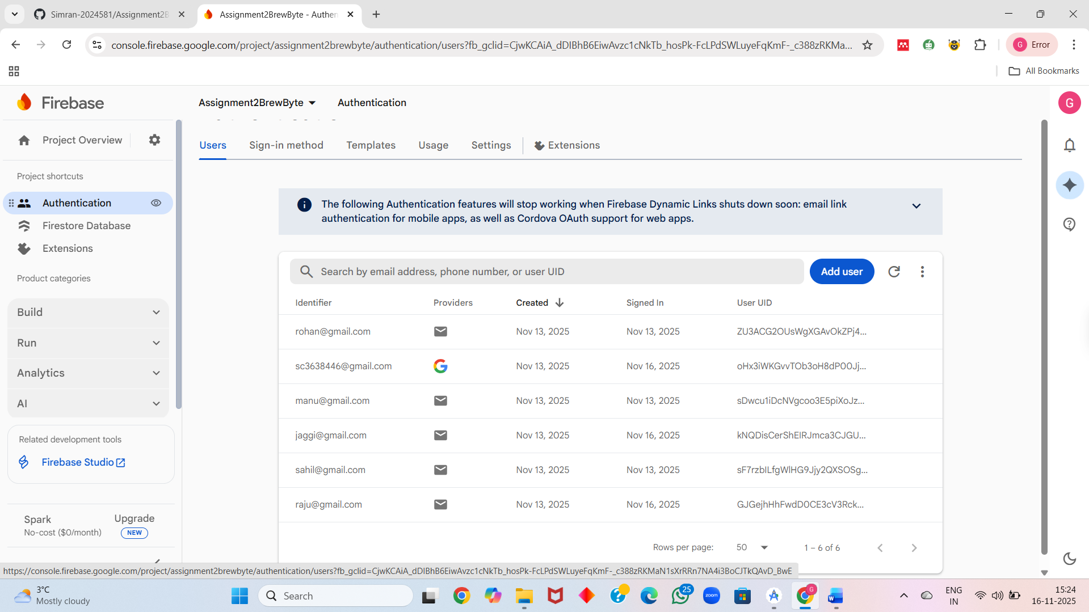
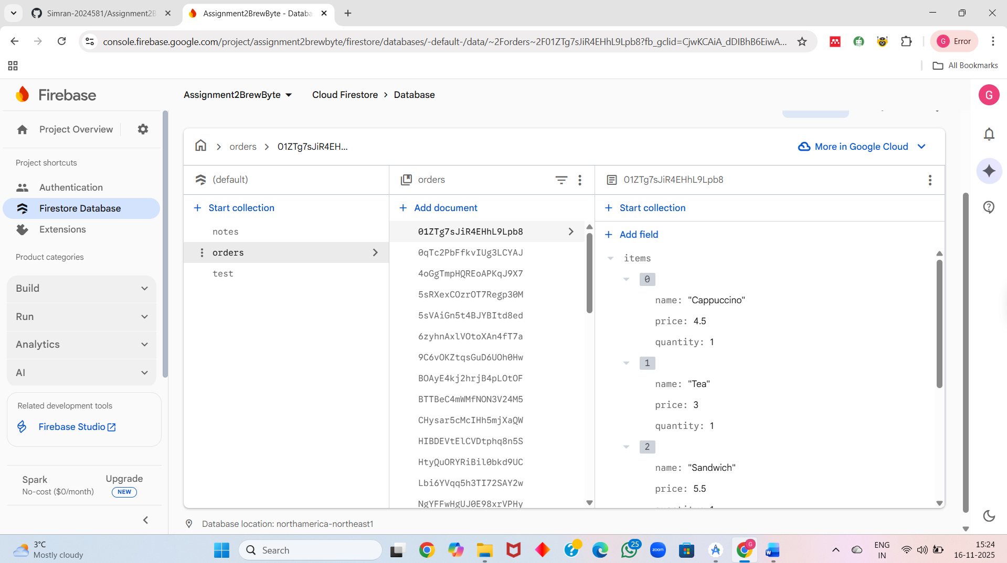

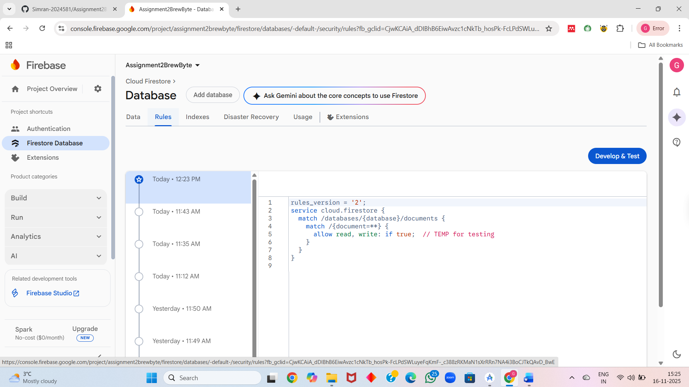

Layout:-
1.login system
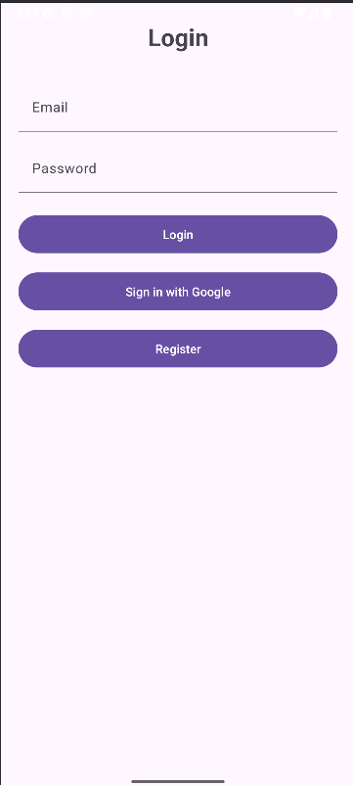

2. register screen
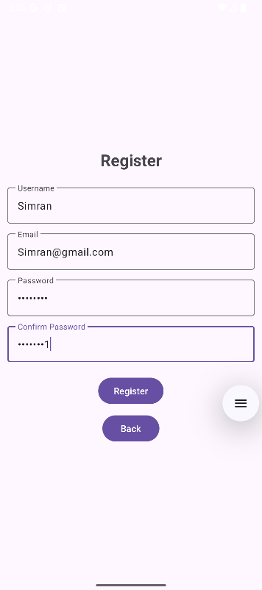
3.google-sign in
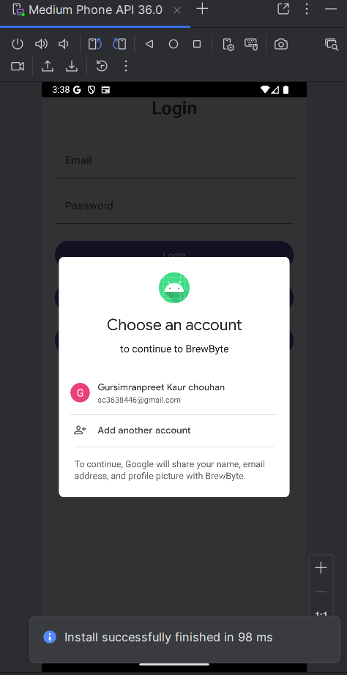
4.Customer Menu Layout

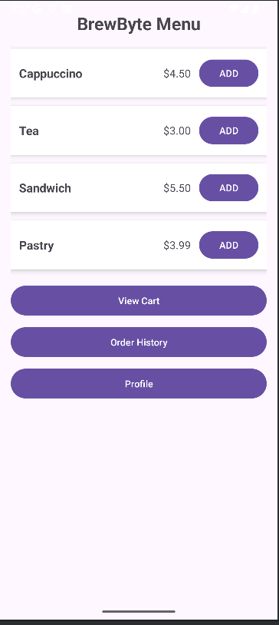

5.Cart / Order Review Screen

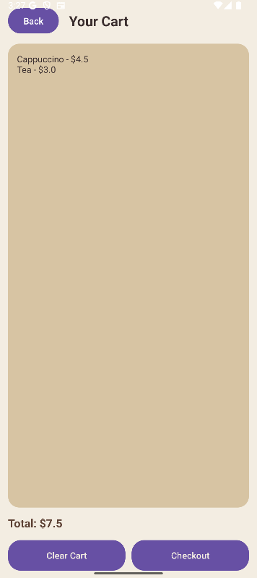

6. checkout screen
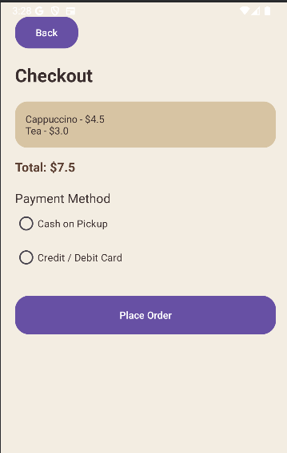
7.Order Summary Screen

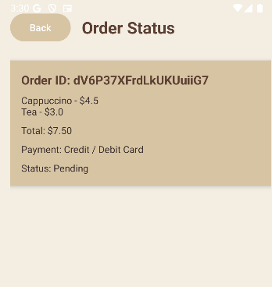
8. checking for database stored in firebase
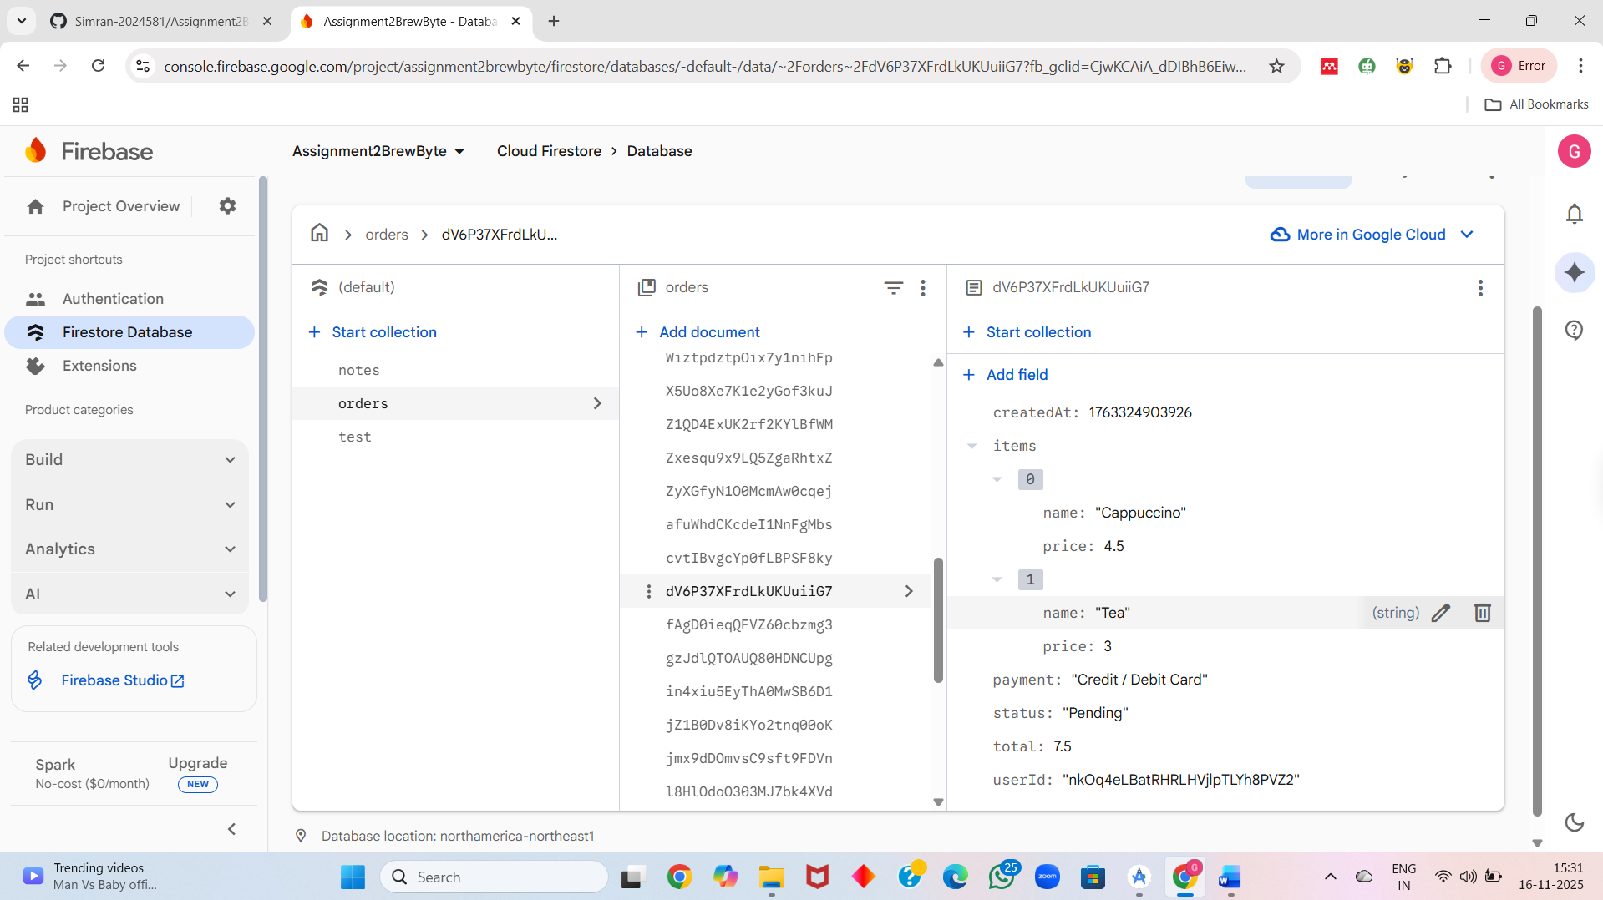
9.order history

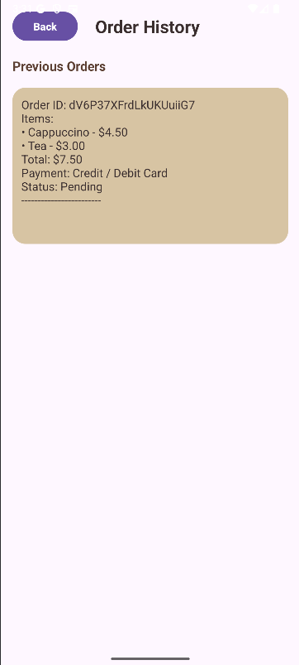
10.
profile

Information:-
1. Introduction
This report explains the work done for the BrewByte mobile application. The main aim of the project is to create a simple and smooth coffee-ordering app for both customers and admins. The focus was on designing clean layouts, fixing navigation problems, and making sure all important features—such as ordering, viewing history, and managing profiles—work properly.

2. Project Overview
The BrewByte app allows customers to browse items, place an order, view their order summary, and check their order history. For admins, the system provides the ability to load any order, view the order details, and check the status. Firebase Firestore is used as the main database to store all user information, profile data, and orders.

3. Features Implemented
- Customers can choose menu items and place an order easily.
- Admins can load any order by entering the order ID.
- Users can view their order summary after placing an order.
- Order history is displayed with a proper scroll view.
- Profile screen lets users see their personal information.
- Back buttons use simple text instead of icons to keep the layout clean.
- Layouts are redesigned to prevent text from going out of shape.

4. Layout Design
The design of the app is kept simple, clean, and user-friendly. All screens follow the same style so the app feels consistent. Special attention was given to spacing, font size, and alignment so the text does not stretch or break the interface. A scroll bar was added to screens with a lot of information, such as order history.

5. Firestore Integration
Firebase Firestore is used to store user profiles, menu items, and order information.
- When an order is placed, it is saved with a unique order ID.
- Admins can search for any order using this ID.
- All Firestore data is loaded smoothly with error handling to prevent crashes.
- Real-time structure helps both users and admins get updated data immediately.

6. Order Summary Screen
After a customer places an order, they are taken to the Order Summary screen.
This screen shows:
- The Order ID
- Items ordered
- Total price
- Date and time
The order ID is displayed clearly at the top so the user can see it at all times. The layout is made simple so the information looks clear and easy to read.

7. Order History Screen
The Order History screen shows all previous orders.
Improvements made:
- Added a vertical scroll bar so users can easily move through many orders
- Each order is shown in a clean card layout
- Text is properly aligned and readable
- Firestore data loads smoothly and quickly
This makes the history feature more useful and professional.

8. Profile Management
The profile screen shows the user's basic details saved in Firestore. If information is missing, the user sees a friendly message. The UI was fixed so the profile screen does not crash and displays data properly. A simple back button text is used to avoid issues with icons.

9. Scroll View and UI Improvements
Scrolling was added where needed (Order History, Admin Dashboard, long order details).
UI fixes include:
- Avoiding overlapping text
- Removing the test button
- Improving button shapes and spacing
- Making back button only text
- Ensuring the layout works on all screen sizes
These changes make the app cleaner and more comfortable to use.

10. Challenges Faced
Some of the challenges faced during the development were:
- Text going out of shape due to long order details
- Admin order loading not showing the order properly
- Profile screen not loading data
- Scroll view not working earlier
- Need to redesign layouts to make them clean and stable
All these issues were identified and fixed to improve the final output.

11. Conclusion
The BrewByte project now has a cleaner layout, working navigation, and improved features for both customers and admins. The app successfully shows order summaries, order history, and user profiles with proper Firestore integration. The UI improvements and scroll features make the app more user-friendly and professional. More features can be added in the future, such as payment integration and menu customization.

