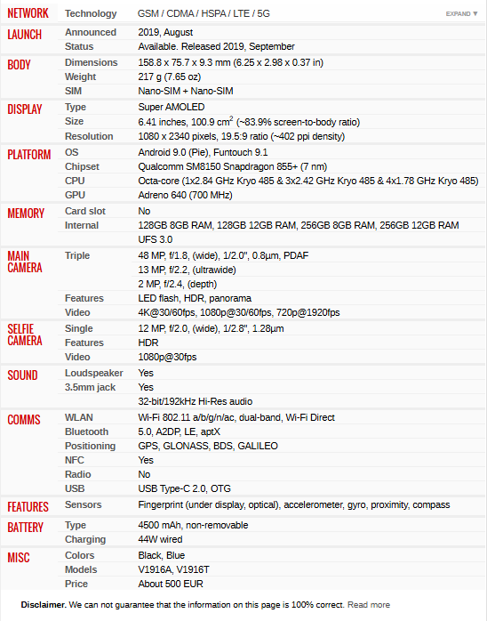

GSM 🡪 Global System for Mobile (2 G)

CDMA 🡪 Code division multiple Access (3 G)

HSPA 🡪 High Sped Packet access (3.5 G)

LTE 🡪 Long term evolution (4 G)

Snapdragon 8150 🡪 [Snapdragon 8150 CPU details surface - GSMArena.com news](https://www.gsmarena.com/snapdragon_8150_cpu_details_surface-news-34383.php#:~:text=The%20Qualcomm%20invitation&text=As%20per%20the%20info%2C%20the,2.419GHz%20in%20another%20cluster.)

Snapdragon (Qualcomm) 🡪 ARM update “kryo” 🡪 “2.84 GHz”

ARM 🡪 Advance RISC micro-processor

RISC (ARM/RISC V) / CISC (X86/X86_64)

CISC 🡪 Complex instruction X86 🡪 instruction execution time will vary

🡪 Div 32/2 (72 clock cycles) 🡪 more pressure on hardware 🡪 battery efficiency less

RISC 🡪 Simple instructions 🡪 instruction time generally 1 clock cycle

🡪 more pressure on SW/Compilers 🡪 battery efficient

🡪 Open Core 🡪 RISC V (new open source processors) (not ARM)

Assignments : Please try hello World in Keil:

[KEIL uVision Simple Tutorial](http://www.vlsiip.com/keil/) 🡪 Hello World!

[Embedded Systems with ARM Cortex-M Microcontrollers in Assembly Language and C](https://web.eece.maine.edu/~zhu/book/tutorials.php) 🡪 To Do

Please try read ARM book send in whatsapp - STM32 Arm Programming for Embedded Systems(By Mazidi) - <Muhammad-Ali-Mazidi.pdf>

* Try working gpio example on keil simulator –

Solution for the assignment – The solution is for STM32F103RE, do the same for STM32F4XX series.

<stm32f10xxx.pdf> - Reference manual for the supplied code .. page 138 to 160 is a good read.

* Try the codes for led and button on ST Nuculeo board STM32F446RE verify it on simulator and also on actual board.

Do install Keil and STMCube on your personal laptop.

* Install Putty and try to catch the uart message from board. Use switch to give external interrupt and service that by 🌟 ng LED. Use external 3.3 V power pin to give interrupt from gpio and service that by printing uart message. Also try the program from STE Cube.

GitHub login creation update the working project in the git repo

* <https://youtu.be/PxQw5_7yI8Q?si=z7ZOIQ6YsfrZ1l2D> - **blinking led with GCC tool chain**
* Setup GCC-ARM tool chain. Try blinky program with gcc

Try running the Mazidi books examples : LCD printing & segment display etc.

Try to use STLink V2 based flash programming and debugging

**Getting started Blue pill blinking LED -** <https://youtu.be/P7DdHO5QmHk?si=p5op5_jByhh-tYWB>

* Learn about how to run freeRTOS on bluepill. Check how to use freeRTOS on cube ide.
* Followed by that is to port FreeRTOS to cortex M85 based processor
* How to put single stepping in gcc/gdb and armcc/gdb.
* <https://youtu.be/saolJ_7E7hc?si=LmmqEo0EseFqkoDJ> - For the bluepill
* Get the bootloader and flash to bluepill
* Get the blinky app working on bluepill
* Get the freeRTOS book and example to run on simulator
* Figure out the bootloader and try compare that with Uboot or how to get the freeRTOS working for our mps4 board
* Using open source code do the entire tool chain and debug setup for bluepill.
* Makefile gcc compiler options linker scatter map file has to be in that
* Zypher rtos in stm32f407re board or bluepill.
* Explore job priority in rtos try it in simulator and board
* Lcd plus i2c program

<https://youtu.be/RZ4p-saaQkc?si=uxCP8C3-YlRyUqeY> – **Vim tutorial for beginners**