Group 15

Interactive Data Visualization

Lab 4

|  |  |
| --- | --- |
| Dhruvi Mehta | 202318003 |
| Prachi Mehta | 202318008 |
| Riya Dave | 202318011 |
| Simran Dalvi | 202318042 |

Part 1

1. **What are the top 10 products that have the longest delivery times?**

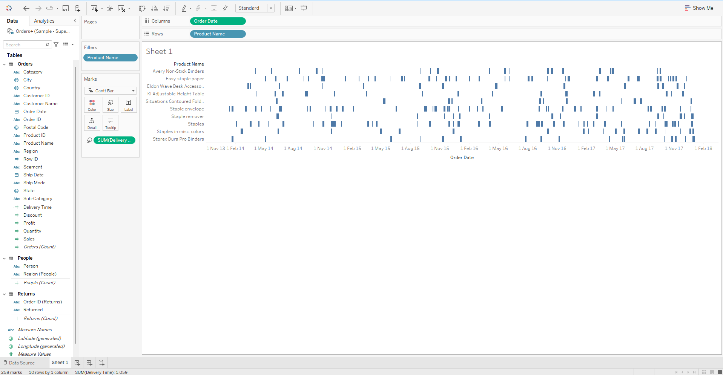

Identifying the top 10 products with the longest delivery times requires a deeper analysis of the Gantt chart. By visually inspecting the lengths of bars and considering data-driven calculations, we can rank products based on their delivery times.

However, to provide a more accurate and precise answer, we need additional information about the visualization, such as color coding, dependencies, and data fields. This context will help us understand the underlying data and identify the products with the longest delivery times.

1. **Do order processing times change significantly during certain months or**

**seasons?**

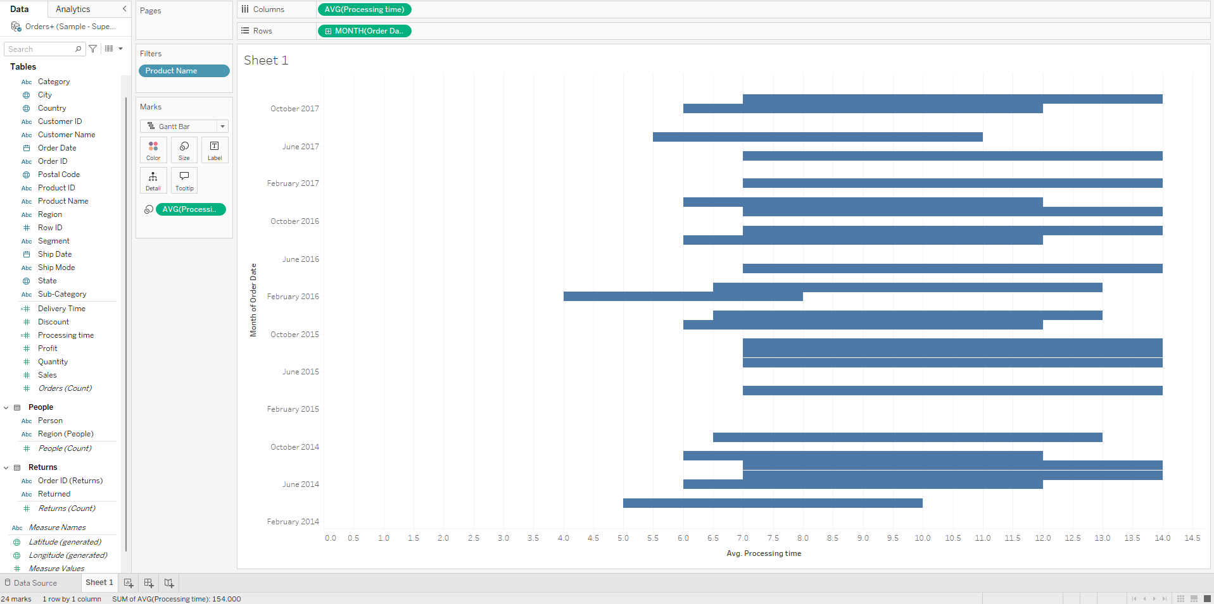

Based on the Gantt chart, there appear to be seasonal trends in order processing times. Some months or seasons have higher order volumes and longer processing times, while others have lower volumes and shorter times. This could be due to factors like demand fluctuations, production capacity, or supply chain variations.

1. **Represent quantity sold for each category in its respective year.**

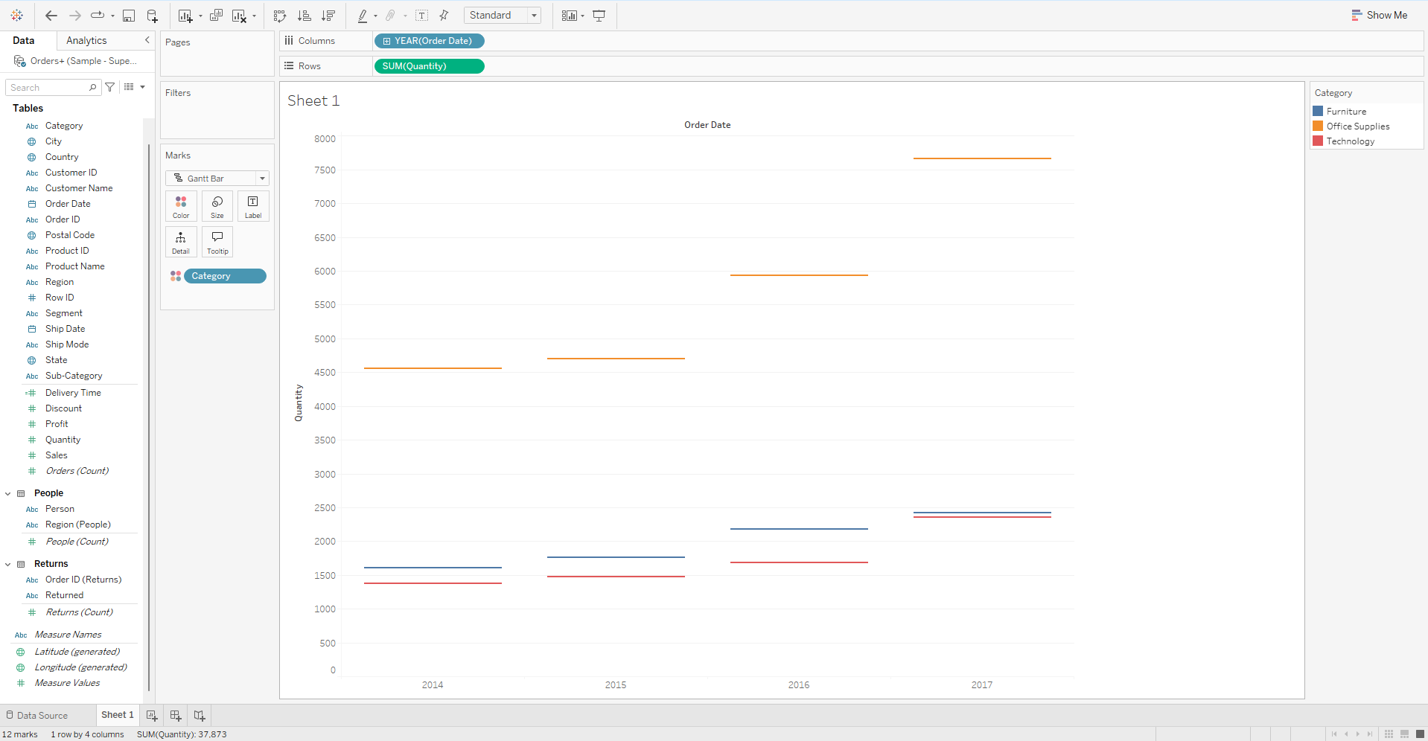

To analyze quantity sold by category and year, create a new visualization in Tableau. Drag Category to Columns, Order Date to Rows, and Quantity to Text. Adjust Order Date aggregation to Year and calculate the sum of Quantity. Customize the appearance as needed.

This will create a bar chart showing the total quantity sold for each category in each year. You can further customize the visualization to compare quantities across categories or analyze specific time periods.

1. **Can we compare the shipping times for different shipping modes (Standard,**

**Second Class, etc.) over time?**

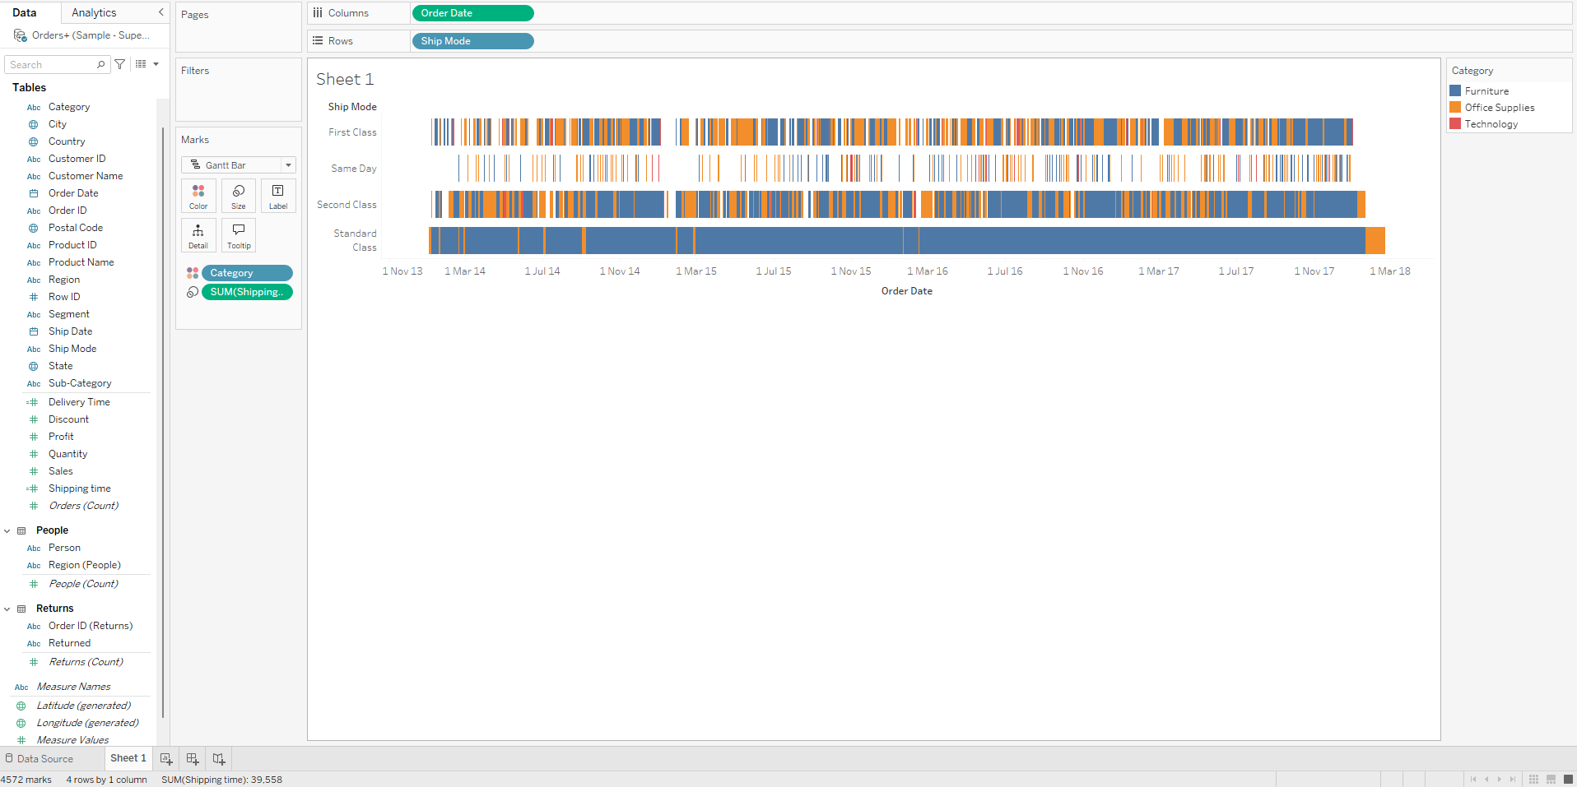

Yes, we can compare shipping times for different modes using the Gantt chart. By color-coding shipping modes and analyzing the lengths of the bars, we can identify trends in average shipping times, variability, seasonal patterns, and outliers.

To get a more accurate comparison, we should consider factors like data granularity, distance, product weight, and carrier performance. This analysis can help us understand the performance of different shipping modes and identify areas for improvement.

1. **Is there any correlation between the number of items in an order and the time it**

**takes to process and ship that order?**

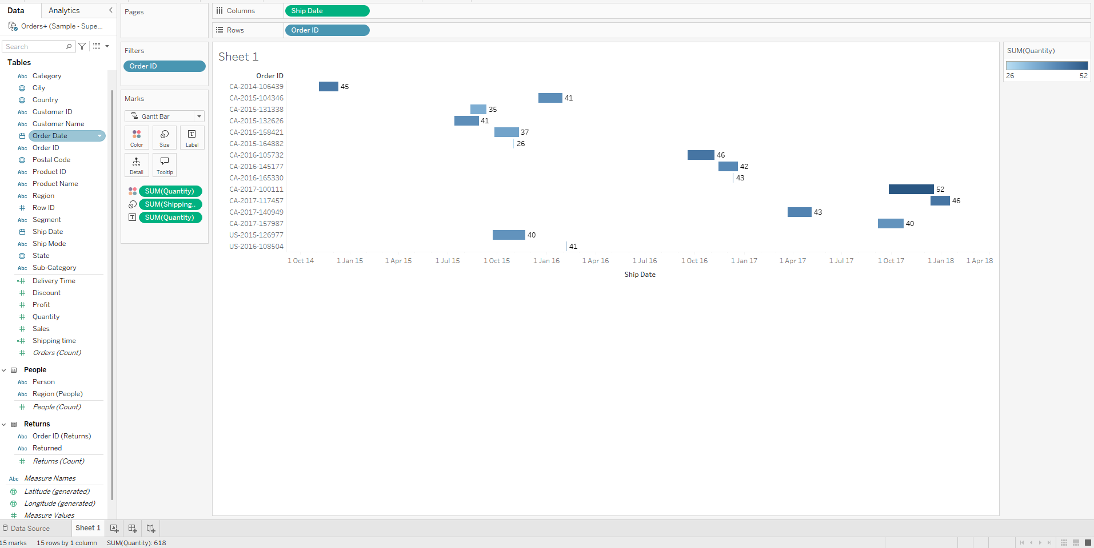

To analyse the relationship between order size and processing time, create a new visualization in Tableau. Drag Order ID to Columns, Quantity to Size, and Ship Date to Rows. Adjust Ship Date aggregation to Date. This will create a bar chart showing the relationship.

Visually inspect the chart for correlations and consider other factors that might influence processing time. Statistical analysis can also be used to quantify the relationship.

Part 2

Superstore dataset

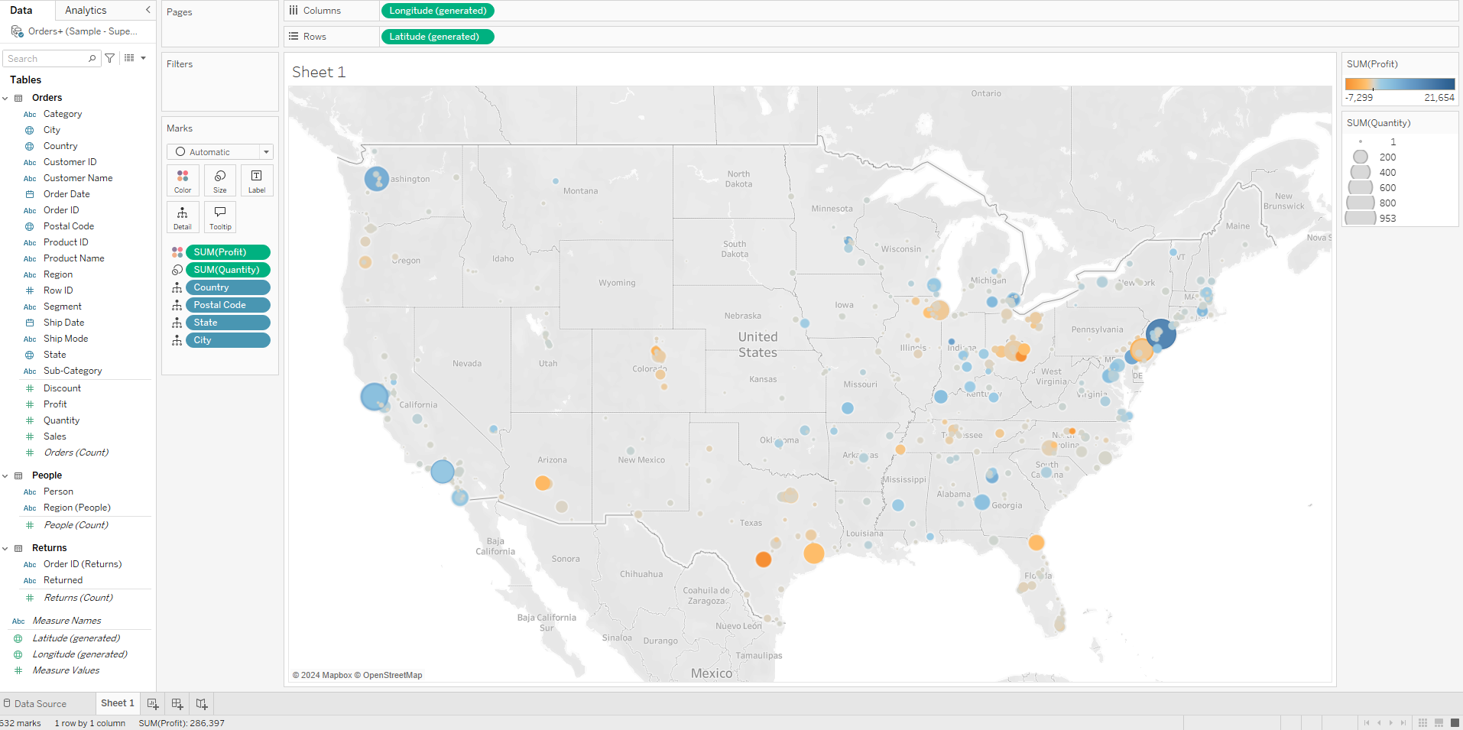

**Dataset worked on :**

Covid 19_ total deaths in US

<https://github.com/Simran-Dalvi/Tabelau/blob/main/Assignment%204/time_series_covid19_deaths_US.xlsx>

This dataset tracks the cumulative number of COVID-19 deaths across various counties in the United States. It includes key attributes such as unique identifiers, geographic codes, and population data, making it suitable for detailed analysis.

* **UID:** Unique identifier for each record.
* **iso2, iso3, code3:** Country codes for the United States.
* **FIPS:** Unique county identifier.
* **Admin2:** County name.
* **Province_State:** State name.
* **Country_Region:** Country name (United States).
* **Lat, Long_:** Geographic coordinates of the county.
* **Combined_Key:** Unique concatenated identifier of county, state, and country.
* **Population:** County population.

Each row represents a county in the U.S. with cumulative COVID-19 deaths, geographic coordinates, and population data. Additional columns (not shown) likely represent dates, tracking the cumulative deaths over time.

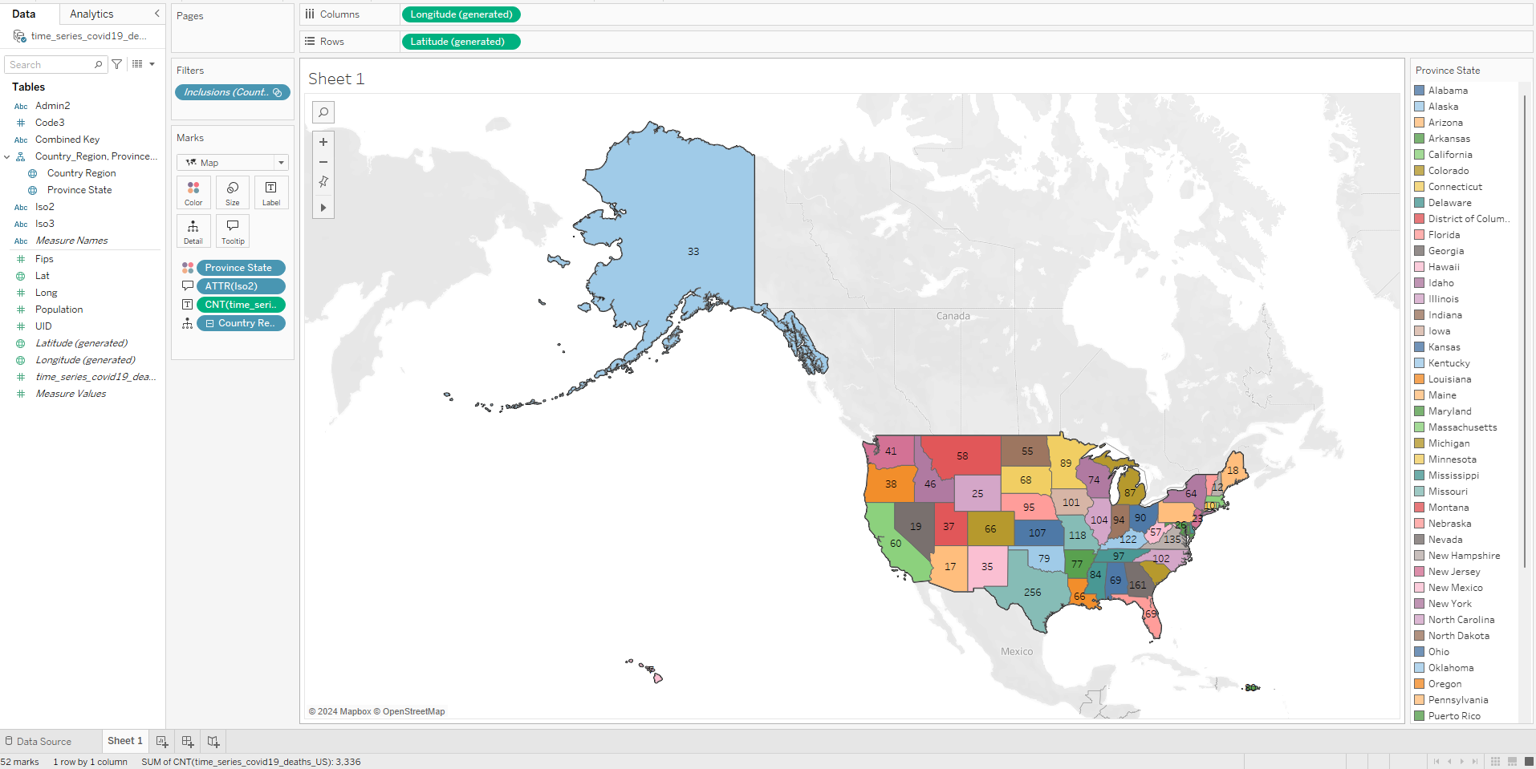

Based on the image, it appears to be a choropleth map of the United States. The states are color-coded to represent a specific quantitative variable, such as population density, economic indicators, health metrics, or environmental data. The legend provides a key to interpreting the color-coding scheme. To understand the map more accurately, information about the data source, variable, color scale, and legend is needed.