Assessment 02

PROG6001 Managing Software Development Projects –

**Group Members**

Simran Kaur

Harpreet Singh

Rajwant kaur Boparai

Contents

PROG6001 Managing Software Development Projects – Assessment 2 1

Task 1: 1

Task 2: 3

Task 3 4

Overview of the Agile Mindset 4

Description of the Scrum Process and the Waterfall Methodology 5

Guidelines for Determining Whether Scrum or Waterfall Suits Specific Software Development Projects 5

Differences Between Agile (Scrum) and Waterfall Methodologies 5

Conclusion 5

References 6

# PROG6001 Managing Software Development Projects – Assessment 2

# Task 1:

**Collaborative Project Using Git**

* **Simran Kaur**

**Git Repository Creation:**

**Commit History with Messages**

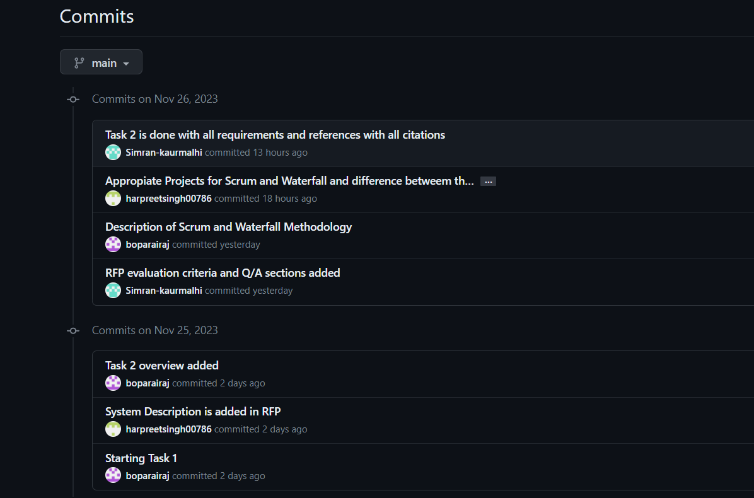

* **Harpreet Singh:**

**Git Repository Fork**

**Commit History with Messages**

**Pull Request**

* **Rajwant kaur Boparai**

**Git Repository Fork**

**Commit History with Messages**

**Pull Request**

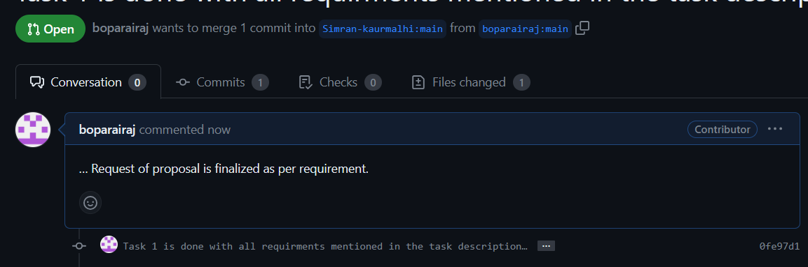

# Task 2:

**Aussie Business Buzz (ABB) Request for Proposal (RFP) for Integrated System Development**

Issued by Aussie Business Buzz (ABB)

Date of Issue: 20 November 2023

Proposal Submission Deadline: 30 November 2023

Aussie Business Buzz is a dynamic enterprise in the technology product sector that is excited to invite proposals for the development and implementation of an integrated system. Our vision encompasses the support of our current four branch shops with the flexibility to accommodate future expansion. The imagined system should be a confluence of a Customer Relations Database and must a Digital Marketing System along with a Stock Management System and Management Reporting tools.

**System Description:** The main objective of this RFP is the development of a system that integrates several key business functions. Predominantly, a robust Customer Relations Database is sought to manage a list of customer details including their purchase history and records of devices entrusted to us for repairs. Additionally, the system should incorporate a dynamic Digital Marketing System. This system should make use of the customer relations database and allow integration of prospective customers' details from our existing website. It is considered equally valuable for the implementation of a Stock Management System which can handle our diverse inventory including products for sale and parts for repairs. This system should facilitate automated ordering from wholesalers and allow inter-branch stock checks and transfers. Furthermore, the development of comprehensive Management Reporting tools is necessary. These tools should provide our management team, who may be located at any of our branches, with real-time updates on all aspects of our operations.

**Proposal Evaluation Criteria:** Proposals submitted will be evaluated on a scale of criteria. The ability of the proposal to comprehensively meet our system requirements will be vital. We are particularly interested in solutions that offer scalability and flexibility to adapt to our growing business needs. It must be evaluated based on cost-effectiveness and without compromising on the quality and efficiency of the solution, will be a key consideration. We also place high value on innovative solutions that bring creativity and modern techniques into production. The experience and reputation of the vendor, evidenced by a track record of successfully handling similar projects, will be considered.

**Process for Answering Questions:** To facilitate clear communication we will organize a dedicated question-and-answer session following the initial review of the proposals. Vendors are encouraged to submit their queries via email by a specified deadline. All inquiries and responses will be compiled and shared with all potential vendors to ensure a transparent and equitable information-sharing process.

**Additional Considerations:** In this RFP, we seek proposals that not only align with our current operational needs but also demonstrate an understanding of the potential integration with our existing website and systems. We encourage vendors to propose innovative solutions, which can include bespoke software development, leveraging existing applications, SaaS solutions, or a combination thereof. We have intentionally avoided overly technical specifications in this RFP to leave room for creative and potentially groundbreaking solutions. Vendors should also include detailed plans for support and maintenance post-implementation of the system.

**Submission Guidelines:** Interested parties are requested to submit their proposals by 30 Nov 2023, to [ceo@aussie.business.com](mailto:ceo@aussie.business.com). It is important to note that submissions received after the deadline will not be considered.

This RFP represents an exciting opportunity for innovative solution providers to collaborate with Aussie Business Buzz in creating a system that not only meets our current needs but also paves the way for future growth and success.

**Issued by:**

CEO,

ceo@aussie.business.com  
Aussie Business Buzz Management

# Task 3

## Overview of the Agile Mindset

The Agile mindset in software development is centered around flexibility as well as collaboration, and responsiveness to change. This approach contrasts with traditional methodologies by emphasizing iterative development where requirements and solutions evolve through collaboration between self-organizing and cross-functional teams. Agile methodologies such as Scrum to promote adaptive planning along with evolutionary development to make early delivery and continuous improvement. They also prioritize a rapid and flexible response to change for making them suitable for projects with evolving requirements or those in rapidly changing environments (Kaur and Kumar, 2015).

## Description of the Scrum Process and the Waterfall Methodology

**Scrum** is known as an Agile framework that organizes work into small to manageable chunks known as sprints typically lasting two to four weeks. During these sprints, cross-functional teams work collaboratively to deliver specific features or product increments. Key roles in Scrum include the Product Owner who defines the product vision the Scrum Master who facilitates the process and the development team. Scrum emphasizes regular reflection and adaptation with frequent meetings and reviews to adjust to changing requirements and priorities (Ben-zahia et al., 2022).

In contrast, the **Waterfall methodology** is a linear and sequential approach. It is characterized by a series of phases: i) requirements gathering ii) design iii) implementation iv) verification and maintenance with each phase completed before the next begins. This approach is often considered more rigid as it typically does not accommodate changes once a phase is completed. Waterfall is more appropriate for projects with exact results and outcomes are expected without changing requirements and a comprehensive plan can be executed without the need for significant changes.

## Guidelines for Determining Whether Scrum or Waterfall Suits Specific Software Development Projects

Choosing the more appropriate software methodology such as Scrum and Waterfall depends on the requirements of the project's nature as well as skills of team dynamics and client requirements (McKinney, 2016). **Scrum** is best for projects with evolving or upgrading the requirements as it supports flexibility and regular alterations. It is particularly effective in dynamic sectors where products must quickly adapt to market changes. Alternatively, **Waterfall** is capable of projects with proper defined requirements that are unlikely to change such as in highly planned industries where changes can be costly and complex (Andrei et al., 2019).

## Differences Between Agile (Scrum) and Waterfall Methodologies

The primary difference between Agile (Scrum) and Waterfall methodologies is in their approach to project management and development. Agile methodologies such as Scrum are adaptive for highlighting continuous feedback to make it iterative development and team collaboration. They allow for more regular adjustments and updates in response to changing requirements or unexpected challenges. This flexibility is particularly beneficial in projects where customer needs are expected to evolve or are not fully understood at the project's outset (McKinney, 2016).

In contrast, the Waterfall methodology follows a more rigid and linear path. Every phase is accomplished in series and there is usually no return to a last phase once it’s finished. This approach can be beneficial in projects where requirements are clearly understood and unlikely to change and where a well-defined plan is critical for success. However, it can be less effective in handling projects where flexibility and adaptability are required (Kuhrmann et al., 2017).

## Conclusion

It is concluded that the decision to use Scrum or Waterfall should be based on the specific needs and circumstances of the project. For a CRM system intended for global banking institutions where requirements might evolve based on diverse customer needs and regulatory environments whereas Scrum’s flexibility and iterative approach could be advantageous. It allows for adapting the product to meet emerging trends and changes in the financial technology sector. On the other hand, if the project requirements are well-defined and stable and if a sequential development approach is preferred and the Waterfall methodology might be more appropriate. The choice ultimately depends on balancing the need for adaptability with the project's scope as well as complexity while considering specific requirements.

# References

ANDREI, B.-A., CASU-POP, A.-C., GHEORGHE, S.-C. & BOIANGIU, C.-A. 2019. A study on using waterfall and agile methods in software project management. *Journal of Information Systems & Operations Management***,** 125-135.

BEN-ZAHIA, M. A. O., ABURAS, A. & GHAWAR, M. The Challenges of Software Development: Waterfall and Agile. 2022. Libyan International Conference for Applied Science and Engineering.

KAUR, C. & KUMAR, V. 2015. Comparative Analysis of Iterative Waterfall Model and Scrum. *International Journal of Computer Science Research (IJCSR) sve,* 3**,** 11-14.

KUHRMANN, M., DIEBOLD, P., MÜNCH, J., TELL, P., GAROUSI, V., FELDERER, M., TREKTERE, K., MCCAFFERY, F., LINSSEN, O. & HANSER, E. Hybrid software and system development in practice: waterfall, scrum, and beyond. Proceedings of the 2017 international conference on software and system process, 2017. 30-39.

MCKINNEY, J. 2016. Optimal Software Development: Waterfall, Scrum & Kanban.