Heart Disease Analysis Using MySQL and Tableau
Course: Bachelor of Technology (Computer Science & Engineering)
College: Ashoka Institute of Technology and Management
Varanasi, Uttar Pradesh
Academic Year: 2026

Submitted By:
- Simran Singh (Team Leader)
- Akash Srivastava
- Arpit Kumar Sharma
- Aryan Yadav
- Simran Bano

Table of Contents:

- Certificate
- Acknowledgement
- Abstract
- Introduction
- Problem Statement
- Objectives
- Project Scope
- Team Members & Work Distribution
- Tools & Technologies Used
- System Requirements
- Dataset Description
- Project Workflow
- Project Development Procedure
- Database Development
- SQL Implementation
- Tableau Integration
- Data Visualization
- Dashboard Development
- Story Development
- Web Integration
- Results & Findings
- Challenges Faced
- Conclusion
- Future Scope
- References
- Appendix

Certificate:
This is to certify that Simran Singh (Team Leader), Akash Srivastava, Arpit Kumar Sharma, Aryan Yadav and Simran Bano has successfully completed the project titled "Heart Disease Analysis Using MySQL and Tableau" as part of the Data Analytics with Tableau program.
The project has been developed using MySQL for database management and SQL analysis, and Tableau for data visualization and dashboard creation. The work presented in this report is based on the project repository and demonstrates the complete process of data collection, cleaning, analysis, visualization, and interpretation.

Acknowledgement:
We would like to express our sincere gratitude to the Skill Wallet Data Analytics with Tableau Program for providing the opportunity to work on this project.
We also thank the mentors and instructors who guided us throughout the learning process and helped us to understand the concepts related to SQL, database management, data visualization, and Tableau.
Finally, we would like to thank our college, Ashoka Institute of Technology and Management, for providing the resources and encouragement to enhance our technical skills.

Abstract:
Heart disease is one of the leading causes of death across the world. Analyzing medical data helps healthcare professionals identify patterns, understand patient conditions, and make informed decisions.
The objective of this project is to analyze a heart disease dataset using MySQL for data storage and SQL analysis and Tableau for creating interactive dashboards and stories.
The project follows a complete data analytics workflow, including collecting the dataset, cleaning and preparing the data, importing it into MySQL, writing SQL queries for analysis, creating database views, connecting MySQL with Tableau, designing dashboards, and presenting insights through Tableau stories.
The analysis focuses on identifying relationships between patient characteristics such as age, gender, chest pain type, blood pressure, cholesterol, heart rate, exercise-induced angina, and the likelihood of heart disease. The dashboards help users easily understand trends and support data-driven decision-making.

Introduction:
Data analytics plays an important role in transforming raw data into meaningful information. In the healthcare sector, patient data can be analyzed to discover hidden patterns that help doctors and researchers make better decisions.
Heart disease is a serious health problem that affects millions of people every year. Medical datasets contain valuable information such as age, gender, blood pressure, cholesterol level, heart rate, chest pain type, and several clinical measurements. By analyzing these attributes, it becomes possible to identify trends associated with heart disease.
In this project, MySQL is used to store and manage the dataset. SQL queries are written to clean the data, create views, and perform various analyses. Tableau is then used to build interactive dashboards and stories that present the results in a clear and visually appealing manner.
The project demonstrates a complete data analytics pipeline, beginning with raw data collection and ending with meaningful visual insights that support decision-making.

Problem Statement:
Heart disease is one of the major causes of death worldwide. Hospitals and healthcare organizations collect large amounts of patient data every day, but without proper analysis, it is difficult to identify meaningful patterns and trends.
The challenge is to transform raw medical data into useful information that helps understand the relationship between different health parameters and the occurrence of heart disease.
This project aims to solve this problem by storing patient data in a MySQL database, analyzing it using SQL queries, and presenting the findings through interactive Tableau dashboards. The visualizations make it easier to understand patient characteristics and identify factors associated with heart disease.

Objectives:
The main objectives of this project are:
- To collect and understand the heart disease dataset.
- To clean and preprocess the data before analysis.
- To create a MySQL database for efficient data storage.
- To write SQL queries for data analysis.
- To create SQL views for simplified reporting.
- To connect MySQL with Tableau.
- To design interactive dashboards for data visualization.
- To create Tableau stories that explain important findings.
- To identify patterns and trends in heart disease data.
- To present the results in an easy-to-understand format for better decision-making.

Scope of the Project:
The scope of this project includes the complete analysis of heart disease data using database and visualization tools.
The project focuses on:
- Data collection from CSV files.
- Data cleaning and preprocessing.
- Database creation using MySQL.
- SQL-based analytical queries.
- Creation of reusable database views.
- Interactive Tableau dashboards.
- Tableau stories explaining the analysis.
- Identification of key insights from patient data.
The project is intended for educational purposes and demonstrates the practical implementation of data analytics techniques using real-world healthcare data.

Project Enrollment Details:
The Heart Disease Analysis project was assigned through the Smart Bridge Skill Wallet (My Skill Wallet) platform as a team-based project. The project team was officially enrolled with the following details:
Particular | Details
Platform | SmartBridge – SkillWallet (MySkillWallet)
Team ID | SWTID-2026-1013
Team Size | 5 Members
Team Leader | Simran Singh
Team Members | Arpit Kumar Sharma, Akash Srivastava, Simran Bano
, Aryan Yadav
The project was completed collaboratively, with each member responsible for specific tasks such as data collection, database management, SQL analysis, dashboard development, web integration, testing, and documentation.

Project Team Members and Work Distribution:
This project was developed as a group project under the guidance of the Skill Wallet Data Analytics with Tableau program. Each team member was assigned specific responsibilities to ensure smooth execution of the project.

Team Structure:
- Team Leader: Simran Singh
- Member 1: Akash Srivastava
- Member 2: Arpit Kumar Sharma
- Member 3: Aryan Yadav
- Member 4: Simran Bano

Work Distribution:

1. Data Collection & Extraction from Database
- Downloading the dataset: Arpit Kumar Sharma
- Storing data in DB & performing SQL operations: Akash Srivastava
- Connecting DB with Tableau: Simran Singh

2. Data Preparation
- Preparing data for visualization: Simran Singh

3. Data Visualization
- Number of unique visualizations: Simran Singh

4. Dashboard Development
- Designing responsive dashboard: Simran Singh

5. Story Development
- Number of story scenes: Simran Singh

6. Performance Testing
- Amount of data to DB: Akash Srivastava
- Utilization of data filters: Arpit Kumar Sharma
- Number of calculation fields: Simran Bano
- Number of visualizations/graphs: Simran Singh

7. Web Integration
- Publishing: Arpit Kumar Sharma
- Dashboard & story embedding with UI using Flask: Simran Singh

8. Project Demonstration & Documentation
- Project demonstration video: Arpit Kumar Sharma
- Step-by-step project documentation: Akash Srivastava

Tool and Technology Stack:
Technology | Purpose
Python: | Main programming language used for backend development.
Flask: | Web framework used to develop the application and integrate Tableau dashboards.
MySQL Workbench: | Database creation, data storage, and SQL query execution.
SQL: | Data cleaning, view creation, and analytical queries.
Tableau Desktop: | Creating worksheets, dashboards, and stories.
HTML5: | Structure of the web interface (index.html).
CSS3: | Styling the web application (style.css).
JavaScript: | Client-side interactivity (script.js).
Git: | Version control during development.
GitHub: | Source code hosting and collaboration.
CSV Dataset: | Source of the heart disease data.
Render: | Cloud deployment of the Flask application (render.yaml and Procfile).
requirements.txt: | Lists Python libraries required to run the application.
README.md: | Project overview, setup instructions, and usage guide.
LICENSE: | Defines the licensing terms of the project.
.gitignore: | Specifies files and folders excluded from version control.

System Requirements:
The following hardware and software requirements were used to develop and execute this project.

Hardware Requirements:
Component | Requirement
Processor | Intel Core i3 or higher
RAM | Minimum 4 GB (8 GB Recommended)
Storage | Minimum 10 GB Free Space
Operating System | Windows 10 / Windows 11

Software Requirements:
Software | Purpose
MySQL Workbench 8.x | Database Management
Tableau Desktop | Data Visualization
Git | Version Control
GitHub | Project Repository
Microsoft Excel | Dataset Verification

Dataset Description:

Dataset Overview:
The dataset used in this project contains medical information related to heart disease patients. It includes demographic details, clinical measurements, and diagnostic information that help in analyzing the factors associated with heart disease.
Two CSV files are included in the project:
Heart_dataset_clean.csv Heart_new2.csv
The cleaned dataset was imported into MySQL and used for SQL analysis and Tableau visualization. The dataset contains patient information such as:
- Heart Diseases
- BMI
- Smoking
- Alcohol Drinking
- Stroke
- Physical Health
- Mental Health
- Diff Walking
- Sex
- Age Category
- Race
- Diabetic
- Physical Activity
- Gen Health
- Sleep Time
- Asthma
- Kidney Disease
- Skin Cancer
These attributes are commonly used for analyzing heart disease risk.
Description of Dataset Attributes:
Column Name | Description
Heart Diseases: | Indicates whether the person has been diagnosed with heart disease (Yes/No).
BMI: | Body Mass Index (BMI), a measure of body weight based on height and weight.
Smoking: | Shows whether the person has ever smoked cigarettes (Yes/No).
Alcohol Drinking: | Indicates whether the person is a heavy alcohol consumer (Yes/No).
Stroke: | Indicates whether the person has ever had a stroke (Yes/No).
Physical Health: | Number of days in the past 30 days when the person's physical health was not good.
Mental Health: | Number of days in the past 30 days when the person's mental health was not good.
Diff Walking: | Indicates whether the person has difficulty walking or climbing stairs (Yes/No).
Sex: | Gender of the person (Male/Female).
Age Category: | Age group to which the person belongs (e.g., 18–24, 25–29).
Race: | Ethnic or racial group of the person.
Diabetic: | Indicates whether the person has diabetes or prediabetes.
Physical Activity: | Shows whether the person performed physical activity during the last 30 days (Yes/No).
Gen Health: | Self-reported general health status (Excellent, Very Good, Good, Fair, Poor).
Sleep Time: | Average number of hours the person sleeps in a 24-hour period.
Asthma: | Indicates whether the person has asthma (Yes/No).
Kidney Disease: | Indicates whether the person has kidney disease (Yes/No).
Skin Cancer: | Indicates whether the person has ever been diagnosed with skin cancer (Yes/No).

Dataset Characteristics:
- Structured dataset
- Stored in CSV format
- Suitable for relational database management
- Contains numerical and categorical attributes
- Used for healthcare data analysis
- Easy to integrate with MySQL and Tableau

Project Work Flow:

- Heart Disease CSV Dataset
- MySQL Database
- SQL Queries & Views
- Tableau Dashboard
- Tableau Story
- Flask Web Application
- HTML + CSS + JavaScript
- Render Cloud Deployment

Project Development Procedure:
The project was developed in a systematic manner by following the complete data analytics workflow. Each phase ensured that the data was prepared correctly before performing analysis and visualization.
The major development steps are:
- Data Collection
- Data Understanding
- Data Cleaning
- Database Creation
- Data Import into MySQL
- SQL Analysis
- View Creation
- Connecting MySQL with Tableau
- Dashboard Development
- Story Development
- Result Analysis
Each step is explained below.

Step 1: Data Collection:
The first step was collecting the heart disease dataset. The dataset was obtained in CSV format and stored in the dataset folder of the project repository.
The project contains two CSV files:
- Heart_dataset_clean.csv (Cleaned Dataset)
- Heart_new2.csv (Given Dataset)
These files contain patient health information, including demographic details, clinical measurements, and heart disease diagnosis.
The dataset was selected because it contains multiple medical parameters that can be analyzed using SQL queries and visualized using Tableau dashboards.
The collected dataset serves as the foundation for the complete analytics process.

Step 2: Data Understanding:
Before importing the data into the database, the dataset was examined to understand its structure and contents.
The following activities were performed:
- Reviewed all column names.
- Identified numerical and categorical variables.
- Checked data types.
- Understood the meaning of each attribute.
- Verified the consistency of the data.
- Examined records for missing or incorrect values.
Understanding the dataset before analysis helps avoid errors during database creation and visualization.

Step 3: Data Cleaning:
Data cleaning is one of the most important phases of any data analytics project. Poor-quality data can produce incorrect results and misleading visualizations.
The SQL script 02_data_cleaning.sql was used to clean and prepare the data for analysis.
The following activities were performed:
- Removal of Duplicate Records:

- Duplicate rows were checked to ensure that every patient record appeared only once in the dataset.

- Handling Missing Values:

- The dataset was examined for missing or NULL values. Any incomplete records were identified and handled appropriately to maintain data quality.

- Data Validation:

- The values in each column were checked to ensure they were valid and consistent with the expected format.

- Data Consistency:

- Categorical values were standardized wherever necessary to maintain consistency across the dataset.

- Data Verification:

- After cleaning, the dataset was verified again to ensure that it was ready for SQL analysis and Tableau visualization.
The cleaned dataset was then saved and imported into MySQL for further processing.

Database Development :

Database Development:
After understanding and cleaning the dataset, the next step was to create a relational database using MySQL. A database provides an organized way to store, manage, and analyze large amounts of data efficiently.
The database was created using SQL scripts available in the project repository. These scripts automate database creation, data cleaning, view creation, and analysis.
The development process followed these steps:
- Create the database.
- Import the dataset into MySQL.
- Create a cleaned table.
- Remove duplicate records.
- Create SQL views.
- Perform SQL analysis.
SQL Implementation:

Creating the Database:
The first SQL script (01_create_database.sql) creates the project database.

SQL Script:

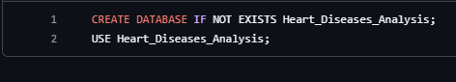

Explanation:
The CREATE DATABASE statement creates a new database named Heart_Diseases_Analysis. The IF NOT EXISTS clause prevents errors if the database already exists.
After creating the database, the USE statement selects it as the active database so that all subsequent SQL operations are performed inside this database.

Importing the Dataset into MySQL:
After creating the database, the cleaned CSV dataset was imported into MySQL Workbench. The imported table was named: heart_data.
The dataset contains patient information related to heart disease, including demographic details, medical measurements, and diagnosis.
After the import process, the records were verified to ensure that all rows and columns were imported successfully.

Benefits of Importing into MySQL
- Fast data retrieval.
- Easy execution of SQL queries.
- Efficient filtering and aggregation.
- Better integration with Tableau.
Data Cleaning Using SQL:
Before performing analysis, duplicate records were removed to improve data quality.
The second SQL script (02_data_cleaning.sql) creates a cleaned table using distinct records.

SQL Script:

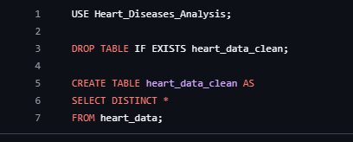

Explanation:
The script first selects the Heart_Diseases_Analysis database.
The existing cleaned table is deleted if it already exists using:
DROP TABLE IF EXISTS
This prevents conflicts when the script is executed multiple times.
A new table named heart_data_clean is then created.
The statement:
SELECT DISTINCT *
copies only unique records from the original table.
This removes duplicate entries and improves the quality of the dataset.
Creating SQL View:
To simplify data analysis, a SQL view was created.
The view automatically categorizes patients based on their Body Mass Index (BMI).

SQL Script:
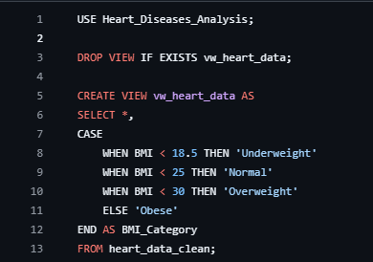

Explanation: The SQL view is named:
vw_heart_data
The view retrieves all columns from the cleaned table and creates one additional column called:
BMI_Category:
The CASE statement automatically classifies patients into four categories.
BMI Range | Category
Less than 18.5 | Underweight
18.5 – 24.9 | Normal
25 – 29.9 | Overweight
30 and above | Obese

Benefits of Using Views:
Instead of writing the BMI classification repeatedly, the view stores the logic once and can be reused in different SQL queries and Tableau dashboards.
Advantages include:
- Faster reporting.
- Better readability.
- Reusable SQL logic.
- Simplified dashboard creation.

SQL Analysis:
The final SQL script (04_analysis_queries.sql) performs different analytical operations on the cleaned dataset.

SQL Script:
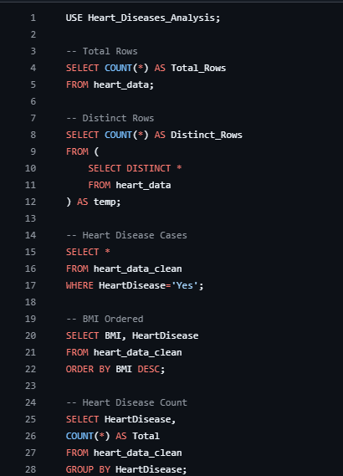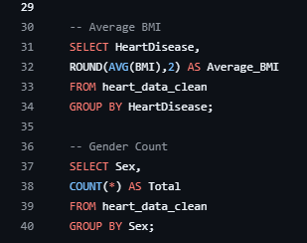
These queries help understand the characteristics of patients and identify patterns related to heart disease.

Tableau Integration:

Connecting MySQL with Tableau:
After completing the SQL analysis, the cleaned dataset stored in the Heart_Diseases_Analysis database was connected to Tableau Desktop. This integration enabled the creation of interactive dashboards and visual reports without manually exporting data multiple times.
The project also includes a Tableau workbook (mysql(tableau).twbx) that demonstrates the connection between MySQL and Tableau.

Steps Followed:
- Open Tableau Desktop.
- Select MySQL as the data source.
- Enter the server details and connect to the MySQL database.
- Select the Heart_Diseases_Analysis database.
- Load the heart_data_clean table or vw_heart_data view.
- Verify that all columns are imported correctly.
- Create worksheets for different analyses.
- Combine the worksheets into dashboards.
- Create a Tableau Story to present the final analysis.
This process allows Tableau to retrieve data directly from MySQL, ensuring that the dashboards always use the latest available data.
Benefits of Connecting Tableau with MySQL:
- Real-time access to the latest data.
- Faster data visualization.
- Interactive filtering and analysis.
- Better performance with structured data.
- Easy dashboard updates when the database changes.

Dashboard Development:
The dashboard development phase transforms SQL analysis into interactive visualizations. Instead of reading tables of data, users can understand trends through charts, graphs, and filters.
The project contains three dashboards that highlight different aspects of the heart disease dataset.
The dashboards were designed with the following goals:
- Present information clearly.
- Enable quick understanding of trends.
- Compare different patient characteristics.
- Support interactive analysis.
- Assist in identifying factors related to heart disease.

Dashboard 1 – Patient Overview Dashboard:

Objective:
The first dashboard provides a general overview of the dataset and summarizes important patient information.

Features:
- Total patient records.
- Distribution of heart disease cases.
- Gender distribution.
- Overall health indicators.
- Summary charts.

Purpose: This dashboard helps users understand the overall composition of the dataset before performing detailed analysis.

Outcome: Users can quickly identify the number of patients, gender ratio, and the proportion of patients diagnosed with heart disease.

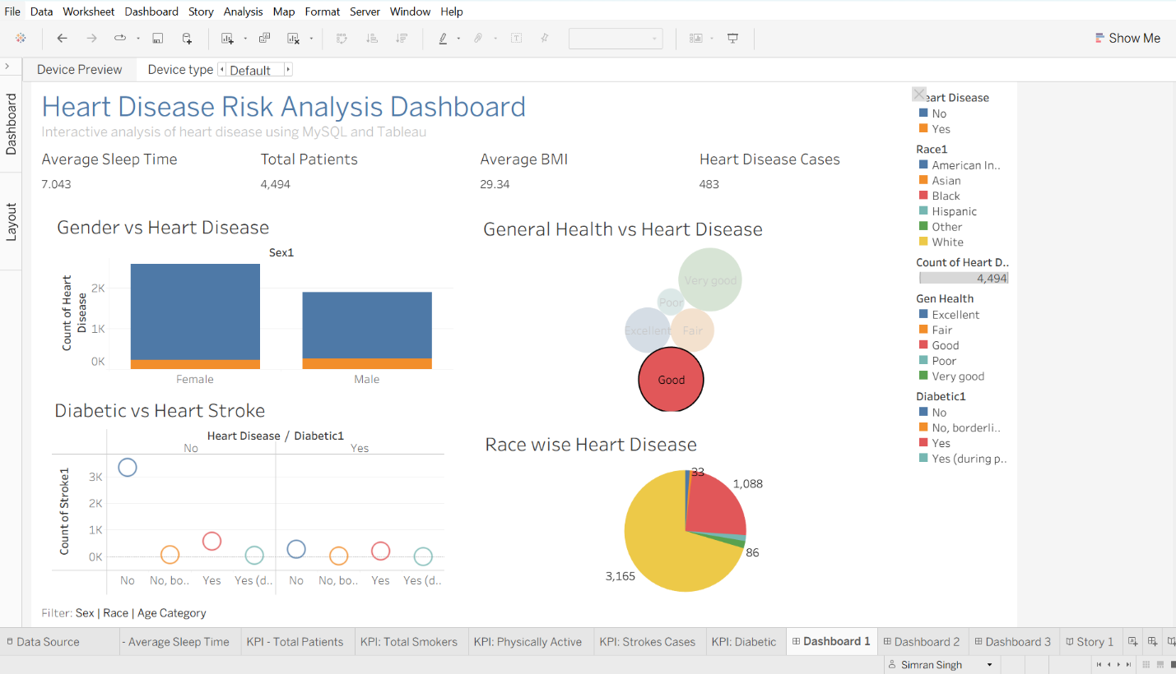

Dashboard 2 – Health Indicator Analysis:

Objective:
The second dashboard focuses on medical characteristics that may influence heart disease.

Features
- BMI comparison.
- Heart disease distribution.
- Clinical measurements.
- Patient health indicators.
- Comparative charts.

Purpose: This dashboard allows users to compare health-related factors and observe differences between patients with and without heart disease.

Outcome: The dashboard highlights trends that may help identify potential health risks associated with heart disease.
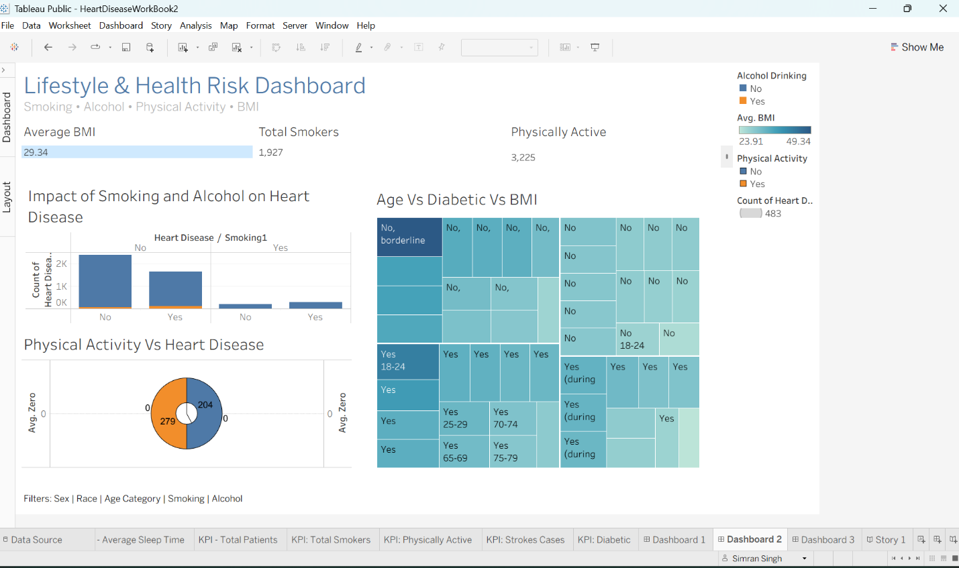

Dashboard 3 – Comparative Analysis Dashboard:

Objective
The third dashboard provides deeper analytical insights by comparing multiple variables.

Features
- Comparison between different patient groups.
- Interactive filtering.
- Relationship between medical attributes.
- Summary statistics.

Purpose: This dashboard helps users analyze relationships between different variables and identify patterns within the dataset.

Outcome: Users can perform detailed comparisons and gain a better understanding of the factors affecting heart disease.

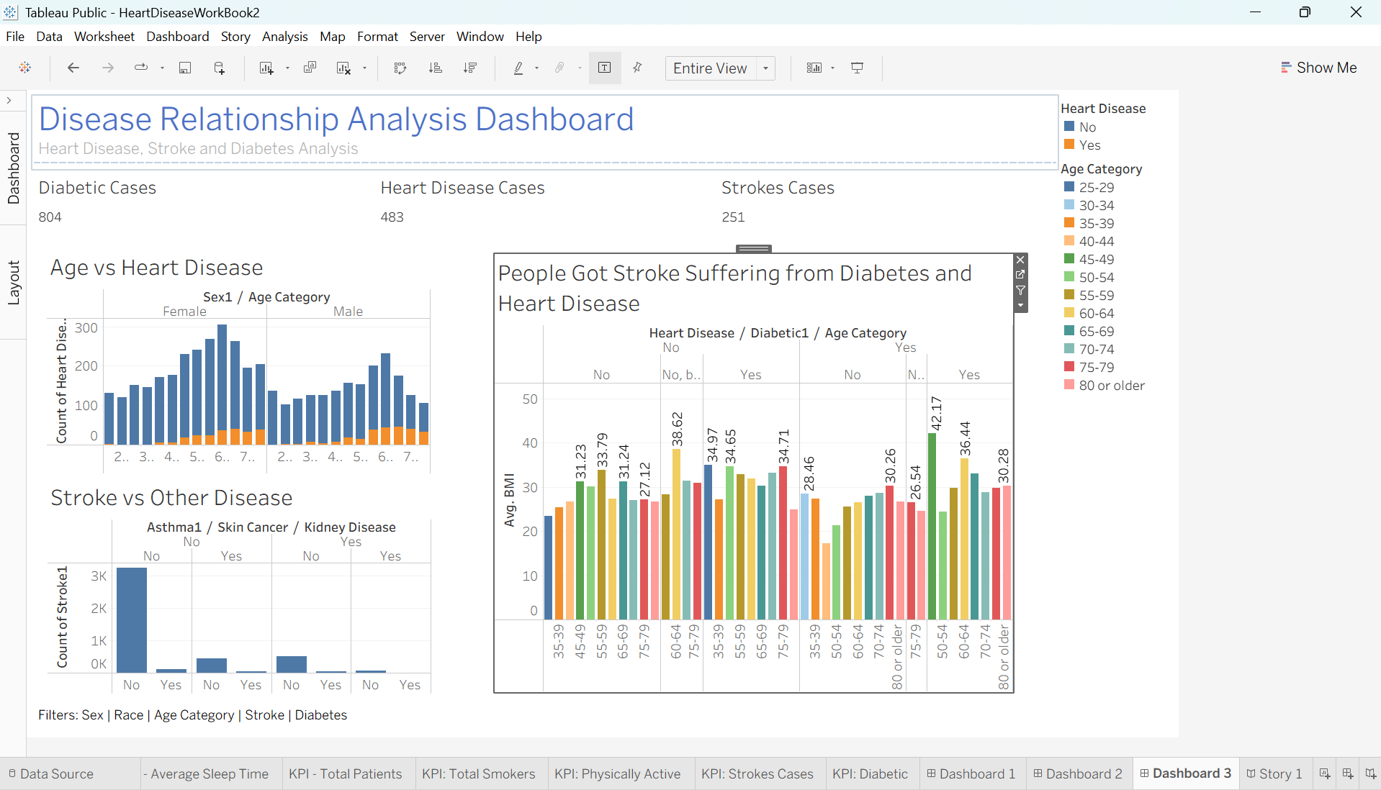

Tableau Story Development:
A Tableau Story presents the analysis in a structured sequence, allowing users to understand the project step by step.
The project contains three story points.

Story Point 1 – Dataset Overview:

Description: The first story point introduces the dataset and presents an overview of patient information.
It explains:
- Total patient records.
- General distribution.
- Initial observations.
- Basic summary of the dataset.

Purpose: To provide users with an understanding of the dataset before detailed analysis begins.

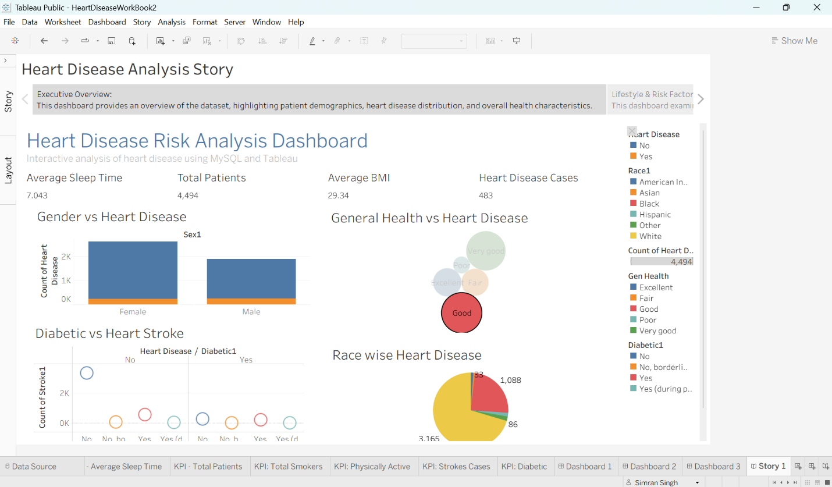

Story Point 2 – Analytical Insights:

Description: The second story point focuses on the analytical findings obtained from SQL queries and Tableau visualizations.
It highlights:
- Heart disease distribution.
- BMI analysis.
- Gender comparison.
- Medical parameter analysis.

Purpose: To explain the important trends discovered during data analysis.

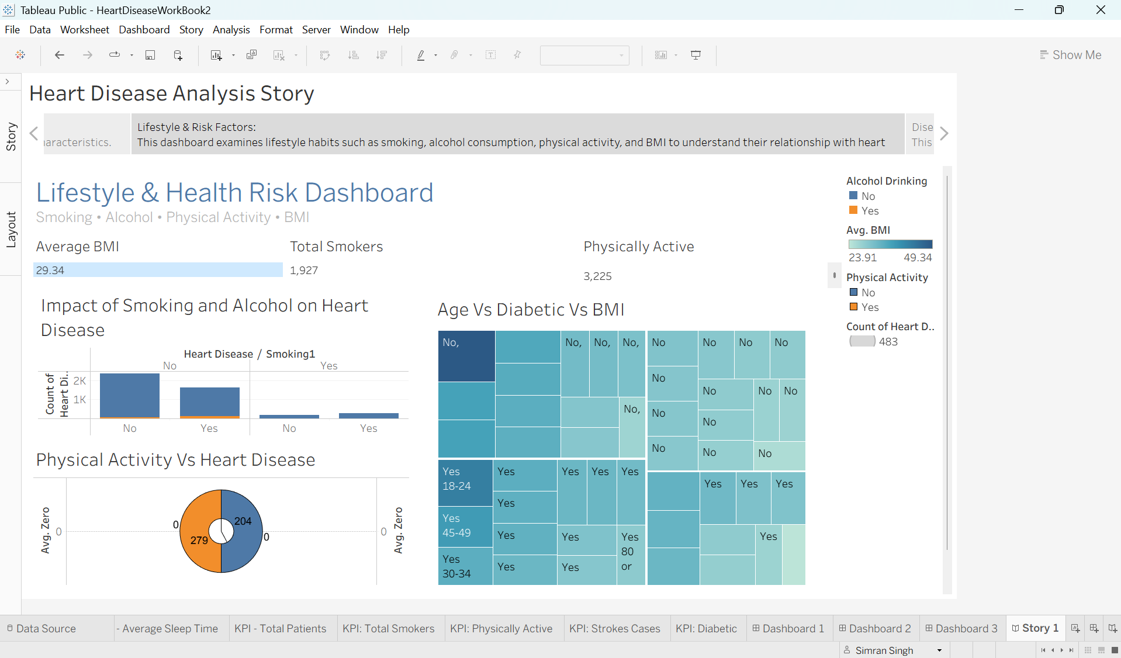

Story Point 3 – Final Findings:

Description: The final story point summarizes the entire project and presents the key conclusions.
It combines all important visualizations into a single narrative and explains the overall findings.

Purpose: To communicate the project results in a clear and logical manner.

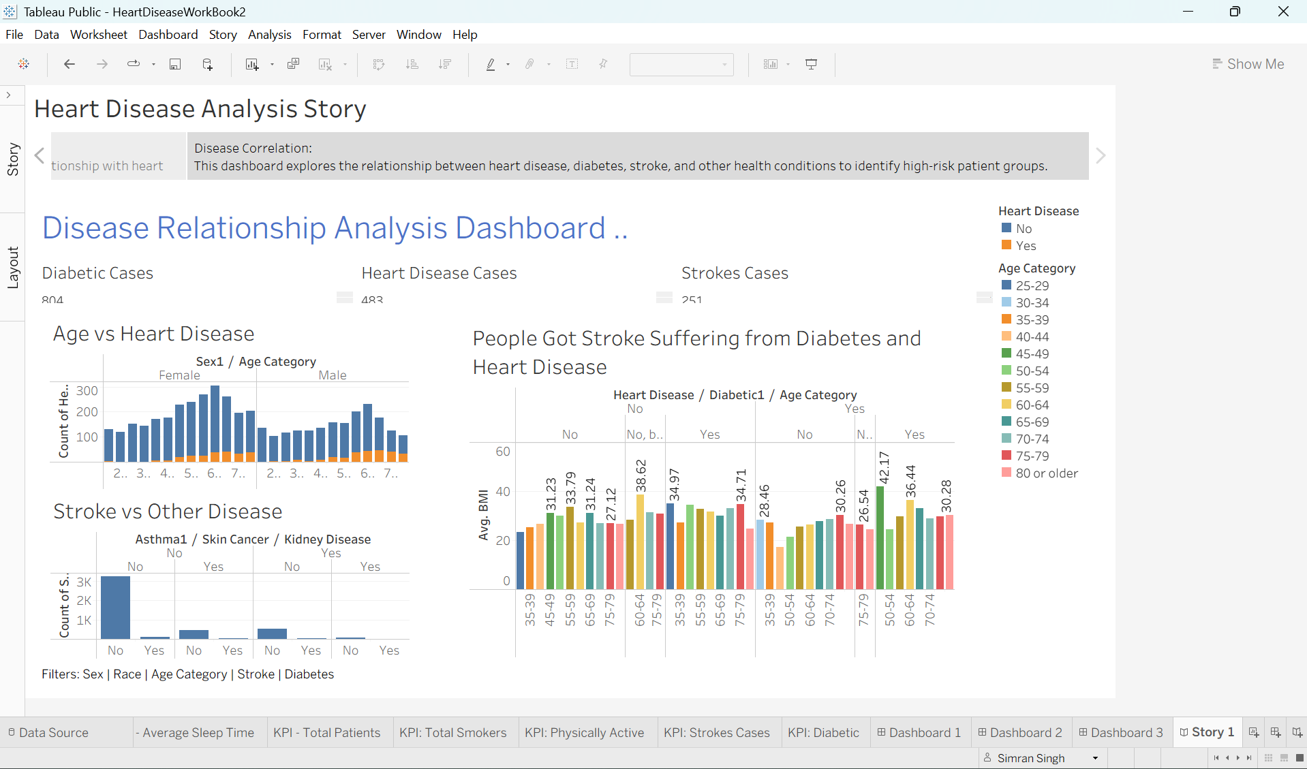

Web Integration:
After completing the database development, SQL analysis, and Tableau dashboards, the project was integrated into a web application using the Flask framework. This made the dashboard and story accessible through a web browser, allowing users to interact with the visualizations in a user-friendly interface.
The project includes the following files for web integration:
- app.py – Main Flask application that handles routing and serves the web pages.
- templates/index.html – HTML page used to display the application interface.
- static/css/style.css – Stylesheet used to improve the appearance and responsiveness of the web application.
- static/js/script.js – JavaScript file used for client-side functionality and interactive behavior.
- requirements.txt – Contains all the Python libraries required to run the Flask application.
- Procfile – Defines the command used to start the application during deployment.
- render.yaml – Configuration file used for deploying the application on the Render cloud platform.
- README.md – Provides project information and setup instructions.
- .gitignore – Specifies files and folders that should not be uploaded to the GitHub repository.
- LICENSE – Defines the licensing terms for the project.

Steps Performed
- The cleaned dataset was stored in the MySQL database.
- Tableau was connected to the MySQL database.
- Dashboards and stories were created in Tableau.
- The Tableau content was embedded into the Flask web application.
- HTML, CSS, and JavaScript were used to create a clean and responsive user interface.
- The project was prepared for deployment using the Procfile and Render configuration.

Results & Findings:
After completing the project, several useful insights were obtained through SQL analysis and Tableau dashboards.

Key Findings:
- The heart disease dataset was successfully imported into the MySQL database.
- Duplicate records were removed by creating the heart_data_clean table.
- SQL queries were used to calculate the total number of records, unique records, and heart disease cases.
- The BMI values of patients were analyzed and grouped into Underweight, Normal, Overweight, and Obese categories using a SQL view.
- Gender-wise analysis was performed to understand the distribution of male and female patients.
- The average BMI of patients with and without heart disease was calculated using SQL aggregation functions.
- Tableau dashboards presented the analysis in an interactive and easy-to-understand format.
- Tableau stories summarized the complete analysis in a logical sequence.
- The Flask web application successfully displayed the Tableau dashboard and story through a web interface.

Overall Outcome:
The project successfully demonstrated the complete data analytics process, beginning with data collection and ending with a web-based visualization platform. The combination of MySQL, SQL, Tableau, and Flask enabled efficient data management, analysis, visualization, and presentation.

Challenges Faced:
During the development of the project, the team encountered several challenges.

1. Data Cleaning:
Duplicate records had to be identified and removed before analysis to ensure accurate results.

2. Database Management:
Importing and organizing the dataset in MySQL required careful verification of table structures and data.

3. SQL Query Development:
Writing analytical SQL queries required proper use of aggregation functions, grouping, sorting, and filtering.

4. Tableau Integration:
Connecting Tableau with the MySQL database and ensuring correct data synchronization required proper configuration.

5. Dashboard Design:
Designing dashboards that were informative, interactive, and easy to understand required multiple improvements.

6. Web Integration:
Embedding Tableau dashboards into the Flask application and configuring deployment files required careful implementation.

7. Team Coordination:
As this was a group project, effective communication and task distribution among all team members were essential for successful completion.

Conclusion:
The Heart Disease Analysis project successfully demonstrated the complete data analytics workflow using modern technologies such as MySQL, SQL, Tableau, Flask, HTML, CSS, and JavaScript.
The project began with collecting the heart disease dataset, followed by storing it in a MySQL database. SQL was used to clean the data, create reusable views, and perform analytical queries. Tableau transformed the analyzed data into interactive dashboards and stories, making the results easy to understand.
Finally, the dashboards and stories were integrated into a Flask-based web application, allowing users to access the analysis through a browser. This integration combined database management, analytics, visualization, and web development into a single project.
The project also demonstrated the importance of teamwork, with each member contributing to different stages of development. Overall, the project achieved its objectives and provided valuable experience in end-to-end data analytics.

Future Scope:
The project can be further enhanced in several ways.
- Integrate Machine Learning models to predict the risk of heart disease.
- Connect the application to real-time healthcare databases.
- Add user authentication and role-based access for better security.
- Include more interactive dashboards and advanced visualizations.
- Develop a mobile-friendly version of the web application.
- Deploy the application on cloud platforms with automated updates.
- Add advanced filtering and search features for easier data exploration.
- Expand the dataset to improve analysis and prediction accuracy.

References:
The following resources were used during the development of this project.

Dataset: Heart Disease Dataset (CSV files used in the project)

Software and Technologies
- MySQL Workbench
- Tableau Desktop
- Python
- Flask
- HTML5
- CSS3
- JavaScript
- Git
- GitHub
- Render

Project Files:

- SQL Scripts
  - 01_create_database.sql
  - 02_data_cleaning.sql
  - 03_create_view.sql
  - 04_analysis_queries.sql
- Tableau Files
  - HeartDiseaseWorkBook.twbx
  - mysql(tableau).twbx
- Web Application Files
  - app.py
  - index.html
  - style.css
  - script.js
  - requirements.txt
  - Procfile
  - render.yaml

Appendix:
The appendix contains supporting project materials used during development.

Repository Structure
- dataset/ – Contains the CSV datasets used for analysis.
- sql/ – Contains SQL scripts for database creation, data cleaning, view creation, and analysis.
- tableau/ – Contains Tableau workbooks, dashboards, stories, and screenshots.
- templates/ – Contains the HTML template for the web interface.
- static/css/ – Contains the stylesheet for the web application.
- static/js/ – Contains the JavaScript file for client-side functionality.
- app.py – Main Flask application.
- requirements.txt – Python package dependencies.
- Procfile – Deployment configuration.
- render.yaml – Render deployment configuration.
- README.md – Project overview and setup instructions.
- LICENSE – Project license information.

Supporting Files
- SQL scripts
- Dashboard screenshots (D1, D2, D3)
- Story screenshots (Story Point 1, Story Point 2, Story Point 3)
- Tableau workbooks
- Dataset files
- GitHub repository files

