Practical File of
Mobile Application Development
Lab



Computer Science and
Engineering Department

Submitted To: | Submitted By:
Mr. Mohit | Ritika
 | 23001001910
 | CSE-B (3rd Year)

INDEX
S.No. | Program | Date | Teacher’s Signature

Program – 1

Aim: Introduction to the compilation process.

Introduction to the Compilation Process
Compiling is a fundamental concept in computer science, particularly in compiler design. It involves transforming human-readable source code into machine-executable instructions. This experiment explores the various stages of compilation, their purposes, and the tools involved in the process.

Stages of Compilation
The compilation process can be divided into several main stages:
- Lexical Analysis
- Syntax Analysis
- Semantic Analysis
- Intermediate Code Generation
- Code Optimization
- Code Generation
- Assembly
- Linking

1. Lexical Analysis
Lexical analysis, also known as tokenisation, is the first phase of the compilation process. During this stage:
- The source code is read character by character.
- The input is divided into meaningful units called tokens.
- Tokens include keywords, identifiers, constants, operators, and punctuation symbols.
- Whitespace and comments are typically discarded.
The lexical analyser, or scanner, performs this task. It uses a set of rules often defined by regular expressions to recognise and categorise different programming language elements. The output of this stage is a stream of tokens that serves as input for the next phase.

2. Syntax Analysis
Syntax analysis, also called parsing, is the second stage of compilation. In this phase:
- The parser takes the token stream from the lexical analyser.
- It checks whether the token arrangement follows the programming language's grammar rules.
- The parser constructs a parse or abstract syntax tree (AST) representing the program's structure.
The parser generates error messages if the input doesn't conform to the language's syntax. The parse tree or AST produced in this stage is used in subsequent compilation phases.
3. Semantic Analysis
After syntax analysis, the compiler performs semantic analysis. This stage involves:
- Checking for semantic errors that syntax analysis cannot detect alone.
- Verifying type consistency.
- Ensuring that variables are declared before use.
- Checking for proper use of language constructs.
The semantic analyser performs these checks using the parse tree or AST and a symbol table. It may also add type information to the AST for use in later stages.

4. Intermediate Code Generation
Once the semantic analysis is complete, the compiler generates an intermediate source code representation. This intermediate code is:
- Closer to machine code than the source code.
- Independent of the target machine architecture.
- Easier to optimise than machine code.
Typical forms of intermediate representation include three-address code, quadruples, and static single assignment (SSA) forms.

5. Code Optimization
Code optimisation is an optional but essential phase to improve the intermediate code. Optimisation techniques include:
- Constant folding and propagation
- Dead code elimination
- Loop optimisation (unrolling, fusion, etc.)
- Common subexpression elimination
- Strength reduction
These optimisations can significantly enhance the performance and efficiency of the resulting program.

6. Code Generation
The optimised intermediate code is translated into the target machine code in the code generation phase. This involves:
- Selecting appropriate machine instructions for each intermediate code instruction.
- Allocating registers and managing memory.
- Generating code that adheres to the target machine's instruction set architecture.
The output of this stage is typically assembly code specific to the target machine.

7. Assembly
The assembly stage converts the assembly code produced by the code generator into machine code. This process involves:
- Translating assembly instructions into their binary equivalents.
- Resolving symbolic addresses.
- Generating object code files.
The assembler performs this task, producing object files containing machine code that may still have unresolved references.

8. Linking
The final stage of compilation is linking. During this phase:
- Multiple object files are combined into a single executable.
- External references are resolved.
- Library functions are incorporated into the program.
- Memory addresses are assigned to various code and data sections.
The linker performs this task, producing the final executable file that can be run on the target machine.

Compilation Tools
Several tools are used in the compilation process:
- Preprocessor: Handles preprocessing directives (e.g., cpp in GCC).
- Lexical Analyzer: Performs tokenisation (often part of the main compiler).
- Parser: Conducts syntax analysis (typically part of the main compiler).
- Semantic Analyzer: Checks for semantic correctness (integrated into the compiler).
- Intermediate Code Generator: Produces intermediate representation (part of the compiler).
- Code Optimizer: Improves intermediate or machine code (maybe a separate tool or part of the compiler).
- Code Generator: Translates to target machine code (part of the compiler).
- Assembler: Converts assembly to machine code (e.g., as in GCC).
- Linker: Combines object files and resolves references (e.g., ld in GCC).

Symbol Table
A crucial data structure used throughout the compilation process is the symbol table. It stores information about identifiers used in the source program, including:
- Variable names and their types
- Function names, return types, and parameter lists
- Constant values
- Scope information
The symbol table is created and updated during various stages of compilation, particularly during semantic analysis. It is vital in type checking, scope resolution, and code generation.

Error Handling
Compilers must be able to detect and report errors at various stages of compilation:
- Lexical errors: Invalid characters or tokens
- Syntax errors: Violations of the language's grammar rules
- Semantic errors: Type mismatches, undeclared variables, etc.
- Logical errors: Errors in program logic that may not be detectable by the compiler
Error handling involves detecting errors and providing meaningful messages to help programmers identify and fix issues in their code.

Cross-Compilation
Cross-compilation is a technique where code is compiled on one platform but intended to run on a different platform. This is common in embedded systems development or when targeting multiple architectures. Cross-compilers must be aware of the target platform's specifics, including:
- Instruction set architecture
- Memory layout
- Operating system interfaces
Cross-compilation adds complexity to the compilation process but is essential for developing software for diverse hardware platforms.

Just-In-Time Compilation
Just-In-Time (JIT) compilation is a technique used in some programming language implementations where code is compiled during execution rather than ahead of time. This approach:
- Allows for dynamic optimisation based on runtime information
- Can lead to better performance for certain types of programs
- Is commonly used in Java Virtual Machines and modern JavaScript engines
JIT compilation combines elements of traditional compilation with interpretation, offering a balance between the performance of compiled code and the flexibility of interpreted code.

Program – 2

Aim: Program to design a DFA with input symbols 1 & 0 and accepting string containing ‘01’ as a substring.

Diagram:
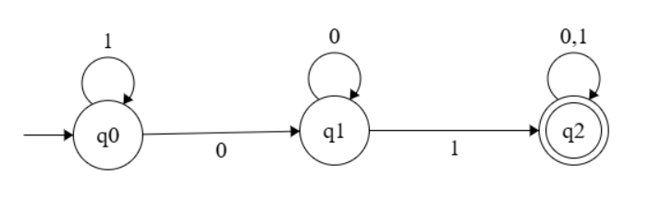

Source Code:
#include <iostream>
#include <string>
using namespace std;
enum State {q0, q1, q2};

bool isAccepted(string input) {
State currentState = q0;
for (char ch : input) {
switch (currentState) {
case q0:
currentState = (ch == '0') ? q1 : q0;
break;
case q1:
currentState = (ch == '1') ? q2 : q1;
break;
case q2:
currentState = q2;
break;
default:
break;
}
}
return (currentState == q2);
}

int main() {
string input;
cout <<"Enter a binary string: ";
cin >> input;

if (isAccepted(input)) {
cout <<"Accepted: The string contains '01' as a substring."<< endl;
} else {
cout <<"Rejected: The string does not contain '01' as a substring."<< endl;
}
return 0;
}

Output:
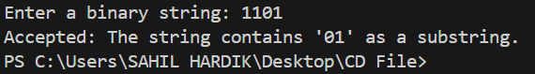
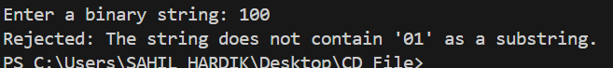

Program – 3

Aim: Design a Finite State Machine(FSM) that accepts all strings over input {0, 1} having three consecutive 1’s as a substring.

Diagram:
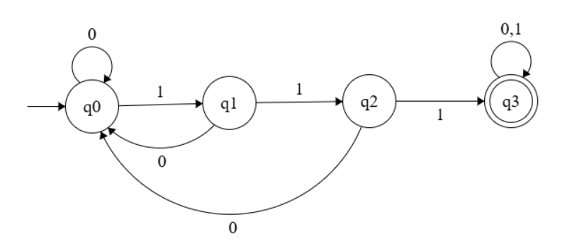

Source Code:
#include <iostream>
#include <string>
using namespace std;
enum State {q0, q1, q2, q3};

bool isAccepted(string input) {
State currentState = q0;
for (char ch : input) {
switch (currentState) {
case q0:
currentState = (ch == '1') ? q1 : q0;
break;
case q1:
currentState = (ch == '1') ? q2 : q0;
break;
case q2:
currentState = (ch == '1') ? q3 : q0;
break;
case q3:
currentState = q3;
break;
default:
break;
}
}
return (currentState == q3);
}

int main() {
string input;
cout <<"Enter a binary string: ";
cin >> input;
if (isAccepted(input)) {
cout <<"Accepted: The string contains '111' as a substring."<< endl;
} else {
cout <<"Rejected: The string does not contain '111' as a substring."<< endl;
}
return 0;
}

Output:
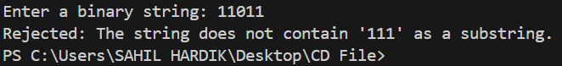
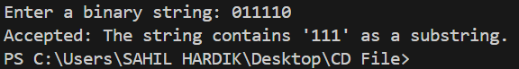

Program – 4

Aim: Design a Finite State Machine (FSM) that accepts all strings over input symbols {0, 1} which are divisible by 3.

Diagram:
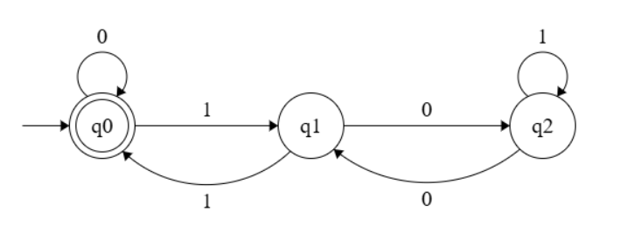

Source Code:
#include <iostream>
#include <string>
using namespace std;
enum State {q0, q1, q2};

bool isAccepted(string input) {
State currentState = q0;
for (char ch : input) {
switch (currentState) {
case q0:
currentState = (ch == '0') ? q0 : q1;
break;
case q1:
currentState = (ch == '0') ? q2 : q0;
break;
case q2:
currentState = (ch == '0') ? q1 : q2;
break;
default:
break;
}
}
return (currentState == q0);
}

int main() {
string input;
cout <<"Enter a binary string: ";
cin >> input;
if (isAccepted(input)) {
cout <<"Accepted: The string is divisble by 3."<< endl;
} else {
cout <<"Rejected: The string is not divisible by 3."<< endl;
}
return 0;
}

Output:
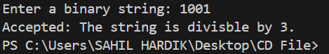
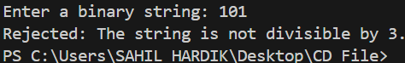

Program – 5

Aim: Design FSM(Finite State Machine) that accepts all decimal string which are divisible by 3.

Diagram:
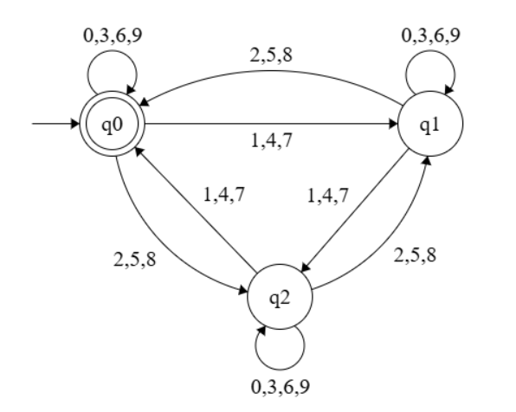

Source Code:
#include <iostream>
#include <string>
using namespace std;

enum State {q0, q1, q2};

bool isAccepted(string input) {
State currentState = q0;
for(char ch: input) {
if (!isdigit(ch)) {
cout <<"Invalid input: Only decimal digits (0-9) are allowed."<< endl;
return false;
}
int digit = ch - '0';

switch (currentState) {
case q0:
currentState = (digit % 3 == 0) ? q0 : (digit % 3 == 1) ? q1 : q2;
break;
case q1:
currentState = (digit % 3 == 0) ? q1 : (digit % 3 == 1) ? q2 : q0;
break;
case q2:
currentState = (digit % 3 == 0) ? q2 : (digit % 3 == 1) ? q0 : q1;
break;
default:
break;
}
}
return (currentState == q0);
}

int main() {
string input;
cout <<"Enter a binary string: ";
cin >> input;

if (isAccepted(input)) {
cout <<"Accepted: The string is divisble by 3."<< endl;
} else {
cout <<"Rejected: The string is not divisible by 3."<< endl;
}
return 0;
}

Output:
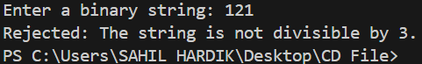
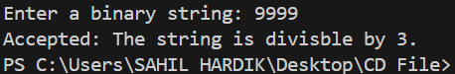

Program – 6

Aim: Program to design lexical analyser.

Source Code:
#include <iostream>
#include <fstream>
#include <cctype>
#include <vector>
#include <unordered_set>
using namespace std;

unordered_set<string> keywords = {"int", "float", "if", "else", "while", "return", "for", "do", "break", "continue"};

bool isOperator(char ch) {
string operators = "+-*/%=<>&|!";
return operators.find(ch) != string::npos;
}

bool isDelimiter(char ch) {
string delimiters = " ;,(){}[]";
return delimiters.find(ch) != string::npos;
}

bool isKeyword(const string& str) {
return keywords.find(str) != keywords.end();
}

void lexicalAnalyzer(const string& input) {
string token = "";
int length = input.length();
for (int i = 0; i < length; i++) {
char ch = input[i];
if (isspace(ch)) {
continue;
}
if (isalpha(ch) || ch == '_') {
token = ch;
while (i + 1 < length && (isalnum(input[i + 1]) || input[i + 1] == '_')) {
token += input[++i];
}
if (isKeyword(token))
cout <<"[Keyword] "<< token << endl;
else
cout <<"[Identifier] "<< token << endl;
}
else if (isdigit(ch)) {
token = ch;
bool isFloat = false;
while (i + 1 < length && (isdigit(input[i + 1]) || input[i + 1] == '.')) {
if (input[i + 1] == '.') {
if (isFloat) break;
isFloat = true;
}
token += input[++i];
}
cout <<"[Number] "<< token << endl;
}
else if (isOperator(ch)) {
token = ch;
if (i + 1 < length && isOperator(input[i + 1])) {
token += input[++i];
}
cout <<"[Operator] "<< token << endl;
}
else if (isDelimiter(ch)) {
cout <<"[Delimiter] "<< ch << endl;
}
else {
cout <<"[Unknown] "<< ch << endl;
}
}
}

int main() {
string input = "int main() { int a = 10; float b = 20.5; if (a < b) { a = a + 1; } }";
lexicalAnalyzer(input);
return 0;
}

Output:
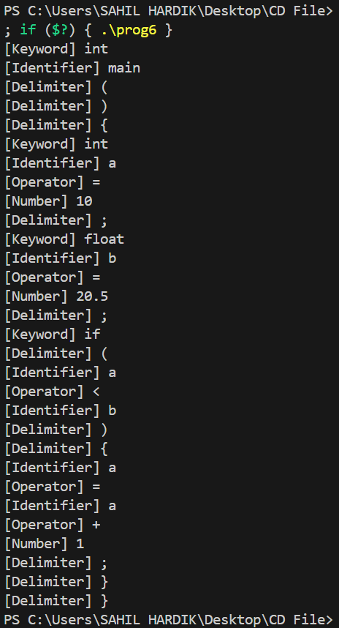

Program – 7

Aim: Practice of LEX/YACC of compiler writing.

Introduction
Some of the most time-consuming and tedious parts of writing a compiler involve LEXical scanning and syntax analysis. Luckily there is freely available software to assist in these functions. While they will not do everything for you, they will enable faster implementation of the basic functions. LEX and YACC are the most used packages with LEX managing the token recognition and YACC handling the syntax. They work well together but conceivably can be used individually as well.
Both operate in a similar manner in which instructions for token recognition or grammar are written in a special file format. The text files are then read by LEX and/or YACC to produce c code. This resulting source code is compiled to make the final application. In practice the LEXical instruction file has a “.l” suffix and the grammar file has a “.y” suffix. This process is shown in Figure 1.

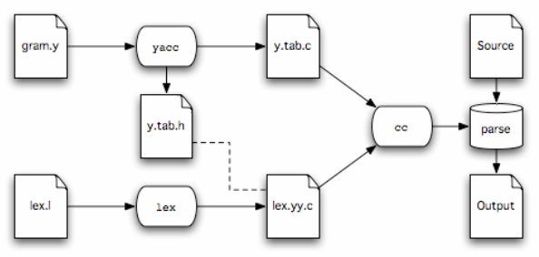
Figure 1. LEX and YACC Process (based on a diagram on page 5 of “A Compact Guide to LEX & YACC” by Thomas Niemann)
The file format for a LEX file consists of (4) basic sections:
The first is an area for c code that will be placed verbatim at the beginning of the generated
source code. Typically, it will be used for things like #include, #defines, and variable declarations.
• The next section is for definitions of token types to be recognized. These are not mandatory, but in general, they make the next section easier to read and shorter.
• The third section sets the pattern for each token that is recognized and can also include the c code to be called when that token is identified
• The last section is for more c code (generally subroutines) that will be appended to the end of the generated c code. This would typically include a main function if LEX is to be used by itself.
• The format is applied as follows (the use and placement of the % symbols are necessary):
%{
//header c code
%}
//definitions %%

//rules
%%
//subroutines
The format for a YACC file is similar but includes a few extras.
• The first area (preceded by a %token) is a list of terminal symbols. You do not need to list single-character ASCII symbols, but anything else, including multiple ASCII symbols, needs to be in this list (i.e. “==”).
• The next is an area for c code that will be placed verbatim at the beginning of the generated source code. Typically, it will be used for things like #include, #defines, and variable declarations.
• The next section is for definitions - none of the following examples utilize this area
• The fourth section sets the pattern for each token that is to be recognized and can also include the c code to be called when that token is identified
• The last section is for more c code (generally subroutines) that will be appended to the end of the generated c code. This would typically include a main function if LEX is to be used by itself.
• The format is applied as follows (the use and placement of the % symbols are necessary):
%tokens RESERVED, WORDS, GO, HERE
%{
//header c code
%}
//definitions
%%
//rules
%%
//subroutines
Thefollowing (4) sections will cover these formats and general usage in greater detail. In general, it is
best not to modify the resulting c code as it is overwritten each time LEX or YACC is run. Most desired functionality can be handled within the Lexical and grammar files, but there are some things that are difficult to achieve that may require editing of the c file.
As a side note, the functionality of these programs has been duplicated by the GNU open-source projects FLEX and Bison. These can be used interchangeably with LEX and YACC for everything thisdocument will cover and most other uses as well.
Program – 8

Aim: LEX Program to Identify multiple parts of speech.

Source Code:
%{
#include <stdio.h>
#include <stdlib.h>
%}

%%
[[:alpha:]]+ing { printf("\"%s\" is a VERB (Gerund)\n", yytext); }
(is|are|was|were|be|been|being) { printf("\"%s\" is a VERB (To be verb)\n", yytext); }
(run|walk|eat|sleep|write|read) { printf("\"%s\" is a VERB\n", yytext); }
(big|small|happy|sad|bright|dark) { printf("\"%s\" is an ADJECTIVE\n", yytext); }
(apple|dog|computer|city|book|teacher) { printf("\"%s\" is a NOUN\n", yytext); }
(he|she|it|they|we|I|you) { printf("\"%s\" is a PRONOUN\n", yytext); }
(and|or|but|because|so|although) { printf("\"%s\" is a CONJUNCTION\n", yytext); }
(the|a|an) { printf("\"%s\" is an ARTICLE\n", yytext); }
[ \t\n]+ ; // Ignore whitespace
. { printf("\"%s\" is UNKNOWN\n", yytext); }
%%

int main() {
printf("Enter a sentence:\n");
yylex();
return 0;
}
int yywrap() {
return 1;
}

Output:
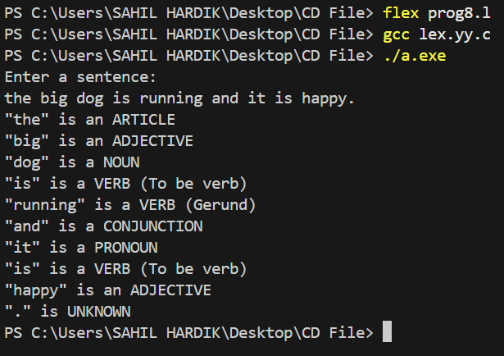

Program – 9

Aim: Program to make verb of any word using Lexer Table.

Source Code:
%{
#include <stdio.h>
#include <string.h>
%}
%%
[a-zA-Z]+ {
char word[100];
strcpy(word, yytext);
printf("Original Word: %s\n", word);

// Verb Forms
printf("Present Continuous: %s-ing\n", word);
printf("Past Tense: %s-ed\n", word);
printf("Third Person Singular: %s-es\n", word);
printf("Infinitive: to %s\n", word);
}
[ \t\n]+ ; // Ignore whitespace
. { printf("Unknown character: %s\n", yytext); }
%%
int main() {
printf("Enter a word:\n");
yylex();
return 0;
}

int yywrap() {
return 1;
}
Output:
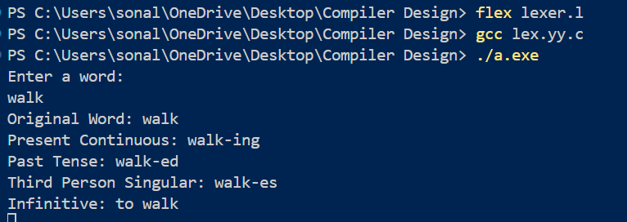
Program – 10
Aim: C Program to find the “leading terminals” of a grammar.

Source Code:
#include <stdio.h>
#include <string.h>
#include <ctype.h>

#define MAX_RULES 10
#define MAX_LEN 20

typedef struct {
char nonTerminal;
char productions[MAX_RULES][MAX_LEN];
int productionCount;
} GrammarRule;

GrammarRule grammar[MAX_RULES];
int ruleCount = 0;

void findLeadingTerminals(char nonTerminal, int visited[], char leading[]) {
for (int i = 0; i < ruleCount; i++) {
if (grammar[i].nonTerminal == nonTerminal) {
for (int j = 0; j < grammar[i].productionCount; j++) {
char *prod = grammar[i].productions[j];

// Check if 'id' appears as the first terminal
if (strncmp(prod, "id", 2) == 0) {
if (!strstr(leading, "id")) {
strcat(leading, "id ");
}
continue; // Move to the next production
}

char firstChar = prod[0];
if (!isupper(firstChar)) { // Terminal symbol
if (!strchr(leading, firstChar)) {
int len = strlen(leading);
leading[len] = firstChar;
leading[len + 1] = '\0';
}
} else { // Non-terminal, recurse
if (!visited[firstChar - 'A']) {
visited[firstChar - 'A'] = 1;
findLeadingTerminals(firstChar, visited, leading);
}
}
}
}
}
}

void displayLeadingTerminals() {
printf("\nLeading Terminals:\n");
for (int i = 0; i < ruleCount; i++) {
char leading[MAX_LEN] = "";
int visited[26] = {0}; // Assuming non-terminals are uppercase English letters
visited[grammar[i].nonTerminal - 'A'] = 1;
findLeadingTerminals(grammar[i].nonTerminal, visited, leading);
printf("%c: { %s}\n", grammar[i].nonTerminal, leading);
}
}

int main() {
printf("Enter number of grammar rules: ");
scanf("%d", &ruleCount);
getchar(); // Consume newline

printf("Enter the grammar rules (Format: A -> aB | c):\n");
for (int i = 0; i < ruleCount; i++) {
char input[MAX_LEN];
fgets(input, MAX_LEN, stdin);
input[strcspn(input, "\n")] = 0; // Remove newline

grammar[i].nonTerminal = input[0];
char *token = strtok(input + 3, "|");

grammar[i].productionCount = 0;
while (token) {
strcpy(grammar[i].productions[grammar[i].productionCount++], token);
token = strtok(NULL, "|");
}
}
displayLeadingTerminals();
return 0;
}

Output:
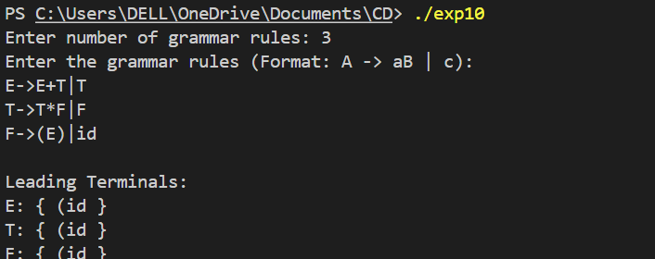

Program – 11
Aim: C Program to find the “trailing terminals” of a grammar.

Source Code:
#include <stdio.h>
#include <string.h>
#include <ctype.h>

#define MAX_RULES 10
#define MAX_LEN 20
// Structure to store grammar rules
typedef struct{
char lhs;
char rhs[MAX_LEN];
} Rule;
// Function to get trailing terminals recursively
void findTrailingTerminals(Rule rules[], int numRules, char symbol, int visited[]){
for (int i = 0; i < numRules; i++){
if (rules[i].lhs == symbol) {
int len = strlen(rules[i].rhs);
if (len > 0) {
char last = rules[i].rhs[len - 1];
if (!isupper(last)){ // If it's not a non-terminal, print it
printf("%c ", last);
} else if (!visited[last - 'A']){ // If it's a non-terminal and not visited
visited[last - 'A'] = 1;
findTrailingTerminals(rules, numRules, last, visited);
}
}
}
}
}

// Function to compute trailing terminals for all non-terminals
void findTrailing(Rule rules[], int numRules){
printf("Trailing terminals of all non-terminals:\n");
for (int i = 0; i < numRules; i++){
char symbol = rules[i].lhs;
int visited[26] = {0}; // To keep track of visited non-terminals
printf("%c: ", symbol);
findTrailingTerminals(rules, numRules, symbol, visited);
printf("\n"); }
}
int main(){
Rule rules[MAX_RULES];
int numRules;
printf("Enter the number of grammar rules: ");
scanf("%d", &numRules);
getchar(); // Consume newline
printf("Enter the grammar rules in the format A->xyz (use # for epsilon):\n");
for (int i = 0; i < numRules; i++){
printf("Rule %d: ", i + 1);
char input[MAX_LEN + 2];
fgets(input, MAX_LEN + 2, stdin);
sscanf(input, "%c->%s", &rules[i].lhs, rules[i].rhs);
}
findTrailing(rules, numRules);
return 0;
}

Output:
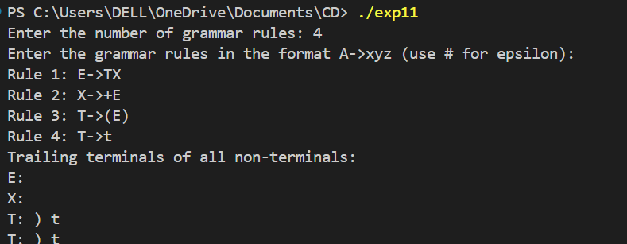
Program – 12
Aim: C program to find the first of the grammar.
Source Code:
#include <stdio.h>
#include <ctype.h>

void FIRST(char);
int count, n = 0;
char prodn[10][10], first[10];

int main(){
int i, choice;
char c, ch;
printf("How many productions? : ");
scanf("%d", &count);
printf("Enter %d productions (use '$' for epsilon):\n", count);

for (i = 0; i < count; i++) {
scanf("%s%c", prodn[i], &ch);
}
do {
n = 0;
printf("Enter element to find FIRST: ");
scanf("%c", &c);
FIRST(c);
printf("\nFIRST(%c) = { ", c);
for (i = 0; i < n; i++) {
printf("%c ", first[i]);
}
printf("}\n");
printf("Press 1 to continue: ");
scanf("%d%c", &choice, &ch);
} while (choice == 1);
return 0;
}
void FIRST(char c){
int j;
if (!isupper(c)) {
first[n++] = c;
return;
}
for (j = 0; j < count; j++){
if (prodn[j][0] == c){
if (prodn[j][2] == '$') {
first[n++] = '$';
}else if (islower(prodn[j][2])){
first[n++] = prodn[j][2];
} else {
FIRST(prodn[j][2]);
}
}
}
}

Output:
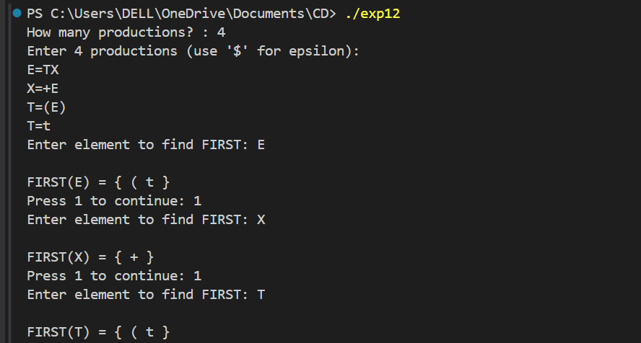

Program – 13
Aim: C program to find the first of the grammar.
Source Code:
#include <stdio.h>
#include <string.h>
#include <ctype.h>

void follow(char c);
void first(char c);
int isPresent(char ch);
int n, m = 0, i = 0, j = 0;
char a[10][10], f[10];

int main(){
int z;
char c;
printf("Enter the number of productions: ");
scanf("%d", &n);
printf("Enter the productions (use '$' for epsilon):\n");
for (i = 0; i < n; i++){
scanf("%s", a[i]); // Fixed input issue
}
do {
m = 0;
printf("Enter the element whose FOLLOW is to be found: ");
scanf(" %c", &c); // Fixed leading whitespace issue
follow(c);
printf("FOLLOW(%c) = { ", c);
for (i = 0; i < m; i++){
printf("%c ", f[i]);
}printf("}\n");
printf("Do you want to continue? (0/1): ");
scanf("%d", &z);
} while (z == 1);
return 0;
}
// Function to check if a character is already in FOLLOW set
int isPresent(char ch){
for (int k = 0; k < m; k++) {
if (f[k] == ch){
return 1;
}
}
return 0;
}
void follow(char c){
// If it is the start symbol, add '$'
if (a[0][0] == c && !isPresent('$')){
f[m++] = '$';
}
// Iterate through all productions
for (i = 0; i < n; i++){
for (j = 2; j < strlen(a[i]); j++){
if (a[i][j] == c){
// Case 1: If the symbol is followed by another character
if (a[i][j + 1] != '\0'){
first(a[i][j + 1]);
}
// Case 2: If it is at the end of production, or after epsilon
if (a[i][j + 1] == '\0' && c != a[i][0]){
follow(a[i][0]); }
}
}
}
}
void first(char c){
int k;
// If it is a terminal, add directly
if (!isupper(c)) {
if (!isPresent(c)) {
f[m++] = c;
} return;
}
// If it is a non-terminal, find FIRST
for (k = 0; k < n; k++) {
if (a[k][0] == c) {
if (a[k][2] == '$') // If epsilon, go to FOLLOW of LHS{
follow(a[k][0]);
}else if (islower(a[k][2])) // If it is a terminal {
if (!isPresent(a[k][2])) {
f[m++] = a[k][2];
}
} else {
first(a[k][2]); // Recursively find FIRST
}
}
}
}

Output:
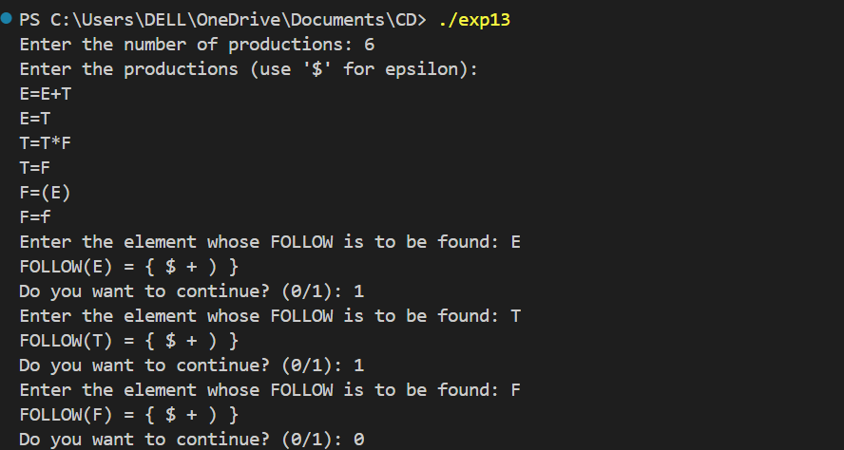

Program – 14
Aim: Program to generate a parse tree.
Source Code:
#include <iostream>
#include <string>
#include <stack>
using namespace std;

struct Node{
string value;
Node *left;
Node *right;
Node(string val) : value(val), left(nullptr), right(nullptr) {}
};

Node *buildParseTree(const string &postfix){
stack<Node *> stk;
for (char ch : postfix){
string val(1, ch);
if (isalnum(ch)){
stk.push(new Node(val));
} else {
Node *node = new Node(val);
node->right = stk.top();
stk.pop();
node->left = stk.top();
stk.pop();
stk.push(node);
}
}
return stk.top();
}

void printParseTree(Node *root, int level = 0){
if (root) {
printParseTree(root->right, level + 1);
cout << string(level * 4, ' ') << root->value << endl;
printParseTree(root->left, level + 1);
}
}

int main(){
string postfix;
cout << "Enter a postfix expression: ";
cin >> postfix;
Node *root = buildParseTree(postfix);
cout << "Parse Tree:\n";
printParseTree(root);
return 0;
}

Output:
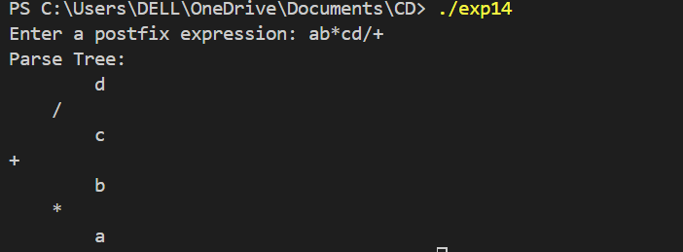

Program – 15
Aim: Write a program to check whether a string belongs to the grammar or not.
Source Code:
#include <stdio.h>
#include <string.h>

// Function to check if the string belongs to the grammar
int checkGrammar(char str[], int start, int end){
// Base case: If the substring is empty, it's valid (ε)
if (start > end)
return 1;

// Check if the first character is 'a' and last is 'b'
if (str[start] == 'a' && str[end] == 'b') {
// Recursively check the substring without first and last character
return checkGrammar(str, start + 1, end - 1);
}
else{
// If first is not 'a' or last is not 'b', it's invalid
return 0;
}
}
int main(){
char str[100];

printf("Enter the string: ");
scanf("%s", str);

int length = strlen(str);

if (checkGrammar(str, 0, length - 1))
printf("The string belongs to the grammar.\n");
else
printf("The string does NOT belong to the grammar.\n");

return 0;
}

Output:
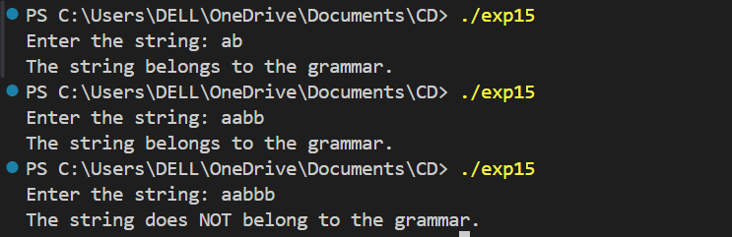
Program – 16
Aim: Write a program to check whether a grammar is left Recursion and remove left Recursion.
Source Code:
#include <iostream>
#include <vector>
#include <sstream>
using namespace std;

bool hasLeftRecursion(string nonTerminal, vector<string> productions) {
for (string prod: productions) {
if (prod[0] == nonTerminal[0]) {
return true;
}
}
return false;
}
void removeLeftRecursion(string nonTerminal, vector<string> productions) {
vector<string> alpha, beta;
for (string prod: productions) {
if (prod[0] == nonTerminal[0]) {
alpha.push_back(prod.substr(1));
} else {
beta.push_back(prod);
}
}

if (alpha.empty()) {
cout << nonTerminal << " - ";
for (size_t i = 0; i < productions.size(); i++) {
cout << productions[i] << (i == productions.size() - 1 ? "" : " | ");
}
cout << endl;
return;
}

string newNonTerminal = nonTerminal + "'";
cout << nonTerminal << " - ";
for (size_t i = 0; i < beta.size(); i++) {
cout << beta[i] << newNonTerminal << (i == beta.size() - 1 ? "" : " | ");
}
cout << endl;
cout << newNonTerminal << " - ";
for (size_t i = 0; i < alpha.size(); i++) {
cout << alpha[i] << newNonTerminal << " | ";
}
cout << "#" << endl;
}

int main() {
int n;
cout << "Enter the number of non-terminals: ";
cin >> n;
cin.ignore();

for (int i = 0; i < n; i++) {
string nonTerminal, productionLine;
cout << "Enter non-terminal: ";
cin >> nonTerminal;
cin.ignore();
cout << "Enter productions (separated by '|'): ";
getline(cin, productionLine);

vector<string> productions;
stringstream ss(productionLine);
string prod;
while (getline(ss, prod, '|')) {
productions.push_back(prod);
}
if (hasLeftRecursion(nonTerminal, productions)) {
cout << "Left recursion detected! Removing it...\n";
removeLeftRecursion(nonTerminal, productions);
} else {
cout << "No left recursion found.\n";
}
cout << endl;
}
return 0;
}

Output:
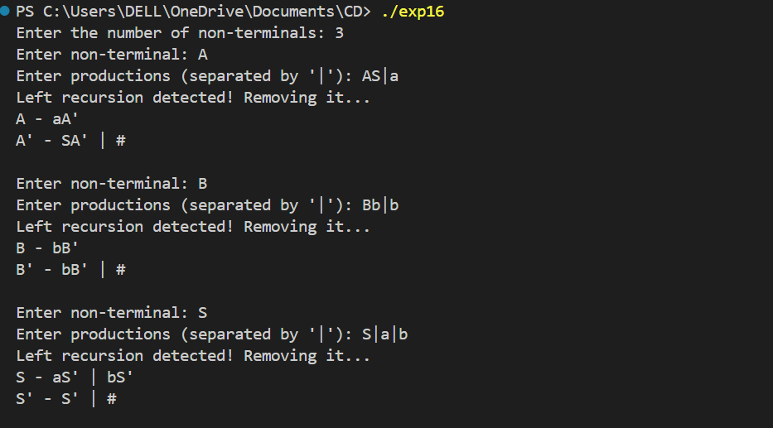

Program – 17
Aim: Write a program to remove left factoring.
Source Code:
#include <stdio.h>
#include <string.h>

int main() {
char gram[100], part1[50], part2[50], modifiedGram[50], newGram[50];
int i, j = 0, k = 0, pos = 0;

printf("Enter Production (e.g., Abc|Abd) : A->");
fgets(gram, sizeof(gram), stdin);
gram[strcspn(gram, "\n")] = '\0';

for (i = 0; gram[i] != '|' && gram[i] != '\0'; i++, j++) {
part1[j] = gram[i];
}
part1[j] = '\0';

if (gram[i] != '|') {
printf("Invalid input! Missing '|'\n");
return 1;
}

j = 0;
i++; // skip '|'
for (; gram[i] != '\0'; i++, j++) {
part2[j] = gram[i];
}
part2[j] = '\0';

for (i = 0; part1[i] != '\0' && part2[i] != '\0'; i++) {
if (part1[i] == part2[i]) {
modifiedGram[k++] = part1[i];
pos = i + 1;
} else {
break;
}
}
modifiedGram[k] = 'X';
modifiedGram[k + 1] = '\0';

for (i = pos, j = 0; part1[i] != '\0'; i++, j++)
newGram[j] = part1[i];
newGram[j++] = '|';
for (i = pos; part2[i] != '\0'; i++, j++)
newGram[j] = part2[i];
newGram[j] = '\0';

printf("\nA->%s", modifiedGram);
printf("\nX->%s\n", newGram);

return 0;
}

Output:
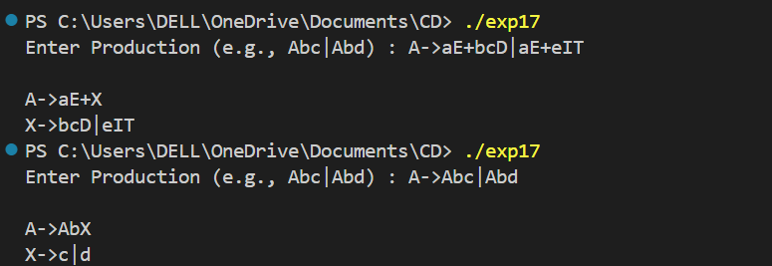

Program – 18
Aim: Write a program to check whether a grammar is operator precedent.
Source Code:
#include <stdio.h>
#include <string.h>
#include <ctype.h>

int isOperatorPrecedence(char grammar[][100], int num_rules) {
for (int i = 0; i < num_rules; i++) {
char *rule = grammar[i];
char *rhs = strchr(rule, '>') + 1;

if (strlen(rhs) == 0) {
return 0; // Not operator precedence grammar
}
for (int j = 0; j < strlen(rhs) - 1; j++) {
if (isupper(rhs[j]) && isupper(rhs[j + 1])) {
return 0; // Not operator precedence grammar
}
}
}
return 1;

int main() {
int num_rules;
printf("Enter the number of grammar rules: ");
scanf("%d", &num_rules);
getchar(); // Consume the newline character

char grammar[num_rules][100];
printf("Enter the grammar rules (e.g., E>E+T):\n");
for (int i = 0; i < num_rules; i++) {
fgets(grammar[i], sizeof(grammar[i]), stdin);
grammar[i][strcspn(grammar[i], "\n")] = 0;
}

if (isOperatorPrecedence(grammar, num_rules)) {
printf("The given grammar is an operator precedence grammar.\n");
} else {
printf("The given grammar is not an operator precedence grammar.\n");
}

return 0;
}

Output:
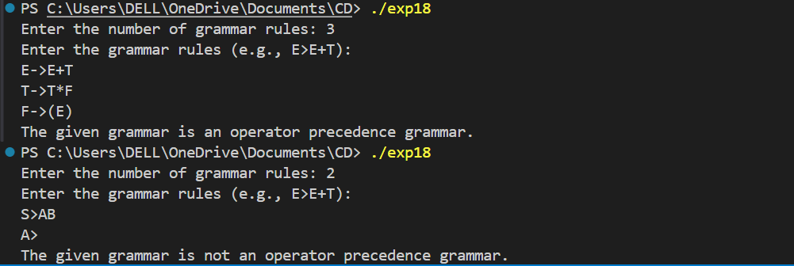

Program – 19
Aim: To show all operations of a stack.
Source Code:
#include <iostream>
using namespace std;
class Stack {
private:
int top, capacity;
int* arr;
public:
Stack(int size) {
capacity = size;
arr = new int[capacity];
top = -1;
}
~Stack() { delete[] arr; }

bool isEmpty() { return top == -1; }
bool isFull() { return top == capacity - 1; }
void push(int value) {
if (isFull()) {
cout << "Stack Overflow! Cannot push " << value << endl;
return; }
arr[++top] = value;
cout << value << " pushed to stack.\n";
}
void pop() {
if (isEmpty()) {
cout << "Stack Underflow! Cannot pop.\n";
return; }
cout << arr[top--] << " popped from stack.\n";
}
void peek() {
if (isEmpty()) {
cout << "Stack is empty.\n";
return; }
cout << "Top element is: " << arr[top] << endl;
}
void display() {
if (isEmpty()) {
cout << "Stack is empty.\n";
return; }
cout << "Stack contents (top to bottom): ";
for (int i = top; i >= 0; i--) {
cout << arr[i] << " "; }
cout << endl;
}
};
int main() {
int size;
cout << "Enter the size of the stack: ";
cin >> size;
Stack s(size);
int choice, value;
cout << "\n--- Stack Menu ---\n";
cout << "1. Push\n2. Pop\n3. Peek\n4. Check if Empty\n5. Check if Full\n6. Display Stack\n7. Exit\n";
do {
cout << "\nEnter your choice: ";
cin >> choice;
switch (choice) {
case 1:
cout << "Enter value to push: ";
cin >> value;
s.push(value);
break;
case 2: s.pop(); break;
case 3: s.peek(); break;
case 4:
cout << (s.isEmpty() ? "Stack is empty.\n" : "Stack is not empty.\n");
break;
case 5:
cout << (s.isFull() ? "Stack is full.\n" : "Stack is not full.\n");
break;
case 6: s.display(); break;
case 7: cout << "Exiting...\n"; break;
default: cout << "Invalid choice. Try again.\n";
}
} while (choice != 7);
return 0;
}

Output:
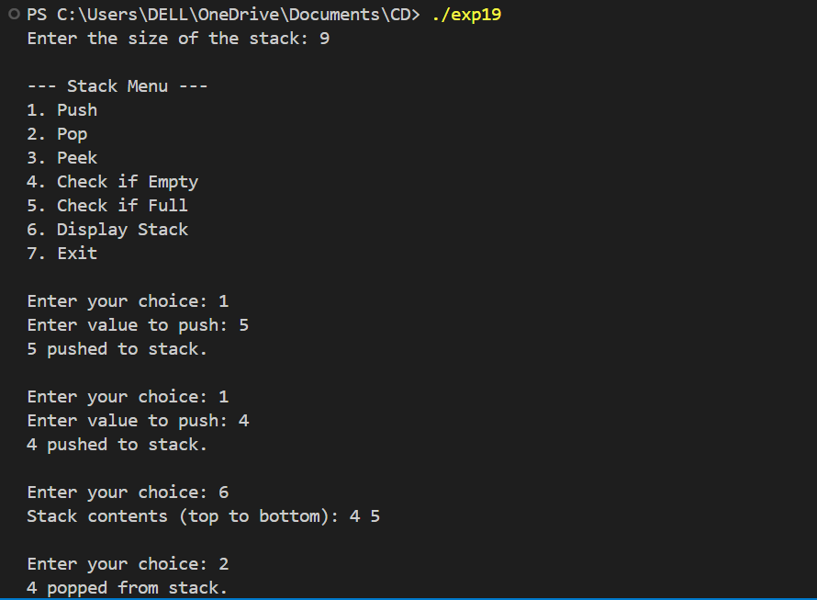

Program – 20
Aim: To design a C calculator using YACC.
Source Code:
YACC File:
%{
#include <stdio.h>
#include <stdlib.h>

int yylex(void);
void yyerror(const char *s);
%}

%union {
int ival;
}

%token <ival> NUMBER
%token PLUS MINUS TIMES DIVIDE LPAREN RPAREN EOL
%left PLUS MINUS
%left TIMES DIVIDE
%nonassoc UMINUS
%type <ival> expr

%%
input:
/* empty */
| input line
;

line:
expr EOL { printf("= %d\n", $1); }
;

expr:
NUMBER { $$ = $1; }
| expr PLUS expr { $$ = $1 + $3; }
| expr MINUS expr { $$ = $1 - $3; }
| expr TIMES expr { $$ = $1 * $3; }
| expr DIVIDE expr {
if ($3 == 0)
yyerror("division by zero");
else
$$ = $1 / $3;
}
| MINUS expr %prec UMINUS { $$ = -$2; }
| LPAREN expr RPAREN { $$ = $2; }
;
%%

void yyerror(const char *s) {
fprintf(stderr, "Error: %s\n", s);
}
int main() { return yyparse(); }

LEX File:
%{
#include "prog20.tab.h"
%}

%%

[0-9]+ { yylval.ival = atoi(yytext); return NUMBER; }
[\t ]+ ; // Ignore whitespace
\n { return EOL; }
"+" { return PLUS; }
"-" { return MINUS; }
"*" { return TIMES; }
"/" { return DIVIDE; }
"(" { return LPAREN; }
")" { return RPAREN; }

. { printf("Invalid character: %s\n", yytext); }

%%

int yywrap(void) {
return 1;
}

Output:
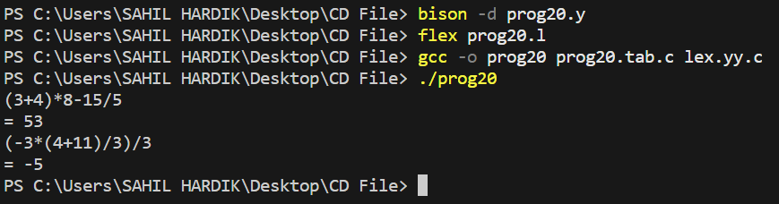

Program – 21
Aim: Lex program to count the no. of lines and characters in an input file.

Text File:
Hello Everyone
Let's Code
Dev & DSA

Source Code:
%{
#include<stdio.h>
int chars = 0;
int lines = 0;
%}
%%
\n {++lines, ++chars;}
. ++chars;
%%
int main(int argc[], char *argv[]){
yyin = fopen("sample.txt", "r");
yylex();
printf("no. of characters: %d\n", chars);
printf("no. of lines: %d\n", lines);
return 0;
}
int yywrap(void) {
return 1;
}
Output:

