CUSTOMER CHURN PREDICTION USING
ARTIFICIAL NEURAL NETWORKS (ANN)
--------------------------------------------
Final Report
--------------------------------------------
Submitted by:
[Your Full Name]
Student ID:
[Your Student ID]
Course Name:
Submitted To:
Table of Contents
1. Introduction 3
2. Dataset Description 3
3. Exploratory Data Analysis 4
4. Data Preprocessing 7
5. ANN Model Architecture 7
6. Model Training and Evaluation 8
7. Key Findings 10
8. Factors Contributing to Churn and Retention 11
9. Customer Segmentation 12
10. Recommendations for Retention Strategies 12
11. Limitations and Proposed Solutions 13
12. Conclusion 14
References 15

Introduction
Churn among customers is one of the most serious problems of organizations in service industries of competition. Having the right way to foretell which customers are likely to drop a service will allow companies to take the first steps, minimize the loss of revenues, and enhance customer satisfaction. It is much more economical to retain customers than to acquire new ones, and thus, churn prediction becomes one of the strategic priorities.
The objective of this project is to create an Artificial Neural Network (ANN) model to forecast the customer churn based on demographic, service-related, and billing characteristics. These goals are to create a predictive model, determine the most significant drivers of churn, classify the customers by the risk of churn, and give the recommendations in the form of actions that can be implemented to increase the retention of customers. This study helps to make data-driven decisions by integrating machine learning with business knowledge.

Dataset Description
The dataset comprises of 7,043 customer records having 10 variables, such as demographic, service subscriptions and billing details. The dependent variable, which is the Churn, is a variable, which reveals whether a customer has left the service.
Out of the total customers:
- 5,174 (73.5%) did not churn
- 1,869 (26.5%) churned
This implies a moderate imbalance in classes and this is a significant factor when assessing the model.

Exploratory Data Analysis
Exploratory Data Analysis (EDA) was performed in order to find trends and correlations between customer characteristics and churn behavior. The churn distribution analysis indicates that though most of the customers are retained, a large number of them still churn and prediction is useful.
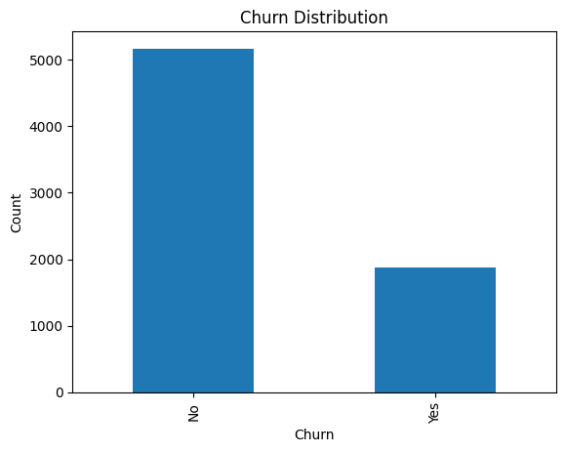
Figure 1: Churn Distribution
One of the key factors that affect churn was determined to be contract type. Customers with month-to-month contracts experienced very high churn rates than those with one year and two year contracts, which demonstrate that insufficient commitment (long term) heightens churn risk.
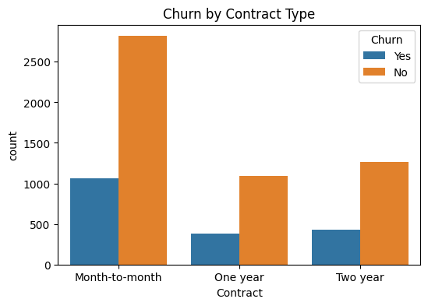
Figure 2: Churn by Contract Type
Churn was also strongly related to monthly charges. Higher monthly charges increased the risks of customers quitting the service indicating that price sensitivity is a major factor in decision-making among customers.
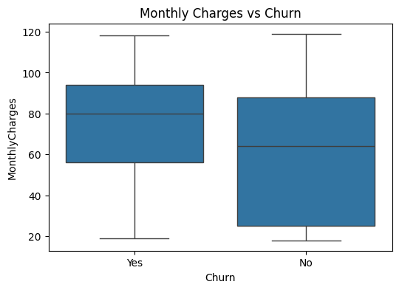
Figure 3: Monthly Charges vs Churn
Tenure analysis indicated that those customers that had less duration of service had a high probability of churning. The retention was higher among long-term customers, which is why it is essential to engage customers early.
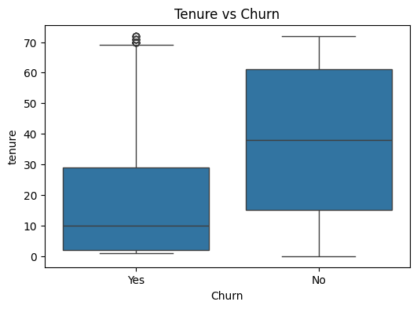
Figure 4: Tenure vs Churn
In general, the findings of EDA show that pricing, contract flexibility, and the stage of customer lifecycle are the factors that determine churn.

Data Preprocessing
The dataset was pre processed so that it could be used in ANN modeling. One-hot encoding was used to transform categorical variables whereas the numerical variables were standardized like tenure and monthly charges so that they would be scaled in a similar manner.
The data was divided into 80:20 ratio training and testing sets and stratified sampling was applied to maintain the churn distribution. This guarantees that the underlying data distribution is accurately covered by both sets and that it is possible to evaluate it.

Project Implementation and Jira Tracking
Jira was used to organize all activities of Stage 3 and provide the structure of work, accountability, and tracking of progress. Every activity, such as ANN architecture design (CCATI-5), model building (CCATI-31), model training (CCATI-32), optimisation (CCATI-33), prediction (CCATI-34), performance evaluation (CCATI-35), and reporting (CCATI-39), had to be implemented by particular team members and tracked using sprint updates.
To monitor project progress, record task completion, and assure project deliverable alignment, Jira served as a central artefact repository. This method allowed transparency, efficient coordination, and efficient identification of blockers, so that all the Stage 3 requirements could be fulfilled in an efficient way and corresponds to assessment expectations.

ANN Model Architecture
The ANN model was developed as a feedforward neural network that can be used in binary classification. All transformed features are received on the input layer after preprocessing. The model will have 2 hidden layers with 32 and 16 neurons with ReLU activation functions to identify nonlinear dependencies.
The dropout rates of 0.30 and 0.20 were added to decrease overfitting and enhance generalization. The output layer is a single neuron with sigmoid activation, and it generates a probability score of the probability of churn.
The model was coded with the Adam optimizer and binary crossentropy loss function and accuracy was the main evaluation metric. The early stopping was used to avoid overtraining.
The detailed architecture of the ANN model, including layer structure and dimensional flow, is illustrated in the architecture diagram (see Appendix), providing a clear visual representation of the model design

Model Training and Evaluation
ANN model had an accuracy of 0.7892 (78.92) which is a good predictive power on unknown data. The model was found to be accurate with 0.641, recall 0.4679, and F1 -score of 0.541.
The value of ROC-AUC 0.8062 means that the model is good in distinguishing the churn and non-churn customers at various thresholds.
The confusion matrix shows that:
- There were 1,035 customers who were rightfully identified as non-churn (true negatives).
- About 175 customers were adequately described as churn (true positives, using recall).
- There were misclassifications on some of the churn cases as indicated by the low value of recall.
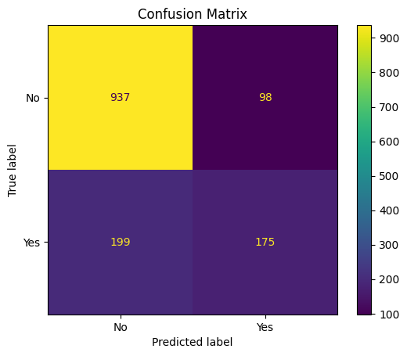
Figure 5: Confusion Matrix
The ROC curve shows that there is a high degree of separation between classes which validates the effectiveness of the model in classification.
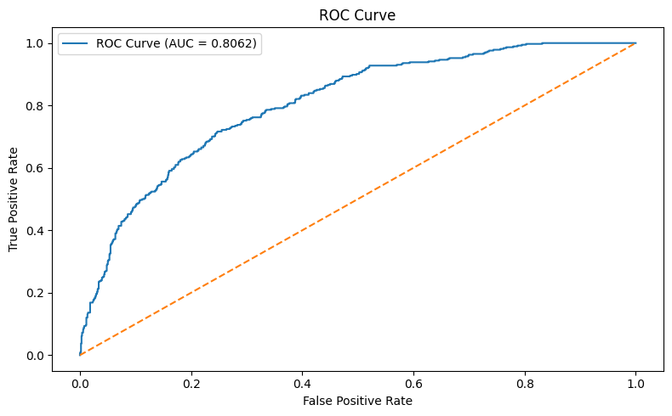
Figure 6: ROC Curve

Table 1: Model Performance Metrics
Metric | Value
Accuracy | 0.7892
Precision | 0.6410
Recall | 0.4679
F1-Score | 0.5410
ROC-AUC | 0.8062

7.1 Model Optimisation
Model optimisation was performed to improve generalisation and predictive performance. Several hyperparameters were considered, including learning rate, number of epochs, and batch size. Early stopping was implemented to monitor validation loss and prevent overtraining, ensuring that the model stopped training once performance plateaued.
Dropout layers (0.30 and 0.20) were introduced to reduce overfitting by randomly deactivating neurons during training. Additionally, the use of the Adam optimizer allowed adaptive learning rate adjustments, improving convergence speed and stability. These optimisation techniques collectively enhanced model robustness and reduced the risk of overfitting.

Key Findings
The outcome of the analysis indicated some important insights into the customer churn behavior that were backed by ANN predictions.
One, contract type is the greatest cause of churn. The churn rates of customers in month-to-month contracts are significantly higher than those in long-term contracts and thus, loyalty does not reduce switching behavior.
Secondly, there is a positive relationship between monthly charges and churn. Those customers with greater prices have a higher chance of churning implying that pricing contributes significantly to customer dissatisfaction.
Third, tenure is another major predictor of churn. Customers who have shorter tenure are far more apt to leave, whereas long term customers are highly loyal. This underscores the need to have early customer involvement.

Also, the model indicates that churn customers are more difficult to identify than non-churn customers, which is represented by the lower recall (46.79%). This implies that not all churn cases are detected and this is an important aspect to business applications.
Overall, churn is primarily driven by:
- pricing sensitivity
- lack of contractual commitment
- weak early-stage engagement

Factors Contributing to Churn and Retention
The Artificial Neural Network (ANN) model offers information-driven understanding of the primary drivers that determine customer churn founded on the trends that have been learnt during the dataset. Some of the key drivers of churn and retention have been established by evaluating the results of prediction and model performance indicators.
The primary ANN-driven factors are outlined below:

9.1. High Monthly Charges (Cost-Driven Risk)
The ANN model attributes more churn rates to clients with increased monthly payments. The high-risk customers are the ones expected to be high in terms of monthly billing (around $70 and more) which provides the evidence that price is a major contributor to churn behavior. This implies that the customer will tend to churn in case the perceived value of the service is not worth the price.

9.2. Low Tenure (Early Churn Risk)
The model always labels the customers who have low tenure high-risk. Customers whose tenure is less than 12-18 months are often categorized and those with lower tenure have higher churn rates meaning that early-stage customers are more susceptible. This indicates the capability of the ANN to capture risk patterns based on lifecycle, i.e. poor engagement at the early service stages increases probability of churn.

9.3. Contract Type Influence (Flexibility vs Commitment)
The ANN model will give greater churn rates to clients with flexible and short-term contracts, especially month-to-month plans. This means that the model is aware of contractual flexibility being a risk factor since customers who are not bound by long-term engagements will tend to exit.

9.4. Model Prediction Limitations (Recall Insight)
The ANN model has a recall of 0.4679 (46.79%), which means that although it is capable of dealing with a certain percentage of churn cases, not all customers who are at risk will be identified. This implies that churn behavior is complicated and conditioned by other latent variables that are not entirely reflected in the data. The ROC-AUC score of the model (0.8062) however indicates high overall capability in the differentiation of churn and non-churn customers.

Customer Segmentation
Customers were segmented based on predicted churn probabilities into three categories:
- High Risk (≥ 0.70)
- Medium Risk (0.40–0.69)
- Low Risk (< 0.40)
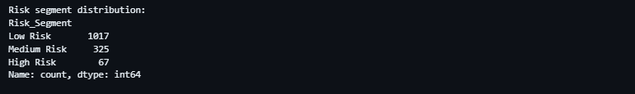
Figure 7: Risk Segmentation
This segmentation allows businesses to prioritize interventions and allocate resources efficiently.

Recommendations for Retention Strategies
Based on the findings, the following strategies are recommended:
- Customers that are high-risk need to be approached with individual offers, discounts, and proactive support.
- Loyalty programs and better service experience should be used to attract medium-risk customers.
- Constant quality of services and rewards should be used to retain low-risk customers.
These strategies directly address the key drivers of churn identified in the analysis.

Risk Identification and Mitigation
Several risks were identified during Stage 3 and were actively managed to ensure project success. One key risk was model overfitting, which could reduce the model’s ability to generalise to unseen data. This was mitigated through the use of dropout layers and early stopping techniques.
Another significant risk was model complexity, as overly complex neural networks may lead to increased computational cost and reduced interpretability. This risk was addressed by selecting a relatively shallow ANN architecture suitable for structured tabular data.
Time constraint risk was also identified due to the limited duration of the project. This was mitigated through effective task allocation and progress tracking using Jira, ensuring that all deliverables were completed within the required timeline.

Limitations and Proposed Solutions
This study has a number of limitations even though it has been found to perform satisfactorily in predictive performance.
The main weakness is the limited feature set of the dataset. The variables available primarily focus on demographic and general service related data but do not provide more profound behavioral, transactional, or customer engagement data. Consequently, it is possible that the model does not adequately represent the intricate customer decision-making patterns, which can be a weakness in its predictive capabilities and extrapolation to new settings.
The other major weakness is the unequal representation of classes in the data, which is characterized by the higher proportion of non-churn customers in the data than the churned customers. This may skew the model towards the majority class that is shown in the comparatively lower recall of the churn prediction. This means that certain high-risk customers can fail to be correctly identified.
Moreover, ANN model is not interpretable, since it is a black-box model. Although this is good in detecting patterns, it fails to give clear explanations as to why it predicts the way it does. This restricts the capacity of the stakeholders to get a full picture of the real drivers of churn and possibly diminishes confidence in model-based decision making.
Moreover, the model performance shows that the prediction of churn is still not easy, as the value of recall is 0.4679, which means that not all the cases of churn are well predicted. This shows how difficult customer behavior is and how there are latent variables not completely reflected in the data.

Team Contribution and Collaboration
The project was accomplished in the framework of effective teamwork, where each member of the team had distinct roles and responsibilities based on Stage 3 deliverables and Jira tasks assignment. The members were involved in particular technical and analytical project parts, which guaranteed effective workflow and responsibility during the development process.

Simran Kaur (Project Manager) had to manage the project overall, with the responsibility of Jira management, sprint planning, task allocation, and monitoring the progress. She was also involved in model assessment, report organization, and ultimate deliverables presentation, which met assessment requirements and deadlines.
Model optimisation and limitations documentation were done by Sonam Galey. She had to find the hyperparameters of learning rate, epochs, track performance of the model and discuss issues of overfitting and data imbalance. She also helped to write down the limitations and solutions to the report.
Praveen Gunaratne was concerned with training ANN model. His tasks included the implementation of the training process, monitoring of the key performance metrics that include accuracy and loss, and the model learning effectively under the dataset.
ANN model was designed and constructed by Abhinaya. She identified the architecture, input, hidden, and output layers and applied the model in TensorFlow/Keras. She then made sure that the model structure was suitable to binary classification and was in line with the properties of the data.
Business interpretation and analysis was done by Akhil Wakde. His duties involved coming up with churn forecasts, churn determinants, customer classification, and coming up with data driven retention strategies relying on the output of the model.
Team meetings were held regularly to update on progress, address challenges and keep project objectives in check. A central project management tool was implemented using Jira to track, monitor project progress, and manage project risks and thus ensure transparency and accountability of all the members of the team. This teamwork method indicates effective teamwork, communication, and project management practices and a high level of compliance with the expectations of the Work Integrated Learning (WIL).

Conclusion
The present project was able to create ANN-based customer churn prediction model and also presented useful customer behavior information. The model has high predictability and it is seen that such factors as type of contract, price, and tenure are the significant churn factors.
The findings can assist organizations to adopt specific retention programs, enhance customer interaction, and lessen churn. Businesses can use machine learning and data-driven insights to make better decisions and have even improved long-term results.
The integration of structured project management through Jira, along with risk mitigation and optimisation techniques, ensured that the project met both technical and assessment requirements effectively.

References
Goodfellow, I., Bengio, Y., & Courville, A. (2016). Deep Learning. MIT Press.
Chollet, F. (2018). Deep Learning with Python. Manning Publications.
TensorFlow. (2024). Keras API Documentation. Available at: https://www.tensorflow.org/api_docs Accessed: 3 April 2026.
Pedregosa, F. et al. (2011). Scikit-learn: Machine Learning in Python. Journal of Machine Learning Research, 12, pp. 2825–2830.
Lundberg, S. M., & Lee, S. I. (2017). A Unified Approach to Interpreting Model Predictions. Advances in Neural Information Processing Systems (NeurIPS).
Brownlee, J. (2020). Machine Learning Mastery with Python. Machine Learning Mastery.
Han, J., Kamber, M., & Pei, J. (2011). Data Mining: Concepts and Techniques. Elsevier.
IBM. (2021). What is Customer Churn?. Available at: https://www.ibm.com/topics/customer-churn Accessed: 3 April 2026.

Appendix

Architecture Diagram
