C:\Users\Admin\Downloads\HOTEL PROCEED BTN CODE.PNG

‘Proceed to booking’ button code

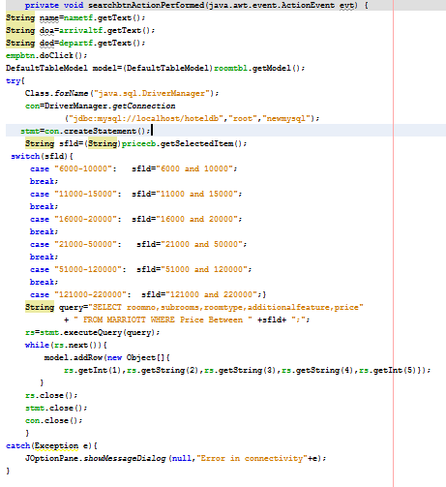

‘KNOW DETAILS’ button code

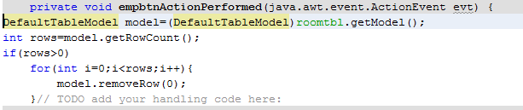

‘Empty table’ button code

C:\Users\Admin\Downloads\HOTEL PROCEED BTN CODE (1).PNG

‘Proceed’ button code

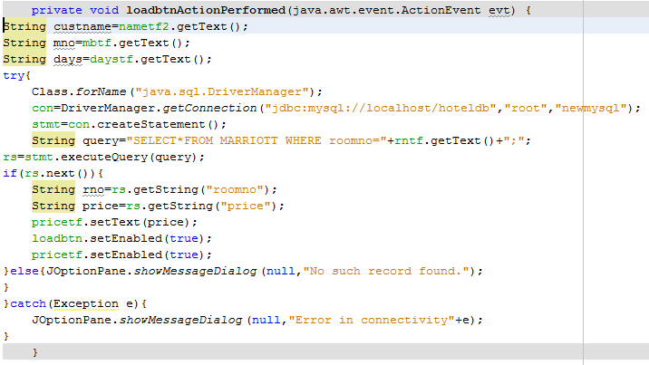

‘Load Price’ button code

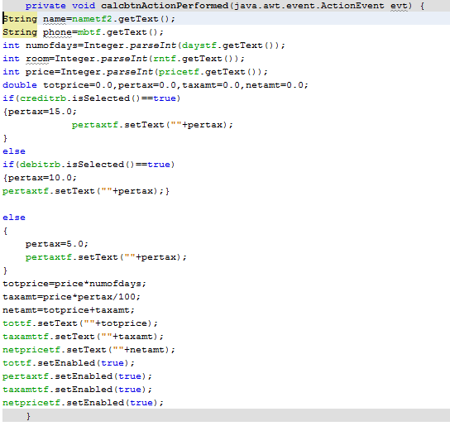

‘CALCULATE NET AMOUNT’ button code

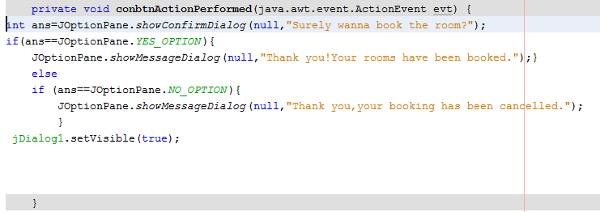

‘BOOK ROOM’ button code

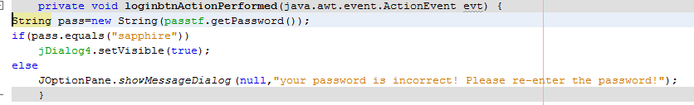

‘LOGIN’ button code

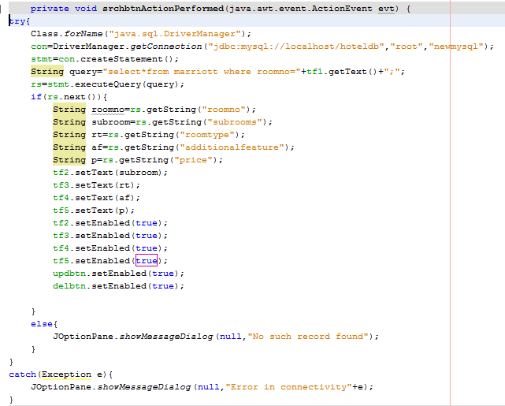

‘Search’ button code

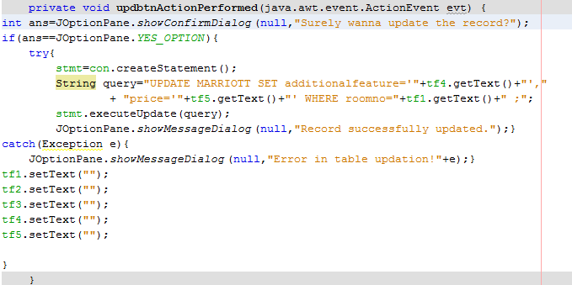

‘UPDATE’ button code

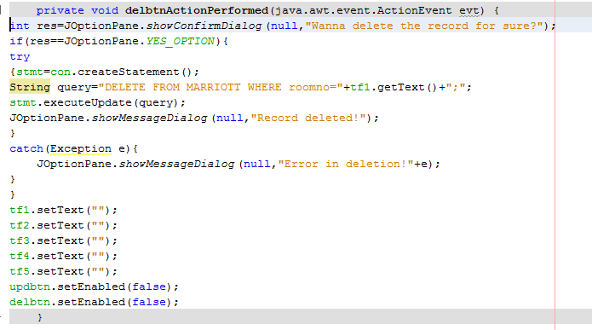

‘DELETE’ button code

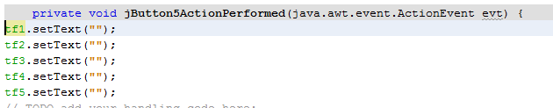

‘Reset’ button code

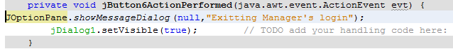

‘Exit’ button code