Route53 DNS Change Monitoring
Automated DNS record change alerting via EventBridge, Lambda & SNS

How It Works
- Any DNS record change made in Route53 triggers a ChangeResourceRecordSets API call.
- AWS CloudTrail captures this API call as a management event.
- An EventBridge rule listens for this specific event and matches it using a defined event pattern.
- EventBridge invokes a Lambda function, passing the full event payload.
- Lambda extracts the relevant details — hosted zone, record name, action, and the IAM user who made the change.
- Lambda publishes an alert to an SNS topic which delivers the email to all subscribed endpoints.

Architecture
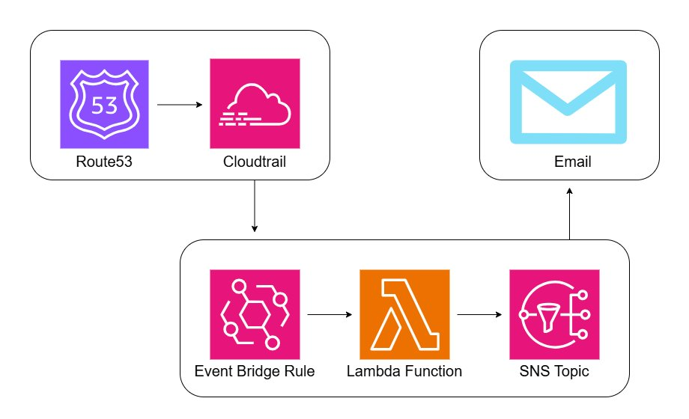

AWS Components

Component | Purpose
AWS CloudTrail | Captures Route53 API calls as management events
Amazon EventBridge | Listens for ChangeResourceRecordSets events and triggers Lambda
AWS Lambda | Parses the event and sends the alert via SNS
Amazon Route53 | Source of DNS change events; also queried to resolve hosted zone names
Amazon SNS | Publishes the email alert to subscribed endpoints

Workflow

New Record Creation in Hosted Zone
Navigate to the Route53 hosted zone and click Create record.
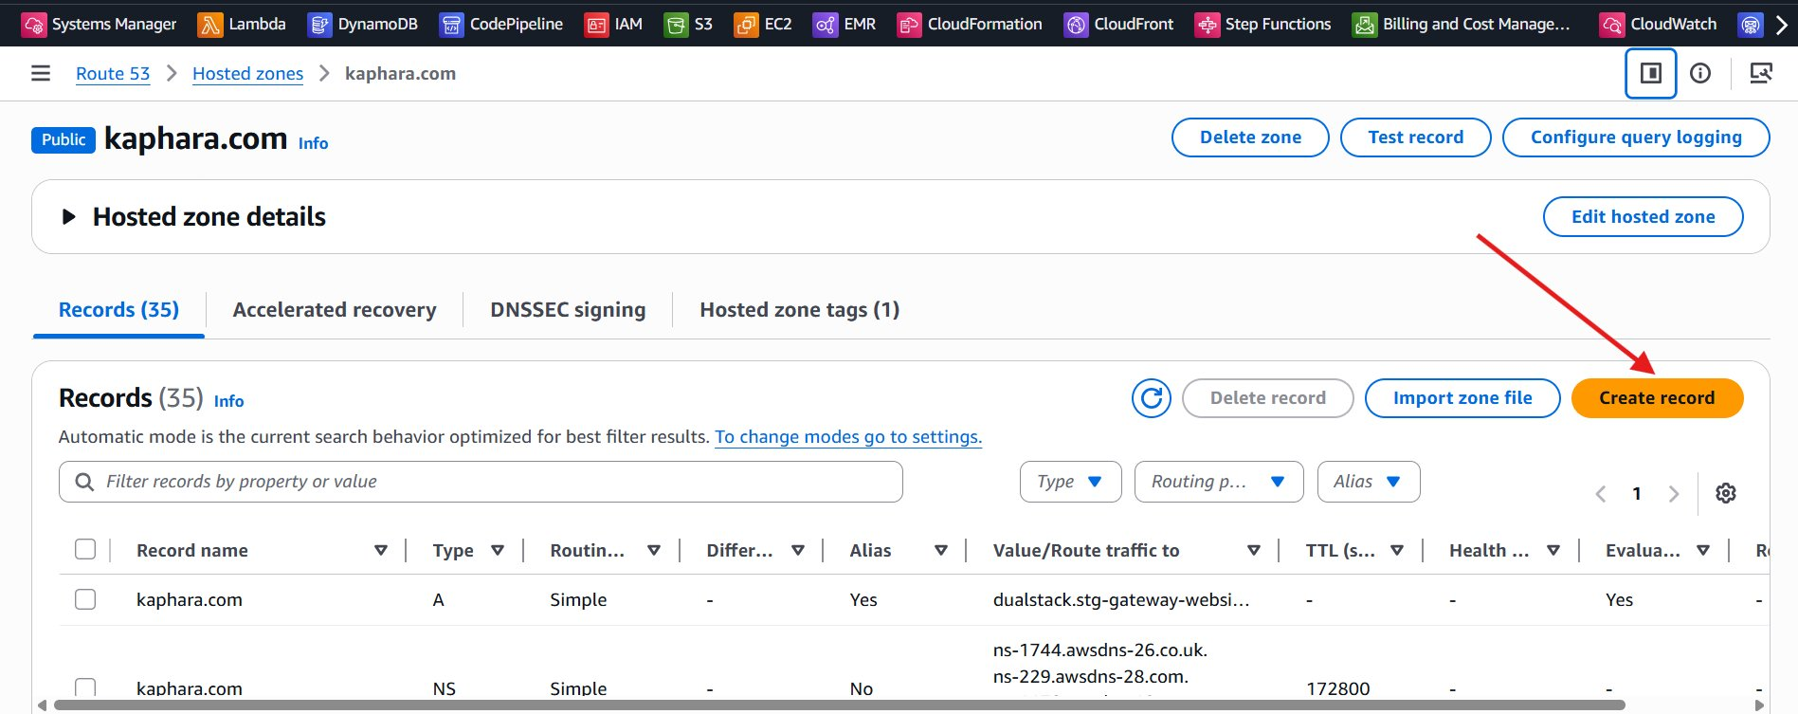

Fill in the record name, type, value and TTL, then click Create records.
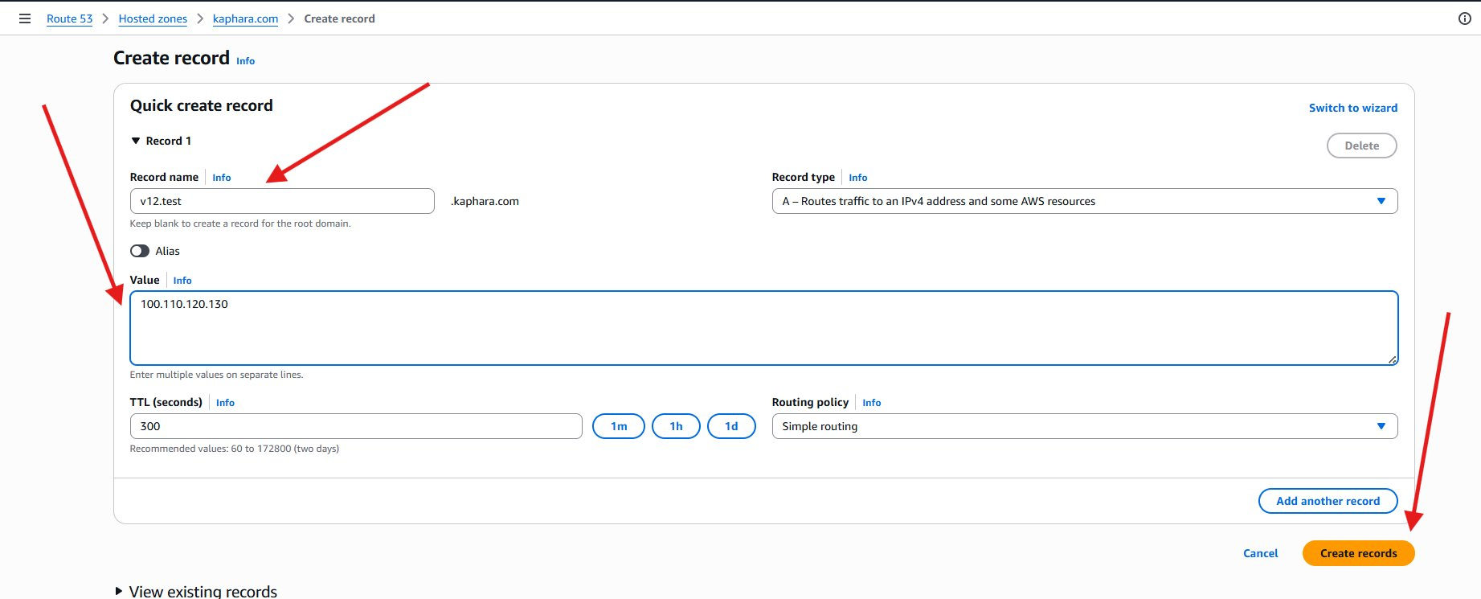

The record is successfully created and appears in the hosted zone records list.
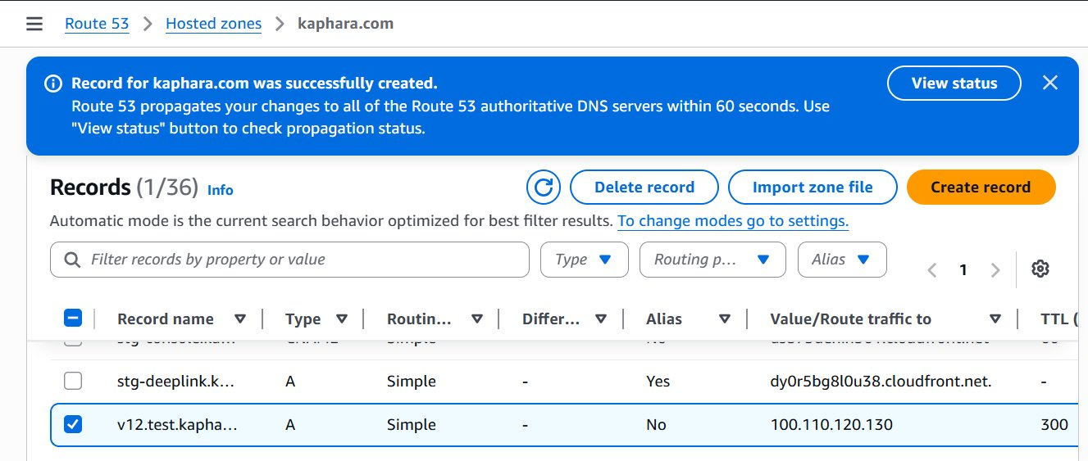

CloudTrail Log Generated
Once the record is created, CloudTrail captures the ChangeResourceRecordSets management event. This can be verified in CloudTrail Event history.
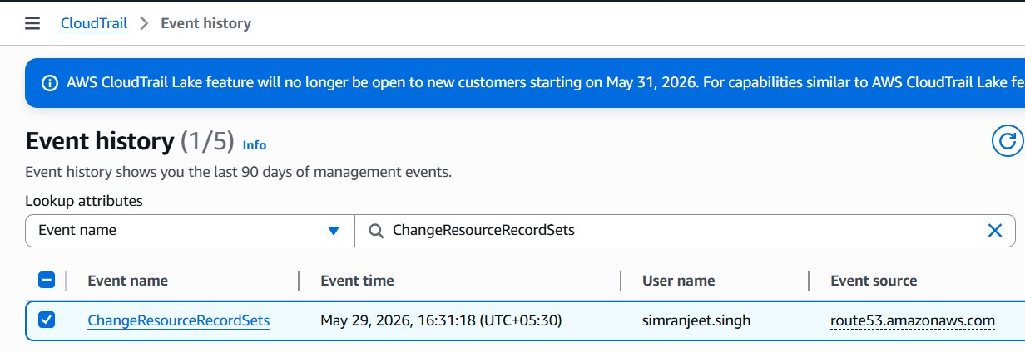

EventBridge Rule
The rule listens for CloudTrail events originating from Route53 where the API call is ChangeResourceRecordSets. It matches across all hosted zones in the account.

Event Pattern
{
"source": ["aws.route53"],
"detail-type": ["AWS API Call via CloudTrail"],
"detail": {
"eventSource": ["route53.amazonaws.com"],
"eventName": ["ChangeResourceRecordSets"]
}
}

Rule Overview
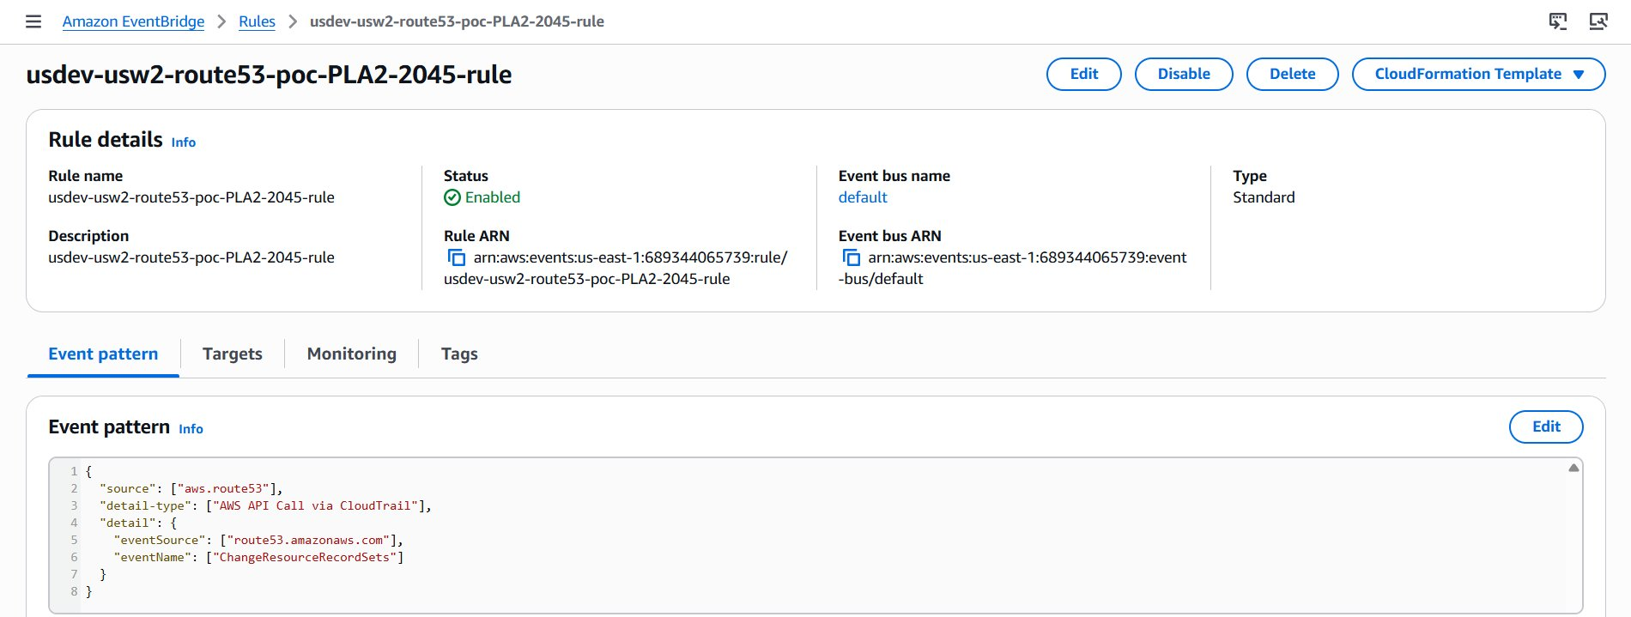

Edit Rule View
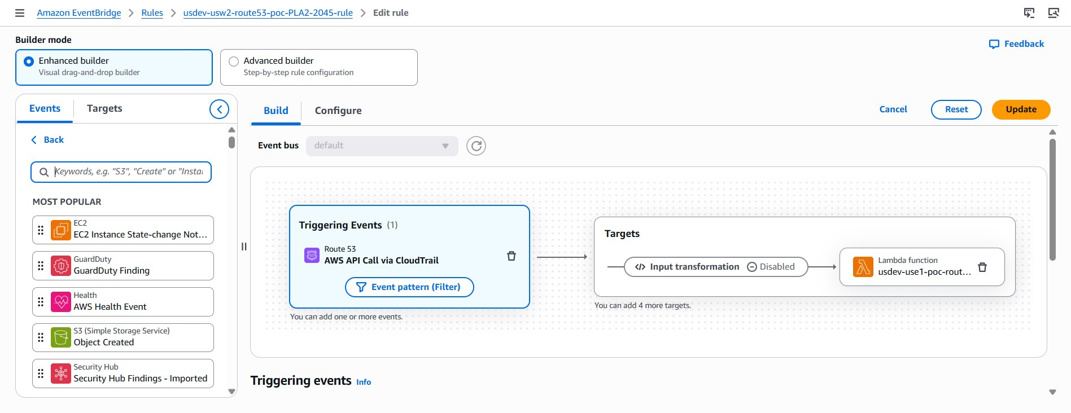

Lambda Function
The Lambda function receives the full EventBridge event payload and performs the following:
- Extracts the hosted zone ID, record name, change action (creation/deletion/modification), and the IAM user who triggered the change.
- Calls route53:ListHostedZones to resolve the hosted zone ID to a human-readable domain name.
- Publishes the formatted alert message to the SNS topic.

Screenshot
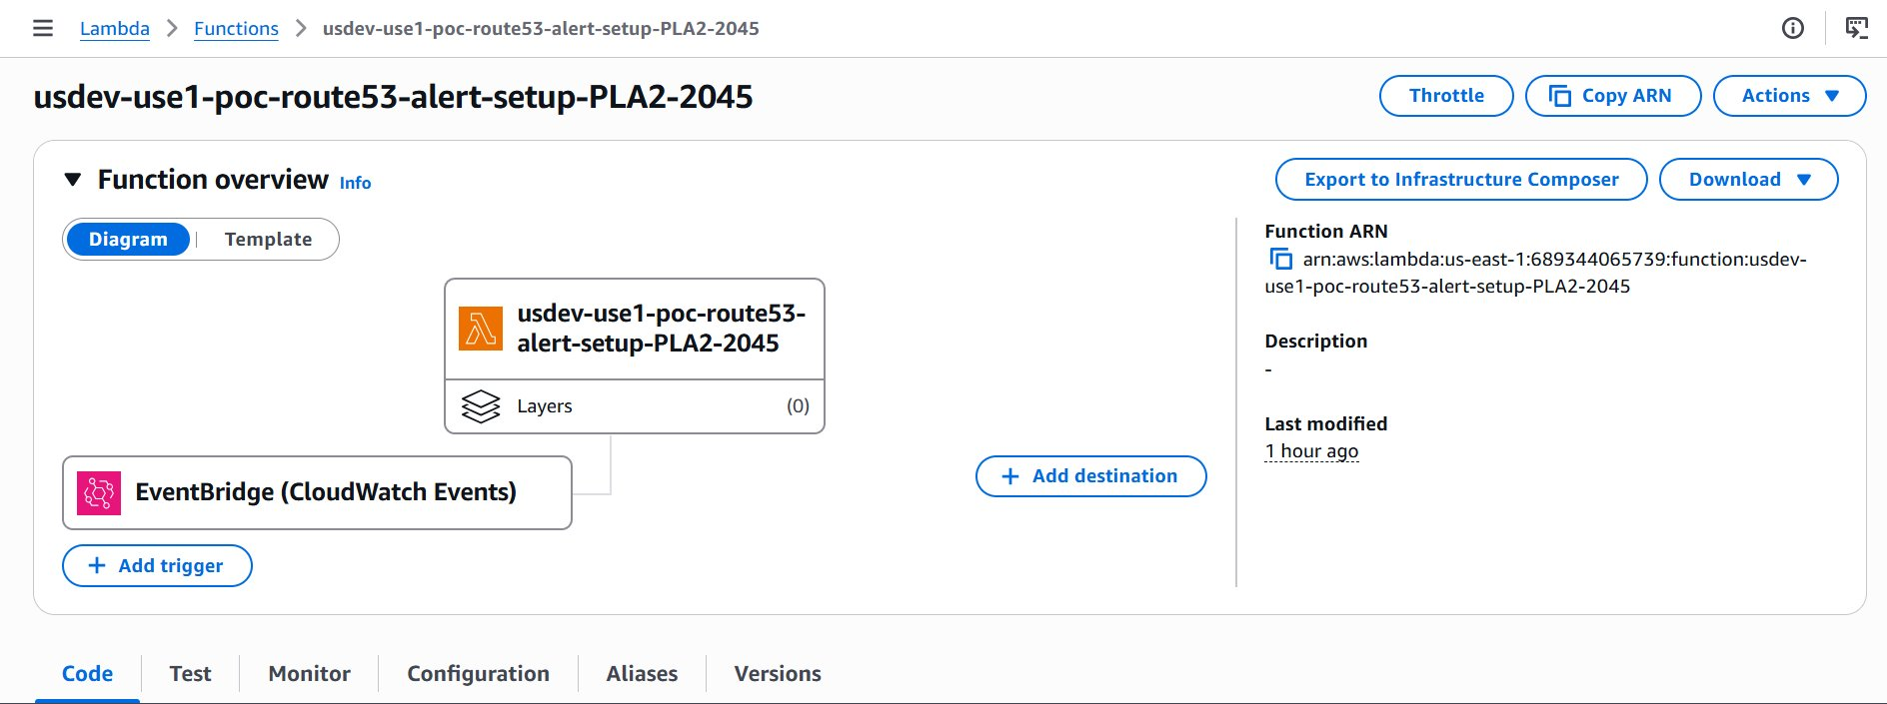

Lambda Function Code
import boto3
import json
import logging

logger = logging.getLogger()
logger.setLevel(logging.INFO)

AWS_REGION = "us-east-1"
SNS_TOPIC = "arn:aws:sns:us-east-1:689344065739:SK-POC-SNS-Custom-Test"
RUNBOOK_URL = "https://omronhealthcare-ohi.atlassian.net/..."

route53 = boto3.client("route53")
sns = boto3.client("sns", region_name=AWS_REGION)

def get_zone_name(zone_id): ...
def get_action_word(change_batch): ...
def get_record_name(change_batch): ...

def lambda_handler(event, context):
detail = event.get("detail", {})
req_params = detail.get("requestParameters", {})
user_identity = detail.get("userIdentity", {})
zone_id = req_params.get("hostedZoneId", "N/A")
caller = user_identity.get("userName") or user_identity.get("arn") or "N/A"
change_batch = req_params.get("changeBatch", {})
zone_name = get_zone_name(zone_id)
action_word = get_action_word(change_batch)
record_name = get_record_name(change_batch)
clean_zone_id = zone_id.split("/")[-1]
subject = f"POC-USSTG-Route53-ALERT Hosted Zone Record change detected | Domain: {zone_name}"
message = f"""Hi Team, ..."""
sns.publish(TopicArn=SNS_TOPIC, Subject=subject, Message=message)
return {"statusCode": 200, "body": "Alert sent."}

IAM Policy
The Lambda execution role requires the following permissions. The SNS permission is scoped down to the specific topic ARN only.

{
"Version": "2012-10-17",
"Statement": [
{
"Sid": "Route53ListZones",
"Effect": "Allow",
"Action": ["route53:ListHostedZones"],
"Resource": "*"
},
{
"Sid": "SNSPublish",
"Effect": "Allow",
"Action": ["sns:Publish"],
"Resource": "arn:aws:sns:us-east-1:YOUR_ACCOUNT_ID:SK-POC-SNS-Custom-Test"
},
{
"Sid": "CloudWatchLogs",
"Effect": "Allow",
"Action": [
"logs:CreateLogGroup",
"logs:CreateLogStream",
"logs:PutLogEvents"
],
"Resource": "arn:aws:logs:*:YOUR_ACCOUNT_ID:log-group:/aws/lambda/*"
}
]
}

Replace YOUR_ACCOUNT_ID with your actual AWS account ID.

SNS Topic
The Lambda function publishes alerts to the SK-POC-SNS-Custom-Test SNS topic. All confirmed email subscriptions on the topic receive the alert.

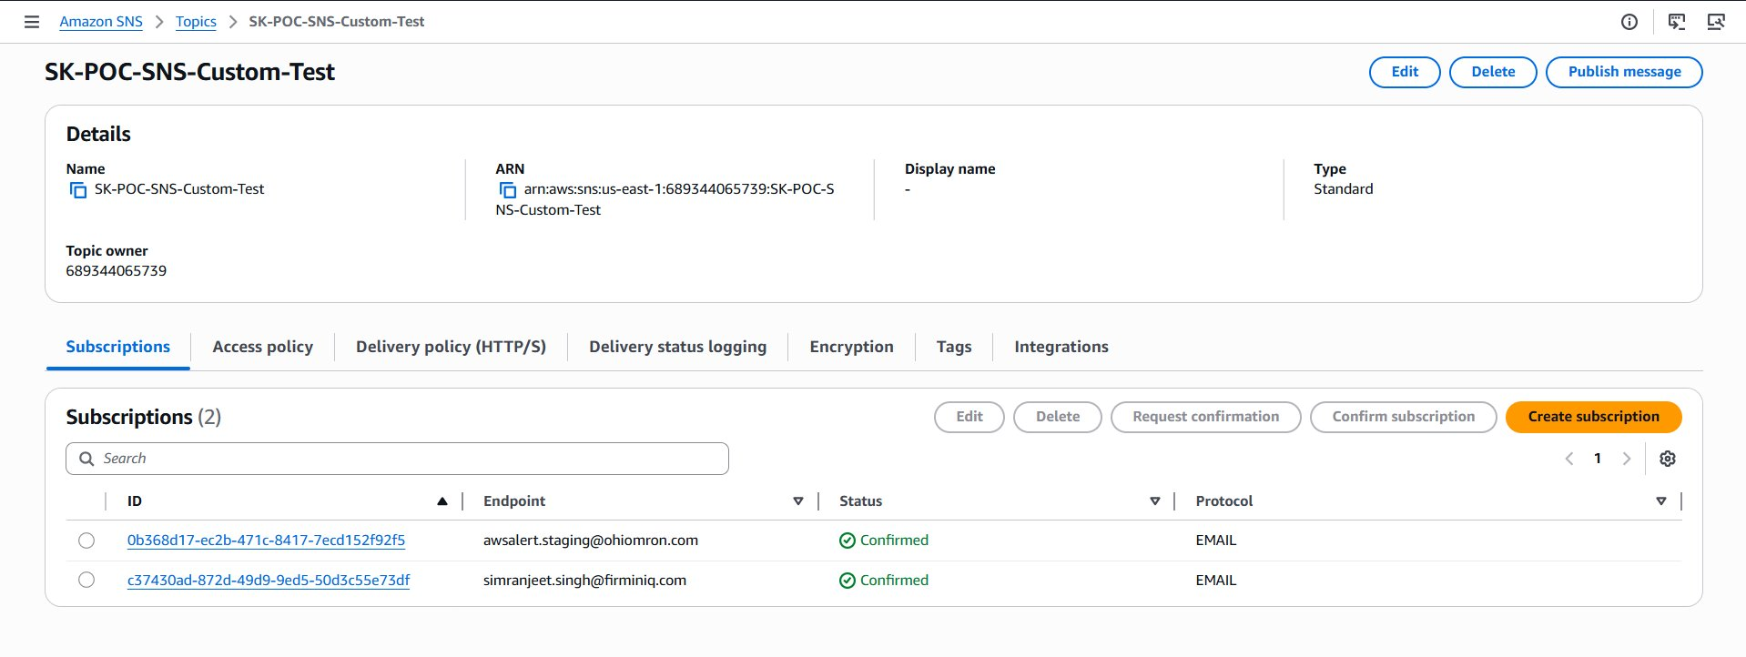

Email Alert
The email is delivered from no-reply@sns.amazonaws.com via the SNS topic. The subject reflects the type of change and the affected domain. The body identifies the record, hosted zone, and the IAM user who made the change.

Record Creation Alert
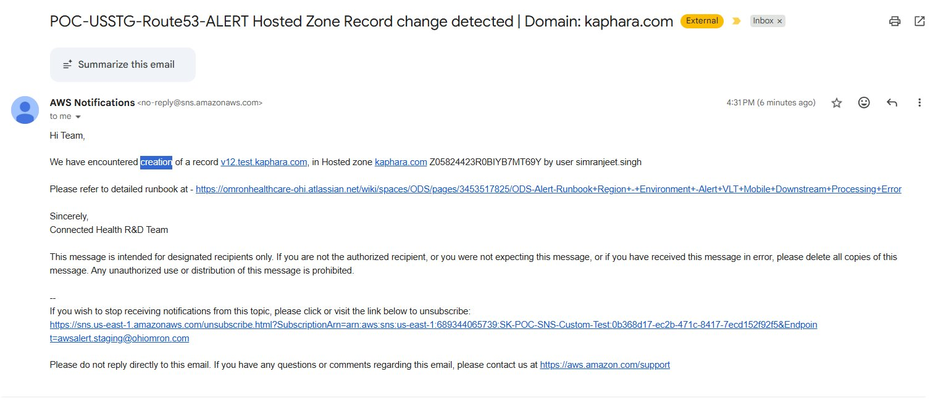

Record Deletion Alert
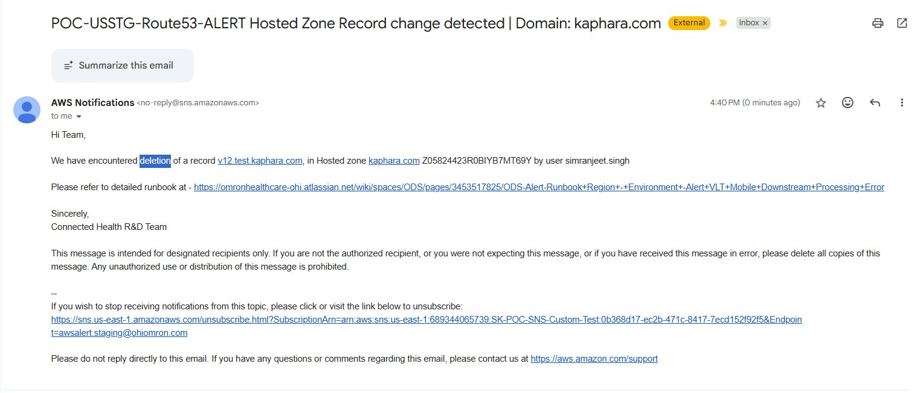

Prerequisites
- CloudTrail must be enabled with management events logging turned on in us-east-1 (Route53 is a global service but logs to us-east-1).
- The email address(es) must be subscribed to the SNS topic and subscriptions must be confirmed.

Repository Structure
.
├── Images/
│ ├── 0.png (Architecture diagram)
│ ├── 1.png (Hosted zone - records list)
│ ├── 2.png (Create record form)
│ ├── 3.png (Record created confirmation)
│ ├── 4.png (CloudTrail event history)
│ ├── 5.png (EventBridge rule overview)
│ ├── 6.png (EventBridge edit rule view)
│ ├── 7.png (Lambda function overview)
│ ├── 8.png (Email alert - creation)
│ ├── 9.png (Email alert - deletion)
│ └── 10.png (SNS topic details)
├── event-bridge-rule-pattern.json
├── lambda-function.py
├── lambda-function-iam-policy.json
└── README.md

