Software Design Document: Library Management System

1. Introduction
Purpose: This document describes the design and architecture of a Library Management System. The system is developed to help librarians manage books and user transactions such as adding books, searching books, issuing books, returning books, and removing books from the library database.The system improves efficiency in library operations by automating manual processes.

Scope: The Library Management System allows the librarian to:
-Add new books to the system
-Search books by title, author, or ID
-Issue books to users
-Return books from users
-Remove outdated or damaged books
This system is intended for use in small to medium-sized libraries.

Users: -Librarian (Primary user)
-Library members (indirect users)

2. System Overview
The system follows a structured approach where all operations are handled by a librarian interface connected to backend logic and a database.
The system is divided into two main parts:
1. Functional module (Library operations)
2. 3-tier architecture (UI, logic, database)
3. Functional Requirements
The system must support the following functions:
Add Book: -Librarian can add new books
-Each book contains: Book ID, Title, Author, Category, Availability Status

Search Book: -Search by:
-Book title
-Author name
-Book ID
-System displays matching results

Issue Book: -Librarian can issue a book to a user
-System checks availability before issuing
-Updates book status to “Issued”

Return Book: -System allows return of issued books
-Updates status to “Available”

Remove Book: -Librarian can remove damaged or outdated books
-System permanently deletes book record

4. Non-Functional Requirements

Performance: -Search results should load within 2–3 seconds
-System should handle multiple transactions efficiently

Security: -Only authorized librarian can access system
-Login authentication required

Reliability: -System ensures accurate book tracking
-No duplicate book entries allowed

Usability: -Simple and easy-to-use interface for librarians
-Minimal training required

Scalability: Can support expansion to multiple library branches

5. Case Diagram:
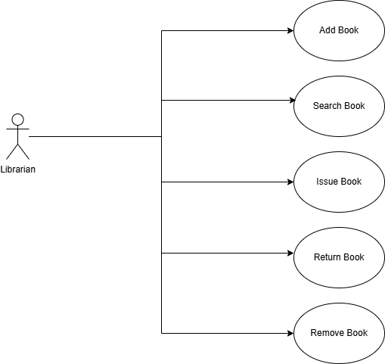

6. System Architecture Diagram
The system uses a 3-Tier Architecture:

Presentation Layer (UI): -Librarian Interface
-Web or desktop screen
-Used to input and view data

Application Layer (Logic)
Handles system operations: -Add Book Service
-Search Service
-Issue Service
-Return Service
-Remove Service
This layer controls all business logic.

Data Layer (Database)
-Stores all library data:
-Book records
-User records
-Transaction history

Architecture Flow
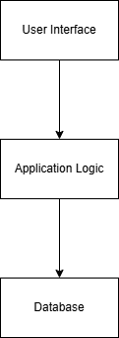

7. Module Interaction Explanation

Add Book Process: 1. Librarian enters book details in UI
2. Request is sent to application layer
3. System validates data
4. Book is stored in database
5. Confirmation message is shown

Search Book Process: 1. Librarian enters search keyword
2. Application layer queries database
3. Matching results are returned
4. Results displayed on UI

Issue Book Process: 1. Librarian selects book and user
2. System checks availability
3. If available → book status updated to “Issued”
4. Transaction stored in database

Return Book Process: 1. Librarian selects issued book
2. System updates status to “Available”
3. Transaction record updated

Remove Book Process: 1. Librarian selects book
2. System deletes record from database
3. Book removed permanently

8. Conclusion
The Library Management System is designed using a structured approach with a clear separation between user interface, application logic, and database. The system ensures efficient management of books and library operations such as adding, searching, issuing, returning, and removing books.
This architecture improves performance, reduces manual work, and ensures accurate record keeping.

