Automated Data Collection & Metrics

Objective: Develop automation and reporting skills using Python.
Tools Used: - Python
- Jupyter Notebook
- Pandas Library
Task Performed:
The Python script performs the following tasks:
- Reads sample CSV files
- Calculates average, maximum, and minimum values
- Generates summary reports
- Implements exception handling and logging
- Saves results into a new CSV file

Python Code
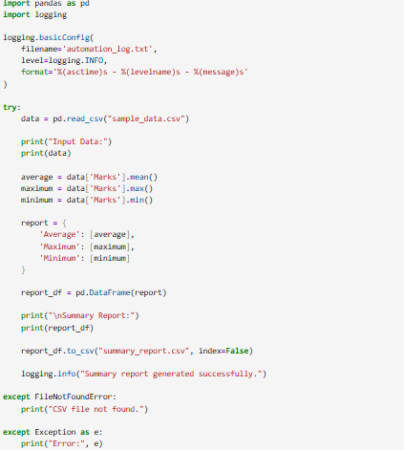
Input CSV File:
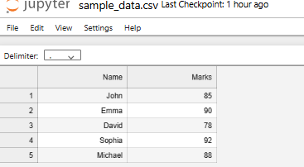

Output Result:
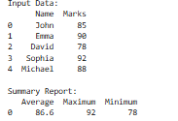

Generated Summary Report:
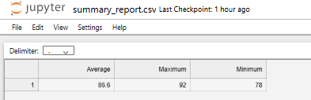

Log File:
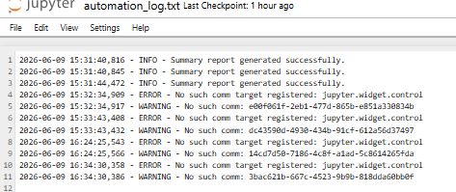
Conclusion:
This project demonstrated automation using Python. The script successfully processed CSV data, calculated statistics, generated reports, implemented logging and exception handling, and saved the output into a new CSV file.

