**Queries (**Simran**)**

1. Sequences:

(to add departmentId into pp_department table in new row using nextvalue)

---------------SEQ (using sequence to add departmentId)

CREATE SEQUENCE PP_SEQ_SIMRAN

START WITH 7007

INCREMENT BY 1000

MINVALUE 1001 MAXVALUE 100000

CYCLE CACHE 2 ORDER; --FOR MAKING A CYCLE IN TWO COMPLETE REPEITION

-------------COMBINING

INSERT INTO PP_DEPARTMENT (DEPTID , MANAGERID) VALUES ( PP_SEQ_SIMRAN.NEXTVAL , 18);

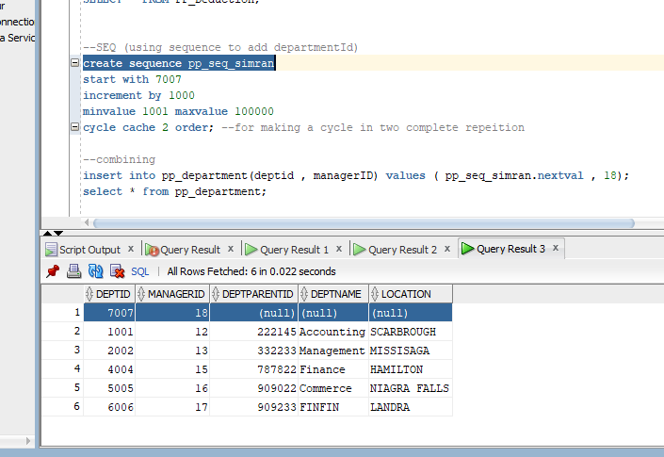

2.) Views

(To check for payment having less than $500 bonus)

-------views

CREATE OR REPLACE VIEW BONUS_MERGED AS

SELECT * FROM PP_BONUS

WHERE BONUSPAYMENT < 500

WITH READ ONLY CONSTRAINT BONUS_ADDED_COSNT;

SELECT * FROM BONUS_MERGED;

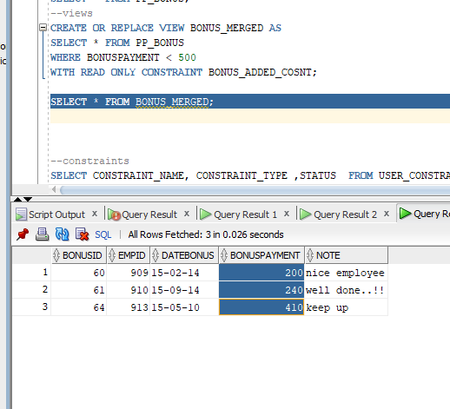

3. Viewing constraints in tables

SELECT CONSTRAINT_NAME, CONSTRAINT_TYPE ,STATUS FROM USER_CONSTRAINTS WHERE TABLE_NAME IN ('pp_department');

4. Indexes

(to identify the deptid by firstname from pp_employee)

SELECT * FROM PP_EMPLOYEE;

CREATE INDEX IND_DEPT_NAME ON PP_EMPLOYEE(DEPID,FIRSTNAME);

SELECT DEPID,FIRSTNAME FROM PP_EMPLOYEE WHERE DEPID = 2002 AND FIRSTNAME = 'jOHN';

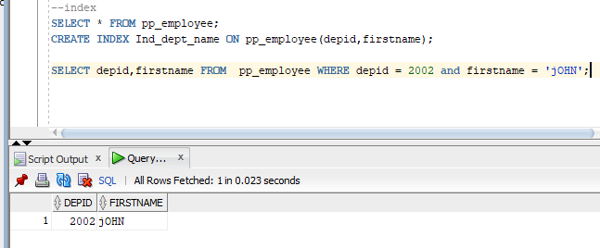

5. pl/sql command {anchor} (TO print payroll information using few variable)

SET SERVEROUTPUT ON;

DECLARE

LV_PAYROLLID PP_PAYROLL.PAYROLLID%TYPE;

LV_EMPID PP_PAYROLL.EMPID%TYPE;

LV_GROSSPAY PP_PAYROLL.GROSSPAY%TYPE;

BEGIN

SELECT PAYROLLID , EMPID, GROSSPAY

INTO LV_PAYROLLID, LV_EMPID,LV_GROSSPAY

FROM PP_PAYROLL WHERE SALARYID = '56';

DBMS_OUTPUT.PUT_LINE(LV_PAYROLLID);

DBMS_OUTPUT.PUT_LINE(LV_EMPID);

DBMS_OUTPUT.PUT_LINE(LV_GROSSPAY);

END;

/

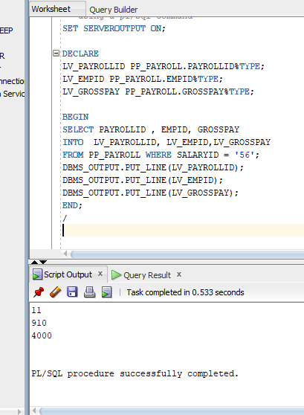

6. Deleting and handling exception

SELECT * FROM PP_DEPARTMENT;

SET SERVEROUTPUT ON;

BEGIN

DELETE FROM PP_DEPARTMENT WHERE DEPTID = 7007 ;

IF SQL%NOTFOUND THEN

DBMS_OUTPUT.PUT_LINE('ROW NOT FOUND- DELETION FAILED');

ELSE

DBMS_OUTPUT.PUT_LINE(SQL%ROWCOUNT || 'ROWS DELETED ');

END IF;

END;

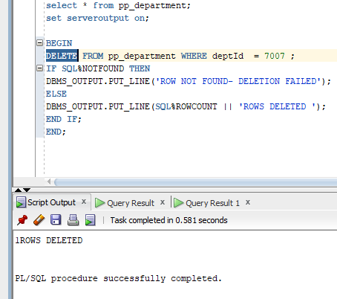

7. Cursor {IMPLICIT METHOD}

SET SERVEROUTPUT ON;

DECLARE

LV_PAYROLLID PP_PAYROLL.PAYROLLID%TYPE;

LV_EMPID PP_PAYROLL.EMPID%TYPE;

LV_GROSSPAY PP_PAYROLL.GROSSPAY%TYPE;

CURSOR C12 IS

SELECT PAYROLLID , EMPID, GROSSPAY FROM PP_PAYROLL;

BEGIN

OPEN C12;

LOOP

FETCH C12 INTO LV_PAYROLLID, LV_EMPID,LV_GROSSPAY;

EXIT WHEN C12%NOTFOUND;

DBMS_OUTPUT.PUT_LINE('ID: ' || LV_PAYROLLID || ' ' ||

'EMP ID: '|| LV_EMPID || ' ' || 'GROSS: ' || LV_GROSSPAY );

END LOOP;

CLOSE C12;

END;

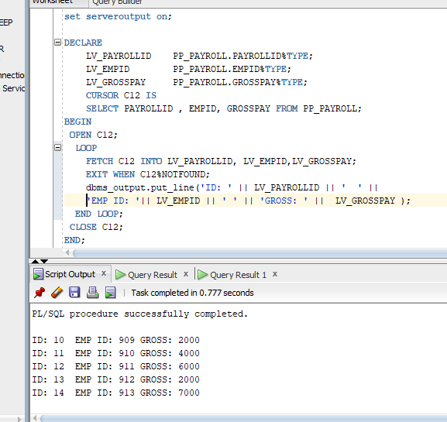

8.) PROCEDURE

CREATE OR REPLACE PROCEDURE MY_PAYROLL_PRODEDURE IS --PROCEDURE

CURSOR C11 IS ---------------USING CURSOR

select * FROM PP_SALARY;

R_CUR C11%ROWTYPE;

BEGIN

OPEN C11;

DBMS_OUTPUT.PUT('CUSTOMER'||' '||'CITY');

LOOP

FETCH C11 INTO R_CUR;

EXIT WHEN C11%NOTFOUND;

DBMS_OUTPUT.PUT_LINE(R_CUR.SALARYID||' '||R_CUR.BASEYEAR);

END LOOP;

CLOSE C11;

END;

/

DESC PROCEDURE my_pAYROLL_PRODEDURE;

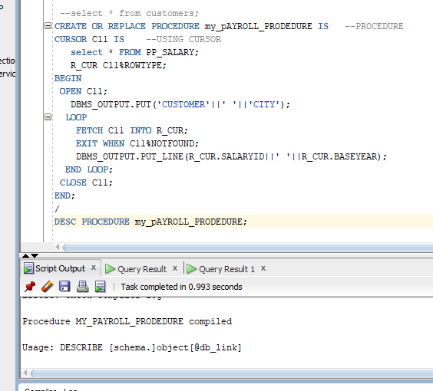

9.) Package

10) Triggers