GROUP 03: Effect of Image Scaling and Zoom Augmentation

WEEK 5

1. OBJECTIVE FOR WEEK 5
To evaluate and visualise the baseline and scaling/zoom-augmented results for YOLOv8n, YOLOv11n, and YOLOv26n using precision–recall curves, confusion matrices, mAP comparison charts, class-wise Average Precision (AP), training/validation loss curves, and representative detection examples.

2. WORK COMPLETED
- Reviewed the saved baseline results from Week 1 and the nine augmented-model results from Week 3.
- Collected the existing precision–recall curves, confusion matrices, and prediction examples.
- Recorded class-wise AP values and overall mAP@0.5 from saved evaluation plots.
- Consolidated saved mAP@50 and mAP@50–95 values for the baseline and augmented configurations.
- Reviewed training and validation loss trends using the saved results.csv/results.png files.
- Compared the effects of Low, Medium, and High scaling/zoom augmentation across the three YOLO versions.

3. EVALUATION RESULTS AND VISUALISATION

3.1 Precision–Recall Curves:
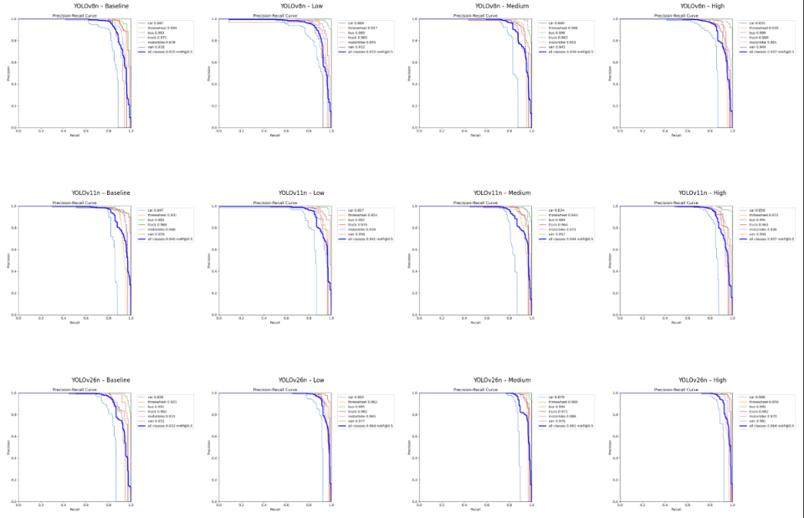

3.2 Confusion Matrix: 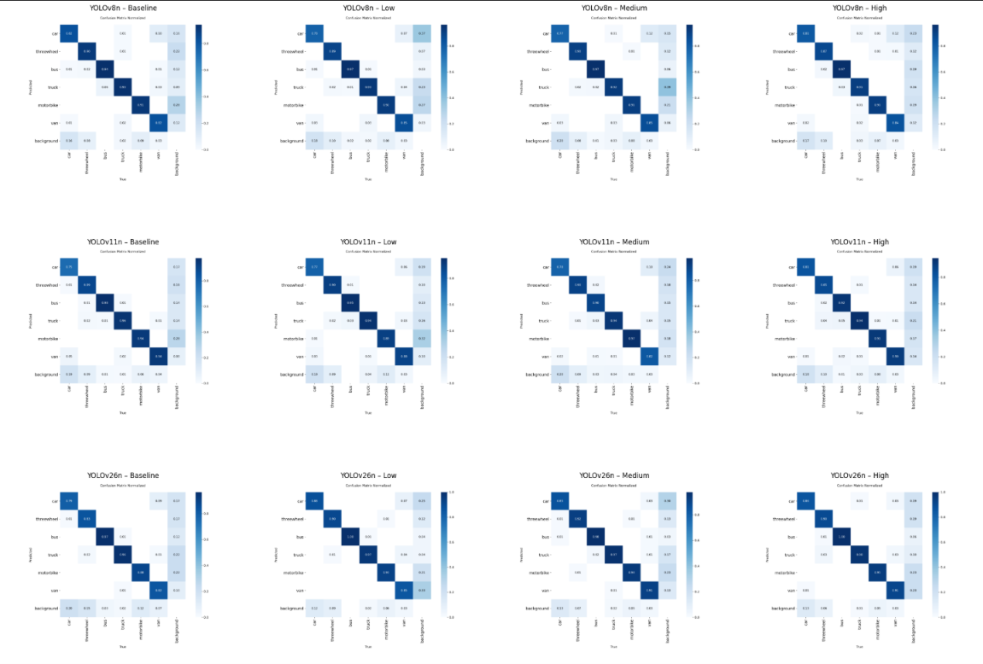

3.3 mAP Comparison Charts:
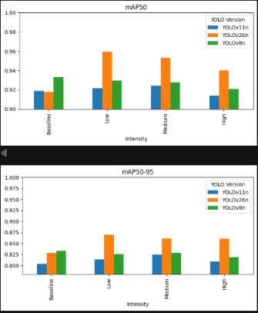

3.4 Class-Wise AP:
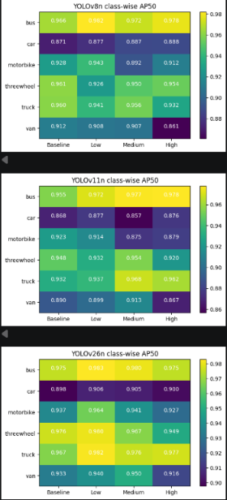
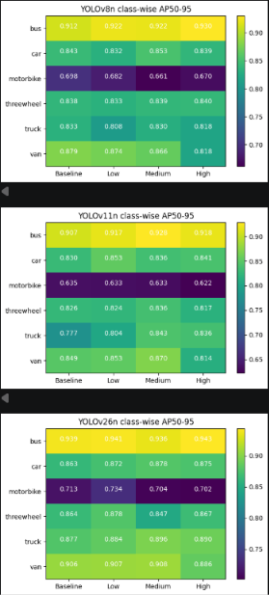

3.5 Training and Validation Loss Curves: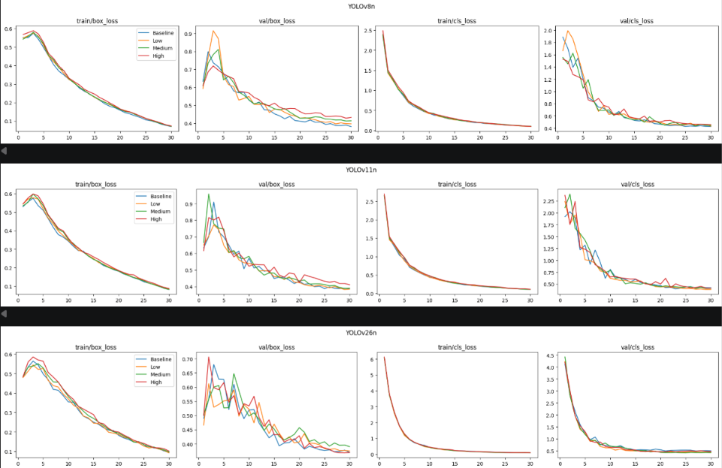

3.6 Sample Detections (Correct / False positive / False negative):
Yellow – False Negative
Green – Correct (True Positive)
Red – False Positive
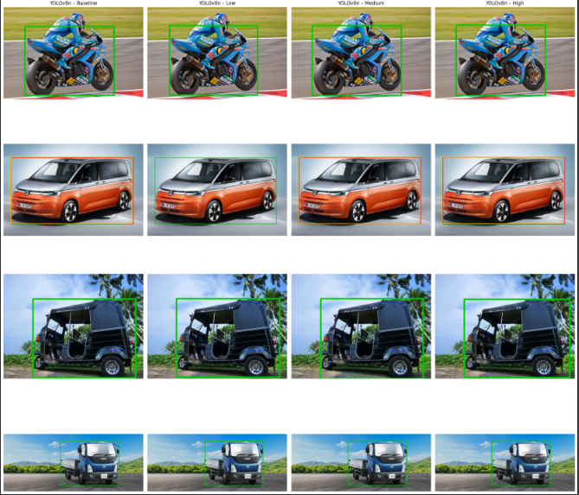

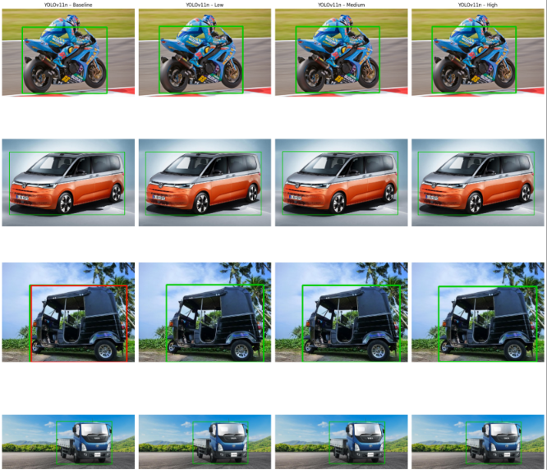

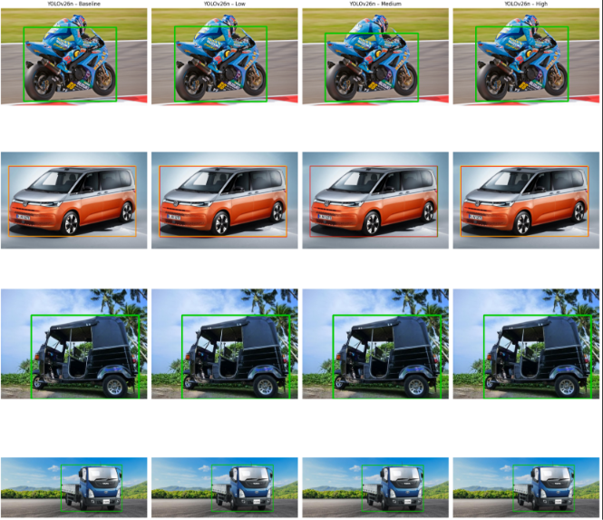

3.7 Analyse why the Augmentation helped or hurt performance, and whether the effect differs by YOLO version:
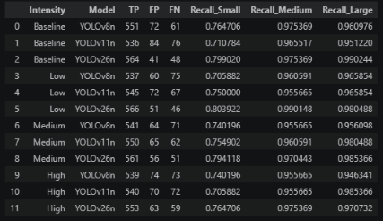

- The results show that augmentation affected each YOLO version differently. YOLOv26n achieved the largest improvement in mAP@0.5, increasing from 0.9176 to 0.9596 with Low augmentation. YOLOv11n improved slightly with Medium augmentation, while YOLOv8n performed best under the baseline condition.
- Small vehicles were more challenging to detect than medium and large vehicles, as their recall was generally lower. Low and Medium augmentation improved small-object recall for YOLOv11n, whereas YOLOv8n showed a decline.
- High augmentation produced the lowest mAP@0.5 among the augmented conditions for all three models. Heavy zooming may crop important vehicle features or make small vehicles harder to recognise. For YOLOv26n, mAP improved considerably, but false positives also increased, suggesting that the improvement did not necessarily result from detecting many more vehicles.
- Overall, augmentation effectiveness depended on the YOLO version and intensity. Low or Medium augmentation was more beneficial in some cases, while stronger augmentation did not consistently improve performance.

4. ISSUES / CHALLENGES:
- Organising the evaluation plots and results for all 12 configurations (baseline, Low, Medium, and High across three YOLO versions) required careful tracking.
- Comparing class-wise AP and detection performance was challenging because augmentation affected each YOLO version differently.
- Analysing correct detections, false positives, and false negatives required careful inspection of the prediction images.
- Interpreting differences between mAP scores, recall, and detection counts required considering multiple evaluation metrics together.

5.PLAN FOR NEXT WEEK:
- Compile the final report covering the methodology, augmentation experiments, evaluation results, and performance comparisons.
- Summarise the key findings and identify which YOLO version benefited most from scaling/zoom augmentation.
- Prepare the final presentation with the important plots, visualisations, and conclusions.
- Review the results and conclusions to ensure consistency across the reports and presentation.

6. HOURS SPENT (PER MEMBER):
Members | Hours  Spent | Contribution
Simran Koshta (B230707CS)
Gunna Mohana Prathyusha
(B230324CS)
Maithili Kolasani (B230385CS)
Sreeneha Bhavanasi (B230092CS)
Ardhra Alaina Winston (B230198CS)

