

### SCHOOL OF COMPUTER SCIENCE AND ENGINEERING

**April 2020**

**COLLISION DETECTION & PREVENTION SYSTEM**

**A Project Report**

**Under the Guidance of,** **Prof. NARESH K.**

### By

|  |  |
| --- | --- |
| **NAME** | **REGISTRATION NUMBER** |
| **RITWIK RANJAN** | **17BCE0488** |
| **SIMRAN KOUL** | **17BCE2210** |
| **SIMRITI KOUL** | **17BCE2211** |
| **R. TEJESH** | **17BCE2331** |

**TABLE OF CONTENTS**

|  |
| --- |
| **CHAPTER - 1** |
| **1.1 AIM** |
| **1.2 OBJECTIVE** |
| **1.3 INTRODUCTION** |
|  |
| **CHAPTER - 2** |
| **2.1 LITERATURE SURVEY** |
| **2.2 EXISTING AND PROPOSED SYSTEM** |
|  |
| **CHAPTER - 3** |
| **3.1 PROPOSED SYSTEM DESIGN ARCHITECTURE** |
| **3.2 ARCHITECTURE EXPLANATION** |
| **3.3 CODE** |
|  |
| **CHAPTER - 4** |
| **4.1 RESULTS & DISCUSSIONS** |
| **4.2 CONCLUSION & FUTURE WORK** |
|  |
| **REFERENCES** |

# ABSTRACT

An obstacle detector is prepared in this project which detects any kind of objects or their movements in a specific range and generates alert sounds and displays the distance at which the obstacle is present. This detector has been made by primarily making use of Arduino uno, Ultrasonic sensors and other components. Obstacle detection is the primary requirement and functionality in any autonomous navigation system.

Arduino uno has been used in preparing the detector which has programmed by making use of Arduino IDE. The ultrasonic sensors have been used which sends out a high-frequency sound pulse and then times how long it takes for the echo of the sound to reflect back. Then buzzer is used in the detector which produces a buzzing noise whenever an object comes in the detection range of the detector.

An SOS button is used here which acts as an emergency button.

Integrated inter circuit (I2C) has been used which acts as an interconnecting bridge between the arduino uno board and the LCD display. The LCD display is used for knowing the distance at which the obstacle is present.

**CHAPTER – 1**

* 1. **AIM:**

The aim of the project is to design an obstacle detector that detects any objects in its specific range and displays the distance of the obstacle from it and generates a buzzing sound on detection.

* 1. **OBJECTIVE:**

The objective of this project is to prepare an obstacle detector by making use of Arduino uno and ultrasonic sensors. This detector detects any kind of objects or their movements in a specific range and generates alert sounds and displays the distance at which the obstacle is present. The alert sound is generated by the buzzer and the distance at which the obstacle is present is generated on the LCD display. An SOS emergency button is also used in this project.

### INTRODUCTION:

We are aware of the fact that for every vehicle there exists a blind spot toward the left back end of the driver. That region is highly prone to collision . our proposed model provides a solution to this problem .

The model consist of ultrasonic sensors which would send signal to arduino. The two sensors are placed at a particular angle. Each sensor has a sender and a receiver. The sensor sends waves from the sender side which when strikes an obstacle returns back and is captured by the receiver. The receiver sends the message to the arduino in which the code has been fed to transmit the signal to the buzzer which makes sound with different frequencies depending on the direction of the obstacle. The information from the arduino will also be transferred to the the I2C module which would forward it to the 16*2 LCD. The LCD displays the distance of the obstacle.

The additional feature of our model is the SOS touch sensor which would display an emergency message on the LCD.

The model is a prototype and future enhancements like magnitude factor of impact , camera module, GPS module could be made . Strong sensors could be used for having large scale implementations maybe on an airplane for detecting birds or any on the obstacle on the runway.

**CHAPTER – 2**

### LITERATURE SURVEY:

|  |  |  |  |  |  |
| --- | --- | --- | --- | --- | --- |
| **Authors** | **Journal** | **Title** | **Methodology** | **Results** | **Future scope** |
| Kirti Bhagat, | International | Obstacle | The robot | Autonomous | Addition of |
| Sayalee | Journal of | avoidance | vehicle | robot which | camera that can |
| Deshmukh, | Science, | robot | includes an | intelligently | give a view of |
| Shraddha | Engineering and |  | intelligent | detects the | the path ahead |
| Dhonde, | Technology |  | system which | obstacle in his | and also the |
| Sneha Ghag | Research |  | assists in | path and | obstacles in the |
|  | (IJSETR), |  | avoiding | navigate | path |
|  | Volume 5, Issue |  | obstacles and | according to |  |
|  | 2, February |  | navigating | the actions that |  |
|  | 2016 |  | accordingly by | has been set |  |
|  |  |  | making use of |  |  |
|  |  |  | AT mega 8 |  |  |
| V. Abilash, | 2017 3rd | Ardunio | A WiFi | Path planning, | Improving the |
| J. Paul Chandra | International | controlled | operated land | obstacle | body designs |
| Kumar | Conference on | landmine | mine detector | detection and | by placing |
|  | Science  Technology Engineering and | detection robot | by using GPS  sensor and Arduino | avoidance  algorithms are used to control | suspension  system to over shock from the |
|  | Management |  | microcontroller | accurately and | uneven surfaces |
|  | (ICONSTEM) |  |  | to navigate of |  |
|  |  |  |  | the proposed |  |
|  |  |  |  | path by |  |
|  |  |  |  | avoiding |  |
|  |  |  |  | obstacles. The |  |
|  |  |  |  | robot system is |  |
|  |  |  |  | embedded with |  |
|  |  |  |  | metal detector |  |
|  |  |  |  | capable of |  |
|  |  |  |  | sensing the |  |
|  |  |  |  | landmine and |  |
|  |  |  |  | buzzer from |  |
|  |  |  |  | producing a |  |
|  |  |  |  | warning alarm |  |
|  |  |  |  | to the nearby |  |
|  |  |  |  | personnel in |  |
|  |  |  |  | that area. |  |
| Syed Tahir Hussain Rizvi,  M. Junaid Asif, Husnain Ashfaq | 2017  International Conference on Communication, Computing and Digital Systems (C-CODE) | Visual impairment aid using haptic and sound feedback | GPS and GSM enabled wearable glove y interfacing different sensors and communication modules with | The implemented design scans the hurdles in a specific path and informs the user with the aid of haptic | Size and weight of the glove can be reduced by using smaller version of arduino.  Accuracy of this wearable |

|  |  |  |  |  |  |
| --- | --- | --- | --- | --- | --- |
|  |  |  | Arduino UNO. | and voice | system can be |
|  | feedback. It | increased by |
|  | does not only | adding more |
|  | notify about the | distance sensor |
|  | hurdles but also | placed on |
|  | informs the | different angles |
|  | location of the | or using |
|  | user to the | advance sensor |
|  | caretaker using | like lidar. |
|  | GSM |  |
|  | technology. |  |
| Saurav | 2nd | Smart walking stick for blind integrated with SOS navigation system | Walking  Stick with in- built ultrasonic sensor with a  arduino uno and an SOS emergency button and webcam | Whenever the | Real time |
| Mohapatra, | International | blind person | image |
| Subham Rout, | Conference on | faces any | processing and |
| Varun Tripathi, | Trends in | hindrance, the | employing |
| Tanish Saxena, | Electronics and | SOS button is | artificial |
| Yepuganti | Informatics | pressed which | intelligence to |
| Karuna | (ICOEI 2018) | generates a video | decide the best |
|  |  | call to his family | path on its own. |
|  |  | with which they |  |
|  |  | can see his/her |  |
|  |  | surroundings and |  |
|  |  | location using an |  |
|  |  | Android |  |
|  |  | application. |  |
| Zannatul | 2017 IEEE | Design of an arduino based voice- controlled automated wheelchair | Arduino based | The designed | The |
| Raiyan, | Region 10 | voice controlled | wheelchair | implemented |
| Md. Sakib | Humanitarian | automated | system does not | design can be |
| Nawaz, | Technology | wheelchair with | require any | more compact |
| A. K. M. Asif | Conference | a voice | wearable sensors | by considering |
| Adnan, | (R10-HTC) | recognition | for using other | several issues |
| Mohammad |  | system, which | biomedical | like positioning |
| Hasan Imam |  | allows the | signals to control | the speech |
|  |  | physically | wheelchair | recognition and |
|  |  | disabled person | movements and | motor driver |
|  |  | to control the | the speech | module at the |
|  |  | wheelchair by | processing is | most suitable |
|  |  | voice command | done solely with | position for the |
|  |  | using Arduino | the available | patient and |
|  |  | Mega2560, Easy | integrated speech | proper |
|  |  | VR3 speech | processing | balancing of |
|  |  | recognition  module, | module. | the wheelchair. |
|  |  | SIM900A GSM |  |  |
|  |  | module |  |  |

* 1. **EXISTING AND PROPOSED SYSTEM:**

#### Existing System:

The existing system of obstacle detection only detects the presence of any obstacle within its range and generates a buzzing sound with the buzzer.

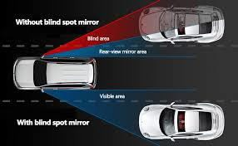

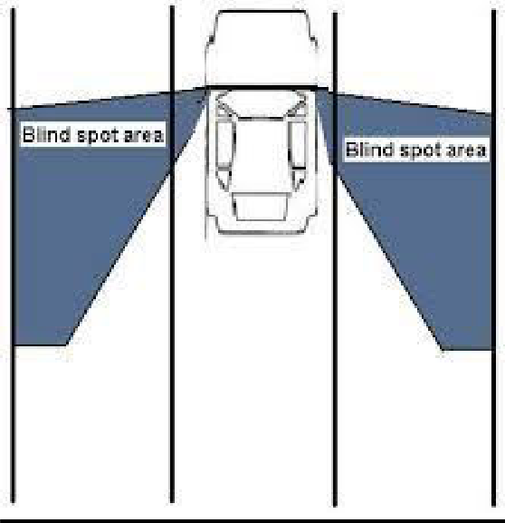

#### Proposed System:

The proposed system in addition to the functionalities of the existing system displays the distance of the obstacle from the detector on a LCD display by using Integrated Inter Circuit (I2C) as an interconnection between Arduino uno and the LCD display and also an emergency SOS button is included also in this proposed system.

## CHAPTER – 3

### PROPOSED SYSTEM DESIGN ARCHITECTURE:

#### Arduino uno

An Arduino is an open-source microcontroller development board. Arduino is a great tool for developing interactive objects, taking inputs from a variety of switches or sensors and controlling a variety of lights, motors and other outputs. The most common version of Arduino is the Arduino Uno. Arduino uno is a microcontroller board dased on the ATmega328P(datasheet). It has 14 digital input/output pins of which 6 can be used as PWM outputs, 6 analog inputs, a 16 MHz quartz crystal, a USB connection, a power jack an ICSP header and a reset button. It is relatively cheap, plugs straight into a computer's USB port, and it is simple to setup and use when compared to other development boards. It has an easy USB interfacing. The chip on the board plugs straight into your USB port and registers on your computer as a virtual serial port. This allows us to serially communicate which is an extremely easy protocol. It has a large number of hardware features like timers, PWM pins, external and internal interrupts, and multiple sleep modes. The other component of the Arduino platform is the Arduino IDE. This contains all the software which will run a computer in order to program and communicate with an Arduino board. Using the IDE the program we wrote is converted to C language and then compiled using avr-gcc. This process produce binary code which the micro controller on the Arduino board will be able to understand and execute. When the Arduino board is connected to a computer using the USB cable, by using the IDE we are able to compile and upload to the board the program.

#### Ultrasonic Sensors:

The Ultrasonic Sensor sends out a high-frequency sound pulse and then times how long it takes for the echo of the sound to reflect back. The sensor has two openings on its front. Tiny speaker to transmit opening ultrasonic waves. The ultrasonic sensor calculates distances by making use of the fact that the speed of sound is approximately 341 meters per second in air. The ultrasonic sensor uses this information along with the time difference between sending and receiving the sound pulse to determine the distance to an object. The limitations of an ultrasonic sensor is some objects might not be detected it which are shaped or positioned in such a way that the sound wave bounces off the object, but are deflected away from the sensor. It is also possible for the object to be too small to reflect enough of the sound wave back to the sensor to be detected. Objects can absorb the sound wave all together which means that there is no way for the sensor to detect them accurately.

#### Integrated Inter Circuit (I2C):

The acronym IIC stands for “Inter Integrated Circuits”. It is normally denoted as I2C or I squared C or even as 2-wire interface protocol. I2C is a synchronous communication protocol meaning, both the devices that are sharing the information must share a common clock signal. It has only two wires to share information out of which one is used for the cock signal and the other is used for sending and receiving data. I2C communication was first introduced by

Phillips. As said earlier it has two wires, these two wires will be connected across two devices. Here one device is called a master and the other device is called as slave. Communication should and will always occur between two a Master and a Slave. The advantage of I2C communication is that more than one slave can be connected to a Master. I2C communication is used only for short distance communication. It is certainly reliable to an extent since it has a synchronized clock pulse to make it smart. This protocol is mainly used to communicate with sensor or other devices which has to send information to a master. It is very handy when a micro controller has to communicate with many other slave modules using a minimum of only wires. Here I2C acts as an interconnecting bridge between the arduino uno board and the LED display.

#### Jumper wires:

Jumper wires are the wires that have connector pins at each end, allowing them to be used to connect two points to each other without soldering. Jumper wires are typically used with a breadboard and other prototyping tools in order to make it easy to change a circuit as needed. Jumper wires typically come in three versions: male-to-male, male-to-female and female-to- female. The difference between each is in the end point of the wire. Male ends have a pin protruding and can plug into things, while female ends do not and are used to plug things into. Male-to-male jumper wires are the most common.

**LCD Display:**

LCD Display is a screen display technology that uses a panel of LCDs as the light source. Currently, a large number of electronic devices, both small and large, use LCD display as a screen and as an interaction medium between the user and the system. Modern electronic devices such as mobile phones, TVs, tablets, computer monitors, laptops screens, etc., use an LCD display to display their output. commercially used. The biggest advantage of the LCD display is its efficient and low-energy consumption, which is

especially needed for handhelds and chargeable devices such as mobile phones and tablets. An LCD display consists of a number of LCD panels that, in turn, consist of several LCDs. LCDs have numerous advantages over other light-emitting sources that can be used alternatively. Aside from being power efficient, LCDs produce more brilliance and greater light intensity.

### ARCHITECTURE EXPLANATION

* + 1. Two ultrasonic sensors are attached to the stick each at angle which is approximately 70 degrees from the center of the stick. Each of these sensors has a sender and a receiver part.
    2. The sender part of the sensor send signals in the form of waves which strikes and obstacles and reflects back. These reflected signals are received by the receiver part of the sensor.
    3. These received signals are send to the arduino in which the code is fed about the frequency ranges and the task which has to be performed further.
    4. On the basis of the detection of the waves, the arduino concludes the direction of the obstacle and sends this information to the buzzer.
    5. Arduino instructs the buzzer about the frequency of its buzz and accordingly the buzzer makes the sound.
    6. The difference in the frequency of the sound would help the user to identify the direction of the obstacle and alert him/her. This would help them react accordingly.
    7. An additional impact detection sensor H2S (touch)will be used in the model.
    8. Brawls might be avoided as a minimum threshold of impact would be set up which would inform the owner of the vehicle if the impact might have caused a major damage or just a minor dent.
    9. Another factor covered is LCD display, the driver will be able to know from which side the vehicle/object is coming and LCD display includes both the distances D1 for left and D2 for the right.
    10. To get the perfection in the LCD display, I2C board is used. It converts the 16 pin signals to 4 pin signals.
    11. After the impact has been done it will send an emergency signal to the arduino and arduino will further send the signal to LCD display and the LCD display will show it on the screen.

At present the different frequencies are set to be 1000 and 500 hertz and the distance range is 70 cms which can be manipulated through the code. Arduino friendly programming language has been used for the implementation .

Both the sensors are attached to the arduino with its trigger pin and echo pin. One sensors has its trigger pin and echo pin attatched to 12 and 13 of the arduino and the other has been attached to pins 4 and 5 respectively.

For the touch sensor the pin used is 3 and for the Liquid Display the pin used is 7.

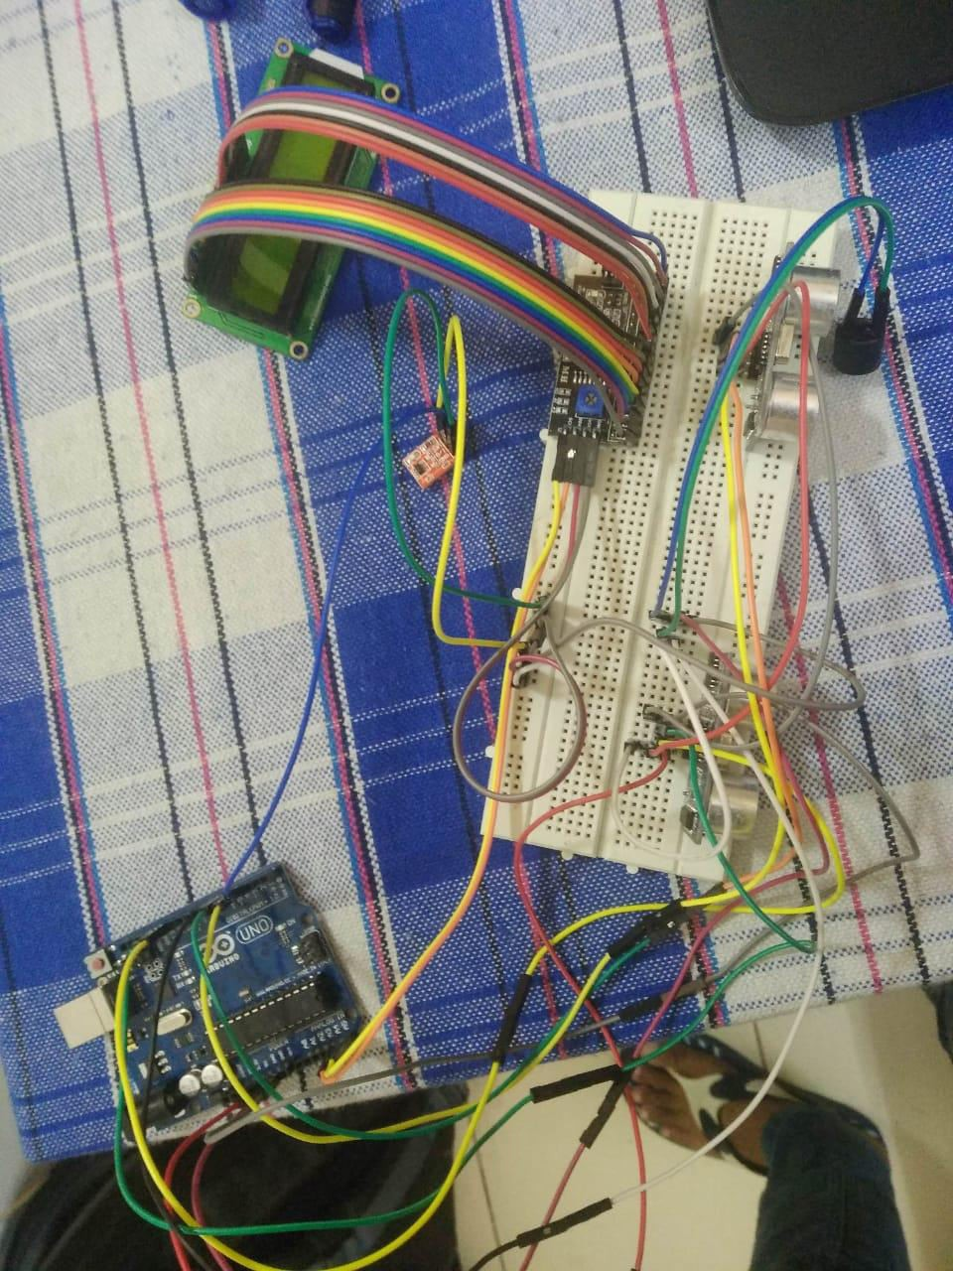

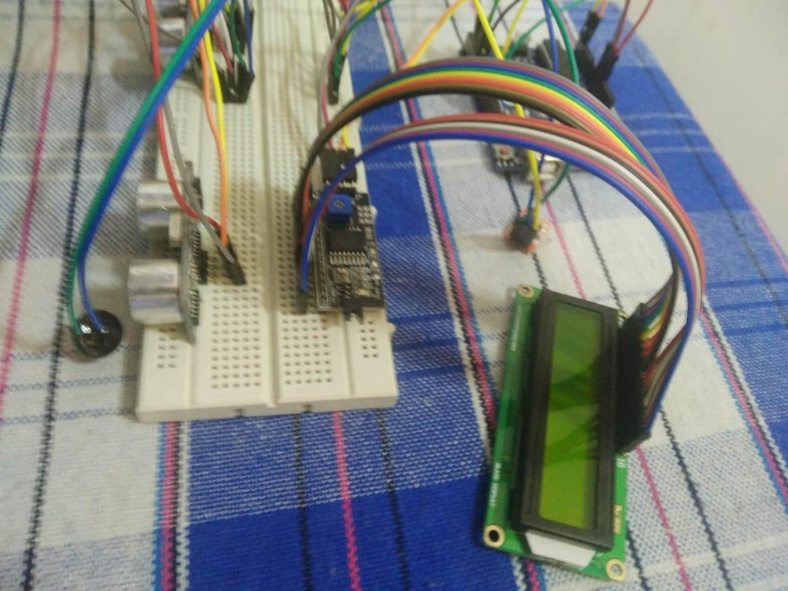

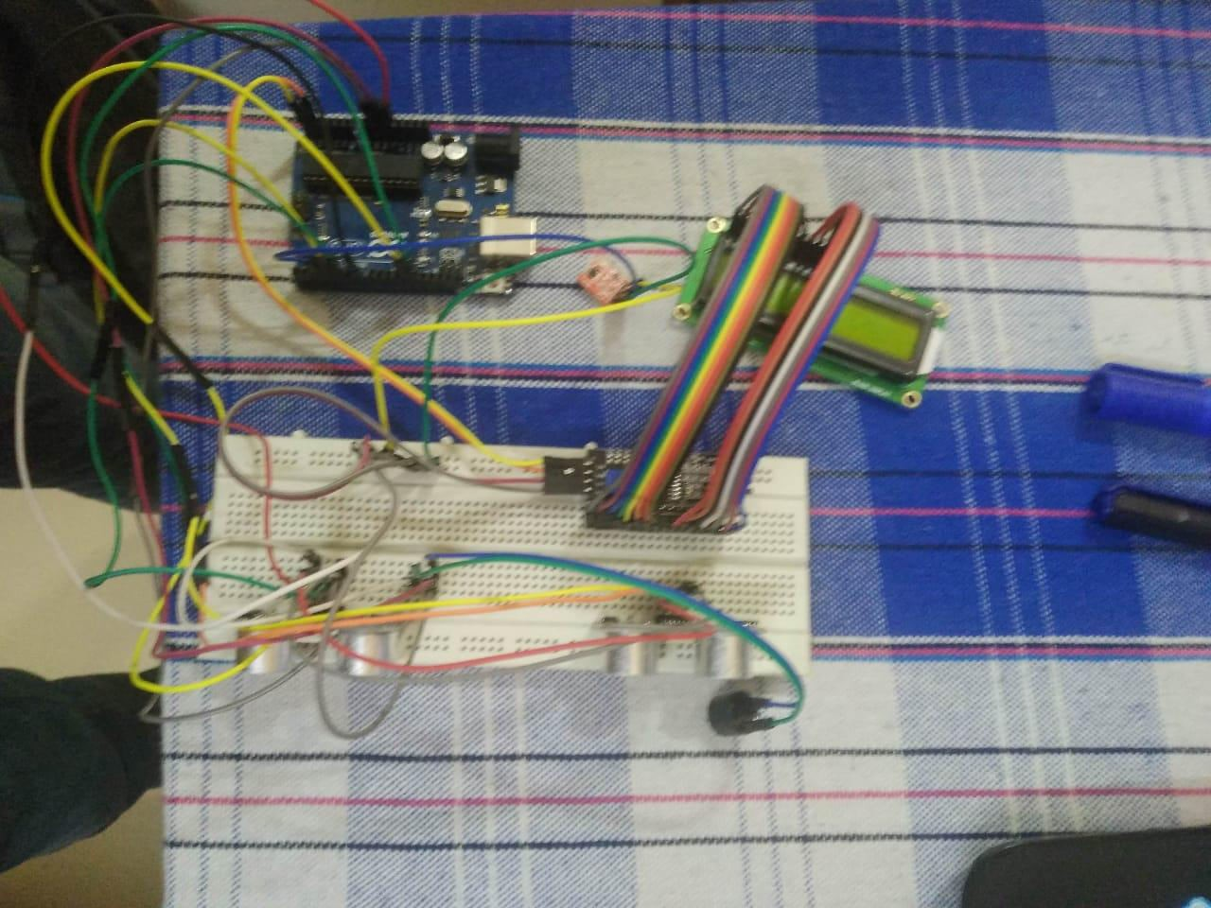

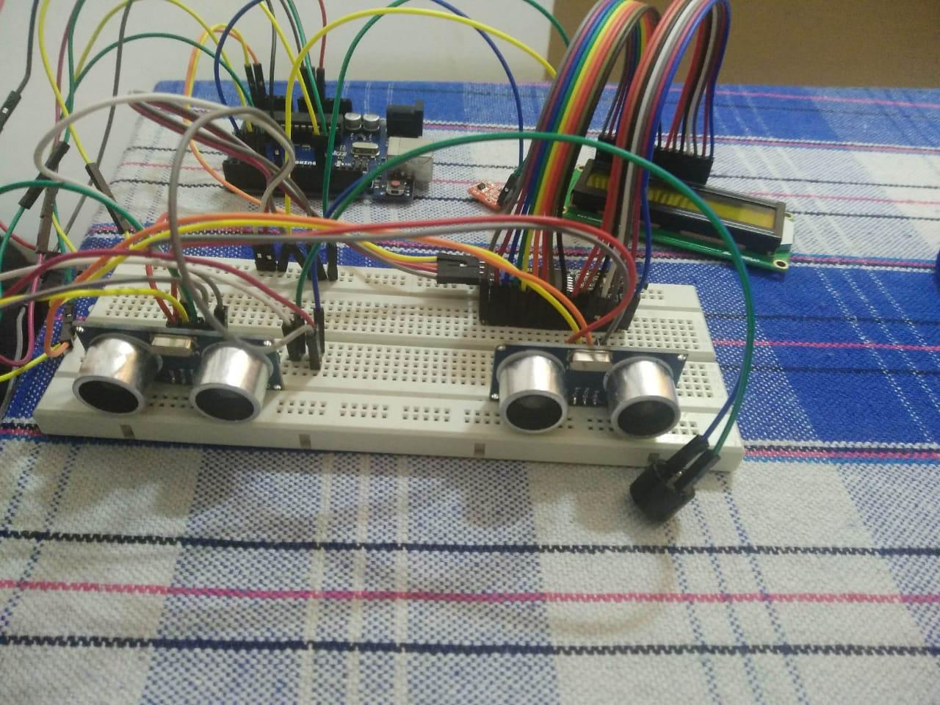

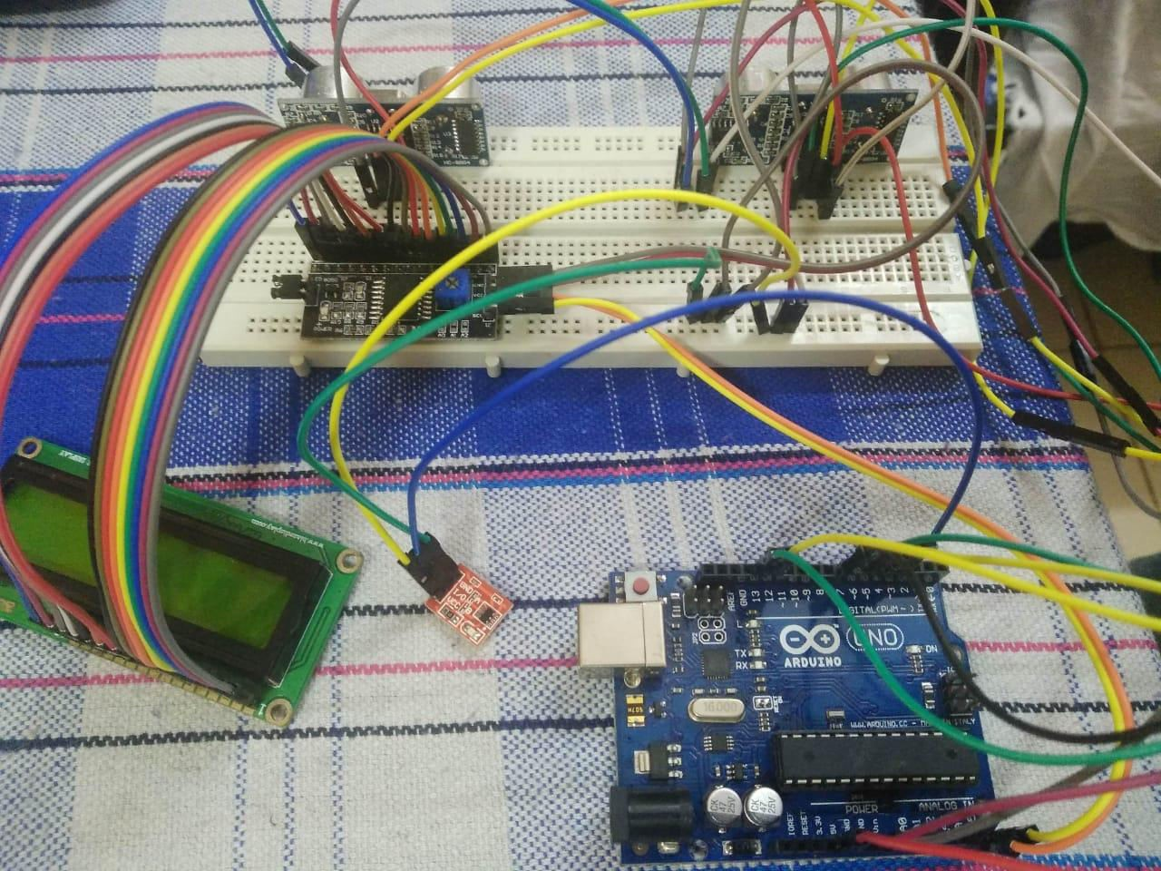

### CODE:

#include <Wire.h>

#include <LiquidCrystal_I2C.h> #define trigPin 12

#define echoPin 13

#define trigPin1 4

#define echoPin1 5

#define Buzzer 7

#define tch 3 int t;

LiquidCrystal_I2C lcd(0x27, 16, 2); void setup ()

{

Serial.begin(9600); lcd.begin(); lcd.backlight(); lcd.clear();

pinMode(trigPin, OUTPUT); pinMode(echoPin, INPUT); pinMode(trigPin1, OUTPUT); pinMode(echoPin1, INPUT); pinMode(tch, INPUT); pinMode(Buzzer, OUTPUT);

}

void loop ()

{

lcd.clear(); t=digitalRead(tch);

long duration,duration1,distance,distance1; digitalWrite(trigPin, LOW); delayMicroseconds(2); digitalWrite(trigPin, HIGH); delayMicroseconds(10); digitalWrite(trigPin, LOW);

duration = pulseIn(echoPin, HIGH); distance = (duration/2) / 29.1; digitalWrite(trigPin, LOW); digitalWrite(trigPin1, LOW); delayMicroseconds(2); digitalWrite(trigPin1, HIGH); delayMicroseconds(10); digitalWrite(trigPin1, LOW); duration1 = pulseIn(echoPin1, HIGH); distance1 = (duration1/2) / 29.1; digitalWrite(trigPin1, LOW); lcd.setCursor(0, 0);

lcd.print("D1="); lcd.setCursor(3, 0); lcd.print(distance); lcd.setCursor(8, 0); lcd.print("D2="); lcd.setCursor(12, 0); lcd.print(distance1);

if (distance<70 || distance>0 && distance1>=70)

{

lcd.setCursor(0, 1); lcd.print("OBJECT");

Serial.println("object detected \n"); Serial.print("distance= "); Serial.println(distance); digitalWrite(Buzzer, HIGH); tone(Buzzer,1000);

}

if (distance>=70 && distance1<70)

{

lcd.setCursor(0, 1); lcd.print("OBJECT"); Serial.println("object detected \n"); Serial.print("distance1= "); Serial.println(distance1); digitalWrite(Buzzer, HIGH); tone(Buzzer,5000);

}

if (distance<70 && distance1<70)

{

lcd.setCursor(0, 1); lcd.print("OBJECT"); Serial.println("object detected"); digitalWrite(Buzzer, HIGH); tone(Buzzer,7000);

}

if(distance>70 && distance1>70)

{

lcd.setCursor(0, 1); lcd.print("NO OBJ");

Serial.println("no object detected");

digitalWrite(Buzzer, LOW); noTone(Buzzer);

}

if(t==0)

{

Serial.println("SOS:NORMAL");

//digitalWrite(Buzzer, LOW);

//noTone(Buzzer); lcd.setCursor(6, 1); lcd.print(" NORMAL ");

}

if(t==1)

{

Serial.println("Emergency Button pressed");

//digitalWrite(Buzzer, LOW);

//noTone(Buzzer); lcd.setCursor(6, 1); lcd.print(" EMERGENCY");

}

delay(500);

}

## CHAPTER – 4

### RESULTS & DISCUSSION:

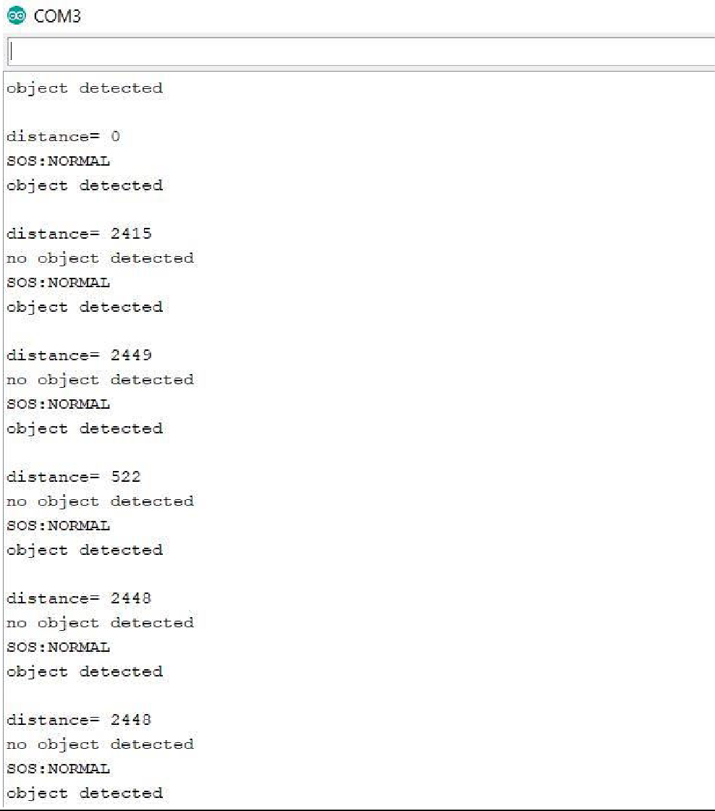

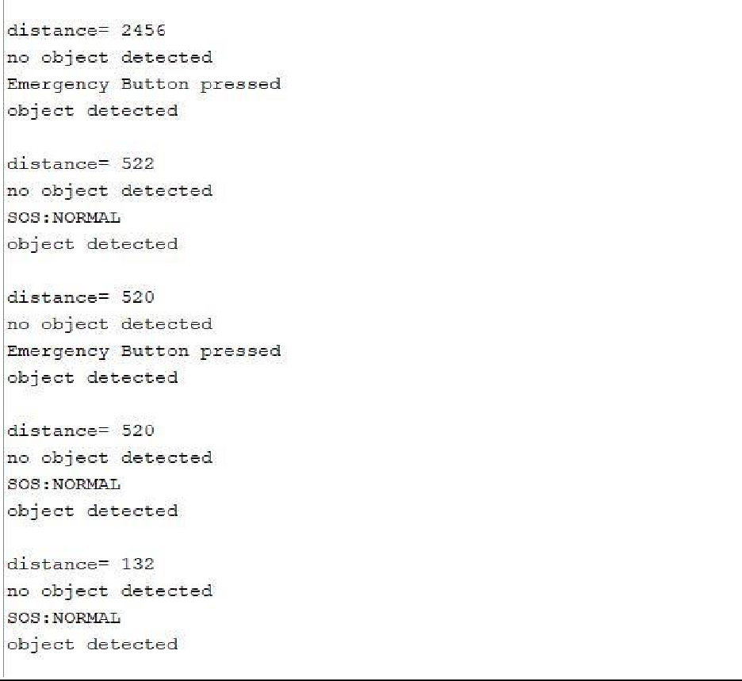

The output window displays the distance of the obstacle from both the sensors and also display the message of “Object Detected” and “No object detected “ depending on the direction of the obstacle.

The window also displays the status of the SOS touch sensor which says “Normal” when there is no impact and “Emergency Button Pressed” whenever an impact occurs.

The arduino functions continuously and both the sensors detect the distance of the obstacle and buzzer gets active only when the obstacle crosses the threshold range.

### CONCLUSION & FUTURE WORK

Our model provide a helping hand to the user in avoiding collisions with minor or major obstacles. The ultrasonic sensors detect the obstacle and sends the signal to the arduino which further informs the user about the obstacle thour the buzzer and the LCD display .

The advantage of this model lies in the fact that it can tell that when impact is about to happen. It shows the details like direction and distance for the avoidance any major accident. When the impact has already occurred it will let the driver know about the impact which has been held.

The system can be supplemented with actual GPS module, used in cars and we can get the information about the place the accident happened. It can be further enhanced by using VLSI technology to design the PCB unit. This makes the system further more compact.

Furthermore, other sensors like temperature, humidity sensors can be added to upgrade this project to the vast field of smart vehicle.

# REFERENCES

* + - Stackoverflow.com
    - Arduino.stackexcahnge.com
    - forum.arduino.cc
    - https://shodhganga.inflibnet.ac.in/bitstream/10603/188945/11/11_chapter%202.pdf