**X-Ray Disease Detection Using Deep Learning**<

A project report submitted for Lean Startup Management (TE-1)

**Bachelor of Technology in Computer Science Engineering**

*by*

## Ritwik Ranjan – 17BCE0488 Udit Singhania-17BCE2060 Simran Koul-17BCE2210

**SCHOOL OF COMPUTER SCIENCE ENGINEERING**



November, 2019

**TABLE OF CONTENTS**

|  |  |  |  |  |
| --- | --- | --- | --- | --- |
| **CHAPTER**  **NO.** | **TITLE** | | | **PAGE**  **NO.** |
|  | **EXECUTIVE SUMMARY / ABSTRACT** | | | i |
|  | **LIST OF TABLES** | | | ii |
|  | **LIST OF FIGURES** | | | iii |
|  | **LIST OF SYMBOLS AND ABBREVIATIONS** | | | v |
| **1** | **INTRODUCTION AND LITERATURE REVIEW** | | | 1 |
|  | 1.1 | | CONCEPT | 1 |
|  | 1.2 | | PROBLEM DEFINITION | 2 |
|  | 1.3 | | OBJECTIVES OF THE WORK | 3 |
|  |  | |  |  |
| **2** | **METHODOLOGY AND EXPERIMENTAL**  **WORK** | | | 5 |
|  | 2.1 | METHODOLOGY | | 5 |
|  | 2.2 | MODELLING/FEA ANALYSIS/LITERATURE  REVIEW | | 7 |
|  | 2.3 | EXPERIMENTAL PROCEDURE  /MATHAMATECIAL CALCULATION | | 10 |
| **3** | **RESULTS AND DISCUSSION** | | | 12 |
| **4** | **CONCLUSION** | | | 21 |
|  | 4.1 | CONCLUSION | | 21 |
|  | 4.2 | FUTURE SCOPE OF WORK | | 22 |
|  |  | **REFERENCES** | | 23 |

## ABSTRACT

This project aims to build an AI based Healthcare startup which will take the image of the X-Ray and predict which of the 8 diseases is present in the patient’s X-Ray.This model will aim to be used by doctors who find it difficult to handle large number of cases at a very substantial fee and also this startup will help the nonmedical individuals to cross-verify the reports that they obtain from the examination from the doctors.This startup is also aimed for radiology students who can cross verify their examination by giving the input of the X-Ray and with the obtained results, thereby increasing the efficiency in the new generation doctors.

X-ray is a classical method for diagnosis of some chest diseases. The diseases are reparable in the event that they are distinguished in their beginning periods. Detection of chest diseases is mostly based on chest X-ray images (CXR). This is a tedious procedure and consumes too much time. At times, medical experts had overlooked the diseases in their first examinations on CXR, and when the images were re- examined, the infection signs could be identified.

Create a AI based Computer Aided Diagnosis Tool, which can classify he input X-Ray images into one of the 14 abnormalities- Atelectasis, Consolidation, Infiltration, Pneumothorax, Edema, Emphysema, Fibrosis, Effusion, Pneumonia, Pleural-thickening, Cardiomegaly, Nodule, Mass and Hernia. Diseases are identified by Class Activation Maps, which highlight the areas of the X-Ray that are most important for making a particular abnormality classification

A major health sector issue in India is lack of Diagnosis Support System and doctors to serve the large number of patients in rural areas. Indian Hospitals in rural areas also lack Radiologist. 1000 of cases are usually handled by single available doctor for X-Ray diagnosis. To assist the doctors in arriving at quick diagnosis, it is recommended to have a solution that can do Computer Aided Diagnosis for the Chest X-Ray

**LIST OF FIGURES**

|  |  |  |
| --- | --- | --- |
| **Figure**  **No.** | **Title** | **Page No.** |
| 1 | ARCHITECTURE OF NEURAL NET USED | 15 |
| 2 - 3 | ACCURACY AND LOSS GRAPHS | 16 |
| 4-7 | SAMPLE CODE OF THE PROGRAM | 17-18 |
| 8 | RESULTS OF TEST DATA | 19 |
| 9-15 | SNAPSHOTS OF THE WEBSITE | 20-25 |
| 16 | FLOWCHART OF THE WEBSITE | 25 |

# INTRODUCTION AND LITERATURE REVIEW

* 1. **CONCEPT**

X-ray is a classical method for diagnosis of some chest diseases. The diseases are reparable in the event that they are distinguished in their beginning periods. Detection of chest diseases is mostly based on chest X-ray images (CXR). This is a tedious procedure and consumes too much time. At times, medical experts had overlooked the diseases in their first examinations on CXR, and when the images were re- examined, the infection signs could be identified.

Create a AI based Computer Aided Diagnosis Tool, which can classify he input X-Ray images into one of the 14 abnormalities- Atelectasis, Consolidation, Infiltration, Pneumothorax, Edema, Emphysema, Fibrosis, Effusion, Pneumonia, Pleural-thickening, Cardiomegaly, Nodule, Mass and Hernia. Diseases are identified by Class Activation Maps, which highlight the areas of the X-Ray that are most important for making a particular abnormality classification.

This project aims to build an AI based Healthcare startup which will take the image of the X-Ray and predict which of the 8 diseases is present in the patient’s X-Ray.This model will aim to be used by doctors who find it difficult to handle large number of cases at a very substantial fee and also this startup will help the nonmedical individuals to cross-verify the reports that they obtain from the examination from the doctors.

This startup is also aimed for radiology students who can cross verify their examination by giving the input of the X-Ray and with the

obtained results, thereby increasing the efficiency in the new generation doctors.

* 1. **PROBLEM DEFINITION**

A major health sector issue in India is lack of Diagnosis Support System and doctors to serve the large number of patients in rural areas.

Indian Hospitals in rural areas also lack Radiologist. Thousands of cases are usually handled by single available doctor for X-Ray diagnosis. To assist the doctors in arriving at quick diagnosis, it is recommended to have a solution that can do Computer Aided Diagnosis for the Chest X-Ray

Our solution proposes the use of transfer learning approaches or traditional handcrafted techniques to achieve a remarkable classification performance, we use cross-verify different algorithms to extract features from a given chest X-ray image and classify it to determine if a person is infected with any of the disease.

This model could help mitigate the reliability and interpretability challenges often faced when dealing with medical imagery. We deployed several data augmentation algorithms to improve the validation and classification accuracy of the CNN model and achieved remarkable validation accuracy.

* 1. **OBJECTIVES OF THE WORK**

Medical check-ups in rural India- Indian Hospitals in rural areas also lack Radiologist. Thousands of cases are usually handled by single available doctor for X-Ray diagnosis. Our product can help them to directly communicate with professional doctors without coming to city

Accurate reports – Accurate reports can be provided instantly to the docter and it will be in the database for further reference and to assist the doctors in arriving at quick diagnosis, it is recommended to have a solution that can do Computer Aided Diagnosis for the Chest X-Ray.

Traditional pricing rules no longer apply -Transparency in Price is one of the best advantages that we can deliver to our customers and this also helps them to pay minimal amount for almost every test they have

This project aims to build an AI based Healthcare startup which will take the image of the X-Ray and predict which of the 8 diseases is present in the patient’s X-Ray.

This model will aim to be used by doctors who find it difficult to handle large number of cases at a very substantial fee and also this startup will help the non-medical individuals to cross-verify the reports that they obtain from the examination from the doctors.

This startup is also aimed for radiology students who can cross verify their examination by giving the input of the X-Ray and with the obtained results, thereby increasing the efficiency in the new generation doctors.

# METHODOLOGY AND EXPERMENTAL WORK

## METHODLOGY

This model will aim to be used by doctors who find it difficult to handle large number of cases at a very substantial fee and also this startup will help the nonmedical individuals to cross-verify the reports that they obtain from the examination from the doctors.

This startup is also aimed for radiology students who can cross verify their examination by giving the input of the X-Ray and with the obtained results, thereby increasing the efficiency in the new generation doctors**.**

Our solution proposes a convolutional neural network (CNN) model trained from scratch to classify and detect the presence of the diseases from a collection of chest X-ray image samples. Unlike other methods that rely solely on transfer learning approaches or traditional handcrafted techniques to achieve a remarkable classification performance, we constructed a convolutional neural network model from scratch to extract features from a given chest X-ray image and classify it to determine if a person is infected with any of the disease.

This model could help mitigate the reliability and interpretability challenges often faced when dealing with medical imagery. We deployed several data augmentation algorithms to improve the validation and classification accuracy of the CNN model and achieved remarkable validation accuracy.

The overall architecture of the proposed CNN model which consists of two major parts: the feature extractors and a classifier (sigmoid activation function). Each layer in the feature extraction layer takes its

immediate preceding layer's output as input, and its output is passed as an input to the succeeding layers.

The proposed architecture consists of the convolution, max-pooling, and classification layers combined together. The feature extractors comprise conv3×3, 32; conv3×3, 64; conv3×3, 128; conv3×3, 128, max-pooling layer of size 2×2, and a RELU activator between them.

The output of the convolution and max-pooling operations are assembled into 2D planes called feature maps, and we obtained 198×198×32, 97×97×62, 46×64×128, and 21×21×128 sizes of feature maps, respectively, for the convolution operations and 99×99×32, 48×48×64, 23×23×128, and 10×10×128 sizes of feature maps from the pooling operations, respectively, with an input of image of size 200×200×3.

## MURA: Large Dataset for Abnormality Detection in Musculoskeletal Radiographs

We introduce MURA, a large dataset of musculoskeletal radiographs containing 40,561 images from 14,863 studies, where each study is manually labeled by radiologists as either normal or abnormal. To evaluate models robustly and to get an estimate of radiologist performance, we collect additional labels from six board-certified Stanford radiologists on the test set, consisting of 207 musculoskeletal studies. On this test set, the majority vote of a group of three radiologists serves as gold standard. We train a 169-layer DenseNet baseline model to detect and localize abnormalities. Our model achieves an AUROC of 0.929, with an operating point of 0.815 sensitivity and 0.887 specificity. We compare our model and radiologists on the Cohen's kappa statistic, which expresses the agreement of our model and of each radiologist with the gold standard. Model performance is comparable to the best radiologist performance in detecting abnormalities on finger and wrist studies.

However, model performance is lower than best radiologist

performance in detecting abnormalities on elbow, forearm, hand humerus, and shoulder studies. We believe that the task is a good challenge for future research.

## LITERATURE REVEIW

1. **Deep learning in radiology: an overview of the concepts and a survey of the state of the art.**

**Maciej A. Mazurowski1, 2, 3, Mateusz Buda1, Ashirbani Saha1, Mustafa**

**R. Bashir1,**

**Abstract:** Deep learning is a branch of artificial intelligence where networks of simple interconnected units are used to extract patterns from data in order to solve complex problems. Deep learning algorithms have shown ground-breaking performance in a variety of sophisticated tasks, especially those related to images. They have often matched or exceeded human performance. Since the medical field of radiology mostly relies on extracting useful information from images, it is a very natural application area for deep learning, and research in this area has rapidly grown in recent years. In this article, we review the clinical reality of radiology and discuss the opportunities for application of deep learning algorithms. We also introduce basic concepts of deep learning including convolutional neural networks. Then, we present a survey of the research in deep learning applied to radiology. We organize the studies by the types of specific tasks that they attempt to solve and review the broad range of utilized deep learning algorithms. Finally, we briefly discuss opportunities and challenges for incorporating deep learning in the radiology practice of the future.

**Methodology:** While detection, diagnosis, and characterization of disease receive the primary attention among algorithm developers, another important area where artificial intelligence could contribute is in facilitating the workflow of the radiologists while interpreting images. With the widespread con- version from printed films to centralized Picture Archiving and Viewing Systems (PACS) as well as the availability of multi- planar, multi-contrast, and multi-phase imaging, radiologists have seen exponential growth in the size and complexity of image data to be analysed. Additionally, interpretations must often be rendered in the context of a multitude of prior examinations. The simple task of finding and presenting these data is complex, and artificial intelligence systems may be well-suited for this role.

An example of a highly complex workflow is that for many cancer patients. Such patients are not uncommonly afflicted with more than one primary tumour, metastatic disease to numerous sites, and may have undergone a variety of biopsies, locoregional therapies, and systemic therapies with varying results. In the simplest scenario, interpretation of a follow-up imaging examination requires colocalization of all relevant sites of disease between the current and prior examinations. Measurements of size are performed, and in some cases functional features, such as tumour perfusion or diffusion restriction, are assessed either subjectively or objectively. Most radiology practices utilize imaging equipment of different types, generations, and often different vendors, thus simply identifying the appropriate image sets in prior examinations can be very challenging. After the appropriate images have been identified, the radiologist must colocalize disease sites and attempt to obtain precise repeated measurements in order to ensure that the values obtained from the current and prior examinations can be compared.

Each of the above tasks is time-consuming and does not necessarily require the full skill of a radiologist. However, standard PACS systems are not able to reliably present all of the above data for a variety of reasons, including the variability in labeling the types and components of imaging examinations, the variability in patient positioning and anatomy between examinations, the variability in modalities used to image the same portion of the anatomy, as well as other factors. In principle, an artificial intelligence algorithm could assess a patient’s prior imaging, bring forward examinations that include the relevant body part(s), detect the image modality and contrast type, and determine the location of the area of interest within the relevant anatomy to reduce the radiologist’s effort in performing these relatively mundane tasks.

Image interpretation tasks that radiologists do not perform but deep learning could. In addition to performing tasks that are a part of the current radiological practice, computer al- gorithms could perform medical image interpretation tasks that radiologists do not perform on a regular basis. The research toward this goal has been underway for some time, mostly using traditional machine learning and image processing algorithms. One example is radiogenomics, which aims to find relationships between imaging features of tumors and their genomic characteristics. Examples can be found in breast cancer, glioblastoma, low grade glioma, and kidney cancer. Radiogenomics is not a part of the typical clinical practice of a radiologist. Another example is prediction of outcomes of cancer patients with applications in glioblastoma, lower grade glioma, and breast cancer. While imaging features have a potential to be informative of patient

outcomes, very few are currently used to guide oncological treatment. Deep learning could facilitate the process of incorporating more of the information available from imaging into the oncology practice.

**Conclusion:** In summary, in this paper there are principles of deep learning as well as the current practice of radiology to elucidate how these new algorithms can be incorporated into radiology workflow. They have discussed the progress and state of art in the field. Finally, they have discussed some challenges and questions related to implementation of deep learning in the current practice of medicine. All signs show that deep learning will play a significant role in radiology. The next 5 years will be a very exciting time in the field that may see many questions stated in this article answered through a collaboration of machine learning scientists and radiologists

1. **PADCHEST: A LARGE CHEST X-RAY IMAGE DATASET WITH MULTI-LABEL ANNOTATED REPORTS**

**Aurelia Bustos Department of Software and Computing Systems University Institute for Computing Research University of Alicante, Spain**

**Abstract**: We present a labelled large-scale, high resolution chest x-ray dataset for the automated exploration of medical images along with their associated reports. This dataset includes more than 160,000 images obtained from 67,000 patients that were interpreted and reported by radiologists at Hospital San Juan Hospital (Spain) from 2009 to 2017, covering six different position views and additional information on image acquisition and patient demography. The reports were labelled with 174 different radiographic findings, 19 differential diagnoses and 104 anatomic locations organized as a hierarchical taxonomy and mapped onto standard Unified Medical Language System (UMLS) terminology. Of these reports, 27% were manually annotated by trained physicians and the remaining set was labelled using a supervised method based on a recurrent neural network with attention mechanisms. The labels generated were then validated in an independent test set achieving a 0.93 Micro-F1 score. To the best of our knowledge, this is the largest public chest x-ray database suitable for training supervised models concerning radiographs, and the first to contain radiographic reports in Spanish. The PadChest dataset can be downloaded from [http://bimcv.cipf.es/bimcv-projects/padchest/.](http://bimcv.cipf.es/bimcv-projects/padchest/)

**Methodology**: The PadChest dataset consists of all the available chest-x rays that had been interpreted and reported by 18 radiologists at the Hospital

Universitario de San Juan, Alicante (Spain) from Jan 2009 to Dec 2017, amounting to 109,931 studies and 168,861 different images, as shown in Tab. 7. This project was approved by the institutional research committee, and both the images and the associated reports were made anonymous and de-identified by the Medical Image Bank of the Valencian Community at the Department of Universal Health and Public Health Services (BIMCV-CSUSP) and the Health Informatics Department at San Juan Hospital. The PadChest dataset can be downloaded from the repository of the medical imaging bank (BIMCV - PADCHEST1), enabled by the Medical Image Bank of the Valencian Community (BIMCV). The BIMCV has launched various projects regarding population medical images, whose objective is to develop and implement an infrastructure with a massive storage capacity following the R&D Cloud CEIB architecture [23]. One of the missions of this bank is to promote the publication of scientific knowledge as open data by its affiliated health institutions.

PadChest contains image files adding up to 1 TB, a csv file with 33 fields for each study and an instruction file containing field descriptions, examples and search information for efficient image retrieval. An example of a dataset study with two projections can be found in C, along with its associated labels and additional information fields. The methodology employed to build PadChest comprises the following main steps:

* Pre-processing of the images and DICOM metadata extraction.
* Pre-processing of the reports.

**Conclusion**: In this work, we present the largest public chest x-ray dataset, which contains more than 160K images and Spanish reports labelled with 299 different medical entities mapped on to UMLS CUIs. It is expected that this dataset and the projects derived from it will ultimately assist in the development of diagnostic decision support systems, thus increasing clinical practice efficiency. The main contributions of PadChest are the following:

This is the first large-scale exploitable dataset available in Spanish. Given that it has been labelled with standardized medical codes, it is ready for further image exploitation, regardless of the language required. This is the largest publicly available labelled dataset that, in contrast to previously published works, includes different projection views and additional metadata, which is essential information if the models are to be trained adequately, as discussed previously. Trained physicians manually annotated 27% of the dataset samples, and a RNN- ATT method was used to label the remaining reports. We propose hierarchical taxonomies in order to categorize radiographic findings, differential diagnoses and anatomical locations following UMLS CUI standard codes. To the best of

our knowledge, available labelled datasets have a lower number of different labels.

The manually labelled dataset was used to train models for the automatic annotation of a Spanish corpus of x-ray reports. The best model was used to label 73% of the PadChest dataset and achieved a 0.93 MicroF1 score for an independent test set, proving the robustness of the proposed approach as regards labelling the full dataset. One downside is that all the data were drawn from a single institution, but the fact that the training and test sets belong to different year intervals (2014-2017 and 2009-2014, respectively), thus increasing the variability of the reporting radiologists, supports that the model has the potential to be generalized. This would, however, have to be confirmed by using reports from other Spanish institutions. This dataset can be used to train models to predict thoracic pathologies affecting lung, cardiovascular and bone structures from x- ray images.

1. **Applying Multi-CNNs model for detecting abnormal problem on chest x- ray images**

**a.Phat Nguyen Kieu Department of Academic Affairs, Nguyen Tat Thanh University Ho Chi Minh City, Viet Nam** [**nkphat@ntt.edu.vn**](mailto:nkphat@ntt.edu.vn)

**b.Hai Son Tran HCM University of Education, University of Informatics Technology- VNU-HCM,**

**Abstract:** Image diagnosis is the significant problem in medicine. Nowadays, with modern facilities that allow doctors to diagnose early and accurately disease, limiting unnecessary treatment procedures. By that way, the image diagnosis is at the forefront of the processing diagnosis and treatment of the disease. Heart and lung failure accounts for more than 500,000 deaths annually in the United States and is most commonly screened for using plain fiOP FKHVW X-Ray (CXR). With the growing number of patients, the doctors must overwork, so he cannot counsel and direct take care of his patient. So, a computer system that supports image classification is needed. In this paper, we propose a deep learning model to detect abnormal sentisy in chest x-ray images. The proposed model uses multiple Convolutional Neural Network to decide input image, this is called Multi- CNNs. Input data is the digital chest X-ray image dataset that was collected from 6/2017 to 3/2018 at An Binh Hospital, HCM, VN (AB-CXR-Database). Each component of the Multi-CNN is a convolutional neural network that is developed base on ConvnetJS library. The output of the proposed model is Normal/Abnormal density. In this paper, we also propose a method for synthesizing the results of the components of the model which we are called Fusion rules. The experimental results 96% in our x-rays image dataset showed the feasibility of a proposed Multi-CNNs model.

**Methodology:** There are many classification methods is proposed to solve this problem. At present, popular methods for solving image classification problems, such as K-Mean, K-NN, deep neural network, Support Vector Machine (SVM). One of the popular approaches is used method of Artificial Neural Networks for pattern classification problem. Convolutional neural network (CNN) is one of the deep learning models that has garnered much interest from researchers in recent years. It's used a lot of in image classification, image recognition, language translate, medical diagnostics, and many other domains, etc. and giving a result with high accuracy.

Therefore, in this paper, they have proposed a model called Multi-CNNs based on convolutional neural network. In this paper, we also propose a method for synthesizing the results of the components of the model which we are called Fusion rules. The experimental results 96% in our x-rays image dataset showed the feasibility of a proposed Multi- CNNs model.

**Conclusion:** In this research, we proposed Multi-CNNs model and a method for synthesizing the results of the components of the model which we are called fusion rules. The proposed Multi-CNNs model consists of three components: CNN 128F, CNN 64L, and CNN 64R. These components are developed based on CNN. The proposed model used the association fusion rule in order to combine the results. The fusion rules process to integrate the results in 8 cases to make the final conclusion of the Multi-CNNs classification model.

* 1. EXPERIMENTAL PROCEDURE

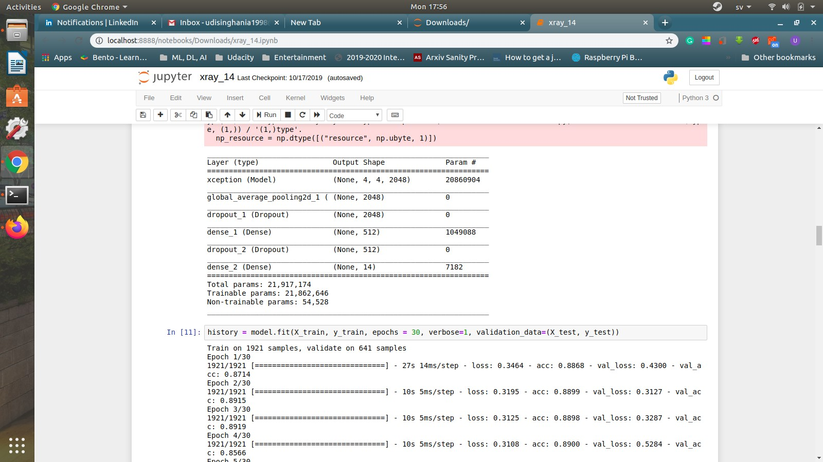

Fig 1

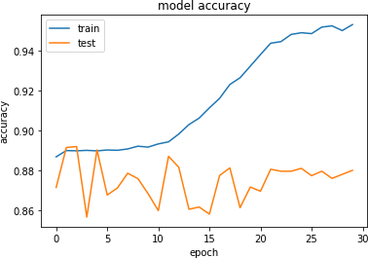

Fig 2

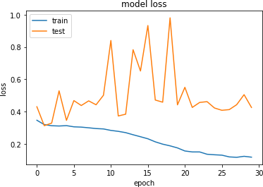

Fig 3

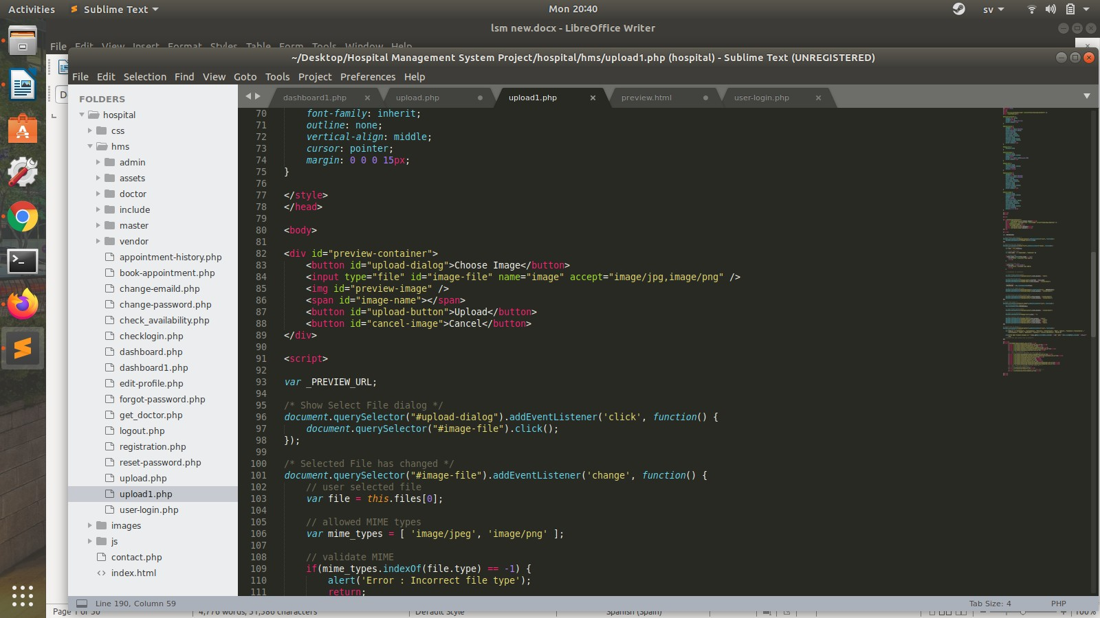

Fig 4

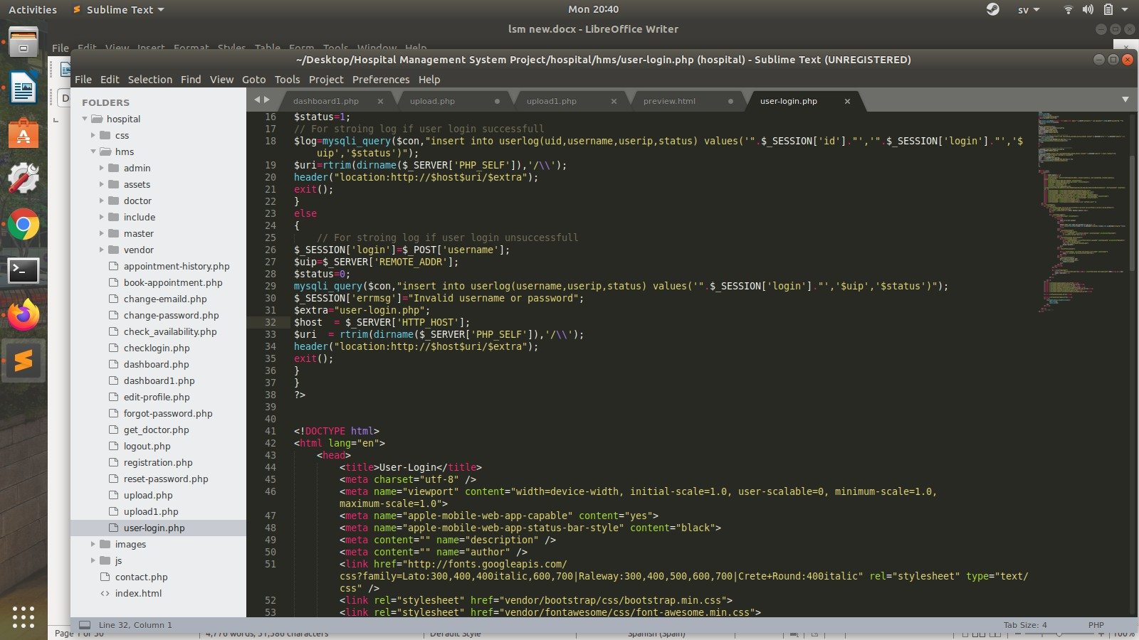

Fig 5

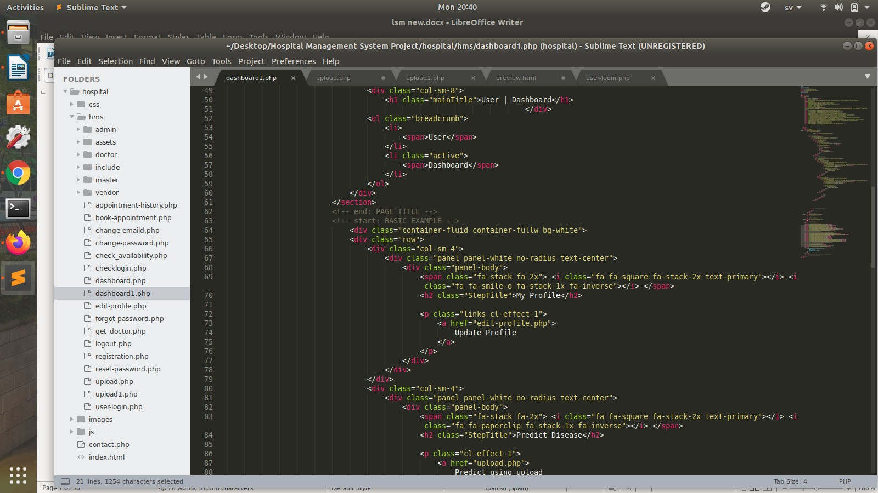

Fig 6

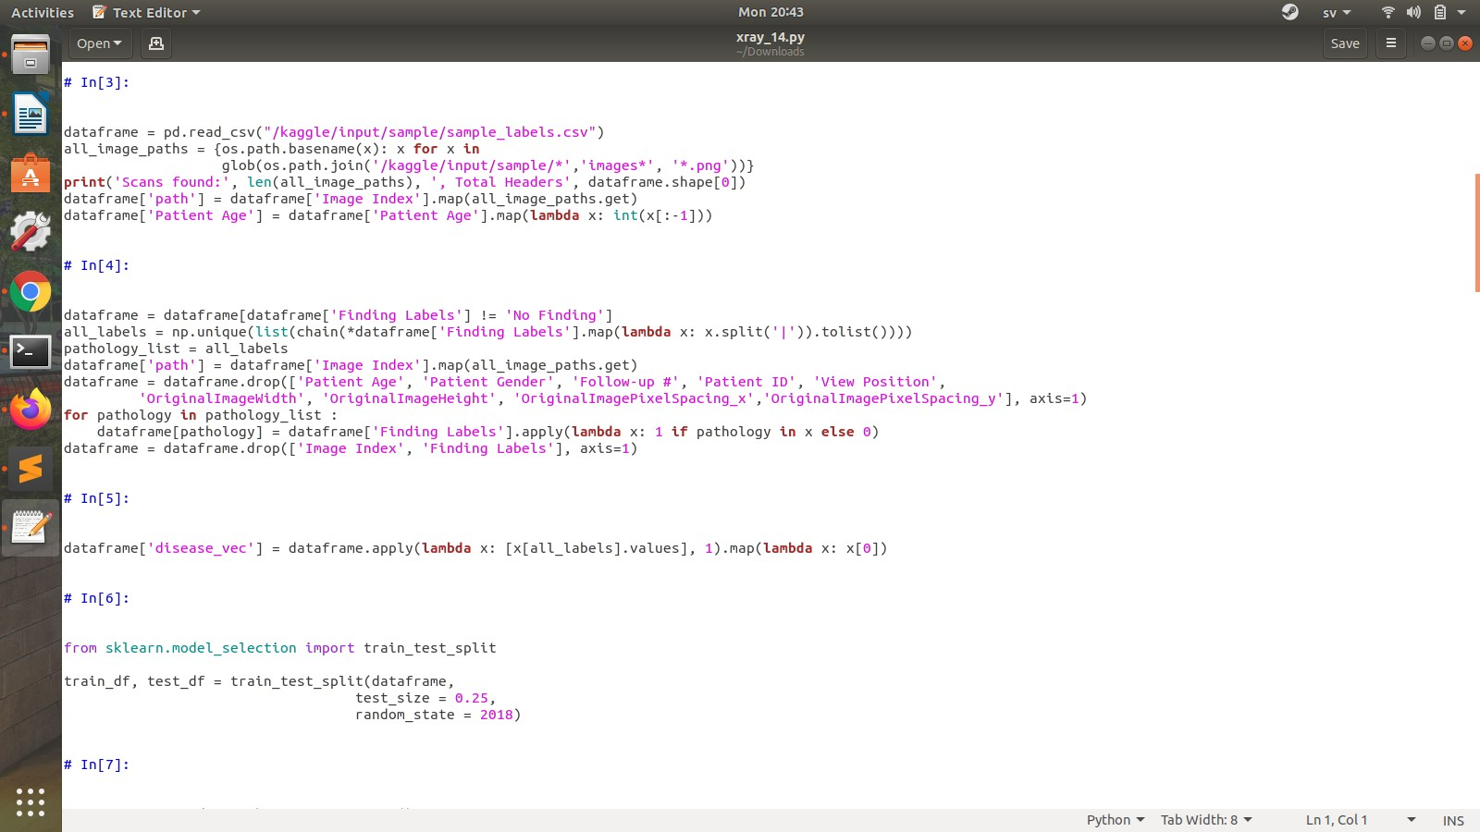

Fig 7

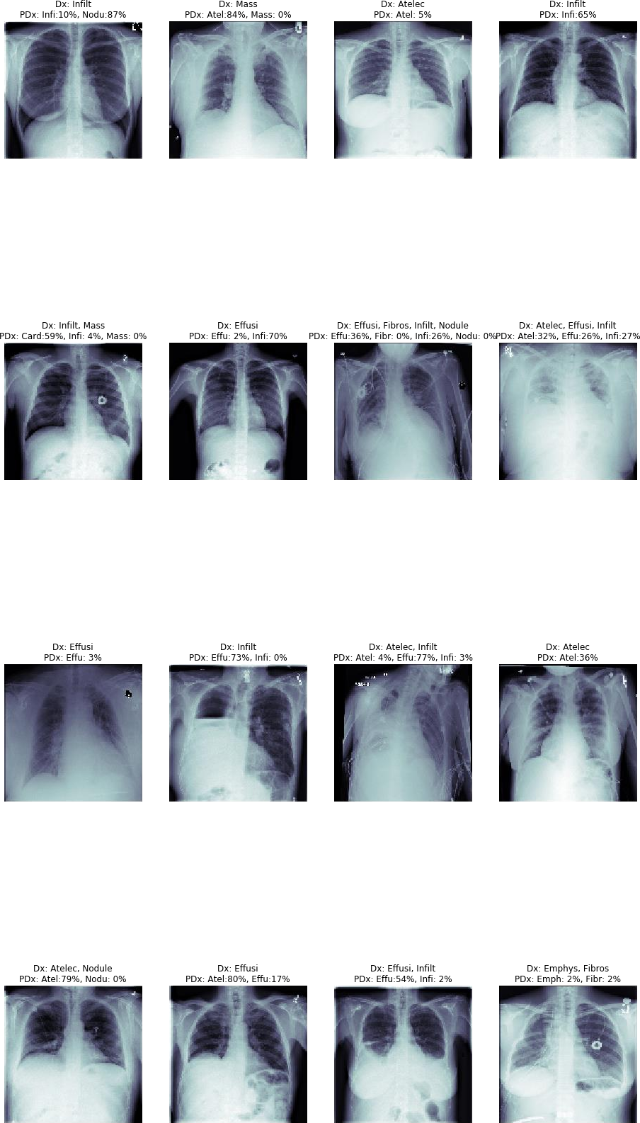

Fig 8

# 3. RESULTS AND DISSCUSSION

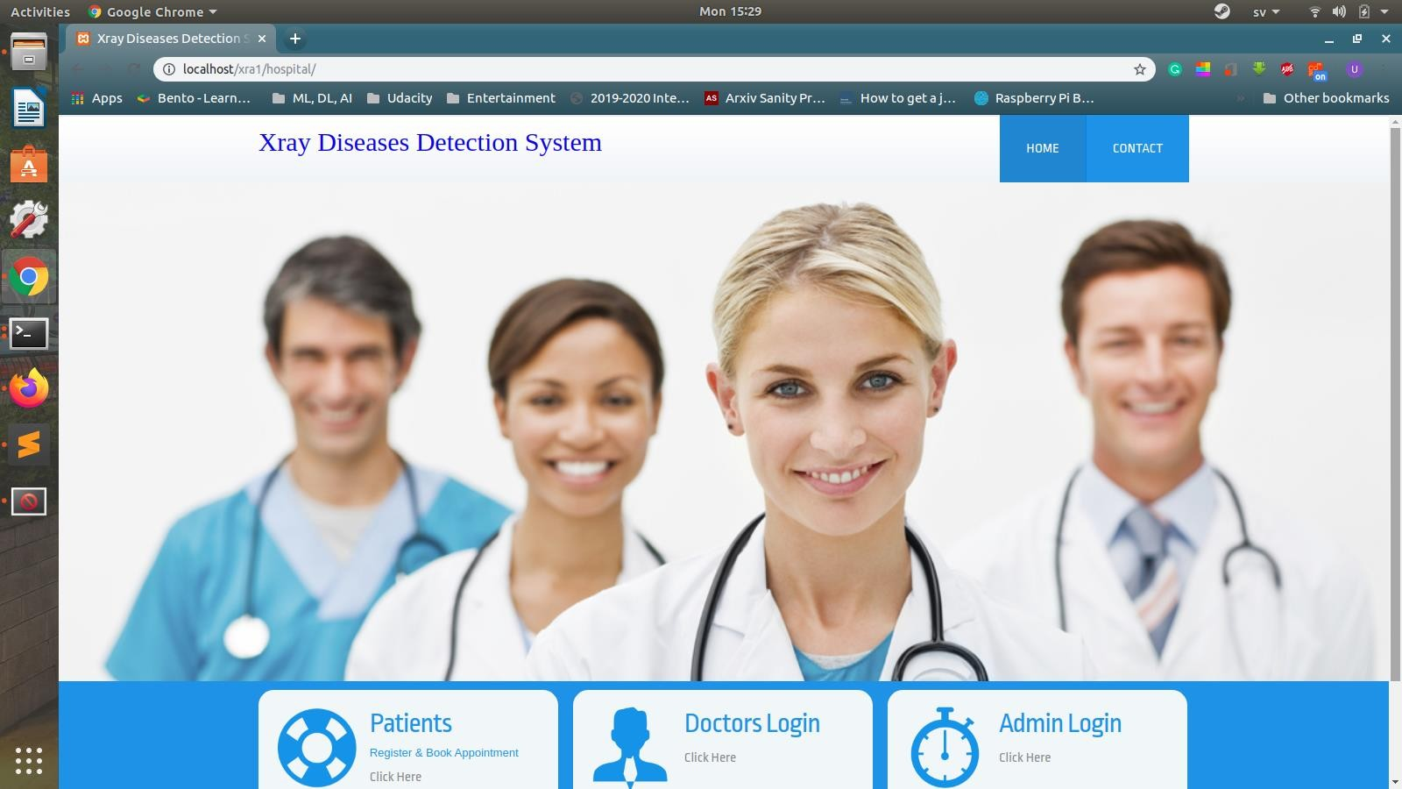

Fig 9

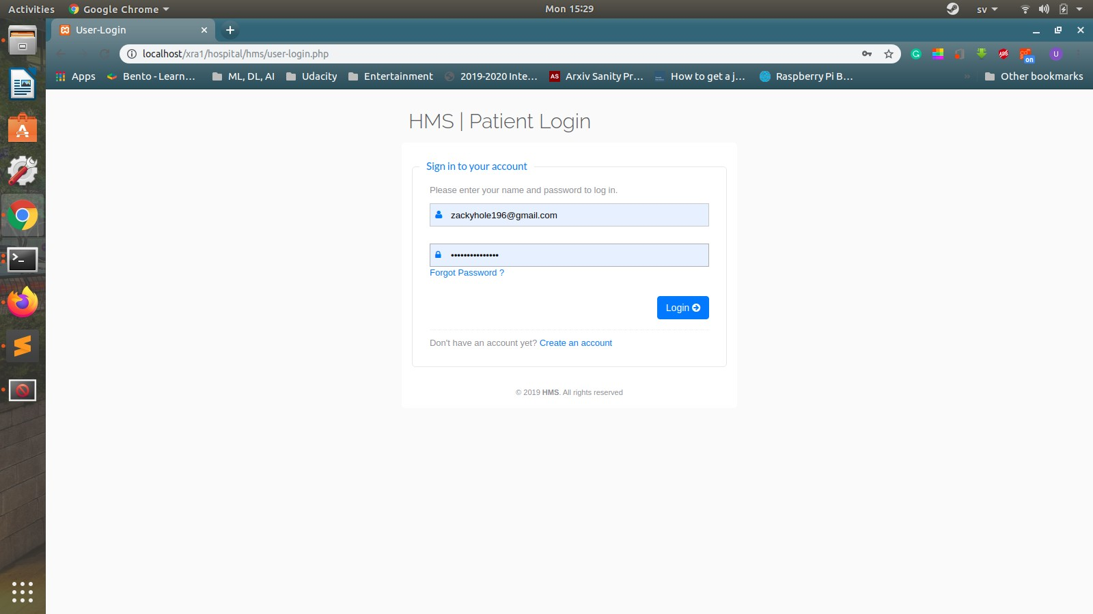

Fig 10

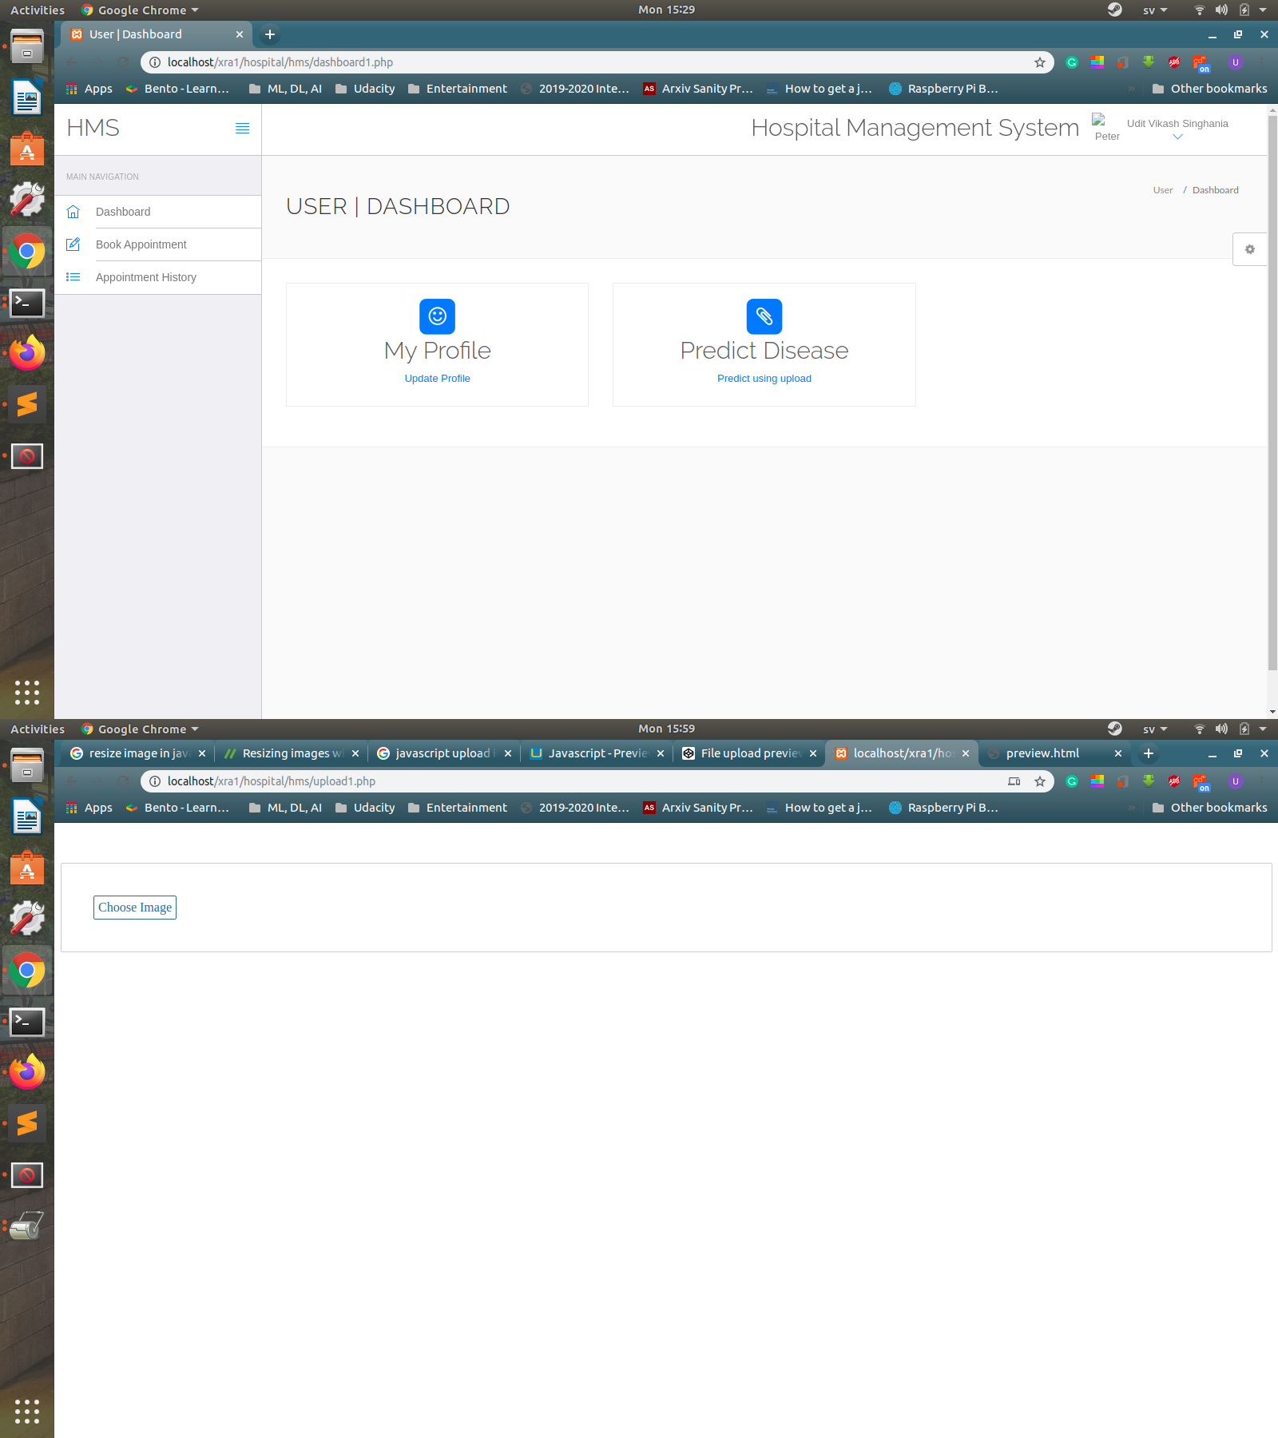

Fig 11

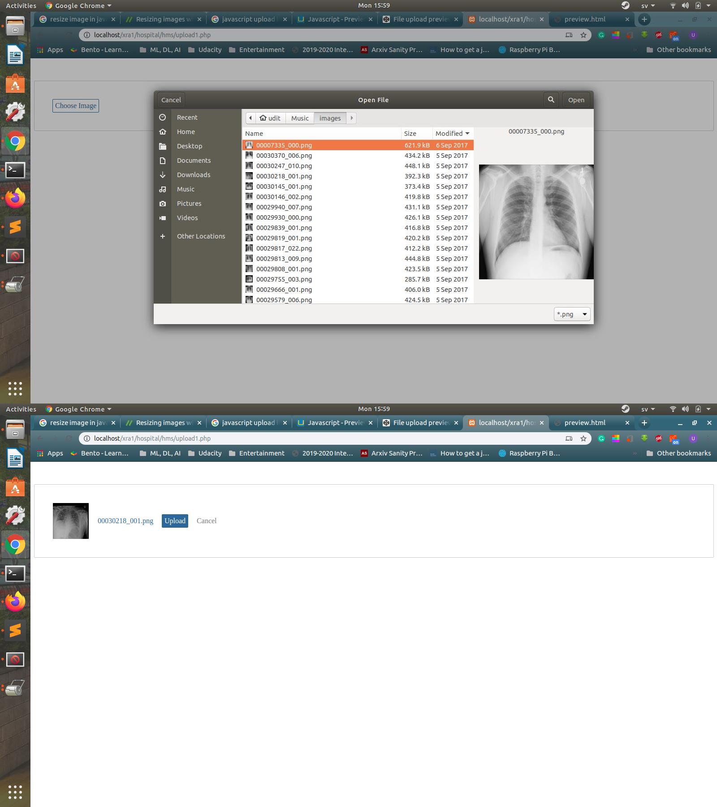

Fig 12

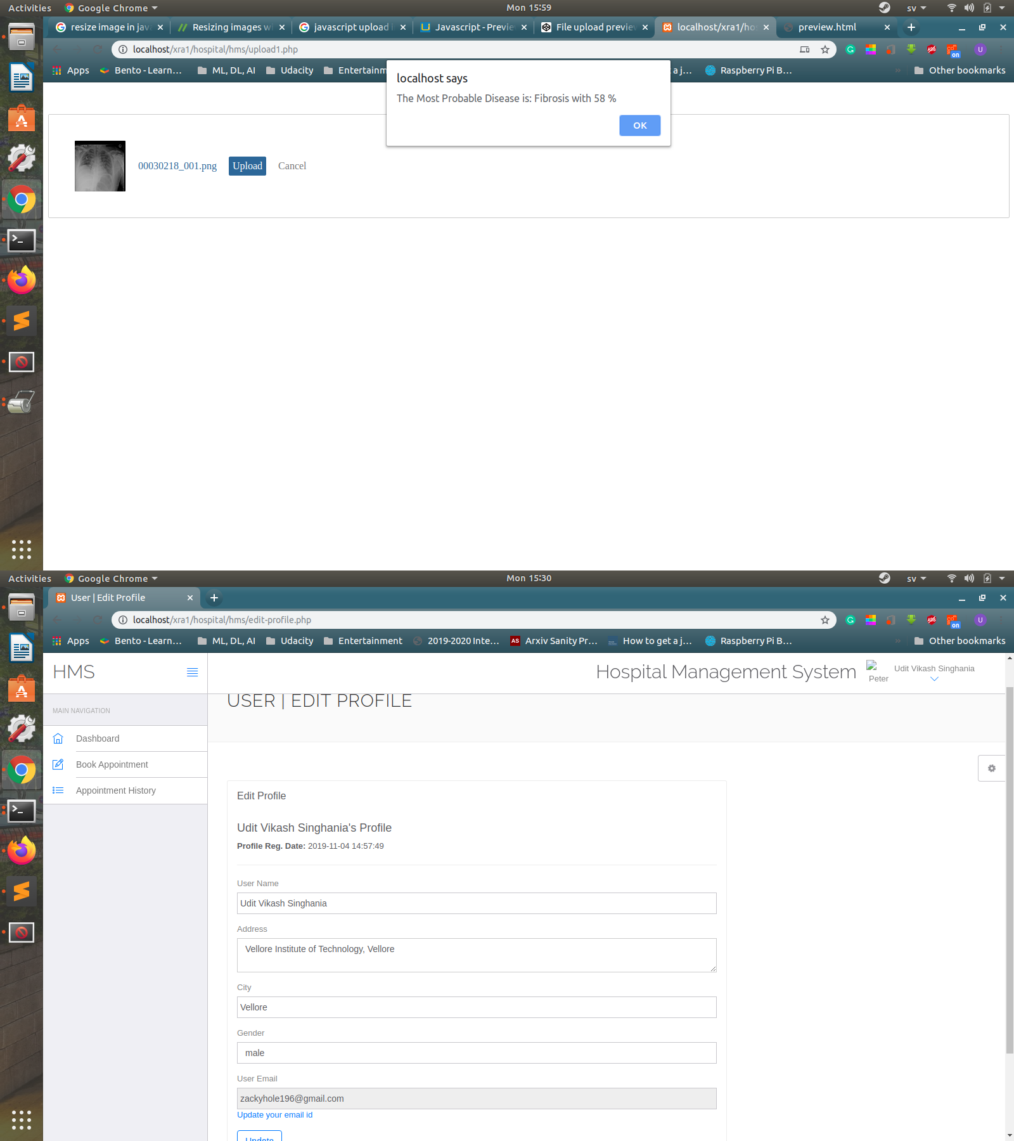

Fig 13

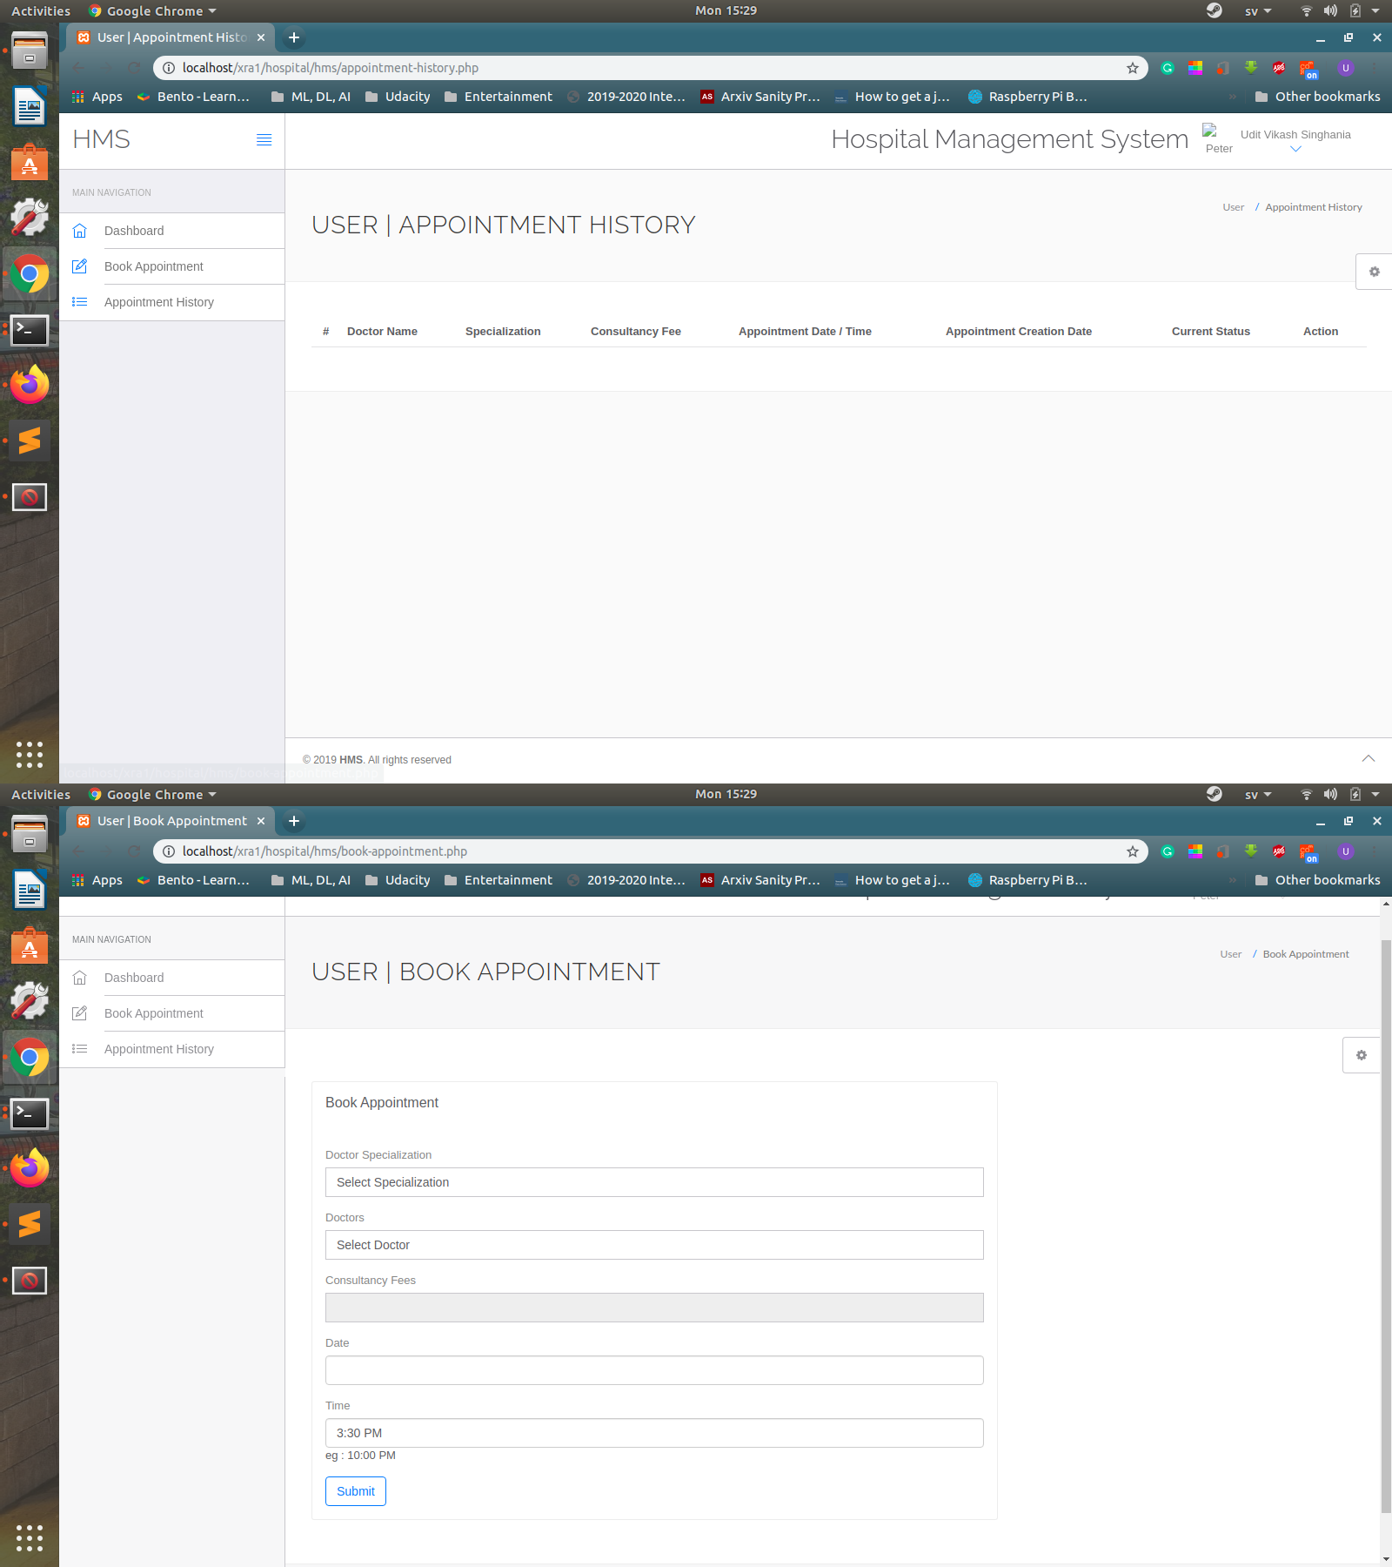

Fig 14

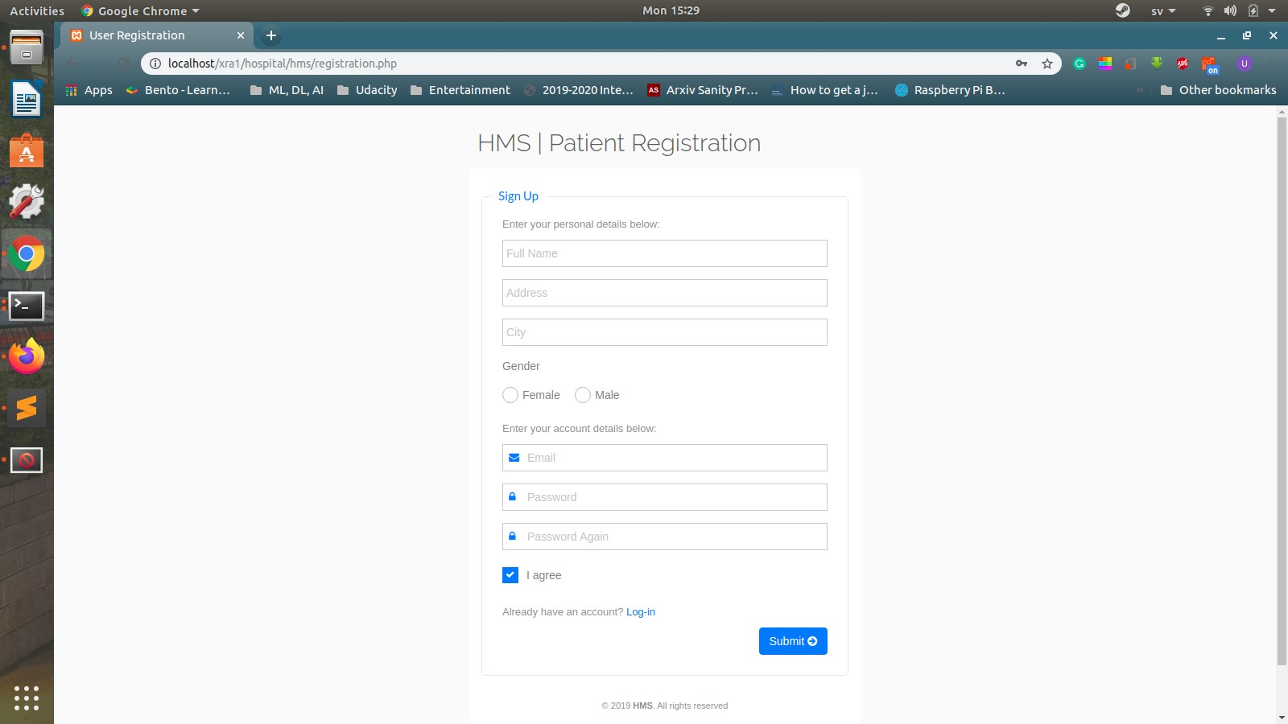

Fig 15

SYSTEM PROCESS FLOWCHART

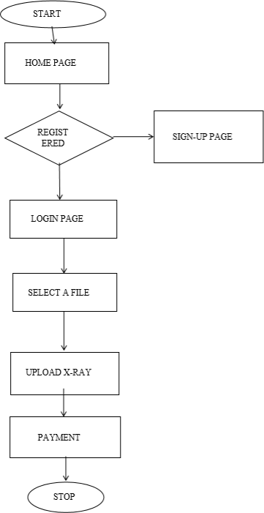

Fig 16

## CONCLUSION:

Initially, our website would operate only inside Vellore. A single office, located in central Vellore would suffice. In the beginning, we will operate from hostels to save on the office setup-cost. It will significantly reduce the initial investment cost. Once break-even is achieved, an office can be setup at the desired location.

A two room apartment is more than enough for well-functioning of our website. Standard office requirements like computers, printers and telephones will be required. Since our website is just a platform like any other website, the clients will have their own X-Rays to upload on this website. Through our website, they would be able to get the results of their uploaded X-Rays.

A website is required for the clients to upload their X-Ray file and place a service request. Only cost involved is of server and its maintenance.

The most important aspect of opening this business is that initially we don’t require any man power. As we have CSE/IT members in our team, we can build the website on our own. This helps us in achieving the breakeven point very fast as there is no salary situation present in the business. In later stages, a trained manager can be hired for each of the 6 categories. Their task would be to handle all the requests and follow up with both the parties i.e. the clients and doctors aptly.

## FUTURE SCOPE OF WORK:

Medical check-ups in rural India- Indian Hospitals in rural areas also lack Radiologist. Thousands of cases are usually handled by single available doctor for X-Ray diagnosis. Our product can help them to directly communicate with professional doctors without coming to city

Accurate reports – Accurate reports can be provided instantly to the doctor and it will be in the database for further reference and to assist the doctors in arriving at quick diagnosis, it is recommended to have a solution that can do Computer Aided Diagnosis for the Chest X-Ray.

Traditional pricing rules no longer apply -Transparency in Price is one of the best advantages that we can deliver to our customers and this also helps them to pay minimal amount for almost every test they have.

Sustainable competitive advantage (Sustainability- Sector1)

The reason we chose this strategy is because we know what exactly hassles general public when it comes to waiting in long queues just to get an X-Ray detected. We provide a platform where people, who have preregistered with us, are given the opportunity to shorten their time and get their disease detected. The disease detection is done using a database that is made with doctor’s consultation of every disease discovered till date and in cheap cost. Each and every service will have different charges based on the complexity of the customer’s demand, like their request to send the X-Ray directly to the doctor to get the prescription for medication or treatment required for the disease or health problem.

Innovation factor (Sustainability – Sector2)

This is very innovative business and one of the very few of its kind. Currently, no such company with the same service provision exists. We will be maintaining proper book of accounts and services of the customers and if a customer uses our services regularly, there will be special offers as well. We will also have an area for the remarks of the customers to know if they are satisfied with our services and they can also provide suggestions where they believe we can make an easier and more accessible GUI.

Avoidance of pitfalls (Sustainability – sector3)

All the customers will have their requests attended to on time and will be provided with the detected result shortly after they upload their X- Ray document. In case if the service performed by the website is delayed, the customer has the advantage to decrease the cost of the service by 5% and then pay the bill. Also, our website maintains internal controls adequate to ensure all standards are met, and where possible, exceed all relevant legal requirements. This website endeavours to behave with honesty, integrity and act fairly and with the intelligence that is inscribed in it and dealings with its customers and other clients.

Graceful Exit (Sustainability – Sector4)

More than 90% of startups fail in India. Therefore, while working hard for the success of the startup we should prepare for its failure. In our startup we have built a website by which the users can request for a detection of their disease from the uploaded X-Ray. In case our startup fails and we are ready to shut down, all the stakeholders, clients, employees, customers and investors will be informed in advance and the whole process will be properly planned and executed in order to make the exit easy on everyone. From the legal stand point, to shut down our start-up we will be using the Fast Track Exit Mode as it allows our company to expedite shut down at a lower cost and a shorter time period. In order to apply for a fast track exit, a company should:

1. not have any assets and liabilities
2. not have any business operation form the past year which has to be fulfilled and if the set of conditions are met, our company can be struck off the registrar of the Registrar of Companies (RoC). The website may be sold to some other party for same or some other service.