DBMS MINI PROJECT SYNOPSIS

PARTNER:- Shruti Susan Matthews (111803134)
Problem Statement
Library Management System

Introduction
This is a basic Library Management System using python and SQL, It can be used in schools/colleges
to monitor the day to day requirements of the library.

Functional Requirements of the system
The system will have 2 modes depending on who is using it(Staff/Students)
Staff
1)Register-Books, Students, Authors, Genres, Personal info
2)View-Students(All, Department wise), Personal info of students
3)Delete-Students, Books, Authors
4)Update/Modify-Books(Restocking, changing info), Authors, Students
5)Manage fines, enquiries and comments

Student
1)Display- books(Genre wise, author wise), authors, borrowed books, fines
2)Issue/Return/Report lost books
3)Search for books using genre, author, title
4)Add enquiries/Comments

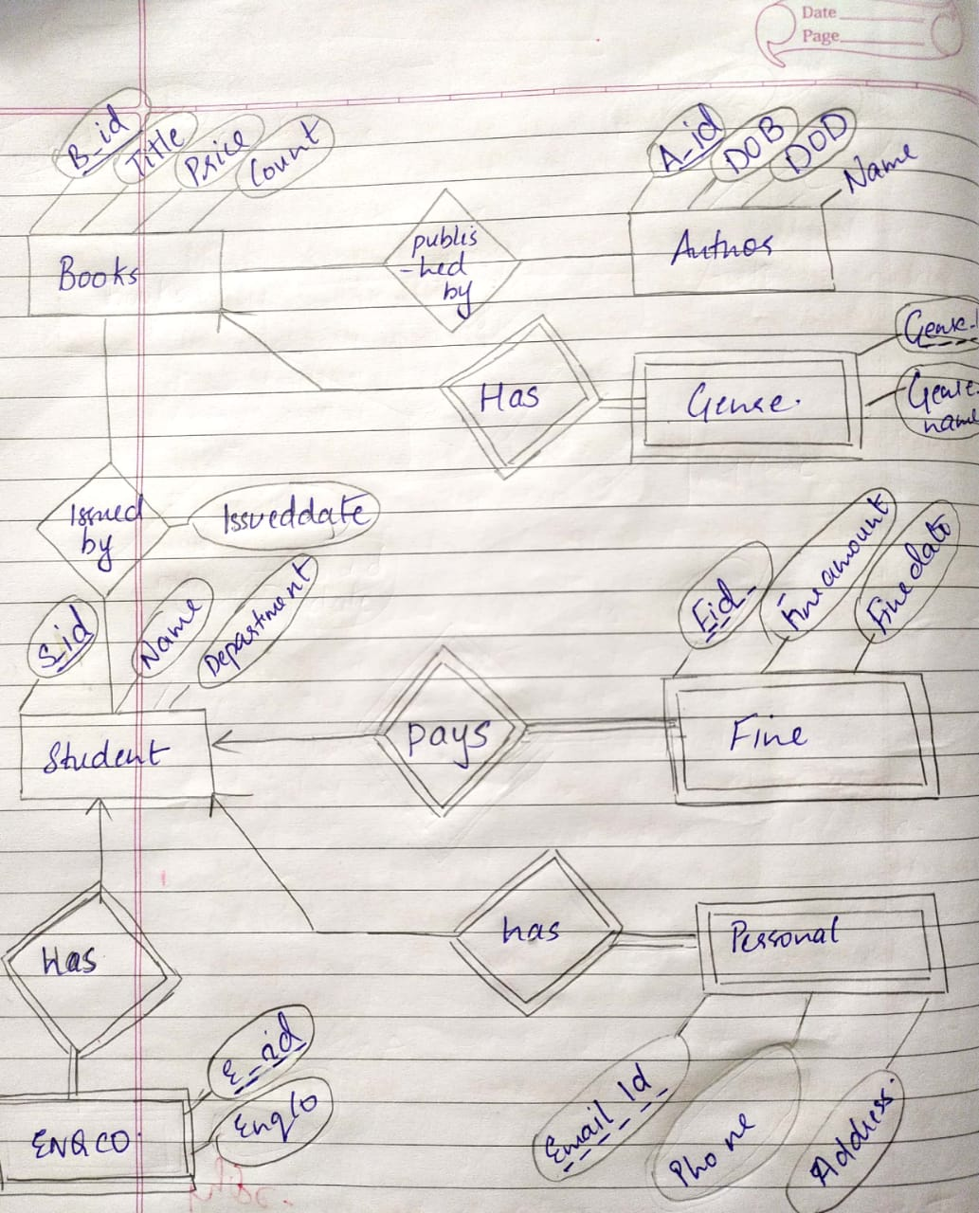
ER Diagram

Relational Schemas
STUDENT
S_ID | Name | Department
AUTHOR
A_ID | DOB | DOD | Name
BOOKS
B_ID | Title | Price | Count | A_ID (f.k)
PINFO
S_ID (f.k) | City | Phone | Email
ISSUED
B_ID (f.k) | S_ID (f.k) | Issueddate
GENRE
G_ID | B_ID (f.k) | Genrename
FINE
F_ID | S_ID (f.k) | Fineamount | Finedate
ENQCO
E_ID | S_ID (f.k) | Enqco

