# **DTC Website Analysis**

# 1: Image Optimization

The image optimization is responsible for the performance of the website.

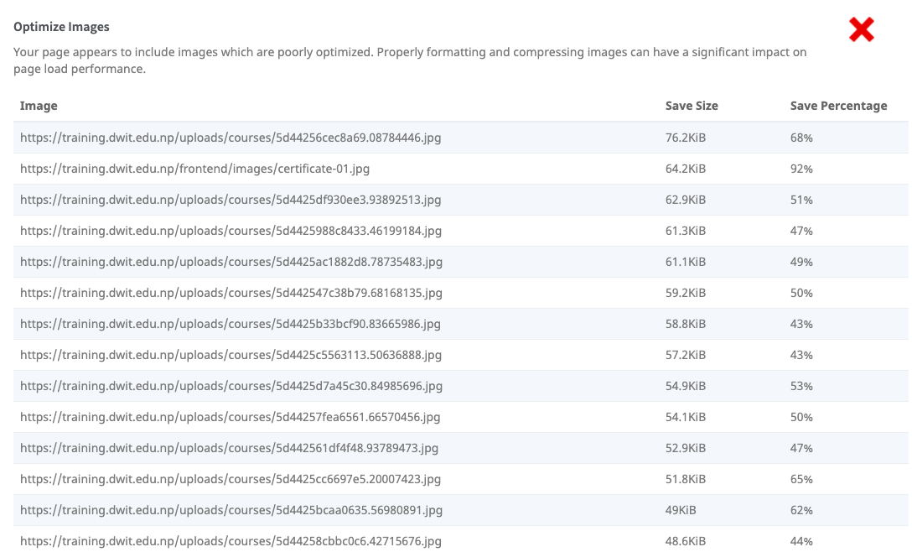

* You can start by using tools such as Picturefill of Adaptive Images on the website, which saves bandwidth and improves the page speed. Or you can also adopt new image formats like WebP and Jpef XR; helps to reduce the weight up to 50% without affecting the image quality.

OR

* **Combine images into CSS sprites**. If you have several images on a page, you are forcing multiple roundtrips of the server to get all the resources secured, which slows down page speed. Sprites combine all background images on a page into one single image, which means all images appear when the main “sprite” loads. This reduces the chance of flickering images and a smoother experience for your users.

## Image Alt Attribute

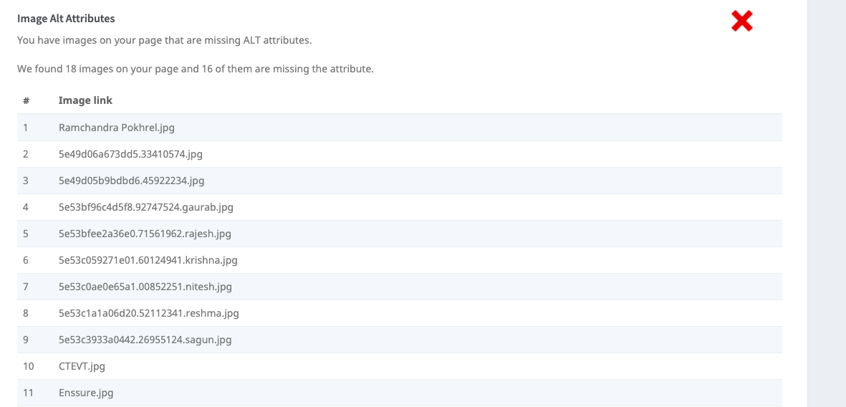

The required alt attribute specifies an alternate text for an image, if the image cannot be displayed. The alt attribute provides alternative information for an image if a user for some reason cannot view it (because of slow connection, an error in the src attribute, or if the user uses a screen reader).

# 2: Friendly URL

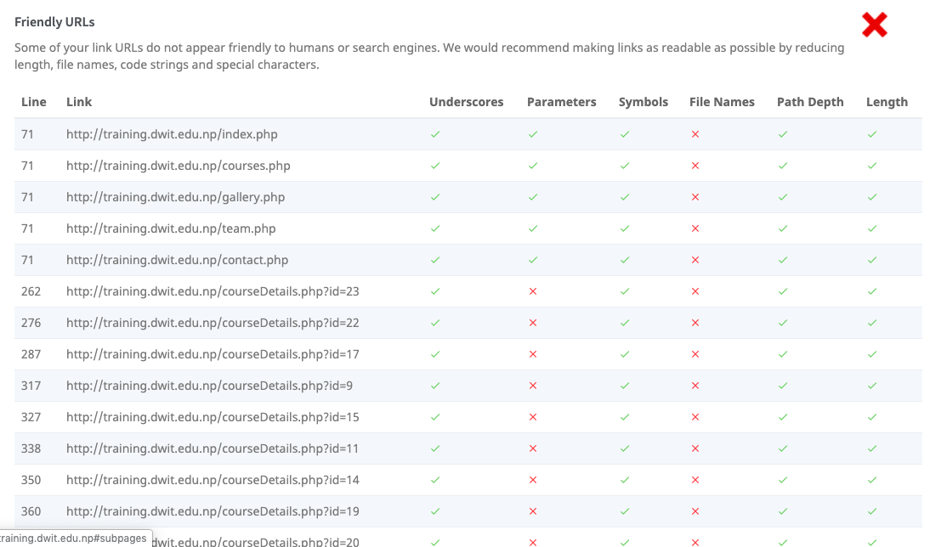

Most of the link URLs do not appear friendly to humans or search engines of DTC. I would recommend making links as readable as possible by reducing length, file names, code strings and special characters.

# 3: Title Tag and Meta description is Missing

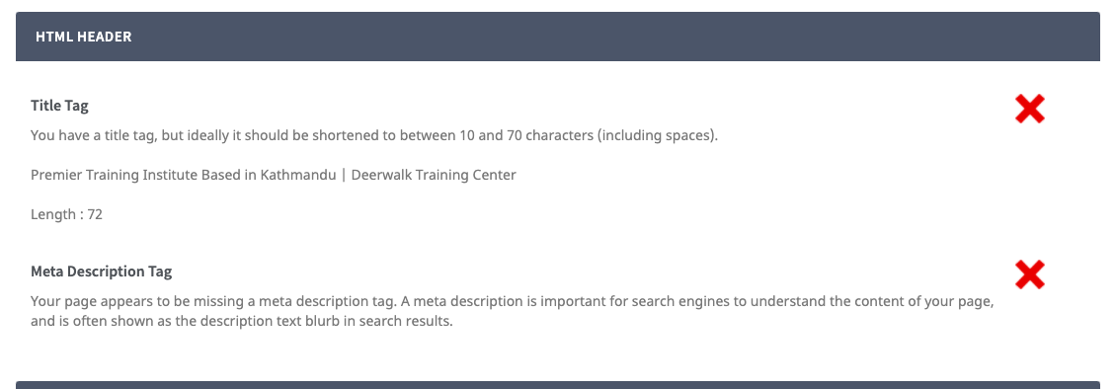

* Only use Premier Training Institute based in Kathmandu as Title Tag
* Check why the meta description is not showing although its already in the script.

# 4: Inline Styles

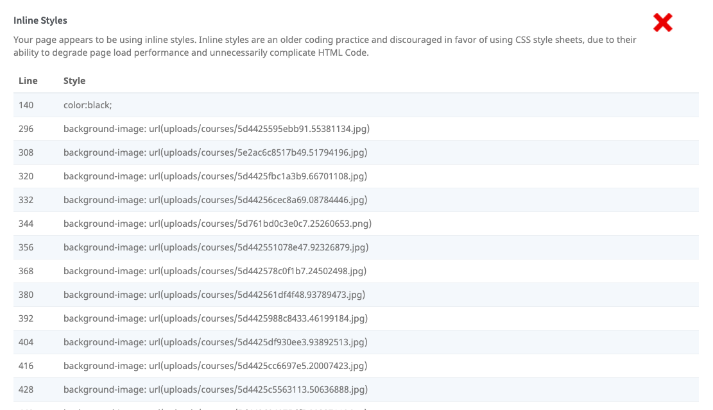

* Use necessarily

# 5: Schema

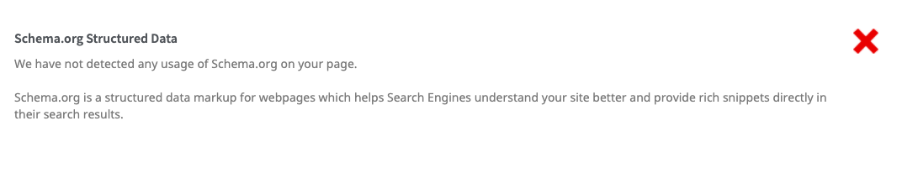

Schema tells the search engines what your data means, not just what it says.

Schema.org is a joint effort, in the spirit of sitemaps.org, to improve the web by creating a structured data markup schema supported by major search engines. On-page markup helps search engines understand the information on web pages and provide richer search results.

# 5: Social

The Facebook pixel is the code that you place on your website. It collects data that helps you track conversions from Facebook ads, optimize ads, build targeted audiences for future ads, and remarket to people who have already taken some kind of action on your website.

# 6: Custom 404 Page and Favicon

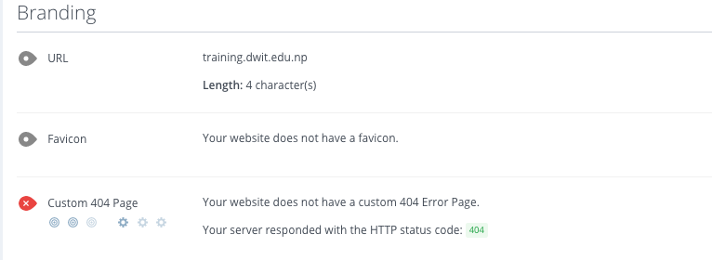

* Make a custom error handling page
* Verify for the Favicon icon of DTC

# 7. For Responsive Mobile Friendliness

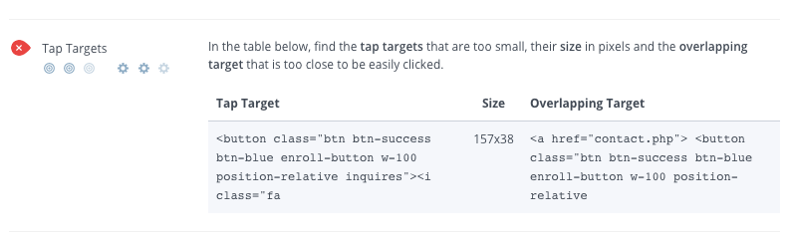

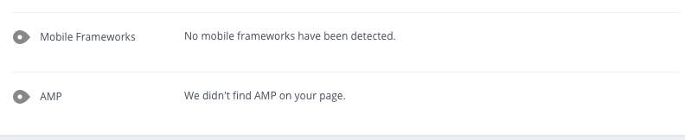

* With more than half of all Google search queries originating on mobile device, it is important to make sure mobile site is optimized for all the users.
* AMP is an open-source custom web development framework created to speed up the loading time of web pages on mobile devices. Implement it for better results.
* Add mobile frameworks if necessary.
* The course codes in request callback feature.
* Remove the slider in a banner and use only the picture with the boy and girl.
* Move the about deerwalk training center section to the banner.