**Lab 10**

1. Complete Lessons 1, 3, 5, 6, 7, 8, 9, 10, 13, 14, 15, and 16 on GCF Learn Free / Excel

Each lesson has a Challenge section at the end and a Practice Workbook in that section (except for Lesson 1). Download and complete the Practice Workbooks, copy all of them (except for Lesson 9) in one excel file. There will be 2 Excel files.

ANS: For lesson1:

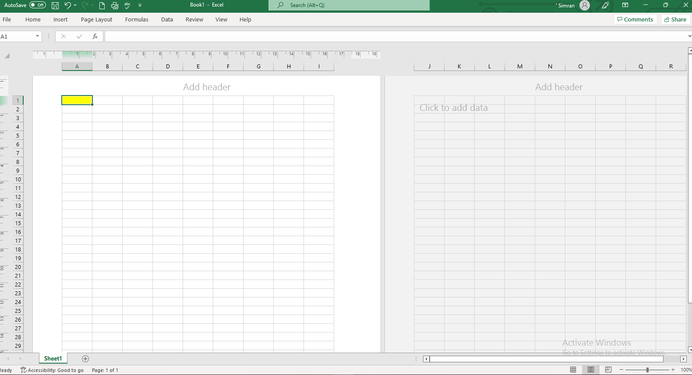

2. W3Schools SQL online editor has a database with 8 tables (https://www.w3schools.com/sql/trysql.asp?filename=trysql_select_all). The list of the tables is on the right side of the page. You may view the content of the tables by clicking on them.

Write the following SQL queries using the editor, run them, and take screenshots from the results.

1) Write a SQL query that returns last name, first name, and date of birth for all Employees ordered by last name.

ANS:

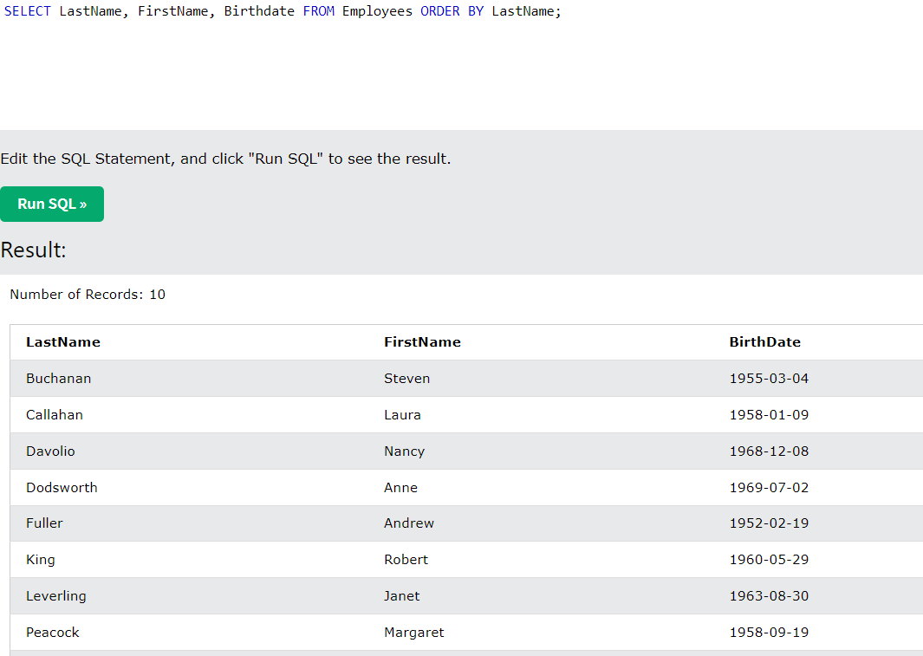

2) Write a SQL query that returns name, city, and country for all Customers who live in London in UK (Note that there is a city called London in Canada!).

ANS:

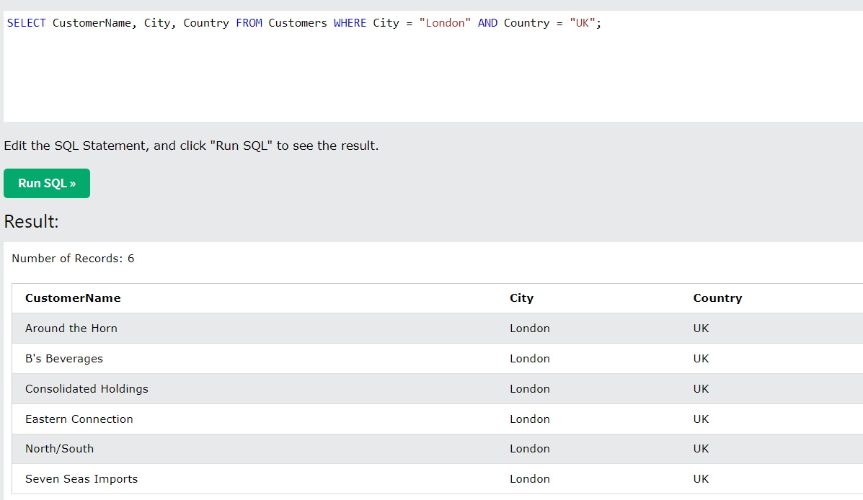

3) Write a SQL query that returns name, address, and postal code for all Customers whose postal code starts with the digit 2.

ANS:

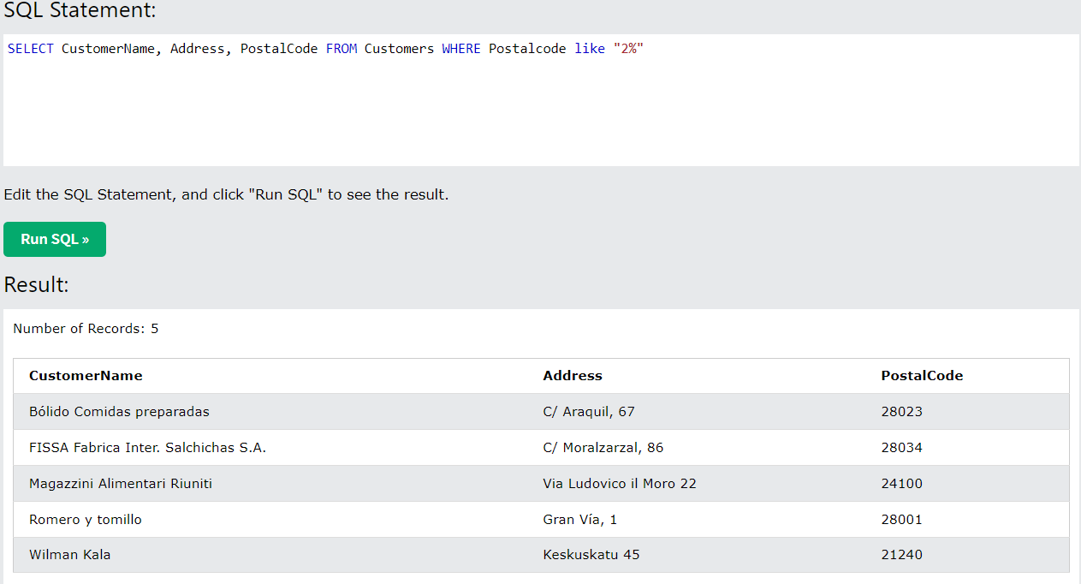

4) Write a SQL query that returns name, address, and postal code for all Customers whose postal code starts with either the digit 8 or digit 9, and do not live in USA (Note that you may need a parenthesis for the condition).

ANS:

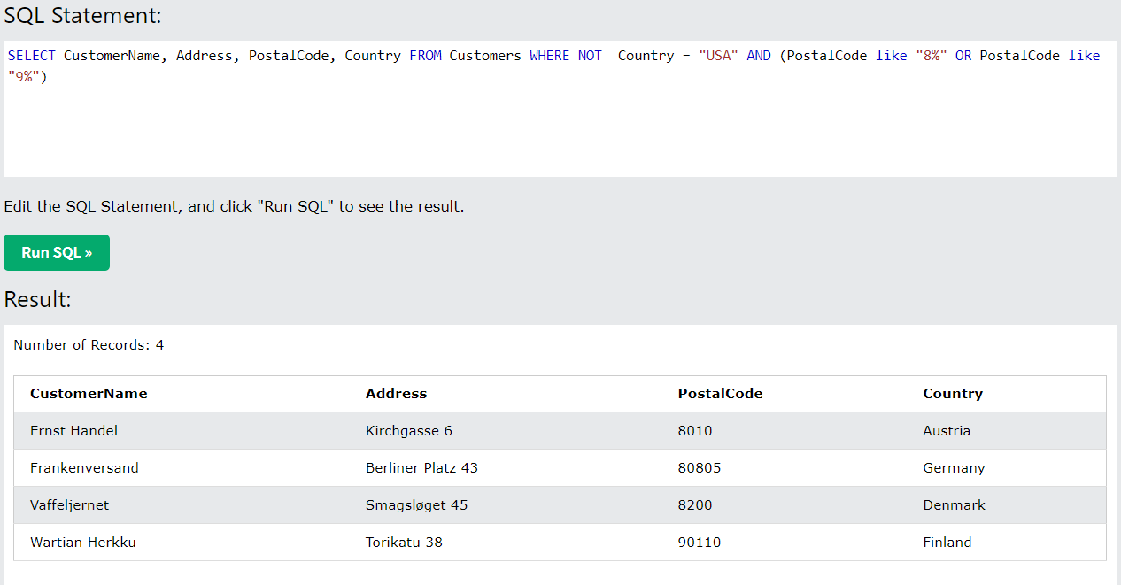

5) Write a SQL query that inserts a new entry (of your choice) into Shippers. Note that the ShipperID is assigned automatically. Take a screenshot of the updated Shippers table.

ANS:

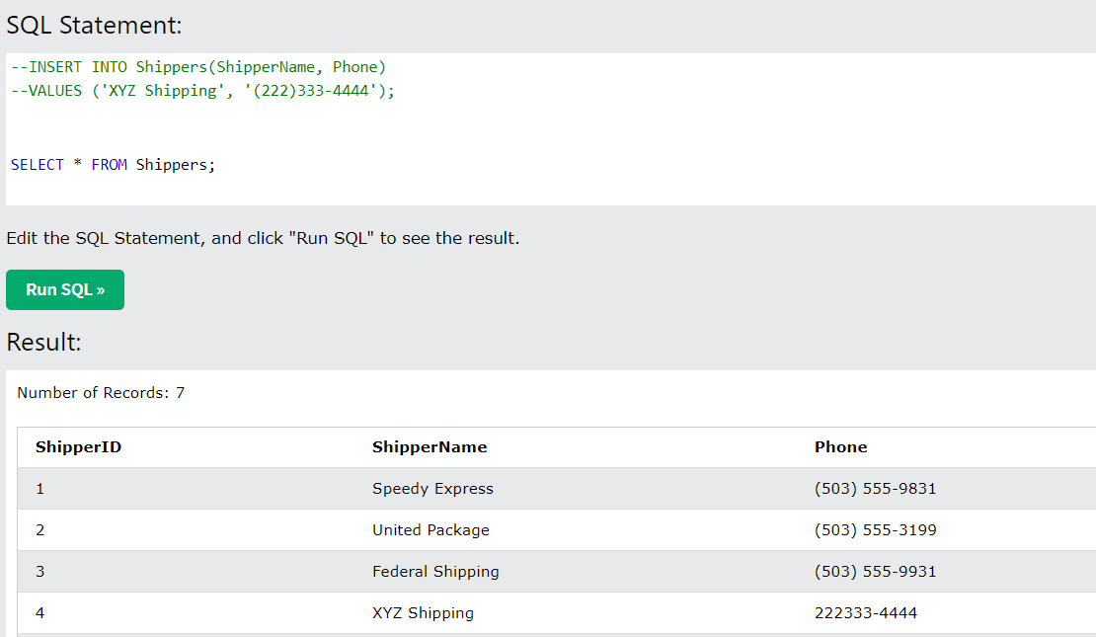

6) Write a SQL query that changes the country from UK to England for Customers. Take a screenshot of the updated Customers table showing all attributes for people from England.

ANS:

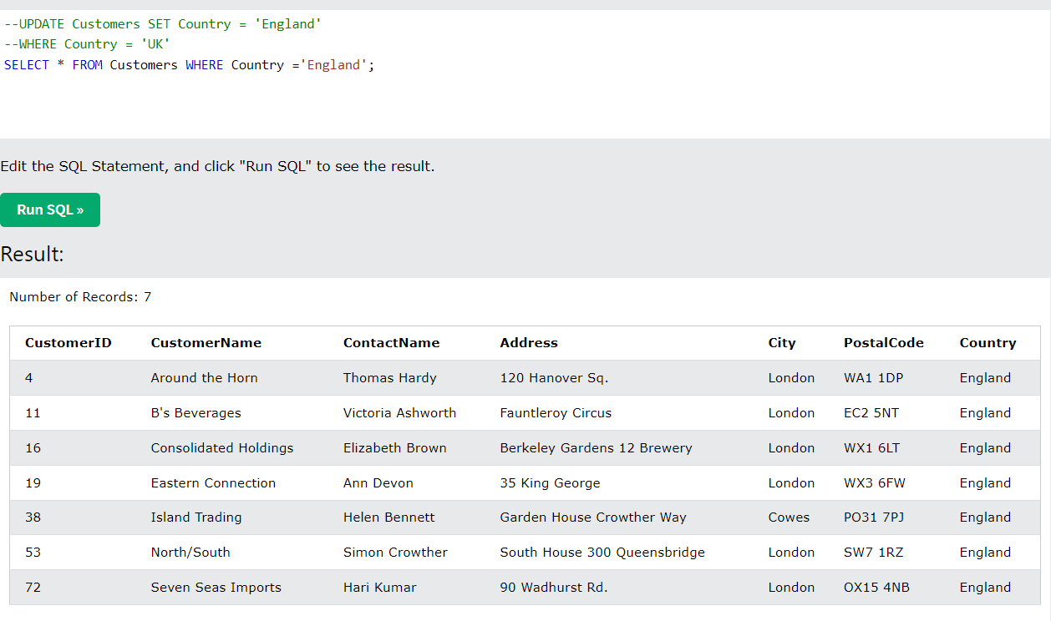

7) Write a SQL query that deletes all Products that cost more than 50 or less than 30. Take a screenshot of the updated Products table.

ANS:

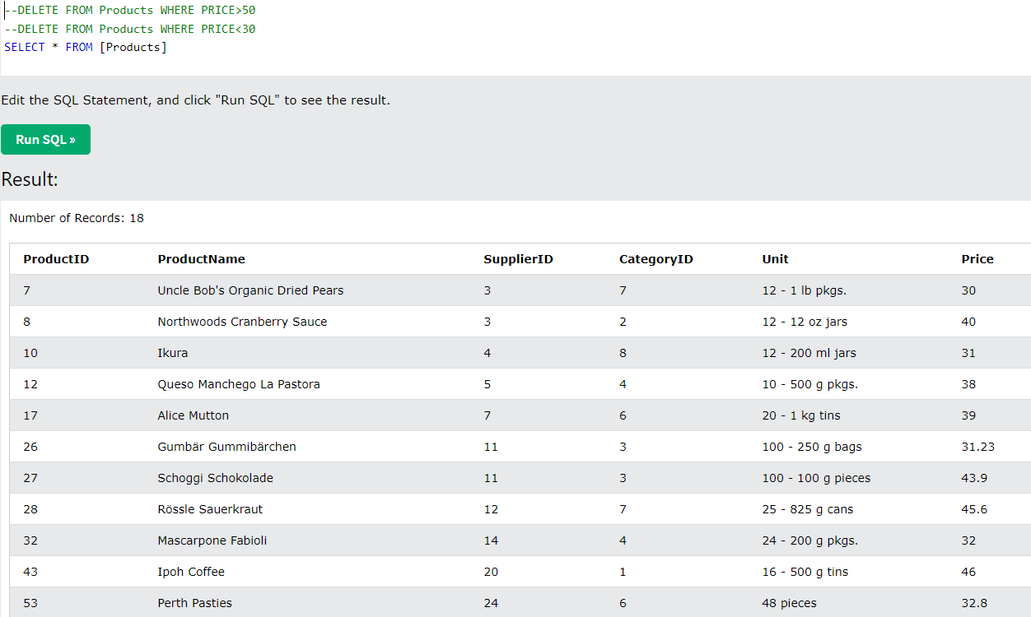

Before writing the next statements, click the button 'Restore Database' under the list of tables to reset the above changes.

8) Write a SQL query that returns the customer name, orderId, and order date for Ernst Handel. (Hint: You need to join 2 tables.)

ANS: SOL Query is:

SELECT Orders.OrderID, Customers.CustomerName, Orders.OrderDate

FROM Customers, Orders

WHERE Customers.CustomerID = Orders.CustomerID

AND Customers.CustomerName = 'Ernst Handel'

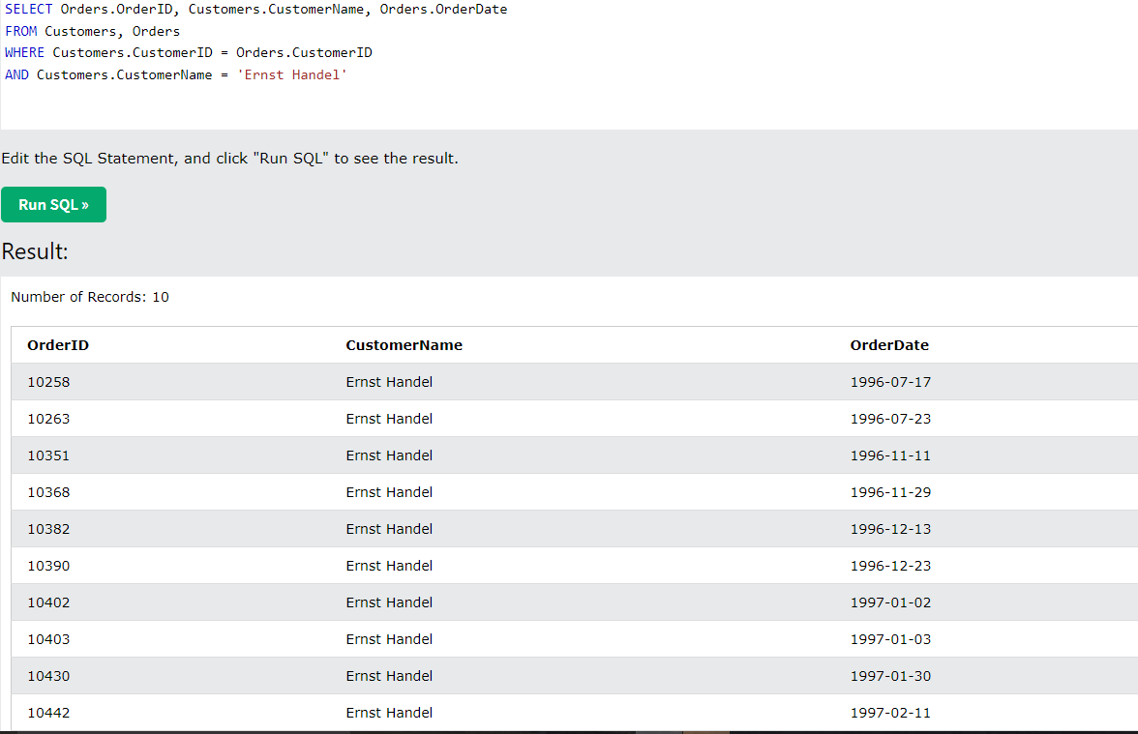

9) Write a SQL query that returns the product name and quantity for all orders with quantity greater than or equal 80. (Hint: You need to join 2 tables.)

ANS: SQL Query is :

SELECT Products.ProductName, OrderDetails.Quantity

FROM Products, OrderDetails

WHERE Products.ProductID = OrderDetails.ProductID

AND OrderDetails.Quantity = "80" OR OrderDetails.Quantity > "80"

10) Write a SQL query that returns the customer name, product name, and order date for the orders in year 1997. (Hint: You need to join 4 tables.)

ANS: SQL Query is:

SELECT Customers.CustomerName, Products.ProductName, Orders.OrderDate

FROM Customers, Products, Orders, OrderDetails

WHERE Customers.CustomerID = Orders.CustomerID

AND Orders.OrderID = OrderDetails.OrderID

AND Products.ProductID = OrderDetails.ProductID

AND Orders.OrderDate LIKE "1997%”

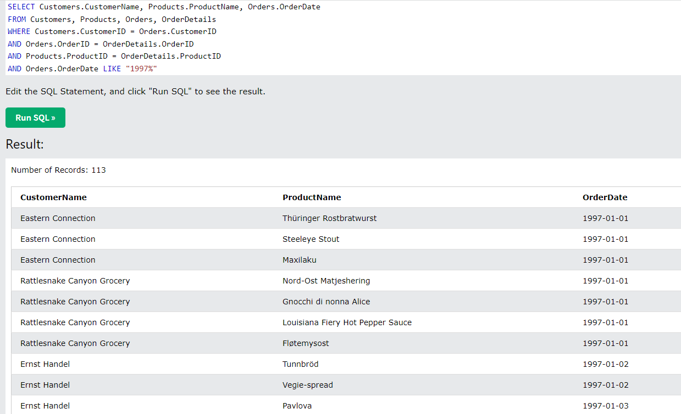

3. (Spreadsheets)Given the following spreadsheet:

a. Write the formula that is likely in cell G4 in such a way that it can be copied to cells G5:G14 and correctly compute their values too.

ANS: The formula that is used in cell G4 is

= D4+ E4+ F4

We can copy this formula to cells G5:G14 we drag the cursor from the lower right corner of G4 and select the cells in which we want to paste it.

Or we can also use Sum function from functions that are available in excel and select D4, E4, F4 to get the total and the formula can be copied to the other cells in the same way as did in upper case.

b. Write the formula that is likely in cell D16 in such a way that it can be copied to cells E16:H16 and correctly compute their values too.

ANS: We can simply use formula ‘Average’ in cellD16 and select D4:D14 in that and after that we can copy this formula to the other cells that are E16 to H16.

4. (SQL) Given the following table called 'forSale':

a. Write a SQL statement that returns the Address and Owner of all houses that have a price not less than $250,000 and SqFt not less than 2000. Write the results in the form of a table.

ANS: SQL Statement is:

SELECT Address, Owner

FROM forSale

WHERE Price >= 250000

AND SqFt >= 2000

The resulting table is :

|  |  |
| --- | --- |
| **Address** | **Owner** |
| 12 Ridge Circle | Alice Perez |
| 1200 Main St | John Smith |

b. 103 is sold to Susan Saran. Write a SQL statement that updates the table.

ANS: SQL statement is:

UPDATE forSale

SET Owner = “Susan Saran”

WHERE ID = “103”

c. Write a SQL statement that adds a record to the table for a property with ID 200 at 202 Clarke St., 1200 SqFt. The price is 200,000 and it belongs to Joe Smith.

ANS: SQL Statement is:

INSERT INTO forSale(ID, Address, SqFt, Price, Owner)

VALUES ( ‘200’ , ‘202 Clarke St.’ , ‘1200’ , ‘200000’ , ‘Joe Smith’ );

d. Write a SQL statement that returns the ID, Address, and Owner of all properties that belong to the Smith family. Write the results in the form of a table.

ANS: SQL Statement is:

SELECT ID, Address, Owner

FROM forSale

WHERE Owner LIKE “% Smith ”

The table for this will be:

|  |  |  |
| --- | --- | --- |
| ID | Address | Owner |
| 180 | 1200 Main St | John Smith |
| 200 | 202 Clarke St. | Joe Smith |

Original Table of question 4

|  |  |  |  |  |
| --- | --- | --- | --- | --- |
| ID | Address | SqFt | Price | Owner |
| 103 | 470 Lindquist St | 1500 | 786000 | James Owens |
| 155 | 12 Ridge Circle | 2000 | 957900 | Alice Perez |
| 165 | 940 Midway Dr. | 1800 | 834100 | Robert Gallant |
| 180 | 1200 Main St | 2200 | 999000 | John Smith |