**LAB 2**

**Representing Negative Numbers**

1. Lab 3 Representing Numbers (Lab3_Manual.pdf)

a. Exercise 1

2.) Type “1”. Study the result. Find the sign bit. How does the app indicate it?

ANS: When we type “+1”, the sign bit is 0 as the binary form is 00000001 and when we type “-1”, the sign bit becomes 1 and it is 10000001 in sign-magnitude and 11111111 in 2’s complement.

3.) Change the no. of bits to 32. Convert “-1” again. Write down how 2 forms of binary “-1” are different in 32 and 8 bits.

ANS: For 32 bits: Sign-magnitude form becomes 10000000000000000000000000000001 and 2’s complement form becomes 11111111111111111111111111111111 and sign bit is 1.

For 8 bits: Sign-magnitude form becomes 10000001 and 2’s complement form becomes 11111111 and sign bit is 1.

5. Write the value of 6 and -6 in different bits.

|  |  |  |
| --- | --- | --- |
|  | -6 | 6 |
| 8 bits | 10000110 | 00000110 |
| 11111010 | 00000110 |
| 12 bits | 100000000110 | 000000000110 |
| 111111111010 | 000000000110 |
| 16 bits | 1000000000000110 | 0000000000000110 |
| 1111111111111010 | 0000000000000110 |
| 32 bits | 10000000000000000000000000000110 | 00000000000000000000000000000110 |
| 11111111111111111111111111111010 | 00000000000000000000000000000110 |

6.) What will -1 and -6 look like using 64 bits?

ANS: -1 in 64 bits might seem like 1000000000000000000000000000000000000000000000000000000000000001

-6 in 64 bits as per my guess will be 1000000000000000000000000000000000000000000000000000000000000110.

7.) Type 127 in 8 bits and describe what you see?

ANS: It will return “01111111” and this is the value of 127 in binary number system.

8.) Now type “-127” and convert. Write down the values. What is diff b/w the values of -127 and +127 in two’s complement?

ANS: The value of “-127” is 11111111 in sign magnitude and10000001 in two’s complement. The difference b/w the values of -127 and 127 in two’s complement is that the value for -127 is the sum of value of 127 in two’s complement and 1.

9.) Type 4 into number of digits in binary and convert number 8. What do you see? Does this seem right.

ANS: It shows that the number can’t fit in 4 bits but it is wrong because the binary of 8 is 1000 and it can be represented by 4 bits.

2. Convert -9410 from decimal to binary using the following methods. Are your answers the same? Test your answer with "Negative Binary Numbers" Applet. a. 8-bit signed magnitude binary notation

|  |  |  |  |
| --- | --- | --- | --- |
| Negative Number | Flip the sign | Convert to binary | Final answer |
| -9410 | 9410 | 010111102 | 110111102 |

b. 8-bit two's complement binary notation

|  |  |  |  |  |
| --- | --- | --- | --- | --- |
| Negative Number | Flip the sign | Convert to binary | Flip the bits | Plus1(final answer) |
| -9410 | 9410 | 01011110 | 10100001 | 10100010 |

3. Convert -10610 from decimal to binary using the following methods. Test your answers with "Negative Binary Numbers" Applet.

a. 8-bit signed magnitude binary notation

|  |  |  |  |
| --- | --- | --- | --- |
| Negative Number | Flip the sign | Convert to binary | Final answer |
| -10610 | 10610 | 01101010 | 11101010 |

b. 8-bit two's complement binary notation

|  |  |  |  |  |
| --- | --- | --- | --- | --- |
| Negative Number | Flip the sign | Convert to binary | Flip the bits | Plus1(final answer) |
| -10610 | 10610 | 01101010 | 10010101 | 10010110 |

4. Convert -13710 from decimal to binary using the following methods. Test your answer with "Negative Binary Numbers" Applet.

Why do we need 16 bits?

a. 16-bit signed magnitude binary notation.

|  |  |  |  |
| --- | --- | --- | --- |
| Negative Number | Flip the sign | Convert to binary | Final answer |
| -13710 | 13710 | 00000000100010012 | 10000000100010012 |

b. 16-bit two's complement binary notation.

|  |  |  |  |  |
| --- | --- | --- | --- | --- |
| Negative Number | Flip the sign | Convert to binary | Flip the bits | Plus1(final answer) |
| -13710 | 13710 | 00000000100010012 | 11111111011101102 | 11111111011101112 |

5. Convert 101101112 from binary to decimal using the following methods. Are your answers the same? Test your answers with "Negative Binary Numbers" Applet.

a. 8-bit signed magnitude binary notation

|  |  |  |  |
| --- | --- | --- | --- |
| Binary number in Signed-Magnitude | Flip the sign bit | Convert to decimal | Final answer |
| 101101112 | 001101112 | 552 | -552 |

b. 8-bit two's complement binary notation

|  |  |  |  |  |
| --- | --- | --- | --- | --- |
| Negative number | Flip the bits | Plus 1 | Convert to decimal | Final answer |
| 101101112 | 010010002 | 01001001 | 7310 | -7310 |

6. Convert 111101002 from binary to decimal using the following methods. Test your answers with "Negative Binary Numbers" Applet.

a. 8-bit signed magnitude binary notation

|  |  |  |  |
| --- | --- | --- | --- |
| Binary number in Signed-Magnitude | Flip the sign bit | Convert to decimal | Final answer |
| 111101002 | 011101002 | 11610 | -11610 |

b. 8-bit two's complement binary notation

|  |  |  |  |  |
| --- | --- | --- | --- | --- |
| Negative number | Flip the bits | Plus 1 | Convert to decimal | Final answer |
| 111101002 | 00001011 | 00001100 | 1210 | -1210 |

**Representing Real Numbers**

7. Convert the following decimal numbers to binary. Write 6 bits for the fractional part.

a. 54.12810

54 = 110110

.128 = .128*2 = 0.256 = 0 + 0.256

.256*2 = 0.512 = 0 + 0.512

.512*2 = 1.024 = 1 + 0.024

.024*2 = 0.048 = 0 + 0.048

.048*2 = 0.096 = 0 + 0.096

.096*2 = 0.192 = 0 + 0.192

.128 = .001000

54.12810 = 110110.0010002

b. 126.78510

126 = 1111110

.785 = .785*2 = 1.570 = 1+.57

.57*2 = 1.14 = 1+.14

.14*2 = 0.28 = 0+.28

.28*2 = 0.56 = 0+.56

.56*2 = 1.12 = 1+.12

.12*2 = 0.24 = 0+.24

.785 = .110010

126.78610= 1111110.1100102

8. Convert the following binary numbers to decimal. Show the full polynomial first.

a. 1001011.0011012

= 1*26 + 0*25 +0*24 + 1*23 + 0*22 + 1*21 + 1*20 + 0*2-1 + 0*2-2 + 1*2-3 + 1*2-4 + 0*2-5 + 1*2-6

= 64+ 8+ 4+ 2+ 1+ 1/8 + 1/16 + 1/64

= 78.20310

b. 111100101.110010112

= 1*28 + 1*27 +1*26 +1*25 + 0*24 +0*23 +1*22 +0*21 +1*20 + 1*2-1 +1*2-2 +0*2-3  +0*2-4 +1*2-5 + 0*2-6 + 1*2-7 + 1*2-8

= 256 + 128 + 64 +32 +4 +1 +0.5 +0.25 +0.0312 + 0.0078 + 0.0039

= 485.792910

**Representing Data**

9. Lab 4 Colorful Characters (Lab4_Manual.pdf)

a. Exercise 1:

2.) Type 100 and write what you see.

ANS: d

3.) Type 68. What relation does it have with first one?

ANS: When 68 is typed, it returns D. The relation with the first one is that both represents same alphabet of English but the case is different that is for 100 it is lowercase and for 68 the alphabet is in uppercase.

4.) Do the same for 101 and 69, and for 102 and 70. Write down the codes and characters you see.

ANS: Number Code: 101 69 102 70

Character: e E f F

5.) What conclusion would you draw about how uppercase and lowercase are described in ASCII table?

ANS: The number from 65 to 90 shows the uppercase alphabets (A-Z) and numbers from 97 to 122 shows the lowercase alphabets (a-z). There is difference of 32 characters in decimal.

6.) If you are writing a function to capitalize the text for word processed program, what transformation would you make in character code?

ANS: I can do it by subtracting 32 in decimal from the characters for lowercase.

7.) Now, type 210, 211, 212, 213 and write what you see?

ANS: 210 – Ò

211 – Ó

212 – Ô

213 – Õ

8.) What characteristics do these characters share?

ANS: It is the “o” with accents.

9.) What does ASCII code 241 shows? What language does this use?

ANS: ASCII code 241 shows “ñ”. It is used in Spanish language.

b. Exercise2:

4.) Take the screenshot of the paragraph you typed.

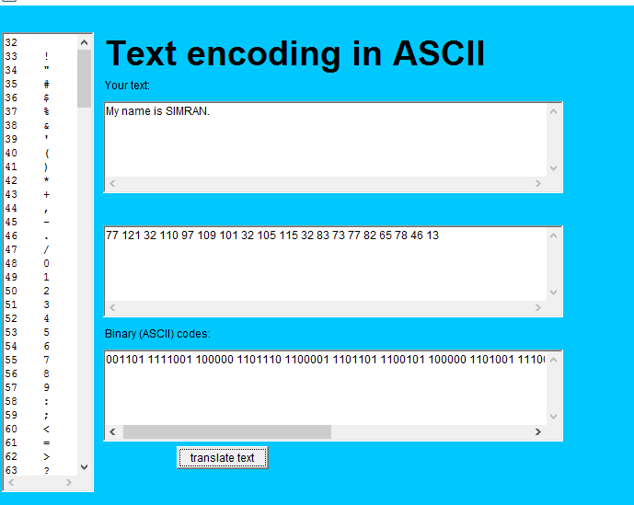

6. Scroll the long tab on the left and write the numeric codes for these symbols.

188 ¼

189 ½

190 ¾

215 ×

247 ÷

177 ±

c. Exercise3:

1.) Open the color maker app.

2.) Write yellow in the drop down menu and write the RGB and HSB values.

ANS: RGB: 255, 255, 0

HSB: 0.1666, 1.0, 1.0

3.) Write Cyan in the drop down menu and do same.

ANS: RGB: 0, 255, 255

HSB: 0.5, 1.0, 1.0

4.) Using more common colors, what color is cyan?

ANS: It is sea-green color.

5.) Suppose kathy’s favourite color is 255, 0, 0. What is that color?

ANS: Red

6.)

ANS: It returns white color and I selected orange color for this.

7.)

ANS: It returns black color at the end.

8.)

ANS:

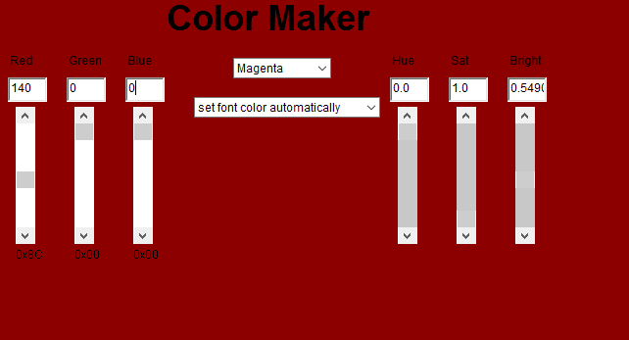

10. Start the "Huffman Text Compression" Applet. Huffman Encoding is a text compression method that replaces each character with a Numeric Code whose length is less than 8 bits. [Note: Original size of the message in this applet is based on using ASCII code with 8 bits for each character.]

a. Click on example and then click compress. What are the Original and Current sizes of the message? How much is Saving?

ANS: Original size is 64, Current size is 25, and the Saving is 60.9%.

b. Repeat part 'a' for example2 in the applet and answer the same questions.

ANS: Original size is 384, Current size is 197, and the Saving is 48.7%.

c. Use the same Huffman table to encode "algorithm". You need to replace each character with the corresponding Huffman code.

ANS: 1010 10110 011110 0110 0100 1000 1110 11110 110110

11. What is your full name (first name + family name) in ASCII code? Write your name in English and then in hexadecimal.

ANS: In English:“SIMRAN”.

In ASCII: 1010011 1001001 1001101 1010010 1000001 1001110 1101 1101

12. Decode the following ASCII coded phrase (these are the decimal numbers for each ASCII character).

67 111 110 118 101 114 116 105 110 103 32 102 114 111 109 32 65 83 67 73 73 32 99 111 100 101 115 32 116 111 32 116 101 120 116 32 105 115 32 102 117 110 46 32 40 78 79 84 33 41

ANS: Converting from ASCII codes to text is fun. (NOT!)

13. Create a Keyword Encoding table that contains a few simple words. Rewrite a short paragraph of your choosing using this encoding scheme. Compute the compression ratio you achieve.

14. Given the following Huffman Encoding table, decode the following bit strings. In each case, calculate the compression ratio if we normally use the 8-bit ASCII code.

a. 1101110001011 – ELATE

Compression ratio: 13/40

b. 0110101010100101011111000 – CHORES

Compression ratio: 25/48

c. 10100100101000010001000010100110110 – FANTASTIC

Compression ratio: 35/72

d. 10100010010101000100011101000100011 – NONSENSE

Compression ratio: 35/64