**RESUME**

**Name: Simran Swain**

**Father’s Name: Ranjan Kumar Swain**

**Mother’s Name: Bishnupriya Swain**

**Mobile: 9668750536**

**Email ID:** [**shrutisimran31@gmail.com**](mailto:shrutisimran31@gmail.com)

**Gender: Female**

**Date of birth: 31/01/2005**

**Religion: Hinduism**

**Present Address: Government College of Engineering,**

**Bandopala, Bhawanipatna, District-Kalahandi, Odisha,**

**Pin No:766003**

**Permanent Address: Gandhi Mandir Road, Near Tarini Mandir, Dhenkanal, Odisha, Pin No:759001**

**Nationality: Indian**

**Languages known: English, Hindi, Odia**

**EDUCATION:**

|  |  |  |  |
| --- | --- | --- | --- |
| **Course/Degree** | **Institution Name** | **Score** | **Year** |
| 10th | St. Xavier’s High School, Dhenkanal | 92 | 2020 |
| 12th | Delhi Public School, Dhenkanal | 80 | 2022 |
| B.Tech(Pursuing)  Branch-CSE | Government College of Engineering Kalahandi, Bhawanipatna | **_** | 2023-2027 |

**SKILLS**

* Coding Languages: C, JAVA, JAVASCRIPT, HTML, CSS
* Communication skills: Played crucial role in many presentations, group discussions
* Working on Web Development

**PROJECTS**

* Building projects using HTML, CSS, JAVASCRIPT

**WORKING EXPERIENCE:** Fresher

**DECLARATION:**

I hereby declare that the above information provided is true and correct to the best of my knowledge.

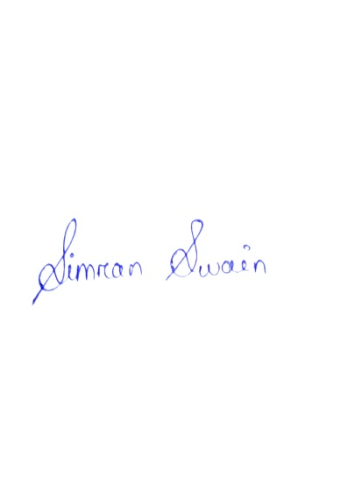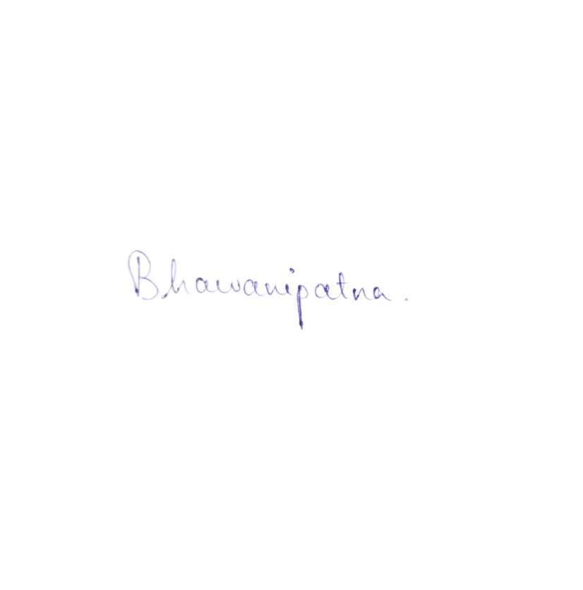

**Place:**

**Date: Signature**