Part 1: Data Model Creation & Validation
Tasks
- Open Model View in Power BI.
- Classify tables into:
  - Fact Tables
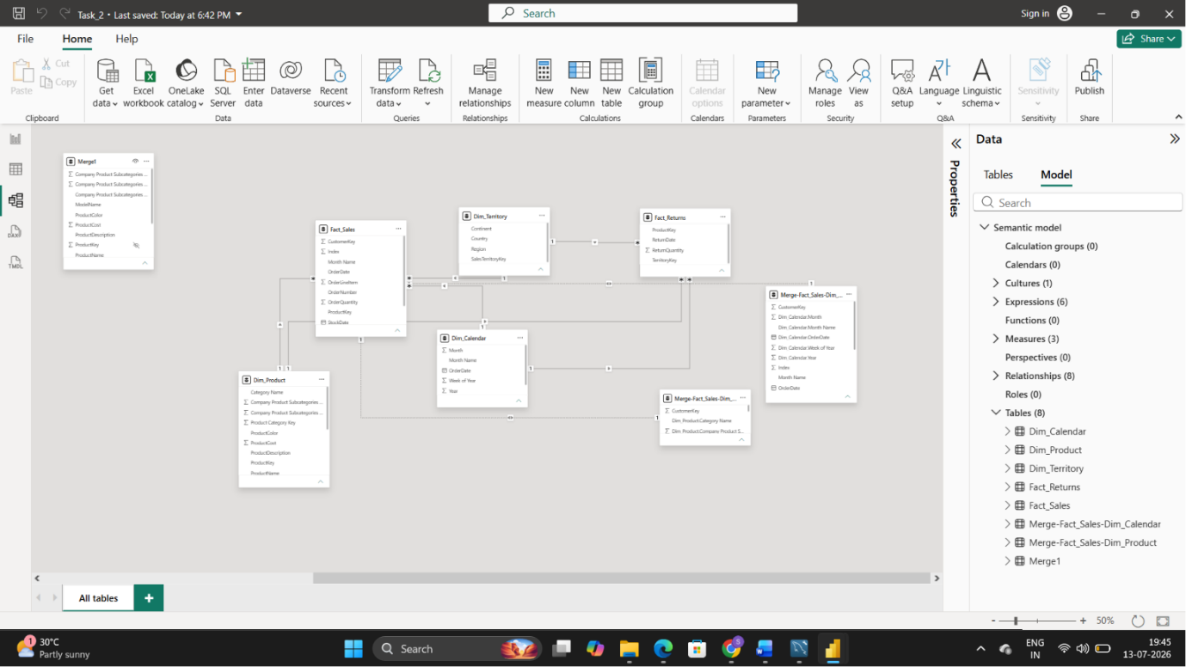
  - Dimension Tables
- Validate key integrity by checking for duplicate keys in:
  - Dim_Product
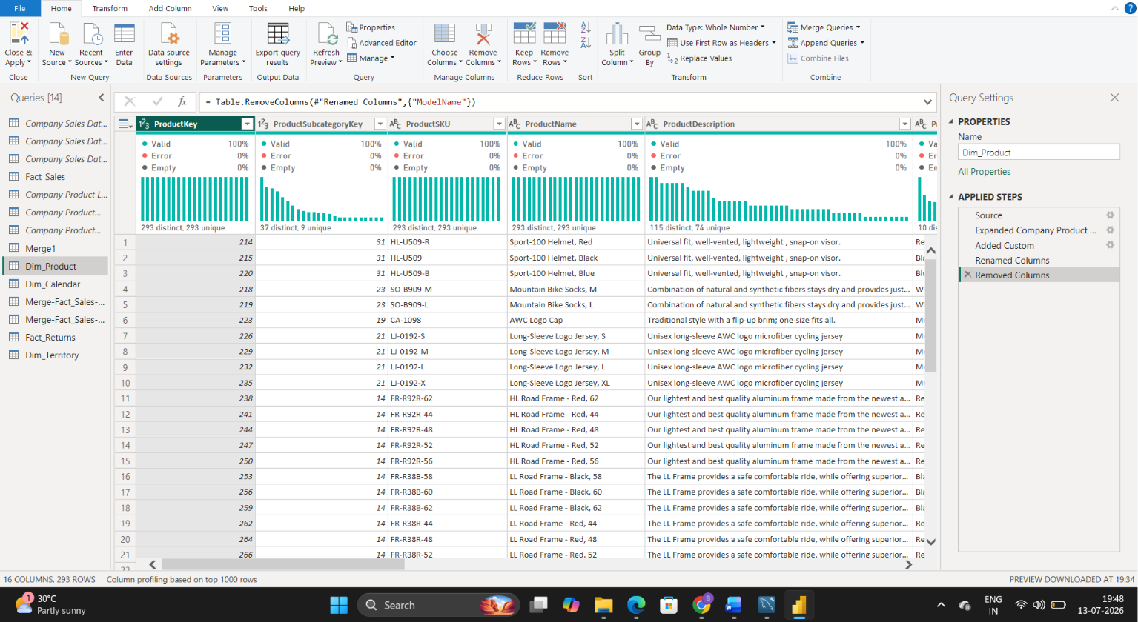
  - Dim_Calendar
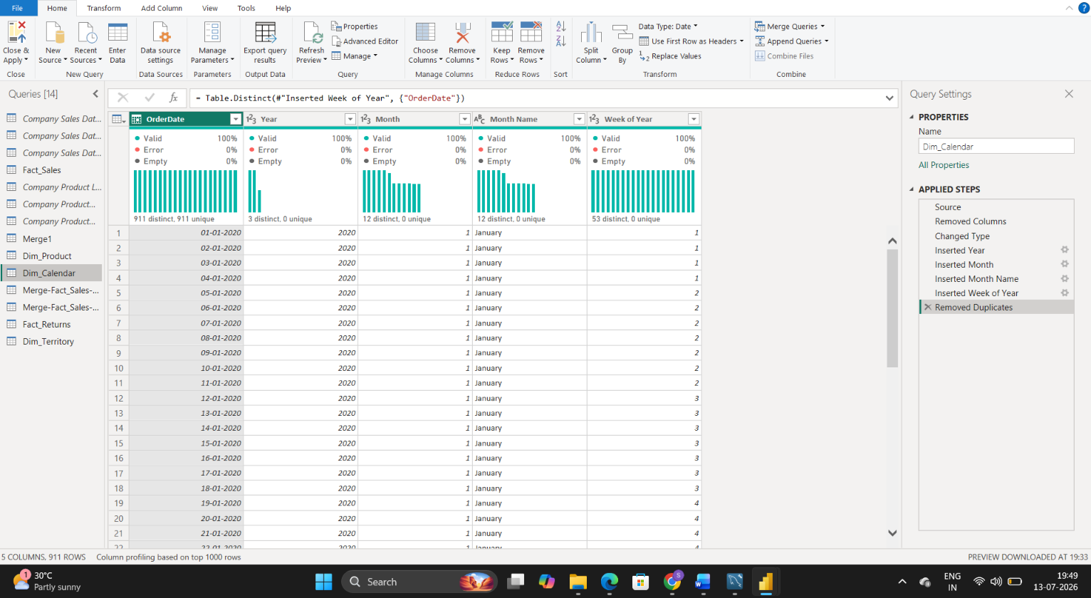
  - Dim_Territory
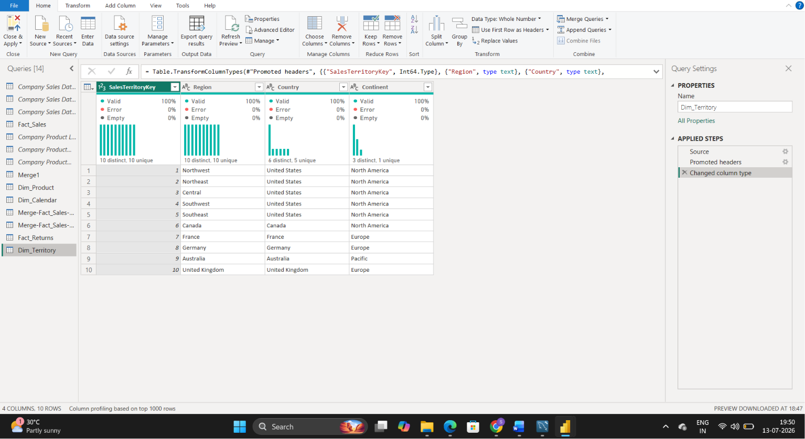

Part 2: Relationship Design (Core Task)
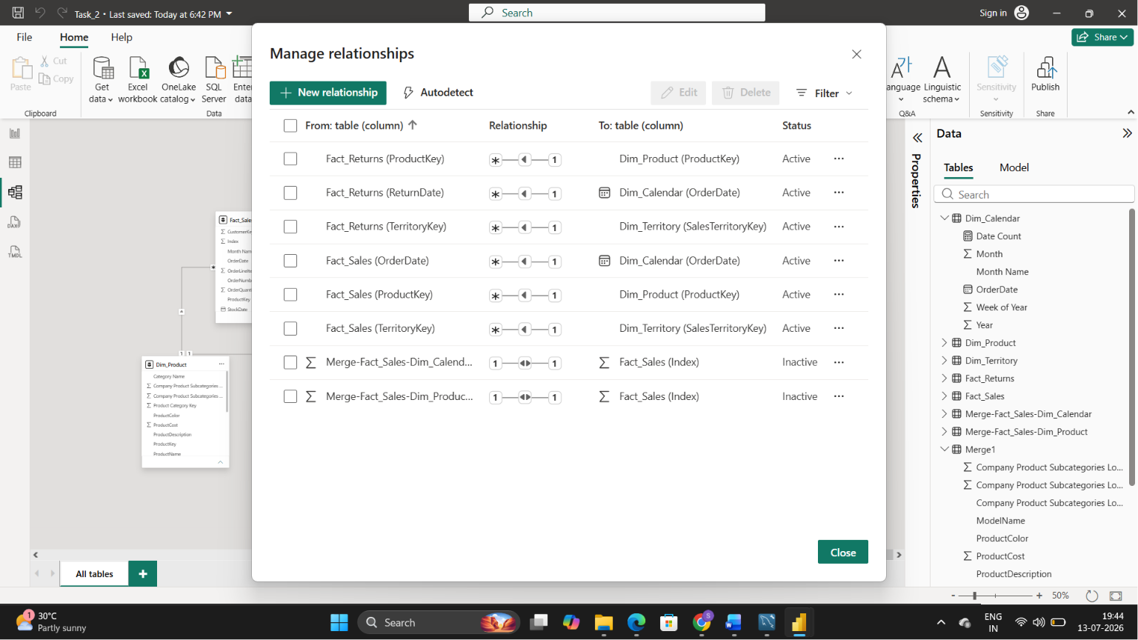

Part 3: Relationship Management & Model Structure
Tasks
- Modify one relationship and set it as Inactive.
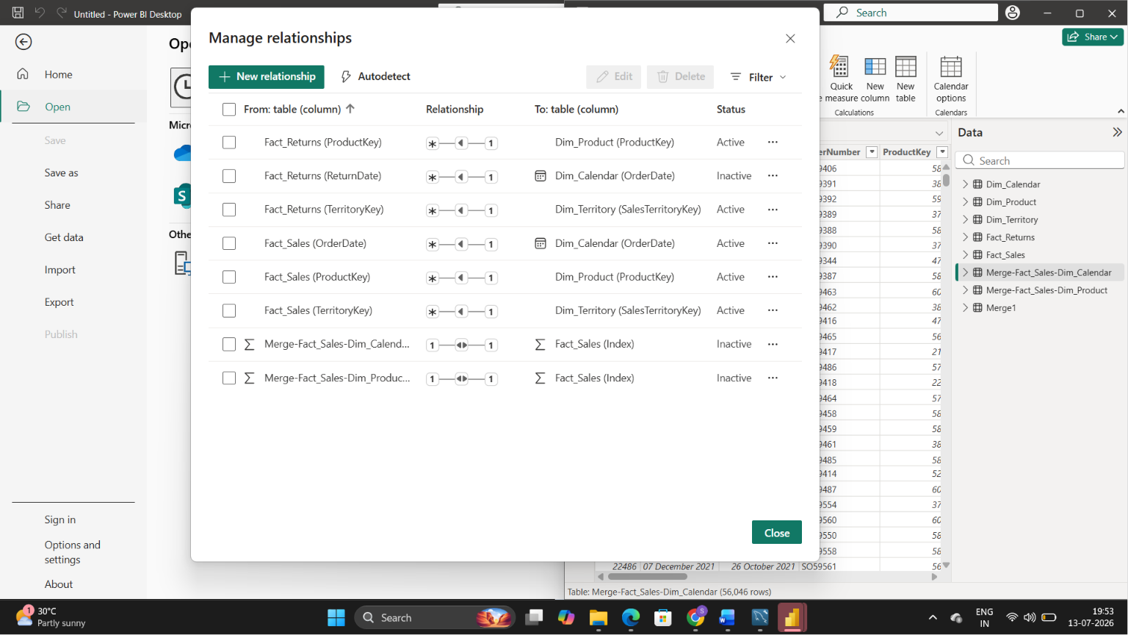
- Observe the impact on visuals.
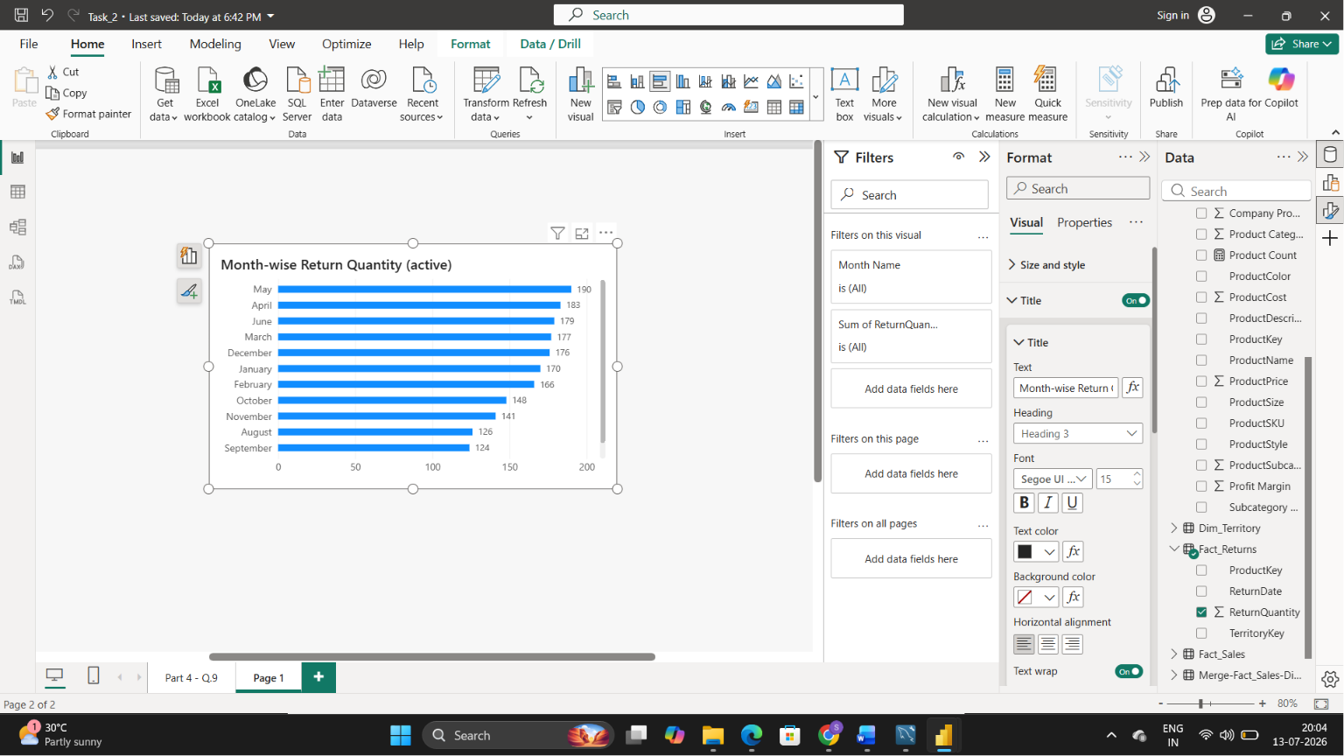
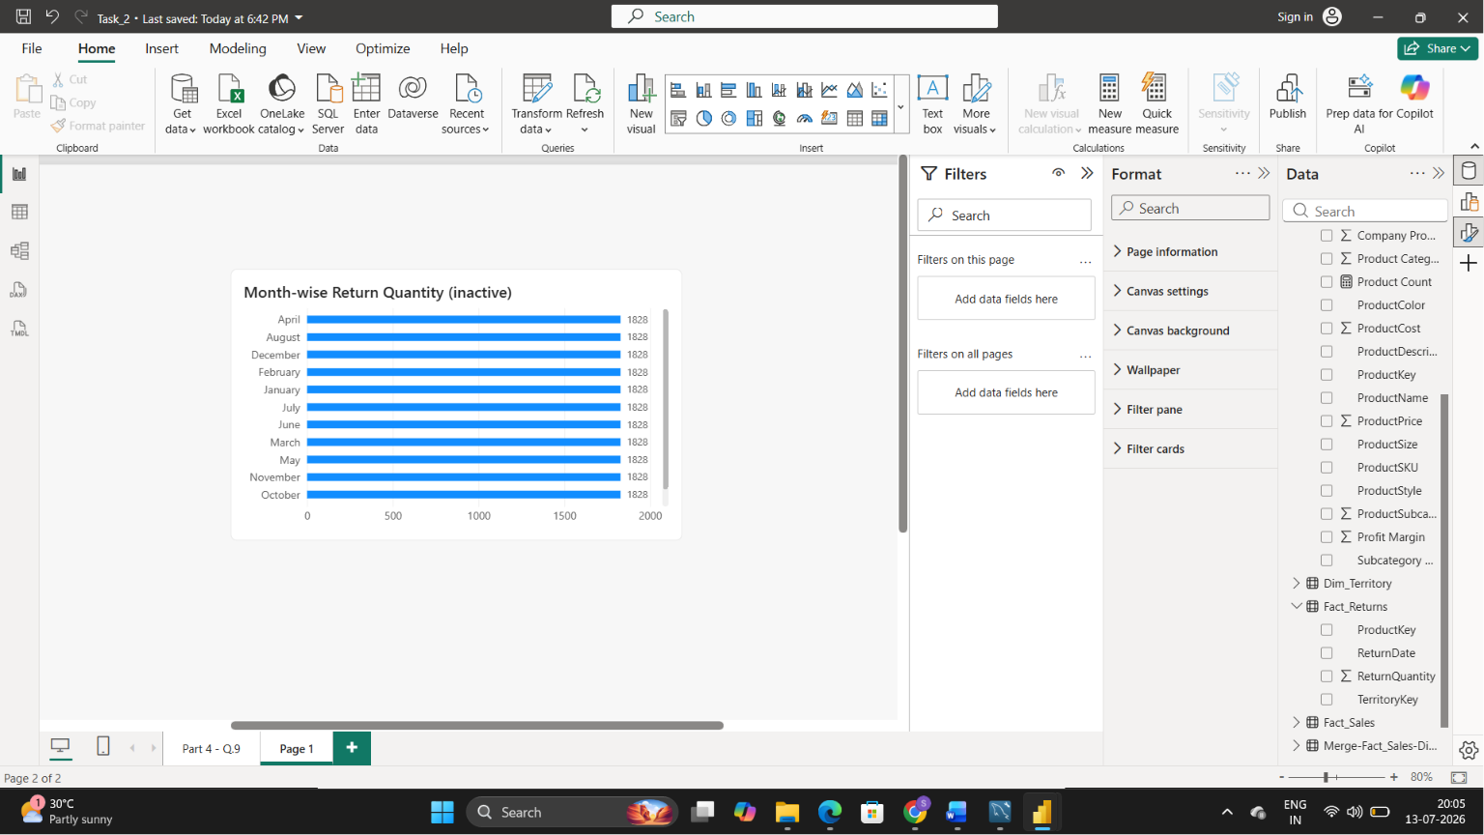
ActiveRelationship:
When the relationship between Fact_Returns and Dim_Calendar is active, the calendar table correctly filters the return data. As a result, return quantities are distributed accurately across different months, providing meaningful month-wise analysis.
Inactive Relationship:
When the relationship is inactive, the calendar table cannot filter the return data. Consequently, the same total return quantity (1828) is repeated for every month, leading to incorrect and misleading results.

- Restore the relationship.
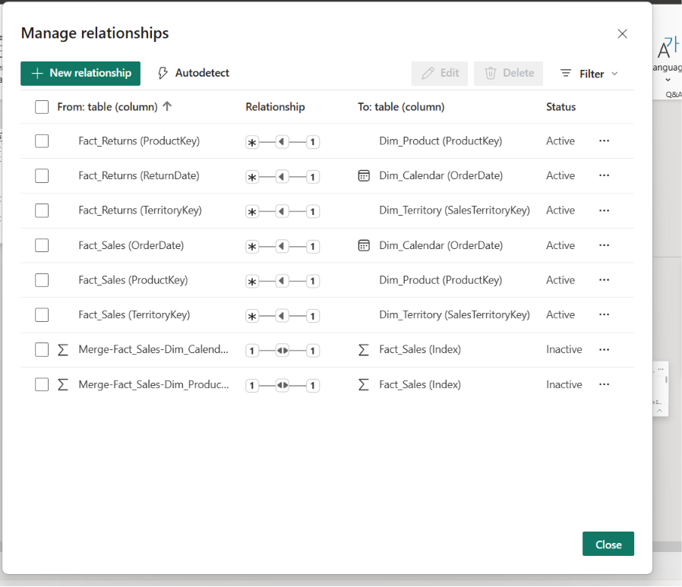
- Identify the schema type used in the model:
The data model follows a Star Schema design because the central fact tables (Fact_Sales and Fact_Returns) are connected directly to dimension tables (Dim_Product, Dim_Calendar, and Dim_Territory).
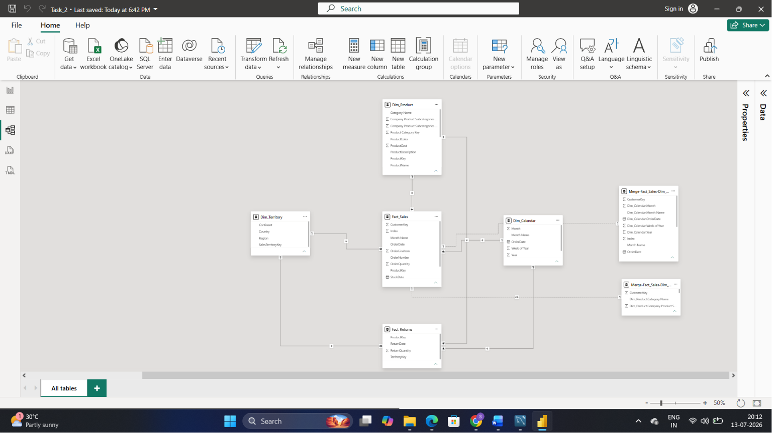

Analytical Questions (Answer Using Visuals)
Q1. Category-wise Sales vs Returns
Compare total Sales Quantity vs Return Quantity and identify high-return product categories.
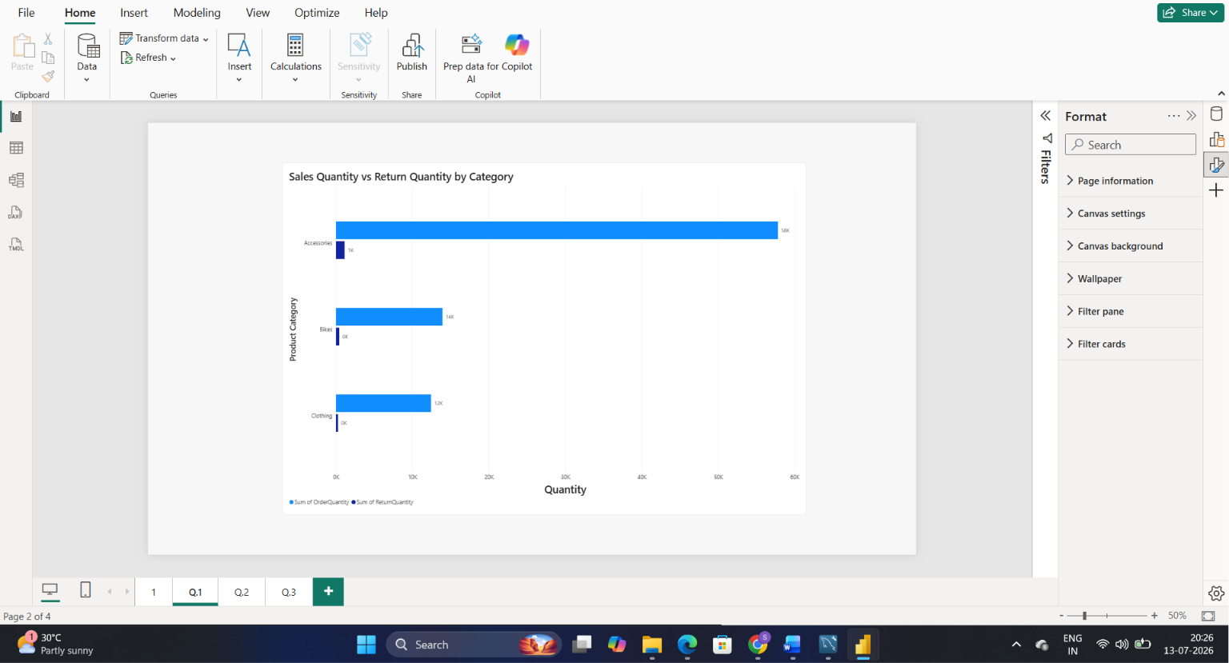
Accessories recorded the highest sales quantity as well as the highest return quantity. Although returns are relatively low compared to sales across all categories, Accessories shows the highest return volume and can be considered the category with the highest return risk.
Q2. Year-wise Sales & Returns Trend
Analyze yearly trends and identify anomaly years where returns are unusually high.
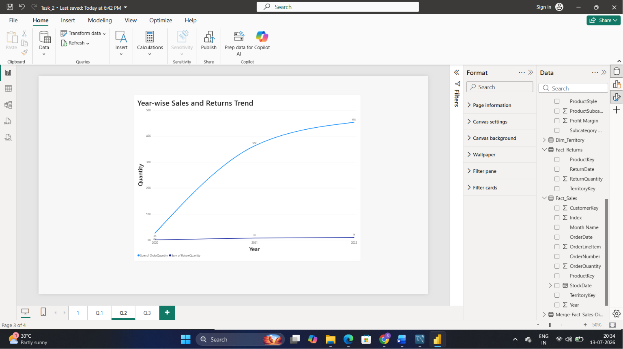
Sales quantity increased significantly from approximately 1K in 2020 to 45K in 2022, indicating strong growth over time. Return quantity remained relatively low throughout the period, with 2022 recording the highest return quantity. Although returns were highest in 2022, no unusual spike or major anomaly was observed, as returns remained stable compared to the substantial increase in sales.
Q3. Continent-level Return Risk
Calculate return quantity by continent and identify the continent with the highest return ratio.
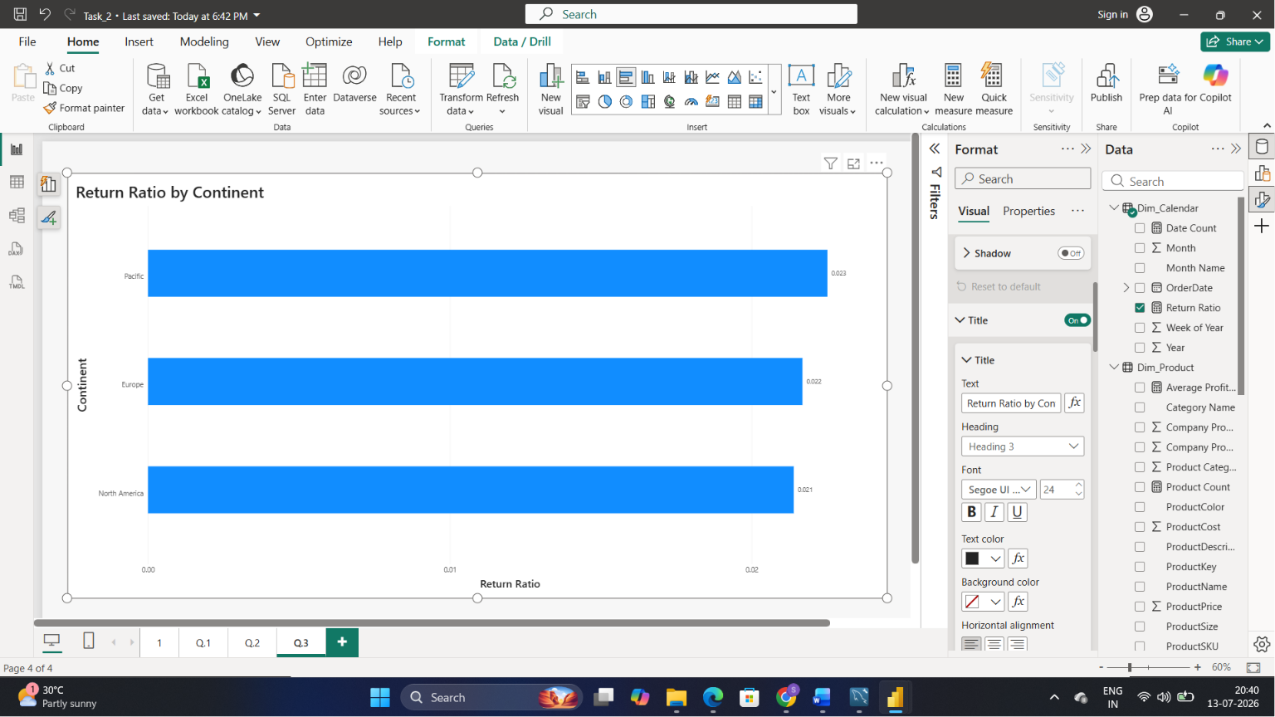
Return risk was analyzed by comparing return ratios across continents. Pacific recorded the highest return ratio (2.3%), followed by Europe (2.2%) and North America (2.1%). Although the differences are small, the Pacific region shows the highest likelihood of product returns and can be considered the continent with the highest return risk.

