EXPERIMENT-2 .
- AIM: To design and implement an end-to-end ETL (Extract, Transform, Load) pipeline using Microsoft Power BI's Power Query Editor, enabling the extraction of data from a real-world business dataset, application of transformation logic, and loading of cleansed data into a unified analytical model for reporting and decision-making.

- OBJECTIVES:
- To understand the ETL process and its role in Business Intelligence.
- To extract data from the Global Superstore dataset using Microsoft Power BI.
- To clean, transform, standardize, and integrate data using Power Query Editor.
- To create relationships between multiple tables in the Power BI data model.
- To prepare the transformed data for reporting and business analysis.

- TOOLS / SOFTWARE REQUIRED:
- Microsoft Power BI Desktop
- Global Superstore Dataset.xlsx
- Power Query Editor – built into Power BI Desktop
- DAX (Data Analysis Expressions)

- DATASET USED: Global Superstore Dataset.xlsx.

- THEORY: ETL: Extract, Transform, Load, is the process BI systems use to pull data from its original source, clean it up into a consistent format, and then bring it into a central location for analysis. It happens in three stages. First, extraction, which is simply gathering the raw data from wherever it lives, in this experiment, that means pulling data from the Orders, Returns, and People worksheets within the Global Superstore dataset. Next comes transformation, the stage where the real cleanup happens: getting rid of duplicate entries and blank rows, fixing incorrect data types, renaming unclear column headers, adding new derived columns where needed, standardizing inconsistent values, and merging the different datasets together. Finally, in the load stage, this cleaned and reshaped data gets pushed into the Power BI data model, where it can be linked through relationships and used to build analytical measures.

Within Power BI, all of this ETL work happens inside Power Query Editor, which essentially functions as the ETL engine. One useful feature here is that every transformation applied to the data gets logged as an "Applied Step," so the entire process stays visible and can be retraced or reproduced later.

- PROCEDURE:
A - Extract –> Connect to Dataset
Step 1: Get the dataset: Download the Global Superstore Dataset.xlsx file and save it into your experiment folder.
Step 2: Connect Power BI to the file: Open Power BI Desktop, go to Home > Get Data > Excel Workbook, select Global Superstore Dataset.xlsx, and click Transform Data.
Step 3: Bring in the needed sheets: Select the Orders, Returns, and People worksheets, then confirm all three appear as separate tables in the Queries pane of Power Query Editor.

B - Transform –> Power Query Editor
Step 4: Open the editor: Go to Home > Transform Data and select the Orders table to begin working on it.
Step 5: Clean up the Orders table: Remove duplicate records and blank rows, verify and correct data types, and rename columns wherever needed. Also extract Year and Month from the Order Date field, create a derived Profit Margin column, and standardize the values in the Region and Segment fields. Once done, check the Applied Steps panel to review everything that was applied.
Step 6: Clean up the Returns table: Remove duplicate Order IDs, check for missing values, and standardize the values in the Returned field.
Step 7: Clean up the People table: Validate the regional assignments, drop any unnecessary columns, and make sure region names are consistent throughout.
Step 8: Merge Orders with Returns: Using the Order ID field as the common key, go to Orders > Merge Queries > Returns > Order ID, choose the appropriate join type, and apply the merge.
Step 9: Finalize and load: Review the Applied Steps across all three tables, then click Home > Close & Apply to push the transformed data into the Power BI data model.

C - Load –> Build Data Model
Step 10: Switch to Model View: Click the Model View icon in the left navigation pane.
Step 11: Build relationships: Link Orders to Returns using Order ID, and Orders to People using Region. Confirm both relationships are set up correctly in the model.
Step 12: Add DAX measures: In the Orders table, use New Measure to create the following:
- Total Sales = SUM (Orders [Sales])
- Total Profit = SUM (Orders [Profit])
- Profit Margin = DIVIDE (SUM (Orders [Profit]), SUM (Orders [Sales]))
- Total Orders = DISTINCTCOUNT (Orders [Order ID])
These measures form the basis for the key performance indicators used in the report.
Step 13: Build the dashboard: Using the transformed data and DAX measures, create a Power BI report featuring Total Sales, Total Profit, Profit Margin, and Total Orders as headline figures, along with a Sales by Category bar chart, a Profit by Category pie chart, a Profit Margin vs. Discount scatter chart, and a detailed Sales & Profit Analysis table. Title the dashboard GLOBAL SUPERSTORE – ETL & SALES ANALYSIS.

- RESULT
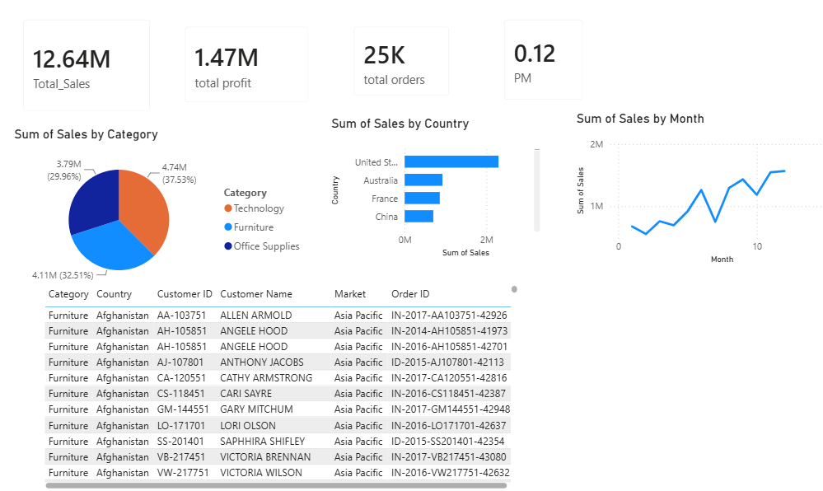
Data was successfully extracted from the Global Superstore dataset, transformed using Power Query Editor, and loaded into the Power BI data model. Data cleaning, standardization, relationship creation, and DAX-based metric generation were performed successfully. The final dataset was prepared for reporting and business analysis.

- LEARNING OUTCOMES
- Understood the ETL process and its role in Business Intelligence.
- Learned how to handle duplicate records, blank values, and data type inconsistencies.
- Understood the use of Total Sales, Total Profit, Profit Margin, and Total Orders measures.
- Learned how to create BI visualizations and dashboards for business analysis.
- Gained practical experience in preparing transformed data for reporting and decision-making.

