**Project Report**

**on**

**SafeStep: Obstacle and Emergency Locator**

in partial fulfilment for the award of the degree of

**BACHELOR OF ENGINEERING**

IN

**CSE (AIML)**

**Submitted by:**

Waseem Akram (24BAI70006)

Simranjeet Kaur (24BAI70048)

Sejal (24BAI70050)

Komal (24BAI70065)

**Under the Guidance of**

Khushal Thakur

**ACADEMIC UNIT-I**



**Chandigarh University**

**16 April 2025**

**Index**

|  |  |  |
| --- | --- | --- |
| **S. No.** | **Content** | **Page No.** |
| 1 | Project Overview | 1 |
| 2 | Objective and Problem Statement | 2 |
| 3 | Proposed Solution & Methodology | 3-7 |
| 4 | Key Findings / Results | 8-9 |
| 5 | Conclusion & Learnings | 10-11 |
| 6 | References | 12 |

**Project Overview**

This project is an object detection and emergency notification system designed to assist visually impaired individuals. It uses an ultrasonic sensor to detect obstacles in the user's immediate surroundings, providing feedback through a buzzer when an object is close. Additionally, the system features an emergency button. When pressed, it retrieves the user's current location using a GPS module and sends an SMS message containing these coordinates to a pre-defined emergency contact via a SIM800L module.

This project addresses critical needs for safety and independence among visually impaired individuals.

* **Enhanced Mobility and Safety**: The object detection feature can help users navigate their environment more confidently by alerting them to potential obstacles, thus reducing the risk of collisions and injuries.
* **Emergency Assistance**: The emergency notification system provides a crucial lifeline in critical situations. By allowing the user to quickly send their location to a trusted contact, it can significantly reduce response times and improve the chances of receiving timely help.
* **Increased Independence**: By providing these assistive technologies, the project aims to empower visually impaired individuals to live more independently and participate more fully in daily activities.

**Brief background or context**

Assistive technologies play an increasingly vital role in improving the quality of life for individuals with disabilities. Traditional aids for the visually impaired often include canes , which are effective but have limitations. Electronic aids, like the one proposed, can offer supplementary information about the environment and provide additional layers of safety. The convergence of affordable and powerful microcontrollers (like the ESP32), compact sensors (ultrasonic, GPS), and communication modules (SIM800L) has made it feasible to develop such integrated assistive systems. This project leverages these technologies to create a low-cost and potentially highly beneficial tool for visually impaired users, combining real-time environmental awareness with emergency communication capabilities.

**Objective and Problem Statement**

The primary problem this project aims to solve is the safety and independence challenges faced by visually impaired individuals in navigating their environment and seeking assistance during emergencies. Specifically:

* **Obstacle Detection:** Visually impaired individuals can encounter unexpected obstacles, leading to potential falls, injuries, and a reduced sense of confidence in their mobility. Traditional aids might not detect all types of obstacles effectively or provide timely warnings.
* **Emergency Situations:** In emergency situations, visually impaired individuals may struggle to communicate their location quickly and accurately to request help, especially if they are in unfamiliar surroundings or disoriented.

The main goals of this project are to:

* + Develop a wearable or portable system capable of detecting objects in the immediate vicinity of a visually impaired user. This system should provide timely and clear feedback (using a buzzer) to alert the user to potential obstacles, thereby enhancing their safety and mobility.
  + Implement an emergency notification feature that allows the user to easily trigger the sending of their current location to a designated emergency contact. Upon activation (via a push button), the system should utilize GPS to determine the user's coordinates and transmit this information via SMS using the SIM800L module.
  + Integrate these two core functionalities (object detection and emergency notification) into a single, low-power, and user-friendly system. The system should be designed to be practical for everyday use.

**Proposed Solution & Methodology**

The plan is to develop an integrated system combining real-time object detection with emergency location reporting for visually impaired individuals. This involves:

**1. Object Detection:** Utilizing an ultrasonic sensor to alert the user when an object comes within a defined proximity threshold.

**2. Emergency Notification:** Implementing an emergency trigger using a push button. Upon pressing this button, the system would:

* Activate the GPS module to obtain the user's current latitude and longitude.
* Format this location data into an SMS message.
* Use the SIM800L module to send the SMS to a pre-configured emergency contact number.

**3. Microcontroller Control:** Employing an ESP32 microcontroller to manage the data flow from the sensors, control the buzzer, handle button presses, communicate with the GPS and SIM800L modules, and orchestrate the overall system logic.

**4. Power Management:** Utilizing a Li-ion battery and a TP4056 charging/protection module to provide a portable power source for the system.

**Tools/Software/Materials used.**

* + **Microcontroller:** ESP32 Development Board
  + **Power Source:** 3.7V Li-ion Battery
  + **Charging & Protection:** TP4056 Module
  + **Cellular Communication:** SIM800L Module (with SIM card)
  + **Location Tracking:** GPS Module i.e.NEO-6M
  + **Object Detection:** Ultrasonic Sensor i.e. HC-SR04
  + **User Feedback:** Buzzer
  + **Emergency Trigger:** Push Button
  + **Prototyping:** Breadboard, Jumper Wires
  + **Software:** Arduino IDE
  + **Libraries (Arduino IDE):** TinyGPS++ Library

**Plan of Implementation**

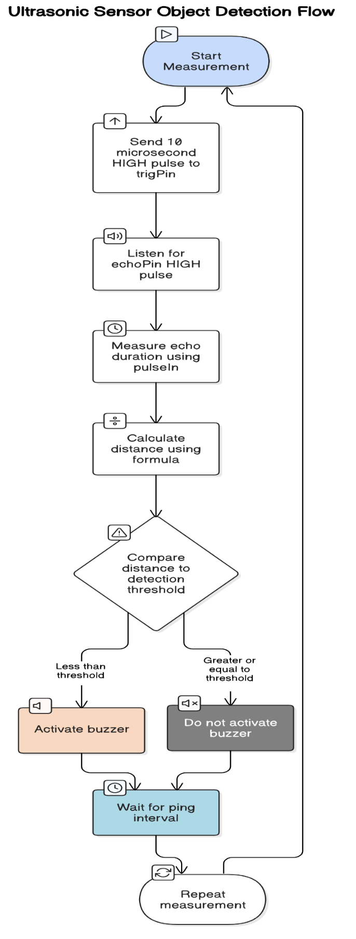

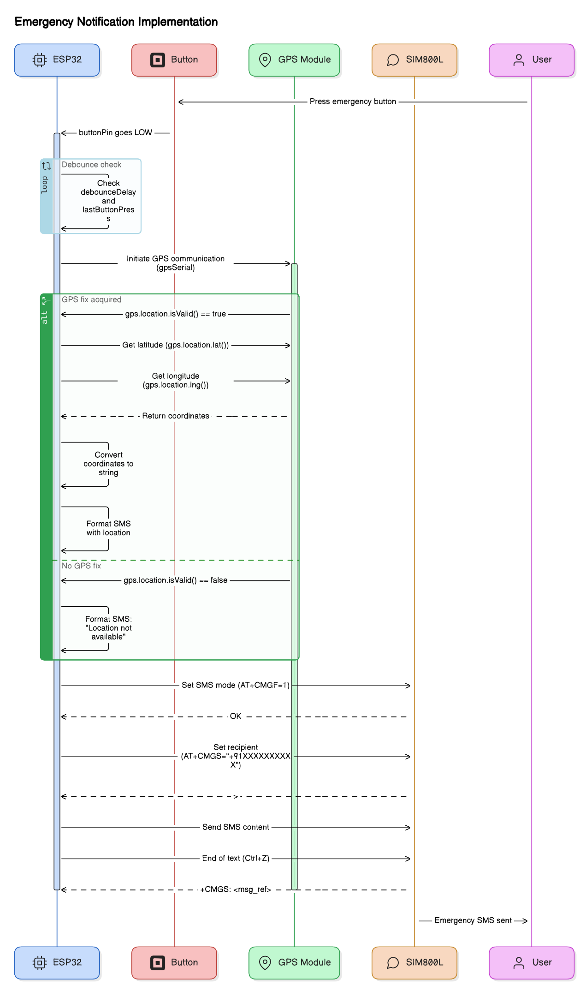

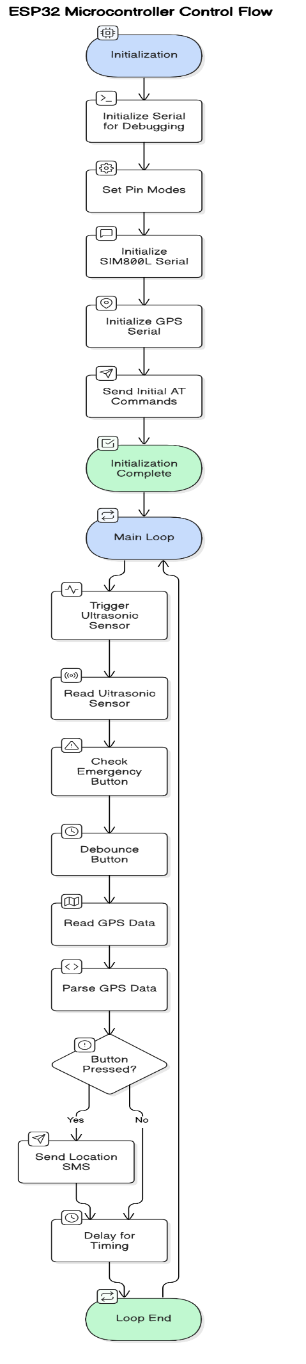

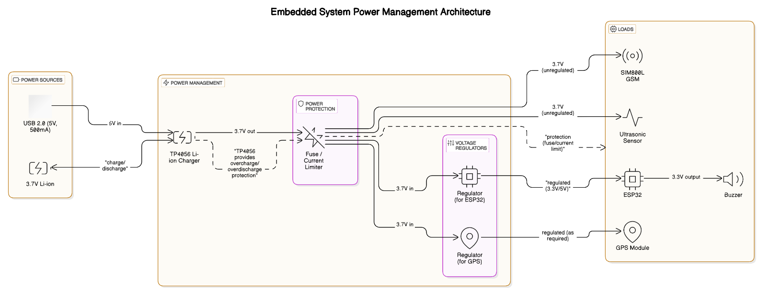

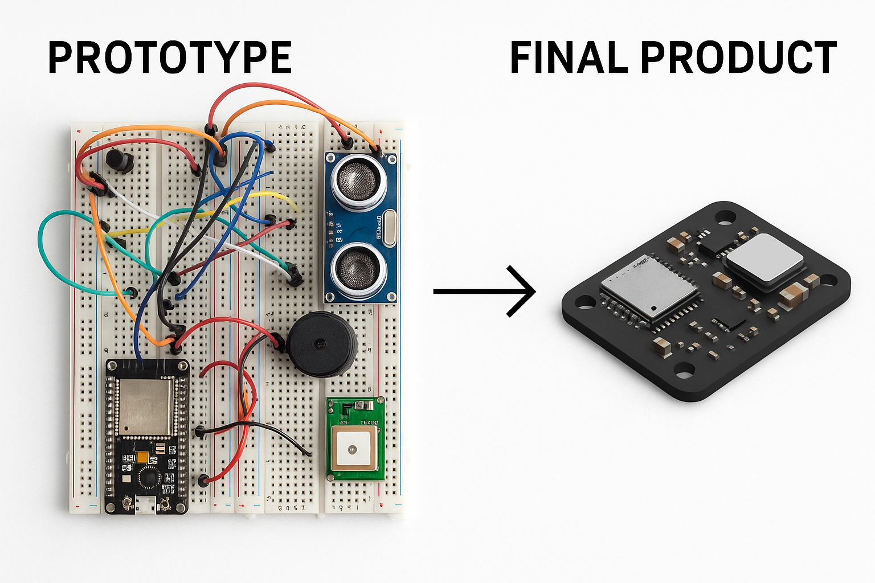

**Key Findings / Results**

After building and testing the prototype, several key findings and results were observed:

* + **Successful Object Detection:** The ultrasonic sensor was able to reliably detect objects within the defined threshold distance (e.g., 50 cm). The buzzer provided a clear audible alert when an obstacle was detected. The responsiveness of the buzzer was directly related to the proximity of the object. Different buzzer pattern like increasing frequency with closer objects was implemented to provide more nuanced feedback.
  + **Functional Emergency Button:** The push button successfully triggered the emergency notification sequence. The debouncing mechanism implemented in the code effectively prevented multiple SMS messages from being sent with a single button press.
  + **GPS Location Acquisition:** The GPS module, after a typical satellite acquisition time, was able to provide valid latitude and longitude coordinates. The accuracy of the GPS coordinates was generally within the expected range for the GPS module used.
  + **Successful SMS Transmission:** The SIM800L module successfully initialized and, upon receiving the location data from the ESP32, was able to send SMS messages to the pre-defined emergency contact number. The content of the SMS message accurately reflected the emergency alert and the obtained GPS coordinates.
* **Power Consumption (Simplified):**
* **ESP32:** Averages ~20-80 mA (active)
* **SIM800L:** Idles <7 mA, averages ~350 mA during SMS
* **GPS:** ~25-45 mA active
* **Ultrasonic:** ~15 mA during measurement
* **Buzzer:** <30 mA when active.
  + **Integration and Communication:** The ESP32 effectively managed the communication between all the modules (ultrasonic sensor, buzzer, button, GPS, and SIM800L) through digital I/O and serial protocols. The chosen libraries (TinyGPS++ Library) simplified the parsing of GPS data.
  + **Limitations Observed:** The accuracy of the ultrasonic sensor could be affected by the shape and surface of the object. The time to obtain a GPS fix could vary. The reliability of SMS delivery depended on network coverage.

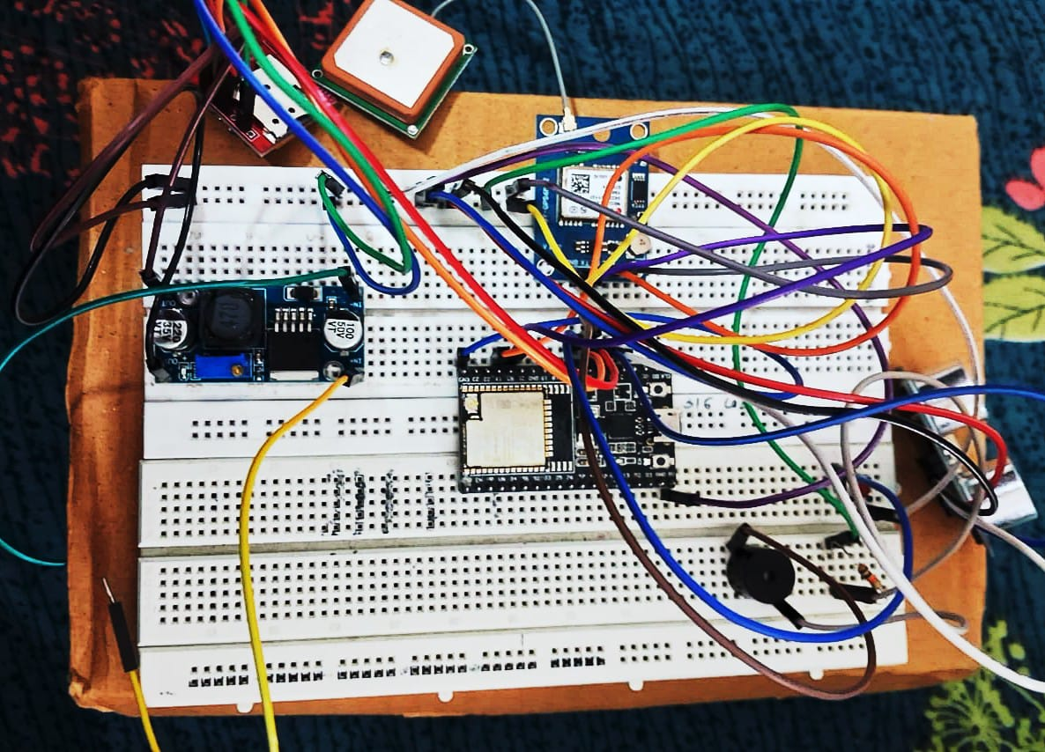

**Conclusions and Learnings**

This project successfully demonstrates the integration of diverse technologies—ultrasonic sensing, GPS, and cellular communication—within an ESP32-based embedded system, highlighting the ESP32's versatility in handling multiple tasks. Key learnings include:

* **Sensor Interfacing:** The project underscored the importance of accurately interfacing sensors like the HC-SR04 ultrasonic sensor. This involves careful timing of trigger pulses, precise measurement of echo signals, and converting these measurements into meaningful distance values.
* **Real-time Control:** Implementing the obstacle detection feature emphasized the need for real-time control. The ESP32 had to quickly and reliably process sensor data and activate the buzzer, demonstrating the importance of efficient code execution and interrupt handling.
* **Efficient Power Management:** Given the power demands of the SIM800L and GPS modules, the project highlighted the critical need for efficient power management in battery-powered embedded systems. This includes understanding the power consumption characteristics of different components and employing techniques to minimize energy usage.
* **System Integration:** A key takeaway was the importance of system integration. Successfully combining hardware components with software control required careful planning, debugging, and ensuring that all parts of the system worked together seamlessly.

**Improvements and Next Steps:**

To enhance this project, future steps should focus on:

**1.Software:**

Implementing robust error handling and data validation to improve system reliability. This includes handling potential issues like GPS signal loss, SIM800L network errors, and unexpected sensor behavior.

**2.Hardware:**

* + Developing a custom PCB to integrate all components, improving compactness, durability, and long-term reliability of the system.
  + Designing a suitable enclosure to protect the electronics from environmental factors and enhance the device's aesthetics and usability.

**3.Power:**

* + Utilizing ESP32 deep sleep modes to minimize power consumption during extended periods of inactivity, significantly prolonging battery life.
  + Implementing duty cycling for the GPS and SIM800L modules, where they are only powered on when needed, further reducing energy consumption.

**4.Features:**

* + Exploring alternative communication methods, such as LoRa or NB-IoT, which offer lower power consumption and longer communication ranges compared to GSM, for specific use cases.
  + Integrating additional sensors, such as accelerometers or gyroscopes, to provide more context in an emergency, such as detecting falls or sudden impacts.

**5.User Experience:**

* Incorporating user feedback mechanisms, such as visual or auditory signals (e.g., LEDs, vibration), to confirm button presses, SMS sending, and other critical events.
* Simplifying the interface and ensuring the device is intuitive and easy to use, even in stressful situations.

**References**

1. Mocanu, B., Tapu, R. and Zaharia, T., 2016. When ultrasonic sensors and computer vision join forces for efficient obstacle detection and recognition. *Sensors*, *16*(11), p.1807.

2. Meliones, A., Filios, C. and Llorente, J., 2022. Reliable ultrasonic obstacle recognition for outdoor blind navigation. *Technologies*, *10*(3), p.54.

3.Websites : Arduino Project Hub, Instructables , DiagramGPT