**Inferential Statistics**

**Inferential Statistics** focuses on making inferences about a population based on sample data. It uses mathematical methods and models to estimate characteristics.

This relies on Probability Theory and Distribution to predict population values.

**What is Distribution?**

Distribution is the function that shows the possible values for a variable and how often they occur.

Probability Distribution provides a Mathematical description of the likelihood of different outcomes for a random variable.

1. **Discrete Probability distribution** – Is the probability distribution that describes the likelihood of outcomes for Discrete Random Variables (one which takes on a finite or countable infinite set of distinct values).

* **Binomial Distribution**- models the number of successes in a fixed number of independent trials.
* **Poisson Distribution**- use to model number of events occurring within a fixed interval of time, space or other dimensions.

1. **Continuous Probability Distribution**- It deals with variable that can take on an infinite number of values within a given range.

* **Normal Distribution**- Gaussian Distribution, the distribution of a dataset show is the frequency at which possible values occur.

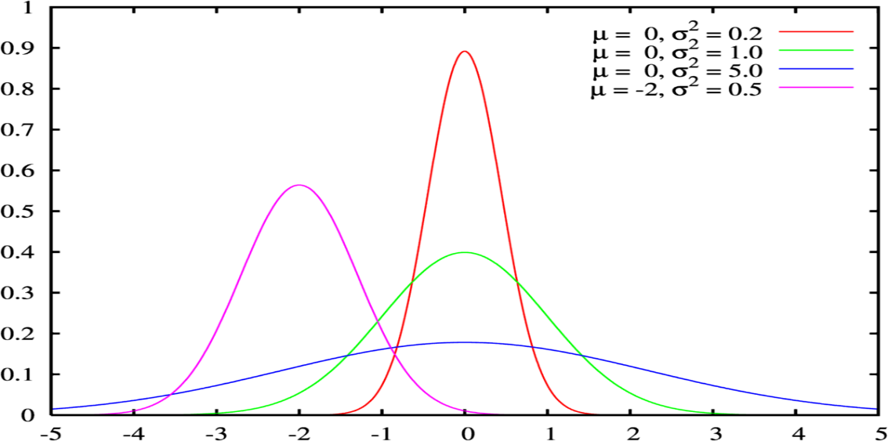

* **Uniform Distribution-** all outcomes in a range are equally likely.
* **Exponential distribution**- Models the time between events in a Poisson process.

Normal Distribution or bell curve

* When mean = median = mode then there is no skewness the graph will be perfectly around mean.

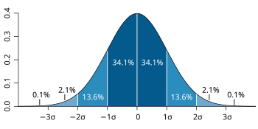

Mean = median = mode

* Lower mean will result in the same shape of the distribution but on the left side of the pane.

* Bigger the mean will result in the same shape of the distribution but on the right side of the pane

Normal distribution is widely used it is only appropriate for certain types of data those that are continuous and symmetrically distributed around a mean.

Standard Normal Distribution – standardization is the process of transforming to one with a mean 0 and standard deviation to 1.

Standardized variable is called **Z- Score.**

$z=\frac{x-μ}{σ}$