Visualization

**Categorical Variables – Visualization techniques**

Most common Visualizations to visualize the categorical variables are:

1. Frequency Distribution tables

1. Bar charts/ Column charts
2. Pie charts
3. Pareto Diagrams - Are special type of bar chart, where categories are shown in descending order of frequency (Number of Occurrences of each item). It is named after **Vil Fredo Pareto**. Curve on the Graph shows the Cumulative frequency (sum of all the relative Frequencies).

Pareto principle- **80-20 rule**, 80% of effect comes from 20% of causes.

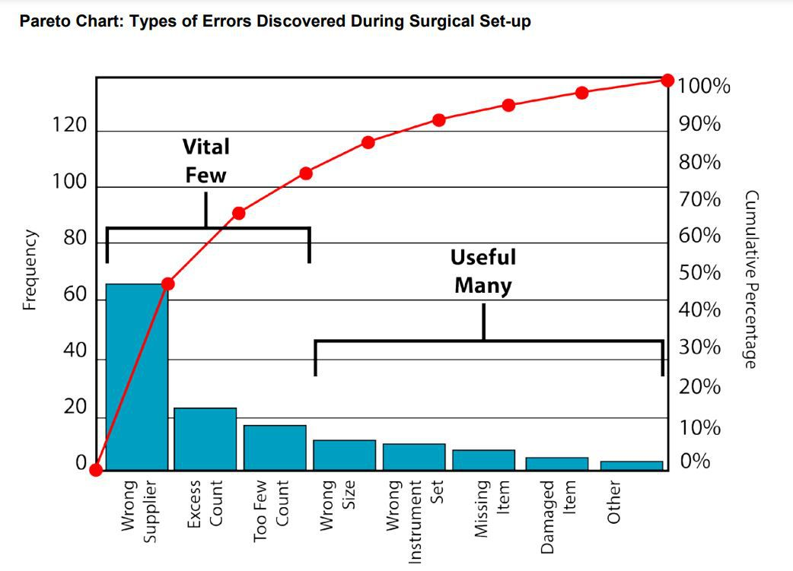

**Numerical Variables – Visualization techniques**

Frequency Distribution tables – a number is included in an interval if that number is greater than the lower bound and if that number is lower or equal to the upper bound.

Relative Frequency = Frequency / Total Frequency

1. Histogram

1. Bar chart

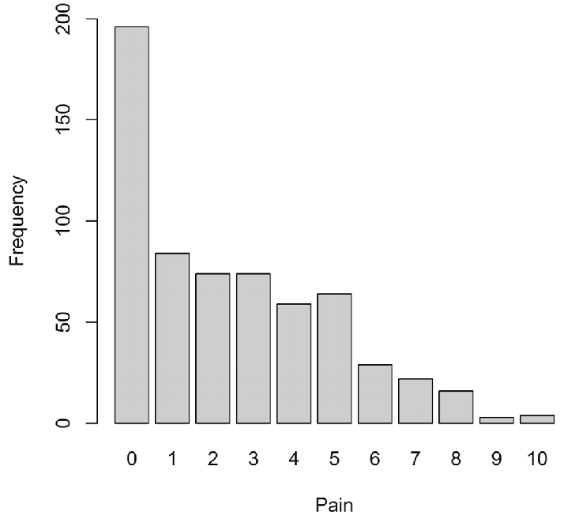

1. Cross Tables – Contingency Tables

1. Scatter plot – Usually tell how data is Distributed, and it is use to represent two numerical variables. Each point on the graph represents a particular information about the data points present in table.