<!DOCTYPE html>

<html>

<head>S

<title>Assignment1</title>

</head>

</body>

<h1>Simranpreet singh</h1>

<div>

<p> <strong> My name is Simranpreet Singh, I am student of Matrix college. I enrolled in CST program</strong></p>

</div>

<div>

<img src= "https://web.whatsapp.com/d2e3bd2d-c0c8-411f-800a-2f065a9a5c7b" alt="Image not available">

<div>

<a href="https://ca.linkedin.com/">

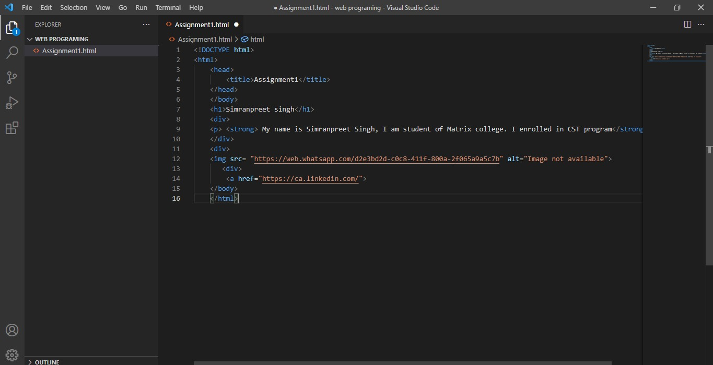 </body>

</html>

