 | Employee Profile 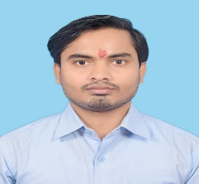
PERSONAL INFORMATION
Full Name | SUDHIR SHAH
Designation | MANAGER | Department |  | IT
Division | AUTOMOBILE | Date of Joining |  | 2076-4-2
Work Station | JEETPUR/SIMARA | Total working Experience |  | 12 YEARS
Official Mail ID | Sudhir.s@mvdugar.com | Age | 28
Mobile No. | 9801012619 | Date of Birth | 2054-06-25
EDUCATIONAL BACKGROUND
HSEB +2 St.Xaviers Higher Secondary School – Birgunj,Shreepur
DIPLOMA IN PROGARMING ASP.NET MVC,C#,Sql Server,Css,Html,JavaScript

CAREER ACOMPLISHMENT
S.No. | Organization Name | Designation | Duration | Workstation
1 | Dynamic Technosoft Pvt.Ltd. | Support (Hospital ERP, School ERP, Accounting ERP) | 2 yrs | BANESHWOR KATHMANDU
2 | Dynamic Technosoft Pvt.Ltd. | Devloping Software | 2 Yrs | BANESHWOR KATHMANDU
3 | PIVOTAL Pvt.Ltd. | Q.A | 2 yrs | BIRGUNJ - TINMURTI CHAUK
- (Trainings etc..)
- Graphic Desining from Education. com

JOB PROFILE IN MV DUGAR GROUP
- Run time issue solving by query
- Solving the financial & Vat report
- Posting the vouchers (Cannabalise In & Out, Stock Journal except KTM Branch)
- Desining the Templates of Vouchers & Report

