1.Employee Profile-------Space Remove garnus
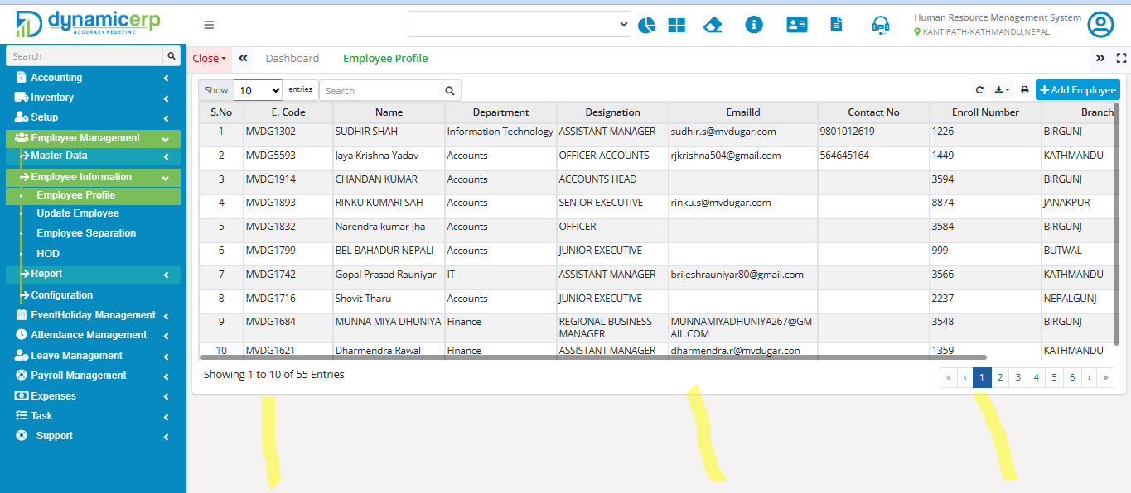
2.Update Employee
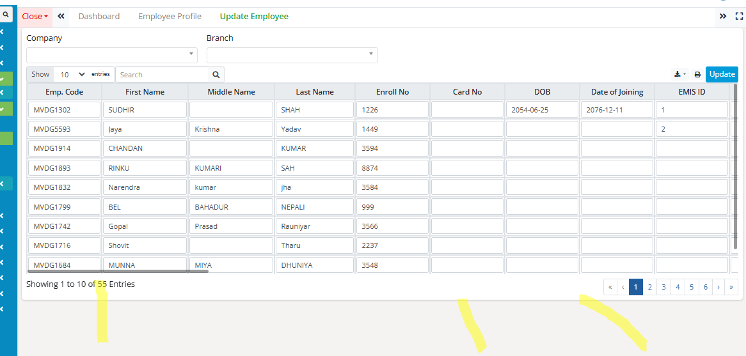

3.Employee Summary
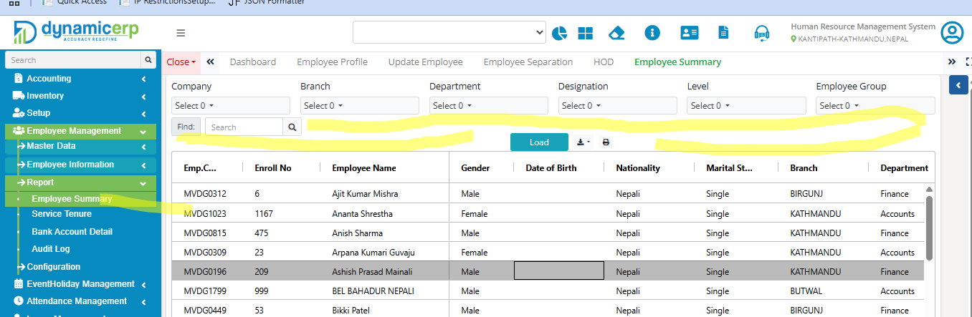

4. Employee Summary------Scroll Fixed garnu parne x
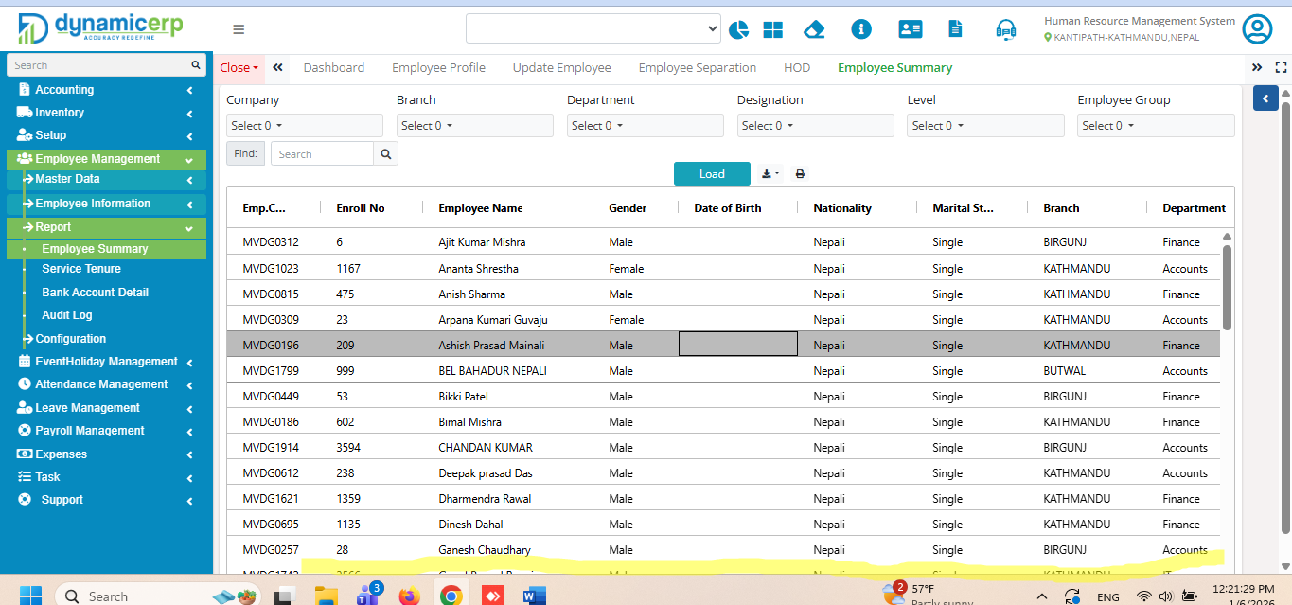

5.Dailly Manual Attendance -------------Scroll Fixed garnu parne
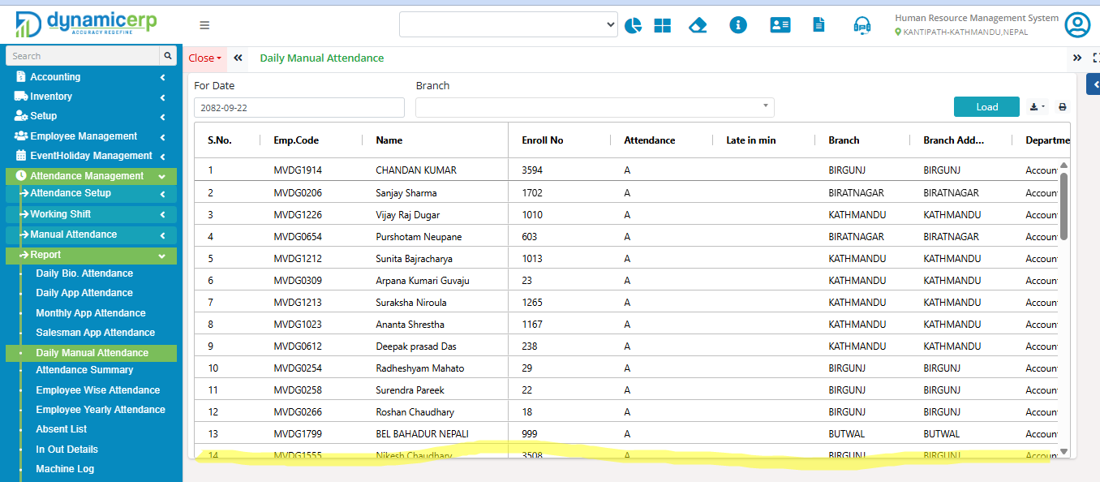

6. Absent List-----------Scroll fixed garnu parne
