FACIAL EXPRESSION RECOGNITION

# ABSTRACT

Facial expression recognition plays a crucial role in the area of human-machine interaction. These Human facial expressions convey much information visually rather than articulately. The automatic facial expression recognition system has many applications, including, but not limited to human behavior understanding, detection of mental disorders, and synthetic human expressions. Recognition of facial expression by computer with a high recognition rate is still challenging. Two popular methods utilized in the literature for automatic FER systems are based on geometry and appearance. Facial Expression Recognition is usually performed in four stages: pre-processing, face detection, feature extraction, and expression classification. This project will apply various deep learning methods (convolutional neural networks) to identify the key seven human emotions: anger, disgust, fear, happiness, sadness, surprise, and neutrality.

# INTRODUCTION

Facial expression is a nonverbal scientific gesture expressed in our face as per our emotions. Automatic recognition of facial expression plays a vital role in artificial intelligence and robotics, and thus it is a need of the generation. Some applications related to this include Personal identification and Access control, Videophone and Teleconferencing, Forensic application, Human-Computer Interaction, Automated Surveillance, Cosmetology, and more. The objective of this project is to develop an Automatic Facial Expression Recognition System which can take human facial images containing some expression as input and recognize and classify them into seven different expression classes such as:

* Neutral
* Angry
* Disgust
* Fear
* Happy
* Sadness
* Surprise

# PROBLEM DEFINITION AND EXPECTED RESULT

Human facial expressions can be easily classified into seven basic emotions: happy, sad, surprise, fear, anger, disgust, and neutral. Our facial emotions are expressed by activating specific sets of facial muscles. These sometimes subtle yet complex signals in an expression often contain much information about our state of mind.

Through facial emotion recognition, we can measure the effects of content and services on the audience/users through an easy and low-cost procedure. For example, retailers may use these metrics to evaluate customer interest. Healthcare providers can provide better service by using additional information about patients' emotional states during treatment. Entertainment producers can monitor audience engagement in events to create desired content consistently.

**DATASET**

In our project we have extracted dataset from Kaggle.

<https://www.kaggle.com/jonathanoheix/face-expression-recognition-dataset>

**IMPLEMENTATION**

Determining whether or not a face is present is perhaps the most important step in the facial recognition process. Mainly because it is essentially the beginning of the first step in the process (besides preparing the data set). OpenCV, the software used for facial recognition in this project, uses classifiers to detect objects. These classifiers are trained by the programmer for whatever it is that he or she wants the recognition software to detect. Because this project focuses primarily on facial expressions and emotions, it was decided that OpenCV be used for facial recognition since the source code and classifier for that is already in place. Training classifiers and databases will be discussed in greater detail in the following section and again in the design section. Once the data set is ready, some common problems have to be taken into consideration.

One common problem is a partially blocked face. When someone sees a picture of someone and that person’s face is partially blocked, that person is able to fill in the missing pieces. Not all systems are capable of filling in those pieces and thus results in poor object detection, or no detection at all. As it stands right now, if the face is blocked in the tiniest bit, the program is not able to detect it. Same goes for if the individual in the current image has their face turned too far to the side or tilted too far back. Another common issue is lighting. Again, this is not as big of an issue for people as it is for machines. When the lighting is too bright, people can squint and still make out that a face is present. This is much more difficult for machines and therefore has to be taken into consideration when creating the positive image database for each emotion. Extreme lighting whether it is natural light or not currently causes the classifier to be less accurate. It is still able to detect a face but the emotion classifier is significantly less accurate. If images in the database contain obscured faces or are lit poorly to where, when creating the classifier, the classifier is unable to extract the necessary facial points from that image. All of these issues could lead to inaccurate results.

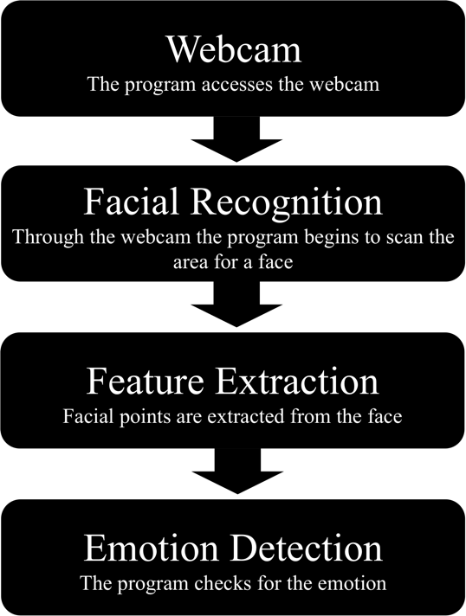

In terms of the actual experimentation, the program first starts off by first accessing the laptop camera. The program then accesses the first cascade classifier that is called within it. This initial classifier is the facial detection classifier already provided by OpenCV. When it is called, it begins scanning the image for a face and when it is found a blue circle is created around the person’s face and the second classifier is called. In this case the nested classifier is the happy classifier that we created. This classifier is performing the exact same way as the face detect classifier except for the fact that it is scanning for facial points and features that it associated with the happy subjects in the database. When it finds the features and points, blue circles are generated around them. This is just one way in which emotion detection can be achieved as there are many other methods out there as well.

**OUTPUT**

**CONCLUSION**

Face Detection individually have numerous use-cases in today’s world. We see object detection algorithms in public parking lots, traffic monitoring systems, etc. that take images of people driving vehicles to keep records. The study of human cognition has also evolved medicines. On the technological front, virtual assistants, profile evaluation assistants, and automation bots are built to mimic the actions of humans and replace them with the hope of increasing accuracy and decreasing errors. It is therefore a very important part of the Artificial Intelligence inspired world we live in today.

**REFERENCES**

* “A deep facial recognition system using computational intelligent algorithms” - Diaa Salama AbdELminaamID1,2*, Abdulrhman M. Almansori1 , Mohamed Taha3 , Elsayed Badr4,5

# “Emotional Expressions Reconsidered: Challenges to Inferring Emotion From Human Facial Movements” - [Lisa Feldman Barrett](https://journals.sagepub.com/eprint/SAUES8UM69EN8TSMUGF9/full), [Ralph Adolphs](https://journals.sagepub.com/eprint/SAUES8UM69EN8TSMUGF9/full), [Stacy Marsella](https://journals.sagepub.com/eprint/SAUES8UM69EN8TSMUGF9/full), [Aleix M. Martinez](https://journals.sagepub.com/eprint/SAUES8UM69EN8TSMUGF9/full), [Seth D. Pollak](https://journals.sagepub.com/eprint/SAUES8UM69EN8TSMUGF9/full)

SIMRON SIMON WASKAR – U39071640

AJITH KRISHNA RAGHURAMAN - U46407261

RUTUJA SUNIL BHAMARE - U25832532