Q1:Find the regular expression for the following:

- L={w∈{a,b}∗∣the first symbol of w=the last symbol of w}

Regular Expression: ((ε + a)+a(a+b)*a ) + ((ε + b)+b(a+b)*b)

- L={w∈{a,b}∗∣∣w∣ is divisible by 3}

Regular Expression: ((a+b)(a+b)(a+b))*

- L={w∈{a,b}∗∣w has alternating characters, starting with a}

Regular Expression: ε + (a(ba)*)(ε + b)
Or (ab)*a* + (ab)*

- L={w∈{a,b}∗∣w does not contain aa as a substring}

Regular Expression: (ε + a)(b + ba)*

- L={w∈{a,b}∗∣the 3rd character of w is b}

Regular Expression: (a+b)(a+b)b(a+b)*

Q2:Design a DFA over the alphabet Σ={0,1} that accepts the language:

- L={w∈{0,1}∗∣the binary number represented by w is divisible by 3}

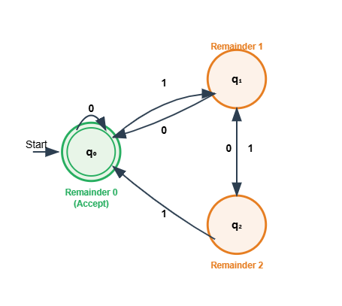

- L={w∈{0,1}∗∣the substring 0101 does not occur in w}.

