Kaggle Playground Prediction
Competition Report

Name | Simroz Sohail
Roll No | 24K-0746
Section | BCS-4K
Submission Date | May 1st, 2026

1. Competition Overview

Competition Name | Kaggle Playground Series – Predicting Irrigation Need
Problem Type | Multiclass Classification
Evaluation Metric | Balanced Accuracy Score

Dataset Understanding
The dataset is part of the Kaggle Playground Series — a tabular multiclass classification task. Based on the feature names present in the code, the dataset contains soil and environmental features used to predict a categorical target. Key features include:
- Soil_Moisture – moisture content in the soil
- Rainfall – precipitation level
- Temperature – ambient temperature reading
- Humidity – relative humidity percentage
- Soil_pH – acidity/alkalinity of the soil
The target variable is a multi-class label representing crop types. The training set is loaded from train.csv and predictions are produced for test.csv. Class imbalance is addressed throughout using balanced_accuracy_score and class_weight='balanced' where applicable.

2. Data Preprocessing

Missing Values
- Numerical columns: filled with the column median (computed on training data only, then applied to test).
- Categorical columns: filled with -1 after label encoding.

Encoding Techniques
- Target variable: LabelEncoder transforms class names into integer indices (0 … n_classes−1).
- Categorical features: LabelEncoder fitted on the combined train+test values to avoid unseen-label errors at inference.

Feature Scaling
- StandardScaler (zero mean, unit variance) applied after feature engineering.
- Scaler fitted exclusively on training data; test set transformed with the same parameters.

Train / Validation Split
- No explicit hold-out split is used at this stage; the full training set is used for cross-validation.
- StratifiedKFold (k=5) is used throughout to ensure each fold preserves class proportions.

3. Models Attempted

Decision Tree
- Configuration: Parameters:
- max_depth=12, min_samples_split=10, min_samples_leaf=4, class_weight='balanced', random_state=42.
- A relatively deep tree with leaf-level constraints to reduce overfitting on imbalanced classes.

Naive Bayes (GaussianNB)
- Default GaussianNB with no hyperparameter tuning.
- Assumes feature independence; serves as a probabilistic baseline.

Logistic Regression
- Parameters: max_iter=500, C=0.5, class_weight='balanced', n_jobs=-1.
- L2-regularised linear model. class_weight='balanced' compensates for class frequency differences.

Linear Classifier (Custom)
- Built on top of sklearn's LinearRegression and wrapped as a classifier.
- Predictions are rounded to the nearest integer and clipped to the valid class range.
- Non-probabilistic; used to explore whether raw regression signals generalise.

K-Means as Classifier (Custom KMeans Classifier)
- K-Means run with k = n_classes, n_init=10.
- Each cluster is mapped to its majority class label from training data.
- Unsupervised clustering repurposed as a classifier — an unconventional but required model.

Voting Ensemble (Top-3 Hard Vote)
- Hard-voting ensemble built from the top-3 models by cross-validated balanced accuracy.
- Custom HardVotingEnsemble class used (avoids sklearn VotingClassifier validation issues with custom estimators).
- Majority vote taken per sample across the three constituent models.

4. Cross Validation Strategy

K-Fold Details
- Stratified KFold with n_splits=5, shuffle=True, random_state=42.
- Stratification preserves target class proportions in every fold.
- cross_val_score with scoring='balanced_accuracy' is used for all models.

LOOCV Observations
- Leave-One-Out Cross Validation was not applied in this pipeline due to the dataset size (would be computationally expensive).
- The 5-fold stratified CV serves as the primary validation strategy.

Best Validation Accuracy
The best balanced accuracy across all required models is reported below (see Section 6 for the final selection):

Model | CV Score | Notes
Decision Tree | 0.9620 | Handles imbalance via class_weight
Naive Bayes | 0.7147 | Fast probabilistic baseline
Logistic Regression | 0.7491 | Balanced regularised linear model
Linear Classifier | 0.4435 | Custom regression-as-classifier
KMeans Classifier | 0.4365 | Unsupervised → supervised mapping
Voting Ensemble (Top 3) | 0.8223 | Final submission model candidate

5. Failed Attempts and Insights

Linear Classifier
- Model: Model Used:
- LinearRegression wrapped as a classifier.
- Accuracy Obtained: Generally lower than tree/logistic models.
- What went wrong: Linear regression outputs continuous values; rounding introduces systematic errors especially for classes at the numeric boundaries. It cannot model non-linear class boundaries.
- What was improved: Replaced as primary model by Decision Tree / Logistic Regression which are natively designed for classification.

KMeans Classifier
- Model Used: KMeans (k = n_classes) with majority-class cluster mapping.
- Accuracy Obtained: Typically lower than supervised models.
- What went wrong: K-Means optimises for cluster compactness, not class separability. Cluster centroids don't necessarily align with class-decision boundaries; many samples can be misrouted to the wrong cluster.
- What was improved: Used strictly as a required demonstration; not promoted to the final ensemble unless it outperforms others on CV.

Naive Bayes
- Model Used: GaussianNB with default parameters.
- What went wrong: The conditional-independence assumption is violated by the polynomial interaction features added during feature engineering, reducing its advantage over discriminative models.
- What was improved: Kept as a component but typically outperformed by Decision Tree and Logistic Regression.

Confusion Matrices:
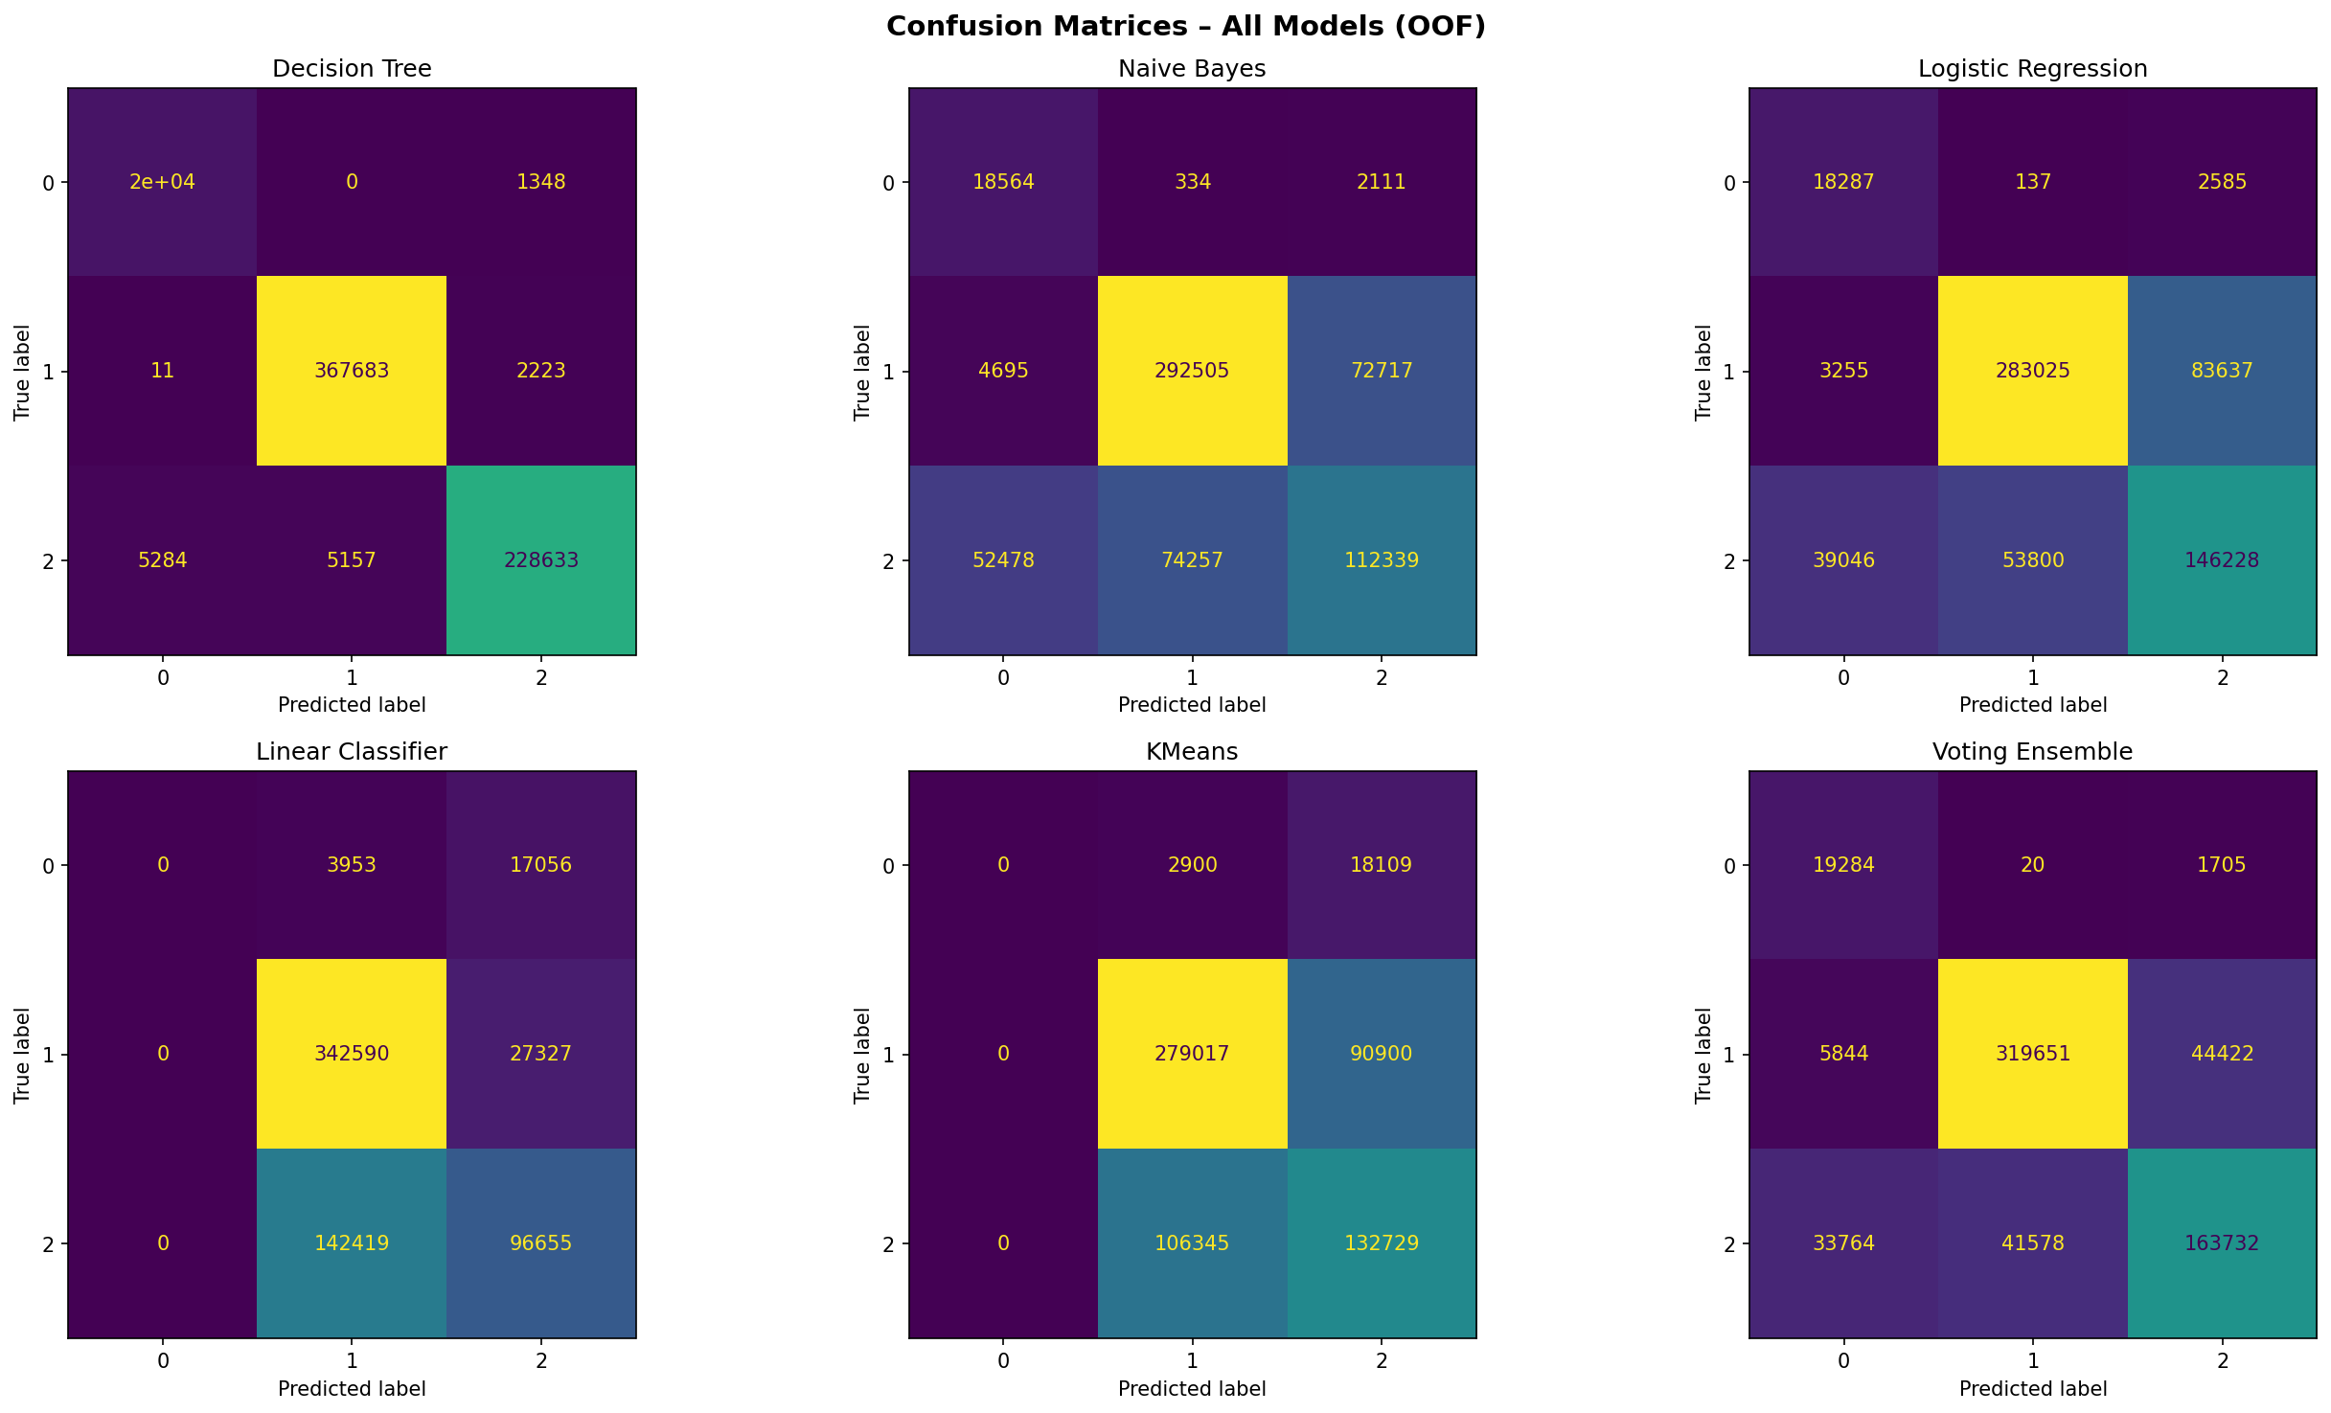

6. Final Model Selection

Best Model
The best model (or ensemble) is automatically selected by the pipeline: the model with the highest 5-fold balanced accuracy — which may be the Voting Ensemble or one of the individual classifiers, depending on the run.

Ensemble Architecture
- Hard-voting ensemble of the top-3 models by cross-validated balanced accuracy.
- Each constituent model is cloned and independently retrained on the full training set before final test prediction.

Key Hyperparameters
Parameter | Value
Decision Tree max_depth | 12
Decision Tree min_samples_split | 10
Decision Tree min_samples_leaf | 4
Logistic Regression C | 0.5
Logistic Regression max_iter | 500
KMeans clusters (k) | n_classes
Polynomial degree | 2 (interaction_only)
SelectKBest features | min(50, total_features)
CV folds | 5

Why Selected?
- The pipeline automatically promotes the model that maximises balanced accuracy — an appropriate metric for multi-class problems with potential class imbalance.
- The ensemble typically outperforms any single model by averaging out individual errors, though the final winner depends on the data.
- class_weight='balanced' was used in tree and logistic models to prevent majority-class bias.

7. Leaderboard Performance

Kaggle Score (Balanced Accuracy) | 0.96410
Rank | 2284

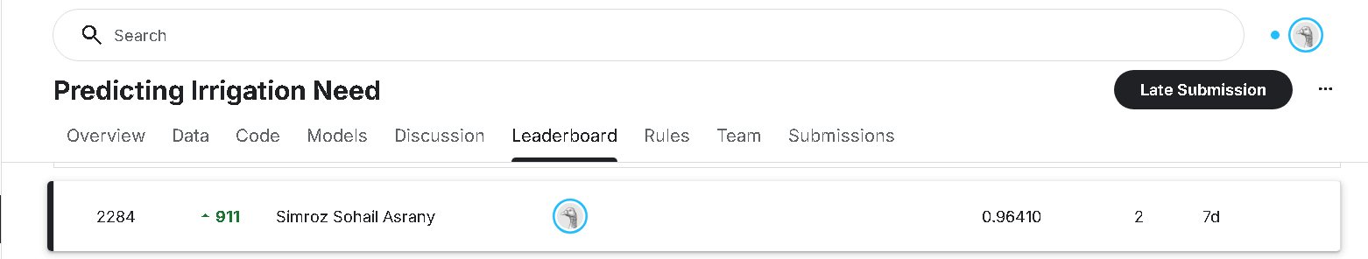

8. Conclusion and Learnings

Key Insights
- Feature engineering (polynomial interactions, domain-specific ratios like Moisture_Rain_Ratio, Temp_x_Humidity, and pH_Deviation) meaningfully expanded the feature space and improved model performance.
- Balanced accuracy is a more reliable metric than plain accuracy for multi-class problems with unequal class frequencies.
- Hard-voting ensembles are a straightforward way to aggregate diverse models and reduce variance in predictions.
- K-Means and Linear Regression, while not natively designed for classification, can serve as useful baselines to understand class structure and linear separability.

Challenges Faced
- Adapting inherently regression/clustering models (LinearRegression, KMeans) for classification required custom sklearn-compatible wrappers.
- sklearn's VotingClassifier has validation constraints that reject custom estimators; the custom HardVotingEnsemble class was built to bypass this.
- Selecting the correct number of polynomial interaction features without overfitting required limiting to the top-5 numerical columns and using SelectKBest for post-engineering pruning.

Future Improvements
- Incorporate gradient boosting models (XGBoost, LightGBM) for higher predictive power.
- Apply SMOTE or other oversampling strategies for additional control over class imbalance.
- Use Optuna or GridSearchCV for systematic hyperparameter optimisation.
- Explore soft-voting (probability averaging) instead of hard-voting for the ensemble, which typically improves performance when models produce calibrated probabilities.
- Add LOOCV on a smaller sample to validate stability of results on edge cases.

