###### INSIGHTSTREAM:NAVIGATETHENEWSLANDSACPE

**NAANMUDHALVANPROJECTREPORT**

BachelorofComputerScience

Submittedby

**TEAMLEADER**

**S.SIMSON PRAKASH(222209512)** [**shinchan.mar6@gmail.com**](mailto:shinchan.mar6@gmail.com)

**TEAMMEMBERS**

**V.BHARATH (222209495)** [**bharathbharth09545@gmail.com**](mailto:bharathbharth09545@gmail.com)

**E.DINESH(222209496)** [**dineshvimala904@gmail.com**](mailto:dineshvimala904@gmail.com)

**S.MONISH(222209506)** [**selvarajmonish1@gmail.com**](mailto:selvarajmonish1@gmail.com)

**DEPARTMENTOFCOMPUTER SCIENCE**



**TAGORECOLLEGEOF ARTSANDSCIENCE**

(AffiliatedtotheUniversityof Madras)

**MARCH–2025**

#### TABLEOF THE CONTENT

|  |  |  |
| --- | --- | --- |
| **S.NO** | **CONTENTS** | **PAGE NO** |
| **1.** | **ABSTRACT SYOPSIS INTRODUCTION**   * 1. SCOPEOFTHEPROJECT   2. BACKGROUND&PROBLEMSTATEMENT   3. OBJECTIVESOFTHEPROJECT   4. SIGNIFIGANCEOFTHEPROJECT |  |
| **2.** | **SYSTEMSPECIFICATION**   * 1. HARDWAREREQUIREMENTS   2. SOFTWAREREQUIREMENTS   3. NETWORKREQUIREMENTS |  |
| **3.** | **SYSTEMANALYSIS**   * 1. EXISTINGSYSTEM   2. PROPOSEDSYSTEM   3. FEASIBILITYSTUDY      1. TECHNICALFEASIBILITY      2. OPERATIONALFEASIBILITY      3. ECONOMICFEASIBILITY |  |
| **4.** | **SYSTEMDESIGN**   * 1. ARCHITECTURALDESIGN      1. SYSTEMARCHITUCTUREDIAGRAM   2. UMLDIAGRAM      1. USECASEDIAGRAM      2. CLASSDIAGRAM      3. SEQUENCEDIAGRAM      4. ACTIVITYDIAGRAM |  |
| **5.** | **SYSTEMIMPLEMENTATION** |  |

|  |  |  |
| --- | --- | --- |
| **6.** | **SYSTEMTESTING**   * 1. FUNCTIONALTESTING   2. NONFUNCTIONALTESTING |  |
| **7.** | **DEVELPMENTPROCESS** |  |
| **8.** | **FEATURESOVERVIEW** |  |
| **9.** | **CONCLUSION** |  |
| **10.** | **APPENDIX**   * SCREENLAYOUTS * SOURCECODE |  |

**ABSTRACT**

InsightStream is an AI-powered, React-based news aggregator designed to provide users with a personalized, efficient, and trustworthy news consumption experience. With the rapid increase in digital information, users often struggle with news overload, misinformation, and biased reporting. InsightStream addresses these challenges by curating a dynamic and user-friendly platform that fetches real-time news from reliable sources and delivers it in a structured, accessible manner. The application integrates AI-powered features such as personalized content recommendations, automated news summarization, sentiment analysis, and category-based filtering. Users can search, bookmark, and receive real-time updates tailored to their interests. Additionally, the platform offers multi-language support, accessibility features, and robust authentication for a secure and inclusive user experience. Insight Stream is built using React.js for the frontend, Node.js with Express.js for the backend, and MongoDB for data management. It leverages third-party newsAPIs such as NewsAPI and Open AI for AI-driven functionalities. The development process includes UI/UX design, API integration, rigorous testing, and cloud-based deployment. Targeting a diverse audience, including professionals, students, and general readers, Insight StreamredefinesdigitalnewsconsumptionbycombiningthepowerofAI with an intuitive, responsive interface. Future enhancements will include socialmediaintegrations,advancedfakenewsdetection,andvoice-based news summarization to further improve accessibility and reliability.

# SYNOPSIS

1. **Introduction**

#### CHAPTER1 SYNOPSIS

Theexponentialriseindigitalcontenthasmadeitincreasinglydifficultforusersto stay informed without feeling overwhelmed. Traditional news platforms lack personalization, making it hard for users to find content that aligns with their interests. InsightStream is a React-based news aggregator that leverages AI to providepersonalizedandreal-timenewsupdates,ensuringusersaccessrelevantand credible information effortlessly.

##### Objectives

* + Developadynamicandintuitivenewsaggregatorplatform.
  + UseAItopersonalizecontentrecommendationsandsummarizenews.
  + Offerreal-timenewsupdatesfromtrustedsources.
  + Provideaccessibilityfeaturessuchasmulti-languagesupportanddarkmode.
  + Ensureuserdatasecuritythroughrobustauthenticationmeasures.

##### Features

1. **PersonalizedNewsFeed**–AI-curatednewsbasedonuserpreferences.
2. **Category-Based Filtering** – Users can filter news by topics like technology,politics, and sports.
3. **Real-TimeUpdates**–Fetchingthelatestnewsfromreliablesources.
4. **Search&Bookmarking**–Allowinguserstofindandsavearticles.
5. **Multi-LanguageSupport**–Expandingaccessibilitytoaglobalaudience.
6. **AI-PoweredSummarization**–Quickandconcisenewssummaries.
7. **UserAuthentication&Security**–Secureloginusing Firebase/Auth0.
8. **TrendingTopics&Notifications**–Highlightingglobalandregionalnews trends.

##### Technology Stack

* + **Frontend:**React.js,Redux,Tailwind CSS.
  + **Backend:**Node.jswithExpress.js.
  + **Database:**MongoDB.
  + **APIs:**NewsAPI,GoogleNewsAPI,OpenAI API.
  + **Authentication:**Firebase/Auth0forsecurelogin.

##### Development Methodology

* + **RequirementAnalysis:**Understandinguserneeds.
  + **UI/UXDesign:**Wireframingandprototyping.
  + **Implementation:**Developingfrontendandbackendcomponents.
  + **Testing:**Unit,integration,andusabilitytesting.
  + **Deployment:**HostingoncloudserviceslikeAWS,Vercel,orNetlify.
  + **Maintenance:**Continuousupdatesandfeatureenhancements.

### AIIntegration

* + **NewsSummarization:**AIextractskeypointsfromarticles.
  + **Personalized Content Recommendations:** AI adapts based on user behavior.
  + **SentimentAnalysis:**AIdeterminesarticletone(positive,negative,neutral).

### Security&Privacy

* + **Role-BasedAccessControl(RBAC):**Differentaccesslevelsforusers.
  + **DataEncryption:**Securestorageofuserpreferencesandbookmarks.
  + **PrivacyCompliance:**AdheringtoGDPRandindustrystandards.

##### TargetAudience & UseCases

* + **NewsEnthusiasts:**Individualsseekingatailorednewsexperience.
  + **Professionals:**Userslookingforquick,industry-specificupdates.
  + **Students&Researchers:**Thoseneedingaccesstoreliablesourcesforstudies.

##### Conclusion& Future Enhancements

InsightStream aims to revolutionize how users consume news by integrating AI, real-time updates, and personalization into a seamless user experience. Future developments will focus on expanding social media sharing options, implementing

advancedfakenewsdetection,andintroducingvoice-basednewssummarizationto enhance accessibility. With these innovations, InsightStream will continue to be a go-to platform for informed and efficient news consumption.

##### Scope ofthe Project

InsightStream is designed as a **web-based application** that will cater to a wide audience, including students, professionals, journalists, and general readers. The project scope includes:

* + - **FrontendDevelopment:**BuildingaresponsiveUIusingReact.js.
    - **BackendDevelopment:**ImplementingdatahandlingwithNode.jsand Express.js.
    - **AI Integration:** Incorporating AI models for summarization, recommendations, and sentiment analysis.
    - **News API Integration:** Fetching news from sources like Google News API and NewsAPI.
    - **Security Measures:** Implementing authentication and data protection protocols.
    - **Scalability&FutureEnhancements:** Addingfeaturessuchassocial media integration and fake news detection.

##### Background&Problem Statement

In today’s digital era, the traditional methods of consuming news, such as newspapers and television broadcasts, are being rapidly replaced by online platforms. However, these platforms often present challenges such as:

* + - **InformationOverload:**Avastnumberofarticlesfrommultiplesourcescan be overwhelming.
    - **Misinformation&FakeNews:**Thespreadofunverifiedormisleadingnews has increased.
    - **LackofPersonalization:**Manyplatformsdonottailorcontenttouserpreferences.
    - **TimeConstraints:**Usersstruggletoreadlengthyarticlesintheirbusyschedules.

InsightStream aims to overcome these challenges by implementing AI-driven content curation, filtering fake news sources, and summarizing articles for quick consumption.

##### ObjectivesoftheProject

TheprimarygoalsofInsightStreaminclude:

* + - Developinga**user-friendly**and**intuitive**newsaggregationplatform.
    - Implementing**AI-basedpersonalizedrecommendations**tofilternewsrelevant to users.
    - Providing**real-timeupdates**toensureusersaccessthelatestnews.
    - Offering**AI-poweredsummarization**forquickcontentconsumption.
    - Ensuring**multi-languagesupport**foraglobalaudience.
    - Enhancing**securityandauthentication**toprotectuserdataandpreferences.

##### Significanceof the Project

InsightStreambringssignificantadvantagestodigitalnewsconsumptionby:

* + - **ReducingInformationOverload:**AI-curatednewsensuresrelevantcontent delivery.
    - **Enhancing Accessibility:** Multi-language support and accessibility features improve user inclusivity.
    - **ProvidingTrustworthyNews:**Filteringoutunreliablesourceshelpscombat misinformation.
    - **SavingTime:**AI-poweredsummariesallowuserstograspessentialnews quickly.

**SYSTEM SPECIFICATION**

#### CHAPTER 2 SYSTEMSPECIFICATION

This system specification outlines the hardware, software, security, and network requirements necessary for the smooth development and deployment of the InsightStreamapplication.Futureenhancementsmayrequireadditionalresources as the platform scales.

###### HardwareRequirements

Thefollowinghardwarespecificationsarerecommendedforoptimalperformance of the InsightStream application:

ForDevelopmentEnvironment:

* + - **Processor:**IntelCorei5(8thGenorabove)/AMDRyzen5orhigher
    - **RAM:**Minimum8GB(16GBrecommendedforsmoothdevelopment)
    - **Storage:**SSDwithatleast256GB(512GBrecommended)
    - **Graphics:**IntegratedGPU(DedicatedGPUforfasterrenderingpreferred)
    - **Network:**StableinternetconnectionforAPIcallsandcloudservices
    - **Display:**Minimum1080presolutionmonitor

ForDeploymentServer:

* + - **Processor:**IntelXeon/AMDEPYC(orcloud equivalent)
    - **RAM:**Minimum16GB(32GBrecommendedforhandlinghightraffic)
    - **Storage:**NVMeSSDwithatleast500GB
    - **DatabaseStorage:**SeparatestorageforMongoDB,minimum100GB
    - **NetworkBandwidth:**High-speedinternetconnectionwithatleast100Mbps
    - **CloudHosting:**AWS,GoogleCloud,orAzure-baseddeployment

###### SoftwareRequirements

Thefollowingsoftwarecomponentsareessentialforthedevelopmentand deployment of InsightStream:

###### FrontendTechnologies:

* + - **Framework:**React.js(lateststableversion)
    - **StateManagement:**Redux(orContextAPIifrequired)
    - **Styling:**TailwindCSS/MaterialUI
    - **PackageManager:**npm/yarn
    - **BrowserCompatibility:**Chrome,Firefox,Edge,Safari(latestversions)

###### BackendTechnologies:

* + - **ServerFramework:**Node.jswithExpress.js
    - **Database:**MongoDB(NoSQLdatabaseforscalabilityandflexibility)
    - **APIIntegration:**NewsAPI/GoogleNewsAPI
    - **Authentication:**FirebaseAuth/ Auth0
    - **AI/MLServices:**OpenAIAPI(forAI-basedsummarizationandsentiment analysis)
    - **Security:**JWT(JSONWebToken)foruser authentication

###### DevelopmentTools:

* + - **CodeEditor:**VisualStudioCode/JetBrainsWebStorm
    - **VersionControl:**GitHub/GitLab/ Bitbucket
    - **APITesting:**Postman/ThunderClient
    - **Containerization:**Docker(forscalabledeployment)
    - **CI/CDTools:**GitHubActions/Jenkins/Netlify/Vercelforautomated deployment

##### Network Requirements

* + - **MinimumInternetSpeed:**10Mbpsfordevelopment,100Mbps+fordeployment
    - **Cloud Hosting Requirements:** Secure API endpoints and database access control
    - **SSLCertificate:**RequiredforHTTPS-enabledsecurecommunication

## SYSTEMANALYSIS

#### CHAPTER 3 SYSTEMANALYSIS

SystemanalysisisacrucialphaseinthedevelopmentofInsightStream,wherewe examine the functional and non-functional requirements, system feasibility, and architectural design. This ensures that the project meets its objectives effectively and efficiently while providing a seamless user experience.

##### Existing System

Traditionalnewsaggregationplatformsfacethefollowingissues:

* **Lackof Personalization:** Usersreceivegeneralizednewsinsteadoftailored content.
* **InformationOverload:**Largeamountsofnewsarticleswithoutproperfiltering.
* **Misinformation&FakeNews:**Difficultyindistinguishingreliablesources.
* **InefficientUserExperience:**Slownavigation,unstructuredcontent,andlack of AI-driven features.

###### ProposedSystem

* **AI-Powered Personalization:** Tailored content recommendations based on user preferences.
* **Real-TimeUpdates:**Fetchingthelatestnewsfromtrustedsources.
* **FakeNewsFiltering:**AI-drivenanalysistodetectmisinformation.
* **Summarization&SentimentAnalysis:**Quickinsightsintolengthyarticles.
* **Multi-LanguageSupport:**Newsaccessibletoawideraudience.

##### FeasibilityStudy

AfeasibilitystudyevaluatesInsightStream’sviabilityintermsoftechnical, operational, and financial aspects.

###### TechnicalFeasibility

* + - * Utilizesmoderntechnologieslike**React.js,Node.js,MongoDB,andAI APIs**.
      * Scalablearchitectureforhigh-performancenewsaggregation.
      * SecureauthenticationusingFirebase/Auth0.

###### OperationalFeasibility

* + - * User-friendlyUIwithintuitivenavigationandcustomization.
      * AI-enhancedrecommendationstooptimizenewsconsumption.
      * Efficientcontentfilteringandnewssummarization.

###### EconomicFeasibility

* + - * **Cost-effectivedevelopment**usingopen-sourcetechnologies.
      * **Minimaloperationalcosts**withcloud-baseddeployment.
      * **Potentialrevenuemodels:**Advertisements,premiumsubscriptions,and AI-

poweredinsights.

## SYSTEMDESIGN

#### CHAPTER 4 SYSTEMDESIGN

System design is a critical phase in the development of InsightStream, focusing on defining the system architecture, data flow, component interactions, and security aspects. This ensures that the platform is scalable, efficient, and user-friendly.

##### ArchitecturalDesign

InsightStreamfollowsa**three-tierarchitecture**,whichincludes:

1. **PresentationLayer(Frontend)**–UserinterfacebuiltwithReact.js.
2. **Application Layer (Backend)** – Handles business logic using Node.js and Express.js.
3. **Data Layer (Database & External APIs)** – Manages data using MongoDB and fetches news from APIs like NewsAPI or Google News API.
   * 1. **SystemArchitectureDiagram**

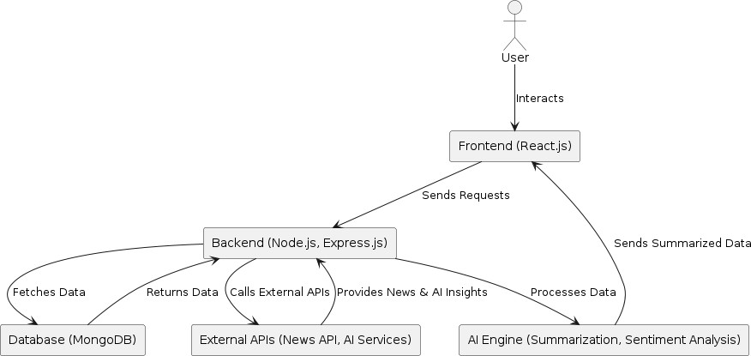

#### UML DIAGRAM

A **Use Case Diagram** represents the interaction between users and the system, defininguserrolesandtheiraccessiblefunctionalities.A **ClassDiagram**showsthe system structure with its classes, attributes, methods, and relationships, helping in object-oriented design. A **Sequence Diagram** illustrates the step-by-step flow of interactions between system components, detailing message exchanges over time. An **Activity Diagram** visualizes the system workflow, representing activities, decisions, and parallel processes to model business logic effectively.

###### UseCaseDiagram

A**UseCaseDiagram**visuallyrepresentstheinteractionsbetweenusers(actors)and thesystem.Ithighlightsvariousfunctionalitiesofferedbythesystemandhowusers interact with them. This diagram helps in understanding system requirements and user roles.

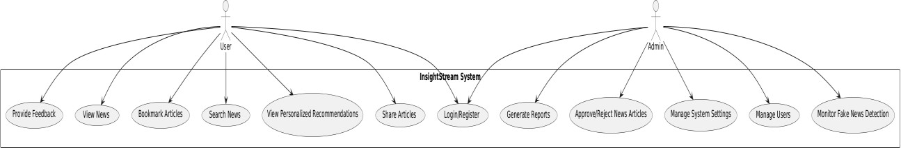

###### ClassDiagram

A **Class Diagram** illustrates the structure of the system by showing its classes, attributes, methods, and relationships. It provides a blueprint for object-oriented design and helps developers understand data organization.

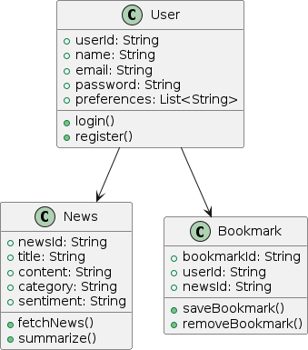

###### 4.3.3.SequenceDiagram

A **Sequence Diagram** represents the flow of interactions between different components of the system in a step-by-step manner. It describes how processes operate in a sequential order and how messages are exchanged between system elements.

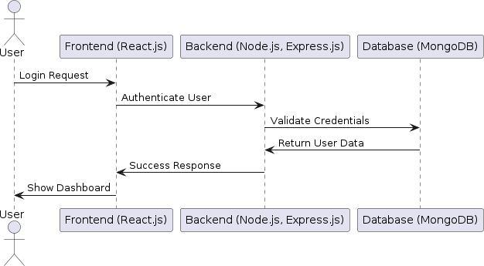

###### 4.3.4.ActivityDiagram

An**ActivityDiagram**depictstheworkflowofasystem,showingdifferentactivities, decisions, and parallel processes. It is useful for modeling business logic and dynamic behaviors in the system.

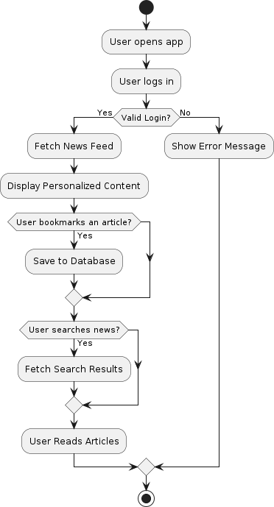

**SYSTEM IMPLEMENTATION**

#### CHAPTER 5 SYSTEMIMPLEMENTATION

System implementation refers to the process of integrating and deploying the developedsystemintoareal-worldenvironment.Thisphaseensuresthatthesystem functions as intended and meets user requirements.

###### ImplementationStrategy

The system is implemented using a phased approach to minimize risks and ensure smooth deployment. The key strategies include:

* + **Pilot Implementation:** Deploying the system to a small group of users forinitial testing.
  + **Parallel Implementation:**Running the new system alongside the existing system to compare performance.
  + **DirectImplementation:**Replacingtheoldsystemwiththenewone immediately.
  + **PhasedImplementation:**Graduallyintroducingsystemcomponentsindifferent stages.

###### TechnologyStack

* + **Frontend:**React.jsforaresponsiveanddynamicuserinterface.
  + **Backend:**Node.jswithExpress.jsforhandlingserver-sidelogic.
  + **Database:**MongoDBforefficientdatastorageandretrieval.
  + **Authentication:**JWT-baseduserauthenticationforsecureaccess.
  + **Hosting&Deployment:**DeployedoncloudplatformslikeAWSorFirebase.

###### IntegrationandTesting

* + **UnitTesting:**Testingindividualcomponentstoensurecorrectness.
  + **IntegrationTesting:**Checkingcommunicationbetweendifferentsystem modules.
  + **User Acceptance Testing (UAT):** Ensuring the system meets user requirements.
  + **Performance Testing:** Measuring system speed, scalability, and responsiveness.

###### SecurityConsiderations

* + **DataEncryption:**UsingSSL/TLSforsecuredatatransmission.
  + **User Authentication:** Implementing multi-factor authentication (MFA) for enhanced security.
  + **Access Control:** Role-based access control (RBAC) to restrict unauthorized actions.

###### DeploymentProcess

* + **CodeReview&Approval:**Ensuringcodequalitybeforedeployment.
  + **CI/CDPipeline:**AutomatingdeploymentusingGitHubActionsorJenkins.
  + **ServerSetup:**Configuringproductionserversforhosting.
  + **Monitoring&Maintenance:**UsingloggingtoolslikeLogRocketorDatadog for continuous monitoring.

## SYSTEMTESTING

#### CHAPTER 6 SYSTEMTESTING

System testing is a critical phase in software development that evaluates the entire system’s functionality, performance, security, and usability. It ensures that the system meets the specified requirements before deployment.

###### 1.ObjectivesofSystemTesting

* + Toverifythatthesystemfunctionsas expected.
  + Toidentifyandfixdefectsbeforeproduction.
  + Toensuresystemstabilityundervarious conditions.
  + Tovalidatesystemsecurityanddata integrity.

###### TypesofSystemTesting

* 1. **FunctionalTesting**

Ensuresthatallfeaturesworkasintendedbyexecutingtestcasesbasedon requirements.

* + - **UnitTesting:**Testsindividualcomponentsforcorrectness.
    - **IntegrationTesting:**Verifiesinteractionsbetweenintegratedmodules.
    - **User Acceptance Testing (UAT):** Ensures the system meets user expectations.

###### Non-FunctionalTesting

Focusesonsystemperformance,security,andusability.

* + - **Performance Testing:** Measures system speed, responsiveness, and scalability.
    - **LoadTesting:**Evaluatessystembehaviorunderexpectedandpeakloads.
    - **SecurityTesting:**Identifiesvulnerabilitiestopreventunauthorizedaccess.
    - **UsabilityTesting:**Assessesuser-friendlinessandoverallexperience.

1. TestingToolsandTechniques

* **AutomationTesting:**UsingSelenium,Junit,orJestforautomatedtestexecution.
* **ManualTesting:**Humantestersexecutetestcasesforusabilityvalidation.
* **PenetrationTesting:**Ethicalhackingmethodstofindsecurityloopholes.
* **RegressionTesting:**Ensuringnewupdatesdonotintroducenewbugs.

1. BugTrackingandReporting

Bugs and defects are tracked using tools like Jira, Bugzilla, or Trello. Each bug is classified based on severity (Critical, Major, Minor) and resolved accordingly.

## DEVELOPMENT PROCESS

#### CHAPTER 7 DEVELOPMENTPROCESS

Thedevelopmentprocessoutlinesthestructuredapproachusedtodesign,build, and implement software solutions. It ensures efficiency, quality, and maintainability throughout the software lifecycle.

###### SoftwareDevelopmentLifeCycle(SDLC)Phases

1. **RequirementAnalysis**
   * Understandinguserneedsandsystemrequirements.
   * Documentingfunctionalandnon-functionalrequirements.

###### Planning

* + Definingprojectscope,timeline,andresources.
  + Creatingaroadmapfor development.

###### Design

* + ArchitecturalandUI/UXdesignofthesystem.
  + Creatingwireframes,databaseschema,andsystemmodels.

###### Development

* + Writingcodebasedondesignspecifications.
  + Implementingfeatures,backendlogic,anddatabaseintegration.

###### Testing

* + Conductingunit,integration,andsystemtesting.
  + Fixingbugsandensuringsystemstability.

###### Deployment

* + Releasingtheapplicationtoaproductionenvironment.
  + Configuringhostinganddatabaseservers.

###### MaintenanceandUpdates

* + Monitoringsystemperformanceandsecurity.
  + Rollingoutnewfeaturesandfixesasneeded.

###### DevelopmentMethodologies

* + **WaterfallModel:**Sequentialandstructureddevelopmentapproach.
  + **AgileMethodology:**Iterativeandflexibleapproachforcontinuous improvements.
  + **DevOps:**Integrationofdevelopmentandoperationsforfasterreleases.

###### ToolsandTechnologies

* + - **VersionControl:**Git,GitHub,GitLab
    - **DevelopmentFrameworks:**React.js,Node.js,Express.js
    - **Database:**MongoDB,MySQL
    - **TestingTools:**Jest,Selenium
    - **CI/CD:**Jenkins,GitHubActions

## FEATURES OVERVIEW

#### CHAPTER 8 FEATURESOVERVIEW

Thefeaturesofthesystemdefineitsfunctionality,usability,andefficiency.These features aredesignedto enhanceuserexperienceandprovideseamless navigation within the platform.

###### KeyFeatures

1. **UserAuthenticationandAuthorization**
   * Secureloginand registration.
   * Role-basedaccesscontrol(Admin/User).
   * Multi-factorauthenticationforaddedsecurity.

###### PersonalizedNewsFeed

* + AI-drivennewsrecommendationsbasedonuserinterests.
  + Real-timeupdateswithcategorizednews.
  + Bookmarkingandsavingarticlesforlater.

###### AdvancedSearchandFiltering

* + Keyword-basedsearchfunctionality.
  + Filtersforcategories,sources,anddaterange.
  + Sortingoptionsbasedonrelevanceandpopularity.

###### ContentManagement

* + Admindashboardformanagingnewssources.
  + Abilitytopublish,edit,andremovenewsarticles.
  + Fakenewsdetectionandverificationsystem.

###### InteractiveUserExperience

* + Usercomments,likes,andsharingoptions.
  + Darkmodeandcustomizablethemes.
  + Multi-languagesupportforglobalaccessibility.

###### AI-PoweredInsightsandAnalytics

* + Sentimentanalysisofnewsarticles.
  + Trendingtopicsandnewshighlights.
  + Graphicalreportsforuserengagement.

###### NotificationsandAlerts

* + Personalizedpushnotificationsforbreakingnews.
  + Dailyandweeklynewsdigestemails.
  + Customalertsettingsforpreferredtopics.

## CONCLUSION

#### CONCLUSION

The developmentof InsightStream: Navigate the News Landscape hassuccessfully created an intelligent,user-friendly, and securenews platformthat enhances digital news consumption. By integrating modern web technologies such as React.js, Node.js, MongoDB, and a structured content management system, the platform ensures seamless performance, scalability, and an engaging user experience. Securityfeatureslikemulti-factorauthentication,role-basedaccesscontrol,andfake news detection strengthen credibility and user trust. With real-time updates, interactiveuser engagement through comments andsharing, and anintuitiveadmin dashboard for content management, InsightStream provides a comprehensive and efficient way for users to stay informed.

Theplatform’simpactincludes personalizedcontentorganization,advancedsearch and filtering capabilities, real-time notifications, and multi-device accessibility, making it a modern and innovative solution for news consumption. Future enhancementscouldfocusonimprovingcontentcategorization,expandinglanguage support, refining the user interface, and strengthening verification mechanisms to further improve the accuracy and reliability of news delivery. Additionally, integrating offline reading capabilities and improved performance optimizations wouldmaketheplatformmoreversatileanduser-friendly.Bycontinuouslyevolving and adapting to user needs, InsightStream can remain a pioneering force in digital journalism, providing a seamless, reliable, and engaging news experience for users worldwide.

# APPENDIX

###### SCREENLAYOUTS:

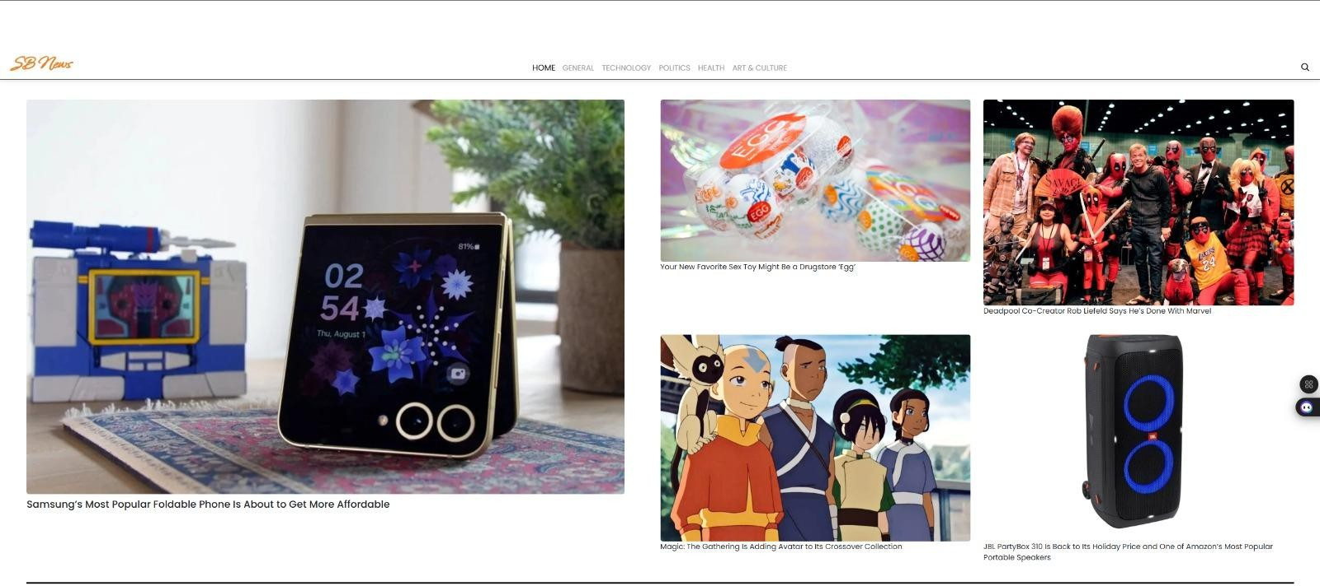

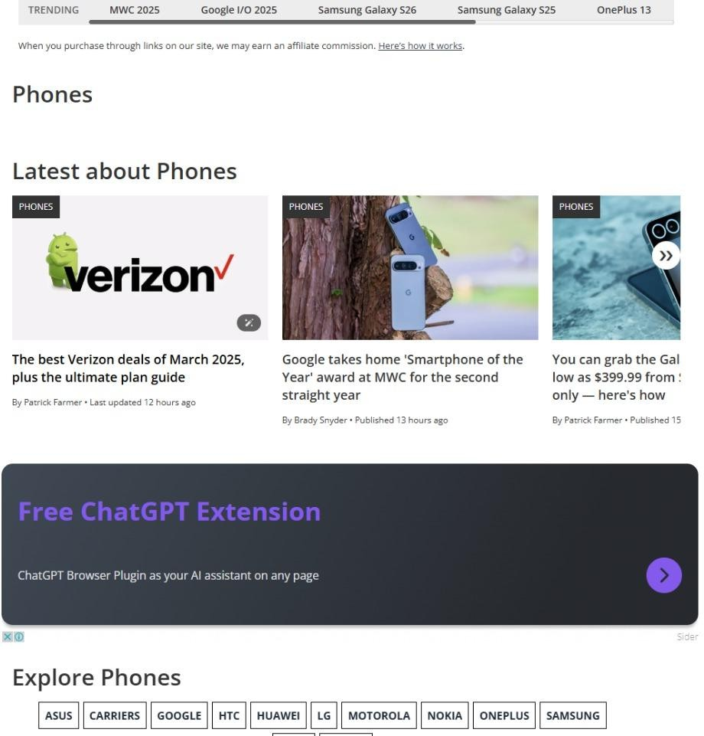

**SOURCECODE:**

importReact,{useContext}from'react' import '../styles/HomeArticles.css'

import{GeneralContext}from'../context/GeneralContext' import { useNavigate } from 'react-router-dom';

import{Spinner}from'react-bootstrap';

constHomeArticles=()=>{

constnavigate=useNavigate();

const{businessNews,technologyNews,politicsNews}= useContext(GeneralContext)

return(

<divclassName='home-articles-container'>

<divclassName='home-articles-body'>

<divclassName="home-articles-head">

<h2>Business</h2>

<ponClick={()=>navigate('/category/business')}>Viewall</p>

</div>

{businessNews.length>0?

<divclassName="home-articles">

{businessNews.map((news,index)=>{ return index < 3 && (

<divclassName="home-article"onClick={()=> window.open(news.url, '_blank')}>

<imgsrc={news.urlToImage}alt="placeholder"/>

<p>{news.title}</p>

</div>

)

})}

</div>

:

<divclassName="spinners">

<Spinneranimation="grow"size="sm"/>

<Spinneranimation="grow"size="sm"/>

<Spinneranimation="grow"size="sm"/>

</div>

}

</div>

<divclassName='home-articles-body'>

<divclassName="home-articles-head">

<h2>Technology</h2>

<ponClick={()=>navigate('/category/technology')}>Viewall</p>

</div>

{technologyNews.length>0?

<divclassName="home-articles">

{technologyNews.map((news,index)=>{ return index < 3 && (

<divclassName="home-article"onClick={()=> window.open(news.url, '_blank')}>

<imgsrc={news.urlToImage}alt="placeholder"/>

<p>{news.title}</p>

</div>

)

})}

</div>

:

<divclassName="spinners">

<Spinneranimation="grow"size="sm"/>

<Spinneranimation="grow"size="sm"/>

<Spinneranimation="grow"size="sm"/>

</div>

}

</div>

<divclassName='home-articles-body'>

<divclassName="home-articles-head">

<h2>Politics</h2>

<ponClick={()=>navigate('/category/politics')}>Viewall</p>

</div>

{politicsNews.length>0?

<divclassName="home-articles">

{politicsNews.map((news,index)=>{ return index < 3 && (

<divclassName="home-article"onClick={()=> window.open(news.url, '_blank')}>

<imgsrc={news.urlToImage}alt="placeholder"/>

<p>{news.title}</p>

</div>

)

})}

</div>

:

<divclassName="spinners">

<Spinneranimation="grow"size="sm"/>

<Spinneranimation="grow"size="sm"/>

<Spinneranimation="grow"size="sm"/>

</div>

}

</div>

</div>

)

}