The initial plan, also called « Project organization manual » or POM, aims to inform stakeholders about the principal elements of the project: planning, management, organization, and control.
The manual provides information on how the project starts, on its realisation, and how it is finalized. It allows a uniform and efficient management of the activities to be performed and of the deliverables to be produced. In addition, it enables stakeholders to rapidly overview the standards and tools used in the project. Finally, the manual facilitates the coordination of activities.

Philip Morris: Data Analysis Improvement of Ciliary Beating of 3D Epithelial Tissue

Initial plan

Team and contact information:
Simon Jenni – simujenni@students.unibe.ch
Laurent Hayez – laurent.hayez@unine.ch

29.03.2016

Version 1.0

Table of contents
1. Project description 4
1.1. Project context 4
1.2. Goals and objectives of the project 4
2. Project organization 5
2.1. Responsibility distribution 5
2.2. Interactions with the client 5
3. Methodology 6
3.1. State of the art 6
4. Constraints and elements of risk 7
5. Deliverable goods 8
6. Efforts and schedule 9

Version monitoring
Monitoring of the version in this project organization document enables following modification activities progress within the project. The version is changed only if a major change takes place. Otherwise, only a decimal is changed (1.0 to 1.1)
Version | Update date | Page modified
1.0 | 29.03.2016

Project Description

Project Context
Philip Morris International (PMI) is a global cigarette and tobacco company with headquarters in Lausanne. The research and development program of PMI focuses on the development of products with the potential to reduce the risk of tobacco related diseases. To this end, new products are tested against ordinary cigarettes by exposing human tissue cultures to smoke or aerosol of both products. The effect of the exposure is then analyzed by observing different features of the tissue, one of which is the ciliary beating.

Goals and Objectives of the Project
The goal of this project is to implement a tool for the automatic analysis of ciliary beating in tissue movies. Concretely the objectives are the following:
- Allowing batch processing of video-data contained in a folder (including subfolders).
- Pre-processing of the video data in order to remove noise by smoothing with a customizable 3D kernel.
- Scoring the tissue surface activity using simple descriptive statistics and storing the results in an activity image.
- Determine the frequency distribution given per region of interest (ROI) and extract the dominant frequency.
- Processing should be possible on multiple scales, i.e. ROI of variable size.
- Illustrate the phase of the beating frequency in regions of similar beating frequency.
Part of the project will also be an evaluation of the performance of different techniques applied to the problem and other research such as:
- Evaluating the effect of the ROI size on performance.
- Evaluating the probable shape of the beating pattern on a “by cilia beating movie” basis.
- Comparing different techniques for the frequency analysis (e.g. FFT, wavelet transform, autocorrelation, …).
Given the scope of this project and the relatively large amount of objectives, it should be noted that some of the objectives are being given a higher priority than others. The ultimate goal of this project is to provide a tool for frequency analysis and task-priorities will therefore be weighted with this goal in mind. This means for example that de-noising, a whole subject on it’s own, will not be studied and evaluated as extensively as techniques for frequency analysis.

Project Organization

Responsibility Distribution
Simon Jenni (simujenni@students.unibe.ch) and Laurent Hayez (laurent.hayez@unine.ch) are the two students involved in the project. They will both be responsible for the development of the tool and management of the project. Development will be split into small independent tasks and each developer will be responsible for the implementation, documentation and testing of the assigned tasks. Additionally, each developer will have to request code reviews when a task is finished, report issues or potential problems to the team and keep track of the work performed in the log. Sprint planning and other management tasks will be performed in two-weekly meetings.
Patrice Leroy (Patrice.Leroy@pmi.com) is the product owner. He is the person to whom the final product will eventually be delivered. Hence, he is the one who we will refer to for feedback on intermediate results and in case of questions about the specifics of the project.
Hugues Mercier (hugues.mercier@gmail.com) is the R&D Workshop coordinator and stakeholder of the project. He will keep an eye on the project progress and be the person to contact in case of problems between the client and the development team.

Interactions with the Client
The interaction between the team members and the client will primarily be done by email. We will see each other from time to time to discuss about the advancement of the project, but we did not set a definite frequency for the meetings. We will contact the client in case of issues, or when a new version of the tool can be delivered at the end of each sprint. Intermediate versions of the tool will be delivered via a shared Dropbox folder and will including a short overview of new features and results as well as a demo script explaining the usage of the tools.
The team will communicate mostly by email or via Taiga. Sprint planning will take place in a meeting either in person or via Skype.

Methodology
The implementation of the tool will be carried out in Matlab. The decision to use Matlab has been taken in agreement with the client and is based on the ease of handling image and video processing and the relatively fast development time that Matlab provides. Matlab requires a license to be used. Philip Morris International has an enterprise license and we have our respective university licenses, so this won’t be a problem. Git will be used as version control tool.

Development will be done in an incremental and iterative fashion roughly following the SCRUM framework. The objectives will be distributed across sprints of two weeks each. Sprint planning of the first sprint has already been done and has the goal of providing an implementation of the minimal requirements. To keep track of the progress and help manage the project we will make use of Taiga, an open source project management platform similar to JIRA. Both the client and project stakeholders will have access to Taiga and will be able to follow the progress if they wish to do so.

To ensure correctness of the implementation, testing using synthetic test-data will be an essential part or the development process. In order to further improve code-quality, code reviews by the other respective developer will be performed for every major task.

State of the Art
The arguably most accurate method for analyzing the ciliary beating frequency is the direct measurement from high-speed video recordings. This is of course very time-consuming and therefore several automated methods have been proposed. The most commonly used approaches for the automated analysis of ciliary beating are based on using the Fast Fourier Transform (FFT) to analyze intensity-signals in a region of interest and will be the principal approach and starting point for further exploration used in this project. Other methods such as photomultiplier and modified photodiode techniques rely on different hardware and inputs and are therefore not considered.

Constraints and Elements of Risk
We can observe the following potential risks related to the project:
- It is unclear how the testing using synthetic data will translate to real-world data.
We therefore have to rely on provided data where ciliary beating is actually detectable vs. not detectable in order to test the implementation.
- In general the verification of the correctness is challenging based solely on example video material provided by the client. This is one reason to also use synthetic test cases to perform sanity checks.
- Evaluation of the performance can be time consuming considering the amount of parameters that can potentially have an influence on it. If this turns out to be a big issue we could leverage data-parallelism and potentially run more experiments on computing-resources provided by the client or university.
- Video processing is largely a new field for both students and will require some learning time.

Deliverable Goods
The main deliverable is the code for a Matlab toolbox for batch analysis of a folder and its subfolders, containing 8bit grey scale .avi files. Along with the code a short but concise documentation and a demo or tutorial on how to use the tools will be shipped. Rather than having very extensive documentation, the client asked for minimal documentation but an emphasis on meaningful variable and function naming.
A final report on the project will explain the applied methods and also report the results of the more research related tasks concerning the performance of the different techniques. Here we will also mention outstanding issues or ideas for future improvement of the tools.
The logbook we will be using during our work on the project will also be delivered with each sprint-release of the tool. The logbook will be an Excel sheet containing the task accomplished, the assignee, duration and a short description.

Efforts and Schedule
As discussed in section 3, we apply a scrum-based approach and distribute the tasks across six sprints in total. The idea is to have a deliverable product at the end of each sprint, adding new features every next sprint.
Sprint planning will be done at the end of the current sprint, adjusting the plan if necessary due to issues that occurred during the sprint. Table 1 gives an overview of the main themes of each sprint and the stories to be implemented during each sprint. The plan for sprint 1 has already been added and the table will be updated with each new sprint.
Subsequent sprints will add new features and solve remaining issues of the previous sprint. Refactoring tasks can also be added if the team judges them to be necessary and, most importantly, feedback by the client on the latest version of the tool can be incorporated.
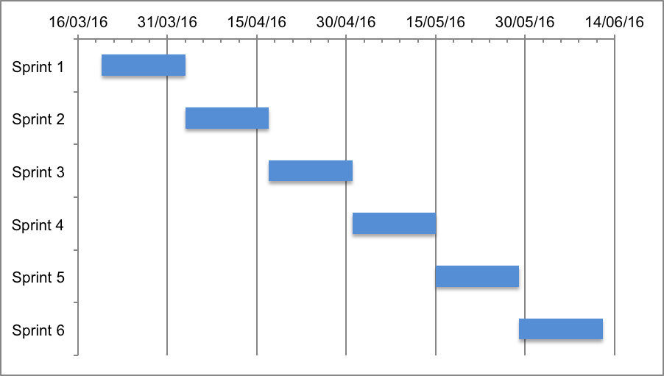
Figure 1: Rundown chart of the sprints
 | Main Theme | Stories
Sprint 1 | Minimum requirements | - Loading and extraction of video data  - Scoring tissue surface activity  - Frequency analysis per ROI using FFT  - Synthetic test data generation (optional)
Sprint 2 | Noise-removal | TBA
Sprint 3 | Phase image & WT | TBA
Sprint 4 | Explore alternatives | TBA
Sprint 5 | Evaluation | TBA
Sprint 6 | Finalization | TBA
Table 1: Overview of sprint plans

