Course: 94587 Assignment 2

The Simulation of Local Traffic Control System
by
Jidong Cao (student #: 350637) and
Xuebing Qing (student #: 3037225)

Part I The Conceptual Model

In Assignment 1, we presented a simple Unit Local Traffic Control System DEVS model, which is only composed of one normal traffic intersection. We continue our work on it and extend it to a more complicated model by using Cell-DEVS, which consists of two interconnected Unit Local Traffic Control System model. The observed physical object is shown in Figure 1. The purpose of this simulation is to use CD++ Cell-DEVS to reproduce the more complicated behaviors of a local traffic control system, and to further identify the factors that affect the throughput of the local traffic system as well as the potential defects of it that may cause vehicle collisions.

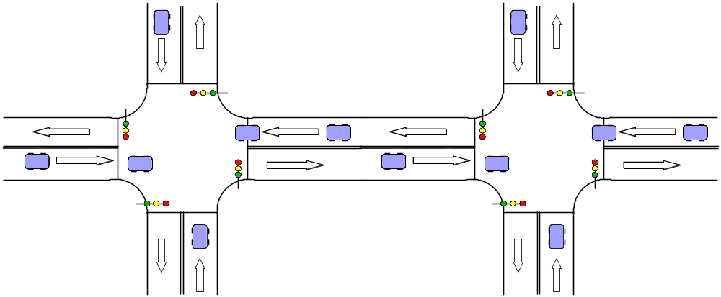

Figure 1 Two Interconnected intersections

Obviously, two Unit Local Traffic Control (DEVS) Models form the new Cell-DEVS model. Moreover, to make the Unit Local Traffic Control model more realistic, we remove the assumptions in assignment 1 that a lane has unlimited length and vehicle passes intersection with constant time, and employ several cell-DEVS models to describe the lanes(segments), the traffic light controller as well as the intersection lane(crossings). We also introduce the variety of speeds among vehicles to make the model more precise.

The following are the assumptions for the model:

- Only one lane per direction is considered at this time.
- The speed of a vehicle can be divided into 4 levels: stop, low, middle and high, which decide how long it takes to move from one cell to the next. The faster the speed, the sooner the movement. However, a vehicle stopped is not necessarily stays still, it can move very slowly, which is the actual behavior for a car waiting for the traffic light.
- Lane composites of limited cells, each cell can only be occupied by one vehicle at a time. When all cells are occupied, no more vehicles are allowed to move into the lane. So if a lane is full, no vehicles are allowed to enter the intersection area ahead and no vehicles can enter into the lane, either.
- A vehicle can only travel from one cell to its adjacent cell ahead, with speed variation not exceeding one level.
- As a rule, each vehicle is responsible for keeping safe space between the vehicle in front of it and itself; the safe space size is in proportion to its speed, that means there is at least 3 spaces ahead of a high speed car, 2 space for middle speed; 1 space for low speed, and 0(zero) space for a stopped car etc.
- Within intersection area, vehicle can change its speed to a lower or a higher level, and the total intersection passing time is determined by speed of vehicle.
- When traffic light is yellow, if a vehicle can stop safely, it must stop; otherwise, it should pass the intersection

All the assumptions in Assignment 1, if not conflicting with the above, are automatically inherited.

Each intersection is exchanging traffic with another. The way they exchange the traffic is through the lanes that are modeled as cell-DEVS.

In each intersection, two lane queues in the same direction are connected with an intersection, as shown in Figure 2.

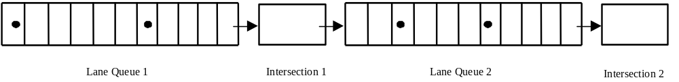
Figure 2 Interconnection between Lane Queue and Intersection

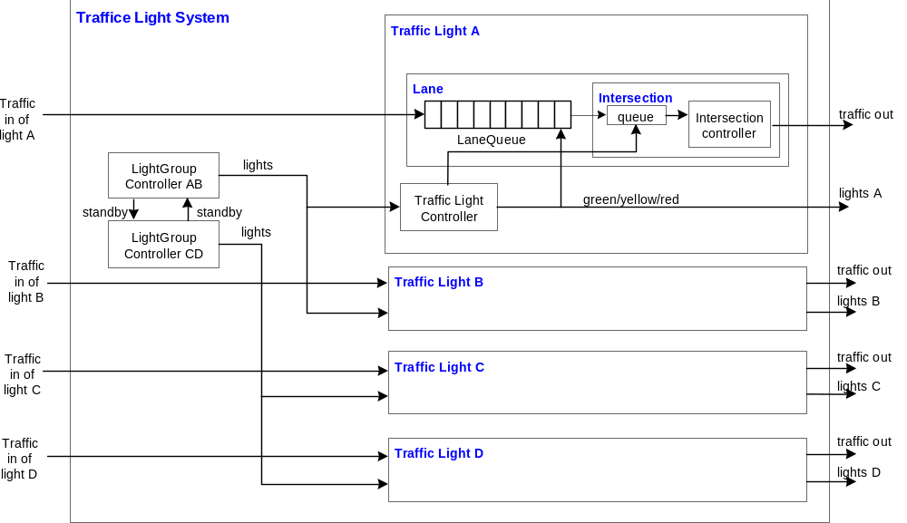

Figure 3 Modified Model Structure of Single Traffic Light System

The four connected traffic lights can be briefly depicted as a cell-DEVS model in Figure 4.

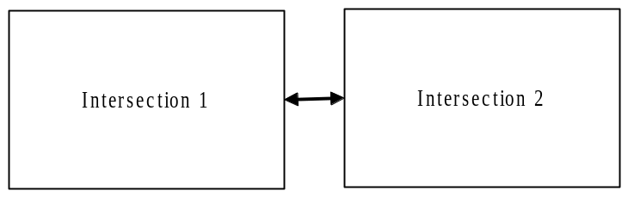

Figure 4 The Cell-DEVS Model for Interconnected Traffic Light Systems

The Model Structure

As shown in Figure 3, the model is similar with the one in Assignment 1. However, we re-implement it with coupled cell-DEVS. We have three basic cell-space DEVS models, namely, light controller, segment and crossing.

Light controller model has the functionality of light group controller and traffic light controller as shown in Figure 3. Segment model represent lane queue and intersection queue is modeled as crossing model. Lane is composed of one segment and its corresponding crossing.

Part II The Formal Specifications for Models

There are differences between the implementation and Part I description at
- We implement all components with cell-DEVS model although we had planed to reuse the atomic models of intersection queue, intersection controller, traffic light controller and light group controllers.
- We discarded the TrafficLightController and IntersectionController models.
- We renamed the laneQueue to Segment and IntersectionQueue to Crossing.
- Implemented the LightGroupController with Cell_DEVS model.
- Because behaviors of 4 intersections are independent at each direction, we only simulated the case of the interconnection between two intersections, and there is traffic at horizontal direction.

2.1 Model Specifications

2.1.1 Segment Model

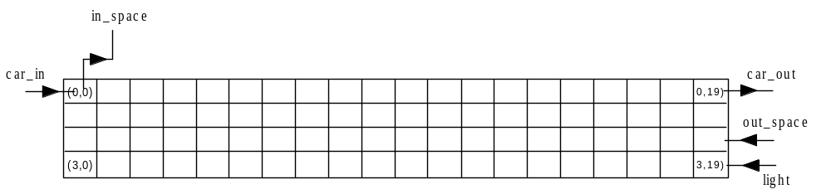
Figure 5 Segment Model

Neither a transport cell-DEVS nor a simple inertial cell-DEVS can model a car’s behavior with changing speed in a segment. Therefore, a 4x20 2-dimensional inertial model is used for one lane of one direction, as shown in Figure 5. A segment begins from the point where a car enters, and ends with the point where a car leaves and enters into a crossing.

The first row is used to keep the position of a car in a segment and record the current state of the car; the second row is employed for the timing of state change of the car (e.g. changing its speed while moving forward or staying still); the third row conducts the generic control, including making the decision of whether increasing / decreasing the current speed, etc; the forth one gets the light signal (input) for these cells that are close to the intersection.

We use a real number with special format to record the status of a car. The format is <current_state>.<next_state><output><two_digit_delay>. For example, 4.0306 represents the current speed is high (4), and next state is null (0); the output is middle (3) speed car (this is only used for the car_out port, and no output when output is 0(zero)), the time that the current car leaving current cell to the next (delay) is 06 x 100 = 600 ms; 0.3010 represents the current null (0) cell will be occupied by a middle (3) speed car 1000 ms later. We use this way to distinguish between normal state and moving state of a cell in traffic plane(the 1st row), to prevent the movement of a car is not interrupted by state change of its neighbors by cooperating with its neighbor in timing plane (the 2nd row).

The specifications is as following:

Segment = <I, X, Y, Xlist, Ylist, , N, {m,n}, C, B, select> where

Xlist = {(0,0); (2,19);(3,19)}
Ylist = {(0,0);(0,19)}
= 11
I = <P^{x}, P^{y}>, with P^{x}={<X(0,0),speed>, <X(2,19),number>, <X(3,19),light>}; P^{y}= {<Y(0,0),speed>, <Y(0,19),speed>}
N = {(0,-1), (0,0), (0,1), (0,2), (0,3), (-3,0), (-2,0), (-1,0), (1,0), (2,0), (3,0)}
X = Y = {0,1,2,3,4} for car speeds, or {5,6,7,8} for light signals, or {k, k Integer} for car space.
m =4; n = 20
B = {(0,0), (0,19), (2,19), (3,19)}
C = {C_{ij} / i[0,3], j [0, 19]}
Z:
P_{ij}^{Y}₁ P_{i,j-1}^{X}₁ P_{i,j+1}^{Y}₁ P_{ij}^{X}₁
P_{ij}^{Y}₂ P_{i,j+1}^{X}₂ P_{i,j-1}^{Y}₂ P_{ij}^{X}₂
P_{ij}^{Y}₃ P_{i,j+2}^{X}₃ P_{i,j-2}^{Y}₃ P_{ij}^{X}₃
P_{ij}^{Y}₄ P_{i,j+3}^{X}₄ P_{i,j-3}^{Y}₄ P_{ij}^{X}₄
P_{ij}^{Y}₅ P_{i-3,j}^{X}₅ P_{i+3,,j}^{Y}₅ P_{ij}^{X}₅
P_{ij}^{Y}₆ P_{i-2,j}^{X}₆ P_{i+2,,j}^{Y}₆ P_{ij}^{X}₆
P_{ij}^{Y}₆ P_{i-1,j}^{X}₇ P_{i+1,,j}^{Y}₆ P_{ij}^{X}₇
P_{ij}^{Y}₈ P_{i+3,j}^{X}₈ P_{i-3,,j}^{Y}₈ P_{ij}^{X}₈
P_{ij}^{Y}₉ P_{i+2,j}^{X}₉ P_{i-2,,j}^{Y}₉ P_{ij}^{X}₉
P_{ij}^{Y}₁₀ P_{i+1,j}^{X}₁₀ P_{i-1,,j}^{Y}₁₀ P_{ij}^{X}₁₀
P_{ij}^{Y}₁₀ P_{ij}^{X}₁₀ P_{ij}^{Y}₁₀ P_{ij}^{X}₁₀

Select = {(-3,0), (-2,0), (-1,0), (1,0), (2,0), (3,0), (0,-1), (0,0), (0,1), (0,2), (0,3)}

The “local state” of single cell
S = {0,1,2,3,4} when the cell is in the 1st row, where 0: empty; 1:stop; 2:low speed; 3:mid speed; 4: high speed
Or
S = {5,6,7,8} when the cell is in the 4th row, where 5:green light; 6: yellow light; 7:red light; 8: standby (red)
Or
S = {i, iInteger} when the cell is in the 3rd row.
Or
S = {0,9} when the cell is in the 2nd row, where 0: not timing; 9: timing.

The local transition functions, in-port transition and zone transition functions can be best described with CD++ specifications (actually, we can consider it as pseudo code here to give a description of these functions); in fact, we have include the whole CD++ specifications of segment model as following:

[segment]
type : cell
height : 4
width : 20
delay : inertial
defaultDelayTime : 1000
border : nowrapped
neighbors : segment1a(-3,0)
neighbors : segment1a(-2,0)
neighbors : segment1a(-1,0)
neighbors : segment1a(0,-1) segment1a(0,0) segment1a(0,1) segment1a(0,2) segment1a(0,3)
neighbors : segment1a(1,0)
neighbors : segment1a(2,0)
neighbors : segment1a(3,0)
initialvalue : 0
initialrowvalue : 0 00100101030010010001
initialrowvalue : 1 00000000000000000000
initialrowvalue : 2 00000000000000000000
initialrowvalue : 3 77777777777777777777
localTransition : traffic_rule
zone : time_plane_rule { (1,0)..(1,19) }
zone : general_plane_update_rule { (2,0)..(2,19) (3,0)..(3,19) }
zone : lane_beginning_rule { (0,0) }
zone : lane_end_rule1 { (0,19) }
zone : lane_end_rule2 { (0,18) }
zone : lane_end_rule3 { (0,17) }
in : light car_in out_space
out : in_space car_out
link : light light@segment1a(3,19)
link : in_space@segment1a(0,0) in_space
link : car_out@segment1a(0,19) car_out
link : car_in car_in@segment1a(0,0)
link : out_space out_space@segment1a(2,19)
portInTransition : car_in@segment1a(0,0) car_in_rule
portInTransition : light@segment1a(3,19) light_change_rule
portInTransition : out_space@segment1a(2,19) out_speed_change_rule

[traffic_rule]
#macro(traffic_timing_rule)
%
#Macro(move_to_next_rule)
%
rule : {0.10+#macro(stop_delay)} 10 { (0,-1) = 1 and (0, 0) = 0 and trunc(#macro(rcell_1))!=0 } % 1 0 1
rule : {0.20+#macro(stop_delay)} 10 { (0,-1) = 1 and (0, 0) = 0 and trunc(#macro(rcell_1))=0 } % 1 0 0
rule : {0.10+#macro(low_delay)} 10 { (0,-1) = 2 and (0, 0) = 0 and trunc(#macro(rcell_1))!=0} % 2 0 1
rule : {0.20+#macro(low_delay)} 10 { (0,-1) = 2 and (0, 0) = 0 and trunc(#macro(rcell_2))!=0 } % 2 0 0 1
rule : {0.30+#macro(low_delay)} 10 { (0,-1) = 2 and (0, 0) = 0 and trunc(#macro(rcell_2))=0 } % 2 0 0 0
rule : {0.20+#macro(middle_delay)} 10 { (0,-1) = 3 and (0, 0) = 0 and trunc(#macro(rcell_1))!=0 } % 3 0 1
rule : {0.20+#macro(middle_delay)} 10 { (0,-1) = 3 and (0, 0) = 0 and trunc(#macro(rcell_2))!=0 } % 3 0 0 1
rule : {0.30+#macro(middle_delay)} 10 { (0,-1) = 3 and (0, 0) = 0 and trunc(#macro(rcell_3))!=0 } % 3 0 0 0 1
rule : {0.40+#macro(middle_delay)} 10 { (0,-1) = 3 and (0, 0) = 0 and trunc(#macro(rcell_3))=0 } % 3 0 0 0 0
rule : {0.30+#macro(high_delay)} 10 { (0,-1) = 4 and (0, 0) = 0 and trunc(#macro(rcell_1))!=0 } % 4 0 1
rule : {0.30+#macro(high_delay)} 10 { (0,-1) = 4 and (0, 0) = 0 and trunc(#macro(rcell_2))!=0 } % 4 0 0 1
rule : {0.30+#macro(high_delay)} 10 { (0,-1) = 4 and (0, 0) = 0 and trunc(#macro(rcell_3))!=0 } % 4 0 0 0 1
rule : {0.40+#macro(high_delay)} 10 { (0,-1) = 4 and (0, 0) = 0 and trunc(#macro(rcell_3))=0 } % 4 0 0 0 0
rule : {(0,0)} 10 { t }

[time_plane_rule]
%
% When its traffic cell neighbor change its state from x to x.xx, I start
% timing according to the value of traffic neighbor. when timeout occur,
% I change my state to non-zero to notify my traffic neighbor.
%
% When I'm wait for timeout, if my time neighbor changed, because I do not
% change my state, cd++ will automatically continute my previous delay.
%
rule : 9 { #macro(delay) - 10} { fractional((-1, 0))!=0 }
%
% When my traffic neighbor got my notification, it should change its state
% from x.xxx to y, so I can get notification to return to zero state. When
% I change to zero state, my traffic neighbor can have chance to do its action
% after it changed to y state.
%
rule : 0 0 { t }

[general_plane_update_rule]
%
% except the signal inject point, all other cells change
% their states according to its neighbors
%
rule : { (0,0) } 0 { isUndefined((0,1)) }
rule : { (0,1) } 0 { t }

[lane_beginning_rule]
#macro(traffic_timing_rule)
%
% 1> totally blocked case.
rule : {1.00+#macro(stop_delay)} 10 { (1,0)=0 and (0,0)=1 and (0,1)=0}
rule : {2.00+#macro(low_delay)} 10 { (1,0)=0 and (0,0)=2 and (0,1)=0}
rule : {3.00+#macro(middle_delay)} 10 { (1,0)=0 and (0,0)=3 and (0,1)=0}
rule : {4.00+#macro(high_delay)} 10 { (1,0)=0 and (0,0)=4 and (0,1)=0}
% 2> one space case.
rule : {(0,0)+send(in_space, 1)} 0 {(1,0)!=0 and (0,0)=0 and trunc(#macro(rcell_1))!=0}
% 3> two spaces case.
rule : {(0,0)+send(in_space, 2)} 0 {(1,0)=0 and (0,0)=0 and #macro(rcell_1)=0 and trunc(#macro(rcell_2))!=0 and fractional(#macro(rcell_2))=0}
% 4> three spaces case.
rule : {(0,0)+send(in_space, 3)} 0 {(1,0)=0 and (0,0)=0 and #macro(rcell_1)=0 and #macro(rcell_2)=0 and trunc(#macro(rcell_3))!=0 and fractional(#macro(rcell_3))=0}
% 5> totally free case.
rule : {(0,0)+send(in_space, 4)} 0 {(1,0)=0 and (0,0)=0 and #macro(rcell_1)=0 and #macro(rcell_2)=0 and trunc(#macro(rcell_3))=0}
%
%
rule : {0.10+#macro(stop_delay)} 10 { (0,-1) = 1 and (0, 0) = 0 and trunc(#macro(rcell_1))!=0 } % 1 0 1
rule : {0.20+#macro(stop_delay)} 10 { (0,-1) = 1 and (0, 0) = 0 and trunc(#macro(rcell_1))=0 } % 1 0 0
rule : {0.10+#macro(low_delay)} 10 { (0,-1) = 2 and (0, 0) = 0 and trunc(#macro(rcell_1))!=0} % 2 0 1
rule : {0.20+#macro(low_delay)} 10 { (0,-1) = 2 and (0, 0) = 0 and trunc(#macro(rcell_2))!=0 } % 2 0 0 1
rule : {0.30+#macro(low_delay)} 10 { (0,-1) = 2 and (0, 0) = 0 and trunc(#macro(rcell_2))=0 } % 2 0 0 0
rule : {0.20+#macro(middle_delay)} 10 { (0,-1) = 3 and (0, 0) = 0 and trunc(#macro(rcell_1))!=0 } % 3 0 1
rule : {0.20+#macro(middle_delay)} 10 { (0,-1) = 3 and (0, 0) = 0 and trunc(#macro(rcell_2))!=0 } % 3 0 0 1
rule : {0.30+#macro(middle_delay)} 10 { (0,-1) = 3 and (0, 0) = 0 and trunc(#macro(rcell_3))!=0 } % 3 0 0 0 1
rule : {0.40+#macro(middle_delay)} 10 { (0,-1) = 3 and (0, 0) = 0 and trunc(#macro(rcell_3))=0 } % 3 0 0 0 0
rule : {0.30+#macro(high_delay)} 10 { (0,-1) = 4 and (0, 0) = 0 and trunc(#macro(rcell_1))!=0 } % 4 0 1
rule : {0.30+#macro(high_delay)} 10 { (0,-1) = 4 and (0, 0) = 0 and trunc(#macro(rcell_2))!=0 } % 4 0 0 1
rule : {0.30+#macro(high_delay)} 10 { (0,-1) = 4 and (0, 0) = 0 and trunc(#macro(rcell_3))!=0 } % 4 0 0 0 1
rule : {0.40+#macro(high_delay)} 10 { (0,-1) = 4 and (0, 0) = 0 and trunc(#macro(rcell_3))=0 } % 4 0 0 0 0
rule : {(0,0)} 10 { t }

[lane_end_rule1]
%
rule : {(0,0)} 1000 { fractional((0,0))!=0 and (1,0)=0 }
rule : {#macro(next_state)} 0 { fractional((0,0))!=0 and (1,0)!=0 and #macro(output)=0}
rule : {#macro(next_state)+send(car_out, #macro(output))} 0 { fractional((0,0))!=0 and (1,0)!=0 and #macro(output)!=0}
%
% These are moving forward rules when yellow/red light.
% if cannot stop safely, do the same as green light.
%
rule : {(0,0)} 10 { (3,0)!=5 and (0,0)=1 } % can stop safely, stop here
%
% These are moving forward rules when green light
%
rule : {(0,0)} 10 { (0,0)=1 and (2,0)<1 } % 0 space ahead, stop here
rule : {1.01+#macro(stop_delay)} 10 { (0,0)=1 and (2,0)=1 } % 1 space ahead, go head
rule : {1.02+#macro(stop_delay)} 10 { (0,0)=1 and (2,0)>1 } % 2 and more space ahead, speed up
%
rule : {2.01+#macro(low_delay)} 10 { (0,0)=2 and (2,0)<2 } % 0/1 space ahead, slowdown/crash
rule : {2.02+#macro(low_delay)} 10 { (0,0)=2 and (2,0)=2 } % 2 space ahead, keep speed
rule : {2.03+#macro(low_delay)} 10 { (0,0)=2 and (2,0)>2 } % 3 and more space ahead, speed up
%
rule : {3.02+#macro(middle_delay)} 10 { (0,0)=3 and (2,0)<3 } % 0/1/2 space ahead, slowdown/crash
rule : {3.03+#macro(middle_delay)} 10 { (0,0)=3 and (2,0)=3 } % 3 space ahead, keep speed
rule : {3.04+#macro(middle_delay)} 10 { (0,0)=3 and (2,0)>3 } % 4 and more space ahead, speed up
%
rule : {4.02+#macro(high_delay)} 10 { (0,0)=4 and (2,0)<4 } % 0/1/2/3 space ahead, slowdown/crash
rule : {4.03+#macro(high_delay)} 10 { (0,0)=4 and (2,0)>=4 } % 4 and more space ahead, keep speed
%
% These are moving_here rules for yellow/red light.
% if cannot stop safely, do the same as green light.
%
rule : {0.10+#macro(stop_delay)} 10 { (3,0)!=5 and (0,-1)=1 and (0,0)=0 } % can stop safely
rule : {0.10+#macro(low_delay)} 10 { (3,0)!=5 and (0,-1)=2 and (0,0)=0 } % can stop safely
% For speed 3 or 4, because it cannot stop safely, do as green light.
%
%else : traffic_rule
%
rule : {0.10+#macro(stop_delay)} 10 { (0,-1) = 1 and (0, 0) = 0 and trunc(#macro(rcell_1))!=0 } % 1 0 1
rule : {0.20+#macro(stop_delay)} 10 { (0,-1) = 1 and (0, 0) = 0 and trunc(#macro(rcell_1))=0 } % 1 0 0
rule : {0.10+#macro(low_delay)} 10 { (0,-1) = 2 and (0, 0) = 0 and trunc(#macro(rcell_1))!=0} % 2 0 1
rule : {0.20+#macro(low_delay)} 10 { (0,-1) = 2 and (0, 0) = 0 and trunc(#macro(rcell_2))!=0 } % 2 0 0 1
rule : {0.30+#macro(low_delay)} 10 { (0,-1) = 2 and (0, 0) = 0 and trunc(#macro(rcell_2))=0 } % 2 0 0 0
rule : {0.20+#macro(middle_delay)} 10 { (0,-1) = 3 and (0, 0) = 0 and trunc(#macro(rcell_1))!=0 } % 3 0 1
rule : {0.20+#macro(middle_delay)} 10 { (0,-1) = 3 and (0, 0) = 0 and trunc(#macro(rcell_2))!=0 } % 3 0 0 1
rule : {0.30+#macro(middle_delay)} 10 { (0,-1) = 3 and (0, 0) = 0 and trunc(#macro(rcell_3))!=0 } % 3 0 0 0 1
rule : {0.40+#macro(middle_delay)} 10 { (0,-1) = 3 and (0, 0) = 0 and trunc(#macro(rcell_3))=0 } % 3 0 0 0 0
rule : {0.30+#macro(high_delay)} 10 { (0,-1) = 4 and (0, 0) = 0 and trunc(#macro(rcell_1))!=0 } % 4 0 1
rule : {0.30+#macro(high_delay)} 10 { (0,-1) = 4 and (0, 0) = 0 and trunc(#macro(rcell_2))!=0 } % 4 0 0 1
rule : {0.30+#macro(high_delay)} 10 { (0,-1) = 4 and (0, 0) = 0 and trunc(#macro(rcell_3))!=0 } % 4 0 0 0 1
rule : {0.40+#macro(high_delay)} 10 { (0,-1) = 4 and (0, 0) = 0 and trunc(#macro(rcell_3))=0 } % 4 0 0 0 0
rule : {(0,0)} 10 { t }

[lane_end_rule2]
#macro(traffic_timing_rule)
%
% These are moving_here rules for yellow/red light.
% if cannot stop safely, do the same as green light.
%
rule : {0.20+#macro(stop_delay)} 10 { (3,0)!=5 and (0,-1)=1 and (0,0)=0 and (0,1)=0 } % can stop safely, speed up
rule : {0.20+#macro(low_delay)} 10 { (3,0)!=5 and (0,-1)=2 and (0,0)=0 and (0,1)=0 } % can stop safely, keep speed
rule : {0.20+#macro(middle_delay)} 10 { (3,0)!=5 and (0,-1)=3 and (0,0)=0 and (0,1)=0 } % can stop safely, slow down
% For speed 4, because it cannot stop safely, do as green light.
%
%else : traffic_rule
%
#Macro(move_to_next_rule)
%
rule : {0.10+#macro(stop_delay)} 10 { (0,-1) = 1 and (0, 0) = 0 and trunc(#macro(rcell_1))!=0 } % 1 0 1
rule : {0.20+#macro(stop_delay)} 10 { (0,-1) = 1 and (0, 0) = 0 and trunc(#macro(rcell_1))=0 } % 1 0 0
rule : {0.10+#macro(low_delay)} 10 { (0,-1) = 2 and (0, 0) = 0 and trunc(#macro(rcell_1))!=0} % 2 0 1
rule : {0.20+#macro(low_delay)} 10 { (0,-1) = 2 and (0, 0) = 0 and trunc(#macro(rcell_2))!=0 } % 2 0 0 1
rule : {0.30+#macro(low_delay)} 10 { (0,-1) = 2 and (0, 0) = 0 and trunc(#macro(rcell_2))=0 } % 2 0 0 0
rule : {0.20+#macro(middle_delay)} 10 { (0,-1) = 3 and (0, 0) = 0 and trunc(#macro(rcell_1))!=0 } % 3 0 1
rule : {0.20+#macro(middle_delay)} 10 { (0,-1) = 3 and (0, 0) = 0 and trunc(#macro(rcell_2))!=0 } % 3 0 0 1
rule : {0.30+#macro(middle_delay)} 10 { (0,-1) = 3 and (0, 0) = 0 and trunc(#macro(rcell_3))!=0 } % 3 0 0 0 1
rule : {0.40+#macro(middle_delay)} 10 { (0,-1) = 3 and (0, 0) = 0 and trunc(#macro(rcell_3))=0 } % 3 0 0 0 0
rule : {0.30+#macro(high_delay)} 10 { (0,-1) = 4 and (0, 0) = 0 and trunc(#macro(rcell_1))!=0 } % 4 0 1
rule : {0.30+#macro(high_delay)} 10 { (0,-1) = 4 and (0, 0) = 0 and trunc(#macro(rcell_2))!=0 } % 4 0 0 1
rule : {0.30+#macro(high_delay)} 10 { (0,-1) = 4 and (0, 0) = 0 and trunc(#macro(rcell_3))!=0 } % 4 0 0 0 1
rule : {0.40+#macro(high_delay)} 10 { (0,-1) = 4 and (0, 0) = 0 and trunc(#macro(rcell_3))=0 } % 4 0 0 0 0
rule : {(0,0)} 10 { t }

[lane_end_rule3]
#macro(traffic_timing_rule)
%
% These are moving_here rules for yellow/red light.
% if cannot stop safely, do the same as green light.
%
rule : {0.30+#macro(middle_delay)} 10 { (3,0)!=5 and (0,-1)=3 and (0,0)=0 and (0,1)=0 and (0,2)=0 } % can stop safely, keep speed
rule : {0.30+#macro(high_delay)} 10 { (3,0)!=5 and (0,-1)=4 and (0,0)=0 and (0,1)=0 and (0,2)=0 } % can stop safely, slow down
%
%else : traffic_rule
%
#Macro(move_to_next_rule)
%
rule : {0.10+#macro(stop_delay)} 10 { (0,-1) = 1 and (0, 0) = 0 and trunc(#macro(rcell_1))!=0 } % 1 0 1
rule : {0.20+#macro(stop_delay)} 10 { (0,-1) = 1 and (0, 0) = 0 and trunc(#macro(rcell_1))=0 } % 1 0 0
rule : {0.10+#macro(low_delay)} 10 { (0,-1) = 2 and (0, 0) = 0 and trunc(#macro(rcell_1))!=0} % 2 0 1
rule : {0.20+#macro(low_delay)} 10 { (0,-1) = 2 and (0, 0) = 0 and trunc(#macro(rcell_2))!=0 } % 2 0 0 1
rule : {0.30+#macro(low_delay)} 10 { (0,-1) = 2 and (0, 0) = 0 and trunc(#macro(rcell_2))=0 } % 2 0 0 0
rule : {0.20+#macro(middle_delay)} 10 { (0,-1) = 3 and (0, 0) = 0 and trunc(#macro(rcell_1))!=0 } % 3 0 1
rule : {0.20+#macro(middle_delay)} 10 { (0,-1) = 3 and (0, 0) = 0 and trunc(#macro(rcell_2))!=0 } % 3 0 0 1
rule : {0.30+#macro(middle_delay)} 10 { (0,-1) = 3 and (0, 0) = 0 and trunc(#macro(rcell_3))!=0 } % 3 0 0 0 1
rule : {0.40+#macro(middle_delay)} 10 { (0,-1) = 3 and (0, 0) = 0 and trunc(#macro(rcell_3))=0 } % 3 0 0 0 0
rule : {0.30+#macro(high_delay)} 10 { (0,-1) = 4 and (0, 0) = 0 and trunc(#macro(rcell_1))!=0 } % 4 0 1
rule : {0.30+#macro(high_delay)} 10 { (0,-1) = 4 and (0, 0) = 0 and trunc(#macro(rcell_2))!=0 } % 4 0 0 1
rule : {0.30+#macro(high_delay)} 10 { (0,-1) = 4 and (0, 0) = 0 and trunc(#macro(rcell_3))!=0 } % 4 0 0 0 1
rule : {0.40+#macro(high_delay)} 10 { (0,-1) = 4 and (0, 0) = 0 and trunc(#macro(rcell_3))=0 } % 4 0 0 0 0
rule : {(0,0)} 10 { t }

[car_in_rule]
#macro(traffic_timing_rule)
rule : {portValue(thisPort)+send(in_space,0)} 0 { (0,0)=0 and portValue(thisPort)<=4 and portValue(thisPort)>=1}
#macro(move_to_next_rule)
rule : {(0,0)} 0 { t }

[light_change_rule]
rule : {(0,0)} 0 { time <= 0 }
rule : {portValue(thisPort)} 0 { (0,0)!=portValue(thisPort) }
rule : {(0,0)} 0 { t }

[out_speed_change_rule]
rule : {portValue(thisPort)} 0 { (0,0)!=portValue(thisPort) }
rule : {(0,0)} 0 { t }

For the macro definitions, please refer to Appendix A.

2.1.2 Crossing Model

It has similar specifications with Segment, as following, the existence of the light plane (4th row) is because we want to reuse the existing rules, so their value are always 5 (green).
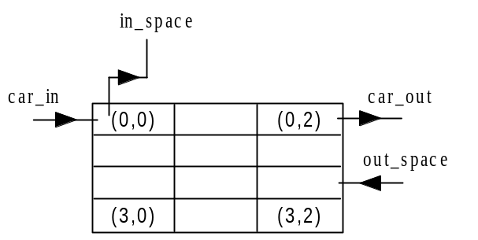
Figure 6 Crossing Model

Crossing = <I, X, Y, Xlist, Ylist, , N, {m,n}, C, B, select> where

Xlist = {(0,0); (2,2)}
Ylist = {(0,0);(0,2)}
= 11
I = <P^{x}, P^{y}>, with P^{x}={<X(0,0),speed>, <X(2,19),number>}; P^{y}= {<Y(0,0),speed>, <Y(0,2),speed>}
N = {(0,-1), (0,0), (0,1), (0,2), (0,3), (-3,0), (-2,0), (-1,0), (1,0), (2,0), (3,0)}
X = Y = {0,1,2,3,4} for car speeds, or {k, k Integer} for car space.
m =4; n = 3
B = {(0,0), (0,2), (2,2)}
C = {C_{ij} / i[0,3], j [0, 2]}
Z:
P_{ij}^{Y}₁ P_{i,j-1}^{X}₁ P_{i,j+1}^{Y}₁ P_{ij}^{X}₁
P_{ij}^{Y}₂ P_{i,j+1}^{X}₂ P_{i,j-1}^{Y}₂ P_{ij}^{X}₂
P_{ij}^{Y}₃ P_{i,j+2}^{X}₃ P_{i,j-2}^{Y}₃ P_{ij}^{X}₃
P_{ij}^{Y}₄ P_{i,j+3}^{X}₄ P_{i,j-3}^{Y}₄ P_{ij}^{X}₄
P_{ij}^{Y}₅ P_{i-3,j}^{X}₅ P_{i+3,,j}^{Y}₅ P_{ij}^{X}₅
P_{ij}^{Y}₆ P_{i-2,j}^{X}₆ P_{i+2,,j}^{Y}₆ P_{ij}^{X}₆
P_{ij}^{Y}₆ P_{i-1,j}^{X}₇ P_{i+1,,j}^{Y}₆ P_{ij}^{X}₇
P_{ij}^{Y}₈ P_{i+3,j}^{X}₈ P_{i-3,,j}^{Y}₈ P_{ij}^{X}₈
P_{ij}^{Y}₉ P_{i+2,j}^{X}₉ P_{i-2,,j}^{Y}₉ P_{ij}^{X}₉
P_{ij}^{Y}₁₀ P_{i+1,j}^{X}₁₀ P_{i-1,,j}^{Y}₁₀ P_{ij}^{X}₁₀
P_{ij}^{Y}₁₀ P_{ij}^{X}₁₀ P_{ij}^{Y}₁₀ P_{ij}^{X}₁₀

Select = {(-3,0), (-2,0), (-1,0), (1,0), (2,0), (3,0), (0,-1), (0,0), (0,1), (0,2), (0,3)}

The “local state” of single cell
S = {0,1,2,3,4} when the cell is in the 1st row, where 0: empty; 1:stop; 2:low speed; 3:mid speed; 4: high speed
Or
S = {i, iInteger} when the cell is in the 3rd row.
Or
S = {0,9} when the cell is in the 2nd row, where 0: not timing; 9: timing.

It uses a sub-set of transition functions (i.e. local transition, in-port transition and zone transition functions) of Model Segment, namely, traffic_rule, time_plane_rule, general_plane_update_rule, lane_beginning_rule, lane_end_rule1, lane_end_rule2, car_in_rule and out_speed_change_rule.

2.1.3 Light Controller Model

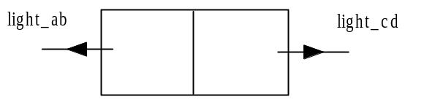
Figure 7 Light Controller Model
Light Controller is an inertial model and its specifications is:

Light = <I, X, Y, Xlist, Ylist, , N, {m,n}, C, B, select> where

Xlist = {}
Ylist = {(0,0);(0,1)}
= 2
I = <P^{x}, P^{y}>, with P^{x}={<X(0,0),light>, <X(0,1),light>}; P^{y}= {}
N = {(0,0), (0,1)}
X ={}
Y = {5,6,7,8} for lights.
m =1; n = 2
B = {}
C = {C_{ij} / i[0], j [0, 1]}
Z:
P_{ij}^{Y}₁ P_{i,j+1}^{X}₁ P_{i,j-1}^{Y}₁ P_{ij}^{X}₁
P_{ij}^{Y}₂ P_{ij}^{X}₂ P_{ij}^{Y}₂ P_{ij}^{X}₂

Select = { (0,0), (0,1)}

The “local state” of single cell
S = {5,6,7,8} where 5: green; 6:yellow; 7:red; 8:standby

The location transition function is (using CD++ pseudo code):

[light_controller_rule]
rule : 5 1000 { (0,0)=7 and (0,1)=8}
rule : {6+send(lights,5)} 45000 { cellpos(1)=1 and (0,0)=5 and (0,1)=7 }
rule : {6+send(lights,5)} 45000 { cellpos(1)=0 and (0,0)=5 and (0,1)=7 }
rule : {8+send(lights,6)} 3000 { (0,0)=6 and (0,1)=7 }
rule : {7+send(lights,7)} 1000 { (0,0)=8 and time > 0 }
rule : 7 1000 { (0,0)=8 }
rule : {(0,0)} 0 { t }

2.1.4 Lane Model (Coupled)

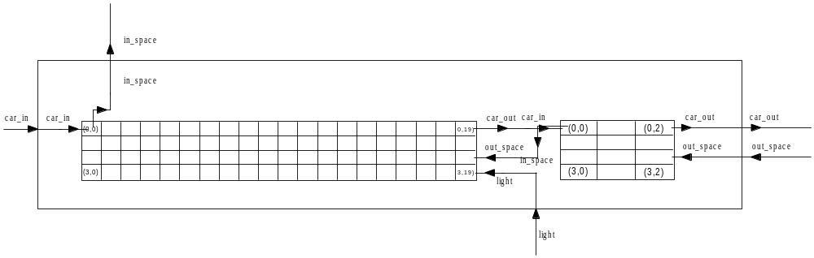

Figure 8 Lane Model

Lane = <X, Y, D, {Mi}, {Ii}, {Zij}, select>

X = {car_in, out_space, light}
Y = {in_space, car_out}
D = {segment, crossing}
I_{segment} = {crossing}
I_{crossing} = {segment}

Zij:

Zs-c = Y(0,19)s X(0,0)c
Zc-s = Y(0,0)c X(2,19)s

Select = {segment, crossing}

2.1.5 Intersection Model

Intersection = <X, Y, D, {Mi}, {Ii}, {Zij}, select>

X = { in_a, in_b,in_c, in_d, out_space_a, out_space_b, out_space_c, out_space_d}
Y = {out_a, out_b, out_c, out_d, in_space_a, in_space_b, in_space_c, in_space_d}
D = {lane_1a,lane_1b, lane_1c, lane_1d, light_controller_1}
I_{lane_1a} = I_{lane_1b} =I_{lane_1c} = I_{lane_1d} = {self}
I_{light_controller} = { lane_1a, lane_1b, lane_1c, lane_1d}

Zij:

Z_{light} = lane_1a; Z_{light}=lane_1b; Z_{light}=lane_1c; Z_{light}=lane_1d

Select = {light_controller, lane_1a, lane_1b, lane_1c, lane_1d}

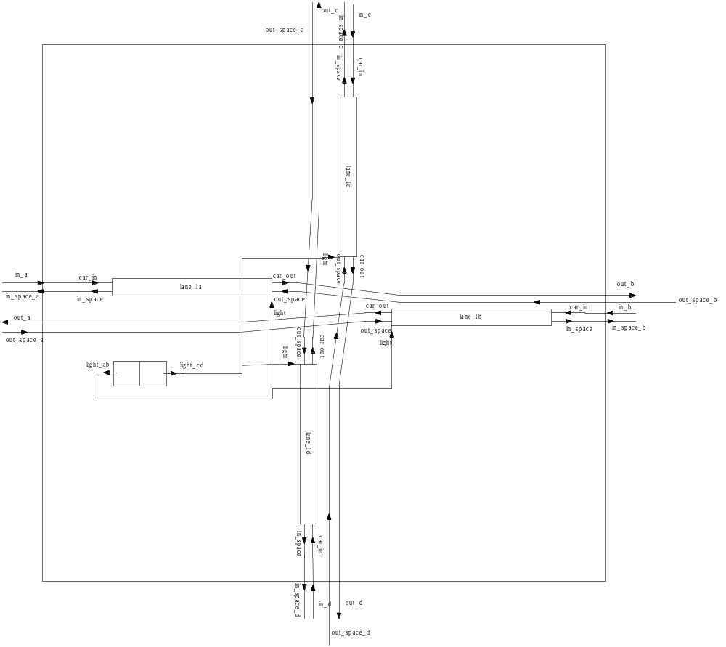
Figure 9 Intersection Model

2.1.6 An Example of Connecting Intersection Models

Figure 10 shows an example of connecting two intersections. This is also the model we use to test our intersection model. The following is its CD++ specifications:

#include(traffic.inc)

[top]
components : gen1@Generator gen2@Generator
components : intersection1
components : intersection2

in : in_space
link : in_space out_space_a@intersection1
link : in_space out_space_b@intersection2

out : out_1a out_2b
link : out_a@intersection1 out_1a
link : out_b@intersection2 out_2b

out : in_1a in_2b
link : out@gen1 in_1a
%link : out@gen2 in_2b
link : out@gen1 in_a@intersection1
%link : out@gen2 in_b@intersection2

link : out_b@intersection1 in_a@intersection2
link : out_a@intersection2 in_b@intersection1
link : in_space_b@intersection1 out_space_a@intersection2
link : in_space_a@intersection2 out_space_b@intersection1

link : out_d@intersection1 in_c@intersection1
link : out_c@intersection1 in_d@intersection1
link : in_space_c@intersection1 out_space_d@intersection1
link : in_space_d@intersection1 out_space_c@intersection1

link : out_d@intersection2 in_c@intersection2
link : out_c@intersection2 in_d@intersection2
link : in_space_c@intersection2 out_space_d@intersection2
link : in_space_d@intersection2 out_space_c@intersection2

[gen1]
distribution : poisson
mean : 10
initial : 1
increment : 0 % all cars enter the lane with "stop" speed.

[gen2]
distribution : poisson
mean : 10
initial : 1
increment : 0 % all cars enter the lane with "stop" speed.

:

:

:

Please note we only use two generators to feed the model with traffics in two directions, A and B; in the directions of C and D, only a small amount of traffic is circulated, in
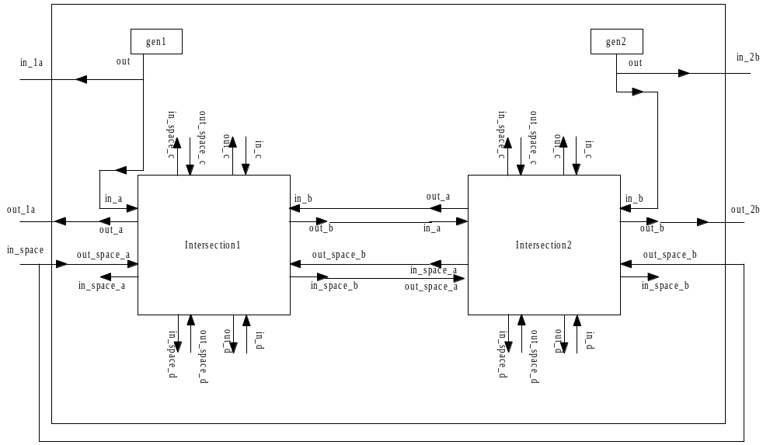

Figure 10 An Example of Connecting Two Intersections

order to reduce the size of the log file (if simulating 10-minute run of the system with only one direction having normal traffic, the log file turns out to be 10 – 20 MB).

Part III Execution Result Analysis Report

3.1 Bug Reports

- The model Only works with Linux & Win32 version (cd++_exes.zip, 3.7MB), which includes both Linux and Windows executables
We tried at school under Linux OS but cannot finish it because the log file is two big (around 92 MB for 10-minute traffic simulation) and our accounts do not provide such big free disk space. It does not work under Win32 version of CD++ for unknown reasons, but it does work perfectly under the Linux & Win32 version.

- It seems that Drawlog tool is not getting the state value of a cell correctly when the cell is outputting value.
Actully, Drawlog is taking the value the cell outputs as its current state value. This can be observed at the Cell (0,0) in the segment model.

- 3D Viewer does not work with either IE browser or Netscape 7.1
Potential solution: make sure cp211_msjava.dll is in PATH; for somehow Cosmo player needs cp211_msjava.dll when getting browser type on Windows.

3.2 Result Analysis

In this assignment, we analyze the model in terms of the simulated behaviors of vehicles under control and the behavior of the traffic control system by observing the animation of the simulation in CD++ Modeler and CD++ 3D Modeler.

3.2.1 Initialization: Standby To Green

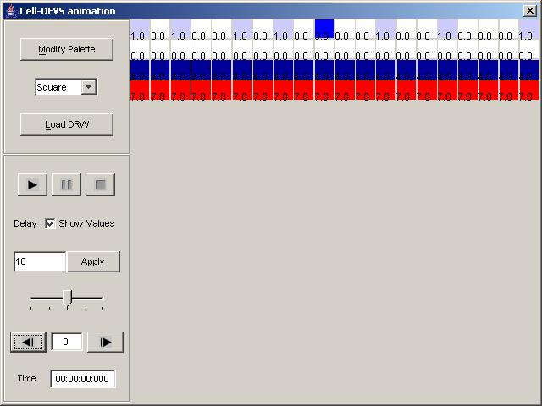

Figure 11 Initial Status of Segment 1a

At the start time, the traffic light is in the status of standby (Figure 11), which lasts for one second; one second after, the light turns green and the traffic starts moving (Figure 12).

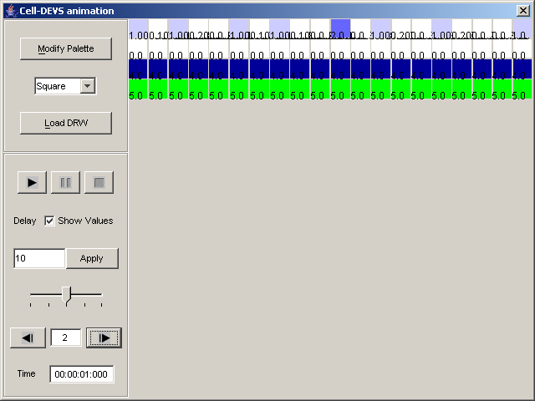

Figure 12 After Standby …

3.2.2 Car Behavior (1): Speed Simulation and The simulation of Decreasing Speed

In Figure 12, please note at the time 00:00:01:000, there is one car (at Cell # 10) with the speed level 2 (mid), which is supposed to move to the next cell at the time 00:00:03:000 according to our definition of car speed in traffic.ma (line865-869); further, there is only one cell between this car and the car in front of it, which is not safe based on our assumption – at least 2 empty cells needed between them. That is to say this car has to decrease its speed from 2 to 1, or slow speed. Let’s take a look at Figure 13. Now it is the right time and this car moves to Cell #11, with speed decreased to 1(slow).

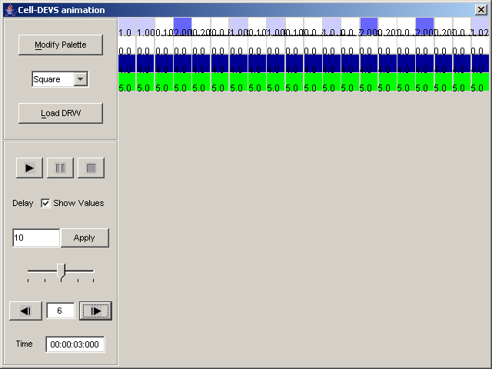

Figure 13 Car Behavior: Speed and Decreasing Speed

3.2.3 Car Behavior (2): Increasing Speed

As shown in Figure 14, at Cell# 17, there is a car with the speed of 2; from the 3rd row, we know that there are 1 free space in the intersection and/or the next lane, plus 2 two more spaces in front of this car. Based on our assumption, we know it is the time for this car to speed up. Figure 15 shows the status after it increases its speed, the time it takes is 00:00:12:500 - 00:00:10:500 = 2 seconds, which completely complies with our assumption.

3.2.4 Light Control

The 4th row is receiving the light control signals from the light controller model, so we can also observe the light control information from segment_1a animation. From Figure 12, 16, 17, 18 we can calculate G_{time} = 45 seconds, Y_{time} = 3 seconds, R_{time} = 50 second = G_{time} + Y_{time} + 2 * R_{time} = 45 + 3 + 2*1, which reflects the reality and the time definitions we made in light controller model.

Using the common sense, more traffic behaviors can be observed. We will not, and it is also impossible for us to enumerate all the situations here one by one.
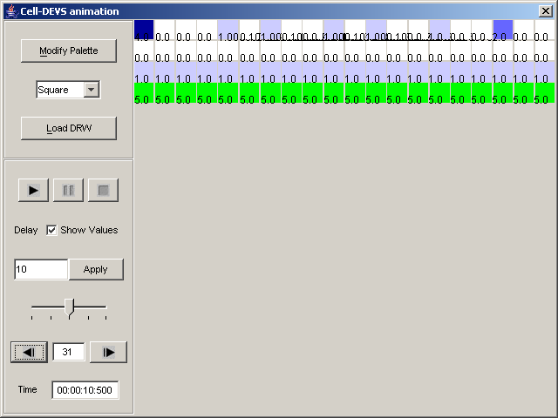Figure 14 Car Behavior: Increasing Speed (1)

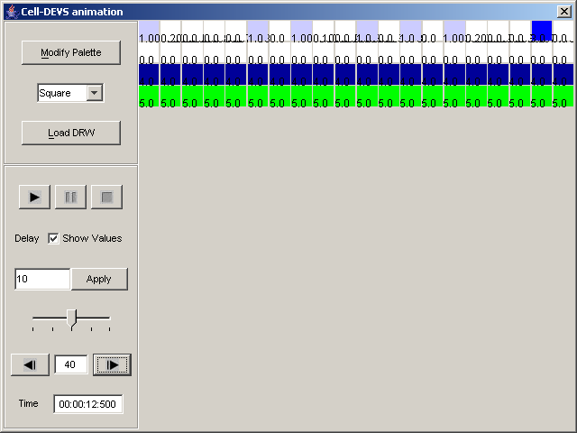
Figure 15 Car Behavior: Increasing Speed (1)

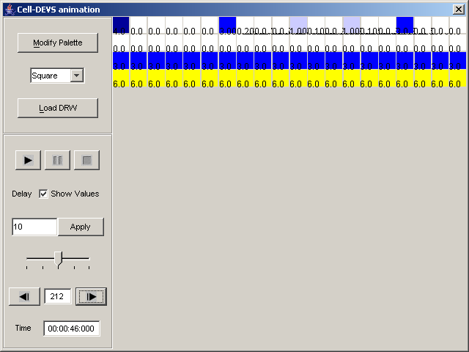
Figure 16 Turning Yellow
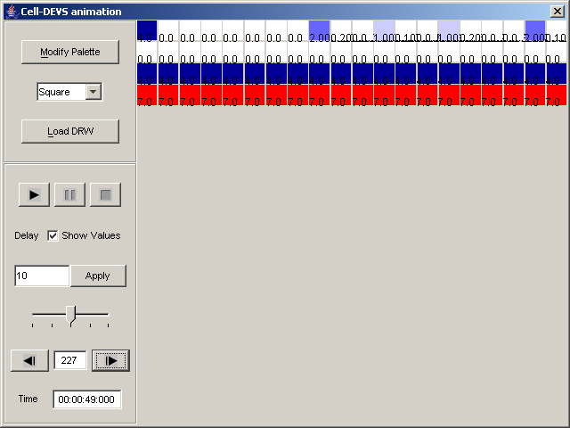
Figure 17 Yellow -> Red
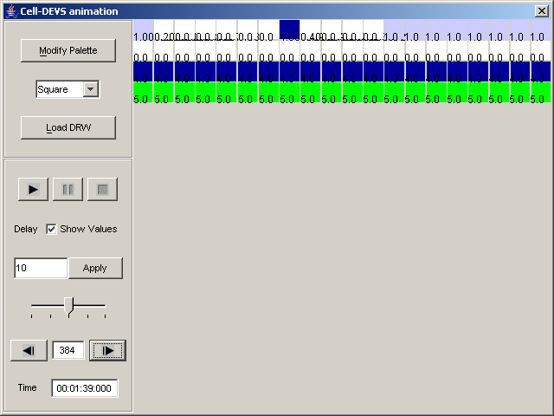
Figure 18 Red -> Green

Appendix A Macro Definitions

#BeginMacro(next_state)
trunc(fractional((0,0))*10)
#EndMacro

#BeginMacro(delay)
(round(fractional(100*(-1, 0))*100)*100)
#EndMacro

#BeginMacro(output)
trunc(fractional(10*(0, 0))*10)
#EndMacro

#BeginMacro(stop_delay)
(2500/1000000)
#EndMacro

#BeginMacro(low_delay)
(2000/1000000)
#EndMacro

#BeginMacro(middle_delay)
(1000/1000000)
#EndMacro

#BeginMacro(high_delay)
(600/1000000)
#EndMacro

#BeginMacro(rcell_1)
if(isUndefined((0,1)),if((2,0)<1,1,0),(0,1))
#EndMacro

#BeginMacro(rcell_2)
if(isUndefined((0,1)),if((2,0)<2,1,0),if(isUndefined((0,2)),if((2,0)<1,1,0),(0,2)))
#EndMacro

#BeginMacro(rcell_3)
if(isUndefined((0,1)),if((2,0)<3,1,0),if(isUndefined((0,2)),if((2,0)<2,1,0),if(isUndefined((0,3)),if((2,0)<1, 1, 0),(0,3))))
#EndMacro

#BeginMacro(move_to_next_rule)
rule : 1.0025 10 { (0,0) = 1 and (if(isUndefined((0,1)),if((2,0)<1,1,0),(0,1)))=0 }
rule : 2.0020 10 { (0,0) = 2 and (if(isUndefined((0,1)),if((2,0)<1,1,0),(0,1)))=0 }
rule : 3.0010 10 { (0,0) = 3 and (if(isUndefined((0,1)),if((2,0)<1,1,0),(0,1)))=0 }
rule : 4.0006 10 { (0,0) = 4 and (if(isUndefined((0,1)),if((2,0)<1,1,0),(0,1)))=0 }
#EndMacro

%BeginMacro(move_from_last_rule)
rule : {0.10+#macro(stop_delay)} 10 { (0,-1) = 1 and (0, 0) = 0 and trunc(#macro(rcell_1))!=0 } % 1 0 1
rule : {0.20+#macro(stop_delay)} 10 { (0,-1) = 1 and (0, 0) = 0 and trunc(#macro(rcell_1))=0 } % 1 0 0

rule : {0.10+#macro(low_delay)} 10 { (0,-1) = 2 and (0, 0) = 0 and trunc(#macro(rcell_1))!=0} % 2 0 1
rule : {0.20+#macro(low_delay)} 10 { (0,-1) = 2 and (0, 0) = 0 and trunc(#macro(rcell_2))!=0 } % 2 0 0 1
rule : {0.30+#macro(low_delay)} 10 { (0,-1) = 2 and (0, 0) = 0 and trunc(#macro(rcell_2))=0 } % 2 0 0 0

rule : {0.20+#macro(middle_delay)} 10 { (0,-1) = 3 and (0, 0) = 0 and trunc(#macro(rcell_1))!=0 } % 3 0 1
rule : {0.20+#macro(middle_delay)} 10 { (0,-1) = 3 and (0, 0) = 0 and trunc(#macro(rcell_2))!=0 } % 3 0 0 1
rule : {0.30+#macro(middle_delay)} 10 { (0,-1) = 3 and (0, 0) = 0 and trunc(#macro(rcell_3))!=0 } % 3 0 0 0 1
rule : {0.40+#macro(middle_delay)} 10 { (0,-1) = 3 and (0, 0) = 0 and trunc(#macro(rcell_3))=0 } % 3 0 0 0 0

rule : {0.30+#macro(high_delay)} 10 { (0,-1) = 4 and (0, 0) = 0 and trunc(#macro(rcell_1))!=0 } % 4 0 1
rule : {0.30+#macro(high_delay)} 10 { (0,-1) = 4 and (0, 0) = 0 and trunc(#macro(rcell_2))!=0 } % 4 0 0 1
rule : {0.30+#macro(high_delay)} 10 { (0,-1) = 4 and (0, 0) = 0 and trunc(#macro(rcell_3))!=0 } % 4 0 0 0 1
rule : {0.40+#macro(high_delay)} 10 { (0,-1) = 4 and (0, 0) = 0 and trunc(#macro(rcell_3))=0 } % 4 0 0 0 0
%EndMacro

This macro should be run when the state of current light signal, timing
and blocking conditions are not within consideration.
a) Move out current car to next cell.
b) Move car into this cell from previous cell with different speed.
stop(1), low(2), middle(3) and high(4) speed.
c) for all other cases, no state change.

This Macro is obsoleted
%BeginMacro(normal_traffic_rule)

rule : {(0,0)} 3000 { (0,0)=1 and (0, 1)=1 }

rule : 1.003 10 { (0, 0) = 1 and (0, 1) = 0 }
rule : 2.002 10 { (0, 0) = 2 and (0, 1) = 0 }
rule : 3.001 10 { (0, 0) = 3 and (0, 1) = 0 }
rule : 4.0005 10 { (0, 0) = 4 and (0, 1) = 0 }

rule : 0.103 10 { (0,-1) = 1 and (0, 0) = 0 and trunc((0, 1))=1 }
rule : 0.203 10 { (0,-1) = 1 and (0, 0) = 0 and trunc((0, 1))!=1 }

rule : 0.102 10 { (0,-1) = 2 and (0, 0) = 0 and trunc((0, 1))=1 }
rule : 0.202 10 { (0,-1) = 2 and (0, 0) = 0 and trunc((0, 1))=2 }
rule : 0.302 10 { (0,-1) = 2 and (0, 0) = 0 and trunc((0, 1))!=0 }
rule : 0.202 10 { (0,-1) = 2 and (0, 0) = 0 and trunc((0,2))=1 }
rule : 0.302 10 { (0,-1) = 2 and (0, 0) = 0 and trunc((0,2))!=1 }

rule : 0.201 10 { (0,-1) = 3 and (0, 0) = 0 and trunc((0, 1))!=0 }
rule : 0.201 10 { (0,-1) = 3 and (0, 0) = 0 and (trunc((0,2))=1 or trunc((0,2))=2) }
rule : 0.301 10 { (0,-1) = 3 and (0, 0) = 0 and trunc((0,2))!=0 }
rule : 0.301 10 { (0,-1) = 3 and (0, 0) = 0 and trunc((0,3))=1 }
rule : 0.401 10 { (0,-1) = 3 and (0, 0) = 0 and trunc((0,3))!=1 }

rule : 0.3005 10 { (0,-1) = 4 and (0, 0) = 0 and (trunc((0, 1))!=0 or trunc((0,2))!=0) }
rule : 0.4005 10 { (0,-1) = 4 and (0, 0) = 0 and trunc((0,3))=4 }
rule : 0.3005 10 { (0,-1) = 4 and (0, 0) = 0 and trunc((0,3))!=0 }
rule : 0.4005 10 { (0,-1) = 4 and (0, 0) = 0 and trunc((0,3))=0 }

rule : {(0,0)} 1000 { t }

%EndMacro

Check whether I'm waiting for timeout notification from time plane.
if so, do onthing before current timing reached. otherwise, when
timeout happened in time plane, change my state to final state.

#BeginMacro(traffic_timing_rule)
rule : {(0,0)} 3000 { fractional((0,0))!=0 and (1,0)=0 }
rule : { trunc(fractional((0,0))*10) } 0 { fractional((0,0))!=0 and (1,0)!=0 }
#EndMacro

