|  |
| --- |
| CARLETON UNIVERSITY |
| Evacuation for a building with multiple levels |
| SYSC 5104 |
|  |
| **MICHAEL VAN SCHYNDEL B.ENG 100736354** |
| **12/21/2011** |

|  |
| --- |
| The following report is for a modified version of the ship evacuation model. It explores the necessity for advanced planning of the emergency exits in buildings and how such planning can affect the overall evacuation time sand thus the safety of the building. As well as how to determine the maximum occupancy of a building using simulation software. |

Table of Contents

List of Figures 2

List of Equations 3

List of Tables 3

Introduction 4

Background 4

Model 4

Conceptual Model 4

Determining the Path 4

The Evacuation 6

Formal Specifications 7

Neighbourhood 7

Cell States 8

Implementation of Rules 9

Simulation Results 12

First Building (*building1.ma and building1LOG.log*) 12

Second Building (*building2.ma and building2LOG.log*) 13

Third Building (*building3.ma and building3LOG.log*) 14

Fourth Building (*building4.ma and building4LOG.log*) 16

Conclusions 18

Future Considerations 18

Works Cited 19

# List of Figures

Figure 1 First Iteration of Pathway 4

Figure 2 Second Iteration 4

Figure 3 Pathway Execution (Wave) 5

Figure 4 Movements 6

Figure 5 Neighbourhood 7

Figure 6 Example of Staircase movement 8

Figure 7 Building One at t = 00:00:00:000 11

Figure 8 Building One at t = 00:00:00:500 11

Figure 9 Building One at t = 00:00:03:000 11

Figure 10 Building One at t = 00:00:08:300 12

Figure 11 Second Building at t=00:00:00:000 12

Figure 12 Second Building at t=00:00:01:000 12

Figure 13 Second Building at t=00:00:22:000 13

Figure 14 Second Building at t=00:00:56:000 13

Figure 15 Modified Building and Unmodified at t=00:00:00:000 14

Figure 16 Modified Building and Unmodified at t=00:00:25:000 14

Figure 17 Modified Building and Unmodified at t=00:00:57:500 15

Figure 18 Fourth Building at t=00:00:00:000 16

Figure 19 Fourth Building at t=00:00:05:000 16

Figure 20 Fourth Building at t=00:00:10:000 16

Figure 21 Fourth Building at t=00:00:15:000 16

Figure 22 Fourth Building at t=00:00:20:500 16

# List of Equations

Equation 1 Pathway Rules 9

Equation 2 Alternative Saturation Rules 9

Equation 3 Pathway Rules for Non-Main Floors 9

Equation 4 Movement of People into a Empty Cell 10

Equation 5 Movement of People into a Stairwell or Exit 10

Equation 6 Emptying cells after successful movement 10

Equation 7 Stairwell Rules 10

# List of Tables

Table 1 Cell States 7

Table 2 Pathway Rules 9

# Introduction

An important step to designing any building is determining the necessary constraints in case of emergencies and natural disasters; earthquake, flood, high winds, bomb threat or fire. The architect or designer must take these into consideration for the overall design. The building must be reinforced in certain locations to prevent collapse during an earthquake, or the building must have sufficient emergency exits to ensure that the building can be evacuated rapidly. This is where simulations are helpful. By first creating a virtual version of the building it is possible to test many different scenarios before construction begins to ensure that it is as safe as it can be, and if problems to arise they can be easily fixed instead of trying to make changes after construction has begun.

For this project we will be examining the evacuation of buildings. Knowing how people evacuate from the building is an important piece of information. For example, it is important to know how many exits a building should have and where would be the optimal location for them. This can be determined using simulations. Similarly, simulations can be used to test an existing building to determine how long it would take to evacuate. This information would then determine the maximum occupancy for the building.

There have been many evacuation models that have been implemented using CellDEVs, however, in each case they have only been implemented on a single floor. While they provide useful information it is not necessarily practical since most buildings contain multiple floors. Therefore the model put forth for in this report will be a modified version of the evacuation model *Ship Evacuation* (Al-Zoubi, 2003) and will implement the same strategies for a building with multiple floors. Several different building types will be examined in this report as well as their efficiencies.

# Background

# Model

As previously stated the basis of this model is from the *Ship Evacuation* model presented by , however since several changes have been made this report will cover both old and new material.

## Conceptual Model

The model can be broken into two main sections. In the first step the model determines pathways that evacuees would take to get to the exit and the placement of people randomly throughout the building. The second part of the model is the actual evacuation of the people.

### Determining the Path

The pathway to the exit is determined by beginning at the exit and determining which direction of movement the person would have to take to get through the exit, see figure 1. The next iteration would then examine one cell space further from the exit and determine which direction of movement would take it to the cell that was already examined, see figure 2. This repeats itself till all the cells have information stored in them about which direction a person would travel. The calculations or determinations are theoretically executed instantaneously, i.e. they do not take up time, however if upon closer examination they are in fact calculated in an expanding wave from each exit, see figure 3.

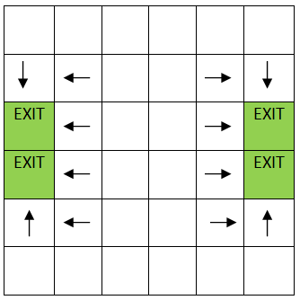

Figure First Iteration of Pathway

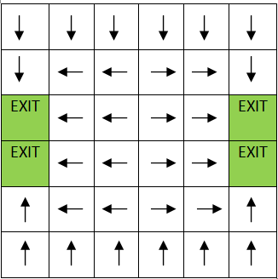

Figure Second Iteration

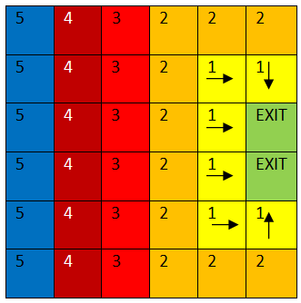

Figure Pathway Execution (Wave)

It is also during this process that people are distributed randomly throughout the building. There density for this report is set at 50% saturation however this can be changed depending on the requirements for the model.

### The Evacuation

Once the pathways have been determined the actual model begins. A person moves through the building one cell at a time and based on the direction that is stored in their current cell, see figure 4.

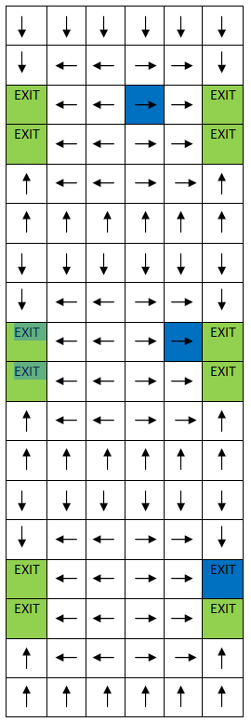

Figure Movements

If the cell that they are instructed to occupy next is full then the person waits in their current cell till it is empty. A person can only move in the 4 Cartesian direction; up, down, left and right.

Up till this point the model has remained similar to that presented by . However, since this model is run for multiple floors there are several changes that had to be made. Depending on their floor the people will move to either a direct exit out of the building or a staircase down to the next floor. Upon reaching the next floor the people exit the staircase and head to the nearest exit or the next set of stairs down.

## Formal Specifications

### Neighbourhood

The neighbourhood is defined as 3 by 3 grid with four additional cells at; (-2,0,0), (0,2,0), (0,0,1) and (0,0,-1), as seen in figure 5.

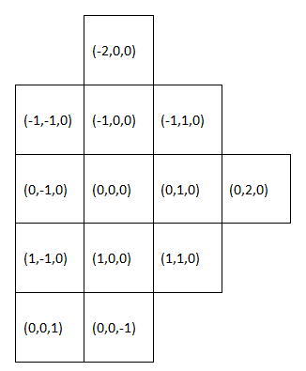

Figure Neighbourhood

Even though people can only move in 4 directions the other neighbours are necessary to avoid *collisions* and to create the proper pathways. The two neighbours that are on different planes are for moving people between floors

*Note: A collision is when two people attempt to enter the same cell, without specifically coding to avoid this one of the cells will disappear or "die"*

### Cell States

The values which appear in the cell are defined in table 1:

Table Cell States

|  |  |  |  |  |  |
| --- | --- | --- | --- | --- | --- |
| Cell State | Cell Color | State Name | Cell State | Cell Color | State Name |
| 1 |  | Wall | 8 |  | Up Occupied |
| 2 |  | Exit | 9 |  | Left |
| 3 |  | Down | 10 |  | Left Occupied |
| 4 |  | Down Occupied | 11 |  | Top of Stairs |
| 5 |  | Right | 12 |  | Top Occupied |
| 6 |  | Right Occupied | 13 |  | Bottom of Stairs |
| 7 |  | Up | 14 |  | Bottom Occupied |

The pathways are defined by the odd numbers between 3 and 10. If the number is an even between 3 and 10 then that cell is occupied by a person and their next move is equal to the cell value minus 1, i.e. a cell with the value of 10 means that the cell is occupied and the person will move to the cell to its left at the next available moment.

The three states appearing as green are transition ways. A 2 represents the exit out of the building. Once a person enters a cell with that value they disappear from the simulation and are thought of as having left the building. The other two green states, 11 and 13, represent staircases, 11 being the top of a staircase and 13 being the bottom. A stair case can only hold two people, one at the top and one at the bottom and when occupied are seen as blue and represented by either 12 or 14 respectively. If both then top and bottom of the stairwell are occupied then no one else can enter until an opening appears. A person enters the stairwell when the pathway tells it to and it has the value of 11, or unoccupied. The descend to the next floor, or the bottom of the stairwell when the cell directly beneath them in the plane below has a value of 13. To exit the stairwell a neighbouring cell must have an odd value between 3-10, representing an empty pathway. See figure 6.

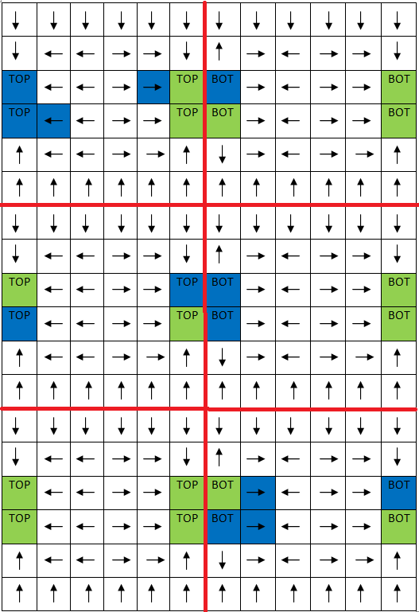

Figure Example of Staircase movement

### Implementation of Rules

The following are the definitions for the rules in the order that they appear in the code.

#### General Parameters

The dimensions change for each building and thus need to be adjusted depending on which building is being modeled. For this report four building models will be examined and there dimensions are:

First Building (*Evacuation1.ma*) <- dim(10,10,3)

Second and Third Building (*Evacuation2,3.ma*) <- dim(20,15,4)

Fourth Building (*Evacuation4.ma*) <- dim(20,20,5)

The initial cell values are *buildings.val* one through four and correspond to the respective *.ma* files.

The local transition function is *evacuation-rule*.

#### Pathway Definitions and Adding People

The first four rules, seen in equation 1, are used to define the pathways at the beginning of the simulation. When executed it could have one of eight results depending on chance and the cells location relative to the exit or stairwell. These results are shown in table 2.

Equation Pathway Rules

*rule : {3 + randInt(1)} 0 { (0,0,0) = 0 and (1,0,0) > 1 and (1,0,0) < 10}*

*rule : {5 + randInt(1)} 0 { (0,0,0) = 0 and (0,1,0) > 1 and (0,1,0) < 10}*

*rule : {7 + randInt(1)} 0 { (0,0,0) = 0 and (-1,0,0) > 1 and (-1,0,0) < 10}*

*rule : {9 + randInt(1)} 0 { (0,0,0) = 0 and (0,-1,0) > 1 and (0,-1,0) < 10}*

Table Pathway Rules

|  |  |
| --- | --- |
| Result | Comments |
| 3 | The nearest way to the exit is down |
| 4 | The nearest way to the exit is down and it is occupied by a person |
| 5 | The nearest way to the exit is right |
| 6 | The nearest way to the exit is right and it is occupied by a person |
| 7 | The nearest way to the exit is up |
| 8 | The nearest way to the exit is up and it is occupied by a person |
| 9 | The nearest way to the exit is left |
| 10 | The nearest way to the exit is left and it is occupied by a person |

As previously stated for this report the saturation of people was set to 50%, and therefore *randInt* was used to determine whether or not a person appears. If a saturation other than 50% was required the code would look similar to equation 2. (This appears in the fourth building model)

Equation Alternative Saturation Rules

*rule: { if (uniform(0,1) < 0.25), 4, 3) } 0 { (0,0,0) = 0 and (1,0,0) > 1 and (1,0,0) < 10}*

The second set of four rules are similar to the first set, however they are used for floors with stairwells instead of exits, seen in equation 3.

Equation Pathway Rules for Non-Main Floors

*rule : {3 + randInt(1)} 0 { (0,0,0) = 0 and (1,0,0) > 10 and (1,0,0) < 13}*

*rule : {5 + randInt(1)} 0 { (0,0,0) = 0 and (0,1,0) > 10 and (0,1,0) < 13}*

*rule : {7 + randInt(1)} 0 { (0,0,0) = 0 and (-1,0,0) > 10 and (-1,0,0) < 13}*

*rule : {9 + randInt(1)} 0 { (0,0,0) = 0 and (0,-1,0) > 10 and (0,-1,0) < 13}*

#### Movement of People

The movement of people through the building is performed using three sets of four rules. the first set, equation 6, is used to move people into an empty cell, the second set, equation 5, is used to move people into the exit or a stairwell and the third set, equation 4, is used to erase a person once they have moved out of the cell.

Equation Movement of People into a Empty Cell

*rule : 4 100 { (0,0,0) = 3 and ( (0,1,0) = 10 or (-1,0,0) = 4 or (0,-1,0) = 6 or (-1,0,0) = 14 or (1,0,0) = 14 or (0,1,0) = 14 or (0,-1,0) = 14 )}*

*rule : 6 100 { (0,0,0) = 5 and ( (1,0,0) = 8 or (-1,0,0) = 4 or (0,-1,0) = 6 or (-1,0,0) = 14 or (1,0,0) = 14 or (0,1,0) = 14 or (0,-1,0) = 14 )}*

*rule : 8 100 { (0,0,0) = 7 and ( (1,0,0) = 8 or (0,1,0) = 10 or (0,-1,0) = 6 or (-1,0,0) = 14 or (1,0,0) = 14 or (0,1,0) = 14 or (0,-1,0) = 14 )}*

*rule : 10 100 { (0,0,0) = 9 and ( (1,0,0) = 8 or (0,1,0) = 10 or (-1,0,0) = 4 or (-1,0,0) = 14 or (1,0,0) = 14 or (0,1,0) = 14 or (0,-1,0) = 14 )}*

Equation Movement of People into a Stairwell or Exit

*rule : 3 100 { (0,0,0) = 4 and ((1,0,0) = 2 or (1,0,0) = 11) }*

*rule : 9 100 { (0,0,0) = 10 and ((0,-1,0) = 2 or (0,-1,0) = 11) }*

*rule : 7 100 { (0,0,0) = 8 and ((-1,0,0) = 2 or (-1,0,0) = 11) }*

*rule : 5 100 { (0,0,0) = 6 and ((0,1,0) = 2 or (0,1,0) = 11) }*

Equation Emptying cells after successful movement

*rule : 3 100 { (0,0,0) = 4 and odd((1,0,0)) }*

*rule : 9 100 { (0,0,0) = 10 and odd((0,-1,0)) and (-1,-1,0) != 4 }*

*rule : 7 100 { (0,0,0) = 8 and odd((-1,0,0)) and (-2,0,0) != 4 and (-1,1,0) != 10 }*

*rule : 5 100 { (0,0,0) = 6 and odd((0,1,0)) and (-1,1,0) != 4 and (0,2,0) != 10 and (1,1,0) != 8 }*

#### Stairwells

The next four rules are used to move people throughout the stairwells, equation 7. People move through the stairwell similarly to how they move through the building, i.e. only one person may occupy any cell at a given time and if the cell they wish to enter is occupied they wait until it becomes free.

Equation Stairwell Rules

*rule : 12 100 { (0,0,0) = 11 and ((-1,0,0) = 4 or (0,-1,0) = 6 or (1,0,0) = 8 or (0,1,0) = 10 ) }*

*rule : 11 100 { (0,0,0) = 12 and (0,0,-1) = 13 }*

*rule : 13 100 { (0,0,0) = 14 and ( (1,0,0) = 3 or (1,0,0) = 5 or (1,0,0) = 7 or (1,0,0) = 9 or (-1,0,0) = 3 or (-1,0,0) = 5 or (-1,0,0) = 7 or (-1,0,0) = 9 or (0,1,0) = 3 or (0,1,0) = 5 or (0,1,0) = 7 or (0,1,0) = 9 or (0,-1,0) = 3 or (0,-1,0) = 5 or (0,-1,0) = 7 or (0,-1,0) = 9) }*

*rule : 14 100 { (0,0,0) = 13 and (0,0,1) = 12 }*

# Simulation Results

## First Building (*building1.ma and building1LOG.log*)

The first simulation was for a ten by ten building with some stairwells placed seemingly at random throughout the building. The results of the simulation are as follows:

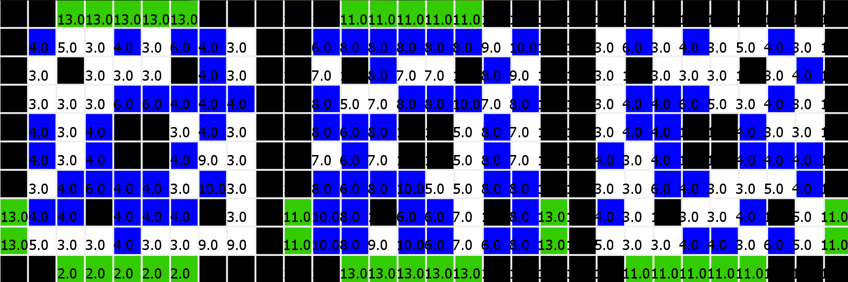

Figure Building One at t = 00:00:00:000

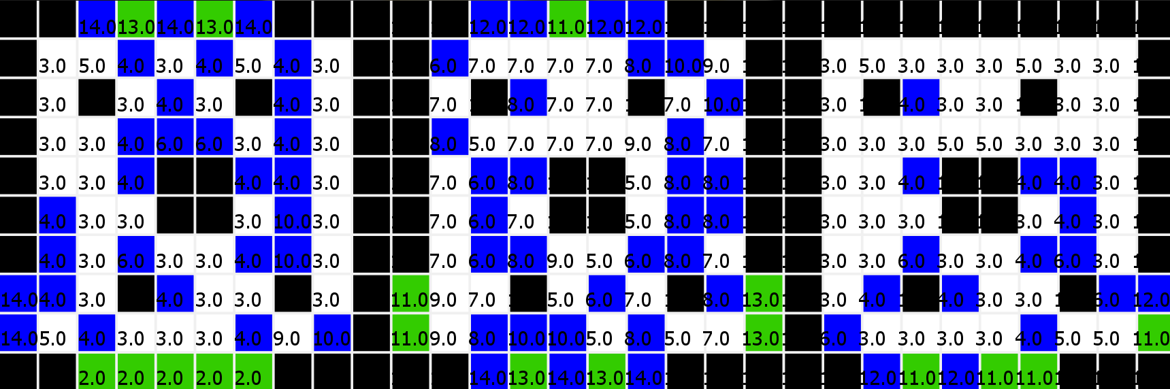

Figure Building One at t = 00:00:00:500

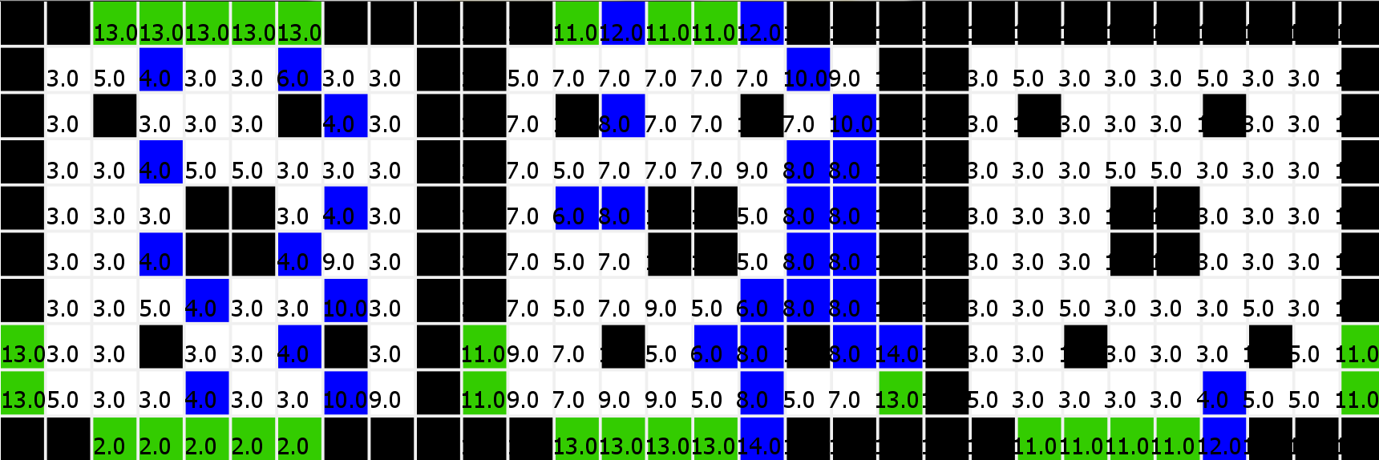

Figure Building One at t = 00:00:03:000

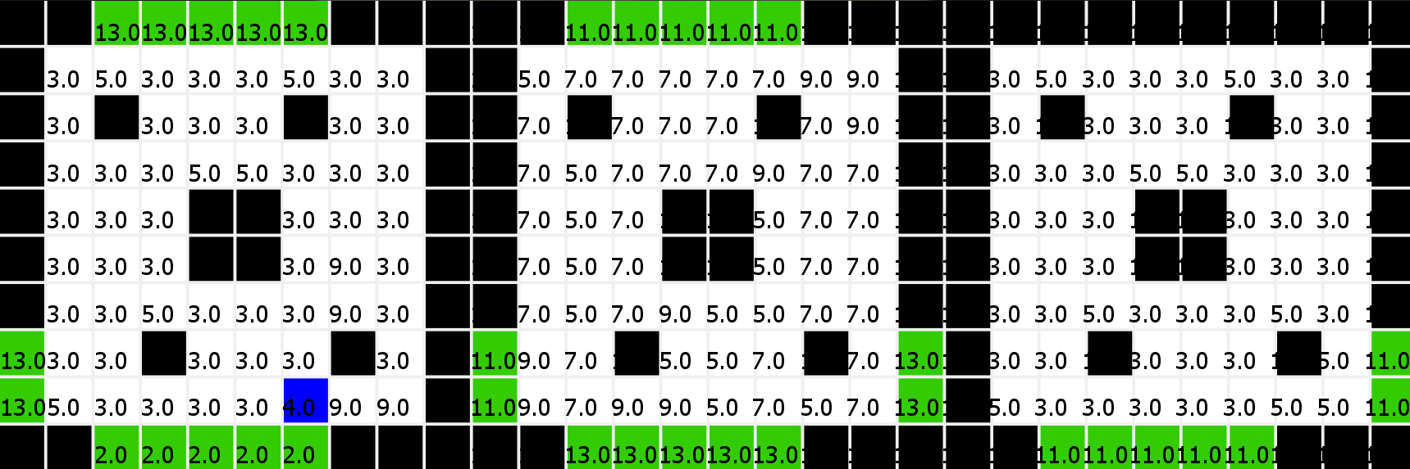

Figure Building One at t = 00:00:08:300

The simulation showed that it took 84 iterations or seconds to empty a three storey building of approximately 80 persons. As well, something to take note of and will be discussed in the conclusion, not all cells in a doorway or stairwell are actually used.

## Second Building (*building2.ma and building2LOG.log*)

The second building simulated was slightly larger than the first. As well, instead of stairwells and exits placed at random the building had only one stairwell that traversed all the floors. This more closely resembles the actual layout of a commercial building. The following figures are the simulation results:

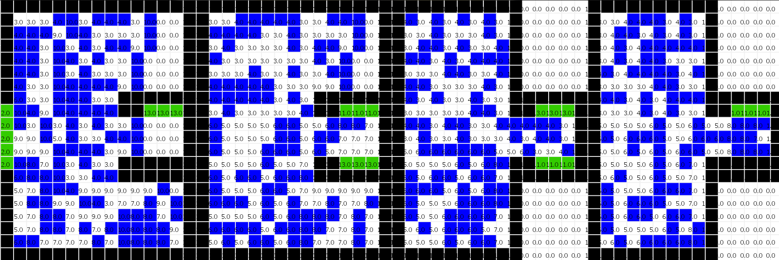

Figure Second Building at t=00:00:00:000

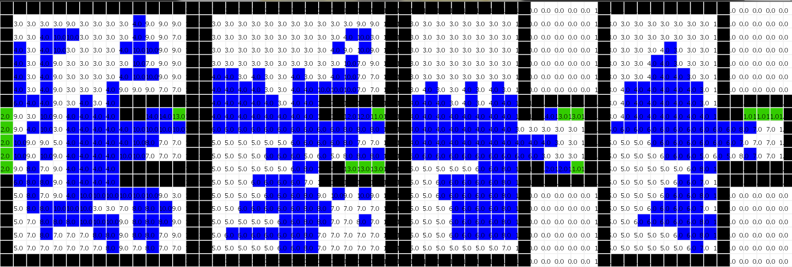

Figure Second Building at t=00:00:01:000

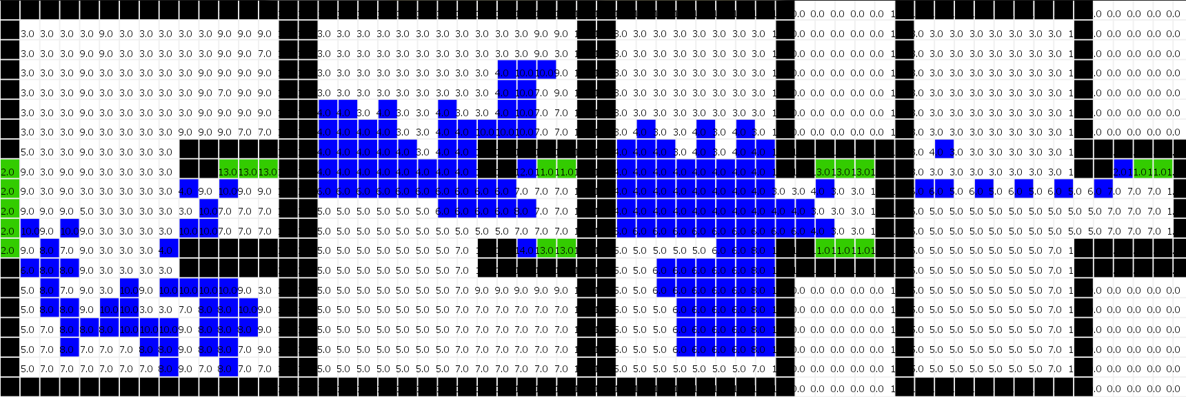

Figure Second Building at t=00:00:22:000

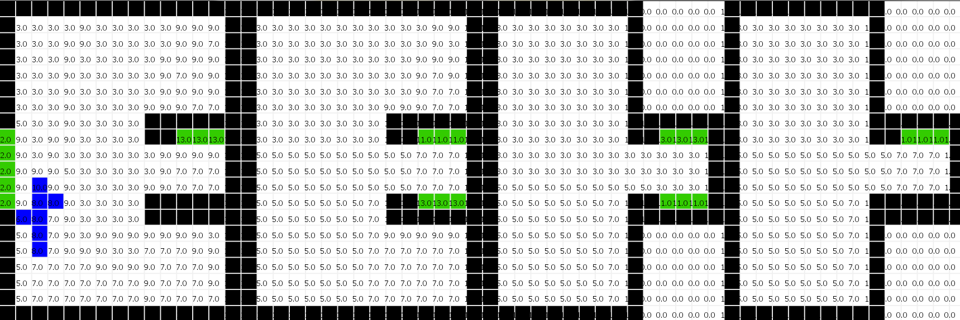

Figure Second Building at t=00:00:56:000

To completely evacuate the building it took 576 seconds. This was clearly longer than the first building, however it was also significantly larger in size and number of people. This building held close to 390 people and only had one stairwell. While the building help nearly 5 times as many people it still took approximately 7 times the length of time to evacuate, therefore more stairwells are required.

## Third Building (*building3.ma and building3LOG.log*)

The third is nearly twin to the second building with the only difference being that an additional two stairwells were added to move people from the 2nd floor to the main floor with the hopes of speeding up the evacuation time. The following results show the modified building compared to the results of the unmodified building on the bottom.

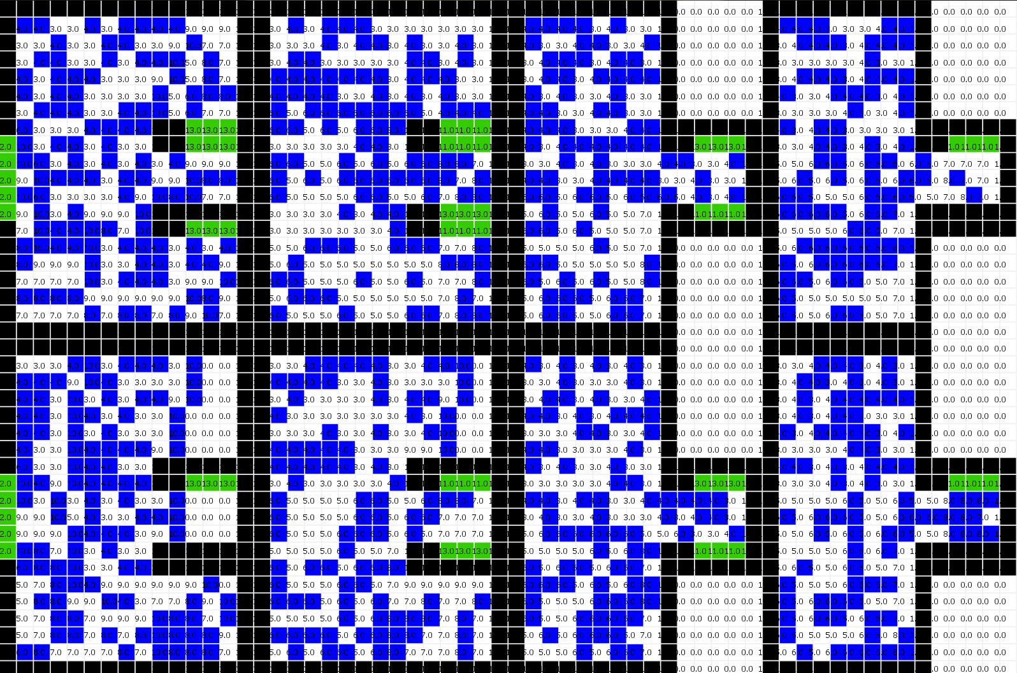

Figure Modified Building and Unmodified at t=00:00:00:000

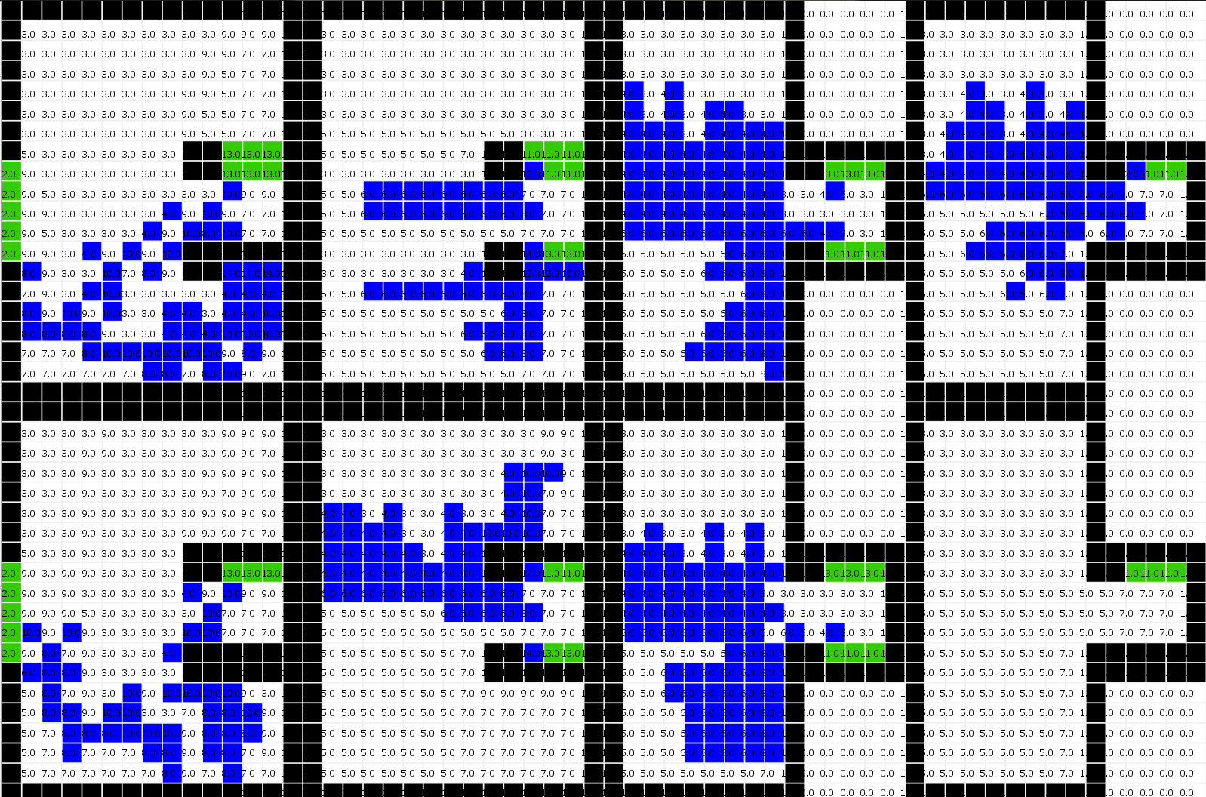

Figure Modified Building and Unmodified at t=00:00:25:000

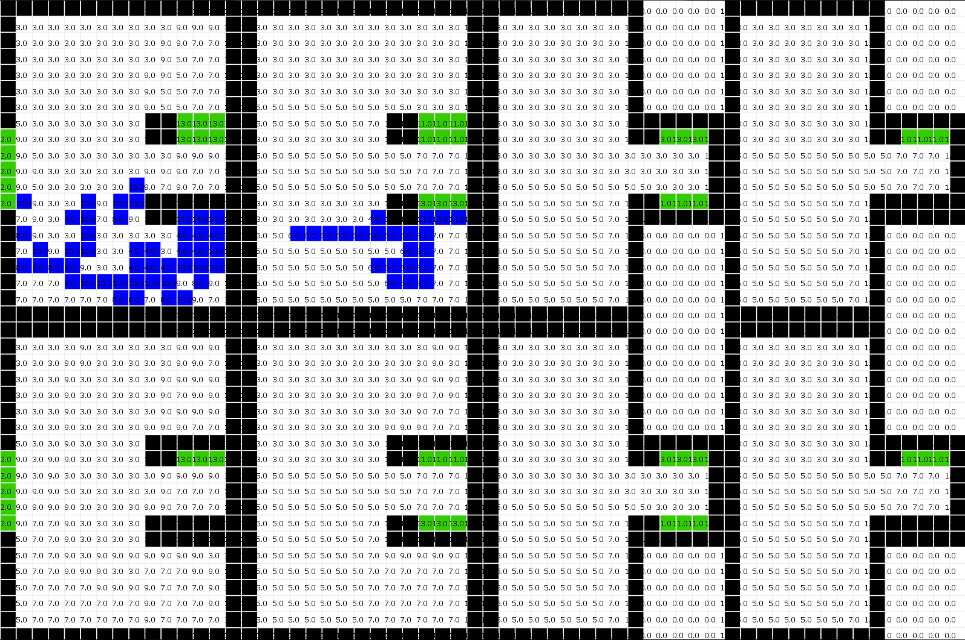

Figure Modified Building and Unmodified at t=00:00:57:500

As you can see adding extra stairwells did not actually improve the results, the exact opposite occurred. The modified building took 711 seconds to evacuate. What happened was that in both models choke points occurred at critical points because of overcrowding near the stairwells and were only relieved once the main floor opened up, i.e. most people were evacuated. At which point the building began evacuating from the top floor down. In the modified building the main floor was instantly flooded with people from the second floor and it took significantly longer for the main floor to clear out enough to reduce the pressure on the choke points. This resulted in it taking longer for a steady rhythm to occur. This goes to show that adding stairwells may not actually be the best method of decreasing the evacuation speed and that more thought has to be placed into the design to insure choke points are kept at a minimum.

## Fourth Building (*building4.ma and building4LOG.log*)

The fourth building is essentially everything done right in the simulation. The saturation is adjustable so that an optimal occupancy can be determined. The building design itself has a single strategic stairwell complex that allows for easier evacuation. The model was run at 50% saturation similar to the others to see how well it performed. The building occupancy was approximately 730 persons, 200 more than the previous building. The building also had an additional floor and was 20 cells by 20 cells for the dimensions. The results were as follows:

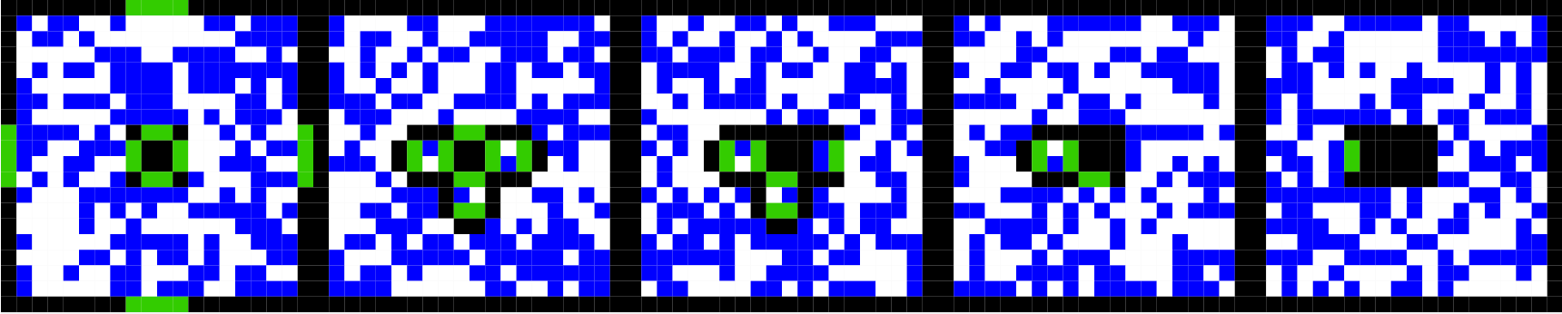

Figure Fourth Building at t=00:00:00:000

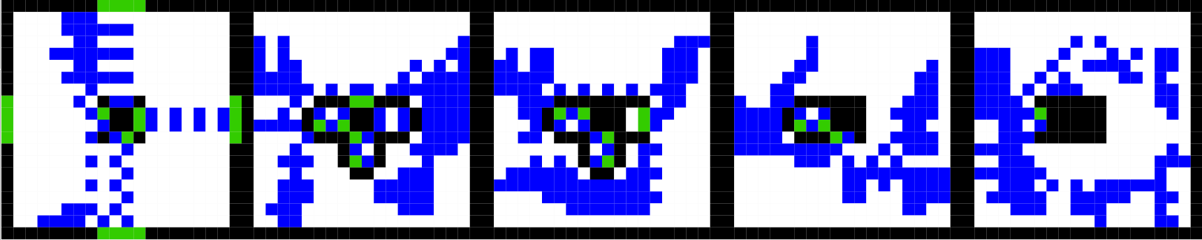

Figure Fourth Building at t=00:00:05:000

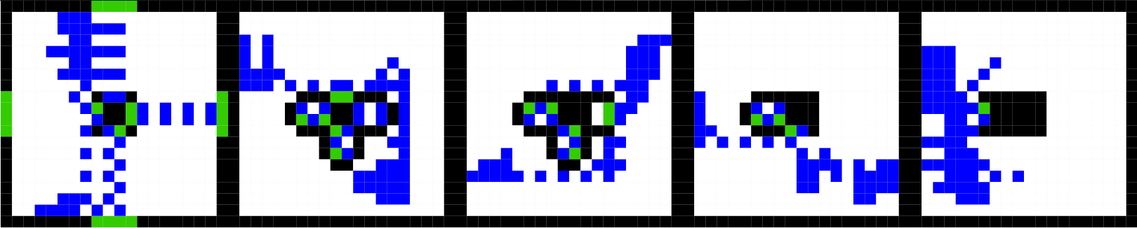

Figure Fourth Building at t=00:00:10:000

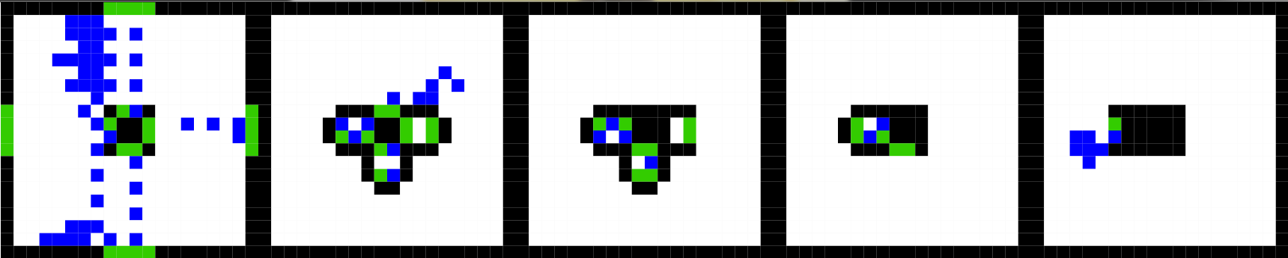

Figure Fourth Building at t=00:00:15:000

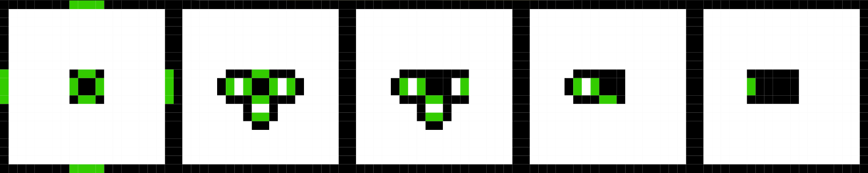

Figure Fourth Building at t=00:00:20:500

It took 205 seconds to evacuate over 700 people from this 5 story building. It evacuated more people in two and a half less time than the second building. Compared to the first building which had allot of random stairwells and only three floors it was able to evacuate over 7 times the people in only 2.5 times the amount of time.

# Conclusions

From the experimentation with the buildings presented in this report it is clear that allot of thought and planning must be placed into the number and placement of emergency exits as well as the number of people that a building can safely hold. This is clearly demonstrated by comparing the results of the first three building to the fourth. In the first building there were many stairwells leading to the exits, however most of the stairwell "space" was not being used, i.e. if the stairwell was 4 cells wide only the outer 2 cells where used. The fourth building used small stairwells of only 2 cells in diameter yet achieved superior results since they were well designed for allowing maximum flow. When comparing the second and third building to the fourth other observations are made. It was clear that the emergency exits for the second building were not sufficient for a building of its size and capacity, however when more stairwells were added, in the third building, it actually made it worse. This shows that just adding more exits is not suffice. The fourth building only had one stairwell complex, however they were arranged in such a fashion that choke points did not occur. That is to say that while there was build up around the exits there was never a moment when people were not moving down the stairs as we saw in the third building most clearly.

# Future Considerations

This project is not in its final stage, instead it is just the first of many steps. The only work left to do using CellDEVs is to introduce behaviours to the evacuating people. This has been attempted in other simulations and discussed in details in several papers and the goal is to implement some of these human characteristics to the final model.

After that, or simultaneously, this model will be rendered into a proper 3 dimensional model using an AutoDesk software, either 3dsMax or Revit.

Finally, an existing building will be converted into CellDEVs and then simulated and finally be displayed using the aforementioned software.

# Works Cited

Al-Zoubi, K. (2003). *Ship Evacuation Model.* Sysc 5807.