M.SC. Intensive Project: 2-D Finite Element examples using Cell-DEVS

Hesham Saadawi
Student# 274490
hsaadawi@scs.carleton.ca

Introduction

Problem to be solved:
We propose a way to solve physical problems in two-dimensions using a Cell-DEVS model.
These problems are usually modeled as one or more Partial Differential Equations (PDE). These systems can be either natural or man-made as engineering systems or structures.
In order get the cell updating rules in our Cell-DEVS model, we use two numerical methods for solving PDE’s, namely Finite differences and Finite Elements analysis. It should be noted however, the accuracy of Cell-DEVS solution would be the same of these previous methods as we merely use Cell-DEVS as a tool to solve systems of equations resulting from approximating the solution of PDE’s with Finite Differences and Finite elements methods.

Usually in problems solved by finite element analysis we find two major components: Field, and Potential. Examples of these are as per [2], p.8.

Field | Potential
Heat flux | Temperature
Mechanical stress | Displacement
Electric Field | Voltage
Magnetic field | Magnetic vector potential
Field velocity | Fluid potential
Table 1. Field and Potential examples.

Conceptual model description:

The example used in this project is example 10.4 at reference [1], p. 337. This is an example of steady state 2-D heat transfer in a long bar of rectangular cross section with thermal conductivity coefficient k =1.5 W/m^{2 o}C. Two opposite sides are kept at constant temperature of 180º C; One side is insulated and the other is exposed to a fluid with temperature of 25 ºC and convection heat transfer coefficient h = 50 W/m^{2 o}C. The problem is represented in Figure 1.

T = 180 ºC

T = 25 ºC
h = 50 W/m^{2 o}C
K = 1.5 W/m^{2 o}C
0.6 m

Insulated
side

T = 180 ºC

0.4 m
Figure 1: Steady-State heat transfer in a long bar.

In order to model this as a Cell-DEVS, rules of cell value update should be deduced. We have used two methods here. First we show the finite differences rules. Second, we show how to get the same rules through Finite elements method.

- Deduction of updating rules.
Heat transfer occurs when there is a temperature difference within a body or between a body and its surrounding medium. Heat flows from hot spots towards cooler ones. Heat conduction in two dimensions steady state isotropic medium is given by:

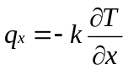 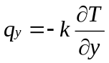 (1)

Where q is the heat flux (W/m² ), k is the thermal conductivity of the material (W/m. ºC), T = T(x,y) is the Temperature field in the medium, and 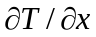 , 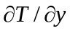 are the temperature gradients over x and y respectively. The minus sign is to indicate that the direction of heat flux is opposite to direction of increasing temperature.

In convection heat transfer, the heat flux is given by:
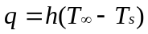 (2)
Where h (W/m².ºC) is the film coefficient is a property of the fluid around the surface, 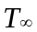 and 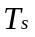 are fluid and surface temperature respectively.

For a small element assuming a linear temperature distribution along its length, the heat flux equation would be:

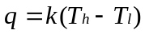
Where, T_{h}, T_{l} are the high and low temperatures of its ends respectively.

Steady Heat transfer without heat generation in the body and in two dimensions is represented by the following diffusion equation as per [3]:

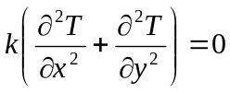

In Figure 2 , we assume a linear temperature change in x direction over a very small finite space Δx.

At A: 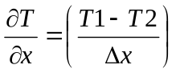

At B: 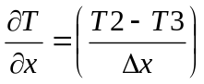
Thus at C: 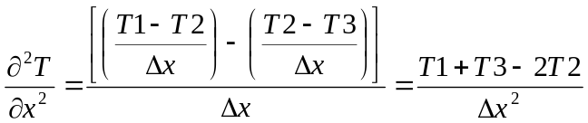

Δx
T1
T3
A
B
Δx/2
Δx/2
C

Figure 2:Heat transfer in one dimension.

The Previous partial differential Equation would be approximated when applied to the grid in Figure 3 as

0
1
4
2
3
a
a

Figure 3:Finite Differences Grid.

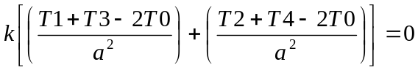

From which we obtain: T1 + T2 + T3 + T4 – 4T0 = 0

This gives us the updating rule for an internal node as node 0 in Figure 3 to be:

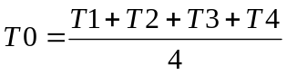

This results for a steady-state heat transfer in a homogeneous medium with constant coefficient of thermal conductivity k in all directions.

In order to get other updating rules for insulated side and convective side, we study the grids shown in Figure 4 and Figure 5 respectively.

Insulated
1
2
0
3
a
Solid

Figure 4: Insulated boundary grid.

Fluid T_{f} , h
1
2
0
3
a
Solid

Figure 5: Convective boundary grid.

We evaluate the heat balance at grid in Figure 4 for an insulated boundary:

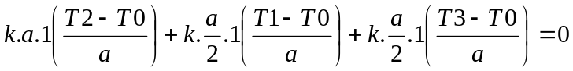
Hence: T1 + T3 + 2T2 – 4T0 = 0

Thus we get the updating rule for a node on the insulated boundary as: 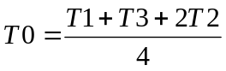

Similarly, we get the updating rule for node 0 on the convective boundary in Figure 5 as:

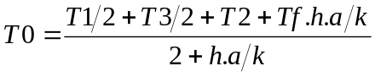

The bar is shown in Figure 6 after it has been divided in a grid of 6 X 4 rows and columns. This grid is used to model the problem in Cell-DEVS with a cell representing each node on the grid.

The model definition is at “2DHeatConduction.ma” file. Cells on constant temperature boundaries are initialized with value of 180 ºC as per “2dfem.val” file. Results of model execution are in “output” file.

(0,0)
(6,0)
(6,4)
(0,4)
Insulated boundary
(1,0)
(5,0)
(5,4)
(1,4)
Constant Temperature of 180 ºC
Constant Temperature of 180 ºC
0.1 m
0.1 m

h = 50 W/m³.ºC
T_{f} =25 ºC

Figure 6: Grid of Finite Differences.

Neighborhood definition for 2D heat transfer.
Each node on the grid, that is the intersection point of a horizontal line and a vertical line, is represented with a cell in our Cell-DEVS model. The neighborhood cells for an internal node with only conduction heat transfer is defined as the diagram shows.

X
Y
(0,1)
(1,0)
(0,-1)
(-1,0)

Figure 7. Internal Cell Nigberhood definition.

The neighborhood cells for a node on the insulated boundary is defined as

X
Y
(0,1)
(1,0)
(-1,0)

Figure 8. Insulated boundary cell neighborhood.

The neighborhood cells for a node on the convective boundary are defined as the diagram shows.

(-1,0)

(0,-1)
X

(1,0)
Y

Figure 9. Convection boundary cell nighberhood.

Execution Results
The above model have been executed giving the following results:

Constant Temperature of 180 ºC
155.3
144.1
118.7
58.7 *
158.5
143.3
138.5
122.6
92
42.1 *
138
132.6
115.6
84.8
39.4 *
143.3
138.5
122.6
92
42.1
158.5
155.3
144.1
118.7
58.7
Constant Temperature of 180 ºC

Figure 10. Simulation results for 7 X 5 nodes grid using Finite Differences.

The same example has been solved using Finite Elements Method with following results.

6-Element solution.

Constant Temperature of 180 ºC
Constant Temperature of 180 ºC
45.4
124.5
34
45.4

Figure 11. Simulation Results for a mesh of 6 Triangular Finite elements.

192 Finite Elements
Using the sample program provided in [1], the same example was simulated with more finite elements to capture the steep temperature gradient over the convective side. Figure 12 shows the mesh structure of the plate under study. Every triangular element has three nodes at its corners as shown. The result of this simulation is shown in Table 2 for half of the plate, as it is symmetric around the middle horizontal line. In this table, every cell contains the corresponding node temperature from Figure 12. Number of triangles in Figure 12 is 96 triangular elements, each with three nodes thus Figure 12 contains 63 nodes.

Constant Temperature of 180 ºC
Constant Temerature of 180 ºC

Figure 12. Material plate divided to 96 Triangular Finite Elements.

180 | 180 | 180 | 180 | 180 | 180 | 180 | 180 | 180
169 | 168.6 | 167.3 | 164.8 | 160.8 | 154.3 | 143.7 | 11 | 68.1
158.9 | 158 | 155.6 | 151.2 | 144 | 132.5 | 122 | 94.9 | 52 *
150.3 | 149.3 | 146 | 140.3 | 131.6 | 119.2 | 103.2 | 79 | 45.1
143.9 | 142.6 | 138.9 | 132.4 | 122.7 | 109.6 | 92.9 | 72.5 | 37.3 *
139.9 | 138.5 | 134.5 | 127.6 | 117.4 | 103.7 | 86 | 63.3 | 42.6
138.5 | 137.1 | 133 | 126 | 115.7 | 101.8 | 84.1 | 62.6 | 39.6 *
Table 2. Tabular form of simulation results for mesh in Figure 12.

The comparison between results in Figure 10 and those in Table 2 can be done through matching the corresponding nodes temperature values. Some values on the convective side were marked with an asterisk (*) to show correspondence between those nodes in grid of Figure 10 and the mesh in Figure 12. This side has the steepest gradient of temperatures, so we ran another simulation with Cell-DEVS with 13 X 9 finite differences. The results of this simulation are shown in Table 3. Same corresponding nodes are marked with (*) for comparison with results in Table 2.
The difference in values on the convection side comes from the fact that we use constant temperature triangles (would be described later), which are a rough estimate for the varying field. These elements are good for slow varying filed over the material. Other types of elements can capture the steep variation more precisely.

180 | 180 | 180 | 180 | 180 | 180 | 180 | 180 | 180
169 | 168.6 | 167.3 | 165 | 161.1 | 154.9 | 144.1 | 123.5 | 76.9
158.9 | 158.1 | 155.7 | 151.4 | 144.6 | 134.1 | 118.2 | 93.0 | 53.4*
150.3 | 149.3 | 146.0 | 140.3 | 131.6 | 119 | 101.4 | 77.1 | 45.4
143.8 | 142.6 | 138.8 | 132.3 | 122.5 | 109.0 | 91.2 | 68.6 | 41.7*
139.8 | 138.5 | 134.4 | 127.4 | 117.2 | 103.4 | 85.7 | 64.3 | 40
138.5 | 137.1 | 132.9 | 125.8 | 115.4 | 101.5 | 84 | 63 | 39.5*
139.8 | 138.5 | 134.4 | 127.4 | 117.2 | 103.4 | 85.7 | 64.3 | 40
143.8 | 142.6 | 138.8 | 132.3 | 122.5 | 109.0 | 91.2 | 68.6 | 41.7
150.3 | 149.3 | 146.0 | 140.3 | 131.6 | 119 | 101.4 | 77.1 | 45.4
158.9 | 158.1 | 155.7 | 151.4 | 144.6 | 134.1 | 118.2 | 93.0 | 53.4
169 | 168.6 | 167.3 | 165 | 161.1 | 154.9 | 144.1 | 123.5 | 76.9
180 | 180 | 180 | 180 | 180 | 180 | 180 | 180 | 180
Table 3. Simulation Results for 96 cells, 117 nodes finite differences.

Deducing Updating Rules from a Finite Element meshing scheme.

Background about 2D FEM.

In our study of 2-dimensional problems using FEM, we used the following triangular element.

Y
X
(x1,y1)
(x2,y2)
(x3,y3)
P

Figure 13. Triangular Element.

The element in Figure 13 has three nodes each at a vertex of the triangle; each would contain a value for the field under study, for example temperature values. Any internal point in the element as P can be evaluated as a function of the three nodes values. The simplest triangular element would assume a linear function over the element for the field under study. That is:

Tp = N₁T1 + N₂T2 + N₃T3

Where N1, N2, N3 are linear shape functions, hence comes the name Constant Strain Triangular as this type of element was historically used to analyze body strain problems.

With further algebraic manipulations, we can get temperature gradient inside the element as

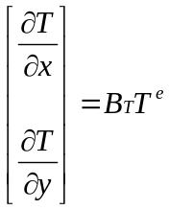

Where:

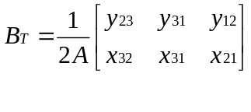 and 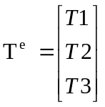, y₂₃ = y₂ – y₃, x₃₂ = x₂ – x₃, …., and A is the area of the triangular element.

The final steady state equations for the element can be represented in a matrix format as follow:

K T = R

Where K is the stiffness matrix (we use the notation of underline to denote a Matrix), which contains the thermal coefficients of the element, T is the node temperatures vector, R is the heat Rate vector at each node. For detailed manipulations, please refer to [1] and [4].

K = kA_{e}B^{T} B for a single element, where k is the material thermal conductivity coefficient.

Global stiffness matrix K_{G} for a mesh of multiple elements would be constructed from elemental K with a simple summation procedure as described in [1].

The final matrix K for a single element would be:

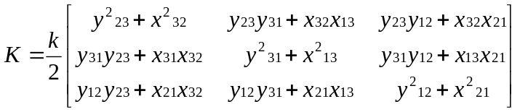
Therefore for a triangular element we have:

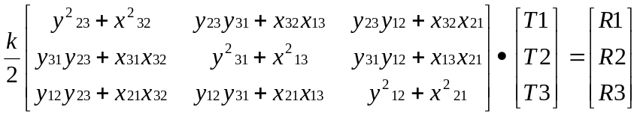

Where T1, T2, T3 are node temperatures, and R1, R2, R3 are initial heat rate values applied at the three nodes. In order to get the updating rules for the Cell-DEVS, we construct a mesh of elements to represent a recurring pattern inside the structure under study. The mesh is shown in Figure 14.

Y
X
0
3
4
5
6
1
2
E4
E1
E2
E3
E5
E6
a
a

Figure 14. Internal mesh of triangular elements.

In Figure 14, we study the mesh composed of six elements marked as E1, E2,..,E6. Those elements has their nodes numbered as shown from zero to six. The middle node 0 is shared among all the elements, thus its value would be a function in al other elements. By studying this structure of elements, we would be able to deduce the updating rules for node 0, which would then repeat again for all similar internal nodes.

Each element has three nodes which are numbered locally and those nodes are referred by the global numbers as in Figure 14. the following table shows the relation between each elemnt local nodes and the global node numbers. The global nodes are in the teble cells.

Local nodes | 1 | 2 | 3
Element 1 | 5 | 0 | 4
Element 2 | 0 | 5 | 6
Element 3 | 6 | 1 | 0
Element 4 | 2 | 0 | 1
Element 5 | 0 | 2 | 3
Element 6 | 3 | 4 | 0
Table 4. Mapping of local nodes to global nodes.

Table 4 can be read as for element 1, its first local node corresponds to the global numbered node in Figure 14 as node 5, its second local node is node 0, third local node corresponds to node 4. The local nodes for an element are usually numbered in a counterclockwise to avoid negative area when applying the above matrix calculations.

Taking Table 4 in mind and with the previous mesh in Figure 14, we get:

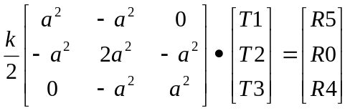 Element 1
Where first row corresponds to local node 1 which is globally numbered as 5 (look into Table 4), second row corresponds to global node 0, and third row corresponds to global node 4.

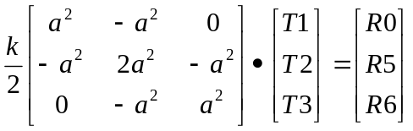 Element 2
Where first row corresponds to local node 1 which is globally numbered as 0 (look into Table 4), second row corresponds to global node 5, and third row corresponds to global node 6.
We then find the matrix equations for all other element similar to those above due to symmetry of shape and numbering scheme for local nodes. The only difference would be the correspondence between rows of the matrix equation and different global nodes.

By taking the summation of heat rate at node 0, we get:

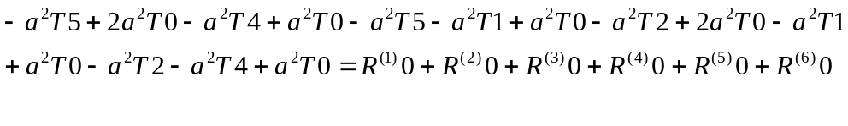 (1)
Where 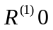 is the heat rate into node 0 from element 1. In a steady state, all input heat rate at any node would equal the output from that node, i.e. 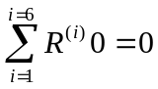, hence equation (1) would be solved to give:

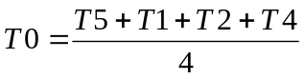

In which resembles the result we obtained using the finite differences method for an internal node during a heat transferred by conduction in a material. To get the updating rules for boundary conditions, we would need to construct the mesh in the same way at the insulated and convective boundaries. The mesh would then be studied in the same previous method.

The previous rule could be obtained in more direct way by constructing the global matrix equations
KT=R for the whold mesh of the 6 elements using the usual FEM technique to add elemnt matrices. The global matrix K would be 7 X 7 with a row that corresponds to each global node. The row that coresponds to node 0 would then be multiplied bt the Temperature vector T and equated to zero as we are in a steady-state. This should give equation (1).

Please note that the previous element used for heat transfer models would have only on degree of freedom DOF per node. That is the temperature. Hence, it is sufficient to represent each node of the triangular element with one cell in the Cells-DEVS model. The following example of solid mechancics however, would has two DOF for each node. These are the strain in X and Y directions. In this case, two cells would be needed in the Cells-DEVS model to capture the two variables of a node.

A solid Mechanics Example

Y
X
1
3
6
7
5
2
4
E4
E1
E2
E3
E5
E6
a
a

Figure 15. Mesh of Constant Strain Triangular Elements.

Y
(x1,y1)
(x2,y2)
(x3,y3)
P
u_{x1}
u_{y1}
u_{x2}
u_{y2}
u_{x3}
u_{y3}

Figure 16. Constant Strain Triangular Element.

In the element shown in Figure 16, we assume a constant strain through the element. Each node has two DOF, thus it has a strain component in X direction u_{x} and another in Y direction u_{y} as shown. All loads that may act on the element are assumed to be concentrated at the nodes.

The mesh of elements shown in Figure 15 represents a sub-structure that we need to examine in order to get the updating rules for the Cell-DEVS model. We start as done previously to construct the force-strain relation for each element. Then, the shared node numbered 1 in the figure, would have 6 forces on it in X direction as one force is applied from each element. Due to equilibrium, the resultant force in X direction should be zero. This would give us the equation we need to relate the strain values in X direction between node 1 and other nodes. The same procedure would be repeated for the strain of node 1 in Y direction.

From [4], we have the following relation between stress-displacement and force on an element in a matrix form:

K . D = F (1)
Where K is the 6 X 6 stiffness matrix for the element, D is the 6 X 1 displacement vector for nodal displacements as shown in Figure 16, and F is 6 X 1 vector for forces acting on each node in X and Y directions.

From [4], K = tAB^{T}EB ,
Where: t is element thickness; A is area of the element,

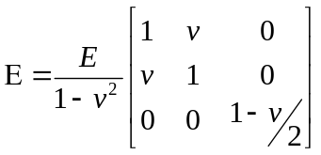 In addition, E is Young’s modulus.

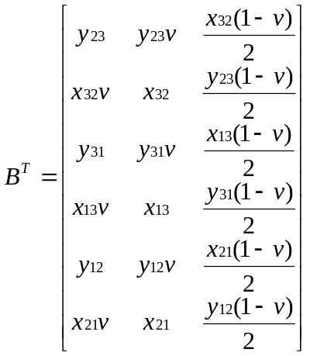

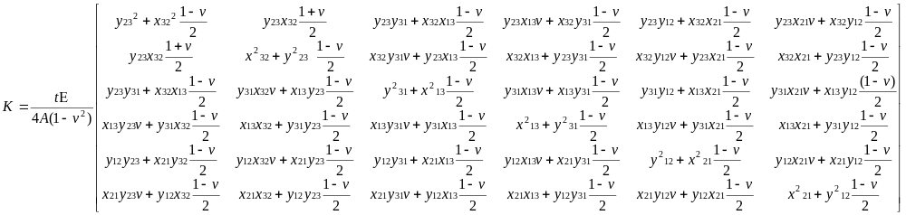

Therefore, the stiffness matrix for each element of Figure 15 would be:
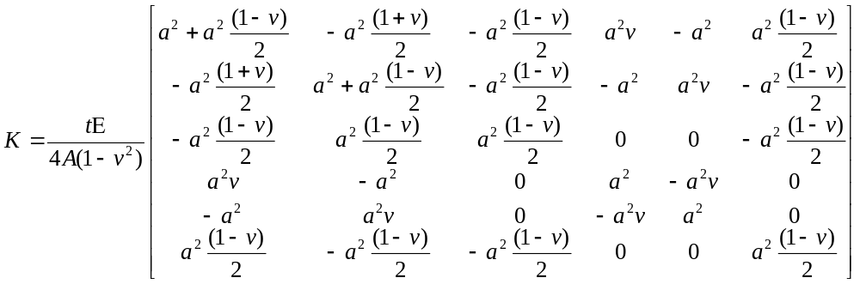

A = Area of element = 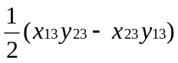

Displacement D and Forces F vectors would be

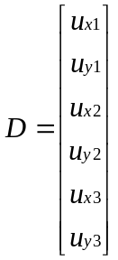 , 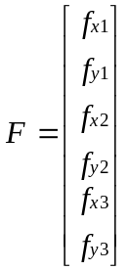

By applying the previous Matrix equation for each element in the mesh in Figure 15, we obtain six equations for node 1. From which, we reach the updating rule for the strains in node 1 as a function of strains in neighbouring nodes.

From equilibrium of forces in X direction we have 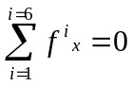 at node 1, that is total of forces from each element in X direction is zero. Similarly, we have in Y direction 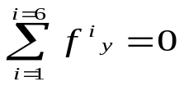.
From equation (1), we construct the matrix equation for each of the 6 elements, and we then get the forces affecting at node 1 from each element as:

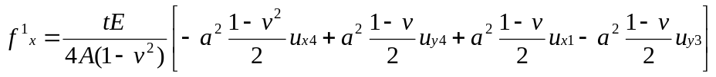
Where 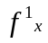 represents force from element 1, is displacement in X direction of node 4 . Similarly, 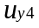 is the displacement of node 4 in the X direction.

For element 2.

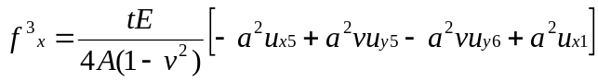 Element 3.

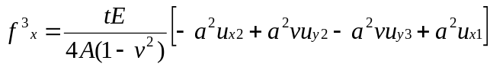

With algebraic manipulations with the equilibrium condition , we reach the updating rule for the displacement at node 1 in X direction to be:

Similarly, we get the displacement of node 1 in Y direction as:

Bibliography.
X

[1] Tirupathi R. Chandrupatla, Ashok D. Belegundu, “Introduction To FINITE ELEMENTS in ENGINEERING”, Prentece Hall, 1997.

[2] Editor, John R. Brauer, “What Every Engineer Should know About Finite Element Analysis”, Marcel Dekker, INC. 1988.

[3] D.H Bacon, “BASIC heat transfer”, Butterworth & Co. (Publishers) Ltd, 1989.

[4] Yijun Liu, “Lecture notes: Introduction to the Finite Element Method ”, http://urbana.mie.uc.edu/yliu/FEM-525/FEM_Lecture_Notes_Liu_UC.pdf

