Text Base Simulation Results

Department of Systems and Computer Engineering

Report 3 of Directed Study – fall 2009

Supervisor: Prof. Arya

By:

Mohammad Moallemi

October 2009
- Introduction to Simulation Methods and Tools
Computer simulation is an effective and easy understandable way of visually representing real-world events. This can include sequences of actions and reactions in macro, micro or nano world. Foe example simulation of solar systems or interaction between molecules can be visually rendered in computer. Modeling and Simulation (M&S) methodologies help formulate real world events in a formal and mathematical based approach. M&S provides a rigorous framework of writing and organizing events.
DEVS [1] is a discrete event M&S methodology which provides an abstract way of thing about the real world phenomena. It uses mathematical notations to represent events and sequences of occurrence and it also defines an abstract simulator model that helps computer engineers to program this methodology. In this project DEVS has been used to simulate the 3D-Elevator system.
Discrete event simulation is a popular M&S theory which has been used in different areas of simulation. Many software tools based on this approach has been produced. An introduction and comparison between these tools is presented bellow.
  - SimPy
SimPy [2] is an open source process-model discrete event simulation software which is written in Python programming language. Simpy provides a discrete event based simulation langiage which enables user to define active components (Processes) like customers, vehicles and passive components (Resources) like servers, checkout counters. Resources have limited point congestion control. It has commands for interaction between entities and provides levels to store quantities and stores to hold sets of objects. Because it is implemented in Python it is platform independent and can be run on all operating systems.
  - Tortuga
Tortuga [3] is a discrete event simulation software, fist released in 2004. It is open source and has available versions for Windows, Linux, Mac, BSD and UNIX operating systems. The simulation code in Tortuga is written in JAVA and the use of AOV puts a burden on compilation that needs javac as the compiler. Tortuga enables the user to define different threads for different simulation entities and use different run methods for threads. It minimizes user work by implementing a consistent simulation paradigm. One drawback of this method is the limitation of threads to the number that JVM supports.
  - Facsimile
Facsimile [4] is a discrete event 3D-Graphics physics simulator which is open-source and has different versions for Windows XP and Vista as well as on Linux, Mac OS, BSD and Unix. Facsimile is designed for industrial purposes in engineering and manufacturing environments.
  - AnyLogic
AnyLogic [5] is a commercial discrete event simulation tool introduce at the beginning of 90’s. It supports three formal M&S methodologies: System Dynamics, Discrete Event simulation, Agent based M&S. It supports combination of theses methods in any model. AnyLogic allows the user to graphically draw the model and enhance the java code, produce by its parsing engine. The java based development nature of AnyLogic gives the superiorities of java environment programming, especially java applets which makes model sharing very easy. In AnyLogic stock and flow diagrams are used for system dynamics modeling, State charts are used in agent based modeling, Action charts are used for defining actions which can be used in discrete event modeling and Process flowcharts are also used to define processes in discrete event modeling.
  - Arena
Arena [6] is a commercial discrete event simulation software that uses SIMAN processor and simulation language. Arena provides graphical tool to draw modules in experimental modeling framework to represent processes and logic. The flow of entities is specified by connectors between these modules. While modules have specific actions relative to entities, flow, and timing, the precise representation of each module and entity relative to real-life objects is subject to the modeler. Statistical data, such as cycle time and WIP (work in process) levels, can be recorded and outputted as reports. Arena integrates in visual basic and provides a good framework for programming. It can import flowcharts of Microsoft Visio and can read or export data to Excel. Several versions like student, researcher, basic, professional and enterprise version are available.
  - CD++
CD++ [7] is an open-source simulation software which implements the DEVS simulation formalism. In CD++, simulators and coordinators progress through the simulation by exchanging messages as described by the abstract simulation mechanism. CD++ benefits from object-oriented design which allows the developer to make use of powerful object-oriented tools to integrate simulation code with modeling code that will be added by user. Working on CD++ can be done writing C++ code in a text-based Linux environment with open source tools. In order to improve the development and simulation experience, an IDE is provided for the CD++ simulator as an Eclipse plug-in that contains CD++ functionalities. It also has a graphical model designer that supports GGAD (Generic Graphical Advanced environment for DEVS modeling and simulation) diagram ‎[8].

- Three Dimensional Elevator Model
Currently, building heights are restricted by the design limitations of their elevators. Elevator cables can reach a maximum length of 500 yards before they stretch too much under their own weight. A solution to this problem has been suggested for the Millennium Tower, a massive, half-mile high skyscraper. The solution [9] involves an electromagnetic elevator that operates not only in the traditional vertical dimension, but also in a horizontal dimension. This would be implemented by using horizontal transfer shafts that allow the elevator cars to move from side to side, allowing multiple cars to be stacked in a single shaft to allow for more efficient traffic routing.
Figure 1 illustrates a 100 floor high skyscraper with 30 blocks in length and width. Four vertical elevator tunnels are located at each cornet of the building and three horizontal tunnels connect the four vertical ones, one in the first floor, one in the 50th floor and one in 99th floor. To simplify the elevator car movements in these tunnels, they must move in regulated pathways. Two diagonal vertical tunnels are only accepting upward moving elevator cars and two others downward moving ones. The restriction on horizontal elevator tunnels is that the elevator cars are only allowed to move in the right direction (as mentioned in the figure).
The two vertical tunnels on each side of the building have 20 blocks distance from each other. On each intersection, the elevator cars are forced to obey the traditional traffic rule; the elevator on the right must go first and the left one must yield. This designs permits efficient use of tunnels with having more number of elevator cars than number of vertical tunnels. The other advantage of this approach is access to both corners of a huge building. People can get in and get off at both corners of the building and have easier access to the elevator. The advantage of having horizontal tunnel is that in emergency situations elevators can be programmed to move to the horizontal tunnels and evacuate people. Horizontal tunnels also open a way for elevators to get people off in their desired corner of the building and they provide horizontal travel path for certain crowded floors.
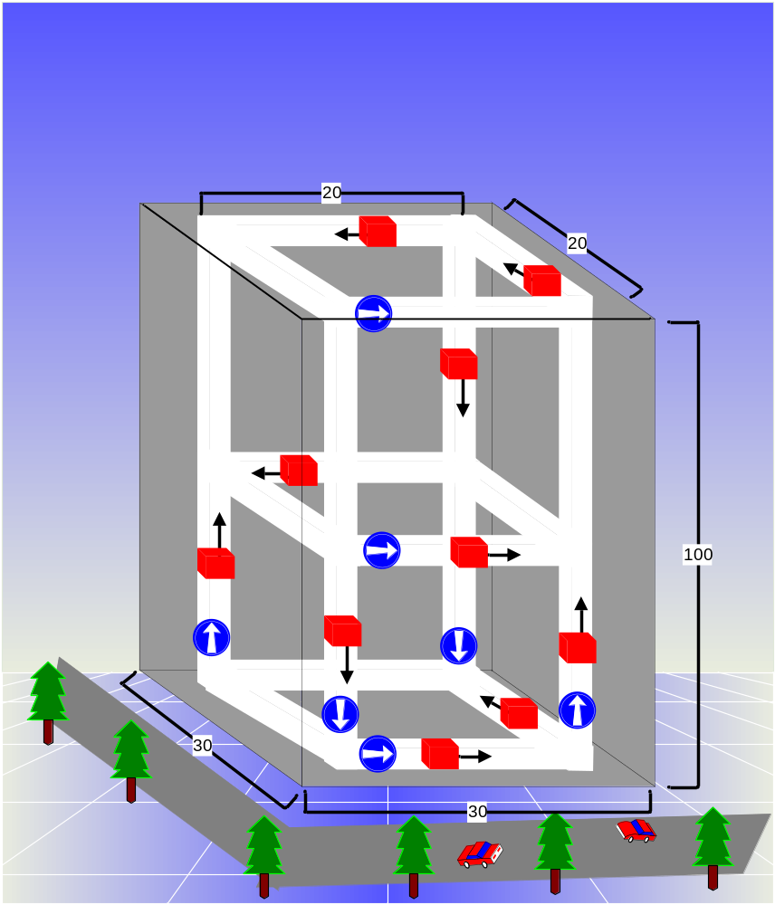
Figure 1. A 3D view of the elevator system in a 100 floor skyscraper
  - Conceptual Model
The first simple cellular implementation idea of this architecture that comes to mind is to use 30 planes of 30 by 100 cells to represent the building, tunnels and the elevators. However that, this design will consume a huge amount of memory on any computer device Thus, making it impossible to run on any machine. To overcome this problem and save memory an intelligent idea has been used. Most of the cells that represent the walls are actually useless during the simulation. An efficient way of abstractly implementing the design is to only simulate the four planes of tunnels on four sides. This way, we unfold the sides of the building and make it a two dimensional cell space with four tunnels with no wrapped neighbors on both sides. The four sides that contain the tunnels are unfolded and connected to each other, making a plane of cells with four vertical tunnels and three horizontal tunnels.
Figure 2 shows a view of the final product after unfolding. The three horizontal tunnels are connected to each other from both sides. The movement direction is signed on each tunnel. Tunnels form a cube of 20 by 20 by 100 blocks. This simplified design will save memory space and computation on the computer and make the execution faster.
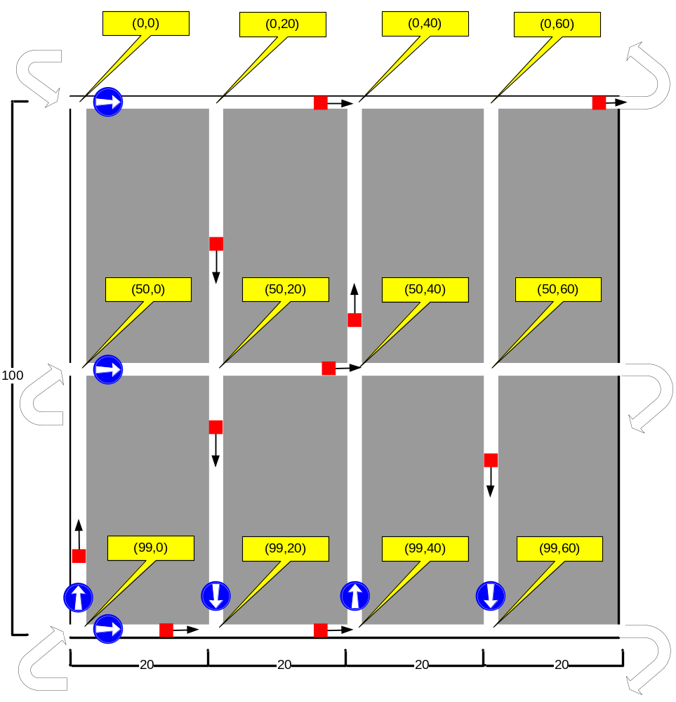
Figure 2. unfolded view of the elevator tunnels
In CD++ the origin of the cell space is the top left cell of the plane (0,0) and as we go down the first component (y) increases and as we go horizontally to the right the second component (x) increases. Thus, we have 12 intersection point with the following coordinates: (0,0), (0,20), (0,40), (0,60), (50,0), (50,20), (50,40), (50,60), (99,0), (99,20), (99,40) and (99,60). Intersection cells must take care of collisions and organize the traffic based on the previously mentioned order to avoid possible collisions between elevator cars. Figure 3 illustrates a collision scenario in a downward moving tunnel intersection cell, where a downward going elevator is going to enter the intersection simultaneously with a right going cell from the horizontal tunnel. Here the right moving horizontal tunnel will go first because it is on the right of the downward going elevator.
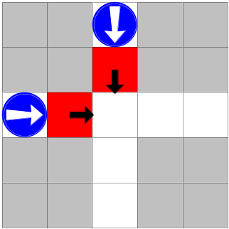
Figure 3. A collision scenario in an intersection cell

To organize the behaviors that govern the conceptual model, several rules must be defined to apply to each active cell in the simulation space. The rules must be consistent and cover all the cells that participate in the simulation. In order to manage the above mentioned conceptual model the following rules have been defined for the cells:
- If I am an intersection cell in a downward moving tunnel, and there is a right going elevator cell at the left of me then I become a downward or right going elevator cell (This provide random direction for elevator cells at the intersections).
- If I am a bottom intersection cell in a downward moving tunnel and left of me is a right going elevator cell then I become a right going elevator cell (There is no choice except going right at the bottom).
- If I am a bottom intersection cell in a downward moving tunnel and there is a downward going elevator cell above me then I become a right moving elevator cell.
- If I am a an intersection cell in a downward moving tunnel and downward moving elevator cell above me then I become a downward or right going elevator cell (to provide random direction for downward going elevator car).
- If I am a an intersection cell in an upward moving tunnel and there is an upward going elevator cell bellow me then I become an upward or right going elevator cell.
- If I am a top intersection cell in an upward moving tunnel and there is an upward going elevator cell bellow me then I become a right going elevator cell (There is no choice except going right at the top).
- If I am a top intersection cell in an upward going tunnel and there is a right going elevator cell left of me then I become a right going elevator cell (There is no choice except going right at the top).
- If I am an intersection cell in an upward going tunnel and there is a moving right elevator cell left of me then I become an upward or right moving elevator cell.
- If I am an empty cell (tunnel cell) and there is a moving up elevator cell bellow me, then I become an upward going elevator cell (to move the elevator cell one floor up).
- If I am an empty cell and there is a downward going elevator cell above me, then I become a downward going elevator cell (to move the elevator cell one floor down).
- If I am an empty cell and there is a right going elevator cell left of me, then I become a right going elevator cell (to move the elevator cell one block to the right).
- If I am an upward going elevator cell and I find empty cell above me, then I become empty cell.
- If I am a downward going elevator cell and I find empty cell bellow me and there is no right going elevator at the intersection (If so, I have to yield), then I become empty cell.
- If I am a right moving elevator cell and I find empty space and there is no upward going elevator cell at the intersection (if so I have to yield) then I become empty cell.
- If I am a wall cell, then I don’t change.
As it is understood from the above rules, elevator cells do not have a target and they randomly move in the tunnels. For simulation purposes we have designed the system to behave like this, but in a real system they will start from a point and aim to another point, therefore shortest path algorithms and a central database might be needed. In Cell-DEVS, if there are more than one rule that apply to a cell, only the first one will be executed. This concept makes intersection crossing mechanism implementation easier as the prioritized elevator will pass first because the rule that applies to it is written before the next one, thus the next crossing will happen in the next step.
  - Cell-DEVS Formal Specifications
After designing the cell space and defining the rules, it is time to specify the neighborhood definition. As it is concluded from the above rules, each cell must be able to watch its above, bellow, left, right, bottom right and bottom left corners. Therefore, the neighbor definition will be a Moore neighborhood. Figure 4 illustrates the neighborhood definition for Elevator model.
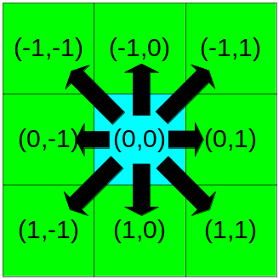
Figure 4. Moore neighborhood for Elevator model
As the figure shows the central cell uses the (0,0) pair. The formal specification of a Cell-DEVS model for the above neighbor cells is given by:
M=<I, X, Y, Xlist, Ylist, η, N, {n1,n2,n3}, C, B, Z, select> Where:
Xlist=Φ
Ylist=Φ
η=9
I=<PX,Py>,with PX={Φ},Py={Φ};
N={(-1,-1)(-1,0),(-1,1),(0,-1),(0,0),(0,1),(1,-1),(1,0),(1,1)}
X=Y= {0,20,51,52,53,61,62,63,71,72,73,81,82,83,91,92,93,101,102,103,111,112,113,121,122, 123,131,132,133,141,142,143};
{n1, n2 }={100,80}
B= {Cij / (i=1v i=100)  (j=1v i=80)} wrapped;
C={Cijz / iε[1,100], jε[1,80],}
Z:
Pij Y1 → Pi,j-1 X1  Pij Y2 → Pi+1,j X2  Pij Y3 → Pi,j+1 X3  Pij Y4 → Pi-1,j X4  Pij Y5 → Pij X5 | Pi,j+1 Y1 → Pij X1  Pi-1,j Y2 → Pij X2  Pi,j-1 Y3 → Pij X3  Pi+1,j Y4 → Pij X4  Pij Y5 → Pij X5
Select ={(-1,-1)(-1,0),(-1,1),(0,-1),(0,0),(0,1),(1,-1),(1,0),(1,1)}
A mapping between numerical values and different physical cell rendering has been defined as follows:
- 0: represents a wall cell.
- 20: represents an empty (tunnel) cell.
- 51, 61, 71, 81, 91, 101, 111, 121, 131, 141: represent upward going elevator cell.
- 52, 62, 72, 82, 92, 102, 112, 122, 132, 142: represent upward going elevator cell.
- 53, 63, 73, 83, 93, 103, 113, 123, 133, 143: represent upward going elevator cell.
Ten elevator cells have been defined to move in the tunnels. Different values have been used for different elevators to be able to define different color palette.
This model has been implemented in CD++ with 1 plane of 100 by 80 cells with wrapped borders and default delay time of 100 milliseconds.
  - Simulation Results Using CD++
After writing the model file with the above Cell-DEVS specifications and the rules, the model has been simulated and variety of tests has been carried out. The logfile of CD++ has been used by drawlog program to draw cell values and the result of drawlog has been fed to the CD++ Modeler program to render the two dimensional view of the cells. Figure 5 shows a snapshot of the CD++ Modeler representing the cell space for elevator model. Ten elevator cells are visible with different colors while the tunnels have white color and the walls are gray.
The simulation has been run for 3 seconds producing 300 steps. Figures Figure 6, Figure 7, Figure 8, Figure 9 shows four steps of the simulations which contain an intersection cross passing by two elevator cells in the right intersection. The green and brown cell are trying to pass the intersection, while the brown cell is in the right side of the green cell, it has the priority to enter the intersection.
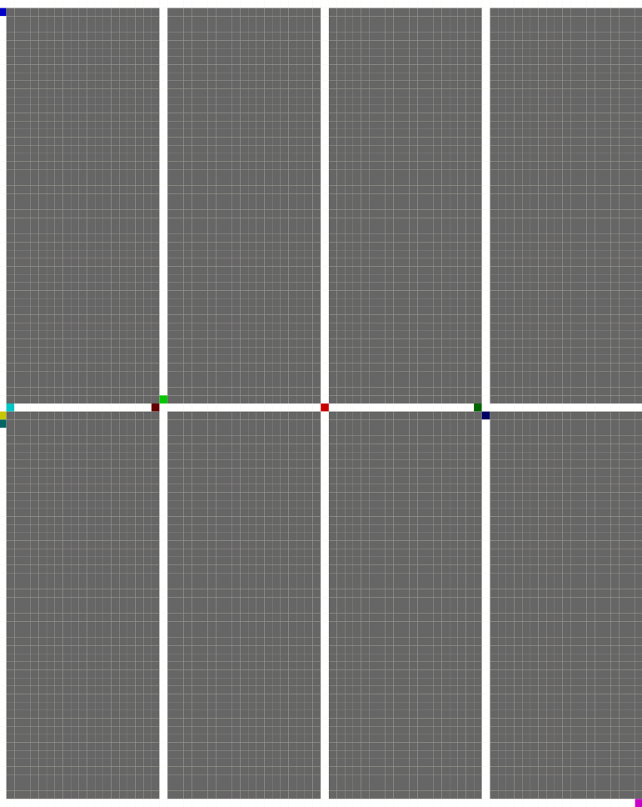
Figure 5. A snapshot of the cell space

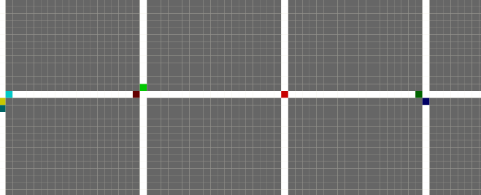
Figure 6. First snapshot of intersection crossing.

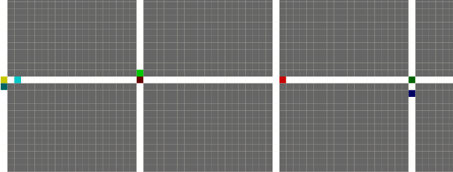
Figure 7. Second snapshot of intersection crossing.

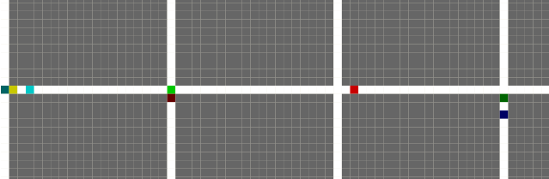
Figure 8. Second snapshot of intersection crossing.

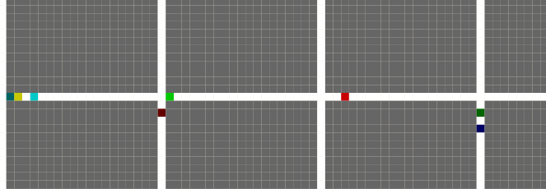
Figure 9. Second snapshot of intersection crossing.

A video of the 2d simulation result is available in [10].
- References
- ZEIGLER, B.; KIM, T.; PRAEHOFER, H. "Theory of Modeling and Simulation". Academic Press. 2000.
- SimPy project homepage available online at: http://simpy.sourceforge.net/
- Tortuga project homepage available online at: http://code.google.com/p/tortugades/
- Facsimile project homepage available online at: http://www.facsim.org/
- AnyLogic project homepage available online at: http://www.xjtek.com/
- Kelton, W. David, et al., Simulation with Arena, 5th edition. (McGraw-Hill Professional, 2006). ISBN 978-0073376288
- Wainer, G. et al. "CD++ A tool for DEVS and Cell-DEVS Modeling and Simulation. User's Guide". Draft. August 2004.
- G. Christen, A. Dobniewski and G. Wainer, "Modeling State-Based DEVS Models in CD++". In Proceedings of MGA, Advanced Simulation Technologies Conference 2004 (ASTC'04). Arlington, VA. U.S.A.
- Mark Hayden, Chris Stasiuk, Tim Tober “2 Dimensional Elevator Controller” project website, available at: http://www.ee.ualberta.ca/~elliott/ee552/projects/1998_w/elevator_controller/
- 3D Elevator project video available online at: cell-devs.sce.carleton.ca/300complete.avi

