3D Free-Form Shape Modeling using Cell-DEVS
By
Pengfei Wu
{pfwu@sce.carleton.ca}
Student Number: 100258560

A project report submitted in partial fulfillment of the requirements of the course of
SYSC 5807: Methodological Aspects of Modeling and Simulation

Department of Systems and Computer Engineering
Carleton University
Ottawa, Ontario, K1S 5B6
Canada
Dec 1st, 2003

INDEX
Abstract 4
Keyword 4
1. Introduction 4
2. Background 6
3. Virtual Clay 7
4. Modeling in Cell-DEVS 10
4.1 Deformation part in Cell-DEVS model 14
4.2 Compression part in Cell-DEVS model 19
4.3 Controller part in Cell-DEVS model 20
5. Experimental Results 21
6. Conclusion 22
Reference 25

APPENDIX A
APPENDIX B
APPENDIX C

FIGURES

Figure 1 : 2D Margolus neighborhood 7
Figure 2 : 2D block patterns and state transition rules 8
Figure 4 : 3D block patterns 9
Figure 5 : Push operation by a moving plate 10
Figure 6 : the Cell-DEVS specification in CD++ on structure of model 13
Figure 7 : A typical cell and its neighbor definition on the deformation stage 14
Figure 8 : the Cell-DEVS specification in CD++ on deformation rules of model 18
Figure 9 : A cell and its neighbor definition on the compression stage 19
Figure 10 : the Cell-DEVS specification in CD++ on compression rule of model 20
Figure 11 : A cell on plane 1 and its neighbor definition for control part 21
Figure 12 : the Cell-DEVS specification in CD++ on control rules of model 21
Figure 13 : the free-form object after the first compression in Cell-DEVS 23
Figure 14 : the free-form object after the second and third compression in Cell-DEVS 25

3D Free-Form Shape Modeling using Cell-DEVS

Abstract
It is difficult to model the free-form shapes in 3D space because considerable computation time based on restrict physical laws is needed in the modeling method. Based on the work of H. Arata, Y. Takai, and etc we focus on the Cell-DEVS formalism and try to apply it to free-form modeling the deformation of objects in 3D space. The user deal with objects in the same way as virtual clay described in the H. Arata’s paper. The Cell-DEVS model is well defined in the project. Each cell in the cell-DEVS model is given a certain amount of clay at the beginning. We assume the object receives the push operation and that leads the overload for some cells. Each cell repeats the transition according to the condition of its Margolus neighborhood cellars. The clay objects are deformed under the constraints of physical conservation laws. The model simulates the behaviour of the deformation, showing the approach described in this project can solve the complex behaviour in a simple fashion.

Keyword
DEVS, cellular automata, Free-form shape modeling, virtual clay, Margolus neighborhood

Introduction

3D modeling techniques are become more and more attractive. These modeling techniques can be widely used in the CAD system for mechanical engineering, and in modern computer graphics for image morphing. The representation of 3D object for a solid model requires us to use the restrictive geometrical operations.

Imagining the 3D free-form objects as clay which is able to be deformed freely, we can comprehend problems on 3D free-form modeling techniques. It looks much easier to understand and solve the free-form object problem if we deal the objects in the same way as real clay works. Thus the modeling task is carried out in a natural and user-friendly way. However it still require us to master enough mathematical knowledge and flexibility of spatial recognition.
Many researches have been carried out on the simulation of such deformations for objects using strict physical laws, such as finite element methods, methods based on elasticity theory, and applications of particle systems. But all these methods and applications need considerable time for computing deformations according to the laws, and the human interactions are not permitted especially in complex shapes.

Some researches are undergoing on volume sculpting in a 3D virtual space. The idea is to use a discretisation of the space in voxel (or pixel in the 2D case). An approach, combined with a cellular automaton, has been developed by Y. Takai and H. Arata [Arata99]. In this approach, a 3D cellular automaton is used to simulate plastic deformations of clay. To each voxel is allocated a finite state automaton which is given the simple distribution rules of the virtual clay instead of complicated physical laws. Each automaton repeats state transitions according to the state of their neighbours. This approach tries to avoid the considerable computation time for plastic deformation and make the deformation process natural by showing the behavior of real clay. S. Druon and A. Crosnier present an extension of the work of Y. Takai and H. Arata and new repartition algorithms for virtual clay have been developed in paper [Druon03]. This is beyond the project.

In the project we will use model a 3D free-form object by Cell-DEVS formalism to simulate the deformation of it so that we can examine the application of the Cell-DEVS formalism. The Cell-DEVS formalism [Wainer01] simulates the behaviour of the deformation for the object by using the DEVS (Discrete Events Systems specifications) formalism [Wainer02] to define a cell space. In this model each cell is defined as a DEVS model and represent a voxel in a three- dimension voxel space. Each repeats state transitions by the same distribution rules as in the paper [Arata99]. This model describes effectively the behavior of free-form object: compression (from outside) and deformation (from inside).

The rest of the report is organized as follows. Section 2 briefly introduces the definition of Cell-DEVS formalism. Section 3 provides a short presentation of the distribution algorithm suggested by H. Arata and al. in [Arata99]. Section 4 describes the definition of the model including deformation and compression. Section 5 validates the model and shows the results of experiments. Section 6 draws the conclusion of the project.

Background

Given a three-dimension voxel space, the free-form object exists with its density. We can define a voxel referred as a cell in the voxel space. We can specify the density as the value of each cell and it is the same as density of the free-form object. It is nature that the value of cell, which is outside of the free-form object, is zero. Thus the behaviour of the deformation is the outcome of the interaction between cells. Therefore we can define a cell space as Cell-DEVS model where each cell is defined as a DEVS model. Here we use a DEVS model for each cell due to discrete events nature of the problem.

The DEVS formalism [Zeigler76, Zeigler00] was originally defined as a discrete-event modeling specification mechanism. It is a systems theoretical approach that allows the definitions of hierarchical modular models that can be easily reused. A DEVS model is built using a set of behavioral models called atomic models, which can be combined to form coupled ones. In Cell-DEVS, each cell of a cellular model is defined as an atomic DEVS using transport or inertial delays. A transport delay allows us to model a variable response time for each cell. Instead, inertial delays are preemptive: a scheduled event is executed only if the delay is consumed.

Cell-DEVS atomic models can be formally specified as:
TDC = < X, Y, I, S, θ, N, Delay, d, δ_{int}, δ_{ext}, τ, λ, D >
Here X represents the external input events, Y is the external outputs, and I is the interface of the model. S is the cell state definition, θ is the definition of the cell’s state variables, and N is the set of input events and each cell will use the N inputs to compute the future state S using the function τ. Delay defines the kind of delay for the cell, and d is its duration. The new value of the cell is transmitted to the neighbors and the delay allows to defer the outputs. This behavior is defined by the δ_{int}, δ_{ext}, λ and D functions.

A Cell-DEVS coupled model is defined by:
GCC = < Xlist, Ylist, I, X, Y, η, N, { t1,...,tn }, C, B, Z, select >
Here, Ylist is the output coupling list, Xlist is the input coupling list and I represents the interface of the model. X are the external input events and Y the external outputs. The η value defines the dimension of the cell space, {t1,...,tn} is the number of cells in each dimension, and N is the neighborhood set. C is the cell space, B is the set of border cells and Z the translation function. select is the tie-breaking function

Virtual Clay

In this section we will reproduce the work suggested by H. Arata and al. in [Ara99] so that we can understand the distribution rule used in the model. In fact the deformation is considered as a physical process of equalizing density distribution of the virtual clay. When the density of virtual clay is under a certain threshold everywhere, the virtual clay objects keeps its own shape. The deformation of the object is caused by clay transportation from high density portions to low density portions. Thus each voxel (in 3D space or pixel in 2D space) is given a positive value in the model corresponding to the mass of clay. A threshold used in the model is defined in the pixel space. Therefore every pixel over this threshold will try to give some clay to its neighbors. The process is implemented by Cell-DEVS model using Margolus Neighborhood. To mitigate the complexity of Arata’s Method we begin it with 2D space then extend it to 3D space.

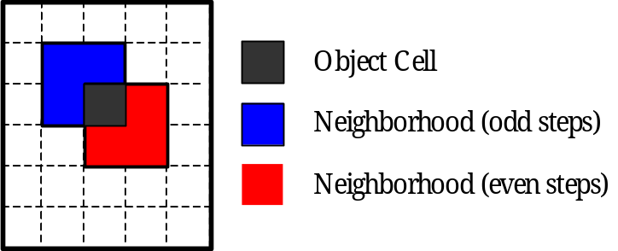

Figure 1 : 2D Margolus neighborhood

Figure 1 shows an example of Margolus neighborhood. In this neighborhood, the nearest 4 cells make one block. The neighborhood can be seen as the block including the cell itself. The transitions of all the cells belonging to a same block will be performed in one step of the algorithm. In addition, the boundaries of the blocks are changed at each step, as shown in figure 1. During even steps, a cell will not belong to the same block as during odd steps: a cell alternates its neighborhood in every transition step.

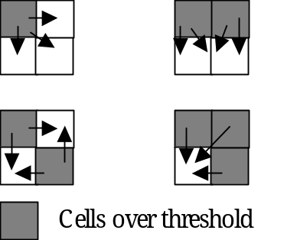
Figure 2 : 2D block patterns and state transition rules

Figure 2 illustrates the transition rules in the 2D case. Each cell has a binary state depending on whether it is above or under the threshold and a certain amount of clay m_{k}. A block is composed of four cells, over or under the threshold. Hence, four different block patterns can occur.
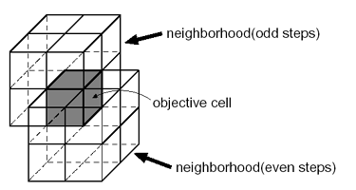
Figure 3 : 3D Margolus neighborhood

In 3D Margolus neighborhood, the nearest 8 cells make one block as shown in Figure. 3. As the same manner as 2D neighborhood, each cell belongs to different blocks in odd and even steps. We have 21 different patterns according to the cell’s binary state which depends on whether a cell includes more virtual clay than the threshold. Figure. 4 illustrates the all block patterns for 3D space.

Let the state of a cell be 1 if its virtual clay is over the threshold. Otherwise, let the state be 0. The repartition of the excess of clay dm_{k} will be performed with the following algorithm:
For each block
[Step A] For each cell k of which state is 1,
dm_{k} ← m_{k} * α
m_{k}.← m_{k} - dm_{k}
[Step B] For each cell j of which state is 0,
m_{j} ← m_{j} + ((dm₁ + dm₂ +…+ dm_{r}) / n),
where α is a rate constant for distribution ( 0 < α < 1 ), r the number of cells over threshold and n the number of cells under threshold. It is obvious that total mass of virtual clay within a block is conserved in course of the state transition. For each block, no transitions happen in either step A all cells in the block are state 1, or step B all cells in the block are state 0.
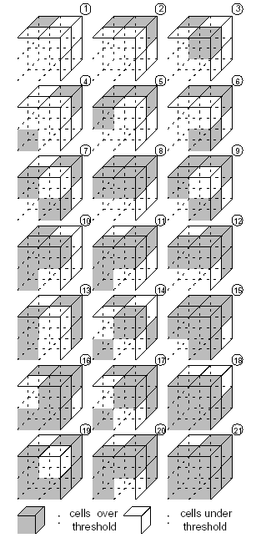
Figure 4 : 3D block patterns
In this model, all deformation of a virtual clay object is based on a push operation. The virtual clay is transferred from a cell into the adjacent cell along the direction of pushing. The surface of a virtual clay object can be pushed at most one cell in depth per step. This kind of distribution caused by outer force is prior to the state transition rule.

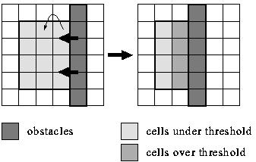
Figure 5 : Push operation by a moving plate

Figure 5 shows an example of the push operation by a moving plate. This plate is implemented in a cell space as a set of the special cells to which virtual clay cannot be distributed. When some cells become over threshold as the result of pushing, virtual clay is distributed around according to the transition rule. The state transitions are repeated until we have no cells over threshold, which results in overall plastic deformation of the virtual clay object. If all cells are under the threshold, such a situation of the cell space is referred to as a stable state. The number of steps passed until the stable state depends on total mass of virtual clay, threshold of cell, and the parameter α.

Modeling in Cell-DEVS

In this section, we present the Cell-DEVS model simulating the behaviour of the virtual clay. We focus on a 3D free-form object in the 3D cell space and use the algorithm of distribution proposed by H. Arata and al. The 3D cell space with a free-form virtual object is represented as a three-dimensional cell array, with the value of density of cell (0 means this cell out of the object and other positive value means this cell is within the object).

As with the algorithm of distribution combined with push operation, we implement the inside behaviour, deformation, and outside behaviour, compression in one model. The rule defining the model’s behaviour can be characterized by a two-stage procedure:
- Deformation stage: All cells within the free-form object are under the threshold, and such a situation of the cell space is referred to as a stable state. Once there are cells within the free-form object are over the threshold, the deformation could happen and the above distribution algorithm should be deployed. This stage should be last until the object return to a stable state again.
- Compression stage: We suppose that there is a moving plate and the virtual clay next to the plate is transferred from a cell into the adjacent cell along the direction of pushing. In fact in the model, this plate is expressed as a dummy plate, which is on the top of the object with the value of each cell as zero. The virtual clay is transferred from a cell into the adjacent cell along the direction of pushing.
This is a closed cellular model with no external inputs or outputs. The final state of the cellular array contains the free-form object after deformation under the stable state.

To represent the free-form object we should specify one value for any given cell. However each cell should choose different neighbor according to odd and even step and each cell also should identify the neighborhood according its location in the block. It is because of the characteristics of the Margolus neighborhood described in section 3. Further more each cell has different transition policy between deformation stage and compression stage. Hence a single three-dimension which only express the free-form object in 3D space is not suffice. A 4D Cell-DEVS model identified by array (x, y, z, c) is proposed by author in this project, in which each plane with (x, y, z) represents a set of state variable and c is the control variable. The x, y and z dimensions are dependent on the input values and represent the three-dimensional space being considered. The model consists of three such planes of size x-y-z, i.e. the dimension of the c-axis is 3. Each plane contains the data represented in each of the four variables discussed previously:
plane 0 (x, y, z, 0) original cell representing the 3D space and free form object within this space
plane 1 (x, y, z, 1) defining the odd step with value 1 or even step with value 0 so that each cell in plane 0 can identify Margolus neighborhood
plane 2 (x, y, z, 2) define compression stage with value 0 or deformation stage with value 0

Each cell in the 3D free-form object model in Cell-DEVS formalism will perform the state transition according to its neighborhood state, defined as follows:

CD = < X, Y, I, S, ?, N, Delay, d, δ_{int}, δ_{ext}, τ, ?, D >.
X = Ø
Y = Ø
S = {s| s >= 0, s R }
N = neighborhood = { (-1,-1,-1,0),(-1,0,-1,0),(-1,1,-1,0),
(0,-1,-1,0) ,(0,0,-1,0) ,(0,1,-1,0),
(1,-1,-1,0) ,(1,0,-1,0) ,(1,1,-1,0),

(-1,-1,0,0),(-1,0,0,0),(-1,1,0,0),
(0,-1,0,0) ,(0,0,0,0) ,(0,1,0,0),
(1,-1,0,0) ,(1,0,0,0) ,(1,1,0,0),

(-1,-1,1,0),(-1,0,1,0),(-1,1,1,0),
(0,-1,1,0) ,(0,0,1,0) ,(0,1,1,0),
(1,-1,1,0) ,(1,0,1,0) ,(1,1,1,0),

(-1,-1,2,0),(-1,0,2,0),(-1,1,2,0),
(0,-1,2,0) ,(0,0,2,0),(0,1,2,0),
(1,-1,2,0) ,(1,0,2,0),(1,1,2,0),

(0,0,0,1),(0,0,0,2)
}
d = 100 ms
τ: N→S is defined by the rules described in the previous section 3, and it can be generalized as follows:
deformation if cell (0,0,0,2) = 0 and cell is on plane 0
compression if cell (0,0,0,2) = 1 and cell is on plane 0
even/odd step control alternates if cell (0,0,0,1) = 0 and cell is on plane 1
deformation/compression control alternates if cell is on plane 2

The formal specification on the structure of the model translates into the following .ma (model definition) in Cell-DEVS (shown in figure 6):
% 3D-Plastic Deformation Model using Margolus Neighborhood
#include(plastic.inc)

[top]
components : plastic

[plastic]
type : cell
dim : (10,9,12,3)
delay : transport
defaultDelayTime : 100
border : nowrapped
neighbors : plastic(-1,-1,-1,0) plastic(-1,0,-1,0) plastic(-1,1,-1,0)
neighbors : plastic(0,-1,-1,0) plastic(0,0,-1,0) plastic(0,1,-1,0)
neighbors : plastic(1,-1,-1,0) plastic(1,0,-1,0) plastic(1,1,-1,0)

neighbors : plastic(-1,-1,0,0) plastic(-1,0,0,0) plastic(-1,1,0,0)
neighbors : plastic(0,-1,0,0) plastic(0,0,0,0) plastic(0,1,0,0)
plastic(0,0,0,1) plastic(0,0,0,2)
neighbors : plastic(1,-1,0,0) plastic(1,0,0,0) plastic(1,1,0,0)

neighbors : plastic(-1,-1,1,0) plastic(-1,0,1,0) plastic(-1,1,1,0)
neighbors : plastic(0,-1,1,0) plastic(0,0,1,0) plastic(0,1,1,0)
neighbors : plastic(1,-1,1,0) plastic(1,0,1,0) plastic(1,1,1,0)

neighbors : plastic(-1,-1,2,0) plastic(-1,0,2,0) plastic(-1,1,2,0)
neighbors : plastic(0,-1,2,0) plastic(0,0,2,0) plastic(0,1,2,0)
neighbors : plastic(1,-1,2,0) plastic(1,0,2,0) plastic(1,1,2,0)

initialvalue : 0
initialCellsValue : plastic.val
localtransition : deformation-rule

[deformation-rule]
……
Figure 6 : the Cell-DEVS specification in CD++ on structure of model

In the following subsection we make further discussion on deformation stage, compression stage and control part of the 3D free-form object model in Cell-DEVS formalism. The complete Cell-DEVS model is shown in appendix A. This Cell-DEVS model has dimension 10*9*12*3, representing a 10*9*12 3D space and three data plane used to model it. The initial cell values are loaded from an external file plastic.val. The file defines a 3D 4*3*10 free-form object whose cells with the value 20. We define the threshed as 21 and choose α as 0.3. To mitigate the complexity of expression for formula, the plastic.inc file is used to defined MACRO supported by Cell-DEVS and it is shown in appendix B.

4.1 Deformation part in Cell-DEVS model

In the subsection we offer the detailed description of constructing the 3D free-form object model in Cell-DEVS formalism on the deformation stage, which involves the odd step deformation, and even step deformation.

Difference of step deformation decides the different neighborhood which the objective cell receives clay from or sends clay to. In fact only plane 0 (x, y, z, 0) performs the deformation transition. Plane 1 (x, y, z, 1) helps to judge whether the cell in plane 0 change in odd step or in even step during the deformation stage and place 2 (x, y, z, 2) can identify the deformation stage with value 0.

Whichever step each cell is belong to, even or odd, its neighborhood can be located in a 2*2*2 block.. We choose a typical cell located in its Margolus neighborhood block shown in figure 7. This typical cell is colored as gray and its neighbors are defined according to the coordinate also shown in figure 7. We can repeat the procedure in figure 7 for other cells in the same Margolus neighborhood block and can get all neighborhood of each objective cell in the same plane.

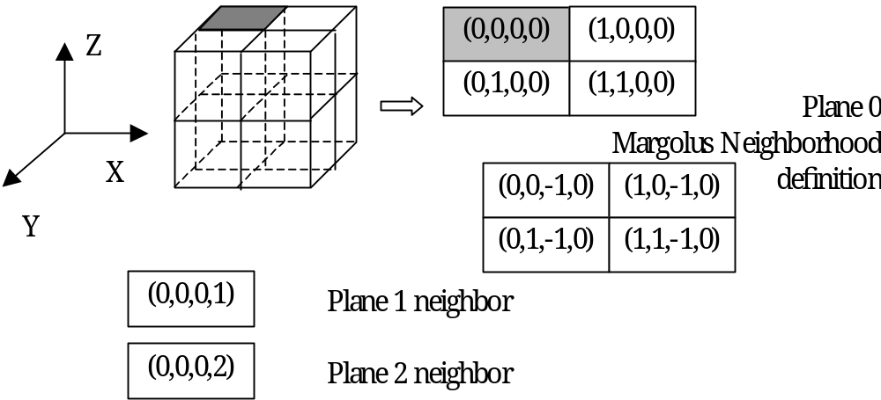
Figure 7 : A typical cell and its neighbor definition on the deformation stage

For each cell (x,y,z,0) together with its neighbor (x,y,z,1) we can know which step it is now, odd or even. Then we can define the neighbor on the plane 0 as described in the previous paragraph. Based on the value of object cell (x,y,z,0) together with the value of all its neighbors in the same Margolus neighborhood block, then we can decide step 1 or step 2 indicated in section 3 should be chosen.

Thus we can reproduce the τ defined in the previous description CD. Here we only focus on the rules on the deformation stage and this rule should be rewrite in .ma file for different cell in the same Margolus neighborhood block at different step (odd or even).
τ: N→S is defined by the rules described in the previous section 3, and it can be generalized as follows:
gain clay from neighbors on plane (x,y,z,0) if cell (0,0,0,2) = 0 and cell(0,0,0,0) is less than threshold and at least one neighbor is greater than threshold
distribute clay to neighbors on plane (x,y,z,0) if cell (0,0,0,2) = 0 and cell(0,0,0,0) is greater than threshold and at least one neighbor is less than threshold

The formal specification on rules for the deformation stage of the model translates into the following .ma (model definition) in Cell-DEVS (shown in figure 8):
……
[deformation-rule]
% deformation
rule : { (0,0,0,0 )+ (#macro(Value<1,0,0,0>)+#macro(Value<1,1,0,0>)+ #macro(Value<0,1,0,0>)+ #macro(Value<1,0,-1,0>)+#macro(Value<1,1,-1,0>)+ #macro(Value<0,1,-1,0>)+ #macro(Value<0,0,-1,0>))/(8 - #macro(Threshhold<1,0,0,0>) - #macro(Threshhold<1,1,0,0>)- #macro(Threshhold<0,1,0,0>)- #macro(Threshhold<1,0,-1,0>) - #macro(Threshhold<1,1,-1,0>)- #macro(Threshhold<0,1,-1,0>)- #macro(Threshhold<0,0,-1,0>)) } 100 { (0,0,0,2) = 0 and cellpos(3)=0 and (0,0,0,0 )<21 and cellpos(0)<9 and cellpos(1) < 8 and cellpos(2)>0 and ((even(cellpos(0)) and even(cellpos(1)) and even(cellpos(2)) and (0,0,0,1)=0) or (odd(cellpos(0)) and odd(cellpos(1)) and odd(cellpos(2)) and (0,0,0,1)=1)) and ((0,0,0,0 ) + (0,1,0,0)+(1,0,0,0)+(1,1,0,0))> 0 and ((0,0,-1,0 ) + (0,1,-1,0)+(1,0,-1,0)+(1,1,-1,0))> 0 and ((1,0,0,0)>=21 or (1,1,0,0)>=21 or (0,1,0,0)>=21 or (1,0,-1,0)>=21 or (1,1,-1,0)>=21 or (0,1,-1,0)>=21 or (0,0,-1,0)>=21) }

rule : { (0,0,0,0 )*0.7 } 100 { (0,0,0,2) = 0 and cellpos(3)=0 and (0,0,0,0 ) >= 21 and cellpos(0)<9 and cellpos(1) < 8 and cellpos(2)>0 and (0,0,0,0 )>21 and ((even(cellpos(0)) and even(cellpos(1)) and even(cellpos(2)) and (0,0,0,1)=0) or (odd(cellpos(0)) and odd(cellpos(1)) and odd(cellpos(2)) and (0,0,0,1)=1)) and ((0,0,-1,0 ) + (0,1,-1,0)+(1,0,-1,0)+(1,1,-1,0))> 0 and ((1,0,0,0)<21 or (1,1,0,0)<21 or (0,1,0,0)<21 or (1,0,-1,0)<21 or (1,1,-1,0)<21 or (0,1,-1,0)<21 or (0,0,-1,0)<21) }

rule : { (0,0,0,0 ) +(#macro(Value<1,0,0,0>)+#macro(Value<0,-1,0,0>)+ #macro(Value<1,-1,0,0>)+#macro(Value<1,0,-1,0>)+#macro(Value<0,-1,-1,0>)+ #macro(Value<1,-1,-1,0>)+ #macro(Value<0,0,-1,0>))/( 8 - #macro(Threshhold<1,0,0,0>)- #macro(Threshhold<0,-1,0,0>) - #macro(Threshhold<1,-1,0,0>)- #macro(Threshhold<1,0,-1,0>)- #macro(Threshhold<0,-1,-1,0>)- #macro(Threshhold<1,-1,-1,0>) - #macro(Threshhold<0,0,-1,0>)) } 100 {(0,0,0,2) = 0 and cellpos(3)=0 and (0,0,0,0 )<21 and cellpos(0)<9 and cellpos(1) > 0 and cellpos(2)>0 and ((even(cellpos(0)) and odd(cellpos(1)) and even(cellpos(2)) and (0,0,0,1)=0) or (odd(cellpos(0)) and even(cellpos(1)) and odd(cellpos(2)) and (0,0,0,1)=1)) and ((0,0,0,0 ) + (1,0,0,0)+(0,-1,0,0)+(1,-1,0,0))> 0 and ((0,0,-1,0 ) + (1,0,-1,0)+(0,-1,-1,0)+(1,-1,-1,0))> 0 and ((1,0,0,0)>=21 or (0,-1,0,0)>=21 or (1,-1,0,0)>=21 or (1,0,-1,0)>=21 or (0,-1,-1,0)>=21 or (1,-1,-1,0)>=21 or (0,0,-1,0)>=21 ) }

rule : { (0,0,0,0 )*0.7 } 100 {(0,0,0,2) = 0 and cellpos(3)=0 and (0,0,0,0 )>=21 and cellpos(0)<9 and cellpos(1) > 0 and cellpos(2)>0 and ((even(cellpos(0)) and odd(cellpos(1)) and even(cellpos(2)) and (0,0,0,1)=0) or (odd(cellpos(0)) and even(cellpos(1)) and odd(cellpos(2)) and (0,0,0,1)=1)) and ((0,0,-1,0 ) + (1,0,-1,0)+(0,-1,-1,0)+(1,-1,-1,0))> 0 and ((1,0,0,0)<21 or (0,-1,0,0)<21 or (1,-1,0,0)<21 or (1,0,-1,0)<21 or (0,-1,-1,0)<21 or (1,-1,-1,0)<21 or (0,0,-1,0)<21) }

rule : { (0,0,0,0 ) + (#macro(Value<-1,0,0,0>)+#macro(Value<0,1,0,0>)+ #macro(Value<-1,1,0,0>)+#macro(Value<-1,0,-1,0>)+#macro(Value<0,1,-1,0>)+ #macro(Value<-1,1,-1,0>)+#macro(Value<0,0,-1,0>))/( 8 - #macro(Threshhold<-1,0,0,0>)- #macro(Threshhold<0,1,0,0>)- #macro(Threshhold<-1,1,0,0>)- #macro(Threshhold<-1,0,-1,0>)- #macro(Threshhold<0,1,-1,0>)- #macro(Threshhold<-1,1,-1,0>) - #macro(Threshhold<0,0,-1,0>)) } 100 { (0,0,0,2) = 0 and cellpos(3)=0 and (0,0,0,0)<21 and cellpos(0)>0 and cellpos(1) < 8 and cellpos(2)>0 and ((odd(cellpos(0)) and even(cellpos(1)) and even(cellpos(2)) and (0,0,0,1)=0) or (even(cellpos(0)) and odd(cellpos(1)) and odd(cellpos(2)) and (0,0,0,1)=1)) and ((0,0,0,0 ) + (-1,0,0,0)+(0,1,0,0)+(-1,1,0,0))> 0 and ((0,0,-1,0 ) + (-1,0,-1,0)+(0,1,0,0)+(-1,1,-1,0))> 0 and ((-1,0,0,0)>=21 or (0,1,0,0)>=21 or (-1,1,0,0)>=21 or (-1,0,-1,0)>=21 or (0,1,-1,0)>=21 or (-1,1,-1,0)>=21 or (0,0,-1,0)>=21)}

rule : { (0,0,0,0 )*0.7 } 100 {(0,0,0,2) = 0 and cellpos(3)=0 and (0,0,0,0 )>=21 and cellpos(0)>0 and cellpos(1) < 8 and cellpos(2)>0 and ((odd(cellpos(0)) and even(cellpos(1)) and even(cellpos(2)) and (0,0,0,1)=0) or (even(cellpos(0)) and odd(cellpos(1)) and odd(cellpos(2)) and (0,0,0,1)=1)) and ((0,0,-1,0 ) + (-1,0,-1,0)+(0,1,-1,0)+(-1,1,-1,0))> 0 and ((-1,0,0,0)<21 or (0,1,0,0)<21 or (-1,1,-1,0)<21 or (-1,0,-1,0)<21 or (0,1,-1,0)<21 or (-1,1,-1,0)<21 or (0,0,-1,0)<21)}

rule : { (0,0,0,0 ) +(#macro(Value<-1,0,0,0>)+#macro(Value<-1,-1,0,0>)+ #macro(Value<0,-1,0,0>)+#macro(Value<-1,0,-1,0>)+#macro(Value<-1,-1,-1,0>)+ #macro(Value<0,-1,-1,0>)+#macro(Value<0,0,-1,0>))/( 8 - #macro(Threshhold<-1,0,0,0>)- #macro(Threshhold<-1,-1,0,0>)- #macro(Threshhold<0,-1,0,0>)- #macro(Threshhold<-1,0,-1,0>)- #macro(Threshhold<-1,-1,-1,0>)- #macro(Threshhold<0,-1,-1,0>)- #macro(Threshhold<0,0,-1,0>))} 100 { (0,0,0,2) = 0 and cellpos(3)=0 and (0,0,0,0 )<21 and cellpos(0)>0 and cellpos(1) >0 and cellpos(2)>0 and ((odd(cellpos(0)) and odd(cellpos(1)) and even(cellpos(2)) and (0,0,0,1)=0) or (even(cellpos(0)) and even(cellpos(1)) and odd(cellpos(2)) and (0,0,0,1)=1)) and ((0,0,0,0 ) + (-1,0,0,0)+(0,-1,0,0)+(-1,-1,0,0))> 0 and ((0,0,-1,0 ) + (-1,0,-1,0)+(0,-1,-1,0)+(-1,-1,-1,0))> 0 and ((-1,0,0,0)>=21 or (-1,-1,0,0)>=21 or (0,-1,0,0)>=21 or (-1,0,-1,0)>=21 or (-1,-1,-1,0)>=21 or (0,-1,-1,0)>=21 or (0,0,-1,0)>=21) }

rule : { (0,0,0,0 )*0.7 } 100 { (0,0,0,2) = 0 and cellpos(3)=0 and (0,0,0,0 )>=21 and cellpos(0)>0 and cellpos(1) >0 and cellpos(2)>0 and ((odd(cellpos(0)) and odd(cellpos(1)) and even(cellpos(2)) and (0,0,0,1)=0) or (even(cellpos(0)) and even(cellpos(1)) and odd(cellpos(2)) and (0,0,0,1)=1)) and ((0,0,-1,0 ) + (-1,0,-1,0)+(0,-1,-1,0)+(-1,-1,-1,0))> 0 and ((-1,0,0,0)<21 or (-1,-1,0,0)<21 or (0,-1,0,0)<21 or (-1,0,-1,0)<21 or (-1,-1,-1,0)<21 or (0,-1,-1,0)<21 or (0,0,-1,0)<21) }

%%%%%%%%%%%%%%%%%%%%%%%%%%%%%%%%%%%%%%%%%%%%%%%%%%%%%%%%%%%%%%%%%%%%%%%

rule : { (0,0,0,0 )+ (#macro(Value<1,0,0,0>)+#macro(Value<1,1,0,0>)+ #macro(Value<0,1,0,0>)+ #macro(Value<1,0,1,0>)+#macro(Value<1,1,1,0>)+ #macro(Value<0,1,1,0>)+ #macro(Value<0,0,1,0>))/(8 - #macro(Threshhold<1,0,0,0>) - #macro(Threshhold<1,1,0,0>)- #macro(Threshhold<0,1,0,0>)- #macro(Threshhold<1,0,1,0>) - #macro(Threshhold<1,1,1,0>)- #macro(Threshhold<0,1,1,0>)- #macro(Threshhold<0,0,1,0>)) } 100 { (0,0,0,2) = 0 and cellpos(3)=0 and (0,0,0,0 )<21 and cellpos(0)<9 and cellpos(1) < 8 and cellpos(2)<11 and ((even(cellpos(0)) and even(cellpos(1)) and odd(cellpos(2)) and (0,0,0,1)=0) or (odd(cellpos(0)) and odd(cellpos(1)) and even(cellpos(2)) and (0,0,0,1)=1)) and ((0,0,0,0 ) + (0,1,0,0)+(1,0,0,0)+(1,1,0,0))> 0 and ((0,0,1,0 ) + (0,1,1,0)+(1,0,1,0)+(1,1,1,0))> 0 and ((1,0,0,0)>=21 or (1,1,0,0)>=21 or (0,1,0,0)>=21 or (1,0,1,0)>=21 or (1,1,1,0)>=21 or (0,1,1,0)>=21 or (0,0,1,0)>=21) }

rule : { (0,0,0,0 )*0.7 } 100 { (0,0,0,2) = 0 and cellpos(3)=0 and (0,0,0,0 ) >= 21 and cellpos(0)<9 and cellpos(1) < 8 and cellpos(2)<11 and (0,0,0,0 )>21 and ((even(cellpos(0)) and even(cellpos(1)) and odd(cellpos(2)) and (0,0,0,1)=0) or (odd(cellpos(0)) and odd(cellpos(1)) and even(cellpos(2)) and (0,0,0,1)=1)) and ((0,0,1,0) + (0,1,1,0)+(1,0,1,0)+(1,1,1,0))> 0 and ((1,0,0,0)<21 or (1,1,0,0)<21 or (0,1,0,0)<21 or (1,0,1,0)<21 or (1,1,1,0)<21 or (0,1,1,0)<21 or (0,0,1,0)<21) }

rule : { (0,0,0,0 ) +(#macro(Value<1,0,0,0>)+#macro(Value<0,-1,0,0>)+ #macro(Value<1,-1,0,0>)+#macro(Value<1,0,1,0>)+#macro(Value<0,-1,1,0>)+ #macro(Value<1,-1,1,0>)+ #macro(Value<0,0,1,0>))/( 8 - #macro(Threshhold<1,0,0,0>)- #macro(Threshhold<0,-1,0,0>) - #macro(Threshhold<1,-1,0,0>)- #macro(Threshhold<1,0,1,0>)- #macro(Threshhold<0,-1,1,0>)- #macro(Threshhold<1,-1,1,0>) - #macro(Threshhold<0,0,1,0>)) } 100 {(0,0,0,2) = 0 and cellpos(3)=0 and (0,0,0,0 )<21 and cellpos(0)<9 and cellpos(1) > 0 and cellpos(2)<11 and ((even(cellpos(0)) and odd(cellpos(1)) and odd(cellpos(2)) and (0,0,0,1)=0) or (odd(cellpos(0)) and even(cellpos(1)) and even(cellpos(2)) and (0,0,0,1)=1)) and ((0,0,0,0 ) + (1,0,0,0)+(0,-1,0,0)+(1,-1,0,0))> 0 and ((0,0,1,0 ) + (1,0,1,0)+(0,-1,1,0)+(1,-1,1,0))> 0 and ((1,0,0,0)>=21 or (0,-1,0,0)>=21 or (1,-1,0,0)>=21 or (1,0,1,0)>=21 or (0,-1,1,0)>=21 or (1,-1,1,0)>=21 or (0,0,1,0)>=21) }

rule : { (0,0,0,0 )*0.7 } 100 {(0,0,0,2) = 0 and cellpos(3)=0 and (0,0,0,0 )>=21 and cellpos(0)<9 and cellpos(1) > 0 and cellpos(2)<11 and ((even(cellpos(0)) and odd(cellpos(1)) and odd(cellpos(2)) and (0,0,0,1)=0) or (odd(cellpos(0)) and even(cellpos(1)) and even(cellpos(2)) and (0,0,0,1)=1)) and ((0,0,1,0) + (1,0,1,0)+(0,-1,1,0)+(1,-1,1,0))> 0 and ((1,0,0,0)<21 or (0,-1,0,0)<21 or (1,-1,0,0)<21 or (1,0,1,0)<21 or (0,-1,1,0)<21 or (1,-1,1,0)<21 or (0,0,1,0)<21) }

rule : { (0,0,0,0 ) + (#macro(Value<-1,0,0,0>)+#macro(Value<0,1,0,0>)+ #macro(Value<-1,1,0,0>)+#macro(Value<-1,0,1,0>)+#macro(Value<0,1,1,0>)+ #macro(Value<-1,1,1,0>)+#macro(Value<0,0,1,0>))/( 8 - #macro(Threshhold<-1,0,0,0>)- #macro(Threshhold<0,1,0,0>)- #macro(Threshhold<-1,1,0,0>)- #macro(Threshhold<-1,0,1,0>)- #macro(Threshhold<0,1,1,0>)- #macro(Threshhold<-1,1,1,0>) - #macro(Threshhold<0,0,1,0>)) } 100 { (0,0,0,2) = 0 and cellpos(3)=0 and (0,0,0,0 )<21 and cellpos(0)>0 and cellpos(1) < 8 and cellpos(2)<11 and ((odd(cellpos(0)) and even(cellpos(1)) and odd(cellpos(2)) and (0,0,0,1)=0) or (even(cellpos(0)) and odd(cellpos(1)) and even(cellpos(2)) and (0,0,0,1)=1)) and ((0,0,0,0 ) + (-1,0,0,0)+(0,1,0,0)+(-1,1,0,0))> 0 and ((0,0,1,0 ) + (-1,0,1,0)+(0,1,1,0)+(-1,1,1,0))> 0 and ((-1,0,0,0)>=21 or (0,1,0,0)>=21 or (-1,1,0,0)>=21 or (-1,0,1,0)>=21 or (0,1,1,0)>=21 or (-1,1,1,0)>=21 or (0,0,1,0)>=21)}

rule : { (0,0,0,0 )*0.7 } 100 {(0,0,0,2) = 0 and cellpos(3)=0 and (0,0,0,0 )>=21 and cellpos(0)>0 and cellpos(1) < 8 and cellpos(2)<11 and ((odd(cellpos(0)) and even(cellpos(1)) and odd(cellpos(2)) and (0,0,0,1)=0) or (even(cellpos(0)) and odd(cellpos(1)) and even(cellpos(2)) and (0,0,0,1)=1)) and ((0,0,1,0) + (-1,0,1,0)+(0,1,1,0)+(-1,1,1,0))> 0 and ((-1,0,0,0)<21 or (0,1,0,0)<21 or (-1,1,1,0)<21 or (-1,0,1,0)<21 or (0,1,1,0)<21 or (-1,1,1,0)<21 or (0,0,1,0)<21)}

rule : { (0,0,0,0 ) +(#macro(Value<-1,0,0,0>)+#macro(Value<-1,-1,0,0>)+ #macro(Value<0,-1,0,0>)+#macro(Value<-1,0,1,0>)+#macro(Value<-1,-1,1,0>)+ #macro(Value<0,-1,1,0>)+#macro(Value<0,0,1,0>))/( 8 - #macro(Threshhold<-1,0,0,0>)- #macro(Threshhold<-1,-1,0,0>)- #macro(Threshhold<0,-1,0,0>)- #macro(Threshhold<-1,0,1,0>)- #macro(Threshhold<-1,-1,1,0>)- #macro(Threshhold<0,-1,1,0>)- #macro(Threshhold<0,0,1,0>))} 100 { (0,0,0,2) = 0 and cellpos(3)=0 and (0,0,0,0 )<21 and cellpos(0)>0 and cellpos(1) >0 and cellpos(2)<11 and ((odd(cellpos(0)) and odd(cellpos(1)) and odd(cellpos(2)) and (0,0,0,1)=0) or (even(cellpos(0)) and even(cellpos(1)) and even(cellpos(2)) and (0,0,0,1)=1)) and ((0,0,0,0 ) + (-1,0,0,0)+(0,-1,0,0)+(-1,-1,0,0))> 0 and ((0,0,1,0 ) + (-1,0,1,0)+(0,-1,1,0)+(-1,-1,1,0))> 0 and ((-1,0,0,0)>=21 or (-1,-1,0,0)>=21 or (0,-1,0,0)>=21 or (-1,0,1,0)>=21 or (-1,-1,1,0)>=21 or (0,-1,1,0)>=21 or (0,0,1,0)>=21) }

rule : { (0,0,0,0 )*0.7 } 100 { (0,0,0,2) = 0 and cellpos(3)=0 and (0,0,0,0 )>=21 and cellpos(0)>0 and cellpos(1) >0 and cellpos(2)<11 and ((odd(cellpos(0)) and odd(cellpos(1)) and odd(cellpos(2)) and (0,0,0,1)=0) or (even(cellpos(0)) and even(cellpos(1)) and even(cellpos(2)) and (0,0,0,1)=1)) and ((0,0,1,0) + (-1,0,1,0)+(0,-1,1,0)+(-1,-1,1,0))> 0 and ((-1,0,0,0)<21 or (-1,-1,0,0)<21 or (0,-1,0,0)<21 or (-1,0,1,0)<21 or (-1,-1,1,0)<21 or (0,-1,1,0)<21 or (0,0,1,0)<21)}

rule : { (0,0,0,0 ) } 100 { t }

Figure 8 : the Cell-DEVS specification in CD++ on deformation rules of model

4.2 Compression part in Cell-DEVS model

In the subsection we describe constructing the 3D free-form object model in Cell-DEVS formalism on the compression stage. Plane 0 (x, y, z, 0) performs the compression transition and this point is the same as the deformation stage. Plane 2 (x, y, z, 2) can identify the compression stage with value 1.

During the compression stage, the clay immediately under the moving plate is transferred from a cell into the adjacent cell along the direction of pushing. A dummy plate which is just on the top of object with value of zero can be thought as a moving plate. We assume the place moves down along z-axle. For each cell (x,y,z,0), if all neighbor cells (-1,-1,2,0), (-1,0,2,0), (-1,1,2,0), (0,-1,2,0), (0,0,2,0), (0,1,2,0), (1,-1,2,0), (1,0,2,0), (1,1,2,0) are zero and at least one of neighbor cells (-1,-1,1,0), (-1,0,1,0), (-1,1,1,0), (0,-1,1,0), (0,0,1,0) , (0,1,1,0), (1,-1,1,0) , (1,0,1,0), (1,1,1,0) is great than zero, cell should gain all clay in its neighbor (0,0,1,0). The neighbors of each cell are defined in figure 9.
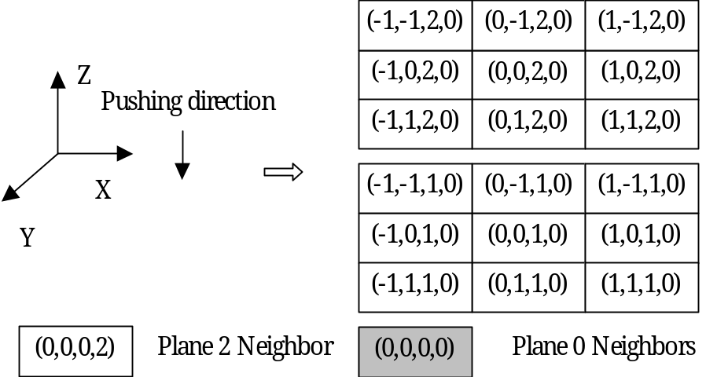
Figure 9 : A cell and its neighbor definition on the compression stage

We also reproduce the τ defined in the previous description CD. Here we focus on the rules on the compress stage and each cell and its neighbors shown in figure 9 should be investigated. The rule for compression should be rewrite in .ma file.
τ: N→S is defined by the rules described in the previous section 3, and it can be generalized as follows:
S ← (0,0,0,0 )+(0,0,1,0) if cell (0,0,0,2) = 1 and cell(0,0,0,0) is next to the cell which is immediately next to the dummy plate
S ← 0 if cell (0,0,0,2) = 1 and cell(0,0,0,0) is next to the cell which is immediately next to the dummy plate
The formal specification on rules for the deformation stage of the model translates into the following .ma (model definition) in Cell-DEVS (shown in figure 8):

[deformation-rule]
……

%plate moving
rule : {(0,0,0,0 )+(0,0,1,0)} 100 {(0,0,0,2) = 1 and cellpos(3)=0 and cellpos(0)>0 and cellpos(0)<9 and cellpos(1)>0 and cellpos(1)<8 and cellpos(2) < 10 and ((-1,-1,2,0)+(-1,0,2,0)+(-1,1,2,0)+(0,-1,2,0)+(0,0,2,0) +(0,1,2,0)+(1,-1,2,0) +(1,0,2,0)+(1,1,2,0))=0 and ((-1,-1,1,0)+(-1,0,1,0)+(-1,1,1,0)+(0,-1,1,0)+(0,0,1,0) +(0,1,1,0)+(1,-1,1,0) +(1,0,1,0)+(1,1,1,0))>0 } %step 1: add the first row to the second row
rule : 0 100 {(0,0,0,2) = 1 and cellpos(3)=0 and cellpos(0)>0 and cellpos(0)<9 and cellpos(1)>0 and cellpos(1)<8 and cellpos(0) < 11 and ((-1,-1,1,0)+(-1,0,1,0)+(-1,1,1,0)+(0,-1,1,0)+(0,0,1,0) +(0,1,1,0)+(1,-1,1,0) +(1,0,1,0)+(1,1,1,0))=0 and ((-1,-1,0,0)+(-1,0,0,0)+(-1,1,0,0)+(0,-1,0,0)+(0,0,0,0) +(0,1,0,0)+(1,-1,0,0) +(1,0,0,0)+(1,1,0,0))>0} %step2 :change the first row to 0

rule : { (0,0,0,0 ) } 100 { t }

Figure 10 : the Cell-DEVS specification in CD++ on compression rule of model

4.3 Control part in Cell-DEVS model

In the subsection we describe constructing the 3D free-form object model in Cell-DEVS formalism on the control part. Plane 0 (x, y, z, 0) performs the deformation and compression transition described in the previous two subsection 4.1 and 4.2. Plane 1 (x, y, z, 1) and Plane 2 (x, y, z, 2) are introduced into the Cell-DEVS model so that we can control between the odd step and the even step during deformation stage and between the deformation stage and compression stage respectively.

Figure 11 shows cell (x,y,z,1) on plane 1 and its neighbor (0,0,0,1). In fact the value of each cell on plane 1 switches between 0 (even step) or 1 (odd step) during the deformation stage. The value of each cell on plane 2 also switches between 0 (deformation stage) or 1 (compression stage). We assume after the duration of the deformation stage with 3000 ms, thirty time of the state transition duration, the 3D free-form object is in the stable state.
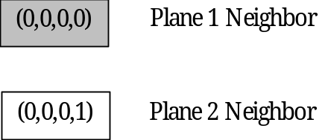
Figure 11 : A cell on plane 1 and its neighbor definition for control part

We reproduce the τ defined in the previous description CD again. Here we focus on the rules on the control part and each cell and its neighbors shown in figure 9 should be also investigated. The rule for control part (shown in figure 12 should be rewrite in .ma file according to the control strategy described in the previous paragraph.
τ: N→S is defined by the rules described in the previous section 3, and it can be generalized as follows:
S ← 1 if cell (0,0,0,1) = 0 and cell (0,0,0,0) =0 and cell is in plane 1
S ← 0 if cell (0,0,0,1) = 0 and cell (0,0,0,0) =1 and cell is in plane 1
S ← 1 if cell (0,0,0,0) =0 and cell is in plane 2
S ← 0 if cell (0,0,0,0) =1 and cell is in plane 2

rule : 1 100 {(0,0,0,1) = 0 and cellpos(3)=1 and (0,0,0,0 )=0 }
rule : 0 100 {(0,0,0,1) = 0 and cellpos(3)=1 and (0,0,0,0 )=1} %alternate the margolous neighborhood

rule : 1 3000 { cellpos(3)=2 and (0,0,0,0 )=0 }
rule : 0 100 {cellpos(3)=2 and (0,0,0,0 )=1} %plate moving

rule : { (0,0,0,0 ) } 100 { t }

Figure 12 : the Cell-DEVS specification in CD++ on control rules of model

Experimental Results

The Cell-DEVS model was simulated using the CD++ tools [Wainer02]. There is a drawing tool which can draw out each value of each cell at different time. However plane 1 and plane 2 provide the control information. A tool (see Appendix C) is developed in this project, which chooses the draw file derived from CD++ tool as source and remove all cells in plane 1 and plane 2 in that draw file. Each cell on different steps had been investigated and the total mass of object on the plane 0 is conserved for each step of the state transition. That meets the requirement of the original algorithm.
A utility developed by Toqeer and Joseph [*] was used in this project to translate the 4 dimensional log files to 3D version supported by the graflog tool. We employed graflog tool for visualizing surface of the 3D free-form object. Figure 13 and figure 14 show the procedure of the first compression and the second, third compression and the related deformation after compression. Figure 13 (a) shows a 3D free-form object with initial values which is pressed a large plate. Figure 13 (b) shows the immediate result after the first compression. Figure 13 (c) and (d) shows the deformation of the object until the stable state. Figure 14 (a) to figure 14 (f) show the repartition of clay after the second and third compression. As shown in these results, the Cell-DEVS model well simulates the deformation of the free-form object with the compression operation. Behavior of the free-form object with compression is very similar to our intuition in clay works. The Cell- DEVS model correctly simulated the behaviour of the deformation of the 3D free-form object.

Conclusion

In this project we have proposed the Cell-DEVS model for simulating the deformation of the 3D free-form object. We used the CD++ toolkit to model and simulate the transition of each cell in the 3D space. Behavior of the free-form object in a 3D space is well simulated by a Cell-DEVS model with 3D Margolus neighborhood. Total mass of a free-form object is conserved in course of its deformation.

The use of Cell-DEVS to simulate the deformation of 3D free form object is very efficient. However the simulation will take long time if we scale the problem to the larger space. That could be the challenging for Cell-DEVS model and the CD++ tool, at the same time it is interesting and could be our future studies.

[*] Toqeer A Israr, Joseph Gammal “Analysis of 4 Dimension Graphs using various tools”, The project of course 94.587 instructed in Carleton U. Canada, 2002, unpublished document
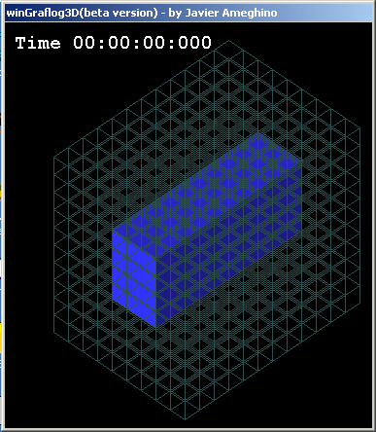  (a) Initial state | 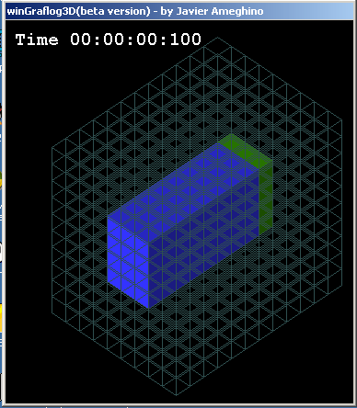  (b) step 1 (compression)
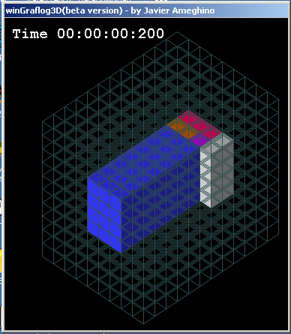  (c) step 2 (deformation) | 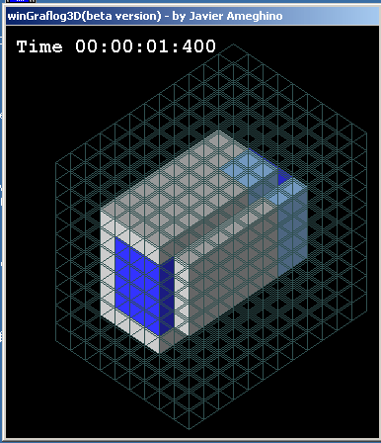  (d) step 14 (deformation, stable state)

Figure 13 : the free-form object after the first compression in Cell-DEVS
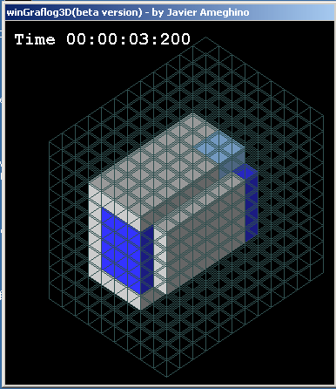  (a) step 32 (second compression ) | 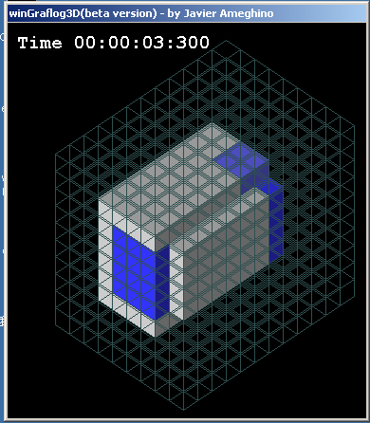  (b) step 33 (deformation)
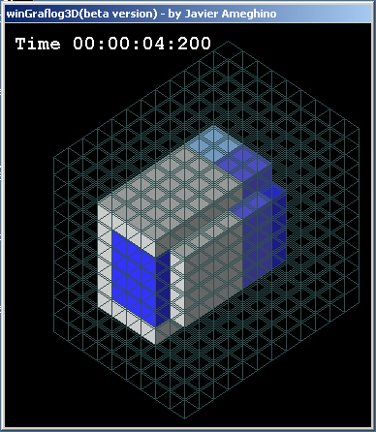  (c) step 42 (deformation, stable state) | 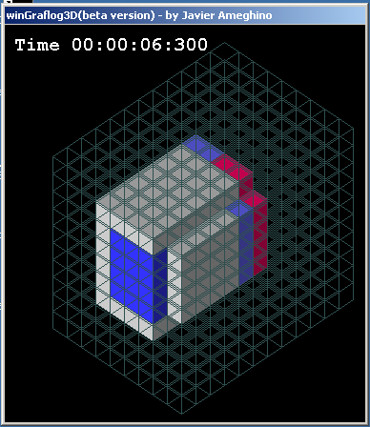  (d) step 63 (third compression)

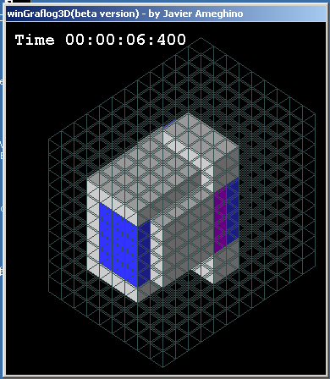  (e) step 64 (deformation) | 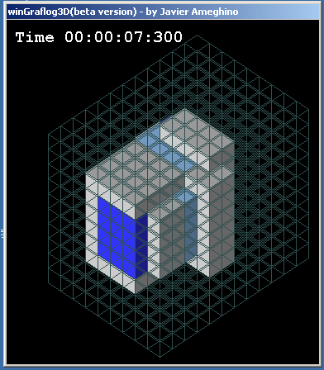  (f) step 73 (deformation, stable state)
Figure 14 : the free-form object after the second and third compression in Cell-DEVS

Reference

[Ara99] H. Arata, Y. Takai, N. K. Takai, and T. Yamamoto. “Free-form shape modeling by 3D cellular automata” In International Conference on Shape Modeling and Applications, 1999.
[Druon03] S. Druon A. Crosnier L. Brigandat, “Efficient Cellular Automata for 2D / 3D Free-Form Modeling ” In The 11th International Conference in Central Europe on Computer Graphics, Visualization and Computer Vision'2003, 2003
[Wainer01] G. Wainer; N. Giambiasi, "Application of the Cell-DEVS paradigm for cell spaces modeling and simulation". G. Wainer, N. Giambiasi. Simulation, Vol. 71, No. 1. January 2001.
[Wainer02] G. Wainer "CD++: a toolkit to define discrete-event models". 2002. In Software, Practice and Experience.Wiley. Vol. 32, No.3. 2002
[Zeigler76] B. Zeigler, “Theory of modeling and simulation”. Wiley, 1976
[Zeigler00] B. Zeigler, T. Kim, H. Praehofer, “Theory of Modeling and Simulation: Integrating Discrete Event and Continuous Complex Dynamic Systems”. Academic Press, 2000

