|  |  |
| --- | --- |
| A picture of a winding road and trees  cell devs: 5 input majority gate  Assignment 1 : SYSC 5104 : METH DISCRET-EVENT MODEL & SIM | Abstract  The document provides a quantum-dot based 5 input majority gate using cellular automata  user  Shashi Bhushan UOttawa Id : 8490661 |

# Part I

The aim of the project is to implement a cellular automata for quantum dot based 5 input majority gate. Quantum dot cellular automata provides improvement on conventional CMOS computer designs. A QCA cell consists of four quantum dots arranged in a square pattern. These dots represents the sites that can be occupied by the electrons using tunneling mechanism.

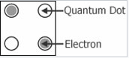

Fig 1: A simplified diagram of four-dot QCA cell

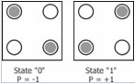

Figure 2: The two possible states of a four-dot QCA cell

A simplified diagram of a four-dot quantum cell is shown in figure 1 above. The figure 2 shows the two possible states of a QCA cell. The use of cell polarization P = +1 to represent logic 1 and P = -1 to represent logic 0 has become a standard practice although it can be arbitrarily chosen. A wire of quantum-dot cells can be made to transmit a polarized state by placing quantum-dot cells in series as shown in figure 3 below.

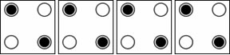

Figure 3: A wire of quantum-dot cells

Majority gate and inverter are considered two most fundamental building blocks of QCA. Here, we give a 5 input majority gate. The result is dictated by which of the two inputs is in majority thus giving the name majority gate. For example, if any three of the five inputs of the gate are 1, the output will be 1. The logical function of a 5 input majority gate is as follows:

**Maj5 (A, B, C, D, E) = ABC + ABD + ABE + ACD + ACE + ADE + BCD + BCE + BDE + CDE**

The majority gate design to be implemented is shown below. There are 5 inputs and 1 output. Other cells work as a delay element in the design**. It should be noted that throughout the document, the inputs values are represented by In1, In2, In3, In4, In5 and interchangeably as A, B, C, D, E.**

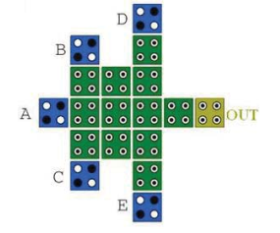

Figure 4: The 5 input majority gate.

The Quantum cellular automata design for the five input majority gate is shown below. The cells with numbers in blue are active while the cells represented in black are neutral.

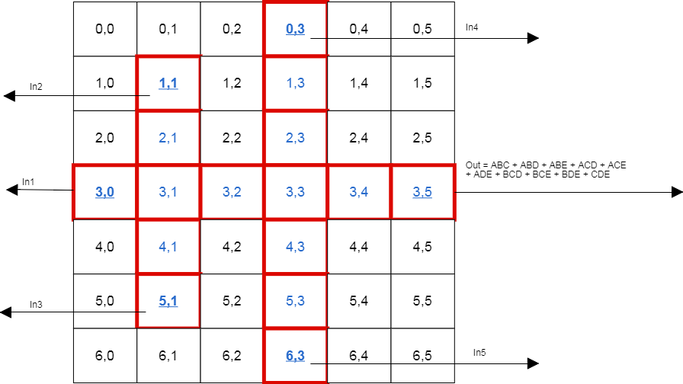

Figure 5: Quantum cellular automata design for 5 input majority gate

# Part II

The 5 input majority gate 2D Cell DEVS model has 5 inputs and one output. The inputs and output are given on various cells as follows:

Input 1: Cell (3, 0)

Input 2: Cell (1, 1)

Input 3: Cell (5, 1)

Input 4: Cell (0, 3)

Input 5: Cell (6, 3)

Output: Cell (3, 5)

The inputs can have value of 1 or -1 and the output is determined by the majority of input values. If the majority of inputs (3 or more is 1), the output is 1 and if the majority of inputs is -1, the output is -1. The formal specifications can be given as follows:

GCC=<I, X, Y, Xlist, Ylist ,η , N ,{m,n} , C , B, Z, select>

Input ports: Xlist = { (3,0); (1,1); (5,1); (0,3), (6,3)}

Output Ports: Ylist = { (3,4) }

Input & Output events: X = Y = {-1, 1};

Neighborhood size η = 5;

Set for cell state { -1; 0; 1 }

Influences I of the model can be given as:

I = < PX,PY> , with external influences PX ={<X(3,0), binary>; <X(1,1), binary>; <X(5,1), binary>;<X(0,3), binary>;<X(6,3), binary>;}, PY={ <Y(3,5), binary> };

Neighborhood set N:

N = { (-1,0); (0,-1); (0,0); (0,1); (1,0) }

Dimension of the model (size of the cell space):

Width m=6;

Height n=7;

Now, in our model, the cell space is unwrapped. The atomic models involved are as follows:

1. **Neutral Zone:** The values in these cells is 0 at all times. The cells which fall in neutral zone are { (0,0) (0,1) (0,2) (1,0) (2,0) (1,2) (2,2) (4,0) (5,0) (6,0) (6,1) (4,2) (5,2) (6,2) (0,4) (1,4) (2,4) (0,5) (1,5) (2,5) (4,4) (5,4) (6,4) (4,5) (5,5) (6,5) }. These follow the cell-DEVS atomic model specification as follows:

Cij= < Iij, Xij, Yij, Sij, Nij, dij, intij, extij, ij, ij, taij > with

Iij = { 0 } as there is no external or internal influences;

Xij = Yij = { 0 } as there is no connections to the rest of the field

State set S = { 0 } as these cells keep 0 value all the time

Nij = { 0 } as these cells do not exchange information;

intij = extij = 0 as there are no internal and/or external transitions for these cells;

ij = { (0,0) } to retain cell’s values;

ij = 0 as there is no output function for these cells;

taij = INFINITY as these cells retain their value all the time.

1. **Input Zone:** These are the cells which are provided with five input values. The cells falling in this zone are { (3,0) (1,1) (5,1) (0,3) (6,3) }. These follow the cell-DEVS atomic model specification as follows:

Cij= < I , Xij, Yij, Sij, Nij, dij, intij, extij, ij, ij, taij > with

I = <PX,PY> , with external influences PX={<X(3,0), binary>; <X(1,1), binary>; <X(5,1), binary>;<X(0,3), binary>;<X(6,3), binary>;}

Xij = { -1; 0; 1 } all are inputs, taking incoming value from the events list;

Yij = { -1; 0; 1 } as these cells are transferring received messages to their next neighbours;

intij = passivate;

extij = accept the external value;

ij = state transition from 0 to incoming value;

ij = output the previous state;

taij = INF (i.e retains 0 ground state infinitely long;

**Output Zone:** This cell provides the output value. The output cell is { (3,5) }. These follow the cell-DEVS atomic model specification as follows:

Cij= < I , Xij, Yij, Sij, Nij, dij, intij, extij, ij, ij, taij > with

I = <PX,PY> , with external influences PX={<X(3,1), binary>; <X(3,3), binary>};

Xij = { -1; 0; 1 } all are inputs, taking incoming value from the events list;

Yij = { -1; 0; 1 } as these cells are transferring received messages to their next neighbours;

intij = passivate;

extij = accept the external value;

ij = state transition from 0 to incoming value;

ij = output the previous state;

taij = INF (i.e retains 0 ground state infinitely long;

**Transport Zone:** The cells in this zone are the ones which are used for the transportation of values. No calculations are done in these cells. No select function is required. The cells falling in this zone are { (2,1) (4,1) (3,2) (1,3) (2,3) (4,3) (5,3) (3,4) }. These follow the cell-DEVS atomic model specification as follows:

Cij= < I , Xij, Yij, Sij, Nij, dij, intij, extij, ij, ij, taij > with

I = <PX,PY> , with external influences PX={<neigbours; binary>};

Xij = { -1; 0; 1 } all are inputs, taking incoming value from the events list;

Yij = { -1; 0; 1 } as these cells are transferring received messages to their next neighbours;

intij = passivate;

extij = accept the external value;

ij = state transition from 0 to incoming value;

ij = output the previous state;

taij = INF (i.e retains 0 ground state infinitely long;

The connections are represented by Z and are given as follows:

Input Zone:

P3,-1Y1→P3,0X1 P3,0Y1→P3,1X1

P0,1Y1→P1,1X1 P1,1Y1→P2,1X1

P6,1Y1→P5,1X1 P5,1Y1→P4,1X1

P-1,3Y1→P0,3X1 P0,3Y1→P1,3X1

P7,3Y1→P6,3X1 P6,3Y1→P5,3X1

Calculus zone { (3,1) }:

P3,0Y3→P3,1X3

P2,1Y3→P3,1X3

P4,1Y3→P3,1X3

P3,1Y3→P3,2X3

Calculate zone { (3,3) }:

P3,2Y3→P3,3X3

P2,3Y3→P3,3X3

P4,3Y3→P3,3X3

P3,3Y3→P3,4X3

Output zone { (3,5) }:

P3,4Y4→P3,5X4 P3,5Y4→P3,6X4

# Part III

## Test Strategies

The model will be tested using “black box” testing method. Test cases are created by adding different combinations of the inputs to the event file (.ev). The log and output file is created after running the simulation. The files are then run on the online tool <http://omarhesham.com/arslab/webviewer/>.

## Test cases and Execution analysis

There are five inputs to the system. As such there are 32 possible input combinations. The inputs combinations and the corresponding outputs are as follows:

|  |  |  |  |  |  |
| --- | --- | --- | --- | --- | --- |
| In1 | In2 | In3 | In4 | In5 | Out= **ABC + ABD + ABE + ACD + ACE + ADE + BCD + BCE + BDE + CDE** |
| -1 | -1 | -1 | -1 | -1 | -1 |
| -1 | -1 | -1 | -1 | 1 | -1 |
| -1 | -1 | -1 | 1 | -1 | -1 |
| -1 | -1 | -1 | 1 | 1 | -1 |
| -1 | -1 | 1 | -1 | -1 | -1 |
| -1 | -1 | 1 | -1 | 1 | -1 |
| -1 | -1 | 1 | 1 | -1 | -1 |
| -1 | -1 | 1 | 1 | 1 | 1 |
| -1 | 1 | -1 | -1 | -1 | -1 |
| -1 | 1 | -1 | -1 | 1 | -1 |
| -1 | 1 | -1 | 1 | -1 | -1 |
| -1 | 1 | -1 | 1 | 1 | 1 |
| -1 | 1 | 1 | -1 | -1 | -1 |
| -1 | 1 | 1 | -1 | 1 | 1 |
| -1 | 1 | 1 | 1 | -1 | 1 |
| -1 | 1 | 1 | 1 | 1 | 1 |
| 1 | -1 | -1 | -1 | -1 | -1 |
| 1 | -1 | -1 | -1 | 1 | -1 |
| 1 | -1 | -1 | 1 | -1 | -1 |
| 1 | -1 | -1 | 1 | 1 | 1 |
| 1 | -1 | 1 | -1 | -1 | -1 |
| 1 | -1 | 1 | -1 | 1 | 1 |
| 1 | -1 | 1 | 1 | -1 | 1 |
| 1 | -1 | 1 | 1 | 1 | 1 |
| 1 | 1 | -1 | -1 | -1 | -1 |
| 1 | 1 | -1 | -1 | 1 | 1 |
| 1 | 1 | -1 | 1 | -1 | 1 |
| 1 | 1 | -1 | 1 | 1 | 1 |
| 1 | 1 | 1 | -1 | -1 | 1 |
| 1 | 1 | 1 | -1 | 1 | 1 |
| 1 | 1 | 1 | 1 | -1 | 1 |
| 1 | 1 | 1 | 1 | 1 | 1 |

Test cases made by using various input combinations and the output generated after the simulation are as follows:

Inputs combinations in event (.ev) file

00:00:00:000 in2 1

00:00:00:000 in3 1

00:00:00:010 in1 1

00:00:00:010 in4 1

00:00:00:010 in5 1

00:00:00:100 in2 1

00:00:00:100 in3 1

00:00:00:110 in1 1

00:00:00:110 in4 -1

00:00:00:110 in5 -1

00:00:00:200 in2 -1

00:00:00:200 in3 1

00:00:00:210 in1 1

00:00:00:210 in4 -1

00:00:00:210 in5 -1

00:00:00:300 in2 -1

00:00:00:300 in3 -1

00:00:00:310 in1 -1

00:00:00:310 in4 -1

00:00:00:310 in5 -1

00:00:00:400 in2 -1

00:00:00:400 in3 -1

00:00:00:410 in1 -1

00:00:00:410 in4 1

00:00:00:410 in5 1

00:00:00:500 in2 1

00:00:00:500 in3 1

00:00:00:510 in1 -1

00:00:00:510 in4 1

00:00:00:510 in5 1

00:00:00:600 in2 -1

00:00:00:600 in3 1

00:00:00:610 in1 1

00:00:00:610 in4 1

00:00:00:610 in5 1

00:00:00:700 in2 -1

00:00:00:700 in3 1

00:00:00:710 in1 1

00:00:00:710 in4 -1

00:00:00:710 in5 -1

00:00:00:800 in2 -1

00:00:00:800 in3 -1

00:00:00:810 in1 -1

00:00:00:810 in4 -1

00:00:00:810 in5 1

00:00:00:900 in2 -1

00:00:00:900 in3 -1

00:00:00:910 in1 -1

00:00:00:910 in4 1

00:00:00:910 in5 1

00:00:01:000 in2 -1

00:00:01:000 in3 1

00:00:01:010 in1 1

00:00:01:010 in4 1

00:00:01:010 in5 1

00:00:01:100 in2 1

00:00:01:100 in3 -1

00:00:01:110 in1 1

00:00:01:110 in4 1

00:00:01:110 in5 1

00:00:01:200 in2 1

00:00:01:200 in3 1

00:00:01:210 in1 -1

00:00:01:210 in4 1

00:00:01:210 in5 1

00:00:01:300 in2 1

00:00:01:300 in3 1

00:00:01:310 in1 1

00:00:01:310 in4 -1

00:00:01:310 in5 1

00:00:01:400 in2 -1

00:00:01:400 in3 1

00:00:01:410 in1 1

00:00:01:410 in4 -1

00:00:01:410 in5 -1

00:00:01:500 in2 1

00:00:01:500 in3 1

00:00:01:510 in1 -1

00:00:01:510 in4 1

00:00:01:510 in5 1

00:00:01:600 in2 1

00:00:01:600 in3 1

00:00:01:610 in1 1

00:00:01:610 in4 1

00:00:01:610 in5 1

**The inputs In2 and In3 are provided 10 time units before the inputs In1, In4 and In5**. This is due to the different travelling times for various inputs. Note that the last input set is same as the first input set and is given just to get the final output for previous set as the output of final input set cannot be seen on the online tool.

The output file for the inputs is as follows:

00:00:00:060 out 1

00:00:00:061 out 0

00:00:00:160 out 1

00:00:00:161 out 0

00:00:00:260 out -1

00:00:00:261 out 0

00:00:00:360 out -1

00:00:00:361 out 0

00:00:00:460 out -1

00:00:00:461 out 0

00:00:00:560 out 1

00:00:00:561 out 0

00:00:00:660 out 1

00:00:00:661 out 0

00:00:00:760 out -1

00:00:00:761 out 0

00:00:00:860 out -1

00:00:00:861 out 0

00:00:00:960 out -1

00:00:00:961 out 0

00:00:01:060 out 1

00:00:01:061 out 0

00:00:01:160 out 1

00:00:01:161 out 0

00:00:01:260 out 1

00:00:01:261 out 0

00:00:01:360 out 1

00:00:01:361 out 0

00:00:01:460 out -1

00:00:01:461 out 0

00:00:01:560 out 1

00:00:01:561 out 0

00:00:01:660 out 1

00:00:01:661 out 0

## Test case execution analysis

The table below shows the outputs alongside the input combination for comparison and confirmation that the rules made for the model are correct.

|  |  |  |
| --- | --- | --- |
| Test case number | Test case (Event) | Output |
| 1 | 00:00:00:000 in2 1  00:00:00:000 in3 1  00:00:00:010 in1 1  00:00:00:010 in4 1  00:00:00:010 in5 1 | 00:00:00:060 out 1  00:00:00:061 out 0 |
| 2 | 00:00:00:100 in2 1  00:00:00:100 in3 1  00:00:00:110 in1 1  00:00:00:110 in4 -1  00:00:00:110 in5 -1 | 00:00:00:160 out 1  00:00:00:161 out 0 |
| 3 | 00:00:00:200 in2 -1  00:00:00:200 in3 1  00:00:00:210 in1 1  00:00:00:210 in4 -1  00:00:00:210 in5 -1 | 00:00:00:260 out -1  00:00:00:261 out 0 |
| 4 | 00:00:00:300 in2 -1  00:00:00:300 in3 -1  00:00:00:310 in1 -1  00:00:00:310 in4 -1  00:00:00:310 in5 -1 | 00:00:00:360 out -1  00:00:00:361 out 0 |
| 5 | 00:00:00:400 in2 -1  00:00:00:400 in3 -1  00:00:00:410 in1 -1  00:00:00:410 in4 1  00:00:00:410 in5 1 | 00:00:00:460 out -1  00:00:00:461 out 0 |
| 6 | 00:00:00:500 in2 1  00:00:00:500 in3 1  00:00:00:510 in1 -1  00:00:00:510 in4 1  00:00:00:510 in5 1 | 00:00:00:560 out 1  00:00:00:561 out 0 |
| 7 | 00:00:00:600 in2 -1  00:00:00:600 in3 1  00:00:00:610 in1 1  00:00:00:610 in4 1  00:00:00:610 in5 1 | 00:00:00:660 out 1  00:00:00:661 out 0 |
| 8 | 00:00:00:700 in2 -1  00:00:00:700 in3 1  00:00:00:710 in1 1  00:00:00:710 in4 -1  00:00:00:710 in5 -1 | 00:00:00:760 out -1  00:00:00:761 out 0 |
| 9 | 00:00:00:800 in2 -1  00:00:00:800 in3 -1  00:00:00:810 in1 -1  00:00:00:810 in4 -1  00:00:00:810 in5 1 | 00:00:00:860 out -1  00:00:00:861 out 0 |
| 10 | 00:00:00:900 in2 -1  00:00:00:900 in3 -1  00:00:00:910 in1 -1  00:00:00:910 in4 1  00:00:00:910 in5 1 | 00:00:00:960 out -1  00:00:00:961 out 0 |
| 11 | 00:00:01:000 in2 -1  00:00:01:000 in3 1  00:00:01:010 in1 1  00:00:01:010 in4 1  00:00:01:010 in5 1 | 00:00:01:060 out 1  00:00:01:061 out 0 |
| 12 | 00:00:01:100 in2 1  00:00:01:100 in3 -1  00:00:01:110 in1 1  00:00:01:110 in4 1  00:00:01:110 in5 1 | 00:00:01:160 out 1  00:00:01:161 out 0 |
| 13 | 00:00:01:200 in2 1  00:00:01:200 in3 1  00:00:01:210 in1 -1  00:00:01:210 in4 1  00:00:01:210 in5 1 | 00:00:01:260 out 1  00:00:01:261 out 0 |
| 14 | 00:00:01:300 in2 1  00:00:01:300 in3 1  00:00:01:310 in1 1  00:00:01:310 in4 -1  00:00:01:310 in5 1 | 00:00:01:360 out 1  00:00:01:361 out 0 |
| 15 | 00:00:01:400 in2 -1  00:00:01:400 in3 1  00:00:01:410 in1 1  00:00:01:410 in4 -1  00:00:01:410 in5 -1 | 00:00:01:460 out -1  00:00:01:461 out 0 |
| 16 | 00:00:01:500 in2 1  00:00:01:500 in3 1  00:00:01:510 in1 -1  00:00:01:510 in4 1  00:00:01:510 in5 1 | 00:00:01:560 out 1  00:00:01:561 out 0 |
| 17 | 00:00:01:600 in2 1  00:00:01:600 in3 1  00:00:01:610 in1 1  00:00:01:610 in4 1  00:00:01:610 in5 1 | 00:00:01:660 out 1  00:00:01:661 out 0 |

We can see from the table that the outputs are generated based on the majority of inputs. E.g. the output in case 1 and 2 is 1 as majority of inputs is 1 and in case 3 and 4, the output is -1 as the majority of inputs is -1. The other outputs are also based on the logic and verify the correct implementation of the model. We can also see the output 0 1ms after the output 1 or -1. This is expected as the output is programmed to reset to 0 after 1ms.

The figures below shows the screenshots of the cell value for case 2. The cell (3, 1) is calculated as 111 as all the inputs In1, In2 and In3 are 1. This 111 travels and the cell (3, 3) is calculated based on the value 111 and In4 and In5. Since three of the five inputs is 1, the output is 1.

* Input In2 (cell (1, 1) ) and In3 (cell (5, 1) ) are given 10ns before other inputs to counter the transport delay difference for various inputs

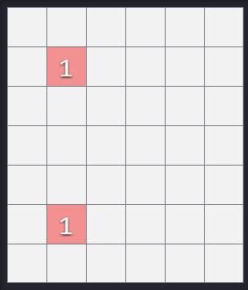

* Inputs In1 (cell (3, 0)), In4 (cell (0, 3)) and In5 (cell (6, 3)) are provided. Inputs In2 travel to cell (2,1) and In3 travels to cell (4, 1) in the time period

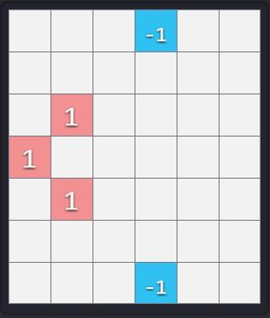

* Input In1, In4 and In5 remain in the initial cells while we calculate the value for cell (3, 1). The value of cell (3, 1) is dependent on In1, In2 and In3. The value is
  + 111 if In1, In2 and In3 are all 1
  + 11 If two of the three inputs are 1
  + 1 if one of the inputs is 1
  + -1 if all three inputs are -1

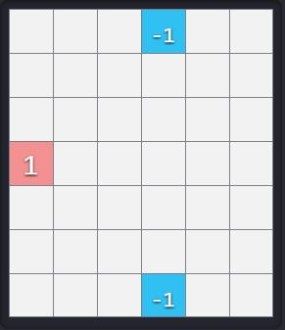

* The value of cell (3, 1) is 111 as In1, In2 and In3 were all 1. In4 travel to cell (1, 3) and In5 to cell (5, 3)

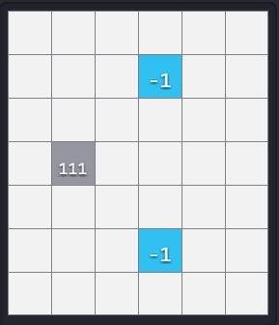

* Time delay

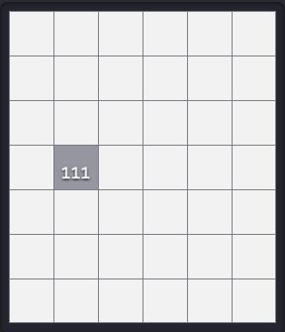

* Value of cell (3, 1) travels to cell (3, 2), In4 travels to cell (2, 3) and In4 to cell (4,3)

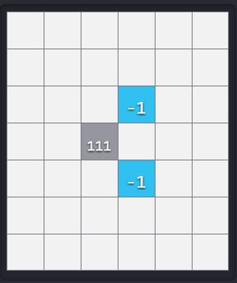

* Time delay for calculating the value of cell (3, 3) based on neighbor values. The value depends on In4, In5 and the value calculated at cell (3, 1)



* Value of cell (3, 3 ) generated based on all the inputs

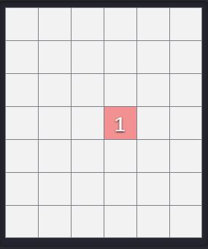

* The value calculated at cell (3, 3) travels to cell (3, 4)

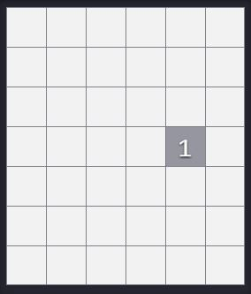

* Time Delay



* The output is provided at cell (3, 5)

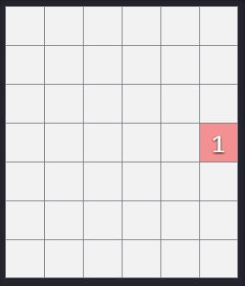

# Conclusion

The cell DEVS model for a 5 input majority gate was made, the formal specifications were provided and the model was tested using various test cases. The output generated based on various test cases was observed to compare with the expected output. The model is tested to be working as per the specifications. The model was ran on web viewer and graphical result of one input test case is provided.