SYSC 5104 Assignment 1
Bowen Yang
10992611

Air Conditioner Cooling Model
Part I

This model is used to simulate the process of how an air conditioner work when it has been set into cooling mode. The air conditioner should be able to receive user’s order such as expected temperature or blocking the blowing rate of fan. However, the air conditioner will also get the interior temperature from the electronic thermometer and control the refrigerator and the fun via such data.

The Diagram:
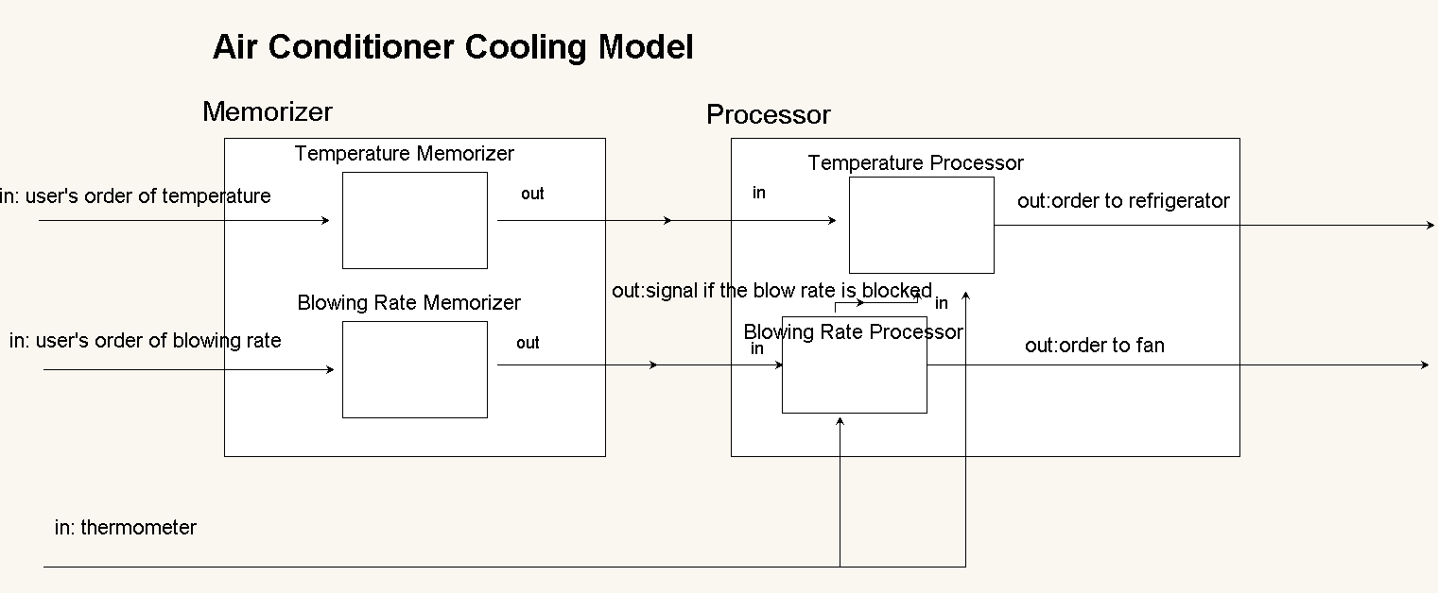

Memorizer:
Collecting the user’s orders, and send the current state to the Processor periodically.

Processor:
Receiving data from the electrical thermometer and the Memorizer,then send the order to the refrigerator and the fan. If the user block the blowing rate, the Processor will set a lower temperature to compensate it.

Part II

This model contains 2 coupled models,there are:
- The Memorizer
- The Processor
The specification of top level is shown below:
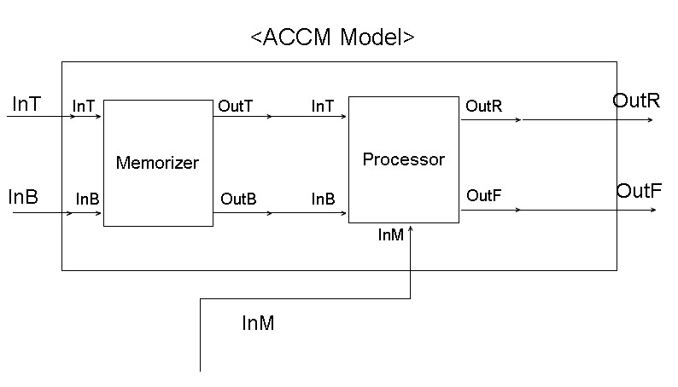

ACCM Model=<X,Y,D,EIC,EOC,IC,Select>
- X={InT,InB,InM}
- Y={OutR,OutF}
- D={Memorizer,Processor}
- EIC={Memorizer.InT,Memorzier.InB,Processor.InM}
- EOC={Processor.OutR,Processor.OutF}
- IC={(Memorizer.OutT,Processor.InT),(Memorizer.OutB,Processor.InB)}
- Select=Φ

InT: The user’s order to maintain the temperature.
InB: The user’s order to maintain the blow rate.
InM: The current temperature of the room.
OutR: The order to control the refrigerator.
OutF: The order to control the fan.

Memorizer contains 2 atomic models, there are:
- Temperature Memorizer
- Blow Rate Memorizer
The specification of Memorizer is shown below:
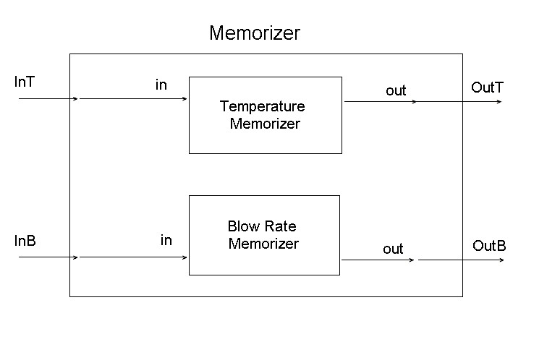
The Memorizer is used to collect and normalize the user’s order. Every time when Memorizer receive orders from user, it will check the value and maintain the value into the proper range, and then send the order to processor.

Memorizer=<X,Y,D,EIC,EOC,IC,Select>
- X={InT,InB}
- Y={OutT,OutB}
- D={Temperature Memorizer,Blow Rate Memorizer}
- EIC={Temperature Memorizer.in,Blow Rate Memorizer.in}
- EOC={Temperature Memorizer.out,Blow Rate Memorizer.out}
- IC=Φ
- Select=Φ

Temperature Memorizer=<X,Y,S,δ_{int},δ_{ext},λ,ta>
- X={in}
- Y={out}
- S={16..28}
- δ_{int}: S→S
- δ_{ext}:X→S, when 16≤X≤28;
- λ:S→Y
- ta:ProcessTime

Blow Rate Memorizer=<X,Y,S,δ_{int},δ_{ext},λ,ta>
- X={in}
- Y={out}
- S={0..6} //0 for auto mode,1-6 for the actual blow rate.
- δ_{int}: S→S
- δ_{ext}:X→S, when 1≤X≤6;0→S,otherwise.\
- λ:S→Y
- ta:ProcessTime

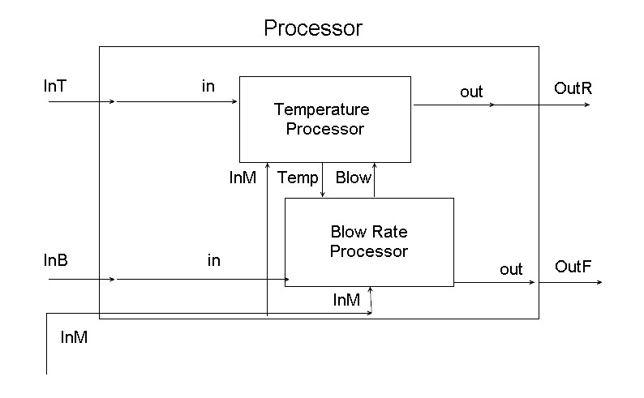
The Processor receives messages from the Memorizer, and send the order to the refrigerator and the fan.Sometimes the user will turn the air conditioner into the auto mode, or set up the temperature or blow rate into some exact value.The processor will make the balance between the refrigerator and the fan, and try to reduce the heat gently.

Processor=<X,Y,D,EIC,EOC,IC,Select>
- X={InT,InB,InM}
- Y={OutR,OutF}
- D={Temperature Processor,Blow Rate Processor}
- EIC={Temperature Processor.in,Blow Rate Processor.in,Temperature Processor.InM,Blow Rate Processor.InM}
- EOC={Temperature Processor.out,Blow Rate Processor.out}
- IC={(Temperature Processor.Temp,Blow Rate Processor.Temp),(Temperature Processor.Blow,Blow Rate Processor.Blow)}
- Select=Φ

Temperature Processor=<X,Y,S,δ_{int},δ_{ext},λ,ta>
- X={in,InM,Blow}
- Y={out}
- S={16..28}
- δ_{int}: S→S
- δ_{ext}:X*Q→S,Q:S=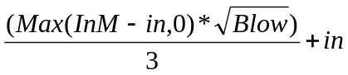
- λ:S→Y
- ta:ProcessTime

Blow Rate Processor=<X,Y,S,δ_{int},δ_{ext},λ,ta>
- X={in,InM,Temp}
- Y={out}
- S={0..6}
- δ_{int}: S→S
- δ_{ext}:X→S.

S= in (1≤in≤6);
when in=0,
1 (InM-Temp<3),
2 (3≤InM-Temp<6),
3 (6≤InM-Temp<6),
4 (6≤InM-Temp<9),
5 (9≤InM-Temp<23),
6 (In≥12)

- λ:S→Y
- ta:ProcessTime

The Test Strategy

To test the correctness of this model, the first step is to check each 4 atomic models.

- Memorizer
For 2 atomic models in the Memorizer are analogous, so the method to test these 2 models can be similar
To test the correctness of these 2 models, it is just need to send some user’s orders some of which are errorless but others are not. Then check the output of the models to see if the models can maintain the values in the orders accurately.

- Processor
Two atomic methods in Processor are coupled, so these 2 models are need to be test in the same time as well.The method to test these 2 models should be simulating the messages from the Memorizer, and check the correctness of the Processor’s output.

If the correctness of 2 coupled models has been proved, the next step should be linking these 2 models and check them as entirety. Sending orders to the Memorizer and check the output of the Processor.
Part II
A Sample output of the model:

00:00:03:005 outf 1
00:00:03:010 outr 26
00:00:04:010 outf 4
00:00:04:015 outr 28
00:00:05:015 outf 6
00:00:05:020 outr 27
00:00:06:005 outf 5
00:00:06:010 outr 25
00:00:07:010 outf 3
00:00:07:015 outr 23
00:00:08:010 outf 6
00:00:08:015 outr 26
00:00:09:005 outf 6
00:00:09:010 outr 23
00:00:10:015 outf 6
00:00:10:020 outr 24

The lines that are output by “outf” means this line is orders that is sent to the refrigerator, other lines that is output by “ouf” are orders that is sent to the fan.
From this result we can see the model maintain itself to reduce the heat step by step.

